Data Visualization and Reporting with Advanced Excel Techniques

1. Introduction and Objective
This report documents how I turned a cleaned Netflix catalogue dataset into an interactive Excel dashboard. The goal of the task was not only to draw charts, but to make a data consumer able to ask a question (for example, "what happened to Movies only?") and see the answer immediately, without needing to understand the formulas behind it. The report explains my planning, the Excel features I used, why each chart type was chosen, what the visuals reveal, the challenges I met, and the best practices I followed.
The source file contains four sheets: Raw_Data, Cleaned_Data, Quality_Check and Summary. The cleaning work was already complete: 8,790 rows, 10 original columns, no blank cells, no duplicate show IDs, dates converted to a standard format, and the duration field split into a numeric duration_value and a duration_unit. I built the dashboard on top of the Cleaned_Data sheet so that every number on the dashboard can be traced to a verified source.

2. Visualization Planning

2.1 Questions the data should answer
Before opening any chart menu I wrote down the questions a manager at a streaming company would realistically ask. Each question became one visual element:
Business question | Metric | Visual chosen
How big is the catalogue and how is it split? | Count of titles; Movie vs TV Show share | KPI cards + doughnut chart
How fast has content been added over time? | Titles added per year, by type | Stacked column chart + line chart
Which countries supply the most content? | Titles per country (Top 10) | Sorted horizontal bar chart
What audience is the catalogue aimed at? | Titles per maturity rating | Column chart
Where do country and rating combine in unusual ways? | Country x rating counts | Heat-map using colour scale
Is growth accelerating or slowing? | Year-on-year % change | Icon set (arrows) + data bars

2.2 Layout sketch
I used the common "KPIs first, trends next, detail last" layout so that the eye moves from the headline numbers at the top to the supporting detail below:
Zone | Content
Header band | Title and the interactive drop-down selector (All / Movie / TV Show)
Row 1 | Six KPI cards across the full width
Row 2 | Left: stacked column of additions per year. Right: dynamic line chart of the selected type
Row 3 | Left: Top 10 countries bar chart. Right: maturity rating column chart
Row 4 | Left: doughnut of Movie vs TV mix. Right: country x rating heat-map and growth table with icons

3. Dashboard Creation

3.1 Structure of the workbook
I kept the original four sheets untouched and added two new ones. The Calc sheet is a small back-end that holds the summary tables feeding the charts. The Dashboard sheet is the only sheet an end user needs to open. Keeping calculations separate from presentation is a deliberate design choice: the dashboard stays clean, and anyone auditing the work can find every formula in one place.

3.2 Making it interactive
Interactivity is delivered with three simple, dependable Excel features rather than macros:
- Data validation drop-down: cell C4 on the Dashboard has a drop-down list (Data > Data Validation > List) with the values All, Movie and TV Show. It is highlighted in yellow with blue text so users know it is the input cell.
- A criteria helper cell: cell B1 on the Calc sheet converts the selection into a criteria string: =IF(Dashboard!$C$4="All","<>",Dashboard!$C$4). The "<>" criterion means "anything that is not blank", so the same formula works for all three choices.
- COUNTIFS formulas: every dynamic table uses COUNTIFS with that criteria cell, for example =COUNTIFS(Cleaned_Data!$B$2:$B$8791,$B$1,Cleaned_Data!$H$2:$H$8791,F5) to count titles of the chosen type with a given rating. Because the charts point at these cells, they redraw automatically when the selection changes.
Figure 1 shows the dashboard with the "All" selection, and Figures 2 and 3 show the same dashboard after the user switches the drop-down to Movie and TV Show. No chart was rebuilt and no formula was edited; only one cell changed.
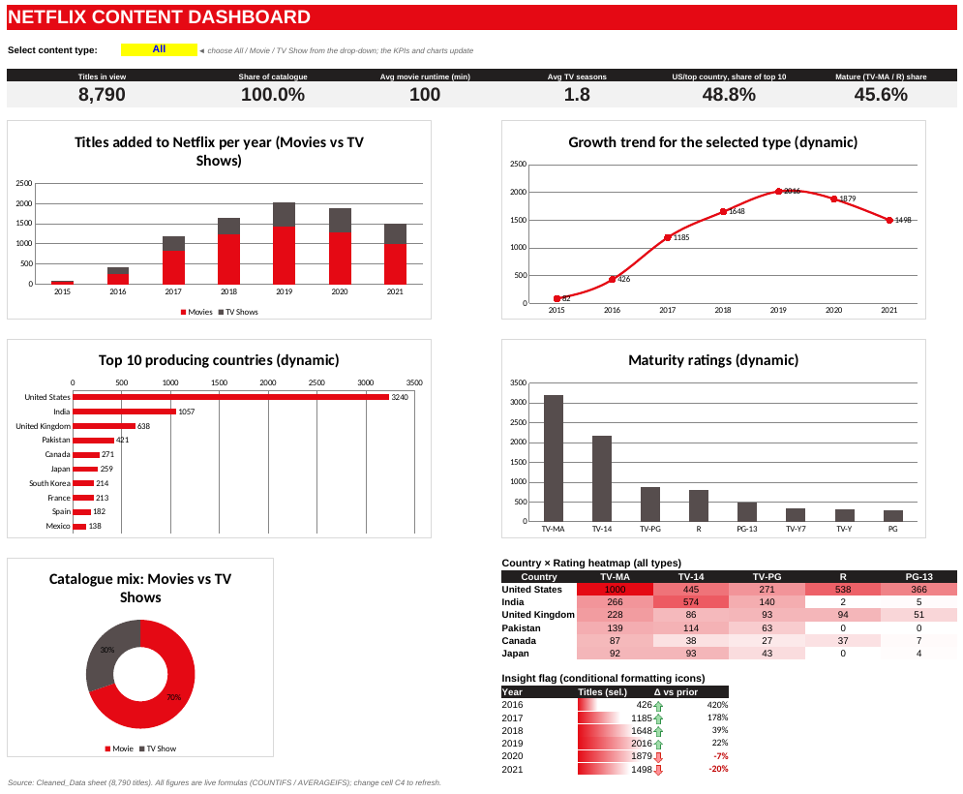
Figure 1: Netflix dashboard, selector set to "All" (8,790 titles).
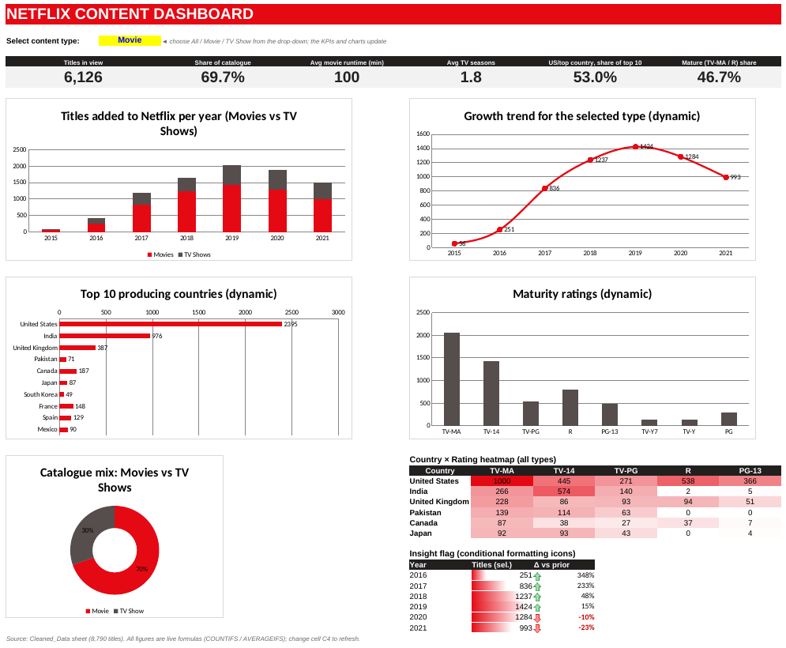
Figure 2: Same dashboard with the selector set to "Movie" (6,126 titles). KPI cards, line chart, country chart and rating chart all updated.
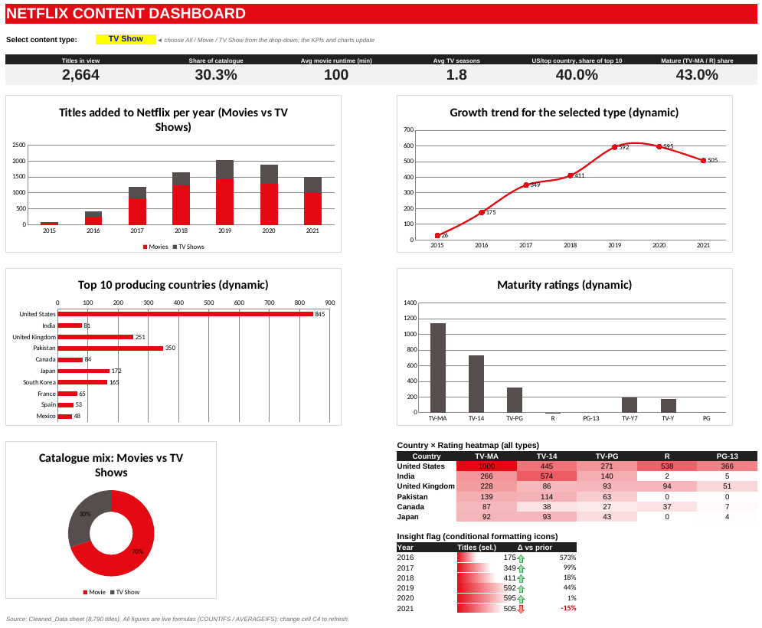
Figure 3: Same dashboard with the selector set to "TV Show" (2,664 titles).

3.3 KPI cards
The six KPI cards at the top use merged cells, a dark header strip and large bold numbers. They give the reader the headline answer in two seconds. They are: Titles in view (a live count), Share of catalogue (selected type as a percentage of all 8,790 titles), Average movie runtime (about 100 minutes, using AVERAGEIFS on duration_value), Average TV seasons (1.8), the share of the largest country among the Top 10, and the Mature share (TV-MA plus R titles, 45.5% across the whole catalogue).
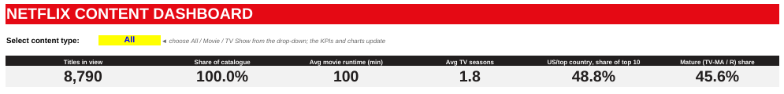
Figure 4: KPI strip with the drop-down selector above it.

4. Chart Development and Why Each Type Was Chosen

4.1 Stacked column: titles added per year
Time is the key dimension for understanding how the catalogue grew, and column charts make year-to-year comparison easy. I stacked Movies and TV Shows in one column so that both the total height (all additions that year) and the mix (red = Movies, dark grey = TV Shows) are visible together. I limited the axis to 2015-2021 because earlier years contain only a handful of records and would just add empty space.

4.2 Line chart with data labels: the dynamic trend
A line chart suits a single continuous series, and the data labels remove the need to read values off the axis. Unlike the stacked column, this chart reacts to the drop-down. It shows that additions climbed steeply from 82 titles in 2015 to a peak of 2,016 in 2019, then fell to 1,879 in 2020 and 1,498 in 2021. (The 2021 figure covers only part of the year because the data ends in September 2021, so the decline should be read with care.)
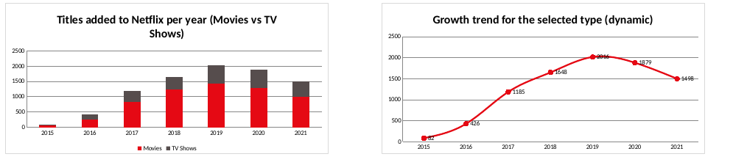
Figure 5: Stacked column (left) and dynamic line chart (right).

4.3 Horizontal bar chart: top 10 countries
Country names are long, so a horizontal bar chart keeps them readable without rotating text. The bars are sorted from largest to smallest so the ranking is obvious, and each bar carries its value. I excluded the placeholder value "Not Given" (287 rows) so that it does not appear as a fake country. The United States leads with 3,240 titles, followed by India (1,057), the United Kingdom (638) and Pakistan (421). Selecting Movie raises India to a strong second place (976 movies), while selecting TV Show moves Pakistan (350), Japan (172) and South Korea (165) up the ranking.

4.4 Column chart: maturity ratings
Ratings are a categorical field with a natural order of volume, so a simple column chart is the clearest choice. TV-MA (3,205 titles) and TV-14 (2,157) dominate, which tells a decision-maker that the catalogue is mainly aimed at teenagers and adults. Children's ratings such as TV-Y and TV-G are small segments.
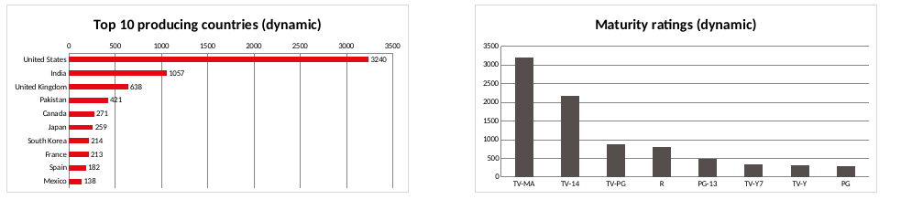
Figure 6: Top 10 countries (left) and maturity ratings (right) for the "All" selection.

4.5 Doughnut chart: catalogue mix
A doughnut chart is only appropriate when there are very few categories that add up to a whole. Movie versus TV Show is exactly that: two slices, 70% versus 30%. I coloured the slices in two clearly different shades, labelled them with percentages, and avoided adding extra categories.

5. Conditional Formatting Techniques
Conditional formatting lets the numbers themselves carry the visual message. I used three different rules, each for a different purpose:
- Colour scale heat-map: the country x rating table uses a white-to-red colour scale. Dark cells mark large counts, so the reader can see at a glance that the US has 1,000 TV-MA titles, that India is unusual because TV-14 (574) is more common than TV-MA (266), and that Pakistan has no R-rated titles at all.
- Data bars: a red bar inside each cell of the "Titles" column shows relative size, giving a tiny chart without using any chart space.
- Icon set and font rule: the "change vs prior year" column shows a green up arrow for growth and a red down arrow for decline. A second rule turns negative percentages red and bold. This flags that the 2020 and 2021 values fell (-7% and -20%) after four years of growth.
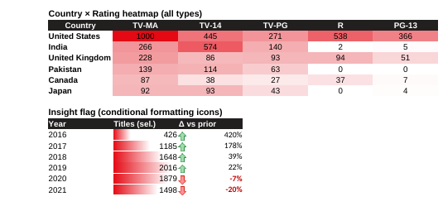
Figure 7: Colour-scale heat-map, data bars and arrow icons.

6. How the Charts Support Decision-Making
A dashboard is only useful if it changes what someone does. The table below links each insight to a practical decision:
Insight from the visual | Possible decision
Movies are about 70% of the catalogue but TV Shows grew from 5 additions in 2013 to 505 in 2021 | Content planners may decide that TV Shows deserve more investment because they keep viewers engaged across several seasons.
Additions peaked in 2019 and have declined since | Management should check whether the slowdown is a strategy shift to quality over quantity or a data coverage issue.
The US supplies 3,240 titles, India 1,057 and the UK 638 | Regional teams can prioritise partnerships in India, the second-largest source, and explore under-represented countries.
45.5% of titles are TV-MA or R | Marketing should be aware that most of the catalogue is not family-friendly, which affects recommendations for children profiles.
India favours TV-14 over TV-MA | Local content strategy can target a broader family audience instead of copying the US pattern.

Because the selector allows each question to be answered for Movies and TV Shows separately, the same dashboard supports both a high-level review and a more detailed look, which is the main advantage of interactive reporting over a static report.

7. Challenges Faced and Alternatives Considered
- Off-by-one total: my first version counted 8,791 titles instead of 8,790. The cause was the wildcard criterion "*", which also matched the header cell in row 1 when whole-column references were used. I fixed it by using bounded ranges (rows 2 to 8791) and the "<>" criterion, and verified that the total matched the Summary sheet.
- Multi-value genre field: the genre column (listed_in) holds several genres in one cell, so counting genres needs wildcards that confuse "Dramas" with "TV Dramas". I chose to leave genre out of the dashboard rather than present unreliable numbers. A future improvement would be to split genres in Power Query.
- Pivot tables versus formulas: slicers and PivotCharts would give a richer filtering experience. I decided to use a drop-down and COUNTIFS because they work in every Excel version, are easy to explain, and keep the logic visible. I treat PivotCharts and slicers as the next step.
- Chart type alternatives: I considered a pie chart for ratings, but twelve slices would be unreadable, so I used a column chart. I also considered a map for countries, but a ranked bar chart communicates the comparison more accurately.
- Text dates: the date_added field is stored as text (for example 2021-09-25). Instead of adding a helper column to 8,790 rows I matched the year with a wildcard (year&"*"), which keeps the Cleaned_Data sheet unchanged.

8. Best Practices for Effective Visualizations in Excel
- Design for the question: put the most important numbers first, in the top-left, and keep one idea per chart.
- Match the chart to the data: bars and columns are for comparison, lines for trends over time, doughnuts only for a simple whole of two or three parts. Avoid 3D effects and decorative styling that distort values.
- Use a restrained palette: I used Netflix red and charcoal grey only. Colour is reserved for meaning (for example red for the highlighted series), not decoration.
- Label clearly and reduce clutter: every chart has a descriptive title, labelled categories and, where helpful, data labels. Gridlines are light and legends are removed when there is only one series.
- Be honest with scales: sort bars by value, start bar axes at zero, and keep consistent number formats.
- Keep the model auditable: separate the calculation sheet from the dashboard, use formulas instead of typed numbers, and mark the input cell with a distinct colour so users know what they may change.
- Document and validate: add a source note, state when a period is incomplete (such as 2021), and check totals against the Summary sheet.
- Consistency and accessibility: keep the layout aligned on a grid, use the same fonts and sizes, and test the dashboard at the screen size where it will be presented.

9. Conclusion
The finished dashboard shows that a small number of well-chosen visuals can summarise a large dataset. With one drop-down, a reader can move from the whole 8,790-title catalogue to Movies or TV Shows and instantly see growth, geography and audience. The most important findings are: Movies make up about 70% of the catalogue, additions peaked in 2019, the United States and India are the largest sources, and nearly half of all titles are rated for mature audiences. The process also taught me that careful planning, clean source data, consistent design and honest scales matter at least as much as the charting tools themselves. Future improvements would be adding slicers, splitting genres with Power Query and adding a month-level trend.
Deliverable files: Netflix_Dashboard.xlsx (the interactive dashboard workbook) and this report.

