Customer Shopping Behavior Segmentation
An Unsupervised Learning Project using K-Means Clustering
Applied Machine Learning – Clustering Assignment

1. Objective
The goal of this project is to group customers into meaningful segments based on their shopping behavior, using an unsupervised machine learning technique called clustering. No labels or 'correct answers' are given in the data — the algorithm finds natural groupings on its own, based on patterns in customer attributes such as age, spending amount, and purchase habits.
This kind of analysis is widely used by retail and e-commerce businesses to understand their customer base, design targeted marketing campaigns, and personalize offers for different types of shoppers.

2. Dataset
The dataset used is a publicly available Customer Shopping Trends dataset (commonly found on Kaggle), containing 3,900 customer records with 18 columns describing demographic details and purchase behavior.
Attribute | Description
Customer ID | Unique identifier for each customer
Age, Gender | Basic demographic details
Item Purchased, Category | What the customer bought and its product category
Purchase Amount (USD) | Amount spent on the transaction
Review Rating | Rating given by the customer (1–5)
Previous Purchases | Number of prior purchases by the customer
Frequency of Purchases | How often the customer shops (Weekly, Monthly, Annually, etc.)
Subscription Status, Discount Applied, Promo Code Used | Yes/No behavioral flags
Payment Method, Shipping Type | How the customer paid and received the order

Note: this project focuses on the numeric behavioral columns (age, spend, ratings, purchase history, frequency) because these directly describe how a customer shops. Categorical columns such as item, color, and location were kept aside for describing the clusters afterwards, not for forming them.

3. Methodology

3.1 Data Cleaning and Preprocessing
Before clustering, the data was cleaned and prepared in a few simple steps:
- Checked for missing values — 37 rows had a missing Review Rating, which were filled in using the median rating.
- Converted the text column 'Frequency of Purchases' (e.g., 'Weekly', 'Monthly', 'Annually') into an approximate number of purchases per year, so it could be used as a number.
- Selected five behavioral features to describe each customer: Age, Purchase Amount, Review Rating, Previous Purchases, and Purchase Frequency per year.
- Standardized all features using StandardScaler, so that columns measured in different units (like age in years vs. amount in dollars) contribute equally to the distance calculations K-Means uses.
A quick check on the raw data showed that the three Yes/No columns (Discount Applied, Promo Code Used, Subscription Status) were perfectly tied to Gender in this dataset — every discount and promo code in the data went to male customers only. Including them made the clusters split almost entirely by gender rather than by real shopping behavior, so they were left out of the clustering features and instead used afterwards to describe each segment.
import pandas as pd
from sklearn.preprocessing import StandardScaler
df = pd.read_csv('customer_shopping_behavior.csv')
df['Review Rating'] = df['Review Rating'].fillna(df['Review Rating'].median())
freq_map = {'Annually': 1, 'Quarterly': 4, 'Every 3 Months': 4, 'Monthly': 12,
'Bi-Weekly': 26, 'Fortnightly': 26, 'Weekly': 52}
df['Purchase Frequency (per year)'] = df['Frequency of Purchases'].map(freq_map)
features = ['Age', 'Purchase Amount (USD)', 'Review Rating',
'Previous Purchases', 'Purchase Frequency (per year)']
X_scaled = StandardScaler().fit_transform(df[features])

3.2 Choosing the Clustering Algorithm
K-Means clustering was chosen because it is simple to understand, fast to run even on thousands of rows, and works well when the features are numeric and standardized, which fits this dataset. K-Means groups customers by repeatedly assigning each customer to the nearest cluster center and then updating the centers, until the groupings stop changing.

3.3 Choosing the Number of Clusters (k)
K-Means needs to be told in advance how many clusters (k) to look for. Two standard techniques were used to choose a good value of k:
- Elbow Method: plots how much the clusters' internal spread (inertia) shrinks as k increases. The 'elbow' point, where adding more clusters stops giving a big improvement, hints at a good k.
- Silhouette Score: measures how well-separated the clusters are, from -1 (poor) to +1 (excellent). Higher is better.
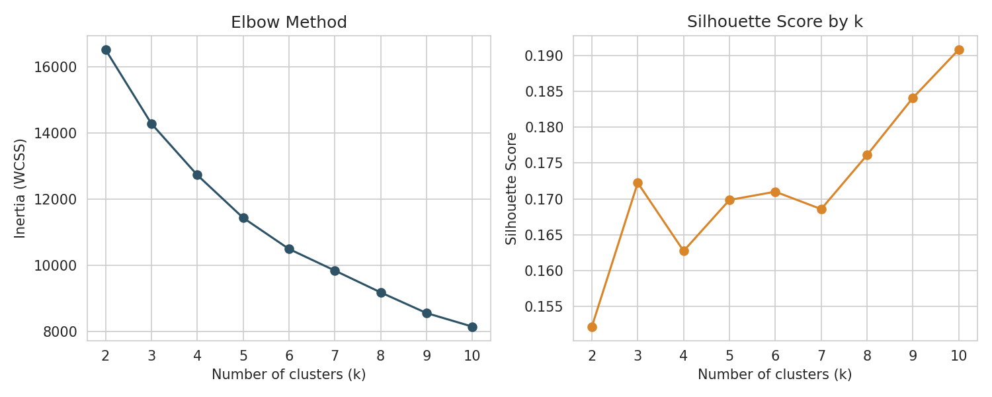
Figure 1. Elbow method (left) and silhouette score (right) for k = 2 to 10.
The elbow chart flattens out noticeably after k = 4, and the silhouette scores across k = 3 to 9 stay in a similar, fairly modest range (0.16–0.19), which is expected for real-world behavioral data where customers don't fall into perfectly separated groups. k = 4 was chosen as the final number of clusters because it sits right at the elbow and produces four clearly interpretable, business-relevant customer segments (shown in Section 4), rather than splitting customers into groups that are statistically separate but not meaningfully different in practice.
from sklearn.cluster import KMeans
from sklearn.metrics import silhouette_score
for k in range(2, 11):
km = KMeans(n_clusters=k, random_state=42, n_init=10)
labels = km.fit_predict(X_scaled)
print(k, km.inertia_, silhouette_score(X_scaled, labels))
# Final model
kmeans = KMeans(n_clusters=4, random_state=42, n_init=10)
df['Cluster'] = kmeans.fit_predict(X_scaled)

4. Results

4.1 Cluster Sizes and Averages
The table below shows the average value of each feature within every cluster, along with how many customers fall into each group.
Cluster | Customers | Avg. Age | Avg. Spend ($) | Avg. Rating | Avg. Past Purchases | Purchases / Year
0 | 539 (13.8%) | 44.7 | 58.97 | 3.76 | 25.8 | 52.0 (weekly)
1 | 1,075 (27.6%) | 46.3 | 36.69 | 3.59 | 32.1 | 11.6 (quarterly)
2 | 1,026 (26.3%) | 45.6 | 80.40 | 3.84 | 36.2 | 12.0 (quarterly)
3 | 1,260 (32.3%) | 40.7 | 62.99 | 3.81 | 10.6 | 12.2 (quarterly)

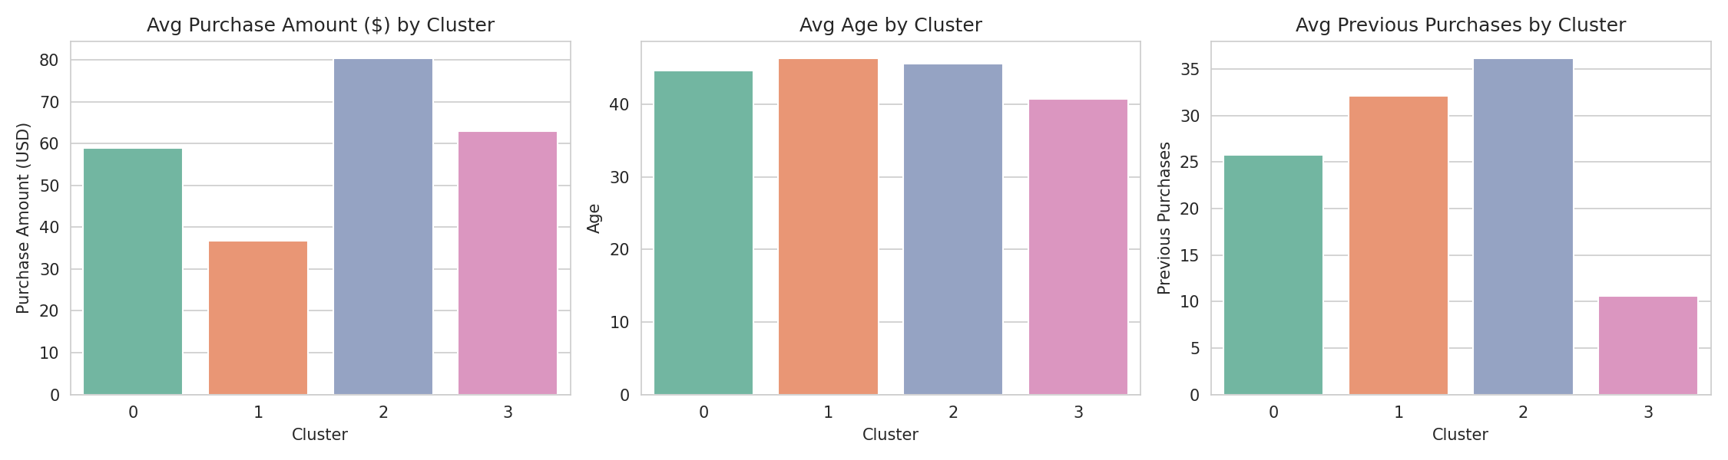
Figure 2. Average purchase amount, age, and previous purchases across the four clusters.
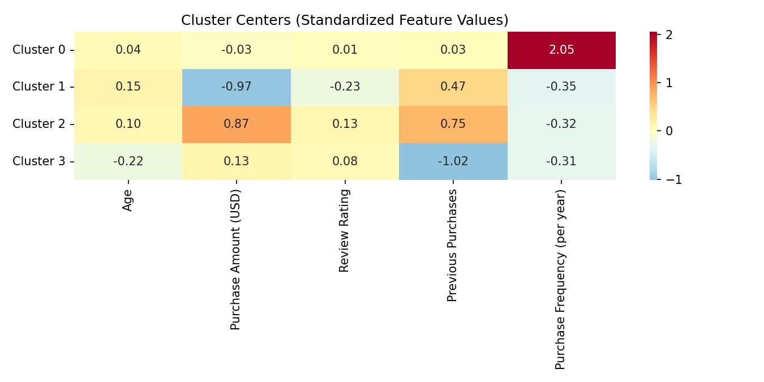
Figure 3. Standardized cluster centers — darker red/blue shows how far above or below average each cluster is for each feature.

4.2 Visualizing the Clusters
Since the clustering uses five features at once, the results were compressed into two dimensions using Principal Component Analysis (PCA) purely for visualization purposes — the actual clustering was performed on the full five-feature data, not on these two components.
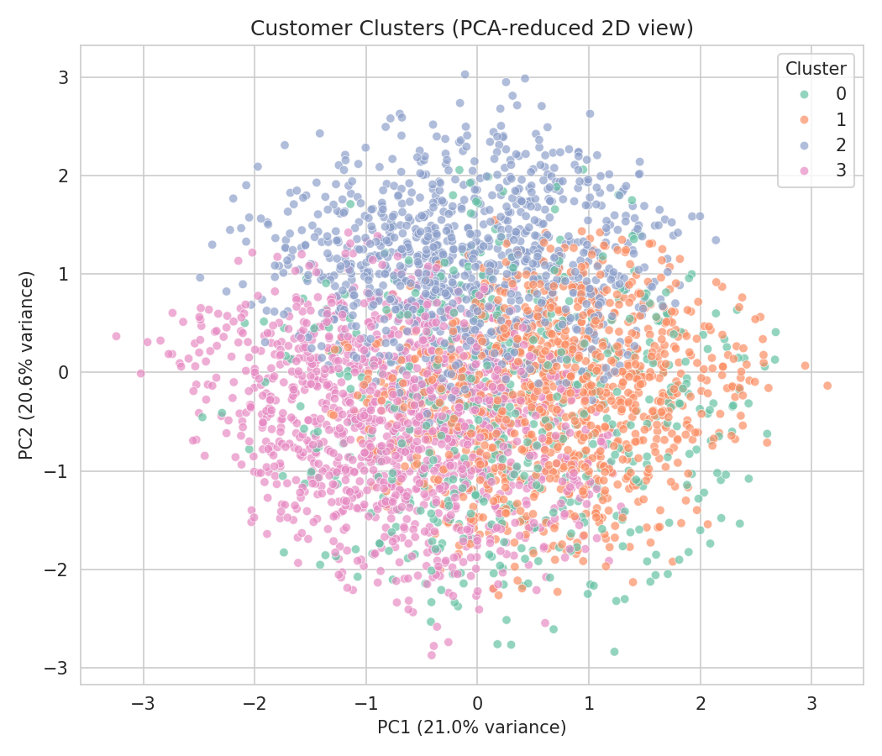
Figure 4. Customer clusters projected onto the first two principal components (together explaining about 42% of the variance).
The clusters overlap quite a bit in this 2D view, and that is expected: real shopping behavior changes gradually rather than in sharp jumps, and the two principal components shown only capture part of the original information. The cluster averages in Section 4.1 are a more reliable way to see the differences between groups than the scatter plot alone.

5. Cluster Interpretation
Based on the average values in each cluster, the four segments can be described in plain business terms as follows:

Cluster 0 — Frequent Shoppers (13.8% of customers)
These customers shop far more often than anyone else — about once a week, versus roughly once a quarter for other clusters — while spending a moderate amount per visit ($58.97 on average).
- Business idea: reward this small but highly active group with a loyalty program, since frequent, smaller purchases add up to strong lifetime value.

Cluster 1 — Budget-Conscious Regulars (27.6% of customers)
This is the largest lower-spending group. They have a long purchase history (32.1 previous purchases on average) but the lowest average spend per transaction ($36.69) and the lowest review ratings of all clusters.
- Business idea: these are price-sensitive, long-standing customers — small discounts, bundle deals, or asking for feedback on why ratings are lower could help retain them.

Cluster 2 — High-Value Loyal Customers (26.3% of customers)
This group has both the highest average spend ($80.40) and the most previous purchases (36.2) — a combination of loyalty and high spending power.
- Business idea: this is the most valuable segment. Early access to new products, premium loyalty tiers, or personalized offers would help retain these top customers.

Cluster 3 — New / Emerging Customers (32.3% of customers)
This is the largest cluster and the youngest on average (40.7 years). Its defining trait is a very low number of previous purchases (10.6), meaning these are likely newer or less-established customers, even though their spend per visit ($62.99) is already reasonably healthy.
- Business idea: focus on onboarding and habit-building here — welcome offers, follow-up emails, and incentives for a second and third purchase could convert this group into loyal customers like Cluster 2.

6. Business Implications
Putting the four segments together, a simple customer lifecycle story emerges from this data:
- New / Emerging customers (Cluster 3) are the entry point — the business's job is to convert them into repeat buyers.
- Budget-Conscious Regulars (Cluster 1) return often but spend cautiously — the opportunity is to gently increase their basket size.
- High-Value Loyal Customers (Cluster 2) are the most profitable segment and should be prioritized for retention.
- Frequent Shoppers (Cluster 0) are a small, highly engaged niche worth nurturing with loyalty perks.
This kind of segmentation lets a marketing or product team move away from a 'one-size-fits-all' approach and instead design different messages, offers, and retention strategies for each type of customer.

7. Limitations and Future Work
- The silhouette scores (around 0.16–0.19) indicate the clusters are only moderately well-separated — this is common for behavioral/demographic data, where customer types tend to blend into each other rather than form neat, isolated groups.
- This dataset appears to be synthetically generated (for example, discount usage being perfectly tied to gender), so the segments should be read as a demonstration of method rather than a real-world business conclusion.
- Future work could try Hierarchical Clustering or DBSCAN for comparison, incorporate the categorical columns (e.g., product category, payment method) using one-hot encoding, or use RFM-style features (Recency, Frequency, Monetary value) if transaction-level date data were available.

8. Conclusion
Using K-Means clustering on standardized behavioral features, the 3,900 customers were grouped into four interpretable segments: Frequent Shoppers, Budget-Conscious Regulars, High-Value Loyal Customers, and New/Emerging Customers. The number of clusters was chosen using the elbow method and silhouette score, and each segment was profiled and visualized to draw out practical business meaning. This project demonstrates a complete, simple, end-to-end unsupervised learning workflow: data cleaning, feature selection, scaling, model selection, evaluation, visualization, and business interpretation.

