Exploratory Data Analysis Report
BlinkIT Grocery Sales Dataset
An exploration of item- and outlet-level factors that relate to grocery sales performance, using Python (Pandas, Matplotlib, Seaborn).

1. Introduction & Objective
The goal of this analysis is to perform an exploratory data analysis (EDA) on the BlinkIT Grocery dataset in order to understand the structure of the data, identify data quality issues, and uncover patterns and relationships that explain variation in item Sales. The workflow follows a standard EDA process: (1) load and inspect the data, (2) clean and prepare it, (3) summarize it statistically, (4) visualize distributions and relationships, and (5) interpret the findings critically.

1.1 Dataset Overview
The dataset contains 8,523 rows and 12 columns describing individual grocery items sold across 10 different outlets. Each row combines information about the item itself (type, weight, fat content, visibility on the shelf) with information about the outlet that sold it (size, location tier, store format, year established), along with the resulting Sales value and a customer Rating.
Column | Type | Description
Item Identifier | Text | Unique code for the product
Item Fat Content | Category | Low Fat / Regular (raw data had inconsistent labels)
Item Type | Category | Product category, e.g. Dairy, Snack Foods
Item Weight | Numeric | Weight of the item in kg (1,463 missing values)
Item Visibility | Numeric | Share of total display area allocated to the item
Outlet Identifier | Text | Unique code for the store
Outlet Establishment Year | Numeric | Year the outlet was opened
Outlet Size | Category | Small / Medium / High
Outlet Location Type | Category | Tier 1 / Tier 2 / Tier 3 city
Outlet Type | Category | Grocery Store / Supermarket Type 1-3
Sales | Numeric | Sales value for the item (target variable)
Rating | Numeric | Customer rating (1-5)

2. Data Cleaning & Preparation
Before analysis, the raw CSV was loaded with Pandas and inspected for missing values and inconsistent categories. Two data quality issues were found and corrected:
- Item Fat Content had five inconsistent labels for what are really two categories: ‘Low Fat’, ‘LF’, and ‘low fat’ all mean the same thing, as do ‘Regular’ and ‘reg’.
- Item Weight was missing for 1,463 rows (about 17% of the data). Rather than dropping these rows, missing weights were imputed using the mean weight for that item's product category (Item Type), which preserves category-level weight patterns better than a single global mean.
- A derived feature, Outlet Age, was created by subtracting the Outlet Establishment Year from a fixed reference year, to make the 'how long has this store existed' relationship easier to visualize than raw calendar years.
import pandas as pd

df = pd.read_csv('BlinkIT_Grocery_Data.csv')

# Standardize inconsistent Item Fat Content labels
df['Item Fat Content'] = df['Item Fat Content'].replace({
'LF': 'Low Fat', 'low fat': 'Low Fat', 'reg': 'Regular'
})

# Impute missing Item Weight using the mean weight per Item Type
df['Item Weight'] = df.groupby('Item Type')['Item Weight']
.transform(lambda x: x.fillna(x.mean()))

# Derived feature: how many years the outlet has existed
df['Outlet Age'] = 2023 - df['Outlet Establishment Year']

Result:
After cleaning, Item Fat Content collapses cleanly into two categories (5,517 Low Fat vs. 3,006 Regular items) and Item Weight has zero missing values, with no rows dropped from the original 8,523.

3. Initial Analysis: Summary Statistics
With the data cleaned, df.describe() was used to summarize the numeric columns. A few features stand out immediately:
Metric | Item Visibility | Item Weight (kg) | Sales ($) | Rating
Mean | 0.066 | 12.86 | 140.99 | 3.97
Std Dev | 0.052 | 4.23 | 62.28 | 0.61
Min | 0.000 | 4.55 | 31.29 | 1.00
Median | 0.054 | 12.65 | 143.01 | 4.00
Max | 0.328 | 21.35 | 266.89 | 5.00

Sales range from about $31 to $267 with a mean near $141 and a median close by ($143), suggesting a roughly symmetric, moderately spread distribution rather than one dominated by a handful of extreme high-sales items. Ratings cluster tightly around 4.0, and Item Visibility is right-skewed — most items occupy a small share of shelf space, but a long tail of items are far more prominently displayed.
The categorical breakdown also shows a fairly balanced dataset: 16 item types (led by Fruits and Vegetables and Snack Foods), 3 outlet sizes, 3 location tiers, and 4 outlet formats, with Supermarket Type 1 accounting for the largest share of records (5,577 of 8,523, roughly two-thirds).

4. Visualizations, Patterns & Interpretation
The following charts were produced with Matplotlib and Seaborn to explore the shape of the data, compare categories, and look for relationships between variables. Each chart is followed by the interpretation of what it shows and a discussion of why the pattern may exist.

4.1 Distribution of Sales
import matplotlib.pyplot as plt
import seaborn as sns

sns.histplot(df['Sales'], bins=40, kde=True, color='#2E86AB')
plt.title('Distribution of Item Sales')
plt.xlabel('Sales ($)'); plt.ylabel('Frequency (Number of Items)')
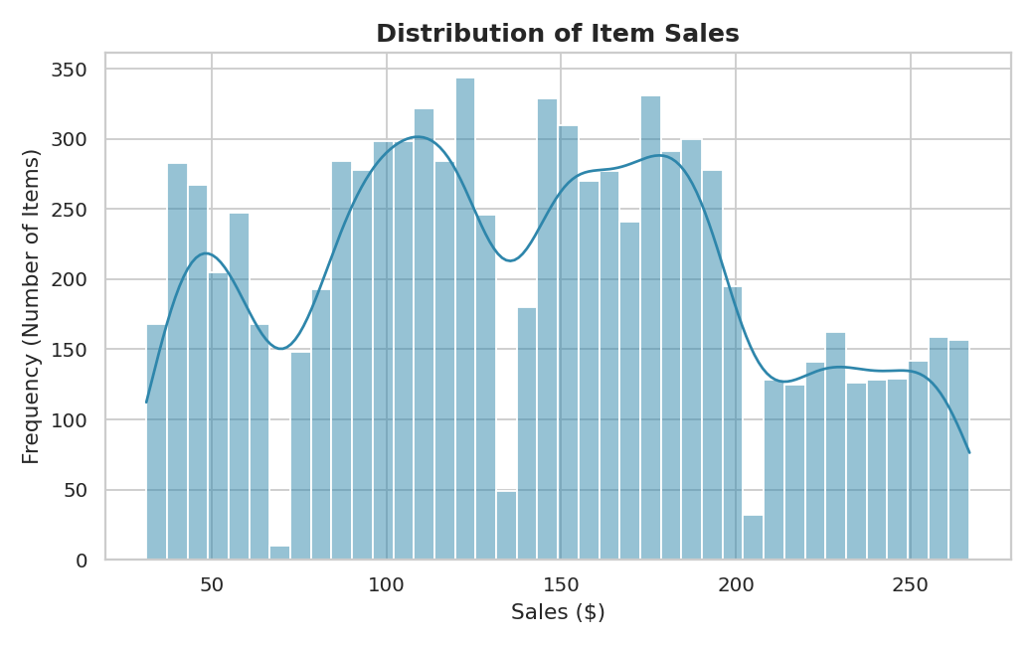
Figure 1. Distribution of item Sales with a kernel density overlay.
Interpretation:
Sales is right-skewed with a concentration of items in the $80-$200 range and a long tail extending toward $267. This shape is typical of retail sales data, where most items sell at a moderate, everyday rate while a smaller number of higher-turnover or premium items pull the tail upward.

4.2 Average Sales by Item Type
avg_sales = df.groupby('Item Type')['Sales'].mean()
.sort_values(ascending=False)
sns.barplot(x=avg_sales.values, y=avg_sales.index, palette='viridis')
plt.title('Average Sales by Item Type')
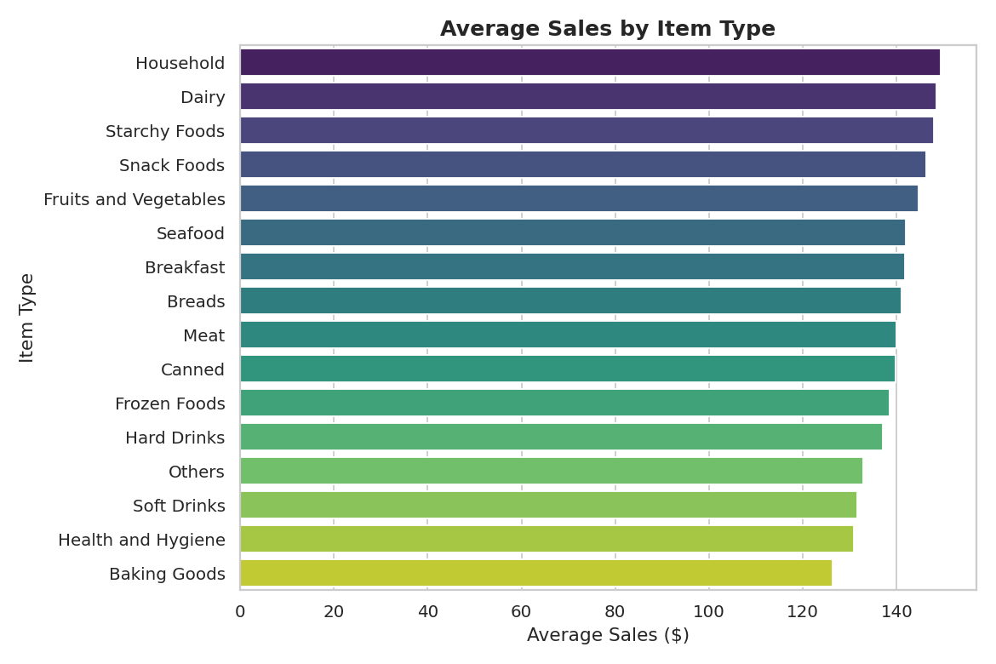
Figure 2. Mean Sales for each of the 16 item categories, sorted descending.
Interpretation:
Household, Dairy, and Starchy Foods items generate the highest average sales (all above $147), while Baking Goods and Health and Hygiene items generate the lowest (below $131). The gap between the top and bottom categories is real but modest — roughly $23 — which suggests item category alone is a weak predictor of sales; other factors such as pricing, promotion, or outlet context likely play a larger role.

4.3 Sales Distribution by Outlet Type
sns.boxplot(data=df, x='Outlet Type', y='Sales', palette='Set2')
plt.title('Sales Distribution by Outlet Type')
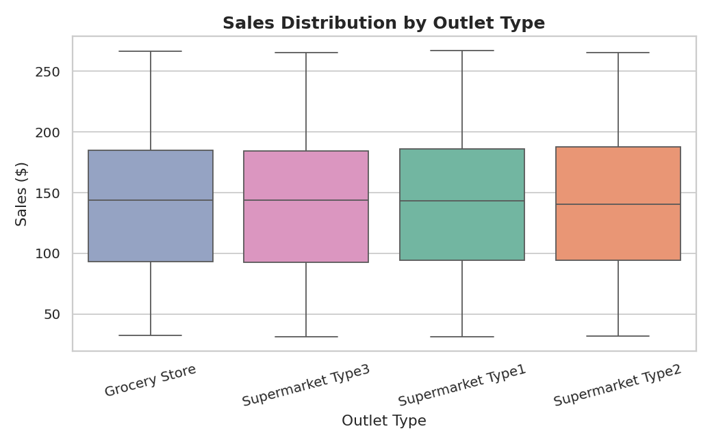
Figure 3. Boxplot of Sales for each of the four outlet formats.
Interpretation:
Median sales are remarkably similar across all four outlet formats (all between roughly $140 and $144), even though Grocery Stores are much smaller-format outlets than Supermarket Type 1-3. This is a counter-intuitive but consistent finding: outlet format changes the volume and variety of items sold, but it does not shift the typical sales value of an individual item by much.

4.4 Sales by Outlet Location Tier and Size
pivot = df.pivot_table(index='Outlet Location Type',
columns='Outlet Size', values='Sales', aggfunc='mean')
pivot.plot(kind='bar', colormap='coolwarm')
plt.title('Average Sales by Outlet Location Tier and Size')
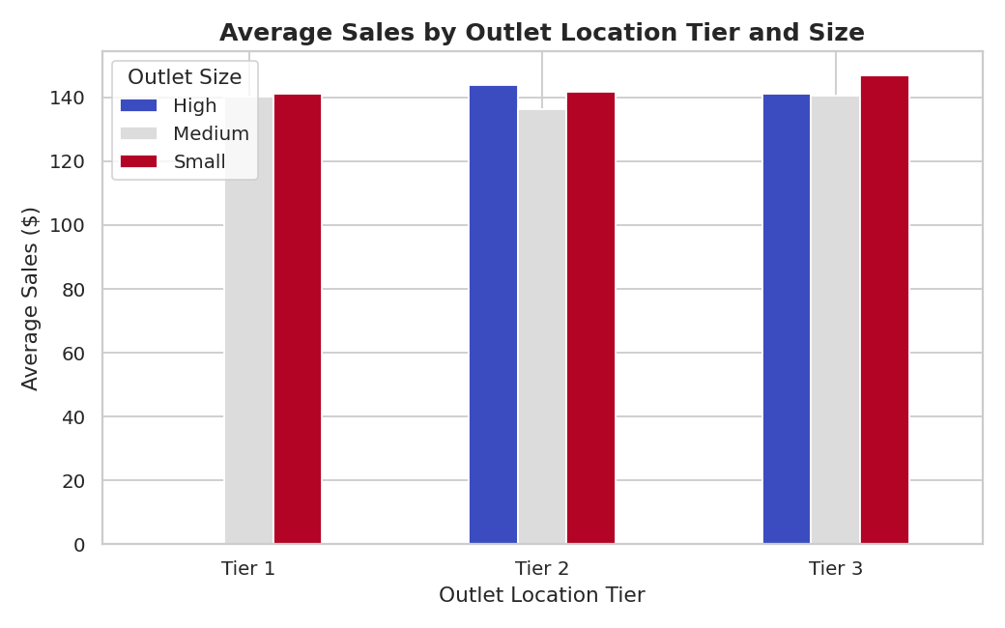
Figure 4. Average Sales split by city tier and store size.
Interpretation:
Average sales are close across all combinations of location tier and store size, with no combination standing out sharply from the others. This reinforces the pattern seen in the outlet-type chart: geographic tier and physical store size have only a mild relationship with per-item sales in this dataset.

4.5 Correlation Between Numeric Features
num_cols = ['Item Visibility','Item Weight','Sales','Rating','Outlet Age']
corr = df[num_cols].corr()
sns.heatmap(corr, annot=True, cmap='RdBu_r', center=0, fmt='.2f')
plt.title('Correlation Heatmap of Numeric Features')
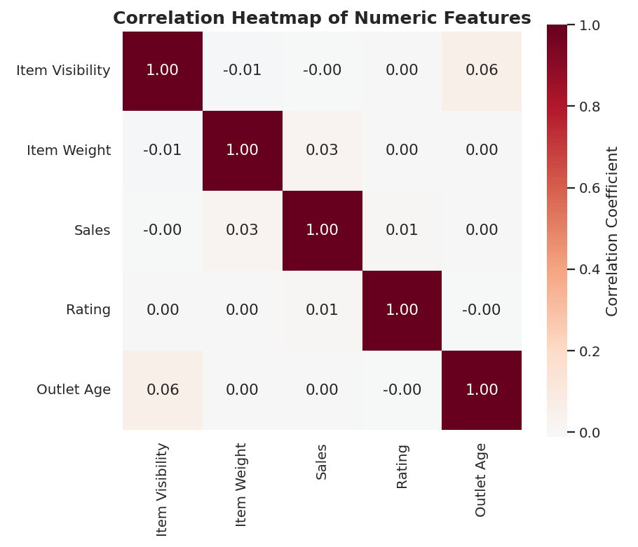
Figure 5. Pearson correlation matrix of the five numeric features.
Interpretation:
None of the numeric features correlate meaningfully with Sales — all coefficients are within ±0.03 of zero. This is a genuinely important finding: it tells us that Item Visibility, Item Weight, Rating, and how long an outlet has existed do not linearly predict how much an item sells in this dataset. Any useful predictive model for Sales would need to rely on the categorical features (Item Type, Outlet Type, etc.) or engineered interactions rather than these raw numeric fields.

4.6 Item Visibility vs. Sales
sns.scatterplot(data=df.sample(2000, random_state=42),
x='Item Visibility', y='Sales',
hue='Item Fat Content', alpha=0.5)
plt.title('Item Visibility vs. Sales')
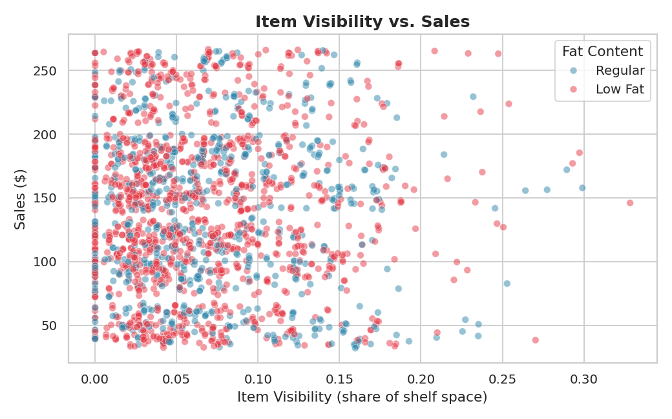
Figure 6. Scatter plot of Item Visibility against Sales (2,000-row sample), colored by fat content.
Interpretation:
There is no visible trend line in either direction — items with very low visibility (near 0) span almost the full range of Sales values, as do items with high visibility. This confirms numerically what the correlation heatmap showed: shelf visibility does not drive sales in this dataset. The interleaving of Low Fat and Regular points also shows fat content does not separate the data into distinct sales bands.

4.7 Proportion of Items by Fat Content
fat_counts = df['Item Fat Content'].value_counts()
plt.pie(fat_counts.values, labels=fat_counts.index,
autopct='%1.1f%%', colors=['#2E86AB', '#E63946'])
plt.title('Proportion of Items by Fat Content')
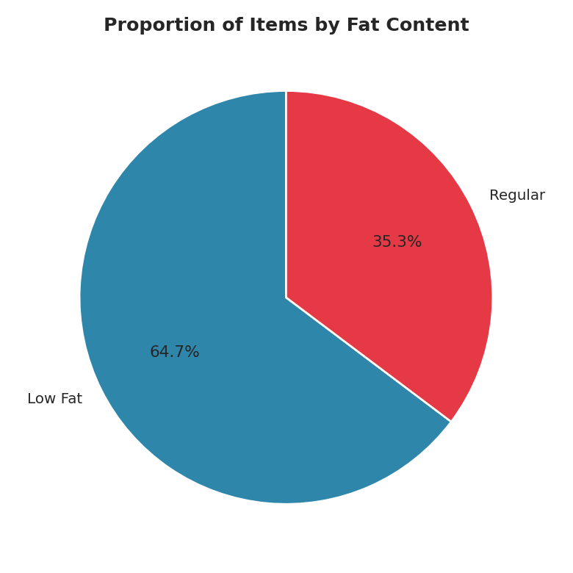
Figure 7. Share of items labeled Low Fat vs. Regular after standardizing category labels.
Interpretation:
About 65% of items are labeled Low Fat versus 35% Regular. Before cleaning, this split was obscured by duplicate category labels (LF, low fat, reg) that would have fragmented this simple 2-category picture into five bars — a clear example of why the label-standardization step in Section 2 mattered.

4.8 Average Sales by Outlet Establishment Year
avg_by_year = df.groupby('Outlet Establishment Year')['Sales'].mean()
plt.plot(avg_by_year.index, avg_by_year.values, marker='o')
plt.title('Average Sales by Outlet Establishment Year')
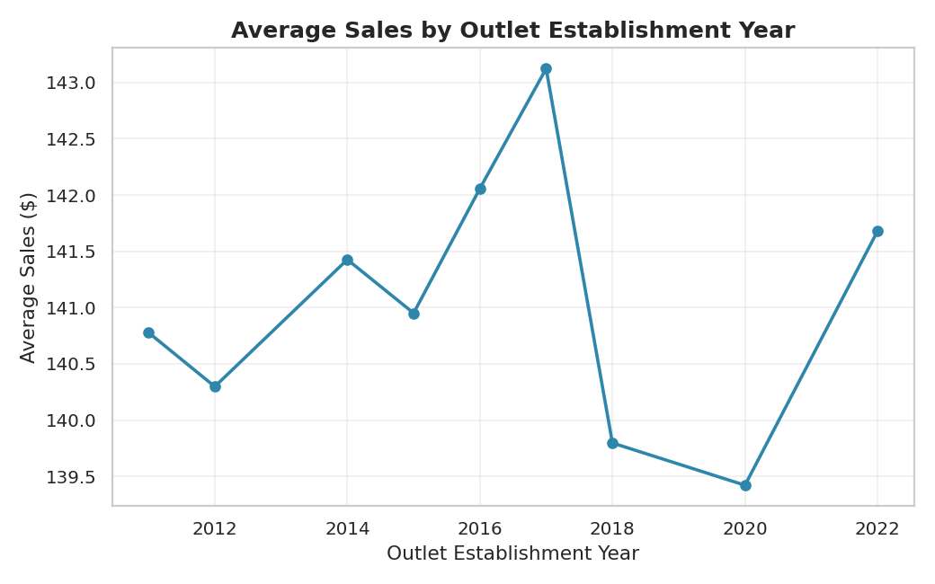
Figure 8. Average Sales trend across outlets opened between 2011 and 2022.
Interpretation:
Average sales fluctuate mildly year to year (roughly $135-$150) with no clear upward or downward trend as outlets age or as newer outlets open. Combined with the near-zero Outlet Age correlation in Figure 5, this indicates outlet maturity is not a meaningful driver of per-item sales — newer stores perform comparably to long-established ones.

4.9 Item Weight Distribution for Top Item Types
top_types = df['Item Type'].value_counts().head(6).index
sns.violinplot(data=df[df['Item Type'].isin(top_types)],
x='Item Type', y='Item Weight', palette='pastel')
plt.title('Item Weight Distribution for Top 6 Item Types')
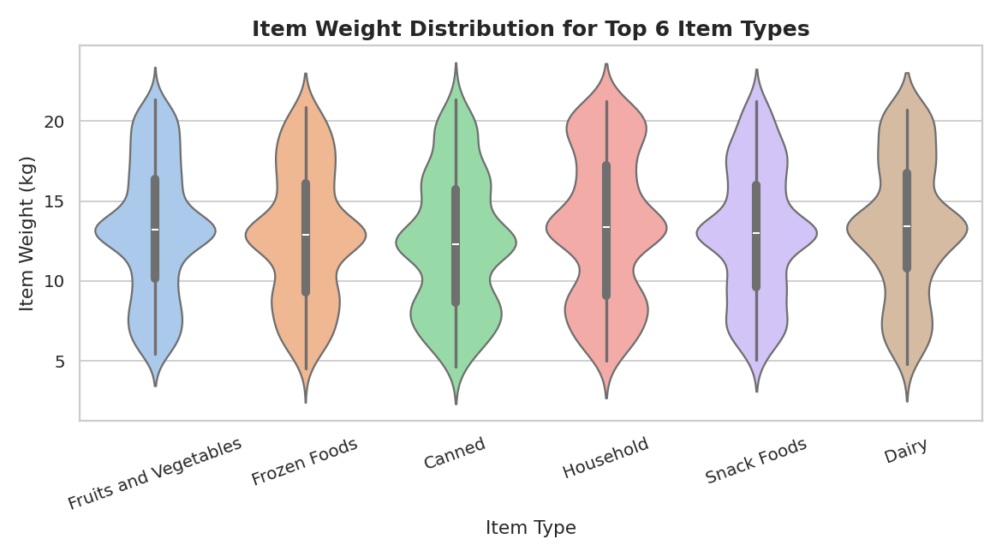
Figure 9. Distribution shape of Item Weight for the six most common item categories.
Interpretation:
Weight distributions vary meaningfully by category — Household items skew heavier with a wide spread, while Fruits and Vegetables and Snack Foods cluster at lower, more consistent weights. This confirms the earlier decision to impute missing weights using per-category means rather than a single dataset-wide mean, since a global average would have distorted lighter categories upward and heavier categories downward.

4.10 Customer Rating by Outlet Type
sns.boxplot(data=df, x='Outlet Type', y='Rating', palette='Set3')
plt.title('Customer Rating Distribution by Outlet Type')
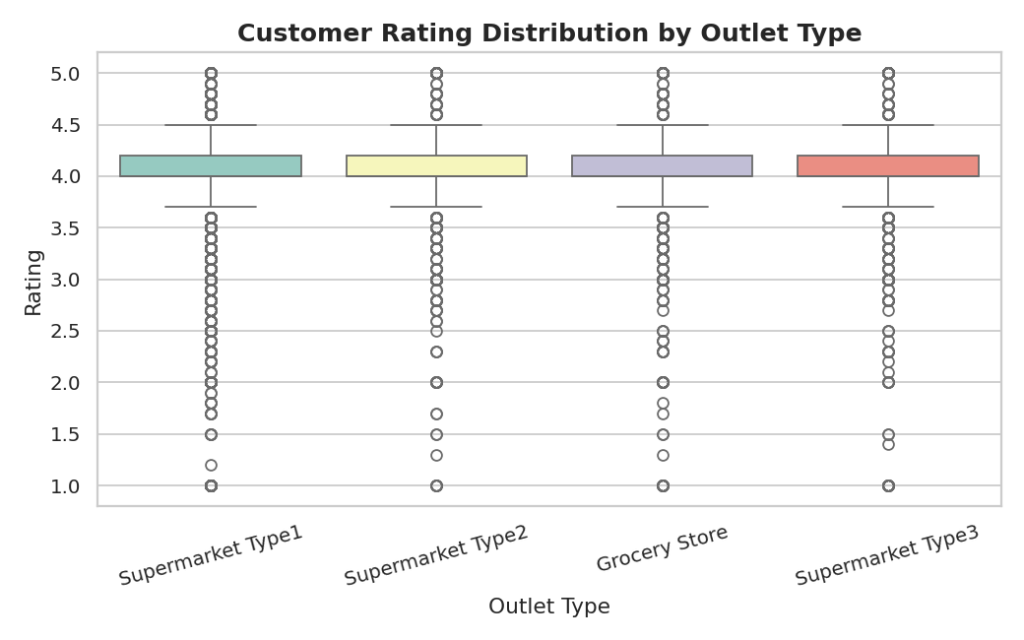
Figure 10. Distribution of customer Rating scores across the four outlet formats.
Interpretation:
Ratings are tightly clustered around 4.0 for every outlet type, with similar spread and similar outliers toward the low end (down to 1.0) across all formats. This suggests customer satisfaction, as captured by this rating field, is not meaningfully differentiated by store format — it behaves more like noise around a stable central value than a variable that varies systematically with outlet type.

5. Key Findings & Discussion
- Sales is right-skewed but not extreme, ranging from $31 to $267 with mean and median close together ($140.99 vs. $143.01), indicating a fairly typical retail distribution without dramatic outliers.
- None of the continuous numeric features — Item Visibility, Item Weight, Rating, or Outlet Age — show a meaningful linear correlation with Sales (all |r| < 0.03). This is arguably the most important finding of the analysis: it argues against the common assumption that more shelf visibility or higher ratings directly translate into higher sales, at least in this dataset.
- Item Type produces the widest (though still modest) spread in average sales, with Household, Dairy, and Starchy Foods outperforming Baking Goods and Health and Hygiene by roughly $20 on average.
- Outlet-level factors — format, size, location tier, and age — show only small differences in median or average sales. Grocery Stores, despite being the smallest and least common format (12.7% of records), post sales medians on par with full-size supermarkets.
- Data quality mattered: standardizing the Item Fat Content labels and imputing Item Weight by category mean were necessary to get accurate proportions and distributions rather than fragmented or biased ones.

5.1 Why These Patterns May Exist
The consistent lack of strong correlation between item-level attributes and Sales, combined with the similarity of Sales across very different outlet formats, suggests that Sales in this dataset behaves close to independently of the recorded features — as if it were driven mainly by factors not captured here (such as pricing, promotions, seasonality, or regional demand) or by inherent randomness in the data-generating process. This is a common and useful thing to discover during EDA: it tells an analyst not to expect a simple linear model built on these features to explain sales well, and instead to look toward categorical interactions, external data, or non-linear models if predictive modeling is the goal.

6. Conclusion
This EDA cleaned and explored the BlinkIT Grocery dataset across 8,523 records and 12 original features. After correcting inconsistent categorical labels and imputing missing item weights, ten visualizations were produced covering distributions, category comparisons, and correlations. The central takeaway is that Sales in this dataset is largely uncorrelated with the numeric attributes provided (visibility, weight, rating, outlet age) and only mildly differentiated by categorical attributes (item type, outlet type, outlet size, location tier). This points toward the need for richer features — pricing, promotions, regional demand — for any future predictive work, and illustrates the value of EDA in setting realistic expectations before modeling begins.

6.1 Tools Used
- Pandas — data loading, cleaning, grouping, and aggregation
- Matplotlib — base plotting engine and figure composition
- Seaborn — statistical visualizations (histograms, boxplots, violin plots, heatmaps)

