DATA CLEANING AND PREPROCESSING REPORT
BlinkIT Grocery Data
Objective
The purpose of this project is to acquire and profile a publicly available grocery-sales dataset, identify data-quality problems, clean and preprocess the records using Python, and document the reasoning behind each transformation so that the resulting dataset is suitable for downstream analysis.

1. Executive Summary
The BlinkIT Grocery Data CSV contains 8,523 records and 12 variables describing products, outlets, visibility, item weight, sales and customer ratings. The initial audit found 1,463 missing Item Weight values, 526 zero Item Visibility values, no duplicate rows, and inconsistent labels in Item Fat Content (LF, reg and low fat in addition to Low Fat and Regular).
The cleaning strategy was deliberately conservative. Missing item weights were imputed from repeated Item Identifier values because the same product identifier has a consistent observed weight elsewhere. Zero visibility values were treated as missing-like observations and replaced using the median visibility within Item Type. Fat-content labels were standardized. Statistical outliers were investigated but not automatically deleted because extreme sales, visibility and ratings can represent legitimate observations.
Metric | Raw | Cleaned | Action
Records | 8,523 | 8,523 | No row deletion
Variables | 12 | 12 | No column deletion
Duplicate rows | 0 | 0 | None detected
Missing Item Weight | 1,463 | 0 | Item Identifier median imputation
Zero Item Visibility | 526 | 0 | Item Type median replacement
Fat-content labels | 5 | 2 | Standardized synonyms

2. Data Collection and Source
The working copy used in this assignment was supplied as “BlinkIT Grocery Data.csv”. The dataset is publicly circulated as BlinkIT Grocery Data and is used in retail analytics practice. A public GitHub project containing BlinkIT-Grocery-Data.csv documents the same 8,523-record dataset and core fields used here. Another public project documents the same dataset structure, Python analysis workflow and the known inconsistent fat-content labels.
Because the assignment dataset was provided directly for analysis, this CSV is treated as the source-of-record for all calculations. Public repositories were used only to corroborate public availability and field structure; no cleaned values were copied from those projects.
Public reference: Harveen-kaur254, “Blinkit-Dashboard”, GitHub.
Additional methodological reference: Rishwanth365, “Blinkit-Sales-Customer-Insights”, GitHub.

3. Tools and Environment
Tool / Library | Purpose
Python 3 | Main programming language
Pandas | Data loading, profiling, cleaning and transformation
NumPy | Numerical operations and missing-value handling
Matplotlib | Diagnostic visualizations
python-docx | Generation of this report

4. Initial Data Exploration
The first step was to inspect the shape, column names, data types, missing values, duplicates and sample records. This establishes a baseline before transformation.
import pandas as pd
df = pd.read_csv("BlinkIT Grocery Data.csv")
print(df.shape)
print(df.columns.tolist())
print(df.dtypes)
print(df.isna().sum())
print(df.duplicated().sum())
print(df.head())
Column | Type | Missing | Role
Item Fat Content | object | 0 | Categorical
Item Identifier | object | 0 | Product identifier
Item Type | object | 0 | Categorical
Outlet Establishment Year | int64 | 0 | Year
Outlet Identifier | object | 0 | Outlet identifier
Outlet Location Type | object | 0 | Categorical
Outlet Size | object | 0 | Categorical
Outlet Type | object | 0 | Categorical
Item Visibility | float64 | 0 | Continuous
Item Weight | float64 | 1,463 | Continuous
Sales | float64 | 0 | Continuous metric
Rating | float64 | 0 | Rating score
The dataset contains categorical variables for product and outlet characteristics and numerical variables for visibility, weight, sales and ratings. Item Weight is the only field with explicit missing values.

5. Categorical Consistency Checks
Item Fat Content contains five text labels. LF and low fat represent Low Fat, while reg represents Regular. If these labels were not standardized, group-by and visualization results would incorrectly split the same business category.
Raw value | Count | Standardized value
Low Fat | 5089 | Low Fat
low fat | 112 | Low Fat
LF | 316 | Low Fat
Regular | 2889 | Regular
reg | 117 | Regular
fat_map = {
"LF": "Low Fat",
"low fat": "Low Fat",
"reg": "Regular"
}
df["Item Fat Content"] = df["Item Fat Content"].replace(fat_map)
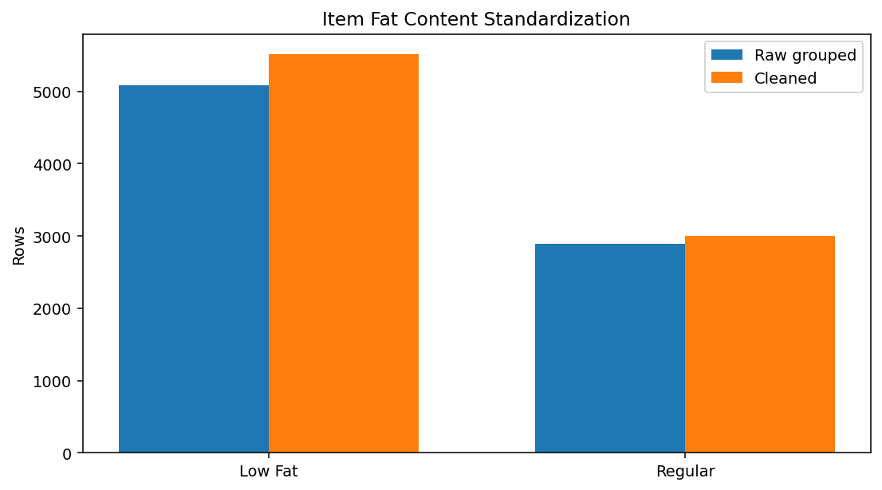
Figure 1. Item Fat Content before and after standardization.

6. Missing-Value Treatment

6.1 Item Weight
There are 1,463 missing Item Weight values, approximately 17.2% of the dataset. Dropping those rows would remove a substantial portion of the sample. Mean imputation was avoided because it can distort the distribution.
A contextual imputation strategy is available because Item Identifier repeats across outlets. A validation check showed that non-missing weights are consistent within each Item Identifier. Therefore, the missing value can be recovered from the same product rather than inferred from an unrelated product.
item_weight_median = (
df.groupby("Item Identifier")["Item Weight"]
.transform("median")
)
df["Item Weight"] = df["Item Weight"].fillna(item_weight_median)
# Safety fallback
df["Item Weight"] = df["Item Weight"].fillna(
df["Item Weight"].median()
)
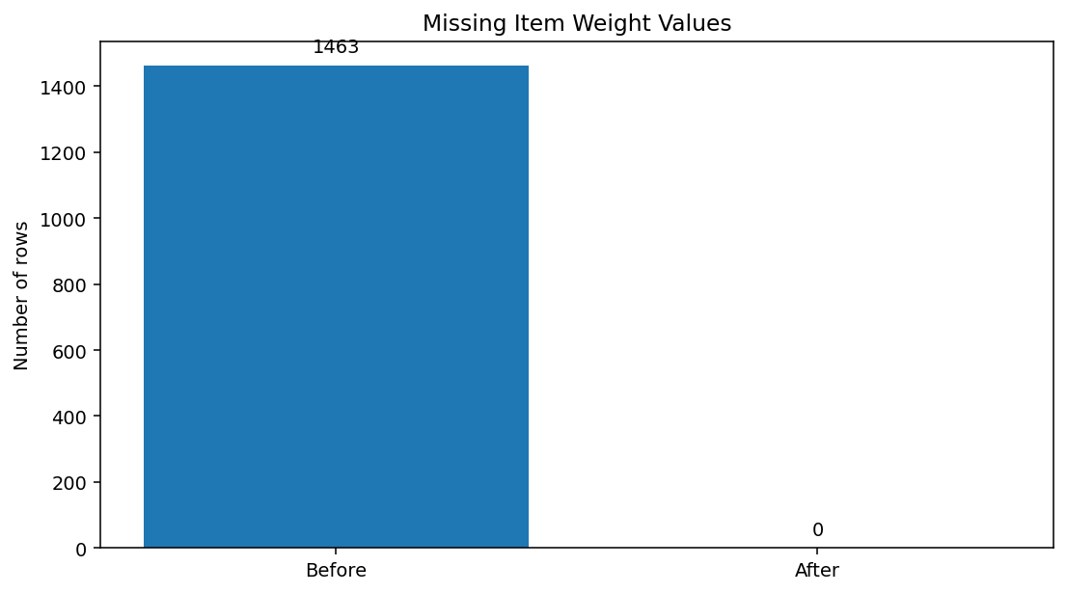
Figure 2. Missing Item Weight values before and after imputation.
- All 8,523 records are retained instead of deleting incomplete rows.
- The imputation is product-specific rather than a single global estimate.
- Median imputation is robust to unusual observed weights.
- For modelling, an imputation indicator could be retained to preserve information about missingness.

7. Erroneous and Missing-Like Values

7.1 Item Visibility Equal to Zero
Item Visibility contains 526 zero values. Although zero is numerically valid, it is treated here as a missing-like observation because a visibility score of exactly zero is suspicious for this product-level measure. The replacement uses the median visibility within Item Type, preserving category-level differences.
visibility_median_by_type = (
df.groupby("Item Type")["Item Visibility"]
.transform(lambda s: s.replace(0, np.nan).median())
)
zero_visibility_mask = df["Item Visibility"].eq(0)
df.loc[zero_visibility_mask, "Item Visibility"] = (
visibility_median_by_type[zero_visibility_mask]
)
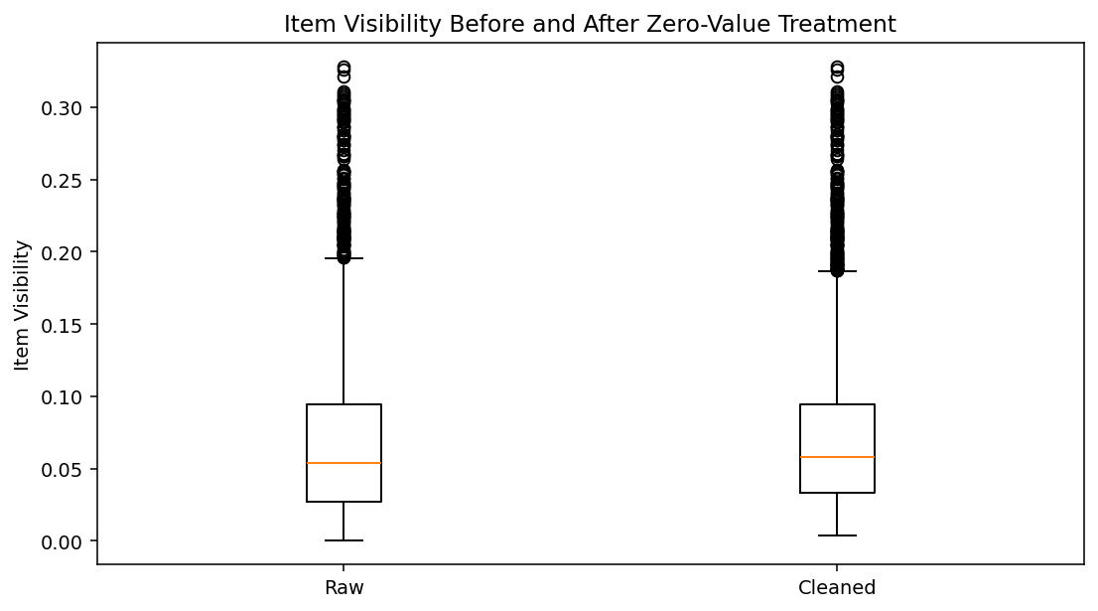
Figure 3. Item Visibility before and after zero-value treatment.

7.2 Logical Range Checks
Variable | Validation rule | Result
Item Visibility | 0 ≤ visibility ≤ 1 | All values within range
Item Weight | Weight > 0 | No non-positive values
Sales | Sales > 0 | No non-positive values
Rating | 1 ≤ rating ≤ 5 | All values within range
Outlet Establishment Year | Plausible year | 2011–2022 observed

8. Outlier Detection and Treatment
Outliers were screened with the Interquartile Range (IQR) rule. A value was flagged if it fell below Q1 − 1.5×IQR or above Q3 + 1.5×IQR. An IQR flag is not automatically a data error: unusual sales, visibility or ratings can be legitimate.
Variable | Q1 | Q3 | Lower bound | Upper bound | IQR flags
Item Visibility | 0.0270 | 0.0946 | -0.0744 | 0.1960 | 144
Item Weight | 8.7737 | 16.8500 | -3.3406 | 28.9644 | 0
Sales | 93.8265 | 185.6437 | -43.8993 | 323.3695 | 0
Rating | 4.0000 | 4.2000 | 3.7000 | 4.5000 | 1931
The IQR method flags 144 Item Visibility observations and 1,931 Rating observations. Sales and Item Weight have no IQR outliers under this rule. The rating flags mainly reflect the strong concentration of ratings near the upper end of the 1–5 scale, so those records are retained.
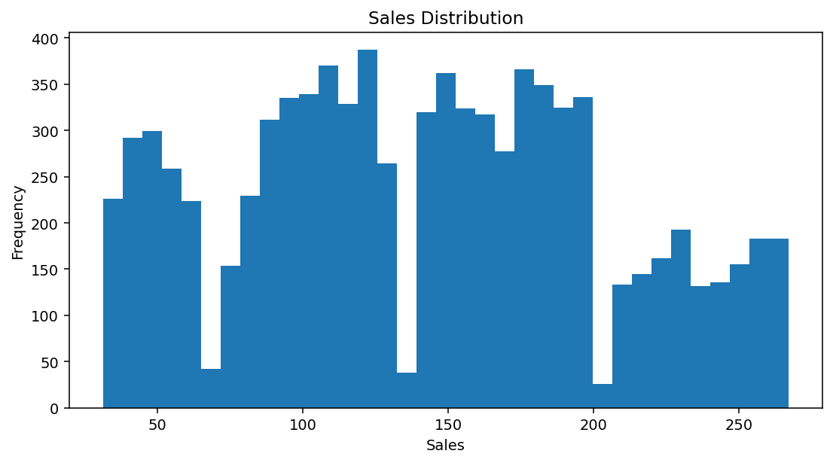
Figure 4. Sales distribution; extreme values are retained because they are positive and plausible.
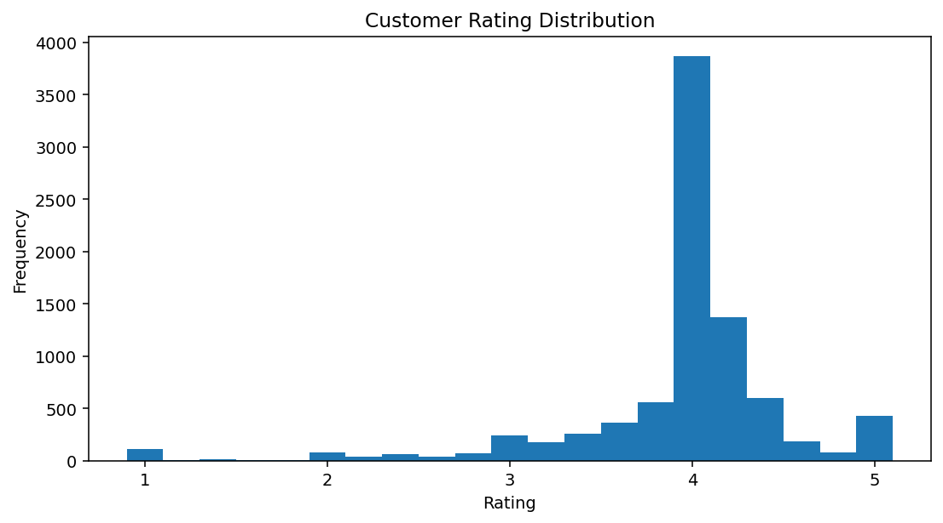
Figure 5. Rating distribution; low ratings are treated as valid observations.

8.1 Outlier Decision
- No rows were deleted solely because they were statistical outliers.
- No winsorization was applied to Sales, Rating or Visibility.
- The cleaning process corrects identifiable quality issues without artificially narrowing legitimate variation.
- Robust scaling or transformations can be considered later if a particular modelling algorithm requires them.

9. Final Preprocessing Pipeline
The final pipeline is reproducible and keeps the raw data unchanged. Profiling is performed before transformation, followed by categorical standardization, contextual imputation, logical validation and export.
import pandas as pd
import numpy as np
df = pd.read_csv("BlinkIT Grocery Data.csv")
# 1. Standardize categorical labels
fat_map = {"LF": "Low Fat", "low fat": "Low Fat", "reg": "Regular"}
df["Item Fat Content"] = df["Item Fat Content"].replace(fat_map)
# 2. Impute Item Weight from the same product identifier
item_weight_median = (
df.groupby("Item Identifier")["Item Weight"]
.transform("median")
)
df["Item Weight"] = df["Item Weight"].fillna(item_weight_median)
df["Item Weight"] = df["Item Weight"].fillna(df["Item Weight"].median())
# 3. Replace zero visibility with Item Type median
visibility_median_by_type = (
df.groupby("Item Type")["Item Visibility"]
.transform(lambda s: s.replace(0, np.nan).median())
)
mask = df["Item Visibility"].eq(0)
df.loc[mask, "Item Visibility"] = visibility_median_by_type[mask]
# 4. Validate
assert df["Item Weight"].isna().sum() == 0
assert df["Item Visibility"].eq(0).sum() == 0
assert df["Sales"].gt(0).all()
assert df["Rating"].between(1, 5).all()
assert df.duplicated().sum() == 0
# 5. Export
df.to_csv("BlinkIT_Grocery_Data_Cleaned.csv", index=False)

10. Before-and-After Quality Assessment
Quality issue | Before cleaning | After cleaning | Interpretation
Missing Item Weight | 1,463 | 0 | Contextual imputation
Zero Item Visibility | 526 | 0 | Missing-like values replaced
Fat labels | 5 | 2 | Synonyms consolidated
Duplicate rows | 0 | 0 | No action required
Invalid Sales | 0 | 0 | No correction required
Invalid Ratings | 0 | 0 | No correction required

11. Impact on Subsequent Analysis
Preprocessing reduces the risk that technical data-quality problems are interpreted as genuine business patterns. For example, without fat-content standardization, sales-by-fat-content analysis would split Low Fat products across three labels. Missing Item Weight values could also reduce the usable sample size or cause some modelling workflows to fail.
The transformations nevertheless have analytical consequences. Imputation replaces unknown values with estimates and can slightly reduce natural variability. Replacing zero visibility changes the literal value and therefore affects statistics such as the mean and correlation with Sales. These choices should be disclosed whenever the cleaned data is reused.
A useful future enhancement is to add Boolean flags such as Item Weight Imputed and Visibility Imputed. This preserves information about the original data-quality state and allows analysts to test whether missingness itself is related to sales.

12. Challenges Faced and How They Were Overcome
Challenge | Problem | Resolution
Inconsistent labels | LF, low fat and reg were duplicate semantic categories. | Mapped to canonical labels.
Substantial missingness | 17.2% of Item Weight was missing. | Used repeated product identifiers for imputation.
Zero visibility | 526 rows contained zero visibility. | Used Item Type median as a contextual replacement.
Outlier ambiguity | IQR flagged many ratings. | Reviewed plausibility and retained valid extremes.
Avoiding sample loss | Dropping incomplete rows would remove 1,463 observations. | Used imputation instead of listwise deletion.

13. Reflective Commentary
The main lesson from this exercise is that data cleaning should be driven by meaning rather than mechanical rules alone. A missing value, a zero, a rare category and a statistical outlier are different quality issues. They require different diagnostic questions and different responses.
The final approach prioritizes traceability: each substantive transformation has a documented rationale, reproducible code and a before/after validation check. This makes the cleaned dataset more defensible for future analysis.

14. Conclusion
The BlinkIT Grocery Data was successfully profiled, cleaned and preprocessed in Python. The final dataset retains all 8,523 records, has no missing Item Weight values, has no zero visibility placeholders, and uses consistent fat-content labels. No statistically flagged observations were deleted merely for being extreme. The cleaned output is therefore better suited to exploratory analysis, visualization and subsequent modelling while preserving legitimate retail variation.

15. References
1. Harveen-kaur254. “Blinkit-Dashboard.” Public GitHub repository containing BlinkIT-Grocery-Data.csv.
2. Rishwanth365. “Blinkit-Sales-Customer-Insights.” Public GitHub repository documenting dataset structure, Python analysis and categorical cleaning.
3. Mogha, A. et al. (2025). International Journal of Research in Engineering and Innovation, methodology discussion referencing the BlinkIT Grocery Data fields.
Note: All numerical results and preprocessing decisions in this report were calculated from the user-supplied CSV.

Appendix A. Reproducibility Checklist
- Preserve the raw CSV as the source-of-record.
- Inspect shape, data types, missing values and duplicates.
- Standardize categorical labels before aggregation.
- Use product-specific median imputation for missing Item Weight.
- Treat zero visibility as missing-like and replace it contextually.
- Run logical range checks after cleaning.
- Flag IQR outliers but review them before deletion.
- Export the cleaned dataset as a separate file.

Appendix B. Key Dataset Statistics
Variable | Min | Median | Mean | Max
Outlet Establishment Year | 2011 | 2016 | 2016.45 | 2022
Item Visibility | 0.0000 | 0.0539 | 0.0661 | 0.3284
Item Weight | 4.555 | 12.600 | 12.858 | 21.350
Sales | 31.290 | 143.013 | 140.993 | 266.888
Rating | 1.0 | 4.0 | 3.966 | 5.0

