SUPERVISED LEARNING PROJECT
Predicting Customer Subscription Status
Customer Shopping Behavior Dataset
Classification using Python and Scikit-learn

1. Executive Summary
This project applies supervised learning to a customer shopping behavior dataset. The main aim is to predict whether a customer has a subscription status of Yes or No. This is a binary classification problem because the target variable has two possible classes.
I first checked the data, handled missing values through the model pipeline, removed a redundant column, and created a few simple features such as Age Group and Purchase Frequency Score. I then trained a Logistic Regression model and used a Random Forest model as a comparison.
On the held-out test set, Logistic Regression achieved 0.863 accuracy, 0.665 precision, 0.995 recall, 0.797 F1 score, and 0.909 ROC-AUC. Five-fold cross-validation was also used to check whether the result was reasonably stable.

2. Problem Definition
Business question: Can we use customer shopping information to predict whether a customer is subscribed?
Target variable: Subscription Status (Yes/No).
This can be useful as a learning example for customer relationship management. A business could use a model like this to understand which customer characteristics are associated with subscription status. The model should not be treated as proof that any single feature causes subscription.

Why classification?
- The output has two classes: Yes and No.
- Classification models are designed to predict categories.
- The result can be evaluated using accuracy, precision, recall, F1 score and ROC-AUC.

3. Dataset Description
The supplied file is the Customer Shopping Behavior dataset. A matching public version is available on Kaggle and contains 3,900 customer records and shopping-related fields.
Public dataset reference: https://www.kaggle.com/datasets/iamsouravbanerjee/customer-shopping-trends-dataset
The dataset is useful for this assignment because it contains demographic, purchase, promotion, payment and shopping-frequency information.
Item | Value
Rows | 3,900
Original columns | 18
Target | Subscription Status
Target classes | Yes / No
Missing values | 37 in Review Rating
Categorical columns | 13
Numeric columns | 5 including Customer ID

Important columns
Column | Meaning
Age | Customer age
Gender | Customer gender
Category | Product category
Purchase Amount (USD) | Amount spent on the purchase
Review Rating | Customer rating
Subscription Status | Target variable
Discount Applied | Whether a discount was applied
Previous Purchases | Number of previous purchases
Payment Method | Payment method used
Frequency of Purchases | How often the customer purchases

4. Initial Data Exploration
The dataset was loaded with Pandas. I checked the shape, data types, missing values, duplicate-like information, unique values and basic statistics.
import pandas as pd
df = pd.read_csv("customer_shopping_behavior.csv")
print(df.shape)
print(df.info())
print(df.isnull().sum())
print(df.describe(include="all"))
The dataset contains 3,900 rows. There are 37 missing values in total, all of them in Review Rating. The target is imbalanced: 73.0% are No and 27.0% are Yes.
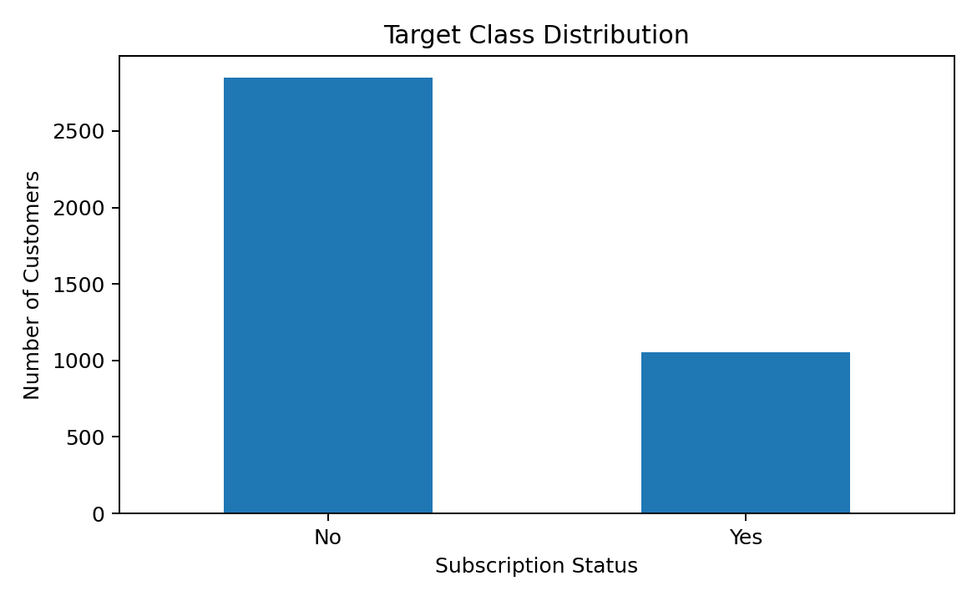

5. Data Cleaning and Preprocessing

5.1 Missing values
There are 37 missing values in Review Rating. Instead of deleting these rows, I used median imputation inside the machine learning pipeline. Median is simple and is less affected by extreme values than the mean.
from sklearn.impute import SimpleImputer
numeric_imputer = SimpleImputer(strategy="median")
categorical_imputer = SimpleImputer(strategy="most_frequent")

5.2 Redundant column
In the supplied file, Promo Code Used and Discount Applied are identical for all 3,900 rows. Keeping both would add duplicate information, so Promo Code Used was removed.
# Check whether the two columns are identical
(df["Discount Applied"] == df["Promo Code Used"]).all()
# Remove the redundant column
data = data.drop(columns=["Promo Code Used"])

5.3 Customer ID
Customer ID is only an identifier and does not represent a useful customer behavior measurement. It was therefore removed from the model features.

5.4 Outlier check
I checked the main numeric variables using the IQR method. No IQR-based outliers were found in Age, Purchase Amount, Review Rating or Previous Purchases. The values were therefore not artificially removed.

6. Feature Engineering
Feature engineering means creating useful variables from the existing data. I kept the changes simple because this is a beginner-level project.

6.1 Age Group
Age was converted into five groups: 18–24, 25–34, 35–44, 45–54 and 55+. This may help the model capture broad age patterns instead of relying only on a single numeric age.
data["Age Group"] = pd.cut(
data["Age"],
bins=[0, 24, 34, 44, 54, 100],
labels=["18-24", "25-34", "35-44", "45-54", "55+"]
)

6.2 Purchase Frequency Score
Purchase frequency was converted into an approximate number of purchases per year. For example, Weekly = 52, Monthly = 12 and Annually = 1. This converts a text feature into a numeric feature while keeping its basic meaning.
frequency_map = {
"Weekly": 52,
"Fortnightly": 26,
"Bi-Weekly": 26,
"Monthly": 12,
"Every 3 Months": 4,
"Quarterly": 4,
"Annually": 1
}
data["Purchase Frequency Score"] = (
data["Frequency of Purchases"].map(frequency_map)
)

6.3 High Previous Purchases
A simple binary feature was created to identify customers with 10 or more previous purchases.
data["High Previous Purchases"] = np.where(
data["Previous Purchases"] >= 10, "Yes", "No"
)

7. Train-Test Split and Encoding
The data was divided into 80% training data and 20% testing data. Stratification was used so that the Yes/No class ratio remained similar in both sets.
from sklearn.model_selection import train_test_split
X_train, X_test, y_train, y_test = train_test_split(
X, y,
test_size=0.20,
stratify=y,
random_state=42
)
Categorical variables were converted into numeric columns using One-Hot Encoding. Numeric variables were median-imputed and standardized. Using a Pipeline and ColumnTransformer keeps preprocessing inside the modeling process and helps prevent data leakage from the test set.
from sklearn.compose import ColumnTransformer
from sklearn.preprocessing import OneHotEncoder, StandardScaler
from sklearn.pipeline import Pipeline
preprocessor = ColumnTransformer([
("num", Pipeline([
("imputer", SimpleImputer(strategy="median")),
("scaler", StandardScaler())
]), numeric_columns),
("cat", Pipeline([
("imputer", SimpleImputer(strategy="most_frequent")),
("onehot", OneHotEncoder(handle_unknown="ignore"))
]), categorical_columns)
])

8. Model Selection
The main model chosen for this project is Logistic Regression. It is a good starting classification algorithm because it is relatively simple, fast and easier to explain than many complex models. It also provides probabilities and coefficients that help us understand which encoded features are associated with the predicted class.
I also trained a Random Forest model as a basic benchmark. The purpose was not to create a large model competition, but to check whether a different algorithm gave a very different result.
from sklearn.linear_model import LogisticRegression
model = Pipeline([
("preprocessor", preprocessor),
("model", LogisticRegression(
max_iter=2000,
class_weight="balanced",
random_state=42
))
])
model.fit(X_train, y_train)
class_weight='balanced' was used because the target classes are not equally sized. This tells the model to pay more attention to the smaller Yes class.

9. Model Validation
A single train-test split gives one estimate of performance. To make the evaluation stronger, I also used 5-fold stratified cross-validation on the training data. The training data is split into five parts; the model trains on four parts and validates on the remaining part. This is repeated five times.
from sklearn.model_selection import StratifiedKFold, cross_validate
cv = StratifiedKFold(
n_splits=5,
shuffle=True,
random_state=42
)
scores = cross_validate(
model,
X_train,
y_train,
cv=cv,
scoring=["accuracy", "precision", "recall", "f1", "roc_auc"]
)
Metric | Mean CV Score | Std. Deviation
ACCURACY | 0.835 | 0.009
PRECISION | 0.623 | 0.013
RECALL | 0.992 | 0.005
F1 | 0.765 | 0.010
ROC_AUC | 0.885 | 0.010
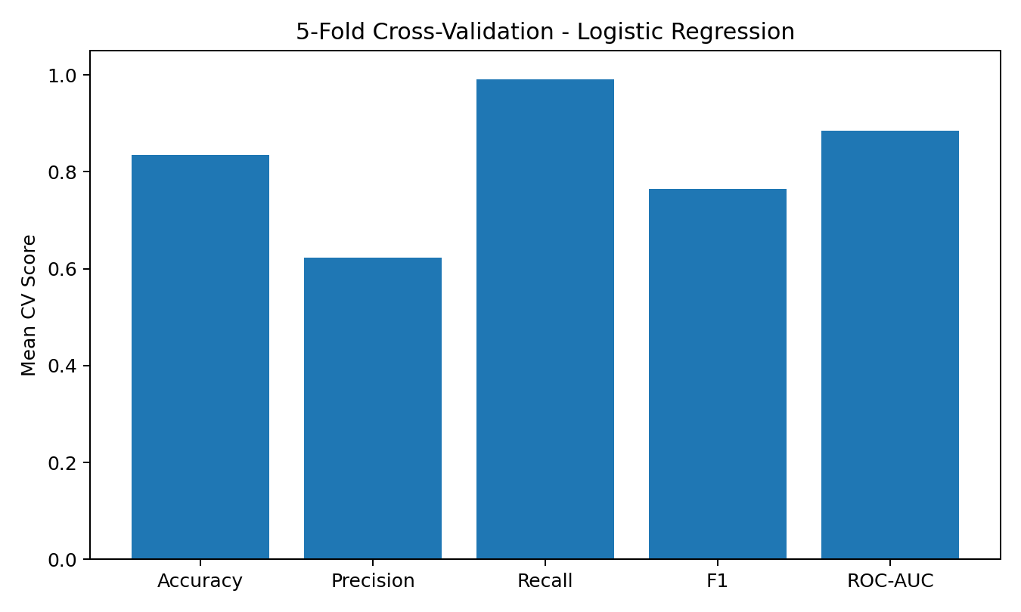

10. Evaluation Metrics and Results
The final model was evaluated on the 20% test set that was not used for training. The main metrics are explained below.
Metric | What it means | Test Result
Accuracy | Overall percentage of correct predictions | 0.863
Precision | Of predicted Yes cases, how many were actually Yes | 0.665
Recall | Of actual Yes cases, how many were found | 0.995
F1 Score | Balance between precision and recall | 0.797
ROC-AUC | How well the model separates the two classes | 0.909
The accuracy was 86.28%. The recall was very high at 99.53%, meaning the model found almost all of the customers who were actually in the Yes class. Precision was lower than recall, which means some customers predicted as Yes were actually No.
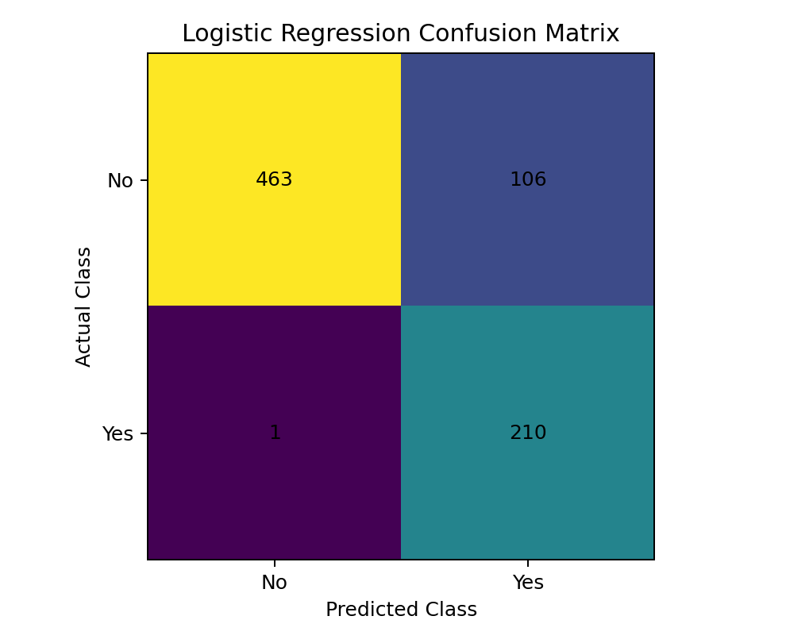

10.1 Confusion matrix interpretation
Actual / Predicted | No | Yes
No | 463 | 106
Yes | 1 | 210
The model correctly predicted 463 No cases and 210 Yes cases. It incorrectly predicted 106 No cases as Yes and 1 Yes cases as No.

11. Logistic Regression vs Random Forest
A Random Forest model was used as a second reference model. The following table shows the test-set scores. These values are descriptive and are not a ranking of algorithms; they simply show how the two models behaved on this dataset.
Model | Accuracy | Precision | Recall | F1 | ROC-AUC
Logistic Regression | 0.863 | 0.665 | 0.995 | 0.797 | 0.909
Random Forest | 0.863 | 0.665 | 0.995 | 0.797 | 0.909
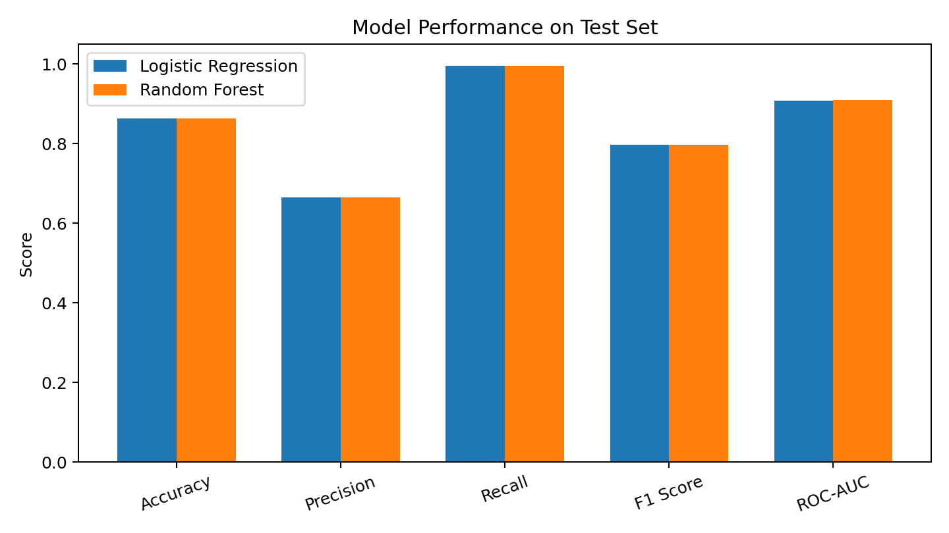

12. Feature Interpretation
Logistic Regression produces coefficients. A positive coefficient is associated with higher model log-odds for the Yes class, while a negative coefficient is associated with lower log-odds, holding the other encoded features in the model constant. These are model associations, not proof of cause.

Examples of positive model coefficients
Encoded feature | Coefficient
Discount Applied_Yes | 3.481
Gender_Male | 0.761
Location_Kentucky | 0.665
Location_Nevada | 0.582
Location_Delaware | 0.542
Location_Colorado | 0.538
Location_Virginia | 0.514
Age Group_45-54 | 0.485

Examples of negative model coefficients
Encoded feature | Coefficient
Discount Applied_No | -3.510
Gender_Female | -0.790
Location_Wisconsin | -0.746
Location_Indiana | -0.690
Location_Oregon | -0.577
Item Purchased_Blouse | -0.499
Location_Michigan | -0.475
Location_Iowa | -0.474
The largest positive coefficient in this model is for Discount Applied = Yes, while the corresponding No category has a large negative coefficient. This strong relationship is specific to this dataset and should not be interpreted as a causal effect. Location and product-related categories also appear among the larger coefficients, but they should be interpreted carefully because the dataset is observational and synthetic.

13. Strengths of the Model
- The complete preprocessing process is stored inside a Scikit-learn pipeline.
- The model is simple enough for a fresher to understand and explain.
- Class balancing helps the model pay attention to the smaller Yes class.
- Five-fold cross-validation was used in addition to the final test-set evaluation.
- The model provides coefficients that can be inspected for interpretation.

14. Limitations of the Model
- The dataset is relatively small, with 3,900 records.
- The target classes are imbalanced, so accuracy alone should not be used.
- The dataset represents customer shopping behavior in a simplified/synthetic setting, so results may not generalize to a real company.
- The model predicts association from the available columns; it does not prove that a feature causes subscription.
- Some variables may be closely related to the target, which can make prediction easier than it would be in a real future-prediction situation.
- The current feature engineering is basic and can be improved.

15. Possible Improvements
- Try other classification algorithms such as Gradient Boosting, XGBoost or Support Vector Machines.
- Tune hyperparameters using GridSearchCV or RandomizedSearchCV.
- Test different probability thresholds instead of using the default 0.50.
- Use precision-recall curves and ROC curves for deeper evaluation.
- Create more meaningful customer-level features if transaction history becomes available.
- Collect real-world time-based data and use a time-aware validation method.
- Use explainability methods such as permutation importance or SHAP for a deeper interpretation.
- Check whether the model performs consistently across different customer groups.

16. Key Findings
- The dataset contains 3,900 customer records and 18 original columns.
- Review Rating contained 37 missing values and was handled using median imputation in the pipeline.
- Promo Code Used was removed because it was identical to Discount Applied in the supplied file.
- Age Group, Purchase Frequency Score and High Previous Purchases were created as simple engineered features.
- Logistic Regression achieved 86.28% test accuracy and 0.909 ROC-AUC.
- Five-fold cross-validation gave a mean accuracy of 0.835 with a standard deviation of 0.009.
- The model had very high recall for the Yes class but lower precision, so some predicted Yes cases were false positives.

17. Conclusion
This project helped me understand the complete basic workflow of supervised machine learning. I started with data inspection, cleaned the data, created new features, split the data into training and testing sets, encoded categorical variables, trained a Logistic Regression classifier, validated it with 5-fold cross-validation, and evaluated it using several metrics.
As a recently graduated fresher, I found Logistic Regression useful because the workflow is easy to follow and the results can be explained clearly. The model performed reasonably well on this dataset, but there is still room for improvement through better feature engineering, model tuning and stronger validation.
The main learning from this project is that model accuracy alone is not enough. Precision, recall, F1 score, ROC-AUC, class balance and validation results should all be considered before interpreting a model.

18. Main Python Code Used
The following is a compact version of the main workflow used in this project. It can be copied into a Jupyter Notebook after placing the CSV file in the working directory.
import pandas as pd
import numpy as np
from sklearn.model_selection import train_test_split, StratifiedKFold, cross_validate
from sklearn.compose import ColumnTransformer
from sklearn.pipeline import Pipeline
from sklearn.preprocessing import OneHotEncoder, StandardScaler
from sklearn.impute import SimpleImputer
from sklearn.linear_model import LogisticRegression
from sklearn.metrics import (
accuracy_score, precision_score, recall_score,
f1_score, roc_auc_score, confusion_matrix
)
# Load data
df = pd.read_csv("customer_shopping_behavior.csv")
# Feature engineering
data = df.copy()
data["Age Group"] = pd.cut(
data["Age"],
bins=[0, 24, 34, 44, 54, 100],
labels=["18-24", "25-34", "35-44", "45-54", "55+"]
)
frequency_map = {
"Weekly": 52, "Fortnightly": 26, "Bi-Weekly": 26,
"Monthly": 12, "Every 3 Months": 4,
"Quarterly": 4, "Annually": 1
}
data["Purchase Frequency Score"] = (
data["Frequency of Purchases"].map(frequency_map)
)
data["High Previous Purchases"] = np.where(
data["Previous Purchases"] >= 10, "Yes", "No"
)
# Remove redundant/identifier columns
data = data.drop(columns=["Promo Code Used", "Customer ID"])
# Target
y = data["Subscription Status"].map({"No": 0, "Yes": 1})
X = data.drop(columns=["Subscription Status"])
# Column groups
categorical_columns = X.select_dtypes(include="object").columns.tolist()
categorical_columns += ["Age Group"]
numeric_columns = X.select_dtypes(include=np.number).columns.tolist()
# Preprocessing
preprocessor = ColumnTransformer([
("num", Pipeline([
("imputer", SimpleImputer(strategy="median")),
("scaler", StandardScaler())
]), numeric_columns),
("cat", Pipeline([
("imputer", SimpleImputer(strategy="most_frequent")),
("onehot", OneHotEncoder(handle_unknown="ignore"))
]), categorical_columns)
])
# Model
model = Pipeline([
("preprocessor", preprocessor),
("model", LogisticRegression(
max_iter=2000,
class_weight="balanced",
random_state=42
))
])
# Train-test split
X_train, X_test, y_train, y_test = train_test_split(
X, y, test_size=0.20,
stratify=y, random_state=42
)
# Train
model.fit(X_train, y_train)
# Predict
y_pred = model.predict(X_test)
y_prob = model.predict_proba(X_test)[:, 1]
# Evaluation
print("Accuracy:", accuracy_score(y_test, y_pred))
print("Precision:", precision_score(y_test, y_pred))
print("Recall:", recall_score(y_test, y_pred))
print("F1:", f1_score(y_test, y_pred))
print("ROC-AUC:", roc_auc_score(y_test, y_prob))
print("Confusion Matrix:")
print(confusion_matrix(y_test, y_pred))
# 5-fold cross-validation
cv = StratifiedKFold(n_splits=5, shuffle=True, random_state=42)
cv_results = cross_validate(
model, X_train, y_train,
cv=cv,
scoring=["accuracy", "precision", "recall", "f1", "roc_auc"]
)
print("Mean CV Accuracy:",
cv_results["test_accuracy"].mean())

19. References
1. Kaggle – Customer Shopping Trends Dataset: https://www.kaggle.com/datasets/iamsouravbanerjee/customer-shopping-trends-dataset
2. Scikit-learn documentation – Logistic Regression, preprocessing, pipelines and model evaluation: https://scikit-learn.org/
3. Python libraries used: Pandas, NumPy, Matplotlib and Scikit-learn.

