Example application for experimenting and performing exercises on.
Exercise.zip – contains source code
Extract the project into a directory of your choice and test using the “serve” command.
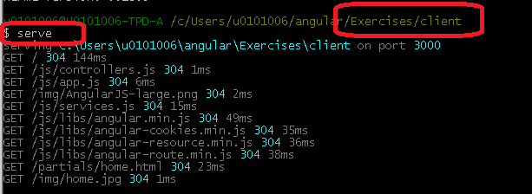
Home view should come up
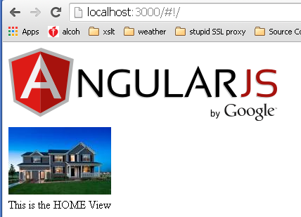

Reference guide:
This is a quick list of installs you may have done or may not have done.
Note:
- “-g” installs globally on your machine so you can run the command in any directory.
- “—save-dev” is a flag to say that you will not be publishing to production when executing the command.

Install Node.js
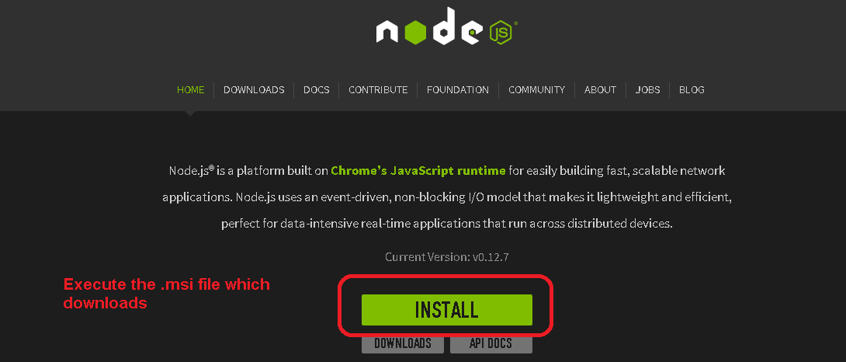

Install Grunt (note you must do this inside node.js command prompt, or git-bash…this will not work in a normal command prompt).
npm install grunt --save-dev
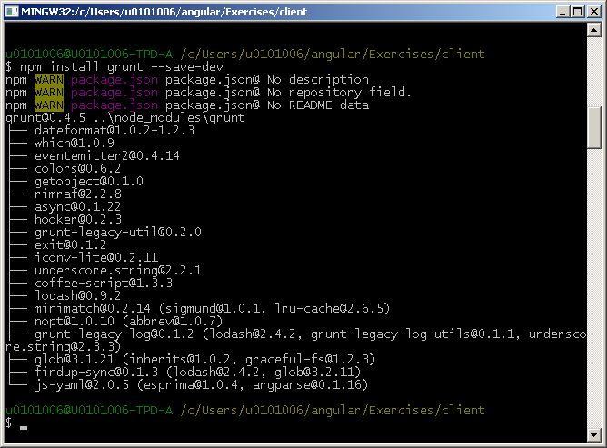
Install Bower
Npm install –g bower
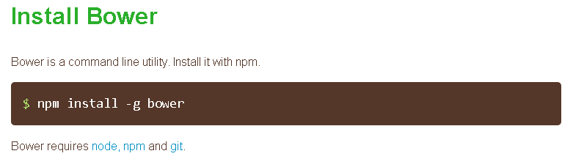

Install Karma
npm install –g karma

You can verify it is installed by checking the version
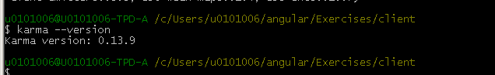

Install serve
You can use other web servers, such as Tomcat, but serve is an easy solution.
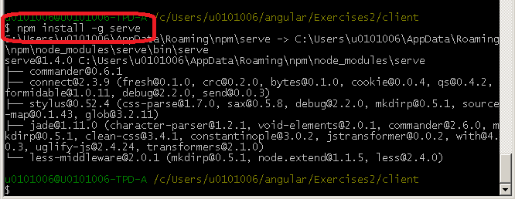
Project
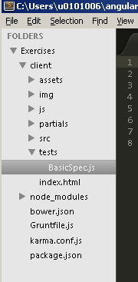

Testing:
Files in the client directory:
bower.json
Gruntfile.js
karma.conf.js
package.json

Run bower init, which will create the bower.json file.
Use all the defaults is fine.

package.json is the definition file for dependencies in which we add all our karma* dependencies.

Gruntfile.js holds the init configuration which includes karma, pointing to the karma.conf.js. The grunt file is set to run one task, karma, so when you execute the command ‘grunt’, karma is all that will run.

karma.conf.js holds config. Could be put in gruntfile, but is easier to manage in a separate file. This determines where to look for tests. This also determines which testing framework to run “jasmine”. The browsers we want to use “chrome”, but we can define every browser.

Test files are under /client/tests, currently there is one simple file BasicSpec.js. Convention is to name the file with *Spec*

To run the karma test, execute “grunt” from the /client directory.
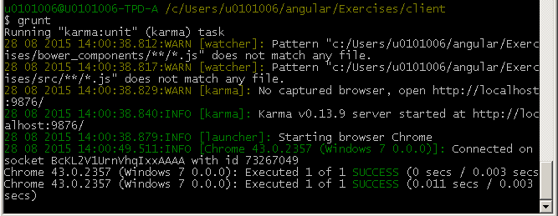
A browser will open and run the test for each browser we have defined in the karma.conf.js
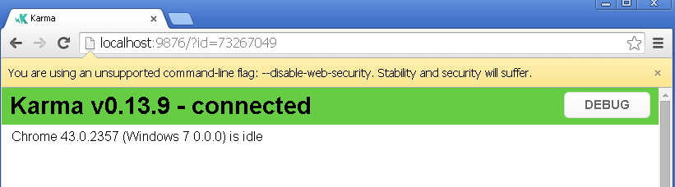
You will see in the terminal “Executed 1 of 1 SUCCESS”.
This will repeat per the number of tests and the number of browsers you run in, for example success Chrome, failed Firefox.

Possible issues:
If you get an exception “grunt-karma” not found. Is it installed?
Install the grunt-karma plugin for grunt:
Npm install grunt-karma –save-dev

