***Assignment on Digital Logic and Computer Design:***

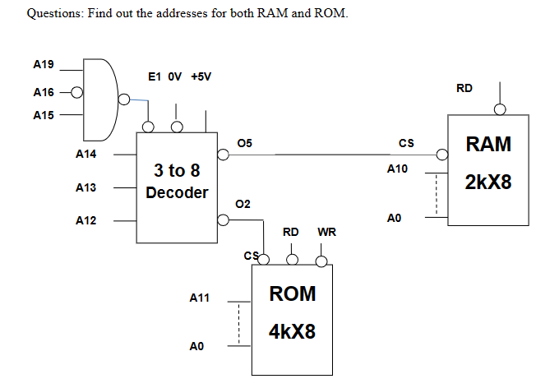

***Address of ROM:***

1st Address: EA0 00

|  |  |  |  |  |  |  |  |  |  |  |  |  |  |  |  |  |  |  |  |
| --- | --- | --- | --- | --- | --- | --- | --- | --- | --- | --- | --- | --- | --- | --- | --- | --- | --- | --- | --- |
| **E** | | | | *A* | | | | **0** | | | | *0* | | | | **0** | | | |
| **A19** | **A18** | **A17** | **A16** | ***A15*** | ***A14*** | ***A13*** | ***A12*** | **A11** | **A10** | **A9** | **A8** | ***A7*** | ***A6*** | ***A5*** | ***A4*** | **A3** | **A2** | **A1** | **A0** |
| **1** | **1** | **1** | **0** | *1* | *0* | *1* | *0* | **0** | **0** | **0** | **0** | *0* | *0* | *0* | *0* | **0** | **0** | **0** | **0** |

**Last Address:** EAFFF

|  |  |  |  |  |  |  |  |  |  |  |  |  |  |  |  |  |  |  |  |
| --- | --- | --- | --- | --- | --- | --- | --- | --- | --- | --- | --- | --- | --- | --- | --- | --- | --- | --- | --- |
| **E** | | | | *A* | | | | **F** | | | | *F* | | | | **F** | | | |
| **A19** | **A18** | **A17** | **A16** | **A15** | **A14** | **A13** | **A12** | **A11** | **A10** | **A9** | **A8** | **A7** | **A6** | **A5** | **A4** | **A3** | **A2** | **A1** | **A0** |
| 1 | 1 | 1 | 0 | 1 | 0 | 1 | 0 | 1 | 1 | 1 | 1 | 1 | 1 | 1 | 1 | 1 | 1 | 1 | 1 |

***Address of RAM:***

1st Address: ED800

|  |  |  |  |  |  |  |  |  |  |  |  |  |  |  |  |  |  |  |  |
| --- | --- | --- | --- | --- | --- | --- | --- | --- | --- | --- | --- | --- | --- | --- | --- | --- | --- | --- | --- |
| **E** | | | | *D* | | | | **8** | | | | **0** | | | | **0** | | | |
| **A19** | **A18** | **A17** | **A16** | **A15** | **A14** | **A13** | **A12** | **A11** | **A10** | **A9** | **A8** | **A7** | **A6** | **A5** | **A4** | **A3** | **A2** | **A1** | **A0** |
| 1 | 1 | 1 | 0 | 1 | 1 | 0 | 1 | 1 | 0 | 0 | 0 | 0 | 0 | 0 | 0 | 0 | 0 | 0 | 0 |

**Last Address: EDFFF**

|  |  |  |  |  |  |  |  |  |  |  |  |  |  |  |  |  |  |  |  |
| --- | --- | --- | --- | --- | --- | --- | --- | --- | --- | --- | --- | --- | --- | --- | --- | --- | --- | --- | --- |
| **E** | | | | *D* | | | | **F** | | | | **F** | | | | **F** | | | |
| ***A19*** | ***A18*** | ***A17*** | ***A16*** | ***A15*** | **A14** | **A13** | **A12** | **A11** | **A10** | **A9** | **A8** | **A7** | **A6** | **A5** | **A4** | **A3** | **A2** | **A1** | **A0** |
| *1* | *1* | *1* | *0* | *1* | 1 | 0 | 1 | 1 | 1 | 1 | 1 | 1 | 1 | 1 | 1 | 1 | 1 | 1 | 1 |