**Object Oriented Design and Programming**

**Unit Code: OODP101**

**Assessment 3 – Report**

Name of the Student:

Student ID:

# SCENARIO - 3

# UML Class Diagram

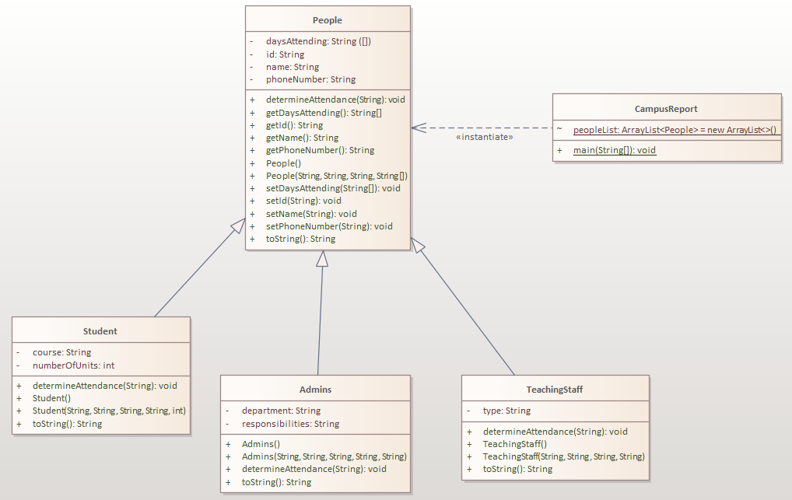

# Testing Report

|  |  |  |  |
| --- | --- | --- | --- |
| Test Case | Input | Expected Output | Actual Output |
| 1 | **Input Day:** "Monday" | **People attending campus on Monday:** Admins: Jason Admins: Carla Admins: David Student: John TeachingStaff: Frank |  |
| 2 | **Input Day:** "Wednesday" | **People attending campus on Wednesday:** Admins: Carla Admins: David Student: Riley |  |
| 3 | **Input Day:** "Friday" | **People attending campus on Friday:** Admins: David Student: Riley TeachingStaff: Bobby TeachingStaff: Frank |  |
| 5 | **Input Day:** "Saturday" | **People attending campus on Saturday:** Sorry! Wrong entry or No one is attending the campus on Saturday |  |
| 6 | **Input Day:** "Sunday" | **People attending campus on Sunday:** Sorry! Wrong entry or No one is attending the campus on Sunday |  |
| 7 | **Input Day:** "Quit" | **Output:** Thank you! |  |