Monatsreporting MRE - Inselgruppe

Spitalhygiene

Letztes update: **05. Oktober 2020**

Übersichtstabelle

|  |  |
| --- | --- |
|  | Overall |
| n | 2913 |
| year (median [IQR]) | 2018.0 [2017.0, 2019.0] |
| group (%) |  |
| Carbapenemasebildner | 82 ( 2.8) |
| Clostridium difficile | 676 (23.2) |
| Clostridium difficile 027 | 33 ( 1.1) |
| ESBL-Bildner | 402 (13.8) |
| MRSA | 585 (20.1) |
| Multiresistente Gram negative Keime | 466 (16.0) |
| Panresistente Gram negative Keime | 22 ( 0.8) |
| VRE | 647 (22.2) |
| nosokomial (%) |  |
| Ja | 1264 (43.4) |
| Nein | 1601 (55.0) |
| NA | 48 ( 1.6) |

# Übersicht (stratifiziert nach Jahren)

Overview, stratified by year

|  |  |  |  |  |
| --- | --- | --- | --- | --- |
|  | 2017 | 2018 | 2019 | 2020 |
| n | 500 | 808 | 690 | 366 |
| year (median [IQR]) | 2017.0 [2017.0, 2017.0] | 2018.0 [2018.0, 2018.0] | 2019.0 [2019.0, 2019.0] | 2020.0 [2020.0, 2020.0] |
| group (%) |  |  |  |  |
| Carbapenemasebildner | 23 ( 4.6) | 15 ( 1.9) | 7 ( 1.0) | 13 ( 3.6) |
| Clostridium difficile | 172 (34.4) | 162 (20.0) | 175 (25.4) | 127 (34.7) |
| Clostridium difficile 027 | 21 ( 4.2) | 7 ( 0.9) | 0 ( 0.0) | 1 ( 0.3) |
| ESBL-Bildner | 72 (14.4) | 65 ( 8.0) | 93 (13.5) | 49 (13.4) |
| MRSA | 123 (24.6) | 106 (13.1) | 92 (13.3) | 63 (17.2) |
| Multiresistente Gram negative Keime | 82 (16.4) | 81 (10.0) | 75 (10.9) | 78 (21.3) |
| Panresistente Gram negative Keime | 4 ( 0.8) | 4 ( 0.5) | 6 ( 0.9) | 3 ( 0.8) |
| VRE | 3 ( 0.6) | 368 (45.5) | 242 (35.1) | 32 ( 8.7) |
| nosokomial (%) |  |  |  |  |
| Ja | 166 (33.2) | 477 (59.0) | 333 (48.3) | 137 (37.4) |
| Nein | 325 (65.0) | 327 (40.5) | 356 (51.6) | 225 (61.5) |
| NA | 9 ( 1.8) | 4 ( 0.5) | 1 ( 0.1) | 4 ( 1.1) |

# ESBL-Bildner

## ESBL-Bildner: Erstbefunde Inselgruppe

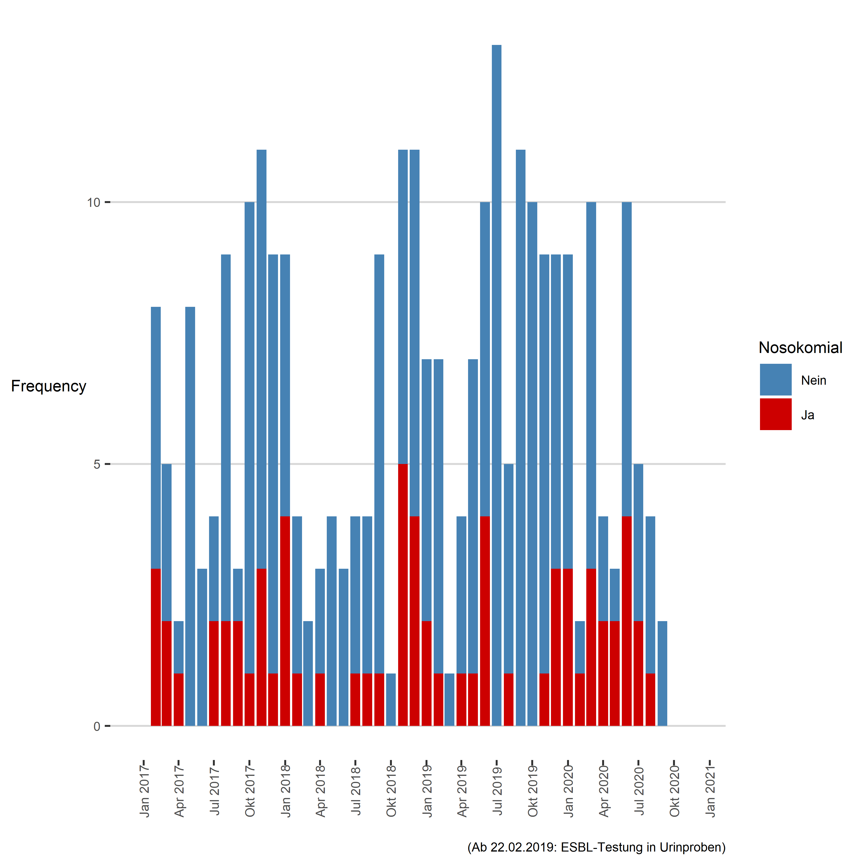

### new page

## Tabelle: ESBL-Bildner

|  |  |  |  |  |
| --- | --- | --- | --- | --- |
| Jahr | Monat | Gruppe | Nicht-nosokomial | Nosokomial |
| 2018 | Jan | ESBL-Bildner | 5 | 4 |
| 2018 | Feb | ESBL-Bildner | 3 | 1 |
| 2018 | Mär | ESBL-Bildner | 2 | 0 |
| 2018 | Apr | ESBL-Bildner | 2 | 1 |
| 2018 | Mai | ESBL-Bildner | 4 | 0 |
| 2018 | Jun | ESBL-Bildner | 3 | 0 |
| 2018 | Jul | ESBL-Bildner | 3 | 1 |
| 2018 | Aug | ESBL-Bildner | 3 | 1 |
| 2018 | Sep | ESBL-Bildner | 8 | 1 |
| 2018 | Okt | ESBL-Bildner | 1 | 0 |
| 2018 | Nov | ESBL-Bildner | 6 | 5 |
| 2018 | Dez | ESBL-Bildner | 7 | 4 |
| 2019 | Jan | ESBL-Bildner | 5 | 2 |
| 2019 | Feb | ESBL-Bildner | 6 | 1 |
| 2019 | Mär | ESBL-Bildner | 1 | 0 |
| 2019 | Apr | ESBL-Bildner | 3 | 1 |
| 2019 | Mai | ESBL-Bildner | 6 | 1 |
| 2019 | Jun | ESBL-Bildner | 6 | 4 |
| 2019 | Jul | ESBL-Bildner | 13 | 0 |
| 2019 | Aug | ESBL-Bildner | 4 | 1 |
| 2019 | Sep | ESBL-Bildner | 11 | 0 |
| 2019 | Okt | ESBL-Bildner | 10 | 0 |
| 2019 | Nov | ESBL-Bildner | 8 | 1 |
| 2019 | Dez | ESBL-Bildner | 6 | 3 |
| 2020 | Jan | ESBL-Bildner | 6 | 3 |
| 2020 | Feb | ESBL-Bildner | 1 | 1 |
| 2020 | Mär | ESBL-Bildner | 7 | 3 |
| 2020 | Apr | ESBL-Bildner | 2 | 2 |
| 2020 | Mai | ESBL-Bildner | 1 | 2 |
| 2020 | Jun | ESBL-Bildner | 6 | 4 |
| 2020 | Jul | ESBL-Bildner | 3 | 2 |
| 2020 | Aug | ESBL-Bildner | 3 | 1 |
| 2020 | Sep | ESBL-Bildner | 2 | 0 |

### new page

## ESBL-Bildner, Trend over time

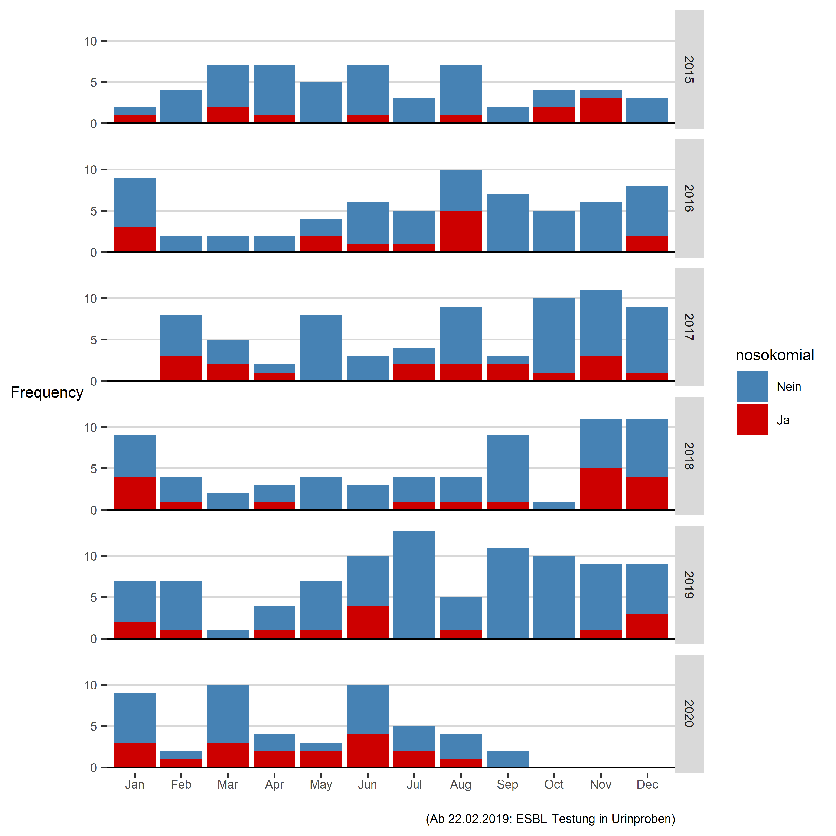

# MRSA

## MRSA: Erstbefunde Inselgruppe

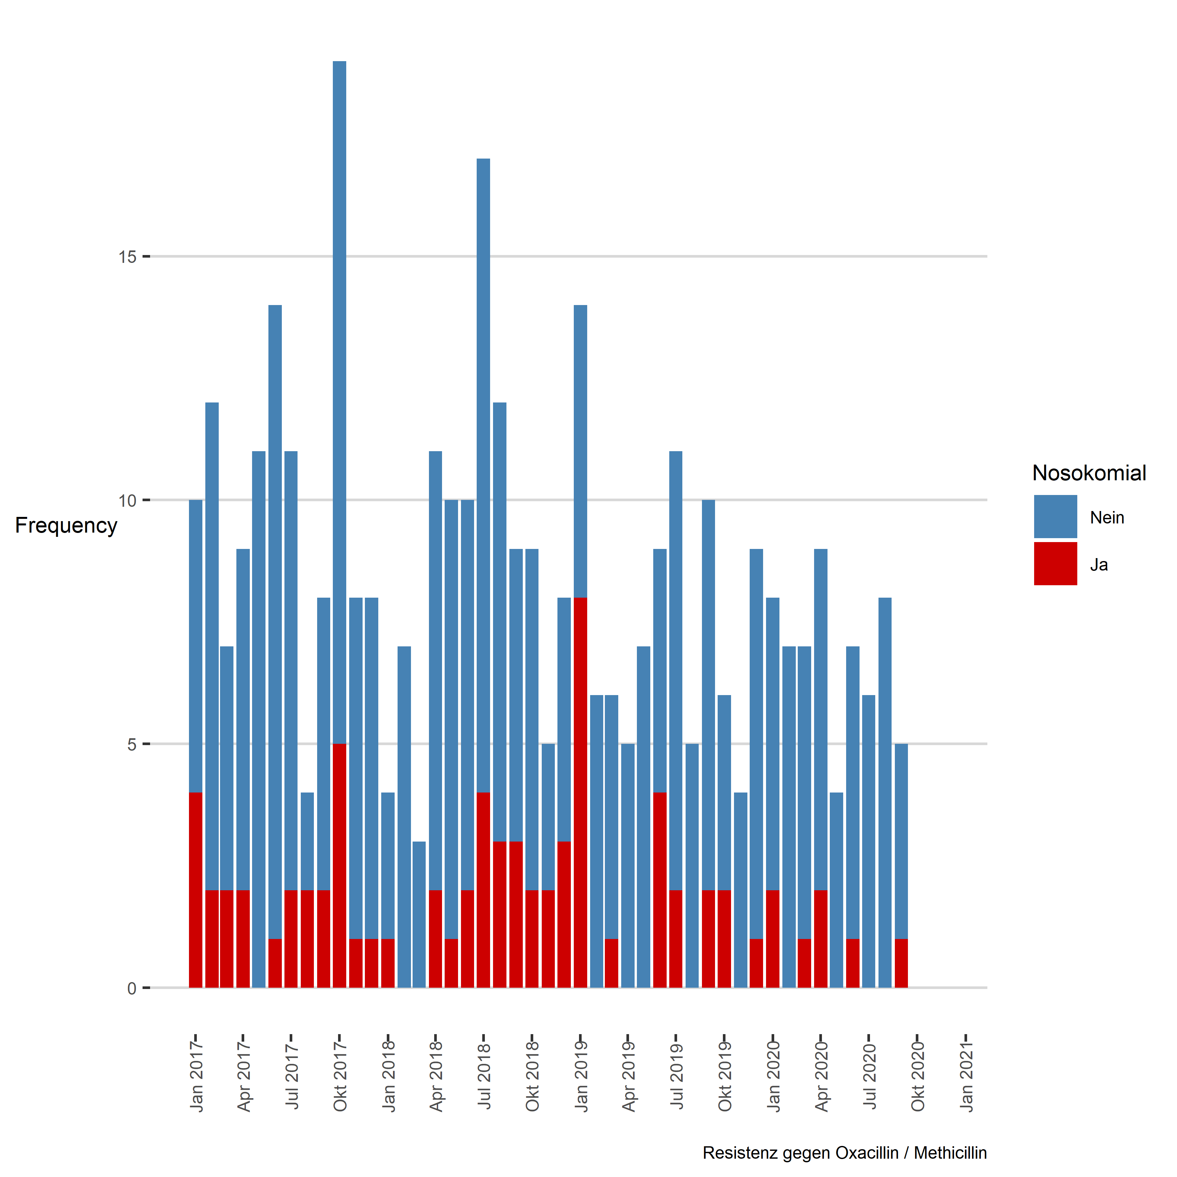

### new page

## Tabelle: MRSA

|  |  |  |  |  |
| --- | --- | --- | --- | --- |
| Jahr | Monat | Gruppe | Nicht-nosokomial | Nosokomial |
| 2018 | Jan | MRSA | 3 | 1 |
| 2018 | Feb | MRSA | 7 | 0 |
| 2018 | Mär | MRSA | 3 | 0 |
| 2018 | Apr | MRSA | 9 | 2 |
| 2018 | Mai | MRSA | 9 | 1 |
| 2018 | Jun | MRSA | 8 | 2 |
| 2018 | Jul | MRSA | 13 | 4 |
| 2018 | Aug | MRSA | 9 | 3 |
| 2018 | Sep | MRSA | 6 | 3 |
| 2018 | Okt | MRSA | 7 | 2 |
| 2018 | Nov | MRSA | 3 | 2 |
| 2018 | Dez | MRSA | 5 | 3 |
| 2019 | Jan | MRSA | 6 | 8 |
| 2019 | Feb | MRSA | 6 | 0 |
| 2019 | Mär | MRSA | 5 | 1 |
| 2019 | Apr | MRSA | 5 | 0 |
| 2019 | Mai | MRSA | 7 | 0 |
| 2019 | Jun | MRSA | 5 | 4 |
| 2019 | Jul | MRSA | 9 | 2 |
| 2019 | Aug | MRSA | 5 | 0 |
| 2019 | Sep | MRSA | 8 | 2 |
| 2019 | Okt | MRSA | 4 | 2 |
| 2019 | Nov | MRSA | 4 | 0 |
| 2019 | Dez | MRSA | 8 | 1 |
| 2020 | Jan | MRSA | 6 | 2 |
| 2020 | Feb | MRSA | 7 | 0 |
| 2020 | Mär | MRSA | 6 | 1 |
| 2020 | Apr | MRSA | 7 | 2 |
| 2020 | Mai | MRSA | 4 | 0 |
| 2020 | Jun | MRSA | 6 | 1 |
| 2020 | Jul | MRSA | 6 | 0 |
| 2020 | Aug | MRSA | 8 | 0 |
| 2020 | Sep | MRSA | 4 | 1 |

### new page

## MRSA, Trend over time

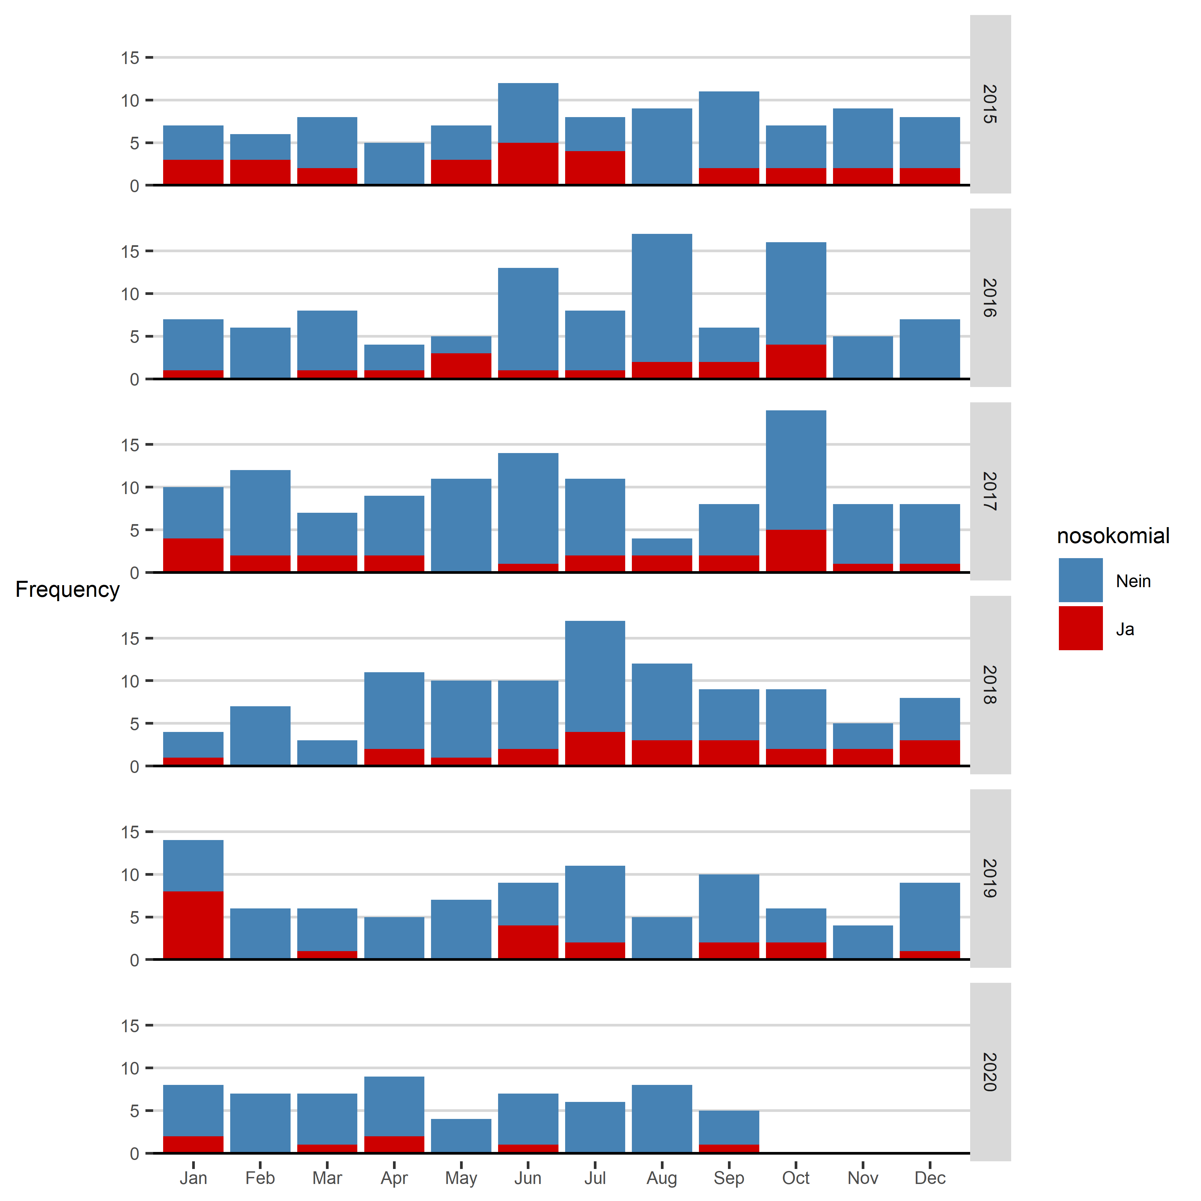

# Panresistente Gram-negative Keime

## Panresistente Gram-negative Keime: Erstbefunde Inselgruppe (inkl. E. coli)

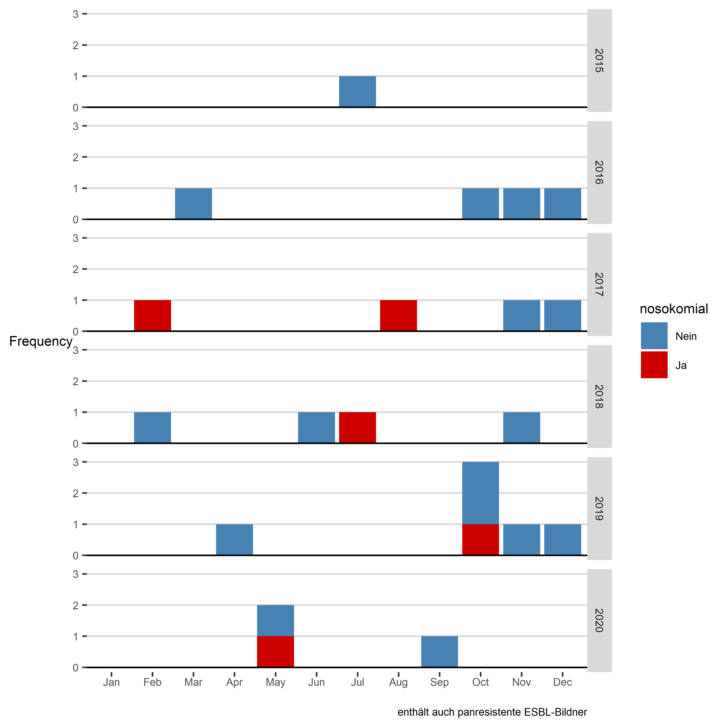

# Multiresistente Gram negative Keime

## Multiresistente Gram negative Keime: Erstbefunde Inselgruppe (ohne E. coli)

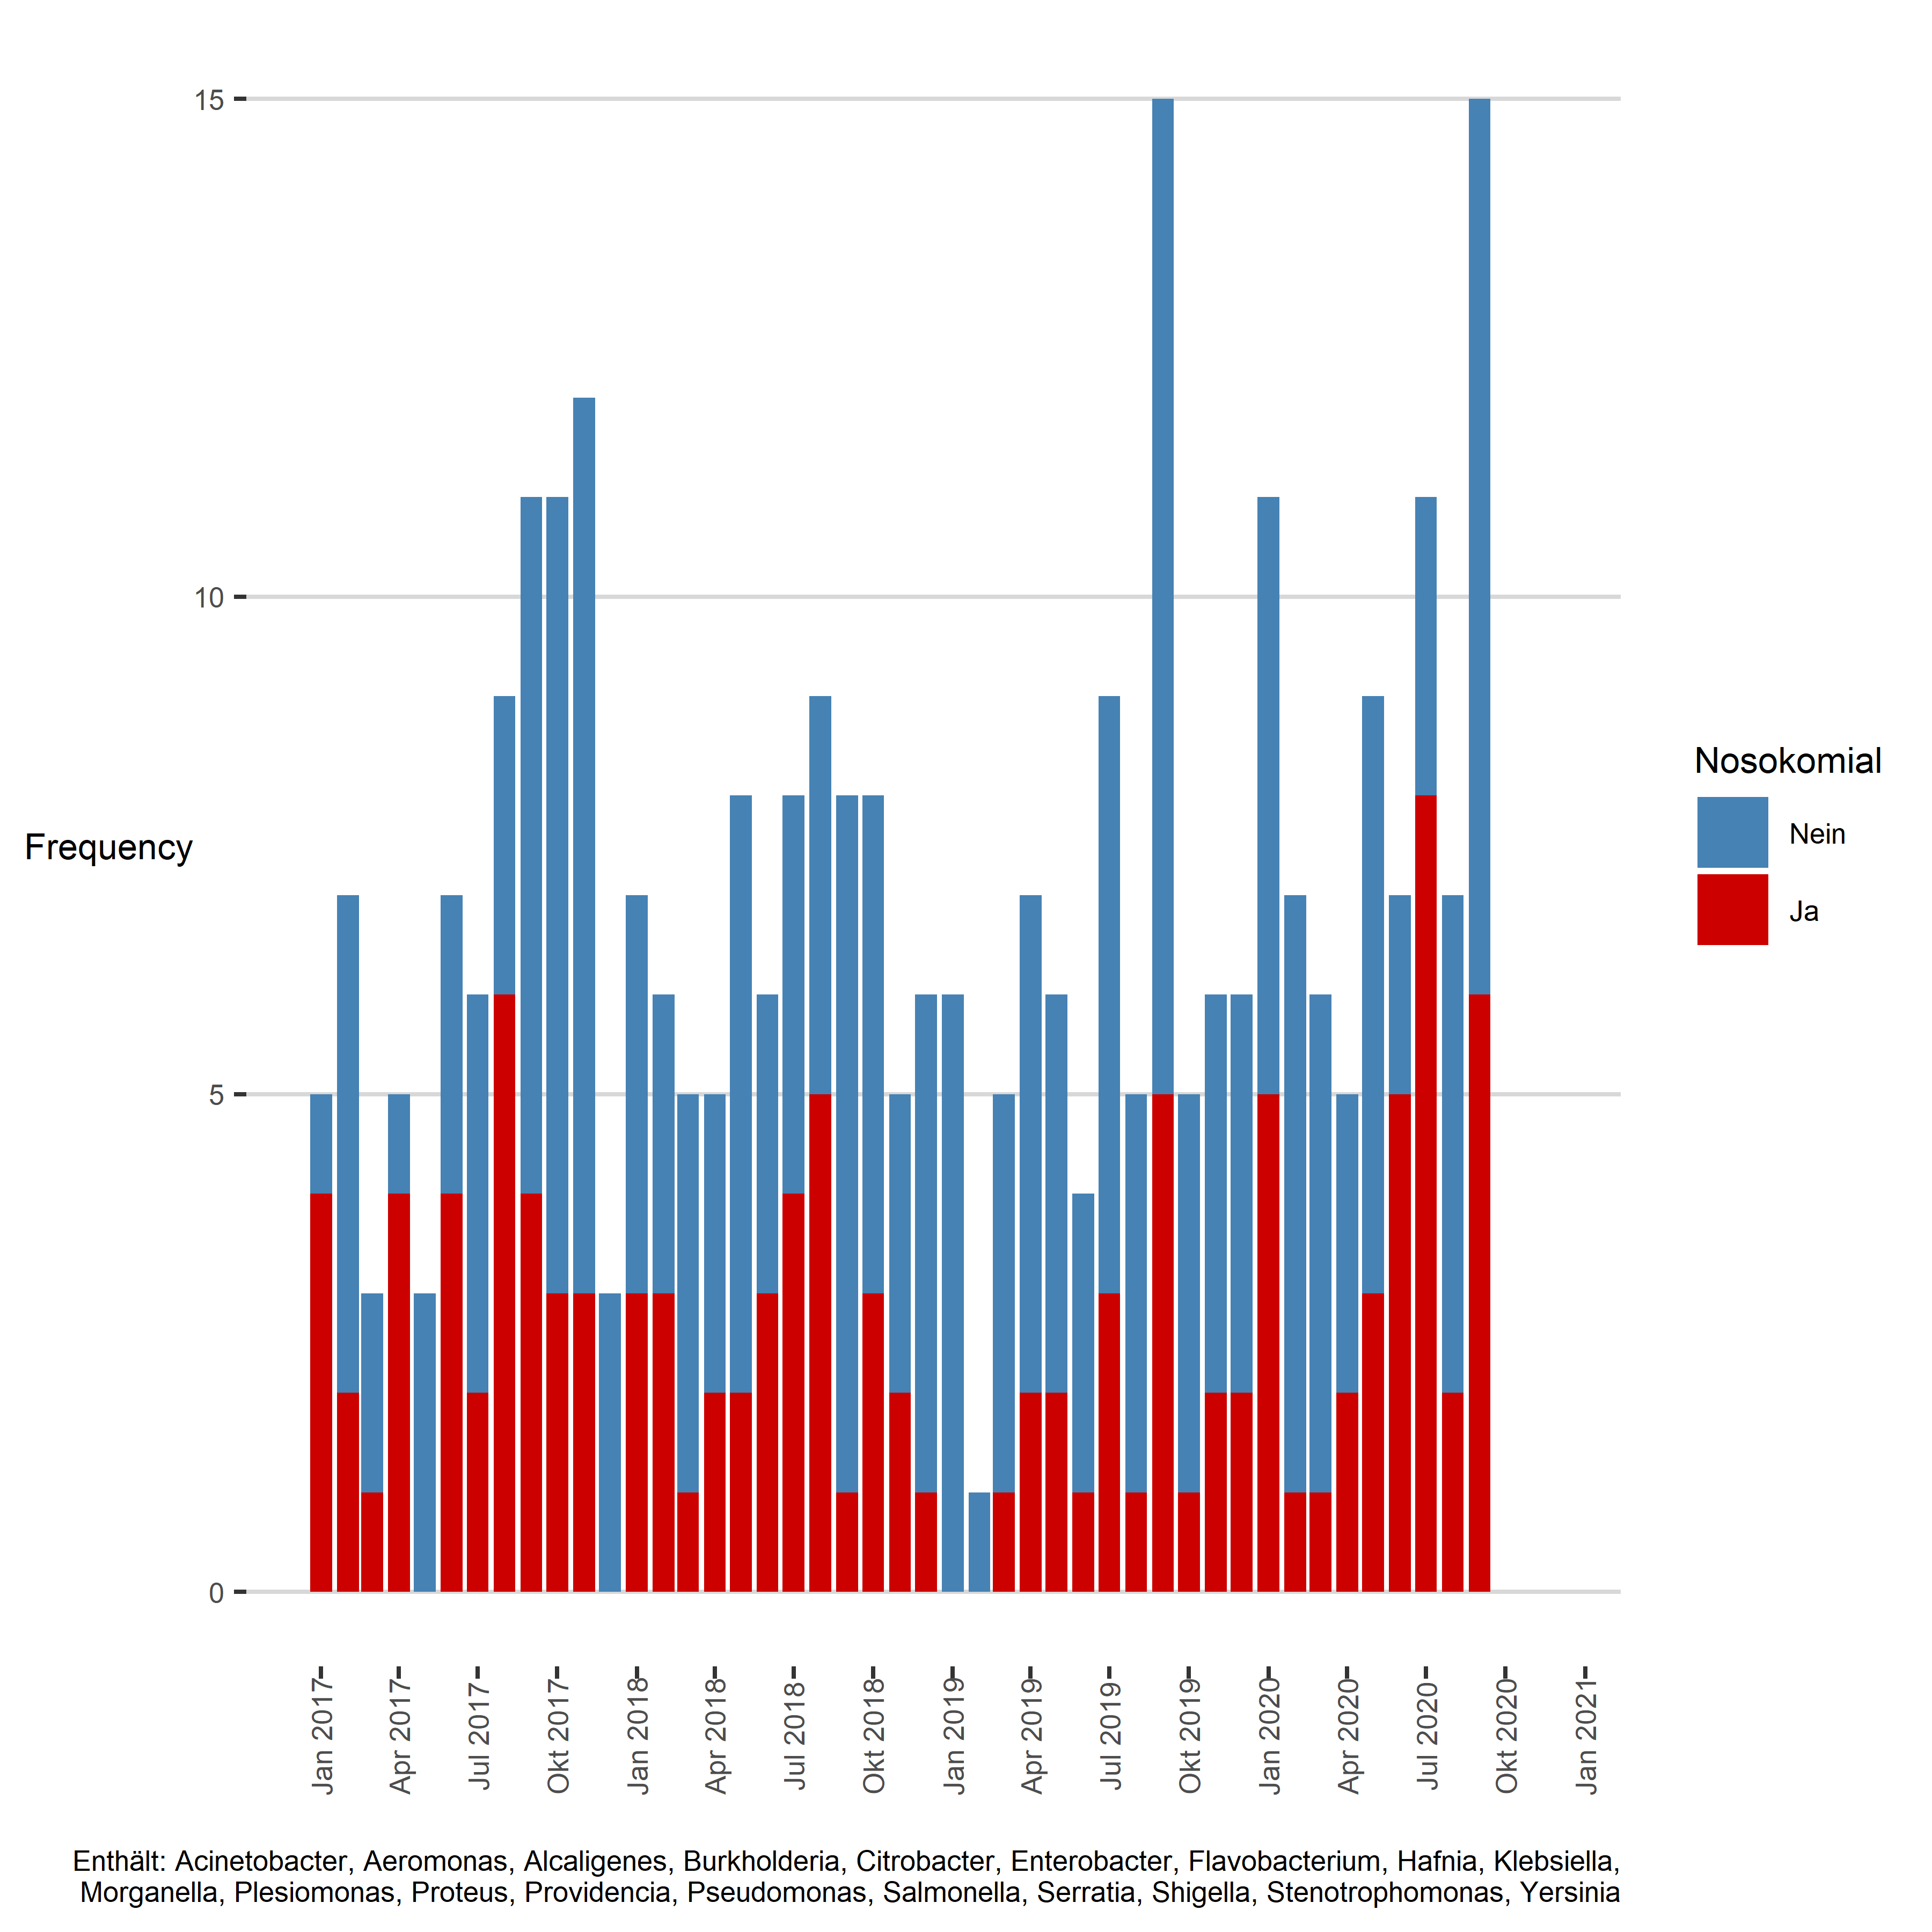

### new page

## Tabelle: Multiresistente Gram negative Keime

|  |  |  |  |  |
| --- | --- | --- | --- | --- |
| Jahr | Monat | Gruppe | Nicht-nosokomial | Nosokomial |
| 2018 | Jan | Multiresistente Gram negative Keime | 4 | 3 |
| 2018 | Feb | Multiresistente Gram negative Keime | 3 | 3 |
| 2018 | Mär | Multiresistente Gram negative Keime | 4 | 1 |
| 2018 | Apr | Multiresistente Gram negative Keime | 3 | 2 |
| 2018 | Mai | Multiresistente Gram negative Keime | 6 | 2 |
| 2018 | Jun | Multiresistente Gram negative Keime | 3 | 3 |
| 2018 | Jul | Multiresistente Gram negative Keime | 4 | 4 |
| 2018 | Aug | Multiresistente Gram negative Keime | 4 | 5 |
| 2018 | Sep | Multiresistente Gram negative Keime | 7 | 1 |
| 2018 | Okt | Multiresistente Gram negative Keime | 5 | 3 |
| 2018 | Nov | Multiresistente Gram negative Keime | 3 | 2 |
| 2018 | Dez | Multiresistente Gram negative Keime | 5 | 1 |
| 2019 | Jan | Multiresistente Gram negative Keime | 6 | 0 |
| 2019 | Feb | Multiresistente Gram negative Keime | 1 | 0 |
| 2019 | Mär | Multiresistente Gram negative Keime | 4 | 1 |
| 2019 | Apr | Multiresistente Gram negative Keime | 5 | 2 |
| 2019 | Mai | Multiresistente Gram negative Keime | 4 | 2 |
| 2019 | Jun | Multiresistente Gram negative Keime | 3 | 1 |
| 2019 | Jul | Multiresistente Gram negative Keime | 6 | 3 |
| 2019 | Aug | Multiresistente Gram negative Keime | 4 | 1 |
| 2019 | Sep | Multiresistente Gram negative Keime | 10 | 5 |
| 2019 | Okt | Multiresistente Gram negative Keime | 4 | 1 |
| 2019 | Nov | Multiresistente Gram negative Keime | 4 | 2 |
| 2019 | Dez | Multiresistente Gram negative Keime | 4 | 2 |
| 2020 | Jan | Multiresistente Gram negative Keime | 6 | 5 |
| 2020 | Feb | Multiresistente Gram negative Keime | 6 | 1 |
| 2020 | Mär | Multiresistente Gram negative Keime | 5 | 1 |
| 2020 | Apr | Multiresistente Gram negative Keime | 3 | 2 |
| 2020 | Mai | Multiresistente Gram negative Keime | 6 | 3 |
| 2020 | Jun | Multiresistente Gram negative Keime | 2 | 5 |
| 2020 | Jul | Multiresistente Gram negative Keime | 3 | 8 |
| 2020 | Aug | Multiresistente Gram negative Keime | 5 | 2 |
| 2020 | Sep | Multiresistente Gram negative Keime | 9 | 6 |

### new page

## Multiresistente Gram negative Keime, Trend over time

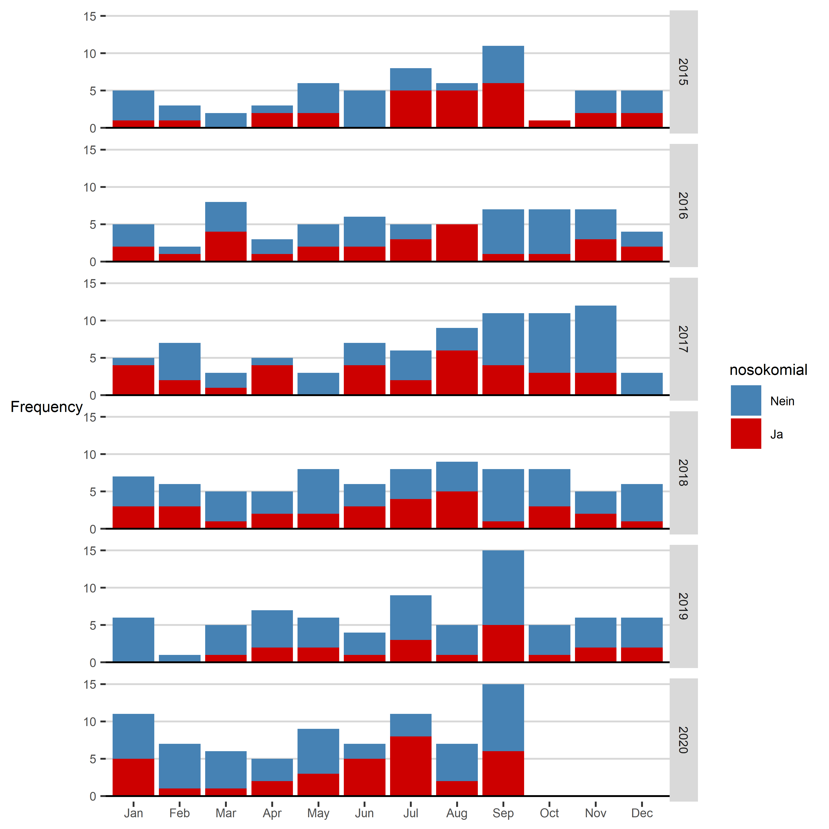

# Vancomycin resistente Enterkokokken (VRE)

## VRE: Erstbefunde Inselgruppe

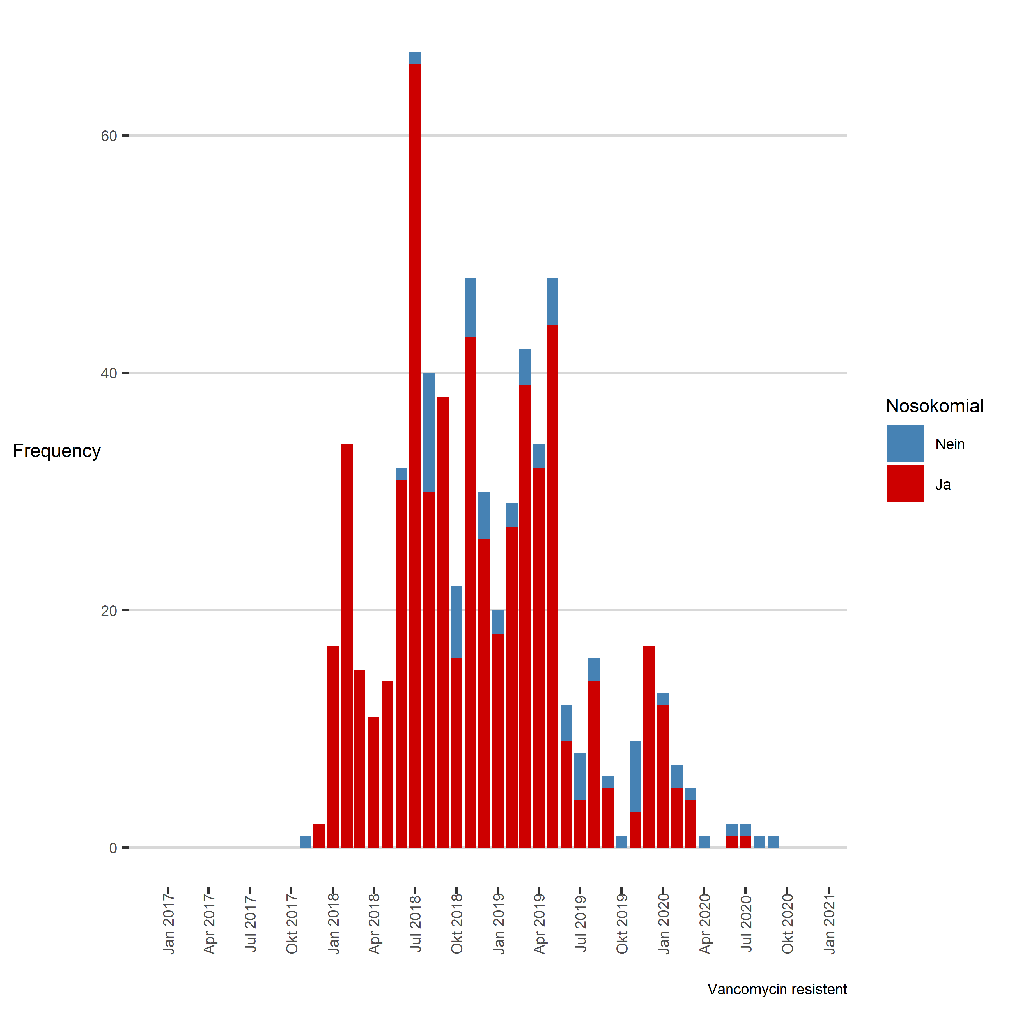

### new page

## Tabelle: VRE

|  |  |  |  |  |
| --- | --- | --- | --- | --- |
| Jahr | Monat | Gruppe | Nicht-nosokomial | Nosokomial |
| 2018 | Jan | VRE | 0 | 17 |
| 2018 | Feb | VRE | 0 | 34 |
| 2018 | Mär | VRE | 0 | 15 |
| 2018 | Apr | VRE | 0 | 11 |
| 2018 | Mai | VRE | 0 | 14 |
| 2018 | Jun | VRE | 1 | 31 |
| 2018 | Jul | VRE | 1 | 66 |
| 2018 | Aug | VRE | 10 | 30 |
| 2018 | Sep | VRE | 0 | 38 |
| 2018 | Okt | VRE | 6 | 16 |
| 2018 | Nov | VRE | 5 | 43 |
| 2018 | Dez | VRE | 4 | 26 |
| 2019 | Jan | VRE | 2 | 18 |
| 2019 | Feb | VRE | 2 | 27 |
| 2019 | Mär | VRE | 3 | 39 |
| 2019 | Apr | VRE | 2 | 32 |
| 2019 | Mai | VRE | 4 | 44 |
| 2019 | Jun | VRE | 3 | 9 |
| 2019 | Jul | VRE | 4 | 4 |
| 2019 | Aug | VRE | 2 | 14 |
| 2019 | Sep | VRE | 1 | 5 |
| 2019 | Okt | VRE | 1 | 0 |
| 2019 | Nov | VRE | 6 | 3 |
| 2019 | Dez | VRE | 0 | 17 |
| 2020 | Jan | VRE | 1 | 12 |
| 2020 | Feb | VRE | 2 | 5 |
| 2020 | Mär | VRE | 1 | 4 |
| 2020 | Apr | VRE | 1 | 0 |
| 2020 | Jun | VRE | 1 | 1 |
| 2020 | Jul | VRE | 1 | 1 |
| 2020 | Aug | VRE | 1 | 0 |
| 2020 | Sep | VRE | 1 | 0 |

### new page

## VRE, Trend over time

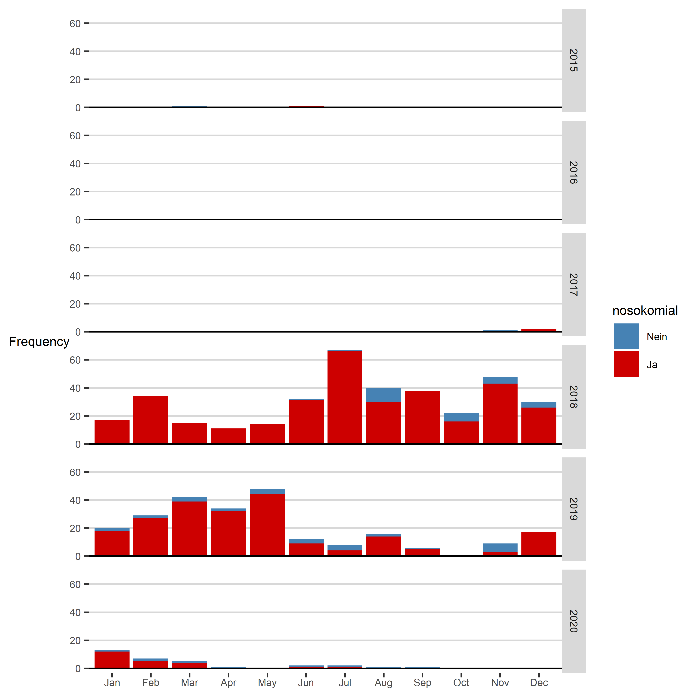

# Carbapenemasebildner

## Carbapenemasebildner: Erstbefunde Inselgruppe (inkl. E. coli)

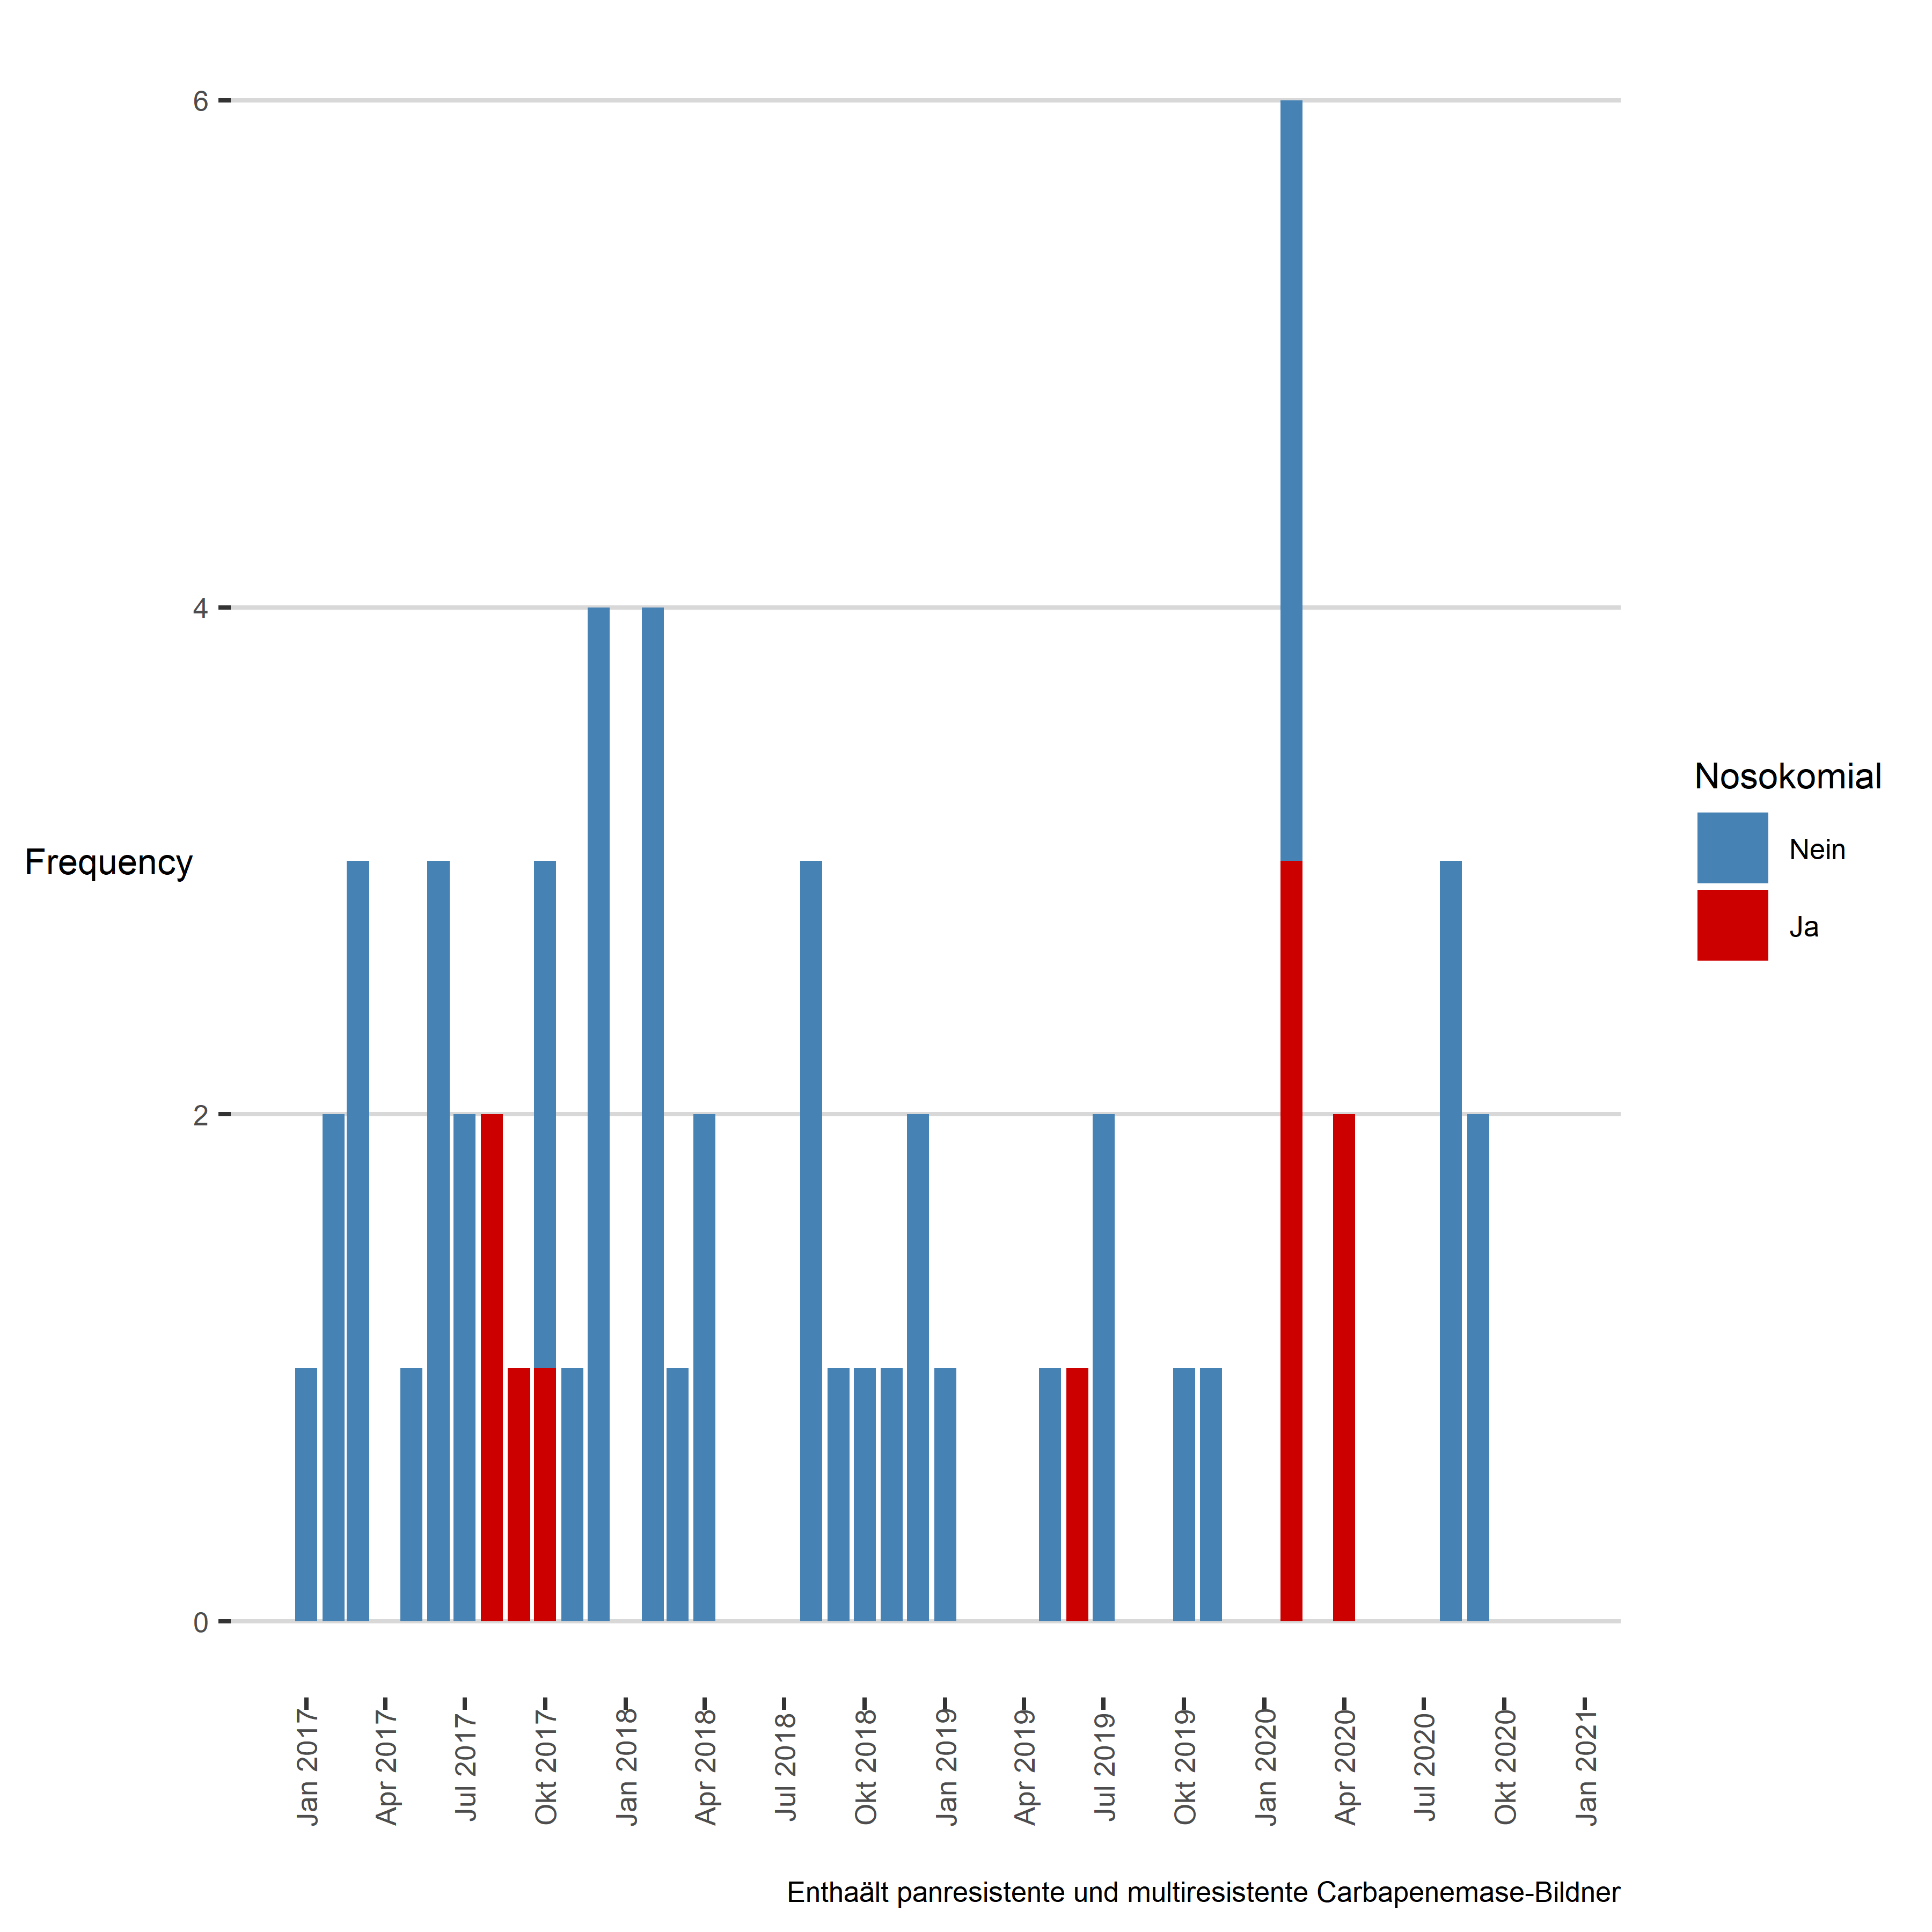

### new page

## Tabelle: Carbapenemasebildner

|  |  |  |  |  |
| --- | --- | --- | --- | --- |
| Jahr | Monat | Gruppe | Nicht-nosokomial | Nosokomial |
| 2018 | Feb | Carbapenemasebildner | 4 | 0 |
| 2018 | Mär | Carbapenemasebildner | 1 | 0 |
| 2018 | Apr | Carbapenemasebildner | 2 | 0 |
| 2018 | Aug | Carbapenemasebildner | 3 | 0 |
| 2018 | Sep | Carbapenemasebildner | 1 | 0 |
| 2018 | Okt | Carbapenemasebildner | 1 | 0 |
| 2018 | Nov | Carbapenemasebildner | 1 | 0 |
| 2018 | Dez | Carbapenemasebildner | 2 | 0 |
| 2019 | Jan | Carbapenemasebildner | 1 | 0 |
| 2019 | Mai | Carbapenemasebildner | 1 | 0 |
| 2019 | Jun | Carbapenemasebildner | 0 | 1 |
| 2019 | Jul | Carbapenemasebildner | 2 | 0 |
| 2019 | Okt | Carbapenemasebildner | 1 | 0 |
| 2019 | Nov | Carbapenemasebildner | 1 | 0 |
| 2020 | Feb | Carbapenemasebildner | 3 | 3 |
| 2020 | Apr | Carbapenemasebildner | 0 | 2 |
| 2020 | Aug | Carbapenemasebildner | 3 | 0 |
| 2020 | Sep | Carbapenemasebildner | 2 | 0 |

### new page

## Carbapenemasebildner, Trend over time

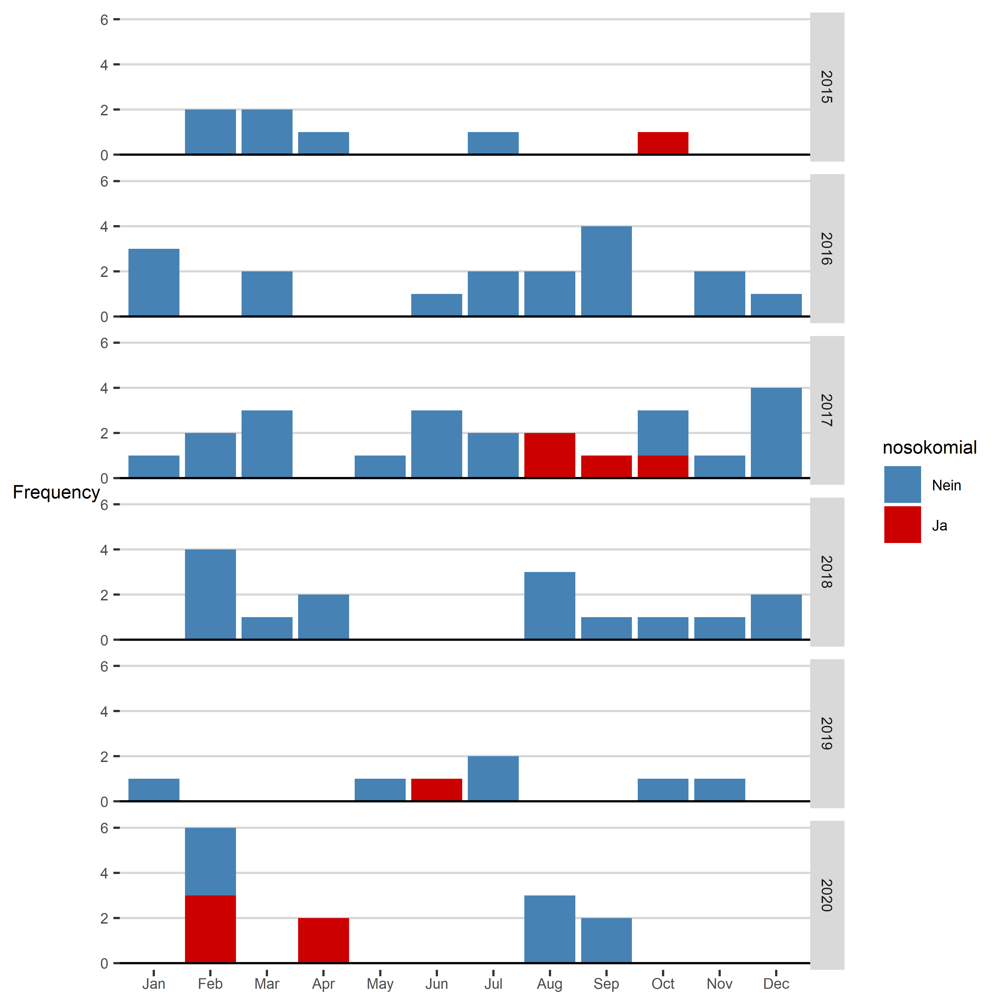

# Clostridium difficle

## Clostridium difficle: Erstbefunde Inselgruppe (ohne GT 027)

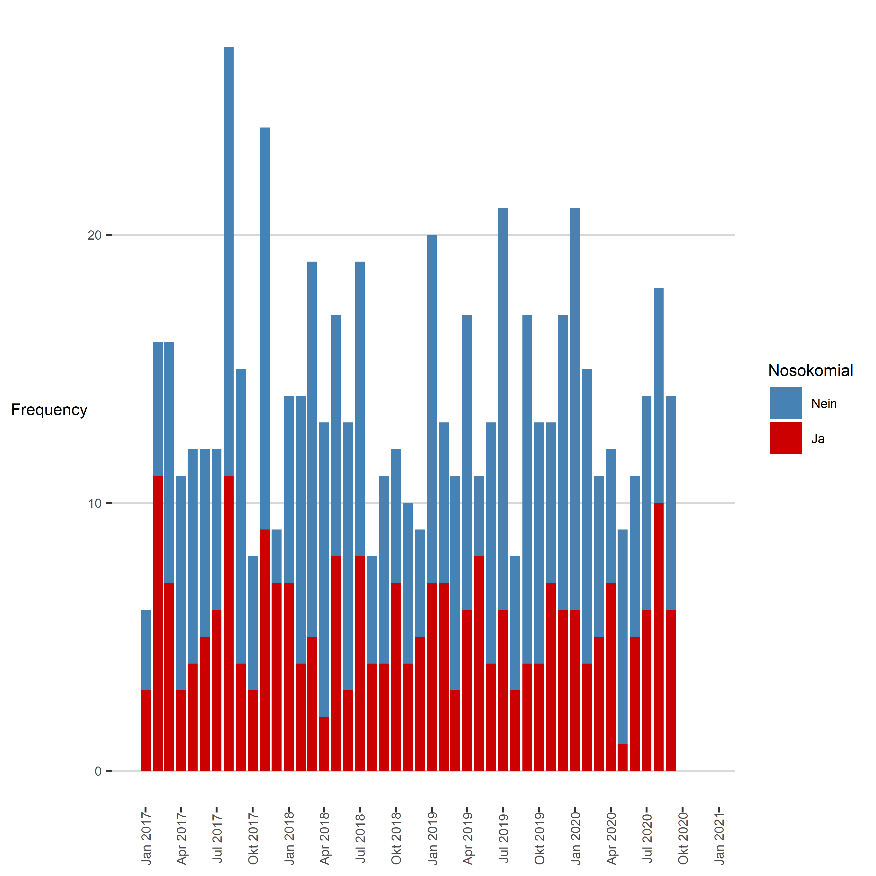

### new page

## Tabelle: Clostridium difficle

|  |  |  |  |  |
| --- | --- | --- | --- | --- |
| Jahr | Monat | Gruppe | Nicht-nosokomial | Nosokomial |
| 2018 | Jan | Clostridium difficile | 7 | 7 |
| 2018 | Feb | Clostridium difficile | 10 | 4 |
| 2018 | Mär | Clostridium difficile | 14 | 5 |
| 2018 | Apr | Clostridium difficile | 11 | 2 |
| 2018 | Mai | Clostridium difficile | 9 | 8 |
| 2018 | Jun | Clostridium difficile | 10 | 3 |
| 2018 | Jul | Clostridium difficile | 11 | 8 |
| 2018 | Aug | Clostridium difficile | 4 | 4 |
| 2018 | Sep | Clostridium difficile | 7 | 4 |
| 2018 | Okt | Clostridium difficile | 5 | 7 |
| 2018 | Nov | Clostridium difficile | 6 | 4 |
| 2018 | Dez | Clostridium difficile | 4 | 5 |
| 2019 | Jan | Clostridium difficile | 13 | 7 |
| 2019 | Feb | Clostridium difficile | 6 | 7 |
| 2019 | Mär | Clostridium difficile | 8 | 3 |
| 2019 | Apr | Clostridium difficile | 11 | 6 |
| 2019 | Mai | Clostridium difficile | 3 | 8 |
| 2019 | Jun | Clostridium difficile | 9 | 4 |
| 2019 | Jul | Clostridium difficile | 15 | 6 |
| 2019 | Aug | Clostridium difficile | 5 | 3 |
| 2019 | Sep | Clostridium difficile | 13 | 4 |
| 2019 | Okt | Clostridium difficile | 9 | 4 |
| 2019 | Nov | Clostridium difficile | 6 | 7 |
| 2019 | Dez | Clostridium difficile | 11 | 6 |
| 2020 | Jan | Clostridium difficile | 15 | 6 |
| 2020 | Feb | Clostridium difficile | 11 | 4 |
| 2020 | Mär | Clostridium difficile | 6 | 5 |
| 2020 | Apr | Clostridium difficile | 5 | 7 |
| 2020 | Mai | Clostridium difficile | 8 | 1 |
| 2020 | Jun | Clostridium difficile | 6 | 5 |
| 2020 | Jul | Clostridium difficile | 8 | 6 |
| 2020 | Aug | Clostridium difficile | 8 | 10 |
| 2020 | Sep | Clostridium difficile | 8 | 6 |

### new page

## Clostridium difficle, Trend over time

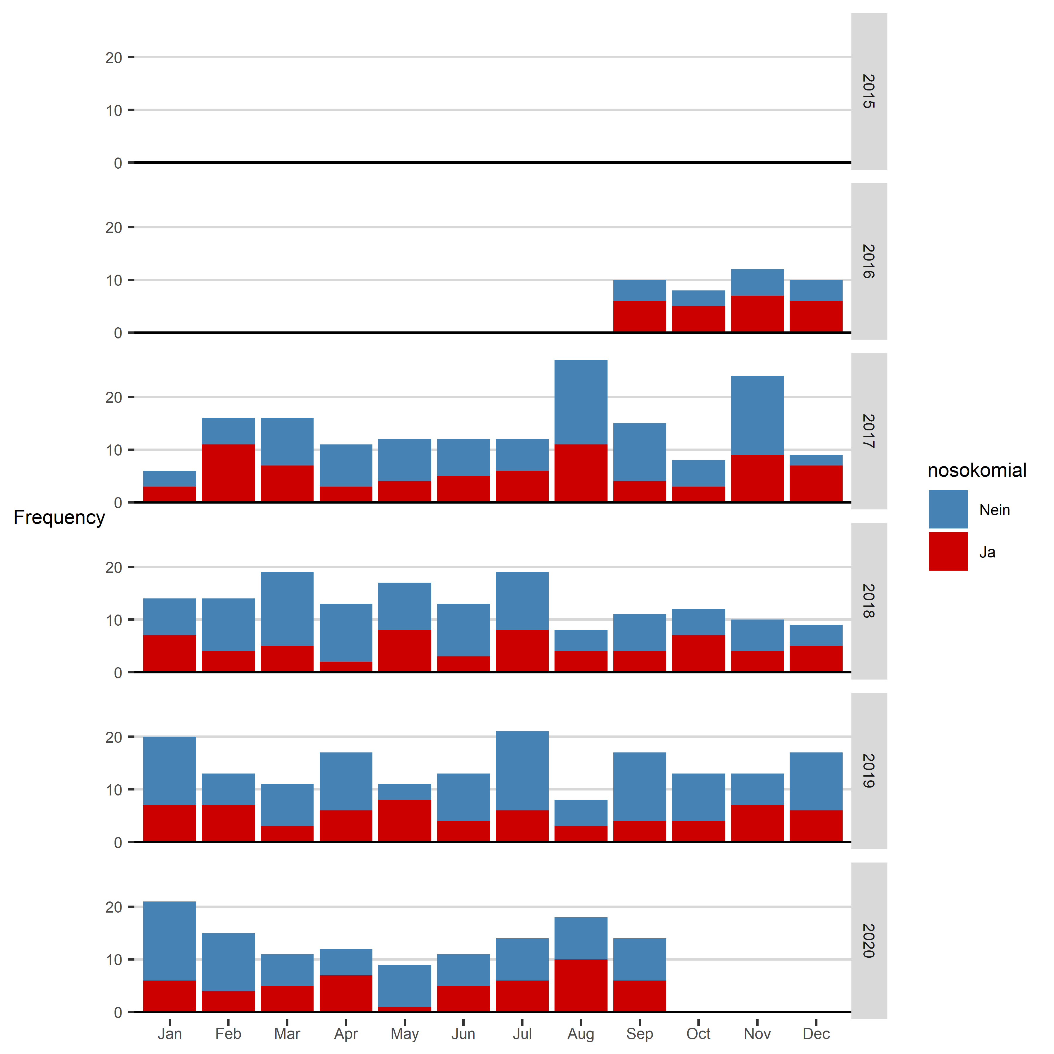

### new page

## Clostridium difficle Genotyp 027

