Monatsreporting MRE - Inselgruppe

Spitalhygiene

Letztes update: **02. January 2021**

# Übersicht

## Übersicht allgmein

| **Variable** | **Kategorie** | **Overall** |
| --- | --- | --- |
| N |  | 2984 |
| Year (IQR) | 2018 (2017 - 2019) |
| Erregergruppe (%) | Carbapenemasebildner | 85 (2.8) |
| Clostridium difficile | 701 (23.5) |
| Clostridium difficile 027 | 33 (1.1) |
| ESBL-Bildner | 415 (13.9) |
| MRSA | 600 (20.1) |
| Multiresistente Gram negative Keime | 479 (16.1) |
| Panresistente Gram negative Keime | 22 (0.7) |
| VRE | 649 (21.7) |
| Nosokomial (%) | Ja | 1285 (43.1) |
| Nein | 1650 (55.3) |
| Missing | 49 (1.6) |

## Übersicht (stratifiziert nach Jahren)

| **Variable** | **Kategorie** | **2017** | **2018** | **2019** | **2020** |
| --- | --- | --- | --- | --- | --- |
| N |  | 500 | 807 | 690 | 438 |
| Erregergruppe (%) | Carbapenemasebildner | 23 ( 4.6) | 15 ( 1.9) | 7 ( 1.0) | 16 ( 3.7) |
| Clostridium difficile | 172 (34.4) | 162 (20.1) | 175 (25.4) | 152 (34.7) |
| Clostridium difficile 027 | 21 ( 4.2) | 7 ( 0.9) | 0 ( 0.0) | 1 ( 0.2) |
| ESBL-Bildner | 72 (14.4) | 64 ( 7.9) | 93 (13.5) | 63 (14.4) |
| MRSA | 123 (24.6) | 106 (13.1) | 92 (13.3) | 78 (17.8) |
| Multiresistente Gram negative Keime | 82 (16.4) | 81 (10.0) | 75 (10.9) | 91 (20.8) |
| Panresistente Gram negative Keime | 4 ( 0.8) | 4 ( 0.5) | 6 ( 0.9) | 3 ( 0.7) |
| VRE | 3 ( 0.6) | 368 (45.6) | 242 (35.1) | 34 ( 7.8) |
| Nosokomial (%) | Ja | 166 (33.2) | 476 (59.0) | 333 (48.3) | 159 (36.3) |
| Nein | 325 (65.0) | 327 (40.5) | 356 (51.6) | 274 (62.6) |
| Missing | 9 ( 1.8) | 4 ( 0.5) | 1 ( 0.1) | 5 ( 1.1) |

# ESBL-Bildner (ohne E. coli)

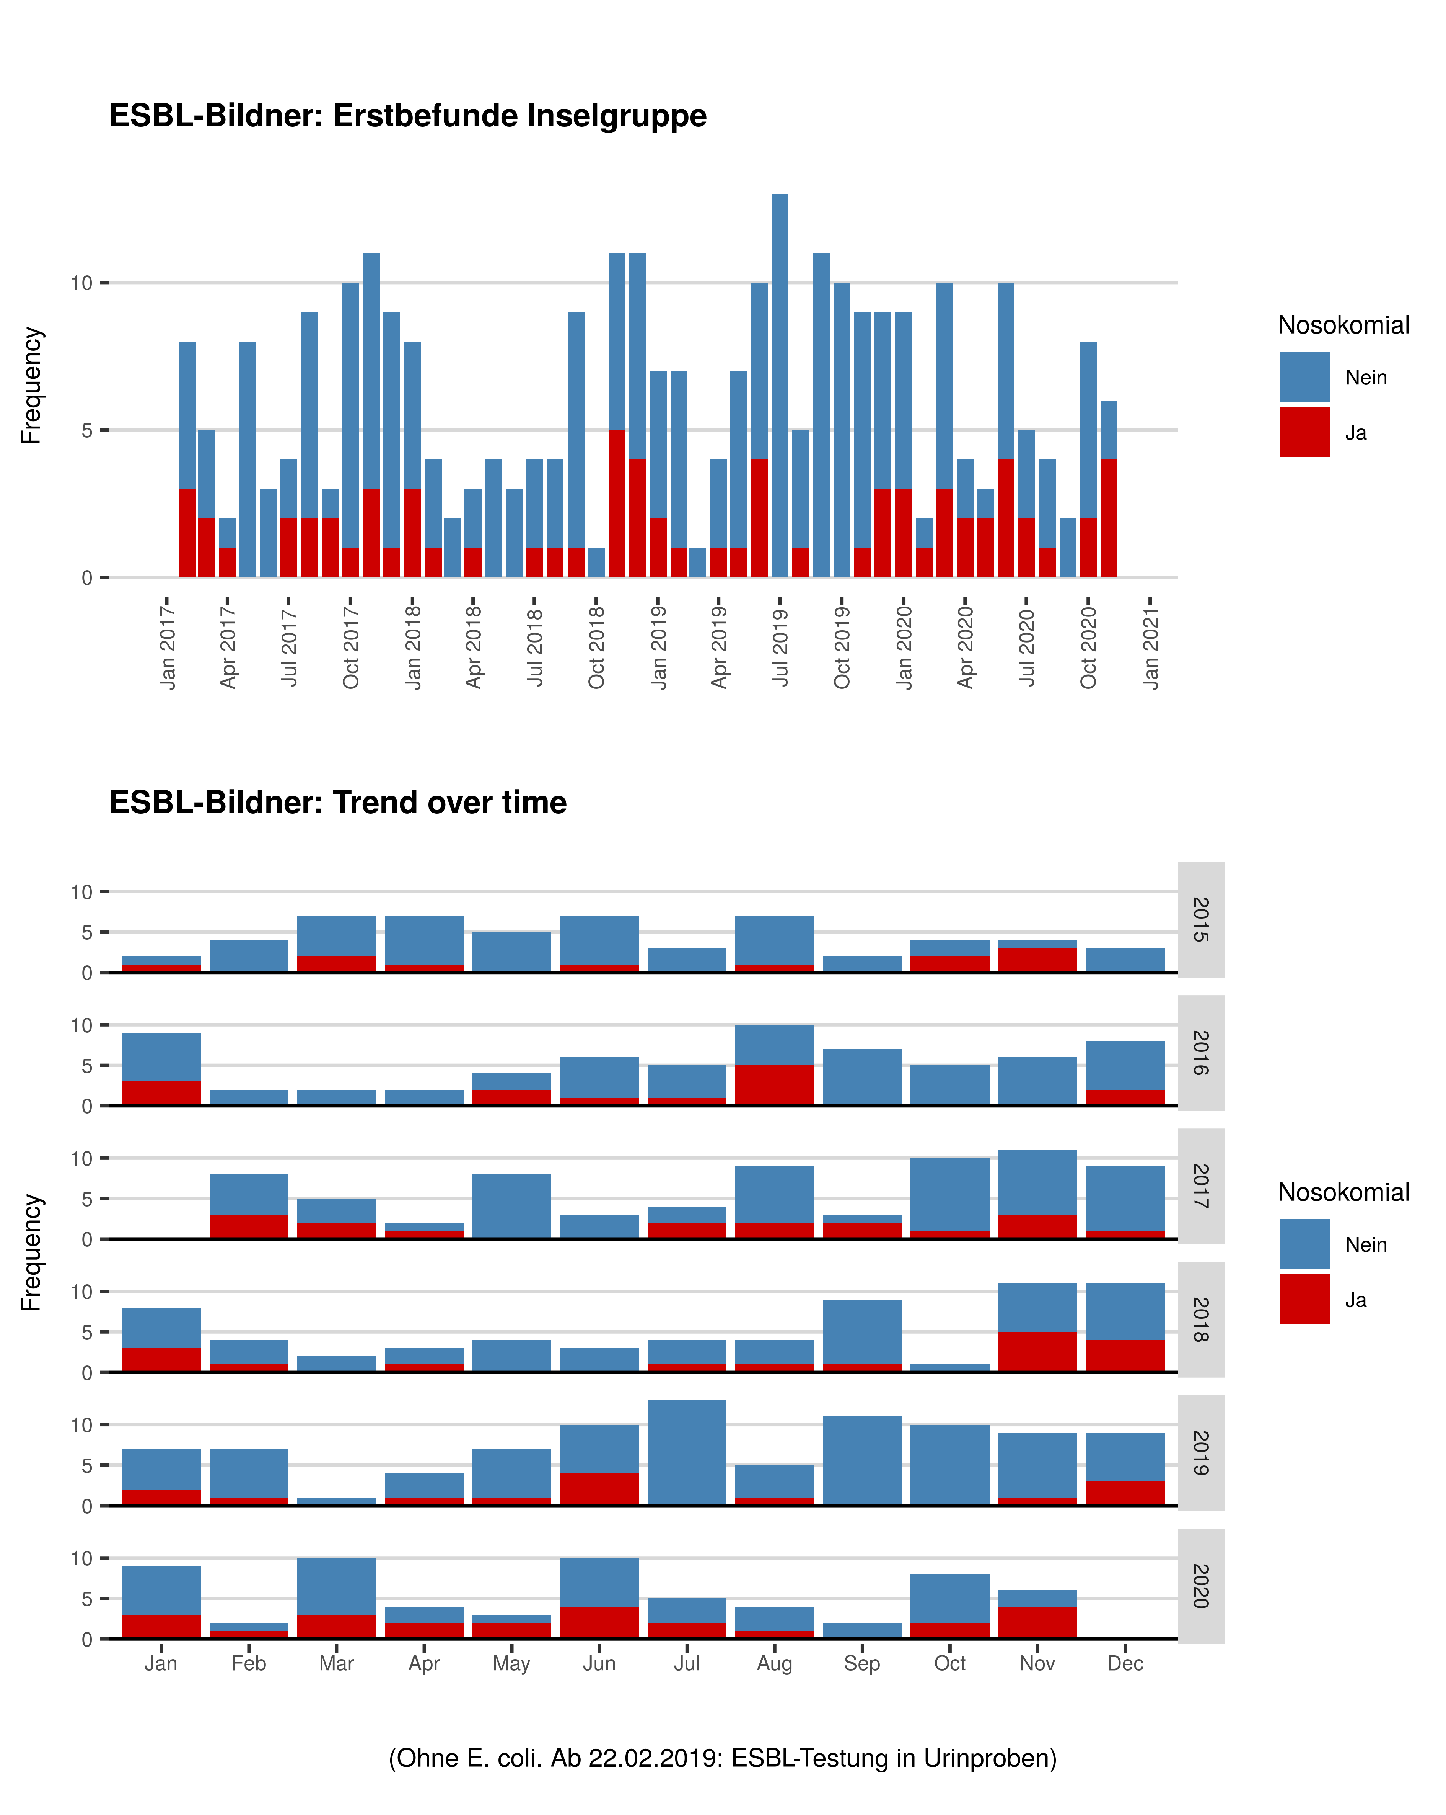

## Tabelle: ESBL-Bildner (ohne E. coli)

| **Jahr** | **Monat** | **Gruppe** | **Nicht-nosokomial** | **Nosokomial** |
| --- | --- | --- | --- | --- |
| 2018 | Jan | ESBL-Bildner | 5 | 3 |
| 2018 | Feb | ESBL-Bildner | 3 | 1 |
| 2018 | Mar | ESBL-Bildner | 2 | 0 |
| 2018 | Apr | ESBL-Bildner | 2 | 1 |
| 2018 | May | ESBL-Bildner | 4 | 0 |
| 2018 | Jun | ESBL-Bildner | 3 | 0 |
| 2018 | Jul | ESBL-Bildner | 3 | 1 |
| 2018 | Aug | ESBL-Bildner | 3 | 1 |
| 2018 | Sep | ESBL-Bildner | 8 | 1 |
| 2018 | Oct | ESBL-Bildner | 1 | 0 |
| 2018 | Nov | ESBL-Bildner | 6 | 5 |
| 2018 | Dec | ESBL-Bildner | 7 | 4 |
| 2019 | Jan | ESBL-Bildner | 5 | 2 |
| 2019 | Feb | ESBL-Bildner | 6 | 1 |
| 2019 | Mar | ESBL-Bildner | 1 | 0 |
| 2019 | Apr | ESBL-Bildner | 3 | 1 |
| 2019 | May | ESBL-Bildner | 6 | 1 |
| 2019 | Jun | ESBL-Bildner | 6 | 4 |
| 2019 | Jul | ESBL-Bildner | 13 | 0 |
| 2019 | Aug | ESBL-Bildner | 4 | 1 |
| 2019 | Sep | ESBL-Bildner | 11 | 0 |
| 2019 | Oct | ESBL-Bildner | 10 | 0 |
| 2019 | Nov | ESBL-Bildner | 8 | 1 |
| 2019 | Dec | ESBL-Bildner | 6 | 3 |
| 2020 | Jan | ESBL-Bildner | 6 | 3 |
| 2020 | Feb | ESBL-Bildner | 1 | 1 |
| 2020 | Mar | ESBL-Bildner | 7 | 3 |
| 2020 | Apr | ESBL-Bildner | 2 | 2 |
| 2020 | May | ESBL-Bildner | 1 | 2 |
| 2020 | Jun | ESBL-Bildner | 6 | 4 |
| 2020 | Jul | ESBL-Bildner | 3 | 2 |
| 2020 | Aug | ESBL-Bildner | 3 | 1 |
| 2020 | Sep | ESBL-Bildner | 2 | 0 |
| 2020 | Oct | ESBL-Bildner | 6 | 2 |
| 2020 | Nov | ESBL-Bildner | 2 | 4 |

# MRSA

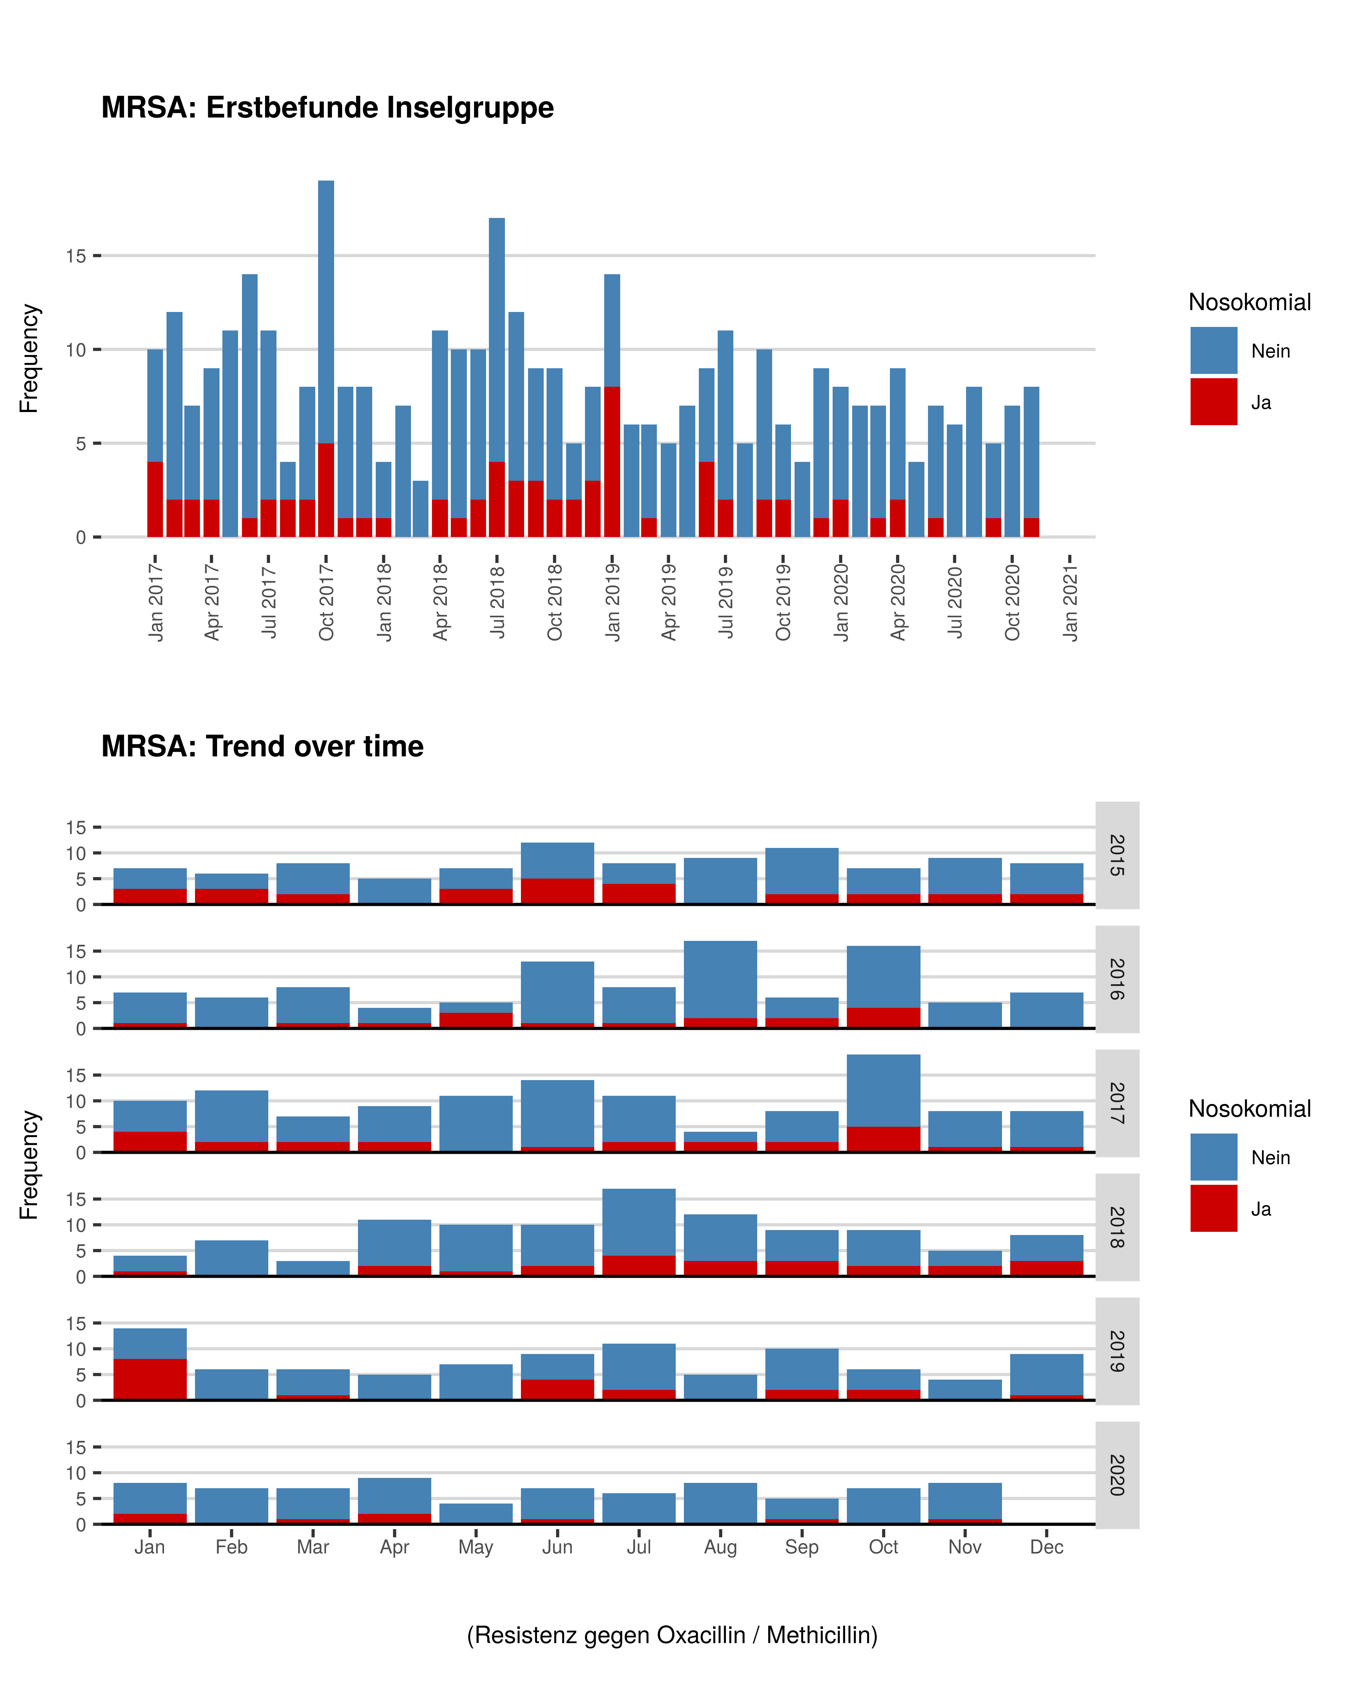

## Tabelle: MRSA

| **Jahr** | **Monat** | **Gruppe** | **Nicht-nosokomial** | **Nosokomial** |
| --- | --- | --- | --- | --- |
| 2018 | Jan | MRSA | 3 | 1 |
| 2018 | Feb | MRSA | 7 | 0 |
| 2018 | Mar | MRSA | 3 | 0 |
| 2018 | Apr | MRSA | 9 | 2 |
| 2018 | May | MRSA | 9 | 1 |
| 2018 | Jun | MRSA | 8 | 2 |
| 2018 | Jul | MRSA | 13 | 4 |
| 2018 | Aug | MRSA | 9 | 3 |
| 2018 | Sep | MRSA | 6 | 3 |
| 2018 | Oct | MRSA | 7 | 2 |
| 2018 | Nov | MRSA | 3 | 2 |
| 2018 | Dec | MRSA | 5 | 3 |
| 2019 | Jan | MRSA | 6 | 8 |
| 2019 | Feb | MRSA | 6 | 0 |
| 2019 | Mar | MRSA | 5 | 1 |
| 2019 | Apr | MRSA | 5 | 0 |
| 2019 | May | MRSA | 7 | 0 |
| 2019 | Jun | MRSA | 5 | 4 |
| 2019 | Jul | MRSA | 9 | 2 |
| 2019 | Aug | MRSA | 5 | 0 |
| 2019 | Sep | MRSA | 8 | 2 |
| 2019 | Oct | MRSA | 4 | 2 |
| 2019 | Nov | MRSA | 4 | 0 |
| 2019 | Dec | MRSA | 8 | 1 |
| 2020 | Jan | MRSA | 6 | 2 |
| 2020 | Feb | MRSA | 7 | 0 |
| 2020 | Mar | MRSA | 6 | 1 |
| 2020 | Apr | MRSA | 7 | 2 |
| 2020 | May | MRSA | 4 | 0 |
| 2020 | Jun | MRSA | 6 | 1 |
| 2020 | Jul | MRSA | 6 | 0 |
| 2020 | Aug | MRSA | 8 | 0 |
| 2020 | Sep | MRSA | 4 | 1 |
| 2020 | Oct | MRSA | 7 | 0 |
| 2020 | Nov | MRSA | 7 | 1 |

# Panresistente Gram-negative Keime

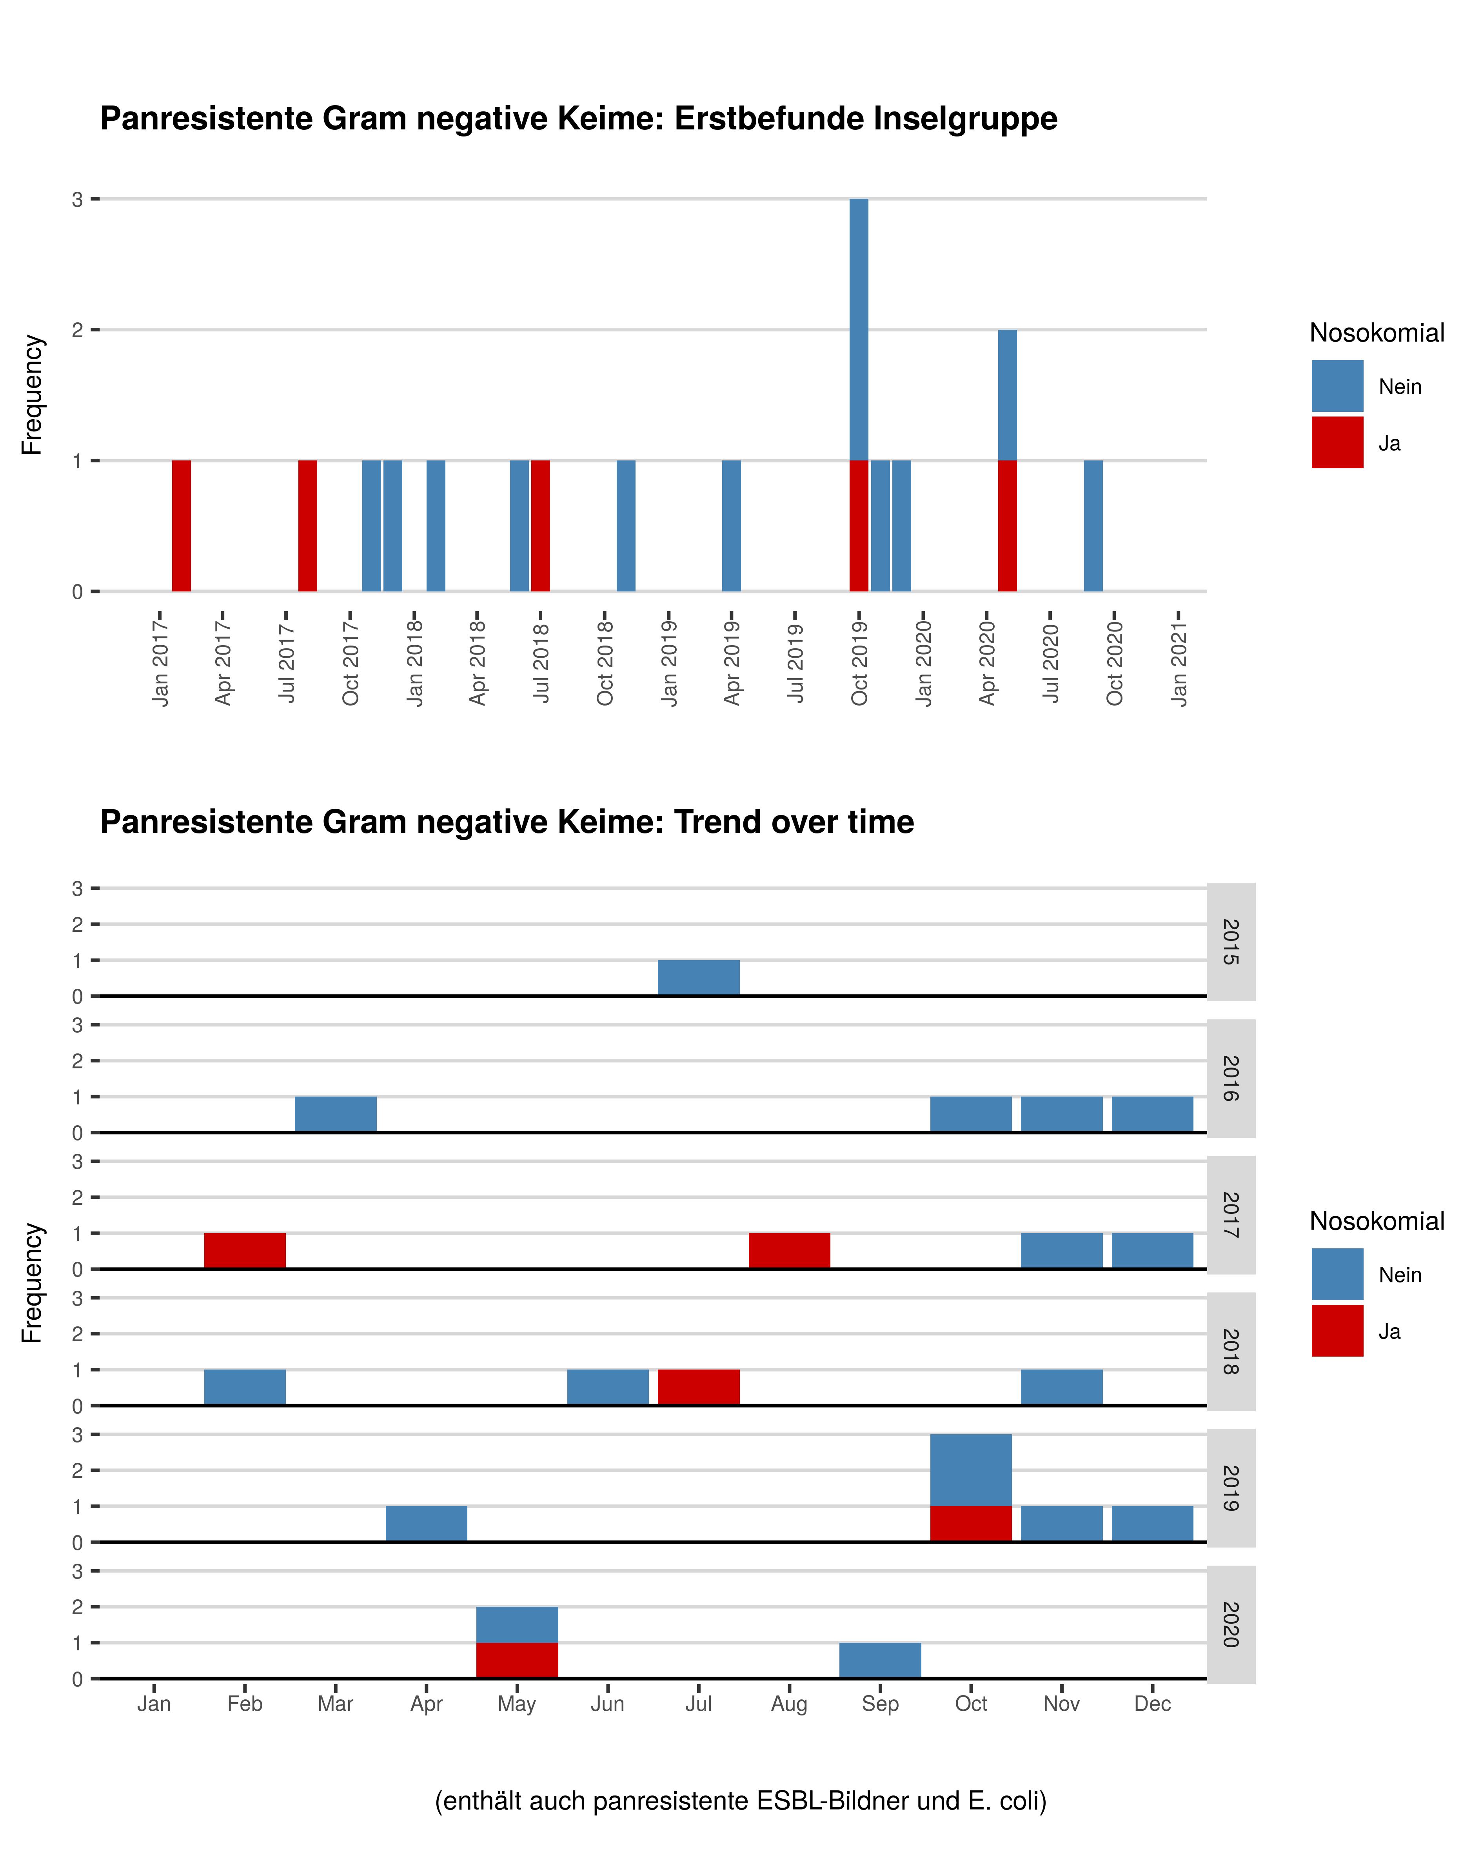

## Tabelle: Panresistente Gram-negative Keime

| **Jahr** | **Monat** | **Gruppe** | **Nicht-nosokomial** | **Nosokomial** |
| --- | --- | --- | --- | --- |
| 2018 | Feb | Panresistente Gram negative Keime | 1 | 0 |
| 2018 | Jun | Panresistente Gram negative Keime | 1 | 0 |
| 2018 | Jul | Panresistente Gram negative Keime | 0 | 1 |
| 2018 | Nov | Panresistente Gram negative Keime | 1 | 0 |
| 2019 | Apr | Panresistente Gram negative Keime | 1 | 0 |
| 2019 | Oct | Panresistente Gram negative Keime | 2 | 1 |
| 2019 | Nov | Panresistente Gram negative Keime | 1 | 0 |
| 2019 | Dec | Panresistente Gram negative Keime | 1 | 0 |
| 2020 | May | Panresistente Gram negative Keime | 1 | 1 |
| 2020 | Sep | Panresistente Gram negative Keime | 1 | 0 |

# Multiresistente Gram negative Keime

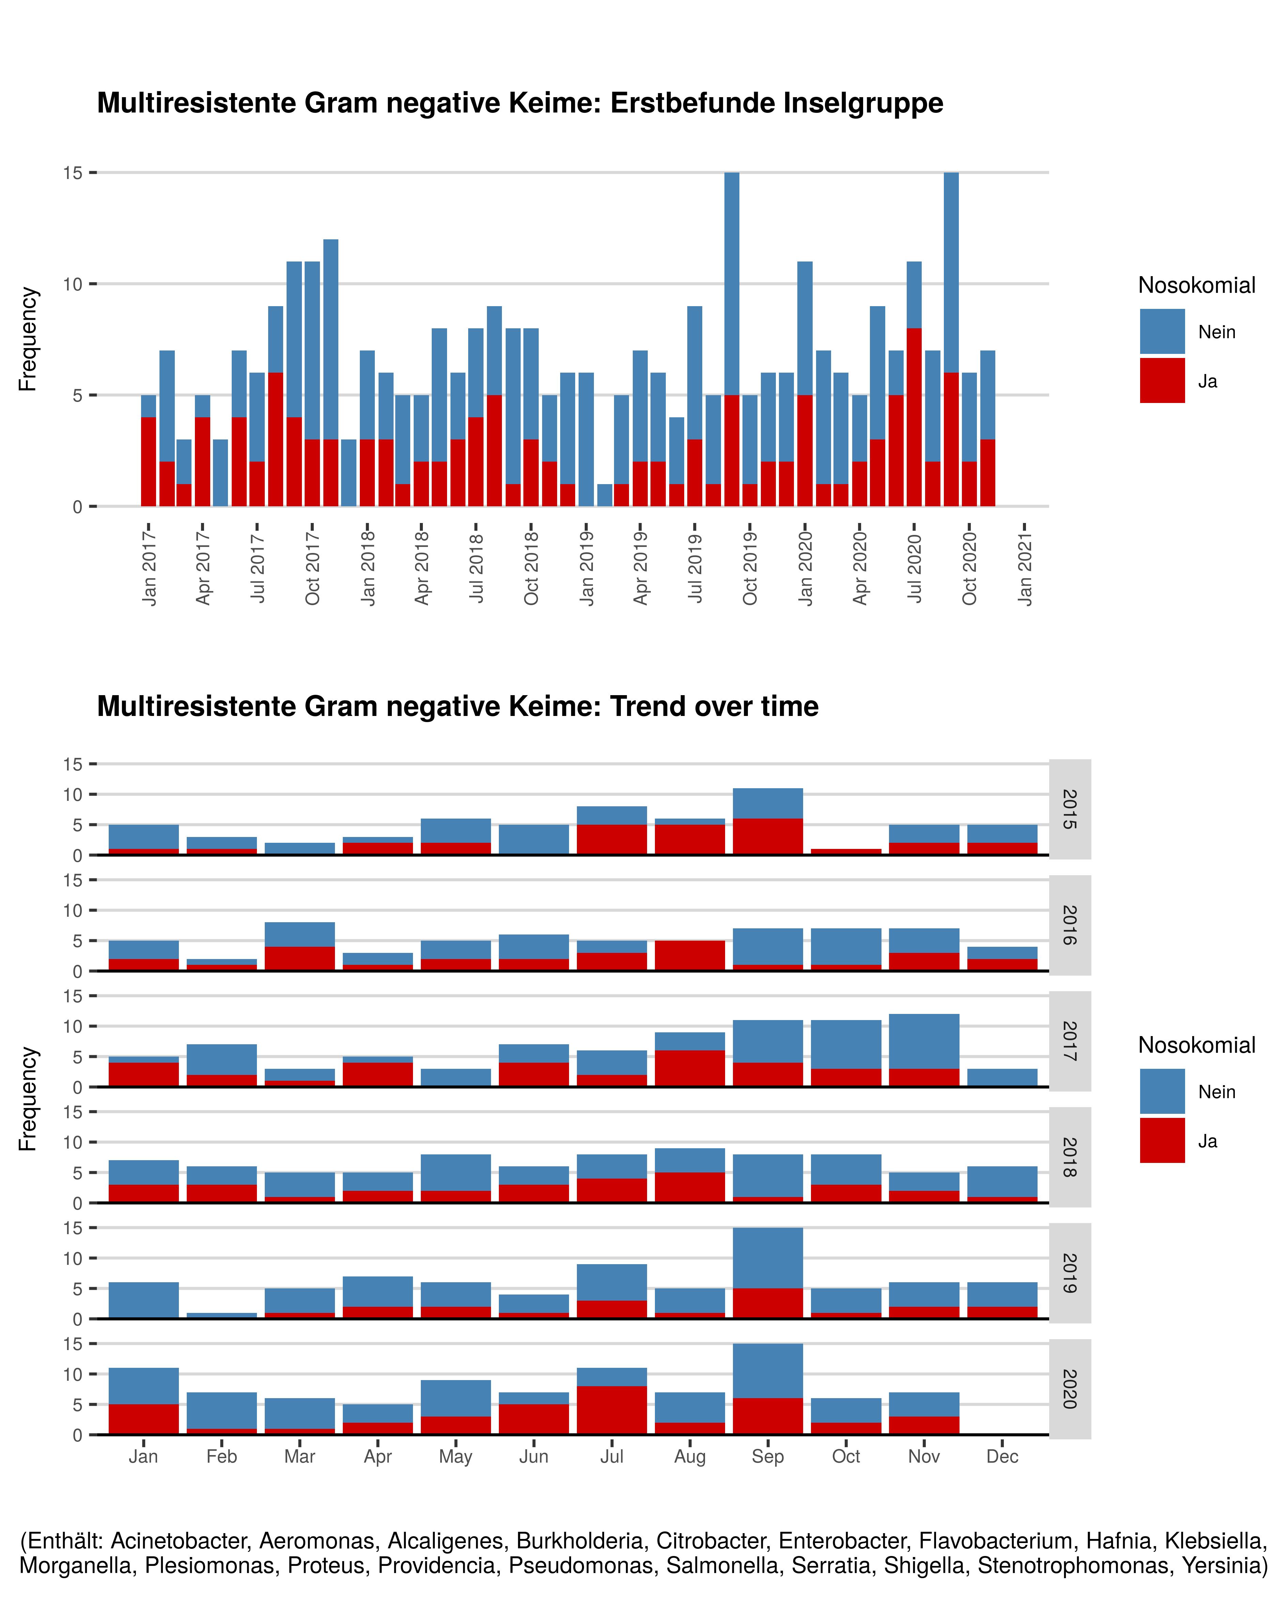

## Tabelle: Multiresistente Gram negative Keime

| **Jahr** | **Monat** | **Gruppe** | **Nicht-nosokomial** | **Nosokomial** |
| --- | --- | --- | --- | --- |
| 2018 | Jan | Multiresistente Gram negative Keime | 4 | 3 |
| 2018 | Feb | Multiresistente Gram negative Keime | 3 | 3 |
| 2018 | Mar | Multiresistente Gram negative Keime | 4 | 1 |
| 2018 | Apr | Multiresistente Gram negative Keime | 3 | 2 |
| 2018 | May | Multiresistente Gram negative Keime | 6 | 2 |
| 2018 | Jun | Multiresistente Gram negative Keime | 3 | 3 |
| 2018 | Jul | Multiresistente Gram negative Keime | 4 | 4 |
| 2018 | Aug | Multiresistente Gram negative Keime | 4 | 5 |
| 2018 | Sep | Multiresistente Gram negative Keime | 7 | 1 |
| 2018 | Oct | Multiresistente Gram negative Keime | 5 | 3 |
| 2018 | Nov | Multiresistente Gram negative Keime | 3 | 2 |
| 2018 | Dec | Multiresistente Gram negative Keime | 5 | 1 |
| 2019 | Jan | Multiresistente Gram negative Keime | 6 | 0 |
| 2019 | Feb | Multiresistente Gram negative Keime | 1 | 0 |
| 2019 | Mar | Multiresistente Gram negative Keime | 4 | 1 |
| 2019 | Apr | Multiresistente Gram negative Keime | 5 | 2 |
| 2019 | May | Multiresistente Gram negative Keime | 4 | 2 |
| 2019 | Jun | Multiresistente Gram negative Keime | 3 | 1 |
| 2019 | Jul | Multiresistente Gram negative Keime | 6 | 3 |
| 2019 | Aug | Multiresistente Gram negative Keime | 4 | 1 |
| 2019 | Sep | Multiresistente Gram negative Keime | 10 | 5 |
| 2019 | Oct | Multiresistente Gram negative Keime | 4 | 1 |
| 2019 | Nov | Multiresistente Gram negative Keime | 4 | 2 |
| 2019 | Dec | Multiresistente Gram negative Keime | 4 | 2 |
| 2020 | Jan | Multiresistente Gram negative Keime | 6 | 5 |
| 2020 | Feb | Multiresistente Gram negative Keime | 6 | 1 |
| 2020 | Mar | Multiresistente Gram negative Keime | 5 | 1 |
| 2020 | Apr | Multiresistente Gram negative Keime | 3 | 2 |
| 2020 | May | Multiresistente Gram negative Keime | 6 | 3 |
| 2020 | Jun | Multiresistente Gram negative Keime | 2 | 5 |
| 2020 | Jul | Multiresistente Gram negative Keime | 3 | 8 |
| 2020 | Aug | Multiresistente Gram negative Keime | 5 | 2 |
| 2020 | Sep | Multiresistente Gram negative Keime | 9 | 6 |
| 2020 | Oct | Multiresistente Gram negative Keime | 4 | 2 |
| 2020 | Nov | Multiresistente Gram negative Keime | 4 | 3 |

# Vancomycin resistente Enterkokokken (VRE)

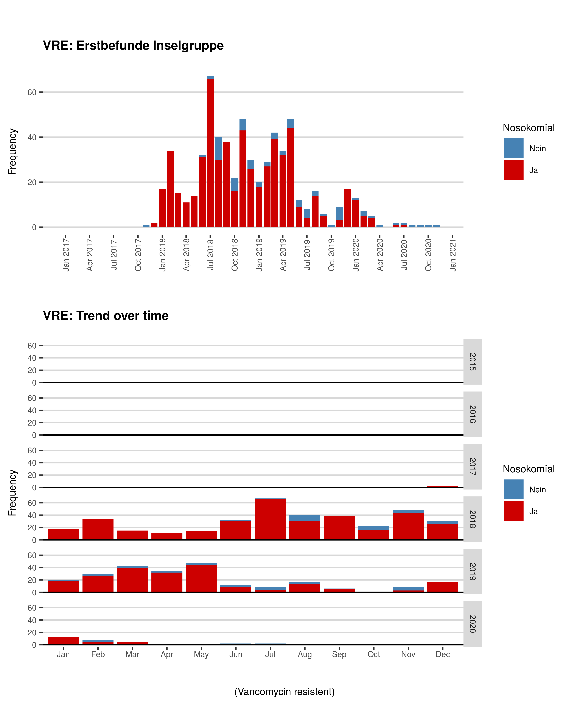

## Tabelle: VRE

| **Jahr** | **Monat** | **Gruppe** | **Nicht-nosokomial** | **Nosokomial** |
| --- | --- | --- | --- | --- |
| 2018 | Jan | VRE | 0 | 17 |
| 2018 | Feb | VRE | 0 | 34 |
| 2018 | Mar | VRE | 0 | 15 |
| 2018 | Apr | VRE | 0 | 11 |
| 2018 | May | VRE | 0 | 14 |
| 2018 | Jun | VRE | 1 | 31 |
| 2018 | Jul | VRE | 1 | 66 |
| 2018 | Aug | VRE | 10 | 30 |
| 2018 | Sep | VRE | 0 | 38 |
| 2018 | Oct | VRE | 6 | 16 |
| 2018 | Nov | VRE | 5 | 43 |
| 2018 | Dec | VRE | 4 | 26 |
| 2019 | Jan | VRE | 2 | 18 |
| 2019 | Feb | VRE | 2 | 27 |
| 2019 | Mar | VRE | 3 | 39 |
| 2019 | Apr | VRE | 2 | 32 |
| 2019 | May | VRE | 4 | 44 |
| 2019 | Jun | VRE | 3 | 9 |
| 2019 | Jul | VRE | 4 | 4 |
| 2019 | Aug | VRE | 2 | 14 |
| 2019 | Sep | VRE | 1 | 5 |
| 2019 | Oct | VRE | 1 | 0 |
| 2019 | Nov | VRE | 6 | 3 |
| 2019 | Dec | VRE | 0 | 17 |
| 2020 | Jan | VRE | 1 | 12 |
| 2020 | Feb | VRE | 2 | 5 |
| 2020 | Mar | VRE | 1 | 4 |
| 2020 | Apr | VRE | 1 | 0 |
| 2020 | Jun | VRE | 1 | 1 |
| 2020 | Jul | VRE | 1 | 1 |
| 2020 | Aug | VRE | 1 | 0 |
| 2020 | Sep | VRE | 1 | 0 |
| 2020 | Oct | VRE | 1 | 0 |
| 2020 | Nov | VRE | 1 | 0 |

# Carbapenemasebildner

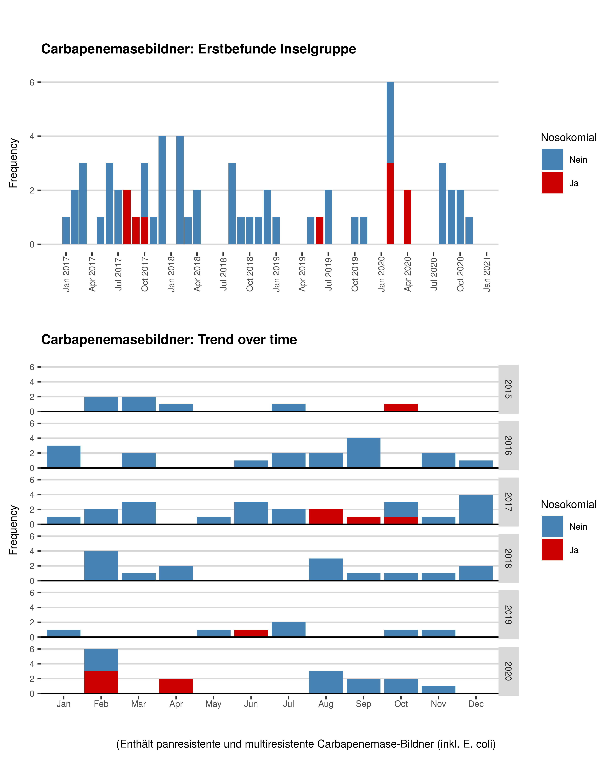

## Tabelle: Carbapenemasebildner

| **Jahr** | **Monat** | **Gruppe** | **Nicht-nosokomial** | **Nosokomial** |
| --- | --- | --- | --- | --- |
| 2018 | Feb | Carbapenemasebildner | 4 | 0 |
| 2018 | Mar | Carbapenemasebildner | 1 | 0 |
| 2018 | Apr | Carbapenemasebildner | 2 | 0 |
| 2018 | Aug | Carbapenemasebildner | 3 | 0 |
| 2018 | Sep | Carbapenemasebildner | 1 | 0 |
| 2018 | Oct | Carbapenemasebildner | 1 | 0 |
| 2018 | Nov | Carbapenemasebildner | 1 | 0 |
| 2018 | Dec | Carbapenemasebildner | 2 | 0 |
| 2019 | Jan | Carbapenemasebildner | 1 | 0 |
| 2019 | May | Carbapenemasebildner | 1 | 0 |
| 2019 | Jun | Carbapenemasebildner | 0 | 1 |
| 2019 | Jul | Carbapenemasebildner | 2 | 0 |
| 2019 | Oct | Carbapenemasebildner | 1 | 0 |
| 2019 | Nov | Carbapenemasebildner | 1 | 0 |
| 2020 | Feb | Carbapenemasebildner | 3 | 3 |
| 2020 | Apr | Carbapenemasebildner | 0 | 2 |
| 2020 | Aug | Carbapenemasebildner | 3 | 0 |
| 2020 | Sep | Carbapenemasebildner | 2 | 0 |
| 2020 | Oct | Carbapenemasebildner | 2 | 0 |
| 2020 | Nov | Carbapenemasebildner | 1 | 0 |

# Clostridium difficle (ohne GT 027)

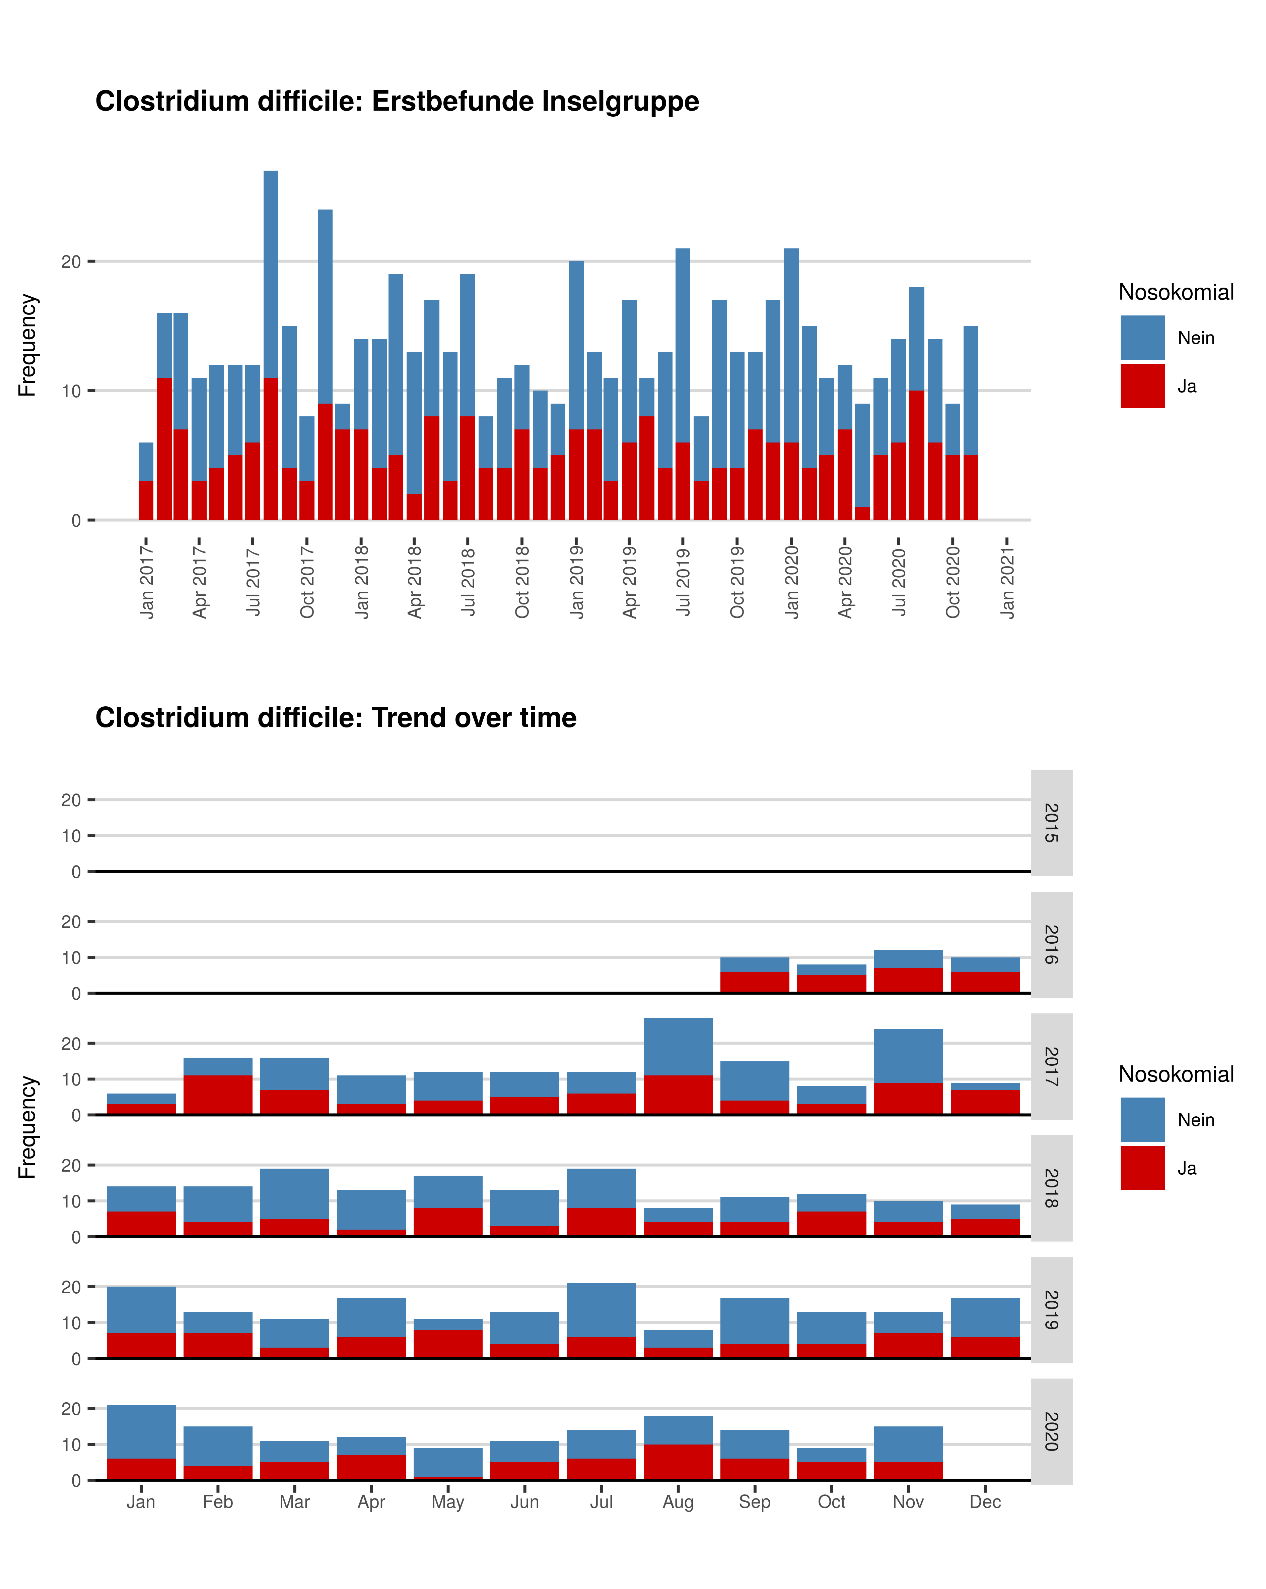

## Tabelle: Clostridium difficle (ohne GT 027)

| **Jahr** | **Monat** | **Gruppe** | **Nicht-nosokomial** | **Nosokomial** |
| --- | --- | --- | --- | --- |
| 2018 | Jan | Clostridium difficile | 7 | 7 |
| 2018 | Feb | Clostridium difficile | 10 | 4 |
| 2018 | Mar | Clostridium difficile | 14 | 5 |
| 2018 | Apr | Clostridium difficile | 11 | 2 |
| 2018 | May | Clostridium difficile | 9 | 8 |
| 2018 | Jun | Clostridium difficile | 10 | 3 |
| 2018 | Jul | Clostridium difficile | 11 | 8 |
| 2018 | Aug | Clostridium difficile | 4 | 4 |
| 2018 | Sep | Clostridium difficile | 7 | 4 |
| 2018 | Oct | Clostridium difficile | 5 | 7 |
| 2018 | Nov | Clostridium difficile | 6 | 4 |
| 2018 | Dec | Clostridium difficile | 4 | 5 |
| 2019 | Jan | Clostridium difficile | 13 | 7 |
| 2019 | Feb | Clostridium difficile | 6 | 7 |
| 2019 | Mar | Clostridium difficile | 8 | 3 |
| 2019 | Apr | Clostridium difficile | 11 | 6 |
| 2019 | May | Clostridium difficile | 3 | 8 |
| 2019 | Jun | Clostridium difficile | 9 | 4 |
| 2019 | Jul | Clostridium difficile | 15 | 6 |
| 2019 | Aug | Clostridium difficile | 5 | 3 |
| 2019 | Sep | Clostridium difficile | 13 | 4 |
| 2019 | Oct | Clostridium difficile | 9 | 4 |
| 2019 | Nov | Clostridium difficile | 6 | 7 |
| 2019 | Dec | Clostridium difficile | 11 | 6 |
| 2020 | Jan | Clostridium difficile | 15 | 6 |
| 2020 | Feb | Clostridium difficile | 11 | 4 |
| 2020 | Mar | Clostridium difficile | 6 | 5 |
| 2020 | Apr | Clostridium difficile | 5 | 7 |
| 2020 | May | Clostridium difficile | 8 | 1 |
| 2020 | Jun | Clostridium difficile | 6 | 5 |
| 2020 | Jul | Clostridium difficile | 8 | 6 |
| 2020 | Aug | Clostridium difficile | 8 | 10 |
| 2020 | Sep | Clostridium difficile | 8 | 6 |
| 2020 | Oct | Clostridium difficile | 4 | 5 |
| 2020 | Nov | Clostridium difficile | 10 | 5 |

# Clostridium difficle Genotyp 027

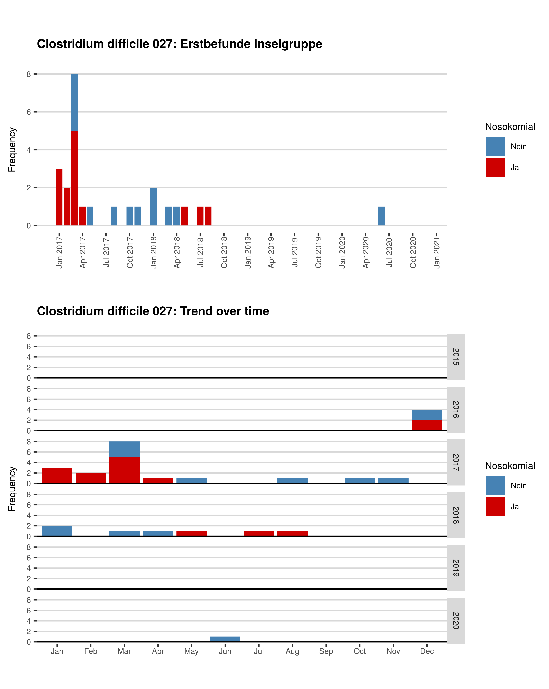

## Tabelle: Clostridium difficle Genotyp 027

| **Jahr** | **Monat** | **Gruppe** | **Nicht-nosokomial** | **Nosokomial** |
| --- | --- | --- | --- | --- |
| 2018 | Jan | Clostridium difficile 027 | 2 | 0 |
| 2018 | Mar | Clostridium difficile 027 | 1 | 0 |
| 2018 | Apr | Clostridium difficile 027 | 1 | 0 |
| 2018 | May | Clostridium difficile 027 | 0 | 1 |
| 2018 | Jul | Clostridium difficile 027 | 0 | 1 |
| 2018 | Aug | Clostridium difficile 027 | 0 | 1 |
| 2020 | Jun | Clostridium difficile 027 | 1 | 0 |