Real Hack

Hierarchical UI of Land Plots

* Helping users find plots faster and easier
* Get complete information regarding the plot
* Plot the land with help of GPS in mobile

TEAM - TANDEM

* Aslam Abbas
* Sebastian Thomas
* Shyjal Raazi
* Ibrahim M T

# Aim

* *To make selling and buying of Land online appealing to the users*
* *Use of Hierarchical UI to help users find plots easier*
* *Use of Android app to plot a location using GPS and capture images*

## How to use?

*Finding the plot*

* *Select the TYPE of plot - it can be just for investing or for immediate use (USE/INVEST)*
* *Choose the subcategory inside USE – (HOUSE/INDUSTRY/AGRI)*
* *Then hierarchically choose a plot of your choice.*

*Plot information*

* *The plot information page will show you*
  1. *Plot address*
  2. *Contact details*
  3. *Graphical information about the water level, how secure the area is and whether the area is a disaster prone area or not*
  4. *Price information*
  5. *Amenities available nearby*

*How to mark a plot*

* *By using the Android app, the seller can accurately mark the boundaries of a plot and then add photos of the plot*
* *The other information regarding the plot can be added by seller on the web app.*

# ScreenShots

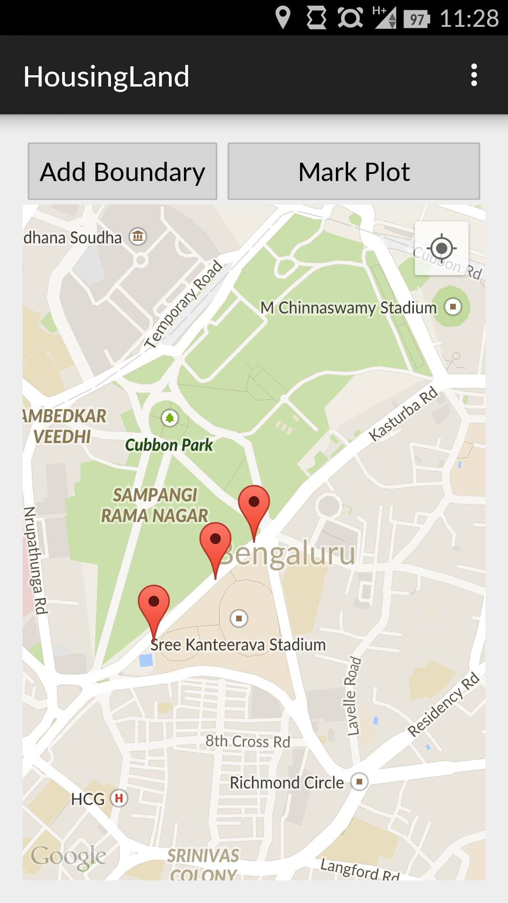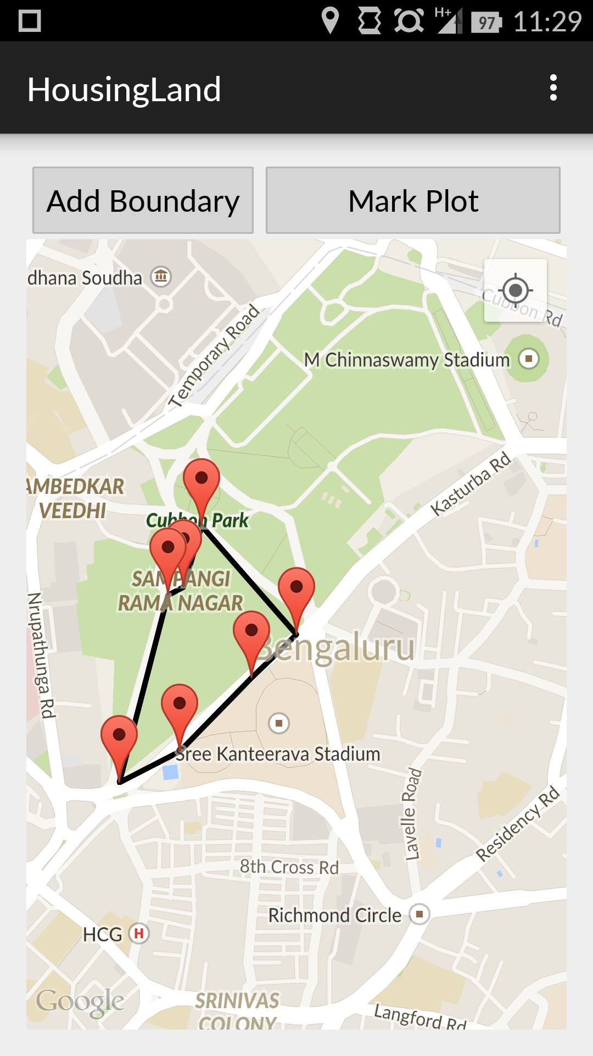

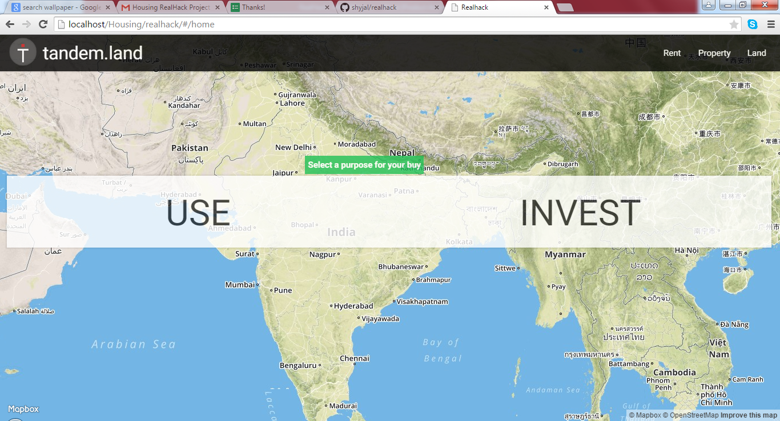

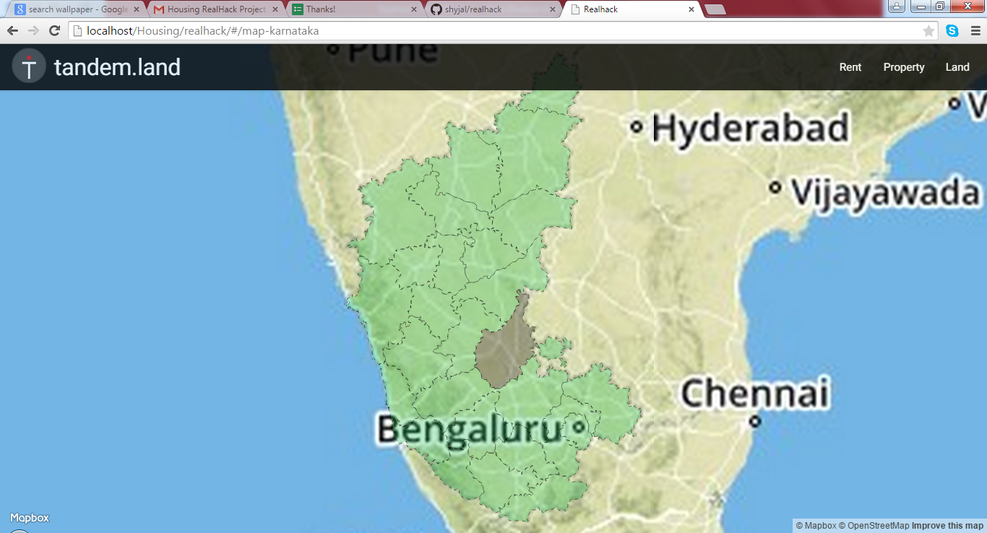

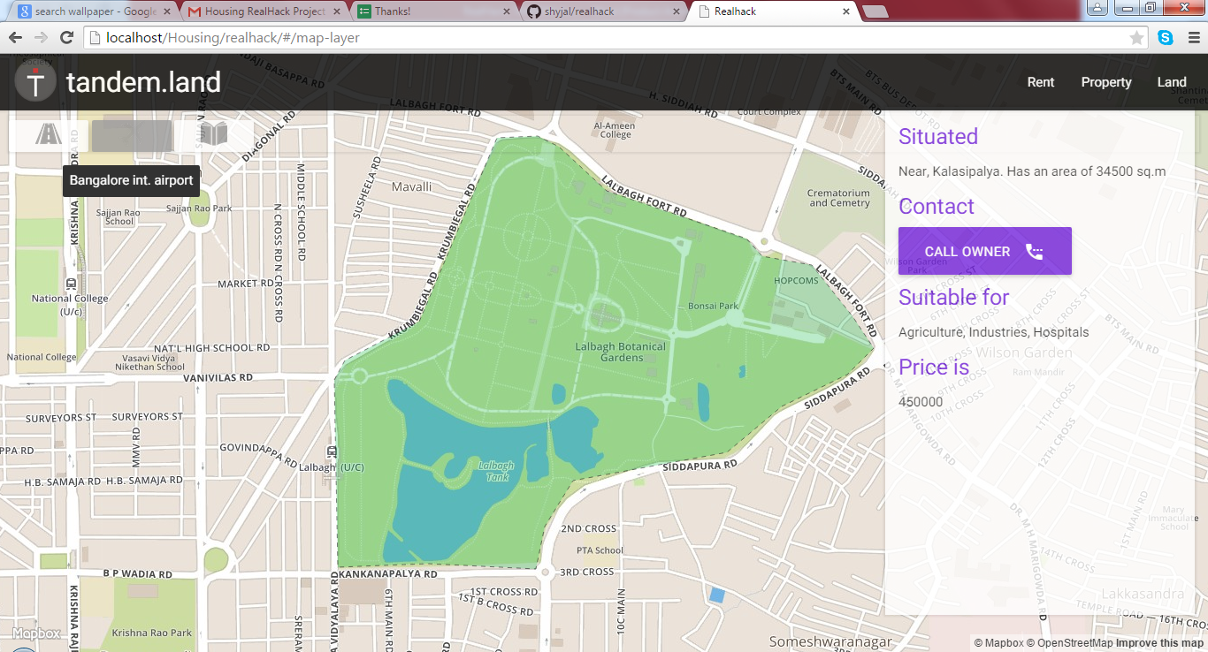

# Links

Android App

<https://github.com/sebastian-thomas/Mark-Geolocation>

Web App

https://github.com/shyjal/realhack

Hosted Web App

<http://shyjal.github.io/realhack/#/home>