**TASK-3: INTEGRATING BACKEND WITH THE KEY-VAULT USING THE CONCEPT OF SERVICE PRINCIPLE (Client Credentials Flow)**

**Goal**:

* Learn to use **Keyvault**
* Use App Registrations and Permissions.

**1.** Create a **New Folder** and **Clone** the latest Code from

<https://siddharthdwivedi318@dev.azure.com/siddharthdwivedi318/Experiential%20Learning/_git/Quick-Cart-Backend>

**2.** Make changes in **CustomerRepository.cs** of DAL

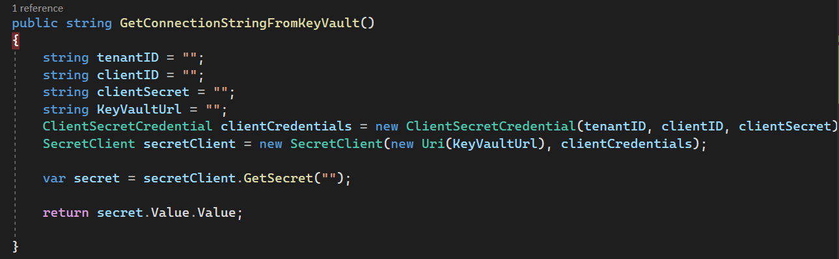

**3.** Create **KeyVault**, Add the Conncetion String as a Secret and Integrate using Service Principle Concept.