**TASK-4: INTEGRATING BACKEND WITH THE STORAGE ACCOUNT**

**Goal**:

* Learn to use Azure Storage Account from the Backend.
* Learn to use Blob-Life Cycle feature to set up access tier rules.
* Learn to connect the Storage Account with a Logic App.

**1.** Create a **New Folder** and **Clone** the latest Code from

**Front-End:**

<https://siddharthdwivedi318@dev.azure.com/siddharthdwivedi318/Experiential%20Learning/_git/Quick-Cart-FrontEnd>

**Backend**:

<https://siddharthdwivedi318@dev.azure.com/siddharthdwivedi318/Experiential%20Learning/_git/Quick-Cart-Backend>

**2.** Write the Upload functionality code in **AdminController.cs**.

**Note:** Make use of Access Connection String/ SAS Connection String to establish the connection.

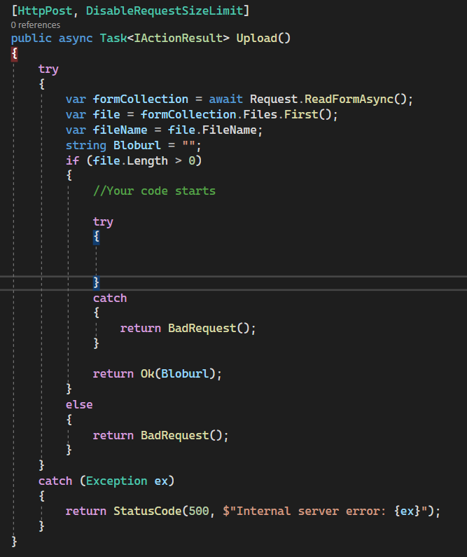

**3.** Test it locally first, whether the upload is working or not.

**4.** If the feature is working then deploy it to respective Azure resources.

**5.** Make sure to set up a Blob Lifecycle rule for that **respective container** only in which your blob is being uploaded.

**The rule should be**

* Upon the upload the Blob should be in Hot Tier.
* From Hot, Move the blob to Cool tier after 2 days,
* From cool, Move it to Archive after 200 days.
* From Archive, Delete the Blob after 600 days.

**6.** After setting up the **Lifecycle**!

Trigger an Outlook Email to the QuickCart Vendor Management Team to review the Product for Compliance purpose using the Concept of Logic App.

---------------------------------------------------------------------------------------------------------