Classification Foundations
Part 1 | A Slide-by-Slide Reader
This part covers pages 1-14 and follows Slides 1-14.
Use each section alongside the slide on screen. The examples and numbers are illustrative unless identified otherwise; they are not measured results from a project dataset.

SECTION 1 | Start with the problem

Slide 1 | Classification: from pixels to decisions
PAUSE AND THINK If you were responsible for returned products, what would you need to know before deciding to pass, review, or reject one?
Today we’ll look at how classification can help a business make decisions about images. Imagine a manufacturer inspecting returned products. Each item might pass, be rejected, or need a person to review it. A classifier predicts a category, but the company still has to decide what to do with that prediction. As we go, keep asking: What is the model being asked to identify, and what action would the business take?
DECISION MAP
Model output | Business action
Predicted pass | Approve if the safety policy allows
Uncertain or borderline | Send for human review
Predicted serious defect | Hold or reject under safety policy

Slide 2 | The route: understand, prepare, compare, decide
PAUSE AND THINK A stakeholder says, “Use AI.” What decision and outcome would you clarify before discussing a model?
A better classifier starts with a better question—not a bigger model. Suppose a bank has a limited number of staff available to call customers about a term-deposit offer. The decision is: Which customers should the bank call this week? The label comes from past campaigns: did each customer subscribe, yes or no? The model predicts that label; the bank uses the prediction to help choose an action.
Next, consider the input: what information is available at the moment the bank makes the call list? It might include the customer’s job category, account balance, loan status, and previous campaign history. These are features the bank already knows. We must not include anything learned after the call—such as whether the customer answered or subscribed—because that would give the model information it would not have at decision time.
If the stakeholder says, “Use AI,” one reasonable starting point is supervised binary classification: the model learns from earlier examples with a yes-or-no outcome. We could begin with logistic regression as an interpretable baseline, then compare it with a tree-based model such as gradient-boosted trees. The goal is not to select the fanciest model; it is to compare defensible candidates for the available data and decision.
Evidence means checking whether the model helps the bank make a better call list—not simply whether it gets many labels right. Imagine 1,000 eligible customers, of whom 100 eventually subscribe, and a call capacity of 100. If the bank’s current method calls 100 people and 12 subscribe, its precision is 12 percent. If the model’s top-100 list reaches 30 subscribers, its precision is 30 percent. With 100 subscribers in the whole group, the current method’s recall is 12 percent and the model list’s recall is 30 percent. At the same call capacity, the model’s list reaches 18 more subscribers in this illustrative comparison.
Call-list method | People called | Subscribed | Precision | Recall
Current method | 100 | 12 | 12% | 12%
Model-ranked list | 100 | 30 | 30% | 30%

HOW TO READ THE TABLE: The table compares illustrative results for the same call capacity. Recall uses the 100 subscribers among the 1,000 eligible customers. A better list suggests improved prioritization; it does not by itself show that the calls caused customers to subscribe.
Read the two measures as different questions. Precision asks, “Of the customers we called, what fraction subscribed?” For the model list, 30 of the 100 people called subscribed, so its precision is 30%. Recall asks, “Of all the customers who subscribed, what fraction did we reach?” There were 100 subscribers in this example and the model list reached 30, so its recall is also 30%. The current list reached 12 of those 100 subscribers, so its recall is 12%. Here precision and recall happen to have the same values because both the number of calls and the number of subscribers are 100; in other situations, the two measures can differ. Higher precision means each call list is more productive; higher recall means reaching a larger share of all potential subscribers.
Metric | Plain-language question | Model-list calculation
Precision | Of the people called, what fraction subscribed? | 30 / 100 called = 30%
Recall | Of all subscribers, what fraction did we reach? | 30 / 100 subscribers = 30%
To make that comparison meaningful, evaluate on a later campaign or other held-out customers the model did not learn from. More subscribers in the model-selected list would be evidence that it can prioritize calls more effectively; it would not prove that making the calls caused the subscriptions. To estimate the effect of the calls themselves, the bank could run a controlled test, randomly assigning eligible customers to be called or not called. All figures here are examples, not results from a real bank dataset.
CHECK THE EXAMPLE
A label is the outcome the model learns to predict (subscription: yes/no). The call list is a decision made using that prediction. Keeping outcome and action distinct prevents us from claiming the model itself decides whom the bank calls.

Slide 3 | Same business, different prediction task
PAUSE AND THINK If the company changes its question from “How much will repair cost?” to “Is there a defect?”, what changes about the target and task?
The target—the answer we want the model to predict—determines the type of task. If a manufacturer wants to predict a repair bill, the target is a dollar amount: that is regression. A model might predict $245 for an item. If its mean absolute error on a separate test set were $35, its estimates would be about $35 away from actual costs on average. MAE and RMSE describe prediction error in dollars; the $35 is only an illustration.
If the company instead wants to predict whether an item has a serious electrical problem, the target is a category such as “pass” or “defect.” That is classification. A logistic-regression model can learn from previously inspected appliances. For this example, its inputs are a leakage-test reading, how much the temperature rises, and whether there is a visible burn mark—a dark spot that looks burned. Its positive class is “serious defect.”
For each appliance, logistic regression multiplies each input by a learned weight, adds the results and an intercept to make a score called the logit, and applies the sigmoid function to turn that score into an estimated probability. For a simple teaching example, suppose the model’s formula is: logit = -3 + 1.2 × leakage + 0.8 × temperature rise + 1.5 × visible burn mark. The leakage and temperature values are standardized: 0 means typical in the training data, and 1 means one standard deviation above typical. The burn-mark input is 1 if present and 0 if absent. These made-up weights demonstrate the calculation; they are not fitted to real appliance data.
For typical readings and no burn mark (0, 0, 0), the logit is -3 and the sigmoid gives about 4.7 percent estimated defect risk. For readings one standard deviation above typical and no burn mark (1, 1, 0), the logit is -1 and the estimated risk is about 26.9 percent. For higher readings and a visible burn mark (2, 1, 1), the logit is 1.7 and the estimated risk is about 84.6 percent. A probability is a model estimate, not a guarantee.
Example appliance | Inputs (leakage, temperature, burn mark) | Logit | Estimated defect risk | Route in this example
Typical readings; no burn mark | (0, 0, 0) | -3 | 4.7% | Approve (<10%)
Elevated readings; no burn mark | (1, 1, 0) | -1 | 26.9% | Technician review (10% to <80%)
High readings; visible burn mark | (2, 1, 1) | 1.7 | 84.6% | Quarantine (>=80%)

MODEL ESTIMATE AND ROUTING POLICY: The next table puts the model output beside the business action. These cutoffs are made up for teaching; they are not universal safety rules.
The company—not logistic regression itself—maps that estimate to an action. For illustration, it might approve an item below 10 percent, send an item from 10 percent to below 80 percent for a technician to review, and quarantine an item at 80 percent or above while making a safety decision. Under this policy, the three examples above would be approved at 4.7 percent, reviewed at 26.9 percent, and quarantined at 84.6 percent. The thresholds are illustrative, not universal.
The routing rules balance consequences. Inspecting every item costs time and money; rejecting every item with any risk could discard safe, repairable products; but approving a dangerous item could put a customer at risk. If inspection capacity is limited, the company can also compare how many defects its current review list finds with how many a model-ranked list finds at the same capacity. For example, if technicians can review 100 items, an existing process might find 25 defects, while a model’s top-100 list might contain 45. That would be evidence the list helps prioritize inspections, if confirmed on held-out items; these counts are made-up teaching examples.
So the same business can have different prediction tasks: predict a dollar amount and it is regression; predict a category and it is classification; choose what to do with the item and that is a business decision informed by the prediction, costs, and capacity. What changes between the tasks is the target—and therefore what counts as useful evidence.
TASK COMPARISON
Question | Target type | Task
How much will repair cost? | Dollar amount | Regression
Does the item have a defect? | Category | Classification
Should it be approved or reviewed? | Action | Business policy

Slide 4 | Binary, multiclass, or multilabel?
PAUSE AND THINK Can an item have both a scratch and a dent? What label setup preserves that possibility?
Classification targets can be organized in different ways. Binary classification chooses one of two labels, such as normal or defective. Multiclass classification chooses one label from several alternatives, such as scratch, dent, or stain. Multilabel classification allows more than one label to apply to the same item. If a product has both a scratch and a dent, multilabel classification can record both. Before modeling, people need a consistent rule for assigning those labels. An unmarked defect should not automatically be treated as a normal item if nobody checked it.
LABEL DESIGN
Product | Binary | Multiclass | Multilabel
No defect | Normal | Normal | No defect labels
Scratch only | Defective | Scratch | Scratch
Scratch + dent | Defective | One forced class | Scratch + dent

Slide 5 | What label? What location? Which pixels?
PAUSE AND THINK Would a pass/defect label tell a technician where the defect is or how many pixels it covers?
With images, we also need to decide how much detail the answer should contain. Image classification gives one label for the whole image: defective or not defective. Object detection adds a box showing where the defect is. Segmentation identifies the pixels belonging to the defect, which can help estimate its shape or area. These tasks require different labels for training. A whole-image label does not tell us which pixels are damaged, and a model’s attention map is not automatically a verified segmentation mask.
OUTPUTS AT A GLANCE
Task | Output | Example question
Classification | One label for image | Is it defective?
Detection | Boxes around objects | Where is each defect?
Segmentation | Class for each pixel | Which pixels are damaged?

Slide 6 | Models consume representations, not file names
PAUSE AND THINK Imagine you have one product record, one customer message, and one product photo. What numbers would each model receive?
A file name such as “returned_item_104.jpg” tells us where a file is; it is not usually the information a prediction model learns from. We first turn the underlying data into a model-ready representation. The right representation depends on whether the example is a table, text, or an image—and on the model we plan to use. The illustrations below show tiny examples of those inputs. They are diagrams, not actual observations or results from a dataset.
Three examples of model-ready input

1. A table: one row of feature values
Suppose we describe one returned appliance using its temperature rise, leakage-test reading, and whether it has a visible burn mark. The row becomes numerical feature values. A product ID can help us look up the record, but it is often excluded from the model because it may act like a memorized name rather than a useful measurement. After appropriate encoding and any required missing-value handling, candidate types include logistic regression, a decision tree, a random forest, or gradient-boosted trees.
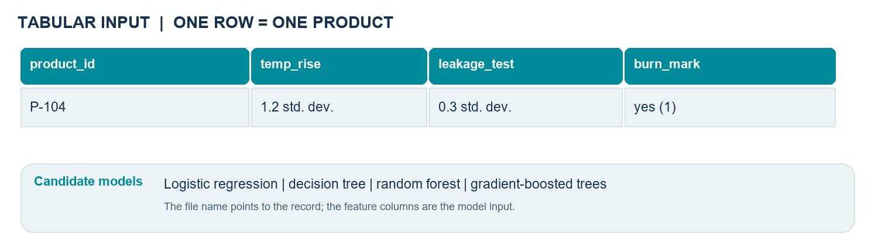

2. Text: words become numbers
Consider a support message: “I did not receive my refund.” A TF-IDF pipeline turns vocabulary words or phrases into a sparse vector: a long row of numbers in which most values are zero. A linear classifier such as logistic regression or a linear support vector machine (SVM) can use those values. A transformer takes a different route: its matching tokenizer converts the message into token IDs, and an attention mask marks real tokens rather than padding. A BERT or DistilBERT classifier can take that tokenized input. Token IDs depend on the tokenizer; they are not universal word numbers.
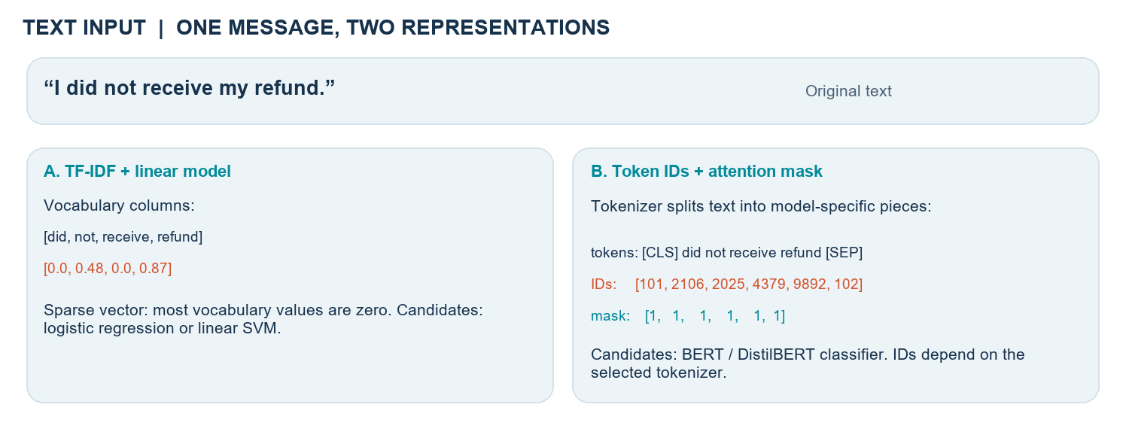

3. An image: pixels become a tensor
A JPEG is first decoded into pixel values. A color image has separate red, green, and blue channels. After resizing and applying the chosen model’s required normalization, one example might be represented as a tensor with shape [3, 224, 224]: three color channels, each with 224 rows and 224 columns. In a batch of N images, the shape might be [N, 3, 224, 224]. Convolutional neural networks such as ResNet or EfficientNet and vision transformers such as ViT can be candidates for image tensors. Another option is a pretrained image encoder: it converts the image to an embedding vector, which a classifier such as logistic regression or an SVM can then use.
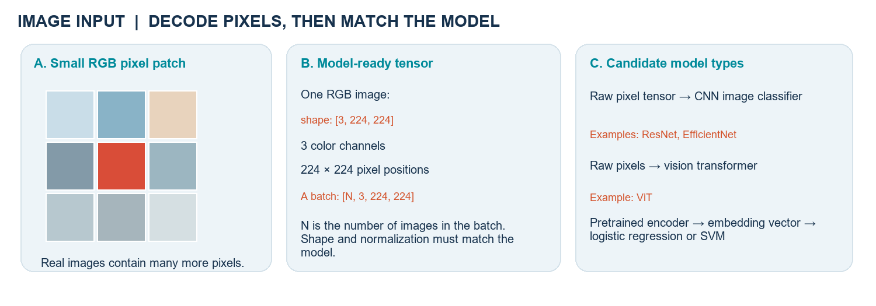
A feature vector is a row of numbers describing one example; a tensor is a multidimensional array of numbers. Either way, check that training and prediction use the same shape, feature order, tokenizer or image transforms, and value conventions.

Slide 7 | The honest model-development loop
PAUSE AND THINK Which data should be used to choose a threshold, and which data must be saved for the final report?
A trustworthy evaluation keeps model building separate from the final check. We will use three sets of examples for three different jobs: training data to learn, validation data to make choices, and test data to estimate how the finished choice may work on new cases. The test set does not train the models.

1. Audit first: check what the data really contains
An audit is a careful check of the examples, labels, and how they were collected before we build a model. For returned-product photos, ask: Do reviewers use the same rule for “defect”? Are several photos of the same physical product present? Do some images have glare, blur, darkness, or a crop that hides the defect? Were photos taken by different cameras or at different times? Are any labels or measurements recorded after the decision we want to make? These checks help us catch unreliable answers, duplicate examples, missing evidence, and shortcuts a model could exploit.
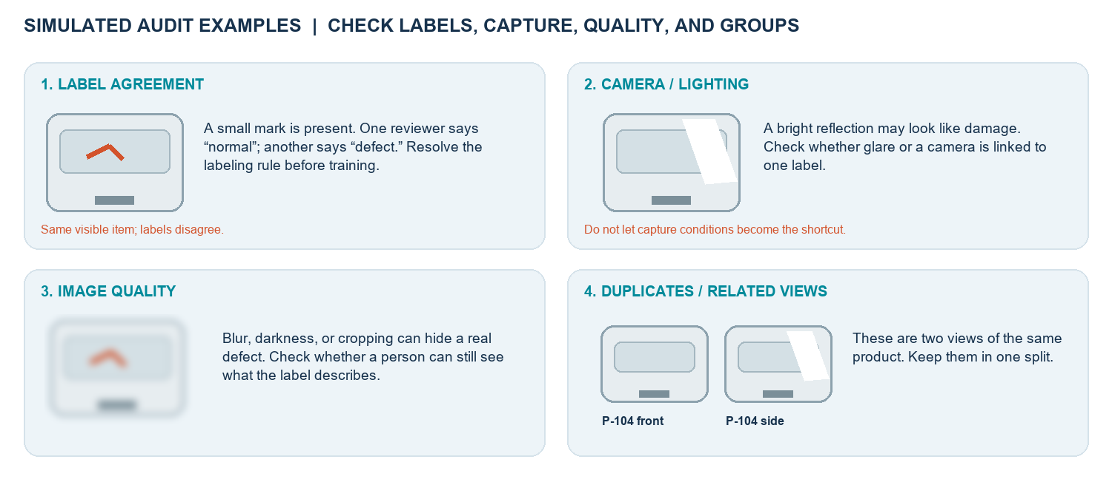
Illustrative drawings made for this reader—not real product photos or examples from a dataset.

A practical audit checklist
Check | Example to look for | Why it matters / what to do
Label quality | Two reviewers disagree whether a small mark is a defect. | Define the rule, review disagreements, and correct uncertain labels.
Duplicates and groups | Front and side photos show the same product ID. | Record product IDs and keep all related views in one data split.
Image quality | Blur, glare, darkness, or a crop hides the damaged area. | Check if the relevant evidence is visible and resembles real use.
Capture differences | One camera or supplier appears mostly with one label. | Check whether the model could learn camera/background instead of defect.
Timing and availability | A “repair outcome” field is recorded only after inspection. | Do not use future information as an input for an earlier decision.

2. Split by product, not by photo
First decide what “new” means at deployment. If the goal is to predict defects on products the company has never seen, the product is the unit that must be new—not merely the photograph. Give every physical product a group ID, then place all its photos together before assigning groups to training, validation, or test.
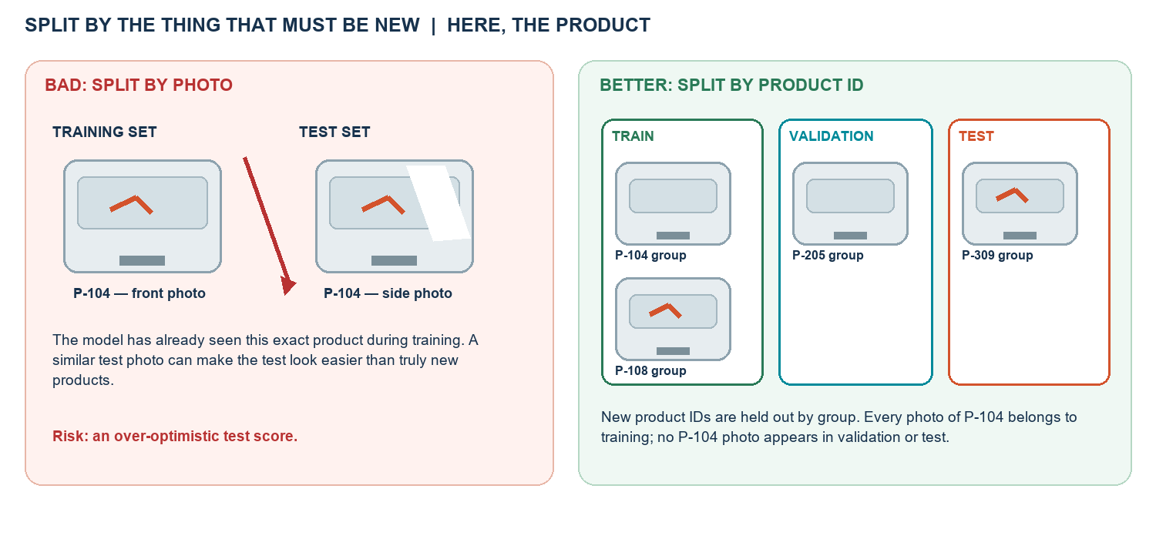
Left: the same returned appliance P-104 crosses the split. Right: all P-104 views stay together. Illustration only.
Why does this matter? Imagine a toaster with a distinctive dent and serial sticker photographed from the front and the side. If the front photo is in training and the side photo is in test, the model may recognize details of that same toaster rather than learn a pattern that works on a new toaster. The test score can then look better than performance on products the model has never encountered. Keeping all views of P-104 in one partition makes the test a more honest check of generalization to new products.

3. Give each data set one job
Partition | Purpose | What happens here | Do not use it to
Training | Teach candidate models from known examples. | Fit model weights and learn preprocessing values. | Claim final, independent performance.
Validation | Compare candidates and make development choices. | Compare models; choose settings and a decision threshold. | Fit a fresh scaler/imputer or report the final unbiased score.
Test | Give one final check after choices are frozen. | Evaluate the selected model and settings on untouched groups. | Train, choose models, tune settings, or keep checking repeatedly.
For example, if the company has 100 product IDs, an illustrative split could assign 60 IDs to training, 20 different IDs to validation, and 20 other IDs to test. If P-104 has five photos, all five go to the same one of those sets. The exact proportions depend on how much data there is and how products arrive in real use; the essential rule is to keep related examples together.

4. “Fit on training only” in everyday terms
An imputer is a preparation step that fills a blank value using a rule, such as the median of the training readings. A scaler changes numeric values to a comparable scale, using numbers such as the training average and spread. Fit means calculate or learn that rule from training examples. Transform means apply the same already-learned rule to training, validation, test, or future examples.
Situation | What the imputer does
Training readings | 10°C, 12°C, blank, 14°C
Fit using training only | Learn the training median: 12°C
Prepare training row | Replace its blank with 12°C
Prepare validation/test row with a blank | Reuse 12°C; do not calculate a new median from these rows
The imputer learns 12°C from training readings only. If we calculated a new median using validation or test readings, information from the evaluation data would influence the pipeline. A scaler follows the same rule: learn its average and spread on training data, then reuse those same values on validation and test. For example, if the training temperature average is 12°C and its learned scale is 2°C, a reading of 14°C becomes +1 scale unit: (14 - 12) / 2 = 1. This is a simplified example of standardization. Logistic regression and distance-based models often benefit when input scales are comparable; tree models may not need the same scaling. Do not assume every model needs identical preparation.

5. Compare candidates fairly on the same validation set
Yes, we may fit several candidate models. Each candidate is trained using the same training partition. Then each one predicts the same validation examples. Comparing them on different examples would be like grading one student on an easy quiz and another on a hard one. We choose a candidate and settings—including the probability threshold—based on the business goal and validation evidence. The test set stays closed while we make those choices.
Candidate | Fit on | Evaluate on
Logistic regression | The same training products | The same validation products
Random forest | The same training products | The same validation products
Gradient-boosted trees | The same training products | The same validation products
Decision | No fitting on validation | Choose using the business-relevant validation results
For a fair comparison, keep the validation examples and evaluation rules the same across candidates. If you also tune model settings, use validation data or cross-validation within the training data; do not use the final test set to keep adjusting candidates.

Which measure fits the business need?
Measure | Plain-language meaning | When it may matter most
Precision | Of all cases flagged, what share are truly positive? | When each alert triggers costly investigation or manual review and unnecessary alerts should be limited—for example, fraud investigation queues.
Recall | Of all true positive cases, what share did the model find? | When missing a positive case is especially costly and there is a safe follow-up step—for example, screening products for potential safety defects before inspection.
F1 score | A single summary balancing precision and recall. | When both false alarms and missed positives matter and a balanced comparison is useful. F1 does not encode dollars, safety costs, or inspection capacity.
Example on the same validation group of 1,000 products: suppose 100 really have defects. A stricter setting flags 100 products, including 80 defects and 20 normal products. Precision is 80/100 = 80%; recall is 80/100 = 80%; F1 is 80%. A broader setting flags 300 products, including 90 defects and 210 normal products. Precision is 90/300 = 30%; recall is 90/100 = 90%; F1 is 45%. The broader setting finds 10 more defects, but sends 190 more normal products to review. Neither setting is automatically better: the choice depends on the cost of missed defects and the inspection team’s capacity.
Validation setting | True defects found | Normal items flagged | Precision | Recall | F1
Stricter | 80 of 100 | 20 | 80% | 80% | 80%
Broader | 90 of 100 | 210 | 30% | 90% | 45%
These figures are illustrative. A false positive here is a normal product sent for review; a false negative is a defective product the model misses. Precision can be especially useful when false positives consume scarce review time. Recall can be especially useful when missed defects are the bigger concern. F1 can summarize a precision-recall balance, but it does not decide what the company can afford or safely handle.

6. Practice explaining results to a stakeholder
Technical version: “On validation data, the broader setting increased recall from 80% to 90%, while precision fell from 80% to 30%; it found 10 additional defects and flagged 190 additional normal products.”
Stakeholder version: “In this comparison, the broader setting found 10 more defective products out of 100, but sent 190 more safe products to inspection. We should use it only if the safety benefit is worth the added inspection work.”
Your turn: explain the stricter setting to a manager who has capacity to inspect only 100 items. State what it catches, what it misses, and what the manager should consider next.

7. Use the test set once for the final check
After choosing the model and threshold, evaluate that frozen choice on the untouched test products. Do not use the test results to choose a different model, change the threshold, or fit new preprocessing. If test results lead us to make another choice, the test set has become part of development; we would need new untouched data for a fresh final estimate.
Technical report: “On the held-out test products, the final model had a defect recall of __%, precision of __%, and F1 of __% at the threshold selected using validation data.”
Stakeholder report: “When checked on products it had not seen before, the model found __ of every 100 defective items and sent __ safe items for review. The results suggest __; the main limitation is __.”

Slide 8 | Choose a shortlist, not a universal winner
PAUSE AND THINK What is one simple candidate you would compare with a more complex model for this data type?
There is no single best algorithm for every kind of data. For tables, a useful comparison might include logistic regression and a tree ensemble. For text, we might begin with a TF-IDF linear model and compare it with a transformer. For images, we could compare simple engineered features with a pretrained image encoder. We also need to consider how many labeled examples we have, how much errors cost, whether people need to understand the model, and what compute, latency, privacy, and maintenance limits apply. A newer or larger model is not automatically more useful.

SECTION 2 | Candidate models and tabular preparation
A DEFENSIBLE SHORTLIST
Input | Simple baseline | Candidate to compare
Table | Logistic regression | Tree ensemble
Text | TF-IDF + linear model | Transformer
Image | Engineered features | Pretrained encoder

Slide 9 | Logistic regression: a transparent first challenger
PAUSE AND THINK If an item's estimated defect probability stays the same, can we change its predicted class without retraining the model?
Despite its name, logistic regression is commonly used for classification. It combines the input features and learned weights into a score, called a logit, then applies the sigmoid function to produce a probability between zero and one. For example, a probability of 0.8 means the model estimates an 80-percent chance of the positive class, assuming its probabilities are reliable. A threshold turns that probability into a predicted label. Training usually uses log loss and regularization. Changing the threshold can change the predicted labels without retraining the weights. A probability or association does not, by itself, prove that an input caused the outcome.
PROBABILITY TO LABEL
Step | Example
Weighted input score | logit z = b + w·x
Sigmoid | p = 1 / (1 + e⁻ᶻ)
Threshold policy | p ≥ threshold → predict positive class

Slide 10 | Decision trees: learn a sequence of questions
PAUSE AND THINK If the tree asks whether texture exceeds a cutoff, what determines which branch the item follows?
A decision tree makes a sequence of if-then-style splits. For example: is the texture score above 0.6? If yes, is edge density above 0.4? Depending on the answers, the item may be flagged as a likely defect or sent for more inspection. A shallow tree can be easier to describe than a large model, and changing a numeric feature from centimeters to meters usually does not change its ordering or basic split. But deep trees can memorize training examples and become hard to interpret, so we limit their depth and check performance on held-out data.
A SMALL TREE
Texture score > 0.6? | If YES: inspect edge density | If NO: likely normal
Edge density > 0.4? | YES → likely defect | NO → inspect further

Slide 11 | Random forest versus gradient boosting
PAUSE AND THINK Which ensemble adds trees in stages, and which combines many varied trees?
Both random forests and gradient boosting combine many trees, but they build the ensemble differently. A random forest fits many varied trees and aggregates their predictions; this can reduce the instability of relying on one tree. Gradient boosting adds trees in stages, with each stage chosen to improve the overall loss. It is useful to say that boosting learns from remaining errors, but it is not literally guaranteed that every new tree fixes every earlier mistake. Both can model nonlinear patterns, but we still need validation, and they are generally less straightforward to explain than a single shallow tree.
HOW THE ENSEMBLES DIFFER
Random forest | Gradient boosting
Fit many varied trees | Add trees sequentially
Aggregate their predictions | Improve the chosen loss stage by stage
Often a robust benchmark | Often a strong tabular candidate

Slide 12 | Today’s practical tabular toolkit
PAUSE AND THINK What should you verify before assuming an estimator accepts missing or categorical values?
Tree libraries differ in what they can handle automatically. Some implementations can learn how to route missing numeric values; some support categorical columns when we declare them in the expected format; and some require encoding or other preparation. These capabilities belong to a specific estimator and version, not to every tree model in general. ‘Built in’ doesn’t mean that arbitrary text can be supplied without a schema or checks. We should verify the documentation for the exact library version and test the same input format we plan to use.
DO NOT ASSUME
Capability | Check before use
Missing values | Which missing types and estimator version?
Categories | Required dtype, declaration, and allowed values?
Default behavior | Does it match the deployment input schema?

Slide 13 | k-NN and SVM: geometry matters
PAUSE AND THINK If dollars are in the thousands and temperature is in tens, which feature might dominate a distance calculation?
Some models depend strongly on distances or margins between points. K-nearest neighbors predicts using nearby examples, so a feature measured in large numbers can dominate distance unless we scale appropriately. Support vector machines seek a separating boundary with a useful margin. A linear SVM can work well with sparse text features; kernel SVMs can model more complex boundaries but may become expensive as the dataset grows. The important idea is that feature scale, representation, and dataset size affect which model is a practical candidate.
WHY SCALE CAN MATTER
Feature | Example difference
Annual sales | $0–$500,000
Temperature | 10–100 degrees
Distance-based model | Large numeric scale may dominate distance

Slide 14 | Text baselines are not obsolete
PAUSE AND THINK For a support message saying “I did not receive my refund,” which words or phrases must the representation preserve?
A simple text pipeline can be a strong place to start. Suppose we route customer support messages into billing, delivery, or refund categories. TF-IDF converts words and phrases into weighted numerical features. A logistic regression model or linear SVM can then predict a category. This approach is often fast and easier to inspect than a large language model. We should compare it fairly with more complex alternatives rather than assuming the newest method will win.
TEXT BASELINE
Message | TF-IDF features | Classifier output
“I did not receive my refund” | Words + phrases | Billing / delivery / refund

