VERTEX AI EDITION | BENCHMARK REPORT | 2026 BEST TECHNOLOGY BREAKTHROUGH (AI)
Fusion Force Gateway
LiteLLM gateway + Headroom compression on Google Cloud Vertex AI (Gemini Flash 3 Lite)

1 Project Overview: Elevator Pitch
A short paragraph that convinces the judges to dig further
ELEVATOR PITCH
Agents pay again and again for the same bloated tool output. Fusion Force Gateway combines LiteLLM with Headroom compression in one shared service, deployed inside your Google Cloud project. Agents change a single setting; the gateway shrinks tool output, then calls Gemini on Vertex AI with Google credentials, with no API keys to manage. On our sample benchmark it cut tokens by 49.4% and cost by 45% (sample data, Claude Haiku 4.5).

49.4%  fewer tokens sent to the model | 45%  lower LLM cost, same tasks | 6 of 6  tasks improved (32% to 63% fewer tokens) | ~$478  saved per month at 50 developers
Sample data: Claude Haiku 4.5, 6 DevOps triage tasks, compression off vs. on, run 2026-10-21. Source: results/run_20261021_235043.json. Gemini Flash 3 Lite on Vertex AI to follow.
2 | Team Name | [Add team name]
3 | Project Short Title | Fusion Force Gateway
4 | Contact person for questions | [Add name, email]

5 Problem Statement
The specific problem or challenge we are solving
AI agents call tools that return large payloads: logs, ticket lists, search results. Every agent step re-sends everything the agent has seen so far, so the same bulky text is paid for again and again.
- It is expensive: in our sample run, 97% of tokens and about 88% of cost were input tokens (126,236 of 129,785).
- It is invisible: teams rarely see token spend per task or per team, so nobody can manage it.
- The fix is hard to roll out: asking every team to add compression to its own agent does not scale, and our org requires models to be reached through Vertex AI with Google credentials.
The challenge: cut token spend org-wide without rewriting agents, using only approved Vertex AI access.

6 Target User
Which product line or department benefits, and who might sponsor this as a project request?
- Primary users: platform and AI engineering teams that run agents for the whole company. First adopters: DevOps/SRE triage agents, coding agents and CI pipelines.
- Likely sponsors: the platform or AI engineering group that owns shared AI services, together with the FinOps or cloud-cost owners who pay the model bill.
- Why it spreads: it is one shared gateway, so a single rollout covers every team that points at it.

7 Value
Why is this valuable, and what is new or differentiated?
1) Why this is worth solving
- Cost savings: input tokens dominate agent bills, so compressing tool output lowers cost directly. Sample data (Claude Haiku 4.5): 49.4% fewer tokens, 45% lower cost, about $478 a month at 50 developers.
- Efficiency: smaller prompts leave more room in the model's context window, so agents can read more evidence per task.
- Risk reduction: no API keys to store or rotate, and every call is metered through one governed gateway.
2) What is new or differentiated
- Zero-rewrite adoption: compression is a gateway setting, not an agent change. One config switch turns it on or off.
- Proof, not a promise: a built-in A/B harness runs identical tasks with compression off and on, and records real tokens and cost from LiteLLM's usage and pricing data.
- From tokens to a business number: a dashboard extrapolates to monthly org savings from your own headcount and usage, with live sliders.
- Built for Google Cloud: Vertex AI models, Google identity and no API keys.

8 Environment
AI tools, data, and anything else the judges need
1) AI tools we leveraged
- Gemini Flash 3 Lite on Vertex AI via LiteLLM: [vertex_ai/<model ID>]
- Headroom: context compression for LLM traffic, the engine inside the gateway.
- LiteLLM: gateway, routing, and token and cost metering.
- Google ADK: framework for the demo DevOps Triage Agent and its tools.
- Streamlit: the savings dashboard. The project was built with Claude Code.
2) Data used to train the agent
No model was trained or fine-tuned. The demo agent uses mock JSON payloads that the repo generates itself (100 log entries, 50 GitHub-style issues, 60 runbook search results, about 88 KB). No customer or proprietary data is used.
3) What else the judges need to evaluate or run it
- Google Cloud project with the Vertex AI API enabled and Application Default Credentials (gcloud auth application-default login).
- Set the model, project and region in config.yaml, then run ./demo.sh benchmark and ./demo.sh dashboard.
- Prerequisite: the Fusion Force Gateway build with Vertex AI support (LiteLLM's vertex_ai provider with project and region). The repo's default configuration uses an API key.
- Benchmark design, results and caveats are in Appendix A. A presentation deck and the architecture diagram are in the docs/ folder.

9 Innovation
Why this is unique, and what we learned
1) Why it is innovative
- Compression as shared infrastructure: one gateway for every team, like a CDN for tokens, instead of a library each team wires into its own agent.
- It closes the loop from technique to money: the harness that runs the A/B test also produces dollars saved and an org-wide estimate.
- Two integration modes (in-process callback and local proxy) are chosen from config alone.
2) What we learned about tools and AI
- Agent cost is mostly input. 97% of benchmark tokens were input, because tool results are re-sent on every step.
- Gateway hooks have limits. LiteLLM runs callback hooks only inside its own proxy server, so plain SDK calls need a small wrapper to apply compression.
- Savings depend on the payload and the model. Compression ranged from 32% to 63% across tasks, and output tokens (not compressed) cost more on some Gemini models, which shrinks the percentage cost saving (Appendix A).

10 GitHub Repository
Link to the repository
https://github.com/shyleshus7/tokengate

11 UI Link or Endpoint
Where the working project can be reached
- Savings dashboard (Streamlit), run locally: ./demo.sh dashboard, then open http://localhost:8501.
- Hosted dashboard URL: [Add URL if deployed]
- Gateway endpoint (Cloud Run or GKE): [Add URL if deployed]

12 High-Level Architecture Diagram
How the solution fits together
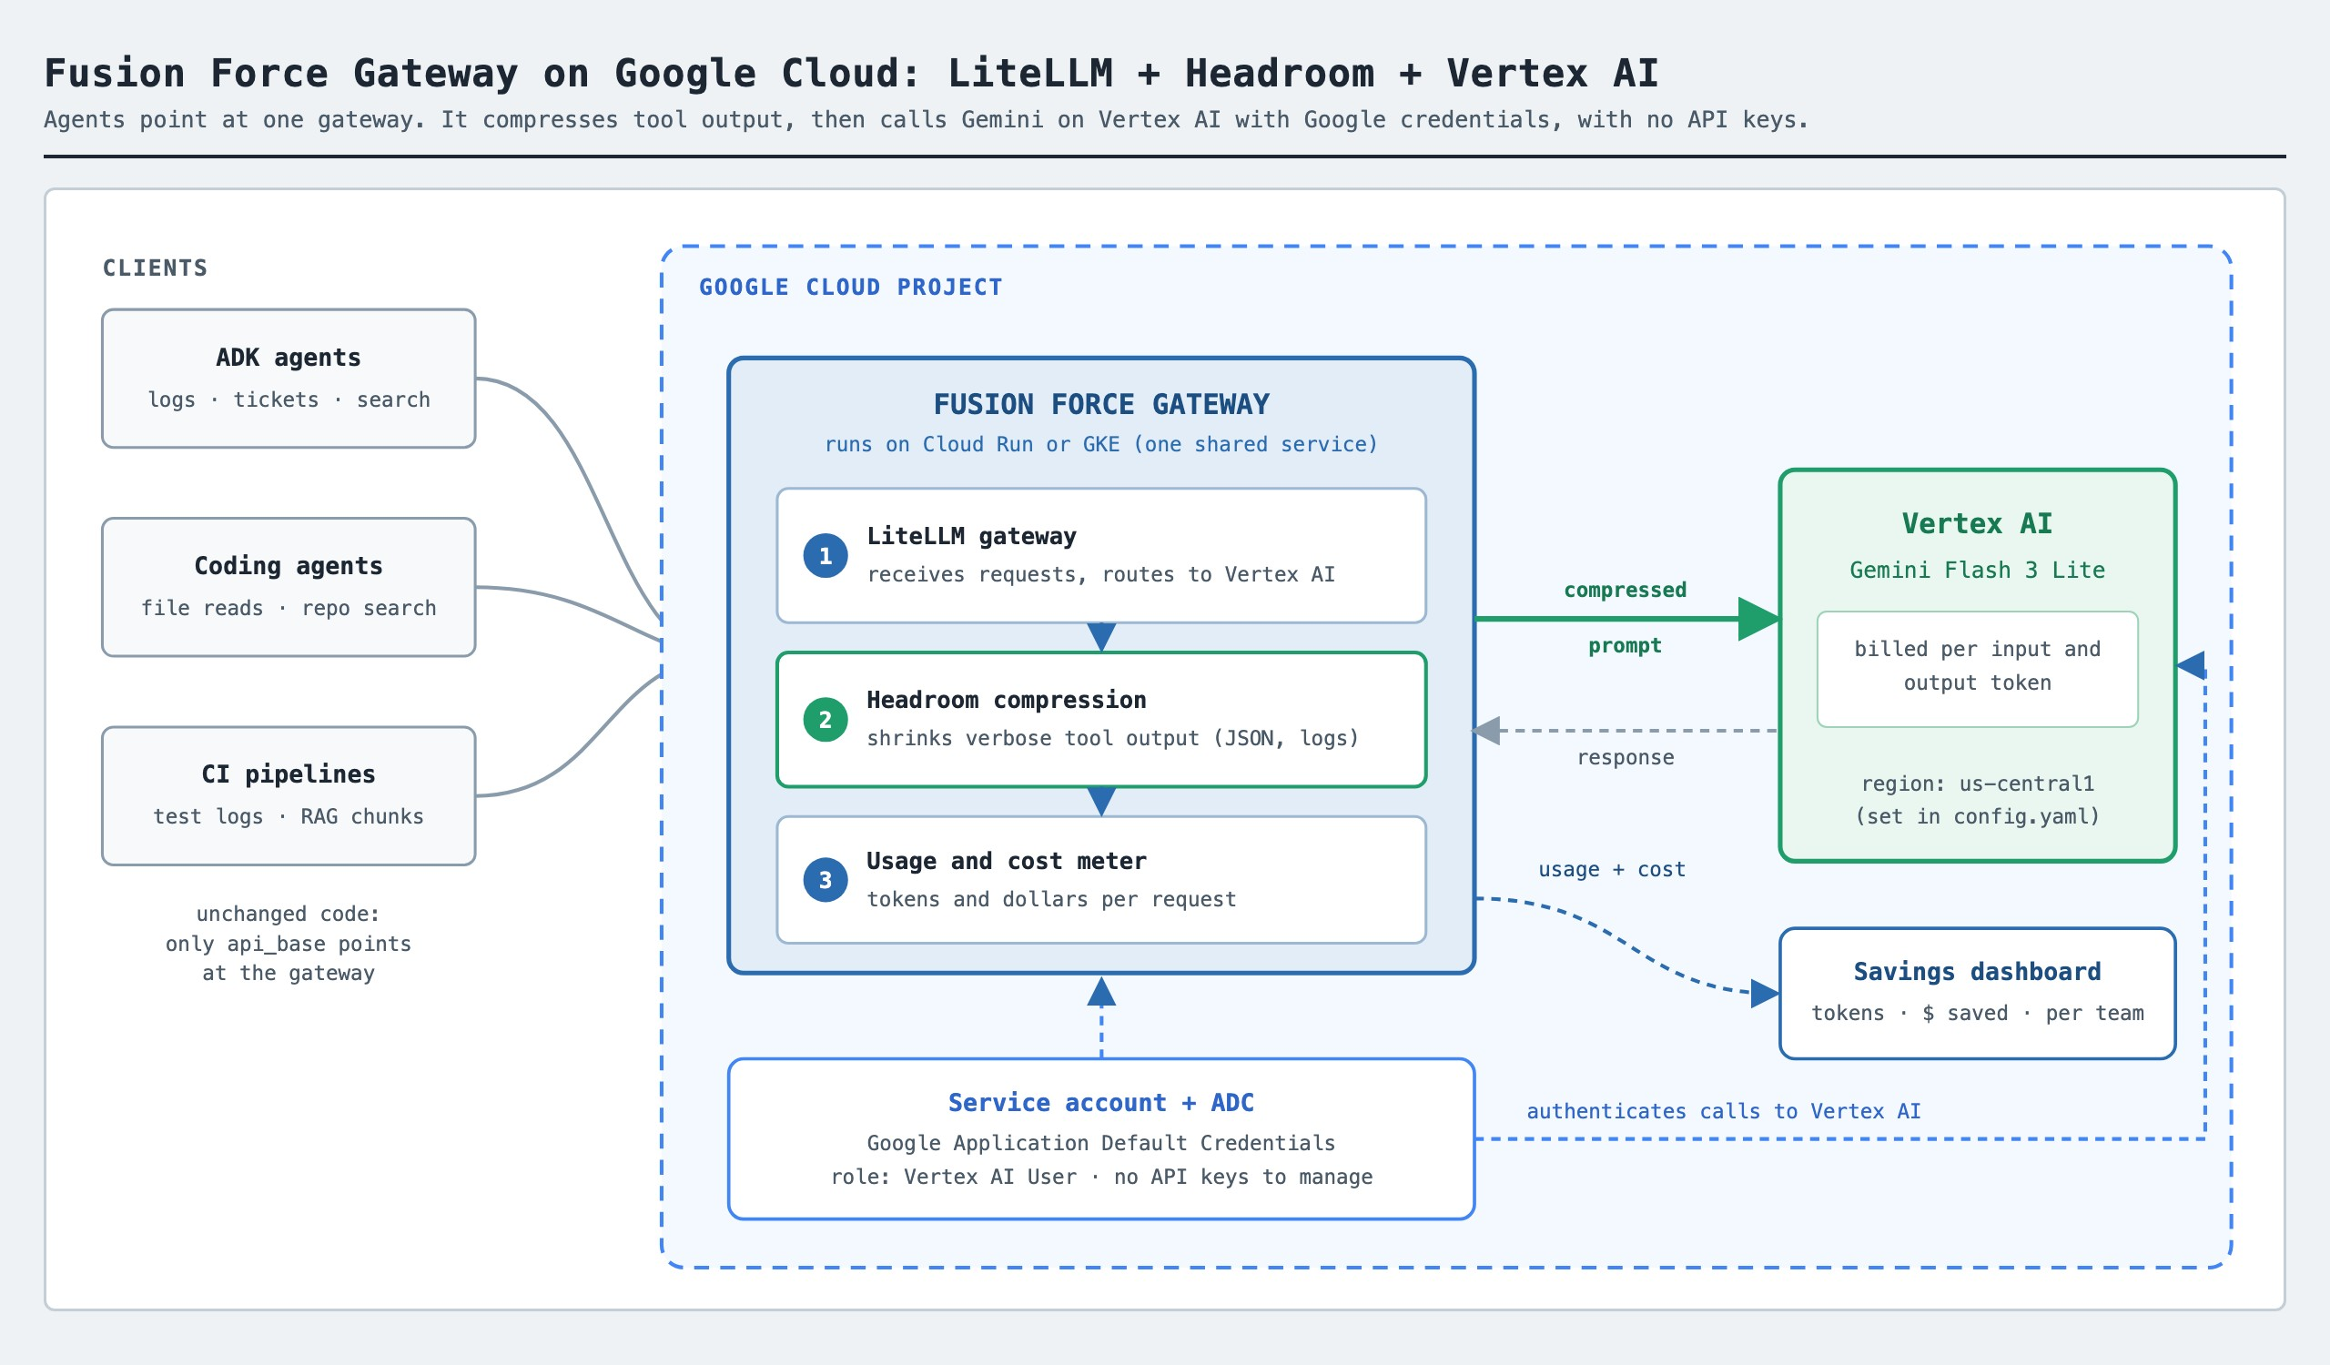
Figure 1. Fusion Force Gateway on Google Cloud: clients, gateway (LiteLLM + Headroom), Vertex AI and identity.
- Clients: ADK agents, coding agents and CI pipelines keep their code and only change where they send requests.
- Gateway: one shared service. LiteLLM receives and routes requests, Headroom compresses tool output, and LiteLLM meters tokens and cost. Target deployment is Cloud Run or GKE; the hackathon demo runs it locally.
- Vertex AI: all model calls go to Gemini Flash 3 Lite in your Google Cloud project and region.
- Identity: a service account with the Vertex AI User role, picked up through Application Default Credentials. No API keys.
- Visibility: usage and cost feed the savings dashboard, per task and per team.

A Appendix: Vertex AI Benchmark
Design, results to fill in, and the output-pricing caveat
Benchmark design
- Tasks: the same 6 DevOps triage tasks as the sample run (tasks.yaml), so results are comparable.
- Two passes: each task is asked once with compression off and once with Headroom on. Same questions, tools and mock data.
- Metrics: input and output tokens and dollar cost per task from LiteLLM usage and pricing data, plus the final answers for a side-by-side quality check.
- Org estimate: saving per request x developers x requests per day x working days (defaults 50 developers, 40 requests a day, 22 days).
- Confirm LiteLLM has a price for the model, otherwise cost shows as $0.
Results (sample data: Claude Haiku 4.5)
Task | Tokens without | Tokens with | Fewer tokens | Cost without | Cost with
checkout failures | 26,958 | 15,249 | 43.4% | $0.0295 | $0.0182
error summary | 11,221 | 7,634 | 32% | $0.0132 | $0.0094
open p1 issues | 8,825 | 5,678 | 35.7% | $0.0103 | $0.0071
slow queries | 28,780 | 11,846 | 58.8% | $0.0316 | $0.0138
rollback guidance | 27,125 | 10,076 | 62.9% | $0.0304 | $0.0126
on call brief | 26,876 | 15,146 | 43.6% | $0.0291 | $0.0177
Total | 129,785 | 65,629 | 49.4% | $0.1440 | $0.0788
Run 2026-10-21, claude-haiku-4-5, Headroom proxy mode, source results/run_20261021_235043.json. To be replaced by the Gemini Flash 3 Lite run on Vertex AI. Fewer tokens = (without - with) / without.
How Gemini output pricing changes the saving
Headroom compresses what you send, not what the model writes back. Output tokens are priced at a multiple of input, and the multiple differs by model: about 5x on Claude Haiku 4.5 and around 8x on some Gemini models. The more of a bill is output, the smaller the percentage saving. Check the Flash 3 Lite input and output prices on your Vertex AI pricing page, and read the Vertex results with that ratio in mind.
Illustration only: the token mix from the sample run, re-priced at different output-to-input ratios. It is not a Gemini measurement.
Output price as a multiple of input | Token saving | Cost saving
1x (equal pricing) | 49.4% | 49.4%
5x (Claude Haiku 4.5) | 49.4% | 45.3%
about 8x (some Gemini models) | 49.4% | 42.7%
Sample token mix: 126,236 input and 3,549 output tokens without compression. Longer answers or reasoning-heavy workloads lower the saving further.
Quality check and limits
- Proposed pass criteria: tokens drop on every task, total cost is lower, and the final answers reach the same conclusions on all six tasks, checked by a person.
- Why check: in the sample run one task reported slightly different error counts with compression on.
- Limits: a small, synthetic benchmark (6 tasks, mock data); prompt caching, latency and gateway operations are not measured. A pilot on real traffic should confirm the savings.

