2026 BEST TECHNOLOGY BREAKTHROUGH (AI) | HACKATHON SUBMISSION
Token Gate
An Org-Wide LLM Compression Gateway

ELEVATOR PITCH
Every AI agent pays, over and over, for the same bloated tool output. Token Gate is one LiteLLM gateway with Headroom compression built in. Teams change a single setting, and verbose tool output is shrunk before it reaches the model. No agent rewrites. In our A/B benchmark the same six agent tasks used 49.4% fewer tokens and cost 45% less, and the built-in dashboard turns that into a live org-wide dollar figure.

49.4%  fewer tokens sent to the model | 45%  lower LLM cost, same tasks | 6 of 6  tasks improved (32% to 63% fewer tokens) | ~$478  saved per month at 50 developers
Measured on Claude Haiku 4.5, 6 DevOps triage tasks, compression off vs. on, run 2026-10-21. Source: results/run_20261021_235043.json.

1 Project Overview
Elevator pitch, team name, short title, contact
Token Gate sits between agents and the model provider. Agents keep their code and point at the gateway, LiteLLM routes and meters every call, and Headroom compresses the bulky JSON that tools return (logs, issue lists, search results) before the model sees it. A benchmark harness runs the same tasks twice, compression off and on, and a Streamlit dashboard shows tokens, dollars and side-by-side answers, with sliders to extrapolate to your org.
Team Name | [Add team name]
Project Short Title | Token Gate
Contact for questions | [Add name, email]
GitHub | https://github.com/shyleshus7/tokengate

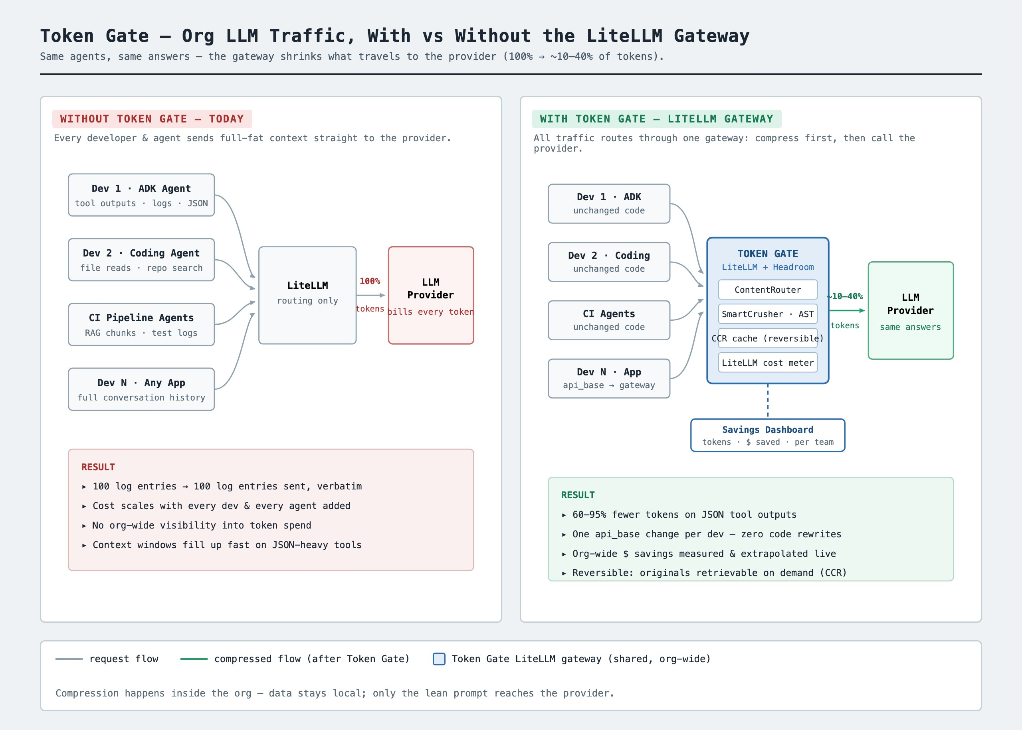
Figure 1. Agent traffic without a gateway (left) and through Token Gate (right).

2 Target User
Which product line or department benefits?
- Primary: Platform and AI engineering teams that run LLM agents for the whole company, and the FinOps owners who pay the bill.
- First adopters: DevOps and SRE (incident triage agents), engineering productivity (coding agents) and CI pipelines. Their agents read logs, files and tickets, so most of their tokens are bulky tool output.
- Why it spreads: it is a shared gateway. One rollout covers every team that points at it.

3 Value
Why is this problem worth solving, and what is new or differentiated?
Why it matters
- Cost savings: 49.4% fewer tokens and 45% lower cost on the benchmark. At 50 developers and 40 requests a day, that is about $478 a month ($5,736 a year), growing in a straight line to about $114,724 a year at 1,000 developers.
- Efficiency: smaller prompts leave more room in the model's context window, so agents can read more evidence per task.
- Visibility: token spend is rarely visible across an org. The gateway meters every request, so spend can be tracked per task and per team.
What is differentiated
- Zero-rewrite adoption: compression is a gateway setting, not an agent change. A single config switch (compression_enabled) flips it on or off.
- Proof, not a promise: a built-in A/B harness runs identical tasks with compression off and on and records real tokens and cost from LiteLLM's usage and pricing data.
- From tokens to a business number: the dashboard extrapolates to monthly org savings from your own headcount and usage with live sliders.

Results at a glance
Benchmark task | Tokens without | Tokens with Token Gate | Fewer tokens
checkout failures | 26,958 | 15,249 | 43.4%
error summary | 11,221 | 7,634 | 32%
open p1 issues | 8,825 | 5,678 | 35.7%
slow queries | 28,780 | 11,846 | 58.8%
rollback guidance | 27,125 | 10,076 | 62.9%
on call brief | 26,876 | 15,146 | 43.6%
Total | 129,785 | 65,629 | 49.4%
Totals: $0.144 without vs. $0.079 with compression for the same 6 tasks.

4 Environment
What AI tools were used, what data, and what do judges need?
AI tools
- Headroom: context compression for LLM traffic (the engine inside the gateway).
- LiteLLM: model gateway, request routing, token usage and dollar cost metering.
- Google ADK: framework for the demo DevOps Triage Agent and its tools.
- Claude Haiku 4.5: the model used for the benchmark. Any model name LiteLLM understands can be set in config.yaml.
- Streamlit: the savings dashboard. The project was built with Claude Code.
Data
No model was trained or fine-tuned. The demo agent uses mock JSON payloads that the repo generates itself (100 log entries, 50 GitHub-style issues, 60 runbook search results, about 88 KB). No customer or proprietary data is used, and no external services are needed besides the model API.
For judges who want to run it
- Python 3.13 and a model API key, supplied as an environment variable whose name is set in config.yaml. The README covers setup.
- Run ./demo.sh benchmark (about 12 agent runs), then ./demo.sh dashboard to explore the results.
- The repo also has the architecture diagram (docs/) and a presentation deck (docs/tokengate-savings.pptx).

5 Innovation
Why is this unique, and what did the team learn?
Why it is innovative
- Compression is treated as shared infrastructure, like a CDN for tokens, instead of a library each team wires into its own agent.
- It closes the loop from technique to money: the same harness that runs the A/B test produces the dollars-saved and org-extrapolation numbers a budget owner needs.
- Two integration modes (in-process callback and local proxy) are selected from config alone.
What we learned
- Agent cost is mostly input. About 97% of the tokens in our benchmark were input, because tool results are re-sent on every agent step.
- Gateway hooks have limits. LiteLLM only runs callback hooks inside its own proxy server, so for plain SDK calls we wrote a small client wrapper to apply Headroom's compression.
- Savings depend on the payload. Compression ranged from 32% to 63% across tasks. Large, repetitive JSON compresses best.

HONEST CAVEATS
- Output tokens are not compressed. They cost more than input, about 5x on Haiku 4.5 and around 8x on some Gemini models, so output-heavy workloads save a smaller share of their bill.
- Small, synthetic benchmark. 6 tasks, one run each, on mock data. Savings on real traffic will differ, so a pilot should confirm them.
- Answer quality needs checking. Conclusions were consistent, but one task reported slightly different error counts with compression on. We recommend validating accuracy on real tasks.

6 GitHub Repository
Link to the repository
https://github.com/shyleshus7/tokengate

