HC-POD Cross-Track Testing & Refinement Log — Week 7
Data Science ↔ Data Analytics
Documented per the 12 required fields in Section 9 of the Week 7 assignment brief. This is a testing/refinement exchange, not a repeat of Week 6's integration exchange — it tests whether Data Analytics' validated findings translate into genuine model-level improvements.

1.Track collaborated with: Data Analytics — primarily Fatimah Oreoluwa Ahmed this week, building on Victorea Ikhazuangbe's Week 6 contribution.

2. Project dependency: Fatimah's Week 7 analytical testing validated several findings (booking lead time, previous no-show history, reminder status, appointment type, and an appointment-type × booking-lead-time interaction) and asked directly whether these remain relevant to the Gradient Boosting model, specifically requesting the appointment-type × lead-time interaction be tested at the model level.
3. Component/output being tested: The Week 6 tuned Gradient Boosting candidate model, with an added specialist_consultation × high_lead_time interaction feature built specifically to answer Fatimah's question. (A second, related test of Victorea's long_lead_time × has_previous_no_show suggestion from Week 6 was also completed this week as part of the same testing cycle.)
4. Information/output received: Fatimah's validated Week 7 findings (booking lead time, previous no-show history, reminder status, appointment type, and the appointment-type × lead-time interaction pattern) and her specific request to test the latter at the model level.
5. Information/output provided: The full before/after test result on that exact interaction — accuracy, ROC-AUC, feature importance, and the Specialist Consultation error rate, both before her request (via the initial reply) and as detailed figures (via the follow-up reply, sent after she asked for the exact numbers for her own documentation).
6. Testing activity completed: Built specialist_consultation × high_lead_time as an explicit feature, retrained and re-tuned the candidate model via grid search, and compared its performance and Specialist Consultation error rate against the unmodified candidate.
7. Issue or finding identified: The interaction feature made no measurable difference — accuracy and ROC-AUC were identical to the candidate to 4 decimal places (0.6480 / 0.6872), the model assigned the feature exactly 0.0 importance (ranked 22nd of 26 features), and the Specialist Consultation error rate moved slightly worse rather than better (39.4% → 42.8%). This is a clean negative result, not an ambiguous one.
8. Refinement/action taken: The interaction feature was not adopted. The Week 6 candidate model was retained unchanged. This is the same evidence-based decision pattern applied to Victorea's Week 6 suggestion, which also tested negative (accuracy 0.6480→0.6460, AUC 0.6872→0.6864).
9. Retest result: Confirmed stable — re-running the candidate model without either interaction feature reproduces the original Week 6 numbers exactly (Acc 0.6480, AUC 0.6872), confirming the decision to leave it unmodified is the correct evidence-based choice.
10. What changed as a result: Confirmed for Data Analytics that two independently-suggested interaction features (Victorea's lead-time × prior-no-show, and Fatimah's appointment-type × lead-time) both test as redundant at the model level. This is useful, transferable knowledge: it demonstrates that tree-based models like Gradient Boosting discover feature interactions automatically through their tree-splitting process, so they don't need — and don't benefit from — hand-engineered interaction terms the way a linear model would. Fatimah confirmed she will document the aggregate pattern as valid on the analytics side while noting it did not produce a measurable model-level improvement, and will review her segment findings for anything more specific about the Specialist Consultation segment that could support further testing before Week 8.
11. Evidence: Slack thread with Fatimah (initial question, first reply with summary numbers, her follow-up request, and the detailed reply with exact figures) — see evidence/fatimah_exchange_week7.png
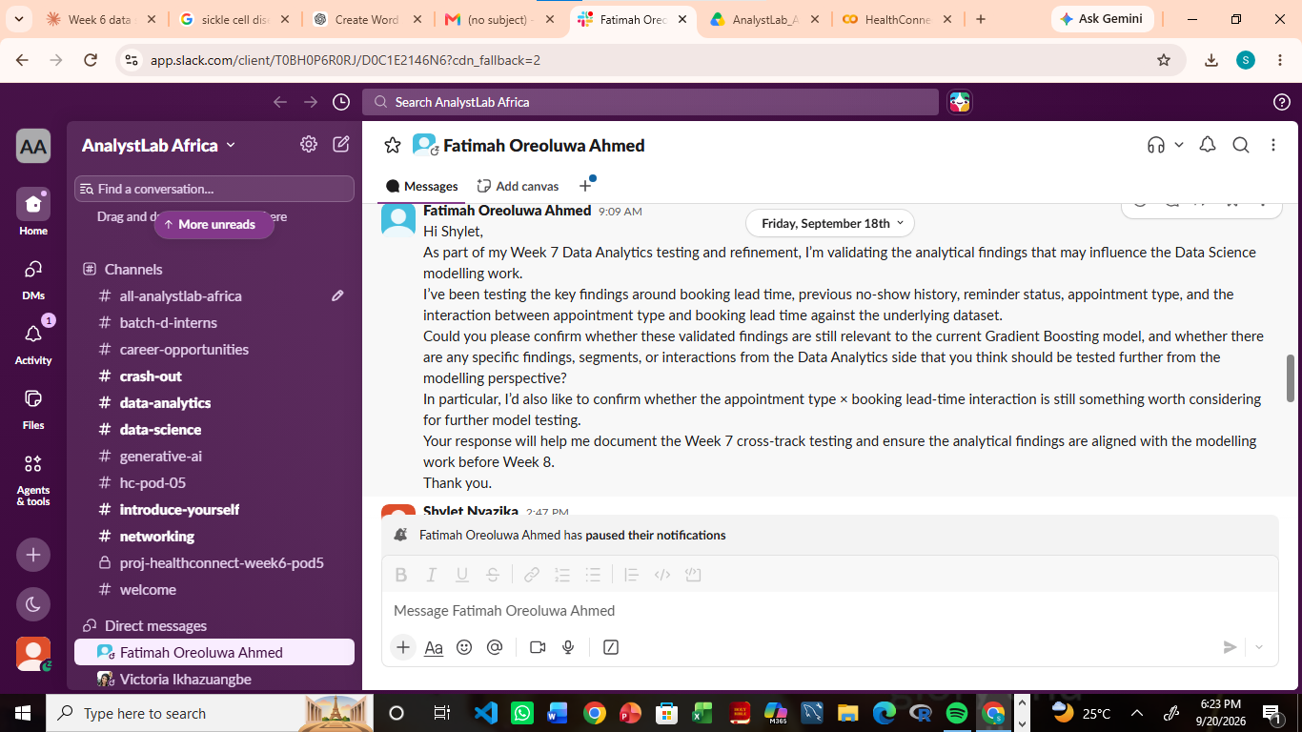
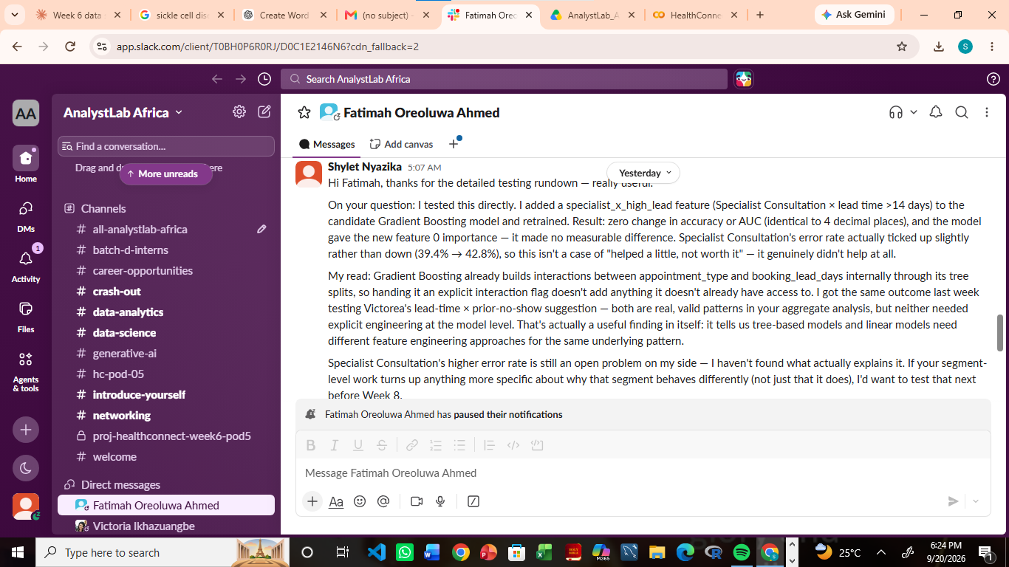
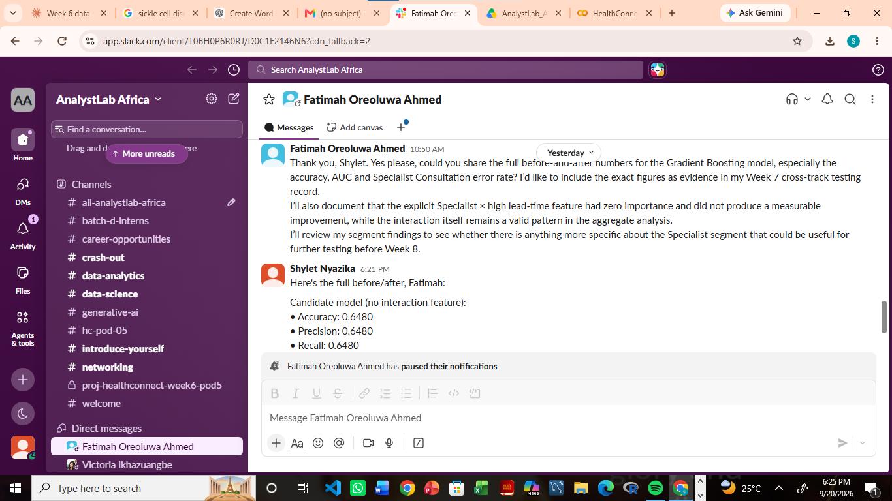
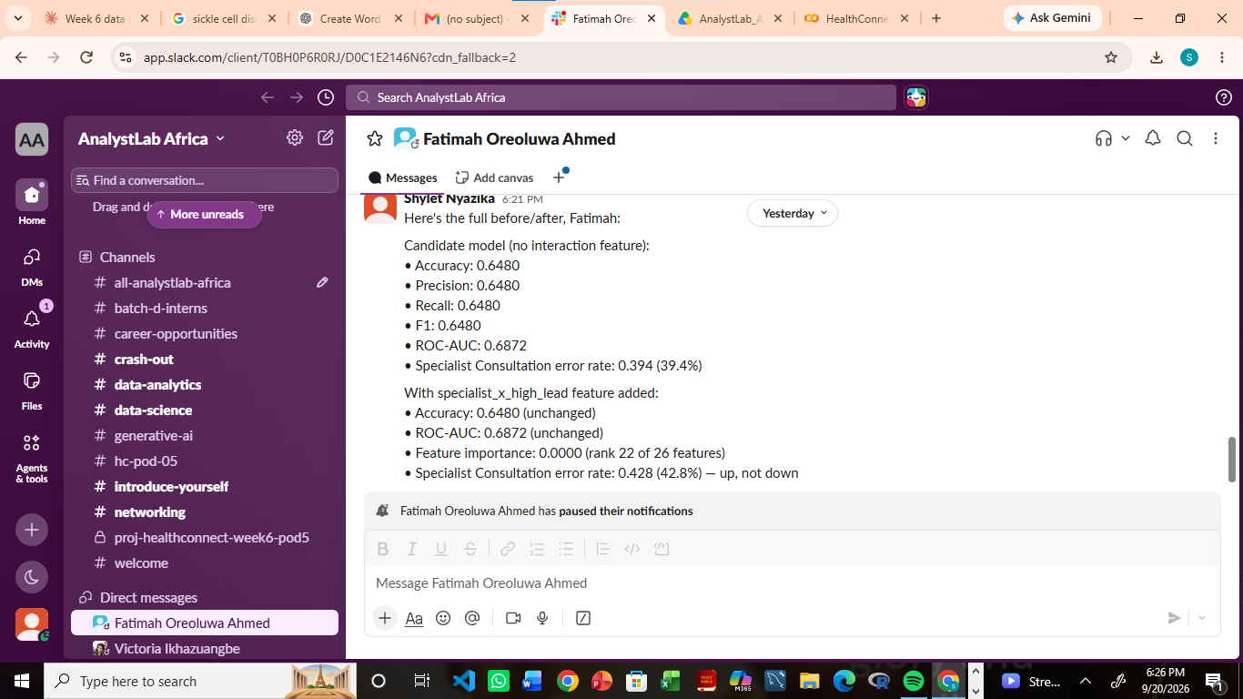

12. How this improved the overall HealthConnect solution: Gives Data Analytics a concrete, tested answer instead of an assumption about whether their aggregate findings need explicit model-side representation — closing the loop rather than leaving it as an open question. It also prevents ML Engineering from integrating untested features into the production pipeline, since both candidate refinements were rejected before reaching that stage. Finally, it reinforces (with two independent tests now, not one) that the Specialist Consultation error pattern is a genuine, currently-unexplained model limitation — worth presenting honestly in Week 8 as an open item rather than something this week's testing resolved.

