Development and Evaluation of an Improved Process-Based Paddy Water Balance Module for SWAT
M. Shyma¹, V. Harithalekshmi¹, Kirthiga Murugesan¹, Balaji Narasimhan¹

¹ Department of Civil Engineering, Indian Institute of Technology Madras, Chennai 600036, India

Abstract
Paddy cultivation consumes a large share of global irrigation water, yet conventional basin-scale hydrological models such as SWAT do not adequately represent paddy-specific hydrological processes. This study develops a new process-based paddy water-balance module for SWAT (SWAT-Rice) by adapting and integrating established formulations from rice crop models (ORYZA and DSSAT-CERES Rice) for multilayer soil-water routing, preferential flow, and paddy evapotranspiration, with a new groundwater–soil-water coupling framework. The module was evaluated under conventional flooded irrigation at the field scale using daily ponded-water observations from ten independent paddy fields in the Gadana basin over two cropping seasons. SWAT-Rice was compared with ORYZA, DSSAT-CERES Rice, HYDRUS-1D, and the standard SWAT pothole formulation (SWAT-P). HYDRUS-1D simulations were used as a numerical benchmark for evaluating water-balance components for which direct field observations were unavailable. Across the ten fields, HYDRUS-1D showed the highest mean NSE (0.59), followed by SWAT-Rice (0.57), DSSAT-CERES Rice (0.55), and ORYZA (0.53). SWAT-Rice reproduced observed daily ponded-water dynamics across all ten fields, with NSE values ranging from 0.46 to 0.74 and a median NSE of 0.55, showing performance comparable to the established rice crop models and HYDRUS-1D. SWAT-Rice also reproduced temporal variations in water-balance components and soil-water storage patterns broadly consistent with HYDRUS-1D under varying field and groundwater conditions. The results demonstrate the potential of the SWAT-Rice model for field-scale simulation of paddy hydrology and provide a basis for evaluating alternative irrigation practices for sustainable rice production and basin-scale water management.
Keywords: Paddy hydrology; Flooded rice systems; Soil water routing; Water balance simulation; SWAT-Rice; Hydrological modeling

- Introduction
Rice is the staple food for the majority of the world’s population and is among the most water-intensive cereals, consuming about 34–43% of global irrigation water and 24–30% of freshwater withdrawals (Barker et al., 1999; Tuong et al., 2005; Bouman, 2007). In India, the world’s second-largest rice producer, sustaining production under increasing water scarcity and climate pressures is a major challenge (Anjali et al., 2025). Flooded rice systems exhibit complex hydrological behavior due to continuous surface ponding, controlled irrigation and drainage, high evapotranspiration, and substantial vertical and lateral fluxes. These processes govern field-scale water use while also affecting basin-scale components such as surface runoff, baseflow, and shallow groundwater recharge (Kim et al., 2014; Sakaguchi et al., 2014a; Mo’allim et al., 2018). In addition, management practices such as bunding, puddling, and irrigation introduce spatio-temporal heterogeneity, causing submerged paddy fields to function as dynamic storage–release systems that modify the timing and magnitude of hydrologic fluxes (Janssen and Lennartz, 2009; Garg et al., 2009; Bwire et al., 2024). Consequently, paddy-dominated basins pose a modeling challenge, as inadequate representation of these distinct surface–subsurface processes may introduce uncertainties in water-balance partitioning and streamflow response simulations, particularly under intensive irrigation at the river-basin scale.
The Soil and Water Assessment Tool (SWAT, Arnold et al., 1998) is a widely used semi-distributed, watershed-scale model for evaluating land and water resource sustainability in agricultural watersheds. Despite their extensive application in rice-dominated basins, conventional SWAT formulations represent paddy fields using generic Hydrologic Response Unit (HRU)- based approaches that do not explicitly simulate flooded-field hydrology (Xie and Cui, 2011; Gassman et al., 2022). Most applications rely on either the SCS Curve Number (CN) method or the pothole routine, despite neither approach being developed for irrigated lowland rice systems (Kang et al., 2006; Abeysingha et al., 2016; Danvi et al., 2018). The CN approach treats paddy HRUs as upland surfaces, thereby neglecting surface water storage, continuous ponding, and stage-wise irrigation control, leading to unrealistic infiltration-runoff partitioning (Im et al., 2007; Kato et al., 2011; Sakaguchi et al., 2014a). The SWAT pothole routine represents paddy fields as variable-area surface depression and inadequately simulates percolation, evaporation, irrigation, and runoff processes, resulting in unrealistic estimates of paddy-field water balance components (Xie and Cui, 2011; Sakaguchi et al., 2014a; Dash et al., 2023).
In response to these limitations, several studies have proposed modified SWAT-pothole based approaches to improve the simulation of inundation dynamics, irrigation management, and paddy water balance processes. Earlier studies enhanced the pothole concept by incorporating paddy-specific storage, evapotranspiration, seepage, irrigation and drainage processes, resulting in improved representation of paddy hydrology and watershed streamflow (Xie and Cui, 2011; Sakaguchi et al., 2014b; Dai et al., 2016; Wu et al., 2019). Subsequently, Tsuchiya et al. (2018) introduced explicit representations of puddling and water-depth-based water balance. This approach improved paddy surface discharge; however, the performance of the river flow simulation at the watershed scale was limited. More recent efforts incorporated Alternate Wetting and Drying (AWD) management by refining percolation algorithms using physically based formulations (Dash et al., 2020). Although this approach improved daily streamflow performance, its implementation requires estimation of soil hydraulic properties through pedotransfer functions, introducing an additional source of parameter uncertainty. Dash et al. (2023) demonstrated that existing pothole-based approaches, including the revised formulation by Sakaguchi et al. (2014), yielded uncertainties in the representation of paddy-field water-balance components, including evapotranspiration, percolation, and groundwater recharge, despite satisfactory streamflow performance. Coupled modeling studies further highlighted the importance of paddy fields in regulating groundwater level and return flow into streams, using SWAT-MODFLOW-PADDY framework (Lee et al., 2023). Gassman et al. (2022) reviewed the limitations of existing SWAT/SWAT+ based models in representing lowland paddy systems and recommended developing a physically based paddy water balance framework that explicitly accounts for ponding, irrigation and drainage management, seepage–percolation losses, field connectivity, and basin-scale integration. More recently, Jeong et al. (2025) developed an enhanced paddy module in SWAT+ by integrating the APEX-Paddy water-balance concept with the wetland HRU framework. The module incorporates paddy-specific management operations and automated management scheduling, resulting in improved irrigation volume estimation and streamflow dynamics at the watershed scale. Despite these advances, most existing SWAT-based paddy approaches remain adaptations of the pothole or wetland concepts, while detailed field-scale process representation and evaluation remain limited. In particular, the representation of groundwater–soil-water feedbacks under shallow water tables, multilayer soil-water redistribution during wetting and drying cycles, and crack-induced preferential flow are either neglected or highly simplified in many existing approaches. Moreover, evaluation of individual paddy water-balance components, including ponded-water dynamics, infiltration, percolation, soil-water storage, groundwater interactions, and evapotranspiration, is constrained by the limited availability of field observations. Consequently, satisfactory watershed-scale streamflow performance alone may mask structural deficiencies in the representation of paddy hydrological processes and water-balance partitioning (Ouyang et al., 2020; Gassman et al., 2022; Lee et al., 2023).
Previous studies on SWAT paddy modeling highlight the need for integrated, process-based modeling frameworks that can bridge detailed paddy-field hydrology and spatially distributed watershed processes to quantify basin-scale water use under scarcity and climate pressures. Several field-scale models, such as ORYZA (Bouman et al., 2001; Li et al., 2017) and DSSAT-CERES Rice (Ritchie, 1998; Jones et al., 2003) are available to simulate water-nutrient–production cycles in small-scale paddy fields. These models can be used to simulate puddled and non-puddled lowland paddy fields under water-limited and nitrogen-limited conditions. Numerous studies have demonstrated their capability to reproduce rice growth, yield, soil-water dynamics, and water-balance components, including field water level, evapotranspiration, percolation, and drainage, under different irrigation regimes. Considerable water savings (up to ~70%) have been reported under water-saving technologies with limited yield penalties, mainly due to the reduction in deep percolation (Feng et al., 2007; Belder et al., 2007; Yadav et al., 2011; Pathak et al., 2004; Kadiyala et al., 2015; Devkota et al., 2015). These studies further highlight that the extent of percolation reduction depends strongly on soil permeability and groundwater table depth, which directly affect irrigation demand and yield. Similarly, a one-dimensional and numerical soil-water model such as HYDRUS (Šimůnek et al., 2005) can simulate variably saturated flow using Richards’ equation and have been applied to quantify ponding depth, surface runoff, and soil-water dynamics in puddled paddy soils under specified boundary conditions (Shekhar et al., 2019; Li et al., 2014; Mo’allim et al., 2018; Li et al., 2017). HYDRUS-1D has also been used as a numerical reference for evaluating soil moisture, evapotranspiration, and deep percolation when direct field measurements were unavailable (Faridani et al., 2025). However, despite their strengths for field-scale process understanding and management evaluation, field-scale paddy models alone are insufficient for basin-scale analysis. Therefore, integrating relevant process formulations from field-scale models into watershed-scale hydrological frameworks is essential for evaluating hydrological impacts of paddy cultivation at the basin scale.
The present study focuses on developing a new process-based paddy water balance module (SWAT-Rice) for the river-basin-scale hydrological model SWAT. The module adapts and integrates established formulations from rice crop models, including ORYZA and DSSAT-CERES Rice, for multilayer soil-water routing, preferential flow, and paddy evapotranspiration, while also introducing a groundwater–soil-water coupling framework within the SWAT structure. The specific objectives are to: (i) improve the representation of paddy soil-water dynamics and water-balance processes within SWAT; (ii) incorporate groundwater–soil-water interactions under shallow water-table conditions; (iii) evaluate SWAT-Rice model against observed daily ponded-water levels from ten independent paddy fields and compare its performance with ORYZA, DSSAT-CERES Rice, HDRUS-1D, and the conventional SWAT pothole-based approach (SWAT-P); and (iv) compare simulated water-balance components and flux dynamics across the models, using HYDRUS-1D as a numerical benchmark where direct field observations were unavailable. The resulting framework provides a basis for subsequent evaluation of alternative irrigation practices and basin-scale assessment of water-resource management in rice-dominated ecosystems.
- Materials and Methods
  - Overview of the standard SWAT Pothole module
Many previous studies using SWAT models have employed the pothole-based approach, in which paddy fields are represented as closed depressions (Du et al., 2005; Neitsch et al., 2011) to simulate water impoundment. In this approach, paddy fields within a subbasin are conceptualized as conical depressions where the surface area varies with depth or storage volume. Once the pothole is set to impound, the water balance of a pothole is calculated as (Neitsch et al., 2011):
$V=V_{stored}+V_{flowin}-V_{flowout}+V_{pcp}-V_{evap}-V_{seep}$ (1)
where V and $V_{stored}$ are the volume of water stored in the impoundment at the end and beginning of the day (m³/d), respectively. $V_{flowin}$ and $V_{flowout}$ are the volume of water entering and flowing out of the pothole (m³/d), $V_{pcp}$ is the volume of precipitation received in a day (m³/d), $V_{evap}$ is the volume of water removed from the pothole by evaporation (m³/d), $V_{seep}$ is the volume of water lost from the pothole by seepage (m³/d). The schematic diagram of the pothole method is illustrated in Fig. 1. Rainfall ($R_{day})$ is first partitioned into infiltration and runoff ($Q_{day})$at the HRU level, and a fraction of runoff, defined by the parameter pot_fr, is routed to the pothole. Subsequently, water retained in the pothole may infiltrate into the soil, evaporate (pot_evap), overflow to the stream, or remain impounded, while seepage (pot_seep) contributes to soil water storage in subsequent time steps. Es_day and Ep_day are the soil evaporation and plant transpiration for the day in HRU.
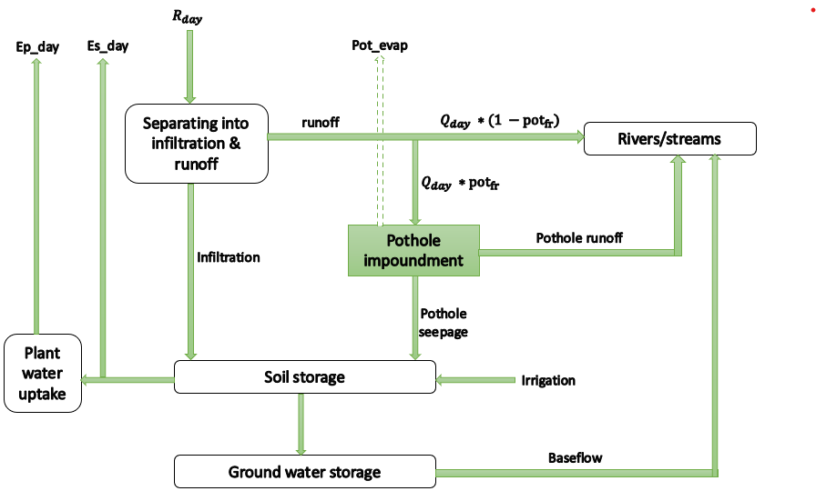
Fig. 1. Schematic diagram showing the pothole procedure in SWAT.
  - Paddy Water Dynamics Simulation Using ORYZA
ORYZA (v3) (Li et al., 2017) is an eco-physiological simulation model developed by the International Rice Research Institute (IRRI) that simulates rice growth and development under varying environmental, field, and crop management conditions. This model can be used to simulate production under water-limited and nitrogen-limited conditions, and potential (unlimited) conditions, in puddled or non-puddled lowland rice fields. A detailed explanation of the model and program code is provided by Bouman et al. (2001). Rice growth is modeled across four phenological stages: emergence, panicle initiation, flowering, and maturity. The one-dimensional, multilayer soil-water balance module, PADDY, dynamically simulates water flow, soil water content, and soil water tension in each soil layer. The daily water balance of a lowland rice field can be written as (Bouman et al., 2001):

$dW=I+R+C-E-T-S-P-D$ (2)
Where dW is the change in soil water storage, I is irrigation, R is rainfall, C is capillary rise, E is evaporation, T is transpiration, S is seepage, P is deep percolation, and D is surface runoff. The module includes a simplified dynamic groundwater routine that simulates groundwater depth, capillary rise, and drainage interactions in lowland rice systems.
  - Rice Growth Simulation Using DSSAT-CERES Rice
CERES-Rice, a physiologically-based crop model for rice, is integrated into the Decision Support System for Agro-technology Transfer (DSSAT), which was developed by the International Benchmark Systems Network for Agrotechnology Transfer (IBSNAT) (Jones et al., 2003). The model considers nine phenological events and stages, including five above-ground stages. The one-dimensional soil water balance is based on Ritchie's formulation (1972, 1998) and utilizes the concepts of drained upper limit (DUL) and lower limit (LL) to represent plant-available soil water. The change in soil water content for the soil profile is calculated daily using the following equation:

$∆S=P+I-EP-ES-R-D$ (3)
Where ∆S is the change in soil water content, P is the precipitation, I is the irrigation, EP is the transpiration, ES is the soil evaporation, R is the surface runoff, and D is the drainage from the soil profile.
The soil water balance uses a cascading-bucket approach, in which drainage occurs when soil water exceeds the DUL and is controlled by a constant drainage parameter (SWCON). Actual drainage is further limited by the saturated hydraulic conductivity, allowing water to accumulate above restrictive layers. DSSAT provides a limited representation of water table dynamics, with simplified groundwater-soil moisture interactions.
  - Soil Water Flow Simulation Using HYDRUS-1D
Hydrus-1D is a one-dimensional model that simulates the movement of water, heat, and multiple solutes in variably saturated media. This model uses mass-lumped linear finite-element schemes to numerically solve the Richards equation (Eq. (4)), which characterizes water movement in unsaturated, partially saturated, or fully saturated porous media (Šimůnek et al., 2005).

$\frac{∂θ}{∂t}=\frac{∂[K\left(h\right)\left(\frac{∂h}{∂z}+1\right)]}{∂z}-S$ (4)
Where $\frac{∂θ}{∂t}$ represents the rate of change in volumetric soil water content with respect to time, z is the vertical space coordinate (cm) defined as positive upward, K(h) is the hydraulic conductivity (cm/day), $h$ is the matric potential head (cm), and S is the root water uptake sink term (cm³/cm³/day). Paddy soil hydraulic properties were described using the van Genuchten (1980) functions, while root water uptake was estimated using the Feddes et al. (1978) approach.
The model accommodates various boundary conditions, including prescribed head, flux, atmospheric, and free-drainage boundaries. Although groundwater table fluctuations are prescribed through the lower boundary condition, HYDRUS-1D explicitly simulates groundwater influences on soil water dynamics, including capillary rise, saturation conditions, and transient groundwater–soil moisture interactions, by numerically solving Richards’ equation.
  - Development of the SWAT-Rice Module
The hydrological processes in paddy fields differ from those of other agricultural land. In this study, a physically based scheme is proposed to simulate paddy-field hydrology using a mass-balance framework as shown in Fig. 2. The daily water balance of the irrigated lowland rice fields in the enhanced model SWAT-Rice can be written as:
$H_{t}={H_{t-1}+R}_{t}+I_{t}-{Q_{surf}}_{t}-{EF}_{t}-{INF}_{t}$ (5)
Where, $H_{t}$and $H_{t-1}$ denote floodwater depth at the end of the current and previous days (mm), respectively; $R_{t}$ is precipitation (mm); $I_{t}$ is irrigation depth (mm); ${Q_{surf}}_{t}$is surface runoff or bund overflow (mm); ${EF}_{t}$ is floodwater evaporation (mm); and ${INF}_{t}$ is infiltration (mm). Estimation of each of these variables is discussed in detail in the subsequent sections.
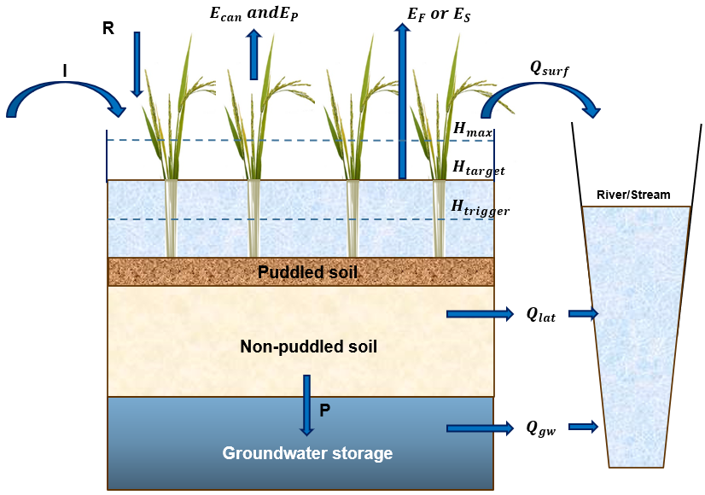
Fig. 2. Schematic illustration of the conceptual water balance, flow pathways, and irrigation controls in paddy fields.
The overall framework of the SWAT-Rice module is illustrated in Fig. 3. Several process-level enhancements have been incorporated into the model source code to improve the simulation of paddy water balance and rice-specific management practices. The module explicitly simulates transplanted and direct-seeded rice under both puddled and non-puddled conditions. Also, it can run in fully irrigated (continuous flooding), intermittent flooding/drying, or upland (no flooding) modes. When an HRU containing paddy fields is designated as impounded, irrigation (manual or automatic) is triggered, and the PADDY module is invoked to perform one-dimensional soil-water routing and redistribution under irrigated or rainfed conditions. The model accounts for puddling and soil shrinkage, with lateral subsurface flow, micropore, and macropore percolation computed accordingly. Subsequently, actual evapotranspiration and baseflow are estimated. Key improvements to SWAT2012 include (1) a depth-based water balance formulation for paddy HRUs, (2) a continuous irrigation scheme based on threshold and target water depths, and (3) Modelling of preferential flow through shrinkage cracks during paddy drying periods. Details of these modifications are described in the following subsections.
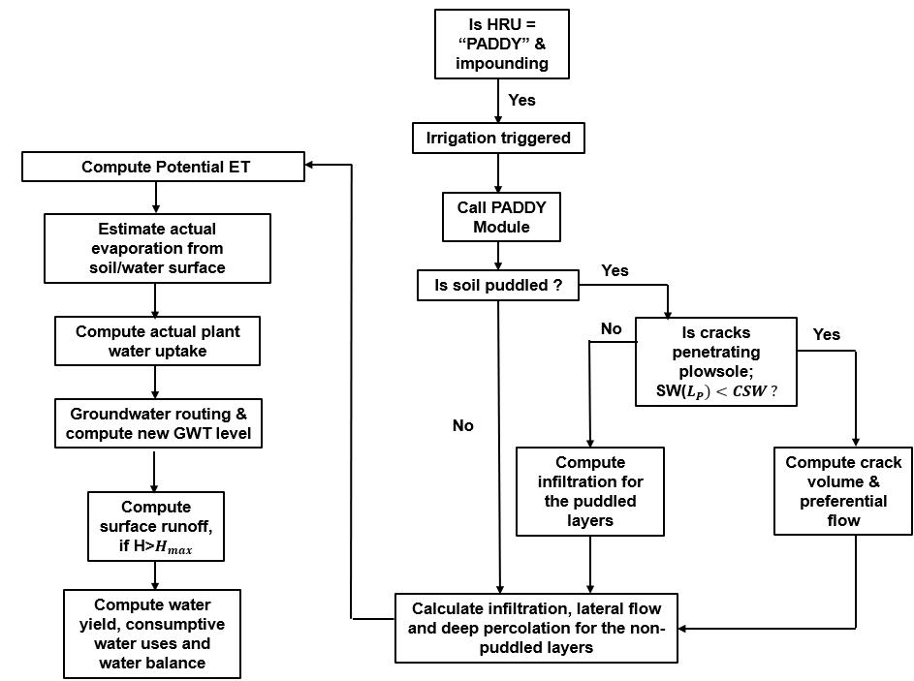
Fig. 3. Methodological framework of the new Paddy module.
    - Dynamic daily simulation of Ground water table (GWT)
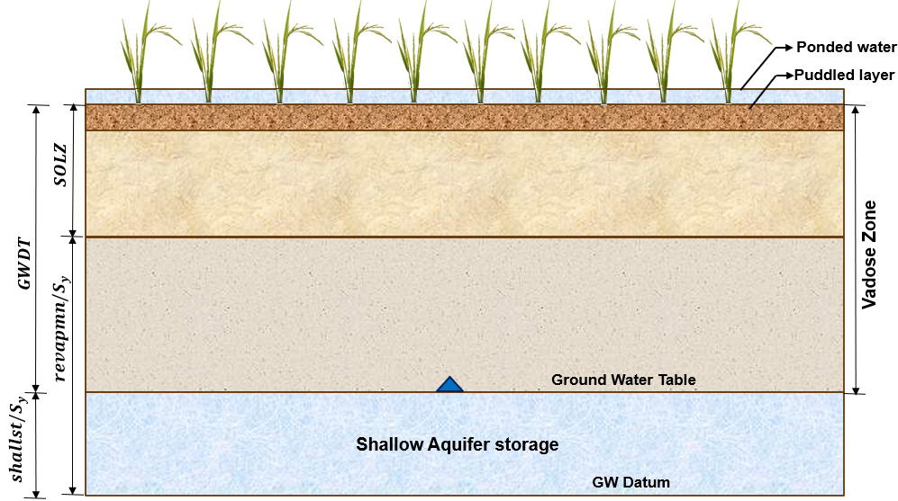
Fig. 4. Conceptual representation of the paddy-field soil profile and groundwater system in SWAT-Rice.
Lowland rice fields are often associated with shallow groundwater tables, which strongly influence percolation dynamics, irrigation requirements, and crop yield (Belder et al., 2007; Feng et al., 2007). Moderate groundwater depths (60–90 cm) tend to promote capillary rise and minimize percolation losses, whereas very shallow or deep-water tables increase deep percolation (Xu et al., 2017).
Percolation from the paddy field replenishes the underlying shallow aquifer. However, the standard SWAT model assumes a freely draining bottom boundary and does not account for groundwater-table effects on soil-water dynamics. To address this limitation, the enhanced modeling framework simulates daily groundwater table depth relative to a common datum (the bottom of the confining layer) and accounts for its interaction with soil water (Fig. 4). Since the fraction of water pertained to specific retention is strongly held by the aquifer matrix and unavailable for upward movement into the overlying vadose zone, specific yield itself is considered more appropriate for defining the groundwater datum. Accordingly, a virtual groundwater datum ($GW_{datum}$; mm) is initially defined using Eq. (6).
$GW_{datum}=\frac{REVAPMN}{S_{y}}+SOL_Z$ (6)
Where REVAPMN is the threshold water depth in the shallow aquifer above which groundwater can rise into the soil profile and contribute to evaporation losses (mm), $S_{y}$ is the specific yield of the shallow aquifer, and SOL_Z is the total depth of the soil profile (mm). The initial available water stored in the shallow aquifer (mm) is then calculated from the measured groundwater table depth (GWDT) from the soil surface at the beginning of the simulation using Eq. (7).
$SHALLST={(GW}_{datum} +GWDT)* S_{y}$ (7)
The groundwater table is updated daily, accounting for evaporation and baseflow losses, as shown in Eq. (8).
$GWDT={GW}_{datum} -\left(\frac{SHALLST-Q_{gw}-w_{revap}}{S_{y}}\right)$ (8)
Where $Q_{gw}$ is the groundwater discharge (baseflow) to the main channel (mm); $w_{revap}$ is the evaporation from the shallow aquifer to the soil profile in response to soil moisture deficits (mm).
    - Puddling operation

Puddling involves repeated plowing and harrowing under flooded conditions, forming a softened muddy top layer (typically 10–20 cm) and a compacted plow sole (typically 2–5 cm) that together reduce hydraulic conductivity. Along with field bunds, this helps retain standing water by reducing macropores and preferential flow pathways. The settling of fine soil particles further decreases saturated hydraulic conductivity ($K_{sat}$), keeping the surface soil saturated. The effectiveness of puddling in reducing water loss depends on the intensity and depth of puddling (Kukal and Aggarwal, 2002).
In the new paddy module, the vertical profile of a puddled paddy is conceptualized as a ponded-water layer over a puddled-soil layer, a compacted plow sole, and the underlying subsoil (Bouman et al., 2001). The reduction in hydraulic conductivity due to puddling is expressed using a puddling coefficient, following approaches used in APEX-based paddy field modifications (Choi et al., 2017) and the SWAT-Rice modeling framework (Tsuchiya et al., 2018) (Eq. (9)).
$K_{PUD}={coeff}_{PUD}*K_{sat}$ (9)
where $K_{PUD}$ is the hydraulic conductivity of the plow sole (mm/h), ${coeff}_{PUD}$ is the puddling coefficient (<1), and $K_{sat}$ is the saturated hydraulic conductivity before puddling (mm/h). This adjustment is applied to puddled soil layers, including the plow sole, when a user-defined plow sole depth is specified.
    - Enhanced Representation of Crack-Induced Percolation under AWD
During Alternate Wetting and Drying (AWD) irrigation, drying of puddled soil causes shrinkage cracks to form in the puddled layer and plow sole. These cracks may extend into the subsoil, allowing rainfall or irrigation water to bypass the root zone and rapidly drain into deeper soil layers. To simulate preferential flow under AWD, the shrinkage-crack formation criteria from the ORYZA model (Bouman et al., 2001) are integrated into the SWAT crack routine. Field experiments conducted at IRRI indicate that cracks penetrate the plow sole when its soil water tension exceeds 100 kPa. In SWAT-Rice, when the actual soil water content of the plow sole drops below the critical water content for cracking (WCCR), cracks are assumed to have penetrated the plow sole, as calculated in Eq. (10).
$WCCR={WP}_{PUDD}+\left(\frac{{FC}_{PUDD}- {WP}_{PUDD}}{2.2}*\left(4.2-PFCR\right)\right)$ ; if $(0≤PFCR≤4.2)$ (10)
where WCCR is the critical water content at which crack formation is triggered; FC is soil water content at field capacity; WP is soil water content at wilting point; PFCR is the critical soil water tension above which crack formation is triggered (pF, pF = log₁₀ |10 × h|, where h is soil water tension in kPa).
Subsequently, daily crack volume and bypass flow are estimated using the SWAT crack flow routine. On days when precipitation or irrigation occurs, water enters cracks, contributing to bypass flow. Flow past the bottom of the puddled soil zone ($w_{crk,btm }, mm)$ is estimated as (Neitsch et al., 2011):
$w_{crk,btm }=0.5*crk*(\frac{{crk}_{ly=nn}}{{depth}_{ly=nn}})$ (11)
Where $crk$ is the total volume of the crack within the puddled layers (mm); ${crk}_{ly=nn}$ is crack volume for the plow sole (mm); ${depth}_{ly=nn}$is the depth of the plow sole (mm). Once the bypass flow is calculated, soil layers are refilled to field-capacity water content from the plow pan upward, and excess water percolates into the underlying non-puddled soil through micropore flow.
    - Improved estimation of infiltration and soil water routing
In flooded paddy fields, rainfall and irrigation first accumulate as ponded water, due to soil puddling and field bunds. Infiltration occurs from this ponded layer whenever the soil profile is unsaturated. The excess water above field capacity moves laterally to adjacent fields or channels and vertically downward through successive soil layers via gravitational drainage. In the new SWAT-Rice module, soil-water redistribution and root-zone drainage are computed using the Ritchie formulation (Ritchie, 1998), adapted to account for daily groundwater-table fluctuations and their interaction with the soil-water profile (water balance Eq. (5)). PADDY is the main module that calculates the water balance components of the paddy field, while the newly added INFIL and SATFLO modules simulate soil water routing during wetting and drying phases, respectively.
During infiltration, water cascades through successive soil layers according to their storage capacity and hydraulic conductivity. Potential water available for infiltration (PINF) is initially calculated using Eq. (12).
$PINF=H+I+R$ (12)
where H is the ponded water depth at the beginning of the time step (mm); I is the irrigation (mm), and R is the rainfall (mm). For puddled soil layers, free drainage of water is restricted and the storage capacity of each soil layer ($SWDELTS$) is calculated from water content at the beginning of the day (${SW}_{ly}$) and saturated water content (${SAT}_{ly}$) (Eq. (13)).
${SWDELTS}_{ly}={SAT}_{ly}-{SW}_{ly}$ (13)
Then the actual infiltration (INF) for the puddled soil (Eq. (14)) and drainage from the plow sole ($SEPDAY)$ (Eq. (15)) is estimated. $SEPDAY$ will infiltrate into the underlying subsoil.
$INF=\left\{\begin{aligned}PINF ; if \sum_{ly=1}^{N_{PUD}}{{SWDELTS}_{ly}}> PINF \\ \sum_{ly=1}^{N_{PUD}}{{SWDELTS}_{ly}} ; if \sum_{ly=1}^{N_{PUD}}{{SWDELTS}_{ly}}≤ PINF\end{aligned}\right\}$ (14)
$SEPDAY=MIN(K_{PUD},PINF-INF)$ (15)
For non-puddled layers, infiltration estimation starts with updated soil water content (${SW}_{ly}$) as shown in Eq. (16). Here, $PINF$= $H+I+R$ if the field is non-puddled and $PINF$=$SEPDAY$for non-puddled subsoil in puddled fields. Drainage and lateral flow occur whenever ${SW}_{ly}$ exceeds the field capacity (${FC}_{ly}$). The drainable volume of water stored (${SW}_{ly,excess}$) is calculated using Eq. (17).
${SW}_{ly}={SW}_{ly}+PINF$ (16)
${SW}_{ly,excess}=\left\{\begin{aligned}{SW}_{ly} - {FC}_{ly} ; if \left(SO{L_Z}_{ly}≤GWDT\right) \\ \left({SW}_{ly} - {FC}_{ly}\right)* \frac{GWDT -SO{L_Z}_{\left(ly-1\right)}}{{depth}_{ly}} ; if \left(SO{L_Z}_{ly} > GWDT\right)& \end{aligned}\right\}$ (17)
Where GWDT is the groundwater table depth from the soil surface (mm); $SO{L_Z}_{ly}$is the depth to the bottom of the soil layer (mm); ${depth}_{ly}$ is the thickness of the soil layer (mm). During the paddy ponding period, two cases are then analyzed based on the value of $PINF$. if $PINF$ ≤ ${SWDELTS}_{ly}$, drainable pore volume ($DRCM, mm$) and percolation rate from the soil layer, ${(DRN}_{ly}, mm)$are estimated using Eq. (18) and Eq. (19), respectively.
$DRCM=\left\{\begin{aligned}0.9 *SWCON *\left({SW}_{ly}-{FC}_{ly}\right) ; if\left(ly=1\right) \\ SWCON *\left({SW}_{ly}-{FC}_{ly}\right) ; if (ly>1)\end{aligned}\right\}$ (18)
${DRN}_{ly}= DRCM$ (19)
Where $SWCON$ is the whole-profile drainage rate coefficient, a user-defined parameter. To allow increased evaporation from wet soils, SWCON is reduced in the topsoil layer. If PINF > ${SWDELTS}_{ly}$, $DRCM$ (Eq. (20)) and ${DRN}_{ly}$ (Eq. (21)) is estimated accordingly. The value of $PINF$ is then set equal to ${DRN}_{ly}$ for computing the percolation rate from successive soil layers. If the groundwater table is within a soil layer, ${DRN}_{ly}$ is set to zero in both cases.
$DRCM=\left\{\begin{aligned}0.9 *SWCON *\left({SAT}_{ly}-{FC}_{ly}\right) ; if\left(ly=1\right) \\ SWCON *\left({SAT}_{ly}-{FC}_{ly}\right) ; if (ly>1)\end{aligned}\right\}$ (20)
${DRN}_{ly}=\left(PINF -{SWDELTS}_{ly}\right)+DRCM$ (21)
During water ponding conditions, soil layers remain near saturation, maintaining high hydraulic conductivity and a strong downward hydraulic gradient that leads to faster percolation. During the drying period, soil becomes unsaturated, hydraulic conductivity declines, and the downward gradient weakens, slowing vertical drainage between layers (Tuong and Bouman, 2003; Genuchten and Pachepsky, 2011). Therefore, when ponded water is absent, the $DRCM$ (Eq. (22)) and ${DRN}_{ly} (Eq. (23))$for each soil layer is calculated using SATFLO routine in the new SWAT-Rice model.
$DRCM=SWCON *\left({SW}_{ly}-{FC}_{ly}\right) ; {if SW}_{ly}>{FC}_{ly}$ (22)
${DRN}_{ly}=\left\{\begin{aligned}DRCM ; if ly=1 \\ {DRN}_{ly-1}+{DRCM}_{ly}-HOLD ;if ly>1\end{aligned}\right\}$ (23)
Where$, HOLD={FC}_{ly}-{SW}_{ly}$. The calculated ${ DRN}_{ly}$ is limited by the saturated hydraulic conductivity of each soil layer ($K_{sat, ly}$). ${DRN}_{ly}$ from the bottommost soil layer is deep percolation from the soil profile (P), which contributes to groundwater recharge and often represents a major component of water loss, particularly in coarse-textured soils.
Lateral subsurface flow is modeled using the hillslope storage method of Sloan and Moore (1984), as implemented in the standard SWAT model (Eq. (24)).
$Q_{lat}=0.024*\left(\frac{2*{SW}_{ly,excess}*K_{sat}*slp}{φ_{d}*L_{hill}}\right)$ (24)
$φ_{d}=φ_{soil}$- $φ_{fc}$ (25)
Where, $K_{sat}$ is the saturated hydraulic conductivity (mm/h); $slp$ is the slope of the hillslope segment; $L_{hill}$ is the ℎ𝑖𝑙𝑙𝑠𝑙𝑜𝑝𝑒 𝑙𝑒𝑛𝑔𝑡ℎ (𝑚); $φ_{d}$ is the drainable porosity of the soil layer (mm/mm); $φ_{soil}$ is the total porosity of the soil layer; $φ_{fc}$ is the porosity of the soil layer at field-capacity.
The total infiltrated water (${INF}_{total}$) from the ponded water layer into the soil profile is calculated using Eq. (26).
${INF}_{total}=INF+ P+Q_{lat}$ (26)
Where INF is the actual water stored within the entire soil profile after deep percolation ($P$) and lateral subsurface flow losses ($Q_{lat}$).

    - Incorporation of groundwater-soil water feedbacks
To represent shallow-water-table interactions with soil-water dynamics, the SWAT groundwater routine was modified. When the groundwater table lies within a soil layer, percolation from the overlying layer is retained in that layer (Section 2.5.4). However, recharge to the aquifers ($w_{rchrg})$ is deducted from soil-water storage, while groundwater removed through evaporation from the shallow aquifer ($w_{revap})$ is added to that layer. Accordingly, the soil-water storage of the groundwater-containing layer is updated using Eq. (27).
${SW}_{ly}= {SW}_{ly}-w_{rchrg}+w_{revap} ;if(SO{L_{Z}}_{ly}≥$ GWDT >$SO{L_Z}_{(ly-1)})$ (27)
Also, when the simulated groundwater table rises into the soil zone at any time step, a groundwater–soil moisture exchange approach adapted from Bailey and Hosseini (2022) is applied. The groundwater volume occupying the saturated portion of the soil profile is calculated as:
${GW}_{i}=\left(SO{L_Z}_{\left(ly=n\right)}-GWDT\right)*S_{y}$ (28)
This volume is transferred from shallow-aquifer storage to soil-water storage (Eq. (29) and Eq. (30)).
${SW}_{tot}={SW}_{tot}+{GW}_{i}$ (29)
$SHALLST= SHALLST-{GW}_{i}$ (30)
Where, ${GW}_{i}$ is the groundwater inflow to the soil profile (mm); $SO{L_Z}_{\left(ly=n\right)}$ is the depth to the bottom of the soil profile (mm); GWDT is the groundwater-table depth (mm); $S_{y}$is the specific yield; ${SW}_{tot}$ is the total soil-water storage (mm); SHALLST is the shallow-aquifer storage (mm). The transferred groundwater volume is distributed among the soil layers in proportion to the fraction of the groundwater-table depth in each layer (Eq. (31)).
${SW}_{ly}=\frac{SO{L_Z}_{\left(ly\right)}-max⁡(GWDT, SO{L_Z}_{\left(ly-1\right)}) }{SO{L_Z}_{\left(ly=n\right)}-GWDT}$* ${GW}_{i}+{SW}_{ly}$ (31)
This formulation enables exchange between groundwater and the soil profile under shallow-water-table conditions, while maintaining water balance between the groundwater and soil-water compartments.
    - Improved estimation of evapotranspiration

Evapotranspiration (ET) calculations in the standard SWAT model are primarily designed for land surfaces/crop canopies and do not explicitly account for evaporation from ponded water. To improve potential evapotranspiration (PET) estimation in paddy fields, the enhanced model computes the surface reflection coefficient (ρ) following ORYZA (Bouman et al., 2001) within the Priestley–Taylor (Priestley and Taylor, 1972) and Penman–Monteith (Monteith, 1965) PET methods. Recent work by Jeong et al. (2025) further highlighted the importance of PET estimation in paddy systems by identifying the PET coefficient (PETCO) as a highly influential parameter that controls the paddy water balance.
The overall reflection coefficient ($ρ)$is determined from the combined contributions of the underlying surface (soil or water; $ρ_{s}$) and the crop canopy ($ρ_{c})$. The reflection of the underlying surface is governed by its albedo ($α);$When ponded water depth exceeds 5 mm, the water albedo (≈0.05) is used; otherwise, the soil albedo is used. The albedo of dry soil is taken as 0.25. Since soil reflectance decreases with increasing moisture content, the soil reflection coefficient is adjusted using the ratio of actual to saturated water content in the topsoil layer (ten Berge, 1989). The $ρ_{s}$ is computed using Eq. (32).
$ρ_{s}=\left\{\begin{aligned}α *\left(1-0.5*\frac{{SW}_{ly=1}}{{SAT}_{ly=1}}\right) ; for soil surface \\ 0.05 ; for water surface \end{aligned}\right\}$ (32)
The combined surface reflectance ($ρ$) depends on canopy shading, represented using an exponential extinction of radiation through the canopy (Eq. (33)).
$ρ=ρ_{s} *\exp\left(-k*LAI\right)+ρ_{c} *(1-exp\left(-k*LAI\right))$ (33)
where ρ_{c} is the reflection coefficient of the crop surface (≈0.25), LAI is the leaf area index, and k is the solar radiation extinction coefficient (taken as 0.5). When LAI equals zero, the reflection coefficient reduces to that of bare soil or ponded water.
Actual evapotranspiration (${ET}_{act}$) from paddy fields consists of plant transpiration ($E_{P}$), evaporation from crop canopy ($E_{can})$ and evaporation from either impounded water ($EF$) or soil surface ($E_{S}$) in the absence of ponding. When paddy is impounded and standing water is present, evaporation is first satisfied from the canopy storage, followed by floodwater evaporation and soil evaporation. Maximum floodwater evaporation (${EF}_{max}$) is calculated (Eq. (34)) using the DSSAT crop modeling approach (Jones et al., 2003) as a function of PET and leaf area index (LAI). Actual floodwater evaporation (Eq. (35)) is limited by the available floodwater depth ($H_{available}$) in the field.
${EF}_{max}=\left\{\begin{aligned}PET *\left(1-0.53 *LAI\right) ; if\left(LAI≤0.85\right) \\ \frac{PET}{1.1 *exp⁡(-0.6 *LAI)} ;if(LAI>0.85)\end{aligned}\right\}$ (34)
$EF=\left\{\begin{aligned}E_{F_max} ;if E_{F_max}≤H_{available} \\ H_{available} ;if E_{F_max}> H_{available} and H_{available}>0 \\ 0 ;otherwise\end{aligned}\right\}$ (35)
Where $H_{available}={H_{t}+R}_{t}$+$I_{t}-{INF}_{t}$. If there is any unmet evaporative demand, it will be satisfied from the underlying soil itself (Eq. (36)). The model computes daily soil evaporation and plant transpiration as described by Ritchie (1972); further details are provided in the SWAT theoretical documentation (Neitsch et al., 2011).
$E_{s_max,new}=\left\{\begin{aligned}min\left(EF-H_{available},E_{s_max}\right) ;if E_{F_max}> H_{available} \\ 0 ;if E_{F_max}≤ H_{available}\end{aligned}\right\}$ (36)
Where $E_{s_max}$ is the potential soil evaporation and $E_{s_max,new}$ is the potential soil evaporation adjusted for floodwater evaporation.
    - Modified Irrigation and Drainage Algorithm
In irrigated lowland rice systems, farmers usually maintain 5–10 cm of standing water during the crop growth period (Bouman et al., 2007). Since farmers commonly irrigate their fields up to a target water level, the new module employs the concept of three critical water depths proposed by Xie and Cui (2011) for continuous flooding simulation: irrigation trigger depth ($H_{trigger}$), irrigation target depth ($H_{target}$), and maximum depth ($H_{max}$). These thresholds can vary with crop growth stage. When the ponded water depth (H) falls below $H_{trigger}$, the model calculates the irrigation depth (I) required for the field (Eq. (37)).
${I=H}_{target}-H$ ; when $H<H_{trigger}$ (37)
$Q_{surf}=H-H_{max}$ (38)
Surface runoff is triggered when the ponded water depth exceeds $H_{max}$ as given in Eq. (38). This runoff is aggregated at the subbasin outlet before entering the stream network. During the paddy water release period, ponded water in the impoundment will be released as surface runoff.
    - Modified soil water balance
The soil water content at the end of the day for the paddy HRU is calculated by deducting total outflows from total inflows (Eq. (39)).
${SW}_{t}={SW}_{t-1}+H_{t-1}+R_{t}$+$I_{t}+{GW}_{i}-{Q_{surf}}_{t}-{Q_{lat}}_{t}-{ET}_{t}-P_{t}-H_{t}$ (39)
Where ${SW}_{t} and {SW}_{t-1}$ are the soil water content at the end of the current day and previous days (mm); $H_{t}$ and $H_{t-1}$ are the ponded water depth at the end of the current day and previous days (mm); $R_{t}$ is rainfall (mm); $I_{t}$ is irrigation (mm); ${GW}_{i}$ is groundwater inflow (mm); ${Q_{surf}}_{t}$ is surface runoff (mm);${Q_{lat}}_{t}$ is the lateral flow (mm); ${ET}_{t}$ is the actual evapotranspiration (mm) and $P_{t}$is percolation past the bottom of the soil profile (mm).
During the paddy water release period, HRU is modeled as a standard SWAT HRU. However, in fields with a shallow water table, the standard SWAT formulation may overestimate percolation losses because groundwater-table effects are not considered. To address this limitation, the calculation of ${SW}_{ly,excess}$​ was revised (Eq. (17)).
  - Model configuration
To incorporate the enhancements described in Section 2.5, the original SWAT FORTRAN code (Rev. 670) was modified using Intel Visual Fortran in the Intel® oneAPI Toolkits (2023) environment, integrated with Microsoft Visual Studio 2022. Table 1 summarizes the formulations and contributions in the SWAT-Rice model. The proposed improvements were implemented across 20 existing SWAT subroutines, along with three new subroutines: PADDY, INFIL, and SATFLO. The ‘PADDY.f’ module was set to call in the ‘subbasin.f’ subroutine. This module serves as the primary routine for simulating soil water routing in both puddled and non-puddled soils under wetting and drying conditions, including preferential flow through shrinkage cracks. The subroutines ‘INFIL.f’ and ‘SATFLO.f’, which calculate soil-water routing for non-puddled soil layers under wetting and drying conditions, were called from the ‘PADDY.f’ module. The ‘crackvol.f’ and ‘percmacro.f’ subroutines were revised to compute crack volume and preferential flow within puddled soil layers. Initial estimates of groundwater table depth were incorporated in ‘readgw.f’ and dynamically updated in ‘gwmod.f’ subroutine. Revised estimation of the reflection coefficient was updated in ‘etpot.f’ subroutine, while floodwater evaporation and updated estimation of actual evapotranspiration from paddy HRUs were included in the subroutine ‘etact.f’. Computation of daily ponded water depth and surface runoff reaching the main channel during the day was incorporated within the ‘subbasin.f’ module. Revised computation of soil water excess (${SW}_{ly,excess}$) during the paddy release period was implemented in ‘percmain.f’, as described in Eq. (17). Daily outputs, including ponded water depth, infiltration, deep percolation, soil evaporation, and plant transpiration, were written to the ‘output.wtr’ file. After updating all routines, the main program (main.f) sequentially reads inputs and executes daily simulations.
Table 2 compares the paddy-related parameters used in the existing SWAT pothole method (SWAT-P) and the newly developed SWAT-Rice model. SWAT-Rice provides user-defined options to explicitly specify puddling status, puddled-layer depth, and preferential-flow activation. In addition, puddling effects are represented using PUD_COEFF, a dimensionless parameter ranging from 0 to 1, rather than POT_K, which represents hydraulic conductivity in mm h⁻¹. The dimensionless formulation of PUD_COEFF provides a more standardized and user-friendly representation of the effect of puddling. The SWAT-P pothole approach includes three calibration parameters (POT_K, POT_VOLX, and EVLAI), whereas SWAT-Rice includes four calibration parameters (PUD_COEFF, SWCON, DEP_PD, and H_max).
Table 1 Summary of Formulations and Contributions in SWAT-Rice
Component | Origin/source | Implementation approach in SWAT-Rice | Contribution
Paddy water balance | DSSAT-CERES Rice; ORYZA | Adapted and integrated | Reformulated within the SWAT HRU water-balance framework
Puddling effect | Choi et al., 2017; Tsuchiya et al.2018 | Adapted | Incorporated into multilayer paddy-specific soil-water routing
Soil-water routing | DSSAT-CERES Rice | Adapted and integrated | Adapted to daily variations in groundwater level
Crack formation criterion | ORYZA | Adapted | Incorporated crack formation criterion with preferential flow processes
Macropore percolation | SWAT | Modified | Coupled with puddled and non-puddled soil layers
PET formulation | ORYZA | Adapted | ORYZA-based reflection coefficient incorporated into SWAT PET calculation
Ponded-water evaporation | DSSAT-CERES Rice | Adapted | Integrated into SWAT actual ET calculation
Actual ET | DSSAT-CERES Rice, SWAT | New integrated formulation | Sequential estimation of canopy, ponded-water, and soil-water contributions
Groundwater–soil-water exchange processes | SWAT; Bailey and Hosseini (2022) | New formulation | Daily GWT update and exchange between shallow aquifer and soil profile

Table 2 Comparison of parameters used in the standard SWAT pothole and SWAT-Rice formulations
Model | Category | SWAT variable | Description | Units | Range / value used | File
SWAT-P | Irrigation | irr_mx | Maximum irrigation water depth applied | mm | 0–120 | .MGT
SWAT-P | Irrigation | imp_trig | Impoundment trigger: 0 = begin impounding water; 1 = release impounded water | – | 0 or 1 | .MGT
SWAT-P | Ponding | POT_FR | Fraction of HRU are that drains into pothole | – | 0-1 | .HRU
SWAT-P | Ponding | POT_VOL | Initial volume of water stored in the pothole, expressed as water depth | mm | 0–120 | .HRU
SWAT-P | Ponding | POT_VOLX | Maximum volume of water that can be stored in the pothole, expressed as water depth | mm | 0–120 | .HRU
SWAT-P | Ponding | EVLAI | LAI at which no evaporation occurs from the water surface | – | > 0 | .BSN
SWAT-P | Puddling | POT_K | Hydraulic conductivity of the pothole surface layer | mm h⁻¹ | >0 | .HRU
SWAT-Rice | Irrigation | H_target | Target ponded-water depth for irrigation management | mm | 0–120 | .MGT
SWAT-Rice | Irrigation | imp_trig | Impoundment trigger: 0 = begin impounding water; 1 = release impounded water | – | 0 or 1 | .MGT
SWAT-Rice | Ponding | H_initial | Initial ponded-water depth | mm | 0–120 | .HRU
SWAT-Rice | Ponding | H_max | Maximum allowable ponded-water depth | mm | 0–120 | .HRU
SWAT-Rice | Puddling | SWITPD | Puddling status switch: 0 = non-puddled; 1 = puddled | – | 0 or 1 | .HRU
SWAT-Rice | Puddling | DEP_PD | Thickness of the puddled soil layer | mm | 0–500 | .HRU
SWAT-Rice | Puddling | PUD_COEFF | Puddling coefficient: reduction in hydraulic conductivity due to puddling expressed as fraction | – | 0–1 | .HRU
SWAT-Rice | Soil water drainage | SWCON | Whole-profile drainage rate constant | – | 0–1 | .HRU
SWAT-Rice | Preferential flow | PFCR | Critical soil-water tension at which shrinkage cracks penetrate the plow sole | pF | 0–4.2* | .HRU
* PFCR is applicable when the crack-flow option (icrk = 1) is activated. The upper limit of 4.2 pF corresponds to the permanent wilting-point threshold used in the SWAT implementation.
- Model evaluation using Case studies
  - Study Area
The improved SWAT-Rice model was set-up for 10 paddy fields spread across the Gadana River basin, covering a drainage area of about 447 km² (Fig. 5), to evaluate its performance in simulating paddy water balance. The basin receives an average annual rainfall of about 762 mm, mainly during the Northeast monsoon (56%), followed by summer rains (23%), the Southwest monsoon (12%), and a smaller contribution during the cold weather period (9%). The basin was selected as a case study due to its extensive paddy cultivation, with about 60% of the total land area and 87.5% of the agricultural land being paddy fields. Rice is predominantly grown in two seasons: Kar (June–September) and Pishanam (October–February).
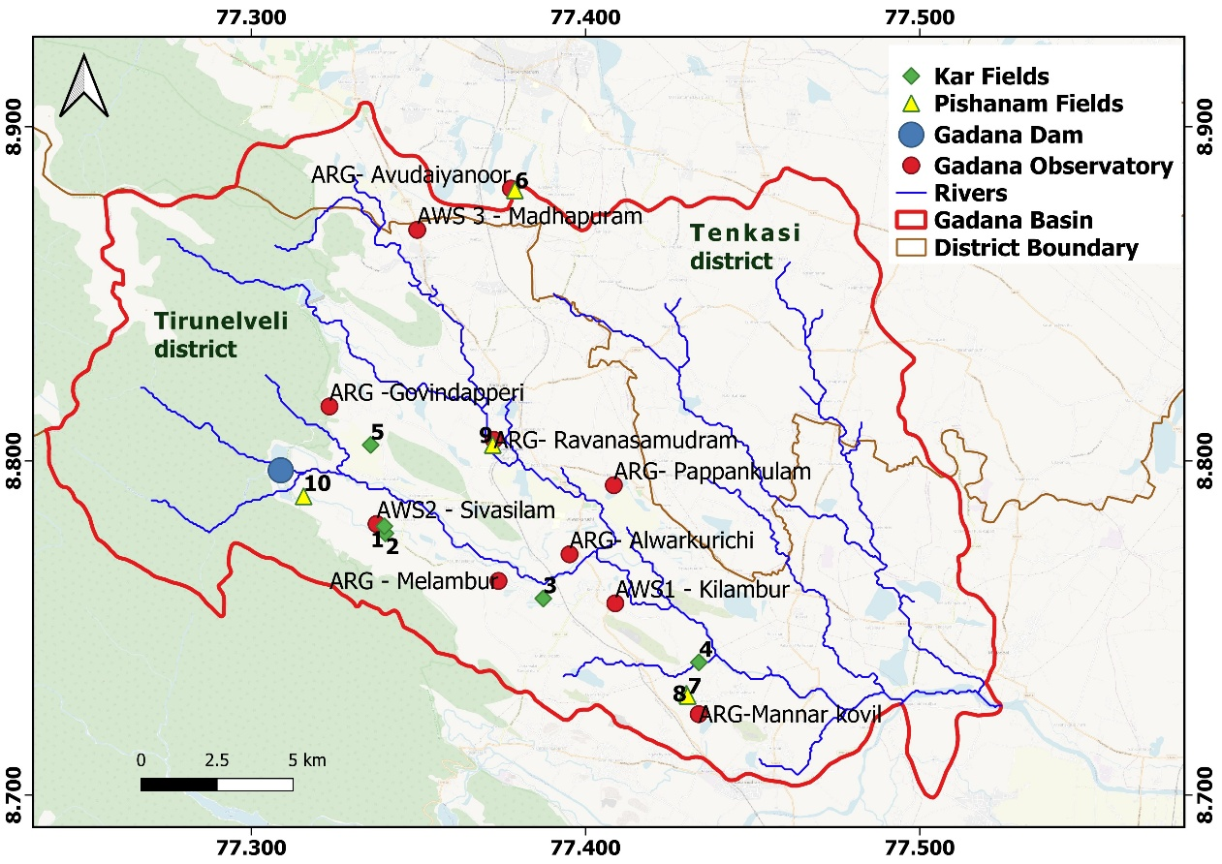
Fig. 5. Location map of the study area showing the ten selected paddy fields.
  - Datasets
Model simulations using SWAT-Rice, and cross-model comparisons with DSSAT-CERES Rice, ORYZA, HYDRUS-1D and SWAT-P, require meteorological, crop, soil, and management data. The study was conducted during the Kar season (2024) and the Pishanam season (2024–2025) across ten farmer fields in the Gadana basin. Paddy field water balance under both direct-seeded (DS) and transplanted (TP) cultivation in puddled fields was evaluated using all models. Daily meteorological variables, including precipitation, minimum and maximum temperature, solar radiation, wind speed, and humidity, were collected from the nearest Automatic Weather Stations (AWS) and Automatic Rain Gauge (ARG) stations (Fig. 5, Table 3). Crop characteristics (planting method, variety) and crop calendar details (sowing, transplanting, and harvest dates) were gathered from farmer surveys. Soil data were derived from the NBSS & LUP soil maps with a scale of 1:250,000 (Bhattacharyya et al., 2009). Table 4 summarizes the physical and hydraulic properties of the soil, derived from the NBSS soil map, which are identical for all 10 paddy fields. Groundwater table depth at each field was monitored at the start of the cropping season. Field water tubes were installed in each farmer's fields to monitor irrigation water depth and field water levels. The PVC tubes, 2 ft in height and perforated along three-quarters of their length, were inserted 1 ft into the soil. A sensor to measure soil water potential was also installed at mid-height of the field tube, so that its top aligned with the ground surface. Measurements were recorded daily in the morning, both before and after irrigation. The difference between them indicates the daily irrigation water applied to the field. The daily changes in field water level before irrigation indicate total water losses, including evapotranspiration and percolation. Fig. 6 illustrates the vertical soil profile of the study area with installed field water tube.
Table 3 Details of crop characteristics and crop calendar for the study fields.
Kar Season (2024)
Field | Lat | Long | ARG | AWS | GWT depth (m) | Planting method | DOS | DOP | Variety | Harvest | Crop days
1 | 8.7783 | 77.3401 | Sivasilam | Sivasilam | 0.6 | DS | 25/6/2024 |  | IR-50 | 28/9/2024 | 95
2 | 8.7804 | 77.3398 | Sivasilam | Sivasilam | 0.6 | DS | 5/7/2024 |  | 1R-50 | 11/10/2024 | 98
3 | 8.7588 | 77.3874 | Melambur | Kilambur | 4.5 | TP | 25/7/2024 | 16/8/2024 | TPS-5 | 23/11/2024 | 121
4 | 8.7397 | 77.4339 | Mannarkovil | Kilambur | 1.2 | TP | 11/7/2024 | 2/8/2024 | TPS-5 | 14/11/2024 | 126
5 | 8.8048 | 77.3357 | Govindapperi | Sivasilam | 1.5 | TP | 1/7/2024 | 29/7/2024 | TPS-5 | 27/10/2024 | 118
Pishanam Season (2024-2025)
6 | 8.8809 | 77.3789 | Avudaiyanoor | Madhapuram | 4.5 | TP | 20/11/2024 | 22/12/2024 | Amman Ponni | 1/4/2025 | 132
7 | 8.7296 | 77.4306 | Mannarkovil | Kilambur | 4 | TP | 5/12/2024 | 28/12/2024 | Aadhudurai 45 | 18/3/2025 | 103
8 | 8.7303 | 77.4302 | Mannarkovil | Kilambur | 4 | TP | 13/11/2024 | 5/12/2024 | Aaduthurai 45 | 18/3/2025 | 125
9 | 8.8048 | 77.3723 | Ravanasamudram | Sivasilam | 3 | TP | 1/11/2024 | 1/12/2024 | Delux  Ponni | 10/3/2025 | 129
10 | 8.7894 | 77.3157 | Sivasilam | Sivasilam | 0.6 | DS | 21/11/2024 |  | T.K 54 | 31/03/2025 | 130
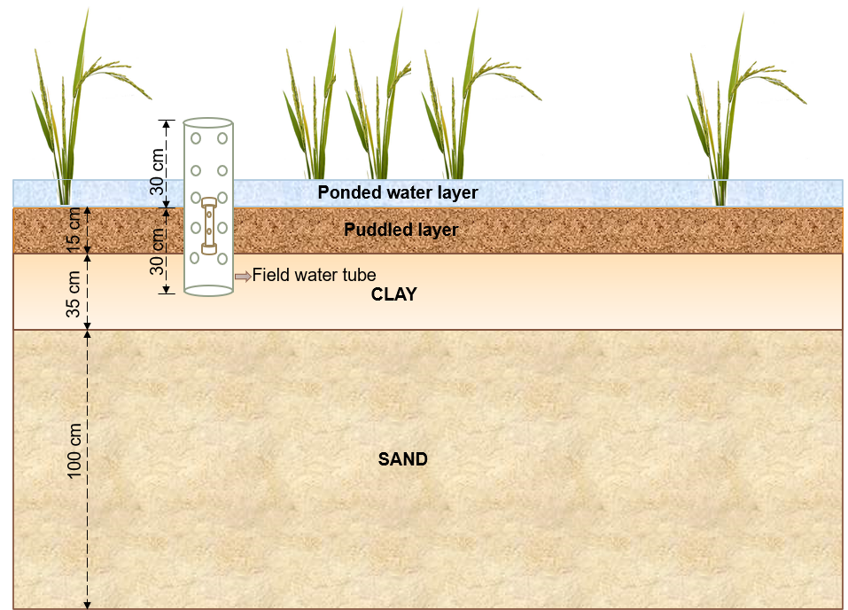
Fig. 6. Schematic vertical soil profile of the study area showing the installed field water tube.
Table 4 Physical and hydraulic properties of the soil layers.
Soil layer | Thickness (cm) | % Clay | % Silt | % Sand | Bulk density  (g/cm3) | Lower limit (PWP) | Drained upper limit (FC) | Saturated volumetric water content | $K_{sat}$  (cm/d)
1 | 15 | 50 | 20 | 30 | 1.38 | 0.276 | 0.401 | 0.479 | 1.174
2 | 35 | 50 | 20 | 30 | 1.38 | 0.276 | 0.401 | 0.479 | 1.174
3 | 100 | 5 | 3 | 92 | 1.65 | 0.033 | 0.0678 | 0.377 | 265.05

  - Model Parameterization and inter-model comparison
To ensure a consistent basis for inter-model comparison, the model configurations were parameterized using common field observations and management information when corresponding inputs were available (Table 5). However, some necessary model-specific parameters for which direct observations were unavailable were calibrated against the observed daily ponded-water levels. Common field conditions, including soil physical and hydraulic properties, bund height, puddling depth, crop calendar, and irrigation schedules, were kept identical across models (Table 5). Simulations were initiated on the sowing date, and irrigation was manually scheduled based on field records. The maximum allowable ponded-water depth ($H_{max}$) was obtained from observed field water levels, and a puddling depth of 150 mm was used for all fields based on field observations. The soil profile was initially assumed to be saturated.
Model-specific parameters were calibrated only where necessary to reproduce observed field behavior. These included the puddling coefficient or effective hydraulic conductivity of the puddled layer, groundwater-related parameters, and selected model-specific evapotranspiration parameters. The effective hydraulic conductivity of the puddled layer was calibrated within a physically constrained range, with an upper limit of 7 mm d⁻¹ based on the clay-rich soil characteristics of the study area and reported percolation rates for paddy fields (Wickham and Singh, 1978; Tabbal et al., 2002; Rezaei et al., 2012). The puddled-layer hydraulic conductivity was the only calibration parameter used for the ORYZA and DSSAT-CERES Rice models, and the calibrated values across the fields are shown in Table 7. Crop-growth parameters in ORYZA, DSSAT-CERES Rice, and the SWAT-based models were adjusted to reproduce a common LAI trajectory within the range reported for irrigated rice in South India and subsequently fine-tuned against observed yield (Fig. 13) (PrabhaKar et al., 2024; Manikandan et al., 2019). Penman–Monteith-based evapotranspiration estimation was used consistently across the model configurations. For HYDRUS-1D, DSSAT-simulated actual evapotranspiration was prescribed because HYDRUS-1D does not include an inbuilt crop-growth module. The van Genuchten parameters required to simulate soil-water flow in HYDRUS-1D were initially estimated using the Rosetta-Lite module and subsequently optimized against observed ponded-water levels.
For the SWAT-based models, SUFI-2 (Sequential Uncertainty Fitting ver. 2) algorithm (Abbaspour et al., 2004) implemented in SWAT-CUP was used to calibrate selected model-specific parameters against observed ponded-water levels. These included hydraulic conductivity of pothole surface layer and puddling coefficient (POT_K and PUD_COEFF), groundwater parameters (GWQMN, REVAPMN, GW_SPYLD, GW_DELAY, GW_REVAP, ALPHA_BF, and RCHRG_DP), evapotranspiration parameters (ESCO and EPCO), and the soil-water drainage parameter (SWCON), where applicable to each model formulation. Impoundment began on the sowing date, and water release was scheduled six days before harvest in both SWAT-based models. Groundwater parameters were constrained using regional hydrogeological information (Senthilkumar et al., 2015; CGWB, 2023) and groundwater-table depths observed in the field on the respective sowing or transplanting dates. Although groundwater-related parameters were optimized for both SWAT-Rice and SWAT-P, their roles differ fundamentally. In SWAT-Rice, these parameters ensure daily simulation of groundwater-table position and groundwater–soil-water exchange. In contrast, in the standard SWAT pothole (SWAT-P) formulation, groundwater parameters influence only the groundwater storage and associated fluxes but do not explicitly simulate shallow groundwater-table depth within the soil profile or its exchange with soil-water storage.
This parameterization strategy ensured that the cross-model comparison was conducted under identical soil properties, field geometry, crop development, and irrigation management. Thus, differences among models primarily reflected their underlying process representations rather than differences in field inputs or management conditions. Evaluation was carried out at the field scale using SWAT-Rice, SWAT-P, ORYZA(v3), DSSAT-CERES Rice (v4.7), and HYDRUS-1D (v4.17) models. Outputs from each of them were compared in terms of ponded-water dynamics and simulated water-balance components. Because direct observations were available only for field water levels, the evaluation of ponded-water dynamics represents the primary observation-based assessment. Infiltration, percolation, runoff, and soil-water storage were compared among model simulations, with HYDRUS-1D serving as a process-based numerical reference for inter-model comparison where direct observations were unavailable. Model performance was evaluated using the coefficient of determination (R²), Nash–Sutcliffe efficiency (NSE; Nash & Sutcliffe, 1970), root mean square error (RMSE), and percent bias (PBIAS).
Table 5 Summary of Parameterization Across Models
Parameter/Category | ORYZA | DSSAT-CERES Rice | HYDRUS-1D | SWAT-Rice | SWAT-P
Soil physical and hydraulic properties | Fixed | Fixed | Fixed | Fixed | Fixed
Bund height and depth of puddling | Fixed | Fixed | Fixed | Fixed | Fixed
Crop calendar | Fixed | Fixed | Fixed | Fixed | Fixed
LAI | Calibrated | Calibrated | DSSAT input | Calibrated | Calibrated
Puddling coefficient/hydraulic conductivity after puddling | Calibrated | Calibrated | Calibrated | Calibrated | Calibrated
Groundwater parameters | Prescribed boundary condition | Prescribed boundary condition | Prescribed boundary condition | Calibrated | Calibrated
Ponding / irrigation schedule | Fixed | Fixed | Fixed | Fixed | Fixed

Computations of each performance index are as shown below:
Coefficient of determination (R²):
$R^{2}={\left(\frac{\sum_{i=1}^{n}{(O_{i}-\overline{O})(S_{i}-\overline{S})}}{\sqrt{\sum_{i=1}^{n}{{\left(O_{i}-\overline{O}\right)}^{2}}}\sqrt{\sum_{i=1}^{n}{{\left(S_{i}-\overline{S}\right)}^{2}}}}\right)}^{2}$ (40)
Nash–Sutcliffe modeling efficiency (NSE):
$NSE=1-\frac{\sum_{i=1}^{n}{{(O_{i}-S_{i})}^{2}}}{\sum_{i=1}^{n}{{(O_{i}-\overline{O})}^{2}}}$ (41)
Root mean square error (RMSE):
$RMSE=\sqrt{\sum_{i=1}^{n}{\frac{{(S_{i}-O_{i})}^{2}}{n}}}$ (42)
Percent bias (PBIAS):
$PBIAS=\left[\frac{\sum_{i=1}^{n}{\left(S-O_{i}\right)*100}}{\sum_{i=1}^{n}{O_{i}}}\right]$ (43)
Where O_{i} and S_{i} are the observed and simulated variables (mm), n is the number of observations, $\overline{O}$ and $\overline{S}$ are the average of observed and simulated variables (mm). When RMSE and PBIAS are close to 0 and R2 and NSE are close to 1, this indicates better performance. For daily simulations, model performance is considered acceptable when NSE > 0.4, good when NSE > 0.6, and excellent when NSE > 0.75 (Skaggs et al., 2012; Tian et al., 2023). The coefficient of determination (R²) ranges from 0 to 1, with values greater than 0.5 generally regarded as acceptable (Moriasi et al., 2007). PBIAS measures the percentage tendency of simulated values to be higher or lower than observed values (Gupta et al., 1999). A negative PBIAS value shows model underestimation, and a positive value indicates model overestimation. PBIAS values within ±15% were considered as acceptable (Moriasi et al., 2007). The normalized RMSE (nRMSE), defined as RMSE expressed as a percentage of the mean observed value, was used to evaluate the performance of the different models in simulating rice yield. According to commonly used crop-model evaluation criteria (e.g., Jamieson et al., 1991), nRMSE values of < 10%, 10–20%, 20–30%, and > 30% indicate excellent, good, fair, and poor model performance, respectively.
- Results and discussions
  - Model calibration and sensitivity analysis

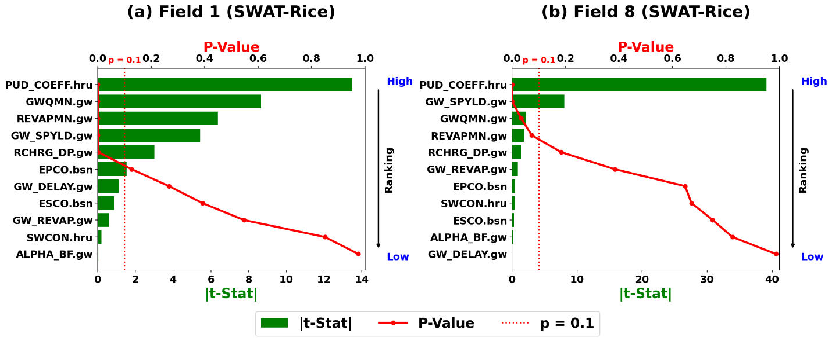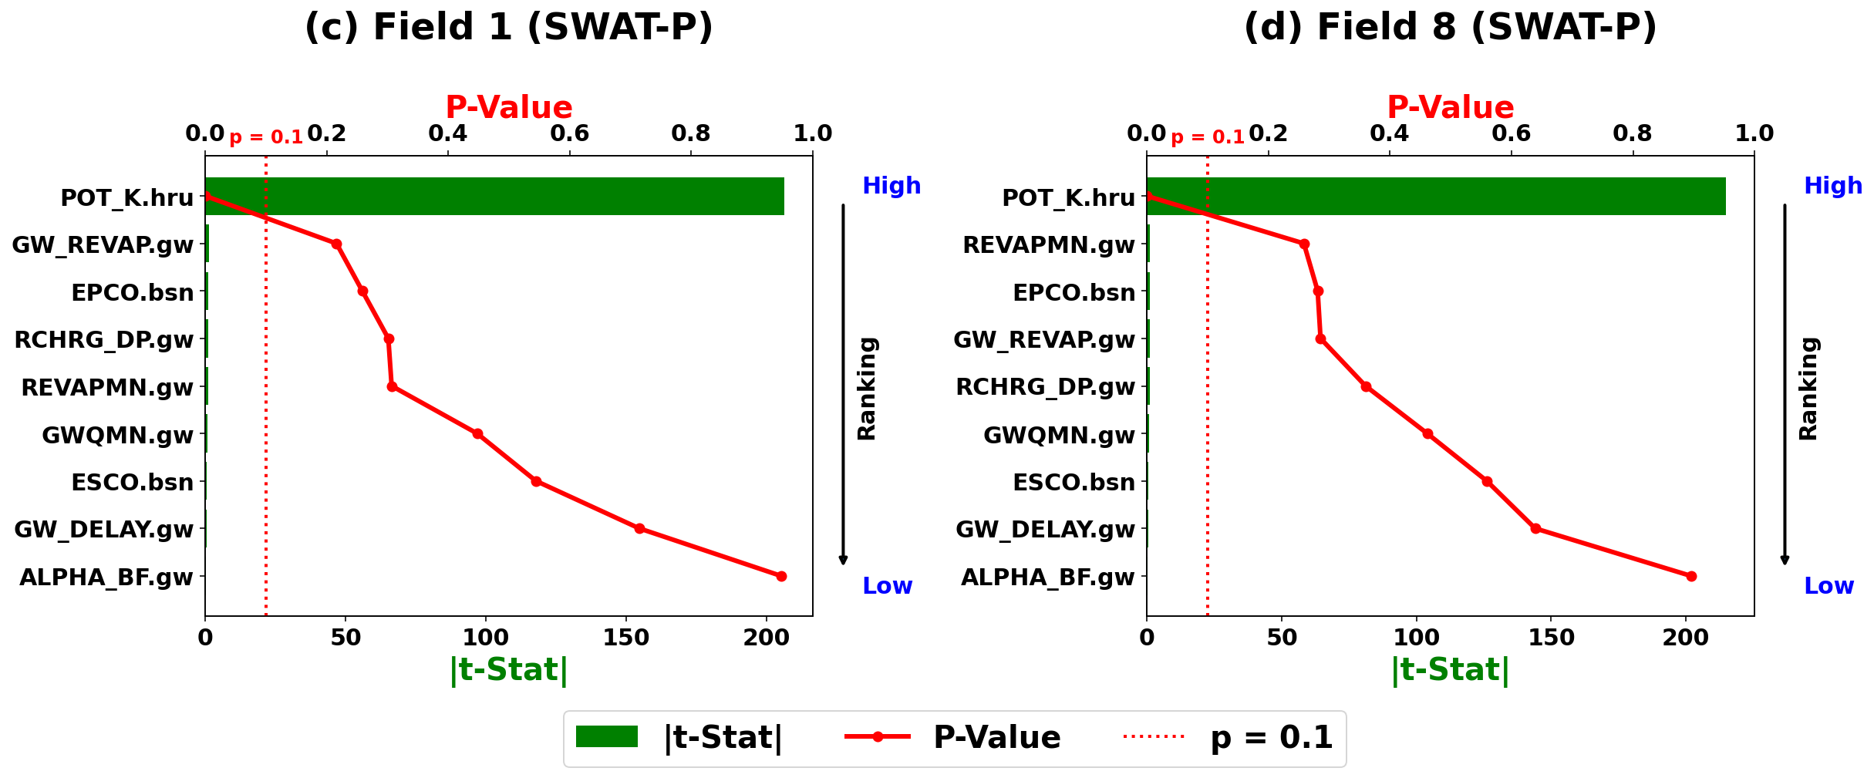
Fig. 7. Sensitivity analysis of the chosen parameters in SWAT-Rice and SWAT-P, with rankings for Fields 1 (GWT at 0.6 m) and 8 (GWT at 4 m).
The LH-OAT (Latin Hypercube–One-factor-At-a-Time) global sensitivity analysis technique in SWAT-CUP was used to evaluate the sensitivity of 11 parameters in SWAT-Rice and 9 parameters in SWAT-P on ponded water simulations. The sensitivity analysis results for the representative Fields, 1 [puddled, shallow water table 0.4 m below ground level (BGL), direct-seeded IR-50 variety during the Kar season] and 8 [puddled, deep water table (4 m BGL), transplanted Aaduthurai-45 variety during the Pishanam season], for both the SWAT-Rice and SWAT-P models are shown in Fig. 7. The most sensitive parameters at a 10% significance level using the SWAT-Rice routine are shown in Table 6. Parameters with p-values ≤0.10 and high t-Stat values (|t-Stat| ≥1.645) were considered sensitive. This threshold indicates that, with 90% conﬁdence, the variables have a signiﬁcant effect.
Table 6 SWAT Model calibration parameters and fitted values for Fields 1 and 8.
Model | Field | Parameter | Fitted Value | Min Value | Max Value
SWAT-Rice | Field 1 | V__PUD_COEFF.hru | 0.510 | 0.000 | 0.600
 |  | V__GWQMN.gw | 2021.250 | 2000.000 | 3000.000
 |  | V__REVAPMN.gw | 2828.750 | 2000.000 | 3000.000
 |  | V__GW_SPYLD.gw | 0.173 | 0.010 | 0.200
 |  | v__RCHRG_DP.gw | 0.099 | 0.000 | 0.200
 | Field 8 | V__PUD_COEFF.hru | 0.140 | 0.000 | 0.600
 |  | V__GW_SPYLD.gw | 0.097 | 0.010 | 0.200
 |  | V__GWQMN.gw | 2587.500 | 2000.000 | 3000.000
 |  | V__REVAPMN.gw | 2962.500 | 2000.000 | 3000.000
SWAT-P | Field 1 | v__POT_K.hru | 0.289 | 0.000 | 0.290
 | Field 8 | v__POT_K.hru | 0.289 | 0.000 | 0.290

Parameters such as puddling coefficient (PUD_COEFF), groundwater baseflow threshold (GWQMN), groundwater evaporation threshold (REVAPMN), groundwater specific yield (GW_SPYLD), and deep aquifer percolation fraction (RCHRG_DP) were more sensitive for Field 1 under shallow groundwater conditions, whereas PUD_COEFF, GW_SPYLD, GWQMN, and REVAPMN were sensitive for Field 8 under deep groundwater conditions, in the SWAT-Rice model. Among these, PUD_COEFF was the most sensitive parameter in both cases which significantly affects percolation losses and other water-balance components. Since the model allows daily simulation of groundwater levels and associated groundwater-soil moisture interactions, parameters governing groundwater fluxes and storage become particularly important in representing field water dynamics.
The existing Pothole routine (SWAT-P) was calibrated using the same parameter set. However, the hydraulic conductivity of the pothole surface soil (POT_K) was the only sensitive parameter and was calibrated to the maximum allowable value (7 mm/d) for both fields. Unlike SWAT-Rice, SWAT-P does not explicitly simulate shallow groundwater-table dynamics and their interactions with the soil-water balance. Consequently, the model relies primarily on POT_K to reproduce ponded-water dynamics, resulting in parameter compensation and limiting the model's ability to represent the subsurface processes governing water movement in paddy fields.
  - Comparison of ponded water levels simulated by different models
Fig. 8 shows a comparison of observed and simulated field water levels for the Kar 2024 and Pishanam 2024–2025 seasons in the Gadana region. Fields 1–5 correspond to the Kar season, whereas Fields 6–10 correspond to the Pishanam season (Table 3). The ponded water depths simulated by ORYZA, DSSAT-CERES Rice, SWAT-Rice, and HYDRUS-1D reproduced the temporal fluctuations in observed water depth across all fields, although peak magnitudes and recession rates varied among models. Model performance was better during the Pishanam season, particularly for low RMSE and PBIAS values. The maximum NSE of 0.74 was obtained for SWAT-Rice in Field 7, followed closely by ORYZA (0.73) and DSSAT-CERES Rice (0.71).
Field-wise performance statistics (Table 7) indicate acceptable-to-good agreement between simulated and observed daily ponded-water depths. SWAT-Rice and HYDRUS-1D achieved NSE ≥ 0.4 in all ten fields, compared with seven fields for ORYZA and nine fields for DSSAT-CERES Rice. Similarly, R² ≥ 0.5 was achieved in all fields for SWAT-Rice and HYDRUS-1D, compared with seven and nine fields for ORYZA and DSSAT-CERES Rice, respectively. However, SWAT-P did not yield satisfactory NSE or R² values for any field. Across the ten fields, HYDRUS-1D showed the highest mean NSE (0.59), followed by SWAT-Rice (0.57), DSSAT-CERES Rice (0.55), and ORYZA (0.53) (Table 8). SWAT-Rice had a median NSE of 0.55, while the corresponding values for ORYZA, DSSAT-CERES Rice, and HYDRUS-1D were 0.59, 0.56, and 0.60, respectively. In contrast, SWAT-P showed substantially poorer performance, with a mean NSE of −0.14 and a wide range from −1.09 to 0.28.
SWAT-Rice showed NSE values ranging from 0.46 to 0.74, compared with 0.19–0.73 for ORYZA, 0.25–0.71 for DSSAT-CERES Rice, and 0.50–0.69 for HYDRUS-1D (Table 8). Its R² ranged from 0.52 to 0.75 and RMSE from 7.80 to 21.10 mm. SWAT-Rice also showed a lower mean RMSE (12.45 mm) than ORYZA (12.94 mm) and DSSAT-CERES Rice (12.70 mm), although HYDRUS-1D had the lowest mean RMSE (12.19 mm). The PBIAS range for SWAT-Rice (−10.25 to 8.89%) was also narrower than those of ORYZA and DSSAT-CERES Rice, while HYDRUS-1D showed the narrowest range among the models. SWAT-Rice performed particularly well in Fields 5 and 7, where it achieved the highest NSE, and generally showed comparable or better agreement than at least one of the other field-scale models across all fields. The number of fields with NSE ≥ 0.6 was highest for HYDRUS-1D and ORYZA, followed by DSSAT-CERES Rice and SWAT-Rice. Nevertheless, poorer performance in some fields reduced the overall statistics of ORYZA and DSSAT-CERES Rice. SWAT-P consistently showed the weakest performance, with a mean RMSE of 19.94 mm and a PBIAS range of −38.02 to 38.99%, substantially higher than those of the other models (Table 8). It generally failed to reproduce the observed daily fluctuations and recession behavior, particularly following major rainfall or irrigation events. Although POT_K was calibrated to the maximum allowable value for most fields (Table 11), SWAT-P remained unable to adequately reproduce the observed decline in water levels. This limitation can be partly explained by the assumption of conical geometry for the pothole, in which pothole seepage is a function of the surface area of impounded water. Some discrepancies occurred when observed water levels declined abruptly to near zero, while model simulations maintained shallow ponding, possibly due to unrecorded drainage operations or bund leakage not represented in the models.
The differences in model performance suggest that ponded-water dynamics are controlled jointly by model structure and field-specific hydraulic and management conditions. The simulation of ponded-water dynamics in irrigated paddy fields depends strongly on how individual models represent field water storage, infiltration, drainage, and irrigation processes. Although the four non-pothole-based models reproduced the observed temporal pattern of ponded water, differences in the representation of these processes resulted in variation in the timing and magnitude of simulated water levels among fields. HYDRUS-1D showed the most consistent performance, because of its explicit representation of soil-water movement and hydraulic processes. The comparable performance of SWAT-Rice with the established rice models is particularly important because it demonstrates that field-scale ponding dynamics can be represented within a watershed-scale modelling framework through improved irrigation and ponding routines. The poor performance of SWAT-P suggests that its simplified pothole representation and conical storage geometry are less suitable for simulations in irrigated paddy fields. However, the model performance cannot be attributed solely to model structure. Farmer-managed paddy fields are subject to considerable spatial and temporal variability in irrigation timing, drainage, bund condition, puddling, and soil hydraulic properties. In particular, the puddled layer can substantially restrict downward water movement and thereby control the persistence of surface water. Variations in groundwater-table depth can further modify the hydraulic gradient and drainage behavior, particularly during periods of prolonged ponding. Consequently, a model parameterization that performs well in one field may not provide the same level of agreement in another field. This field-to-field variability is reflected in the wider range of performance observed for some models and highlights the importance of incorporating locally relevant soil and water-management characteristics during calibration. Overall, the results demonstrate that SWAT-Rice provides a practical and effective approach for representing irrigation-driven ponding dynamics in lowland paddy systems, while further characterization of intermediate drainage and bund losses could improve simulation accuracy.
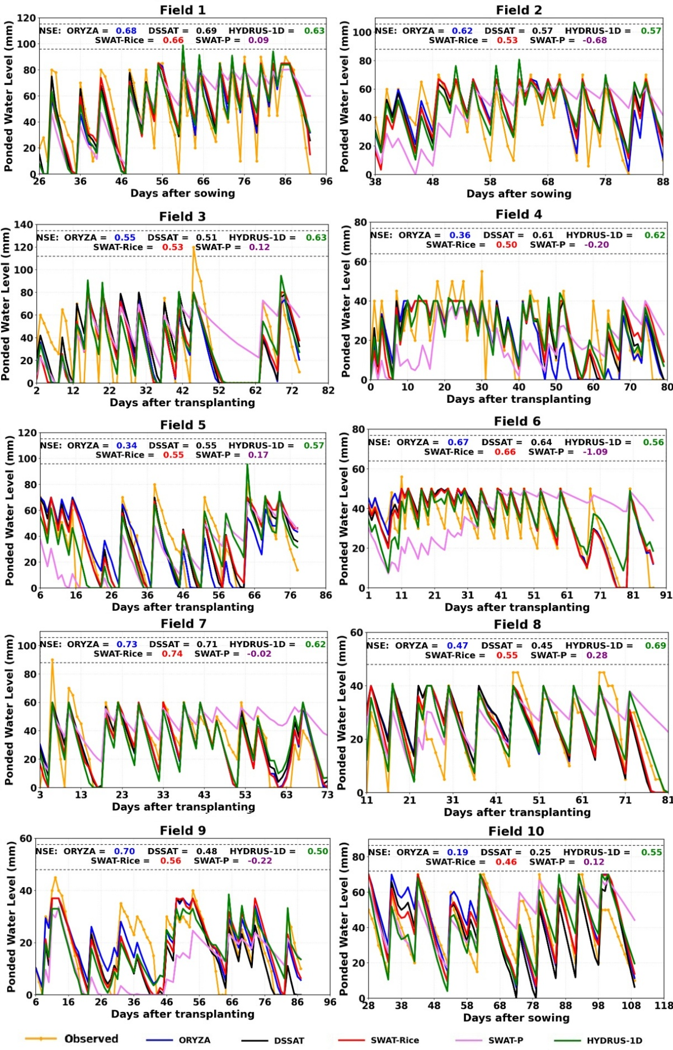
Fig. 8. Observed and simulated ponded water levels for the ten paddy fields using different models.

Table 7 Performance statistics of simulated field water levels from different models for the ten paddy fields.
Farmer field | NSE |  |  |  |  | R-square |  |  |  |  | RMSE |  |  |  |  | PBIAS
Farmer field | ORYZA | DSSAT | SWAT-Rice | SWAT-P | HYDRUS-1D | ORYZA | DSSAT | SWAT-Rice | SWAT-P | HYDRUS-1D | ORYZA | DSSAT | SWAT-Rice | SWAT-P | HYDRUS-1D | ORYZA | DSSAT | SWAT-Rice | SWAT-P | HYDRUS-1D
1 | 0.68 | 0.69 | 0.66 | 0.09 | 0.63 | 0.69 | 0.71 | 0.68 | 0.30 | 0.66 | 15.18 | 14.93 | 15.62 | 25.56 | 16.29 | -0.30 | 3.82 | 4.07 | 6.00 | -1.64
2 | 0.62 | 0.57 | 0.55 | -0.68 | 0.57 | 0.66 | 0.63 | 0.59 | 0.01 | 0.59 | 12.07 | 12.92 | 13.17 | 25.45 | 12.93 | 8.97 | 11.79 | 8.89 | 6.17 | 6.37
3 | 0.55 | 0.51 | 0.53 | 0.12 | 0.63 | 0.58 | 0.54 | 0.56 | 0.26 | 0.65 | 20.69 | 21.50 | 21.10 | 28.99 | 18.74 | -12.44 | 5.29 | -10.25 | 30.64 | -11.63
4 | 0.36 | 0.61 | 0.50 | -0.20 | 0.62 | 0.49 | 0.62 | 0.52 | 0.08 | 0.62 | 12.37 | 9.68 | 10.94 | 16.99 | 9.54 | -13.81 | -1.51 | 0.71 | -18.23 | 0.78
5 | 0.34 | 0.55 | 0.55 | 0.17 | 0.57 | 0.43 | 0.59 | 0.58 | 0.31 | 0.58 | 20.35 | 16.71 | 16.85 | 22.82 | -16.40 | 0.96 | 3.28 | 5.94 | -16.39 | -3.81
6 | 0.67 | 0.64 | 0.66 | -1.09 | 0.56 | 0.73 | 0.70 | 0.71 | 0.03 | 0.58 | 7.72 | 8.06 | 7.80 | 19.34 | 8.83 | 7.76 | 6.24 | 5.16 | 8.57 | 4.39
7 | 0.73 | 0.71 | 0.74 | -0.02 | 0.62 | 0.73 | 0.71 | 0.75 | 0.35 | 0.64 | 10.84 | 11.13 | 10.59 | 21.02 | 12.73 | -3.94 | 1.06 | -5.77 | 38.99 | -6.11
8 | 0.47 | 0.45 | 0.55 | 0.28 | 0.69 | 0.53 | 0.52 | 0.58 | 0.38 | 0.69 | 9.09 | 9.24 | 8.36 | 10.60 | 7.01 | 7.67 | 7.23 | 4.40 | 17.11 | 3.49
9 | 0.70 | 0.48 | 0.56 | -0.22 | 0.50 | 0.70 | 0.61 | 0.59 | 0.21 | 0.53 | 6.72 | 8.91 | 8.20 | 13.59 | 8.68 | 2.94 | -21.50 | -5.47 | -38.02 | -7.97
10 | 0.19 | 0.25 | 0.46 | 0.12 | 0.55 | 0.43 | 0.48 | 0.56 | 0.37 | 0.62 | 14.41 | 13.90 | 11.83 | 15.07 | 10.71 | 8.36 | -5.03 | 3.84 | 18.19 | -2.18

Table 8 Statistics of model performance across 10 farmer fields
Model | NSE |  |  | R-square |  |  | RMSE |  |  | PBIAS
Model | Mean | Median | range | Mean | Median | range | Mean | Median | range | Mean | Median | range
ORYZA | 0.53 | 0.59 | 0.19–0.73 | 0.60 | 0.62 | 0.43–0.73 | 12.94 | 12.22 | 6.72–20.69 | 0.62 | 1.95 | −13.81–8.97
DSSAT-CERES Rice | 0.55 | 0.56 | 0.25–0.71 | 0.61 | 0.62 | 0.48–0.71 | 12.70 | 12.03 | 8.06–21.50 | 1.07 | 3.55 | −21.50–11.79
SWAT-Rice | 0.57 | 0.55 | 0.46–0.74 | 0.61 | 0.58 | 0.52–0.75 | 12.45 | 11.39 | 7.80–21.10 | 1.15 | 3.96 | −10.25–8.89
SWAT-P | −0.14 | 0.04 | −1.09–0.28 | 0.23 | 0.28 | 0.01–0.38 | 19.94 | 20.18 | 10.60–28.99 | 5.30 | 7.37 | −38.02–38.99
HYDRUS-1D | 0.59 | 0.60 | 0.50–0.69 | 0.62 | 0.62 | 0.53–0.69 | 12.19 | 11.72 | 7.01–18.74 | −1.83 | −1.91 | −11.63–6.37

Table 9 Performance statistics of water balance components relative to HYDRUS-1D simulations for Farmer Fields 1 (Kar season) and 8 (Pishanam season).
Farmer field | Water balance component | NSE |  |  |  | R-square |  |  |  | RMSE |  |  |  |  | PBIAS
Farmer field | Water balance component | ORYZA | DSSAT | SWAT-Rice | SWAT-P | ORYZA | DSSAT | SWAT-Rice | SWAT-P | ORYZA | DSSAT | SWAT-Rice | SWAT-P | ORYZA |  | DSSAT | SWAT-Rice | SWAT-P
1 | Runoff over the bund | 0.68 | 0.80 | 0.85 | 0.95 | 0.76 | 0.87 | 0.91 | 0.95 | 5.87 | 4.68 | 4.03 | 2.34 | -48.68 |  | -39.09 | -32.45 | -5.26
1 | Percolation | 0.50 | 0.00 | 0.56 | < 0.00 | 0.50 | 0.61 | 0.63 | 0.01 | 1.85 | 2.61 | 1.73 | 33.01 | -2.52 |  | 54.30 | 19.69 | 54.83
1 | Infiltration | 0.26 | 0.51 | 0.34 | < 0.00 | 0.47 | 0.58 | 0.49 | 0.17 | 4.34 | 3.55 | 4.10 | 7.48 | -5.16 |  | 0.65 | -9.66 | -27.95
1 | Soil water storage | < 0.00 | < 0.00 | < 0.00 | < 0.00 | 0.59 | 0.04 | 0.39 | 0.20 | 8.27 | 6.58 | 14.58 | 356.34 | -1.13 |  | -0.94 | -2.04 | -57.71
8 | Runoff over the bund | 0.99 | 0.99 | 0.99 | 0.97 | 0.99 | 0.99 | 0.99 | 0.99 | 2.58 | 2.66 | 2.45 | 4.00 | 9.63 |  | 7.83 | 1.15 | -22.96
8 | Percolation | < 0.00 | < 0.00 | < 0.00 | < 0.00 | 0.10 | 0.15 | 0.29 | 0.05 | 0.81 | 0.79 | 0.80 | 2.02 | -2.86 |  | -19.04 | -36.40 | 7.17
8 | Infiltration | < 0.00 | < 0.00 | 0.04 | < 0.00 | 0.19 | 0.19 | 0.49 | 0.09 | 2.62 | 2.93 | 2.19 | 5.90 | -26.93 |  | -28.45 | -17.69 | 1.62
8 | Soil water storage | < 0.00 | < 0.00 | < 0.00 | < 0.00 | 0.39 | 0.54 | 0.57 | 0.39 | 292.12 | 287.77 | 53.66 | 62.13 | 90.17 |  | 88.85 | -16.15 | -18.79
Water balance  component | Performance  statistic | ORYZA |  |  | DSSAT |  |  |  | SWAT-Rice |  |  |  | SWAT-P
Water balance  component | Performance  statistic | Mean | Median | Range | Mean | Median | Range | Mean |  | Median | Range | Mean |  | Median | Range
Runoff over the bund | NSE | 0.70 | 0.90 | <0.00–1.00 | 0.84 | 0.91 | 0.21–0.99 | 0.87 |  | 0.93 | 0.54–0.99 | 0.86 |  | 0.94 | 0.44–0.99
Runoff over the bund | R-square | 0.77 | 0.91 | 0.01–1.00 | 0.86 | 0.94 | 0.23–0.99 | 0.89 |  | 0.95 | 0.55–1.00 | 0.92 |  | 0.94 | 0.72–0.99
Runoff over the bund | RMSE | 3.77 | 3.59 | 2.35–6.42 | 3.24 | 3.12 | 2.53–4.68 | 3.06 |  | 2.71 | 2.22–4.58 | 3.79 |  | 3.56 | 1.74–6.87
Runoff over the bund | PBIAS | -11.10 | 0.02 | -48.68–9.63 | -12.80 | -8.91 | -39.09–10.93 | -13.64 |  | -5.83 | -40.51–3.74 | -11.63 |  | -14.01 | -76.15–53.27
Percolation | NSE | 0.09 | <0.00 | <0.00–0.53 | <0.00 | <0.00 | <0.00–0.28 | 0.29 |  | 0.31 | <0.00–0.85 | <0.00 |  | <0.00 | <0.00–0.56
Percolation | R-square | 0.16 | 0.06 | 0.00–0.53 | 0.20 | 0.08 | 0.01–0.61 | 0.52 |  | 0.57 | 0.01–0.98 | 0.48 |  | 0.40 | 0.01–0.99
Percolation | RMSE | 7.08 | 3.08 | 0.57–18.43 | 7.19 | 3.42 | 0.68–18.43 | 4.74 |  | 3.00 | 0.61–14.55 | 21.26 |  | 24.05 | 2.02–33.01
Percolation | PBIAS | -19.17 | -6.92 | -81.86–37.85 | -15.15 | -28.76 | -44.46–54.30 | -12.98 |  | -5.33 | -74.68–41.09 | 135.64 |  | 31.00 | -29.97–1042.63
Infiltration | NSE | <0.00 | <0.00 | <0.00–0.57 | <0.00 | 0.18 | <0.00–0.68 | <0.00 |  | 0.15 | <0.00–0.70 | <0.00 |  | <0.00 | <0.00–-0.51
Infiltration | R-square | 0.31 | 0.30 | 0.03–0.65 | 0.36 | 0.40 | 0.03–0.71 | 0.41 |  | 0.47 | 0.03–0.75 | 0.12 |  | 0.12 | 0.00–0.22
Infiltration | RMSE | 3.91 | 3.42 | 2.29–7.33 | 3.45 | 3.08 | 2.41–5.29 | 3.37 |  | 3.15 | 2.08–5.84 | 6.65 |  | 6.67 | 5.54–7.63
Infiltration | PBIAS | -24.25 | -24.41 | -48.30–-5.16 | -19.98 | -20.60 | -34.75–0.65 | -20.92 |  | -16.24 | -45.19–-7.45 | -14.78 |  | -19.21 | -39.82–46.79
Soil water storage | NSE | <0.00 | <0.00 | <0.00–0.35 | <0.00 | <0.00 | <0.00 | <0.00 |  | <0.00 | <0.00 | <0.00 |  | <0.00 | -<0.00
Soil water storage | R-square | 0.35 | 0.38 | 0.00–0.59 | 0.44 | 0.51 | 0.04–0.72 | 0.29 |  | 0.32 | 0.00–0.62 | 0.26 |  | 0.27 | 0.04–0.47
Soil water storage | RMSE | 112.22 | 57.16 | 1.96–292.12 | 115.27 | 69.10 | 3.86–287.77 | 46.02 |  | 37.99 | 9.66–85.90 | 239.63 |  | 277.50 | 62.13–359.03
Soil water storage | PBIAS | 29.93 | 10.73 | -1.13–90.17 | 30.41 | 13.14 | -1.15–88.85 | -7.47 |  | -2.84 | -22.83–3.60 | -35.66 |  | -50.84 | -58.17–42.31
Table 10 Summary performance statistics of water-balance components relative to HYDRUS-1D simulations (Fields 1–10)
  - Assessment of water balance components
As described earlier in section 3.4. HYDRUS-1D is a widely used numerical model for simulating vadose-zone water transport. This model can simulate variably saturated flow using Richards’ equation and has been widely demonstrated to effectively quantify ponding depth, surface runoff, and soil water dynamics in puddled paddy soils under controlled boundary conditions. The performance of HYDRUS-1D in simulating observed water levels across the 10 fields was also evaluated in section 4.2. Due to this consistent performance of HYDRUS-1D, and because observed data for other water balance components were unavailable, simulation results from HYDRUS-1D were treated as a numerical reference for other water balance components (surface runoff, infiltration, percolation, and soil water storage) for evaluating ORYZA, DSSAT, SWAT-Rice, and SWAT-P. For illustration, the water balance components of Field 1 [puddled, shallow water table 0.4m below ground level (BGL), direct-seeded IR-50 variety during the Kar season] and Field 8 [puddled, deep-water table (4m BGL), transplanted Aaduthurai-45 during the Pishanam season] are discussed in detail.
    - Actual evapotranspiration estimates across different models

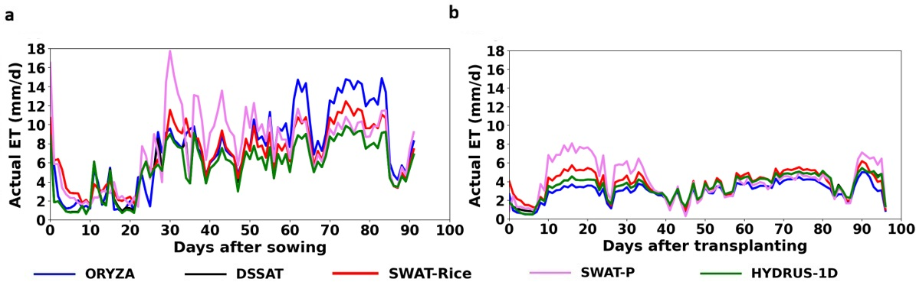
Fig. 9. Simulated daily evapotranspiration by different models: (a) Field 1 (Kar season; GWT at 0.4m BGL) and (b) Field 8 (Pishanam season; GWT at 4m BGL).
The temporal patterns of actual evapotranspiration (ET) estimated by different irrigation routines, except SWAT-P, showed comparable trends across the fields. The Penman–Monteith method was used to estimate potential ET in all models. In general, during the Pishanam season (Fields 6–10), ET magnitudes were lower, and temporal variability was less pronounced than during the Kar season. SWAT-Rice improved ET simulations in the study region compared to SWAT-P, for submerged paddy HRUs. ET was the dominant loss component during the Kar season across all fields, driven by higher atmospheric demand and irrigation requirements.
Simulated daily variations of actual ET for representative Fields 1 and 8 are shown in Fig. 9. Differences were observed in the daily ET values and seasonal totals among the models. SWAT-P simulated unrealistically high ET values on several days and didn’t reasonably reproduce the temporal ET dynamics during either season. However, SWAT-Rice-simulated daily ET estimates were comparable to those from crop growth models. Seasonal ET was highest in ORYZA for Field 1, followed by SWAT-P, SWAT-Rice, and DSSAT-CERES Rice (Table 12). Similarly, SWAT-P simulated the highest seasonal ET in Field 8, followed by SWAT-Rice, DSSAT-CERES Rice, and HYDRUS-1D. The comparatively lower seasonal ET in Field 8 across all models is attributable to reduced solar radiation and wind speed, which decreases atmospheric evaporative demand. In addition, the deeper groundwater table and lower irrigation inputs may have further limited water availability for crop water use.
The ET simulated by ORYZA was highly sensitive to surface water availability and incoming solar radiation. Consequently, sudden declines in ET values were observed in several fields following the disappearance of ponded water. During drying periods, ORYZA assumes cumulative soil evaporation is proportional to the square root of the time since ponded water disappeared and limits soil evaporation to 60% of the potential rate (Penning de Vries et al., 1989; Bouman et al., 2001), resulting in sharp reductions in ET. ORYZA generally produced higher ET during the Kar season but lower ET during the Pishanam season because of its high sensitivity to solar radiation. However, DSSAT-CERES Rice exhibited comparatively stable ET responses across the fields in both seasons. Hence, DSSAT ET was used as input to the HYDRUS-1D model for subsequent water-balance simulations.
The unrealistic ET estimates simulated by SWAT-P can be attributed to the conceptual limitations of the pothole routine, in which pothole processes are not fully integrated with soil-water processes. Water lost from the pothole through seepage contributes to subsequent-day soil moisture dynamics, increasing soil water content and enhancing evaporation from the moist soil during flooded conditions. Soil evaporation is initially calculated without accounting for pothole evaporation, resulting in high ET values (which may even exceed PET) during the ponding period. In addition, evaporation from the pothole is constrained by the amount of water stored in a conical-shaped pothole, which is a function of the surface area of impounded water. This underscores the underlying uncertainties associated with evaporation formulations in potholes. In contrast, SWAT-Rice explicitly represents the interaction between the ponded layer and the soil profile and calculates evaporation sequentially from the canopy, ponded water, and soil water. The improved ET formulation therefore provides a more physically realistic representation of evapotranspiration processes in flooded paddy fields and produces ET estimates comparable to those of crop growth models. The simulated seasonal ET values of SWAT-Rice (662.5 mm in Kar and 393.5 mm in Pishanam) were closest to the reported dry- and wet-season ET ranges for tropical lowland rice fields (Tuong & Bouman, 2003; Debnath et al., 2025), indicating improved representation of evapotranspiration processes under paddy cultivation. An additional advantage of the new ET formulation in SWAT-Rice is that it does not require extra calibration parameters such as the evaporation coefficient used in the revised pothole method (Sakaguchi et al., 2014b) or the PET scaling parameter (PETCO) employed in the SWAT+ model (Jeong et al., 2025), to compensate for uncertainties in ET estimation.
    - Simulation of surface runoff responses
Surface runoff was episodic and primarily triggered by heavy rainfall or irrigation events that exceeded the bund height (Fig. 10). Overall, all models reproduced the major runoff events reasonably well, although simulated runoff volumes varied among fields and models. Surface runoff was the dominant water-loss component for fields experiencing high puddling intensity. In Field 1, characterized by a shallow groundwater table (0.4 m BGL) and low puddling intensity, SWAT-P produced the seasonal runoff volume closest to HYDRUS-1D (307.8 mm vs. 324.9 mm), followed by SWAT-Rice (267.4 mm), DSSAT-CERES Rice (197.9 mm), and ORYZA (166.7 mm) (Table 12). In Field 8, with a deeper groundwater table (4 m BGL) and higher puddling intensity, showed similar runoff dynamics among ORYZA, DSSAT-CERES Rice, and SWAT-Rice, with SWAT-Rice providing the closest seasonal estimate to HYDRUS-1D (453.6 mm vs. 448.5 mm). SWAT-P produced the lowest runoff volume (345.5 mm) during this season.
Performance statistics further supported these trends (Table 9). In Field 1, DSSAT-CERES Rice, SWAT-Rice, and SWAT-P demonstrated excellent agreement with HYDRUS-1D (NSE > 0.75), with SWAT-P showing the lowest RMSE and relatively low PBIAS. In Field 8, all models achieved excellent NSE values (>0.75), while SWAT-Rice showed particularly low RMSE (2.45 mm) and PBIAS (1.15%). Across the ten fields, runoff showed consistently high agreement with HYDRUS-1D, with generally high NSE and R² values and relatively low RMSE for most models, although the wider ranges in NSE and PBIAS indicate greater variability in performance under field-specific hydrological conditions (Table 10). Overall, SWAT-Rice showed a slight advantage across the performance statistics.
The comparable runoff performance of SWAT-Rice with established crop models and HYDRUS-1D demonstrates its ability to reproduce runoff dynamics in paddy fields. However, the satisfactory runoff performance of SWAT-P, despite its weaker performance for ponded-water levels and other water-balance components, highlights that runoff statistics alone may not fully reflect overall model performance because of compensating errors within the water balance (Gassman et al., 2022).
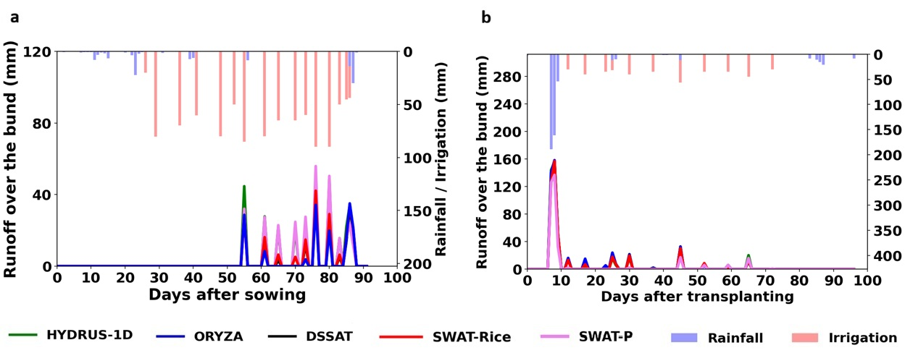
Fig. 10. Simulated runoff from the paddy fields by different models: (a) Field 1 (Kar season; GWT at 0.4m BGL) and (b) Field 8 (Pishanam season; GWT at 4m BGL).
    - Soil Water Movement: infiltration and percolation processes under different models
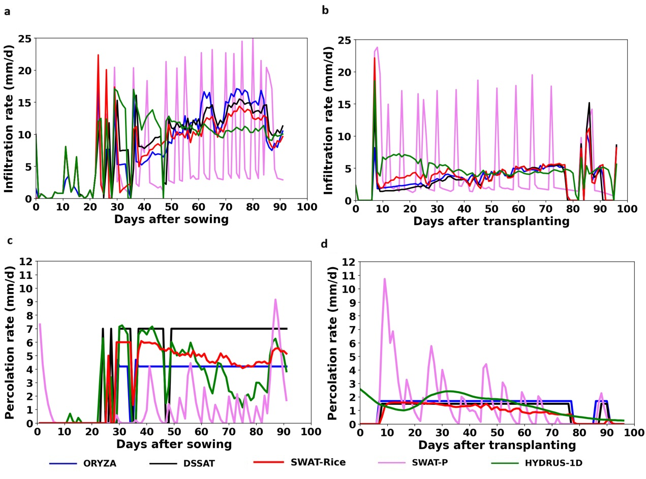Fig. 11. Simulated daily infiltration and percolation rates by different models: (a) Field 1 infiltration (Kar season; GWT at 0.4m BGL), (b) Field 8 infiltration (Pishanam season; GWT at 4m BGL), (c) Field 1 percolation, and (d) Field 8 percolation.
Table 11 Calibrated hydraulic conductivity of the plow sole for the ten paddy fields.
Field no. | GWT depth (m) | Maximum water level (H_max, mm) | Rainfall during the season (mm) | Total irrigation water consumption (mm) | $Calibrated hydraulic conductivity$of the Puddled layer, $K_{sat,pud}$ (mm/d)
 |  |  |  |  | SWAT-Rice | ORYZA | DSSAT-CERES Rice | HYDRUS-1D | SWAT-P
1 | 0.4 | 85 | 134.7 | 1120 | 6.0 | 4.2 | 4.6 | 5.4 | 7.0
2 | 0.4 | 67 | 86.0 | 855 | 6.1 | 3.6 | 5.7 | 5.1 | 7.0
3 | 4.5 | 80 | 271.4 | 984 | 6.7 | 6.9 | 7.0 | 5.4 | 7.0
4 | 1.2 | 40 | 251.3 | 650 | 2.0 | 1.2 | 2.9 | 2.9 | 7.0
5 | 1.5 | 70 | 69.5 | 870 | 1.4 | 0.8 | 3.0 | 3.2 | 7.0
6 | 0.45 | 50 | 125.6 | 461 | 1.5 | 1.6 | 1.0 | 2.1 | 2.5
7 | 0.9 | 60 | 119.0 | 755 | 6.6 | 6.8 | 6.4 | 6.1 | 7.0
8 | 4 | 40 | 527.2 | 390 | 1.6 | 1.7 | 1.3 | 1.9 | 7.0
9 | 0.4 | 37 | 621.2 | 370 | 0.3 | 0.5 | 0.3 | 0.8 | 7.0
10 | 3 | 70 | 761.5 | 505 | 3.4 | 3.4 | 3.7 | 2.9 | 7.0
 |  |  |  | Mean | 3.56 | 3.07 | 3.59 | 3.58 | 6.55
 |  |  |  | Median | 2.70 | 2.55 | 3.35 | 3.05 | 7.00

Across the ten paddy fields, infiltration and percolation dynamics were primarily governed by the hydraulic conductivity of the puddled layer ($K_{sat,pud}$), groundwater table depth, and ponding conditions. Infiltration represents the total water entering the soil profile from the ponded surface, whereas percolation represents the water moving downward and contributing to shallow aquifer storage. Daily infiltration and percolation patterns for representative Fields 1 and 8 are shown in Fig.11a, b. SWAT-Rice, DSSAT-CERES Rice, and ORYZA reproduced physically realistic infiltration responses, characterized by sharp increases following irrigation or rainfall events and gradual stabilization toward near-steady-state rates under prolonged flooding. ORYZA simulated comparatively larger infiltration peaks than other models in the Kar season, especially during the flowering and ripening stages. As the DSSAT-CERES Rice forms the basis for soil water routing in SWAT-Rice, their infiltration behavior was also comparable. Whereas SWAT-P generated abrupt infiltration peaks followed by rapid drawdown and failed to approach steady-state infiltration under saturated conditions. Performance statistics indicated that DSSAT-CERES Rice and SWAT-Rice agreed more closely with HYDRUS-1D for Field 1 and Field 8 respectively, as reflected by higher NSE and R² values and lower RMSE (Table 9).Across the ten fields, infiltration simulations showed relatively weak overall agreement with HYDRUS-1D, as indicated by negative mean NSE values for all models; nevertheless, SWAT-Rice showed comparatively better performance, with the highest mean and median R² (0.41 and 0.47) and the lowest mean RMSE (3.37 mm), while SWAT-P showed the poorest overall agreement (Table 10).
The calibrated $K_{sat,pud}$ values for ORYZA, DSSAT-CERES Rice, and SWAT-Rice were comparable to those estimated by HYDRUS-1D, ranging from 0.1 to 7 mm d⁻¹ (Table 11). Fields 3 and 7 had the highest values, where groundwater tables were well below the root zone. Fields subjected to greater puddling intensity generally exhibited lower $K_{sat,pud}$ values and lower seasonal percolation, consistent with reduced irrigation requirements. Inter-field variability in percolation closely reflected differences in $K_{sat,pud}$: fields with high $K_{sat,pud}$(Fields 3 and 7; ~5-7 mm d⁻¹) showed sustained high percolation, whereas fields with low $K_{sat,pud}$(Fields 6, 8, and 9; 0.3–2.1 mm d⁻¹) exhibited minimal losses. All simulated percolation rates were within the reported range of 0–24 mm d⁻¹ for puddled rice fields (Wickham and Singh, 1978; Tabbal et al., 2002). Results from ORYZA, DSSAT-CERES Rice, and SWAT-Rice showed that the hydraulic conductivity of the puddled layer controlled percolation more strongly than groundwater depth alone.
The representative fields (Fields 1 and 8) further illustrate these dynamics (Fig. 11c, d). Field 1, characterized by shallow groundwater (0.4m BGL) and low puddling intensity, showed moderately high seasonal percolation losses (287-353 mm) by ORYZA, DSSAT-CERES Rice, and SWAT-Rice. Since the groundwater table was located within the bottom soil layer, percolating water remained stored within the soil profile in SWAT-Rice, resulting in zero deep percolation below the bottom layer. However, some of this percolating water also recharged the shallow aquifer. This enables soil saturation condition under shallow water table. The model also simulated lateral subsurface flow (66.9 mm) from the vadose zone, highlighting the influence of shallow groundwater interactions on field-scale hydrology. In contrast, Field 8, characterized by deeper groundwater (4 m BGL) and intensive puddling, exhibited comparatively low seasonal percolation losses (84.8–135 mm). ET and percolation were the major water-loss components in 7 of 10 fields evaluated (Tables 5 and 6; Appendix A). Percolation dynamics simulated by SWAT-Rice were closer to those estimated by HYDRUS-1D in both representative fields (Table 9). ORYZA and DSSAT-CERES Rice typically maintained nearly constant percolation rates under flooded conditions, whereas SWAT-P produced unrealistic fluctuations and frequent days with zero percolation, even under ponded conditions. Similar limitations of the pothole-based approach have been reported by Sakaguchi et al. (2014a). Percolation simulations showed generally weak NSE performance across the ten fields, but SWAT-Rice performed comparatively better, with the highest mean NSE (0.29) and R² (0.52), lowest mean RMSE (4.74 mm), and relatively low PBIAS (−12.98%), whereas SWAT-P showed substantially poorer performance (Table 10).
The unrealistic infiltration and percolation rates simulated by SWAT-P arise from the conceptual limitations of representing paddy fields using the pothole routine. In SWAT-P, rainfall is initially partitioned into infiltration and runoff using the SCS-CN method, and the infiltrated water contributes directly to soil-water redistribution and percolation. Consequently, a considerable fraction of rainfall/irrigation water can infiltrate and percolate before entering the pothole storage, leading to the abrupt infiltration and percolation peaks observed in the simulations. The tendency of the calibrated $K_{sat,pud}$ to reach its upper limit (7 mm/d) further reflects the limitations of the pothole seepage formulation, which is controlled by the ponded surface area of a conical impoundment. Whereas the new SWAT-Rice routine stores rainfall and irrigation water within the impoundment before partitioning it into infiltration, percolation, evaporation, transpiration, and groundwater flow. The SWAT-Rice routine reproduced both the magnitude and temporal variability of infiltration and percolation more consistently with HYDRUS-1D than SWAT-P. The results demonstrate that explicit representation of bunded-field hydrology, with puddled-layer hydraulic properties and groundwater–soil-water interactions, substantially improves the simulation of subsurface water fluxes in irrigated paddy fields.

    - Soil water storage dynamics during the crop season
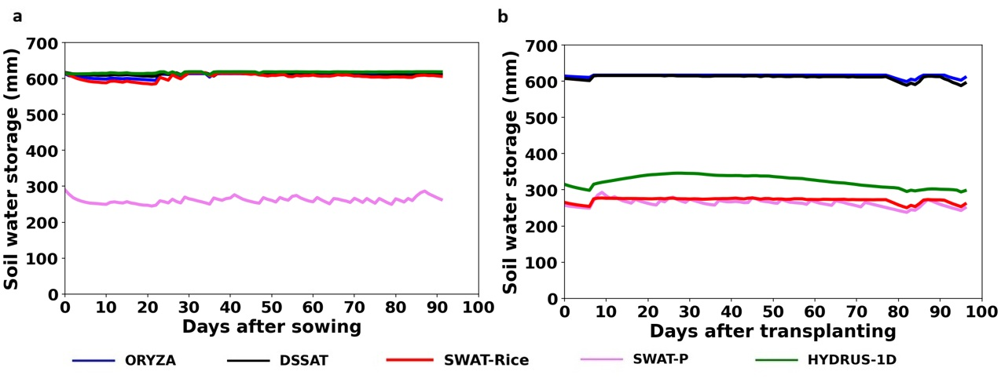
Fig. 12. Simulated soil water storage in the soil profile by different models: (a) Field 1 (Kar season; GWT at 0.4m BGL) and (b) Field 8 (Pishanam season; GWT at 4m BGL).
Simulated soil water storage exhibited substantial differences among the models across the ten paddy fields. Fig. 12 shows the soil water storage in representative Fields 1 and 8. The crop growth models, ORYZA and DSSAT-CERES Rice, consistently maintained high soil water storage, generally remaining close to saturation (~ 580-617 mm), with only minor temporal fluctuations throughout the cropping seasons. SWAT-Rice reproduced similar temporal patterns and maintained near-saturated conditions under shallow groundwater-table scenarios (Fields 1, 2, 6, 7, and 9). However, under deeper groundwater-table conditions (Fields 3, 8, and 10), SWAT-Rice simulated lower soil water storage because of gravitational drainage from the initially saturated soil profile. The sandy bottom layer led to rapid percolation during the early growth stages, causing the soil profile to drain toward field capacity when the water table is sufficiently deep. ORYZA and DSSAT-CERES Rice generally agreed more closely with HYDRUS-1D under shallow groundwater conditions, whereas SWAT-Rice better reproduced HYDRUS-1D trends under moderate-to-deep groundwater conditions (Table 9). SWAT-P consistently simulated the lowest soil water storage and failed to reproduce near-saturated conditions under shallow groundwater-table scenarios. Although none of the models achieved satisfactory NSE values, SWAT-Rice showed comparatively better performance in terms of RMSE and PBIAS, with the lowest mean RMSE (46.02 mm) and lowest absolute mean PBIAS (7.47%), whereas DSSAT-CERES Rice achieved the highest R² (0.44) (Table 10).
Total soil water storage at saturation was about 617 mm across all fields. HYDRUS-1D simulated soil water storage ranging from 570–617 mm under shallow groundwater conditions (≤1.0 m), 430–500 mm under moderate depths (1.0–1.5 m), and 260–370 mm under deep groundwater conditions (>1.5 m). Corresponding SWAT-Rice values were 495–565 mm, 295–355 mm, and 225–270 mm, respectively (Tables 5 and 6; Appendix A). These results show the SWAT-Rice routine's ability to simulate soil water dynamics under varying groundwater-table conditions compared with both crop growth models and SWAT-P models.
Table 12 Seasonal water budgets for Fields 1(GWT at 0.4m BGL) and 8 (GWT at 4 m BGL) simulated by different models (all values in mm).
Water balance component | Field 1 (Kar Season) |  |  |  |  | Field 8 (Pishanam Season)
Water balance component | HYDRUS-1D | ORYZA | DSSAT | SWAT-Rice | SWAT-P | HYDRUS-1D | ORYZA | DSSAT | SWAT-Rice | SWAT-P
Rainfall | 134.7 |  |  |  |  | 527.2
Irrigation | 1020 |  |  |  |  | 390
Actual ET | 545.7 | 726.5 | 556.4 | 662.5 | 726.2 | 370.7 | 306.7 | 372.6 | 393.5 | 423.9
Percolation | 293.2 | 287 | 443 | 353.0 | 424.3 | 135 | 129.6 | 108 | 84.8 | 143
Lateral flow | - | - | - | 66.9 | 9.7 | - | - | - | 2.3 | 3.6
Surface runoff | 324.9 | 166.7 | 197.9 | 267.4 | 307.8 | 448.5 | 491.7 | 483.6 | 453.6 | 345.5
Final soil water storage | 612.4 | 603.3 | 605 | 545.2 | 247.2 | 281 | 604 | 576 | 248 | 241
Note: Water-budget components for Field 1 represent the period from sowing to harvest (98 days), while those for Field 8 represent the period from transplanting to harvest (103 days).
  - Crop growth dynamics: Comparison of simulated LAI and rice yield
Seasonal variations in Leaf Area Index (LAI) simulated by different models are shown in Fig. 13. Across all fields, LAI increased gradually following crop establishment, peaked during the reproductive stage, and subsequently declined during maturity due to canopy senescence. During the Kar season (Fields 1–5), LAI peak ranged from 2.2 to 3.3, whereas during the Pishanam season (Fields 6–10) it ranged from 2.7 to 4.2. Higher peak LAI values were generally associated with longer-duration varieties, while shorter-duration varieties exhibited lower peaks. Peak LAI typically occurred between 55 and 80 days after sowing or transplanting, with slight variations among fields due to differences in crop duration and management practices. ORYZA showed greater sensitivity to water-stress conditions, followed by DSSAT-CERES Rice, whereas the SWAT models exhibited comparatively lower sensitivity. Nevertheless, all models reproduced similar seasonal LAI trends across the study fields.
Observed and simulated grain yields from different models are presented in Table 12. All models reasonably reproduced the seasonal yield patterns, although simulated yields were generally higher than observed values. This overestimation can be attributed to the assumption of potential production conditions in the simulations, where stresses due to nutrient limitations, pests, and diseases were not considered. Consequently, yield estimates were primarily governed by water-stress conditions. Based on the performance statistics, ORYZA demonstrated the best performance in simulating rice yield across the study fields. Although NSE values ranged from 0.43 to 0.50, the models exhibited high R² (0.91–0.94), low normalized RMSE values (9.1–9.7%), and PBIAS below 10%, indicating good agreement between simulated and observed yields. The normalized RMSE values were also lower than those reported by Radanielson et al. (2018) for ORYZA-based models, further supporting the satisfactory performance of the models.

Table 12 Comparison of observed and simulated rice yields across the study fields.
Field | Variety | Observed yield (kg/ha) | Simulated Rice yield (kg/ha)
Field | Variety | Observed yield (kg/ha) | ORYZA | DSSAT-CERES Rice | SWAT-Rice | SWAT-P
1 | 1R-50 | 4885 | 5512 | 5195 | 5340 | 5329
2 | IR-50 | 4633 | 4685 | 4999 | 4977 | 4970
3 | TPS-5 | 6250 | 6596 | 7271 | 6548 | 6555
4 | TPS-5 | 6672 | 7739 | 6871 | 7846 | 7839
5 | TPS-5 | 6124 | 6414 | 6421 | 6246 | 6227
6 | Amman Ponni | 7239 | 7806 | 8360 | 7760 | 7751
7 | Aadhudurai 45 | 5405 | 5953 | 5933 | 5550 | 5551
8 | Aaduthurai 45 | 5900 | 6252 | 6228 | 6501 | 6483
9 | Delux Ponni | 6384 | 6927 | 6609 | 7021 | 7014
10 | T.K 54 | 6500 | 6954 | 7034 | 7196 | 7191
 |  | R² | 0.94 | 0.91 | 0.92 | 0.92
 |  | NSE | 0.50 | 0.43 | 0.44 | 0.45
 |  | nRMSE (%) | 9.1 | 9.7 | 9.6 | 9.5
 |  | PBIAS | 8.1 | 8.2 | 8.3 | 8.2
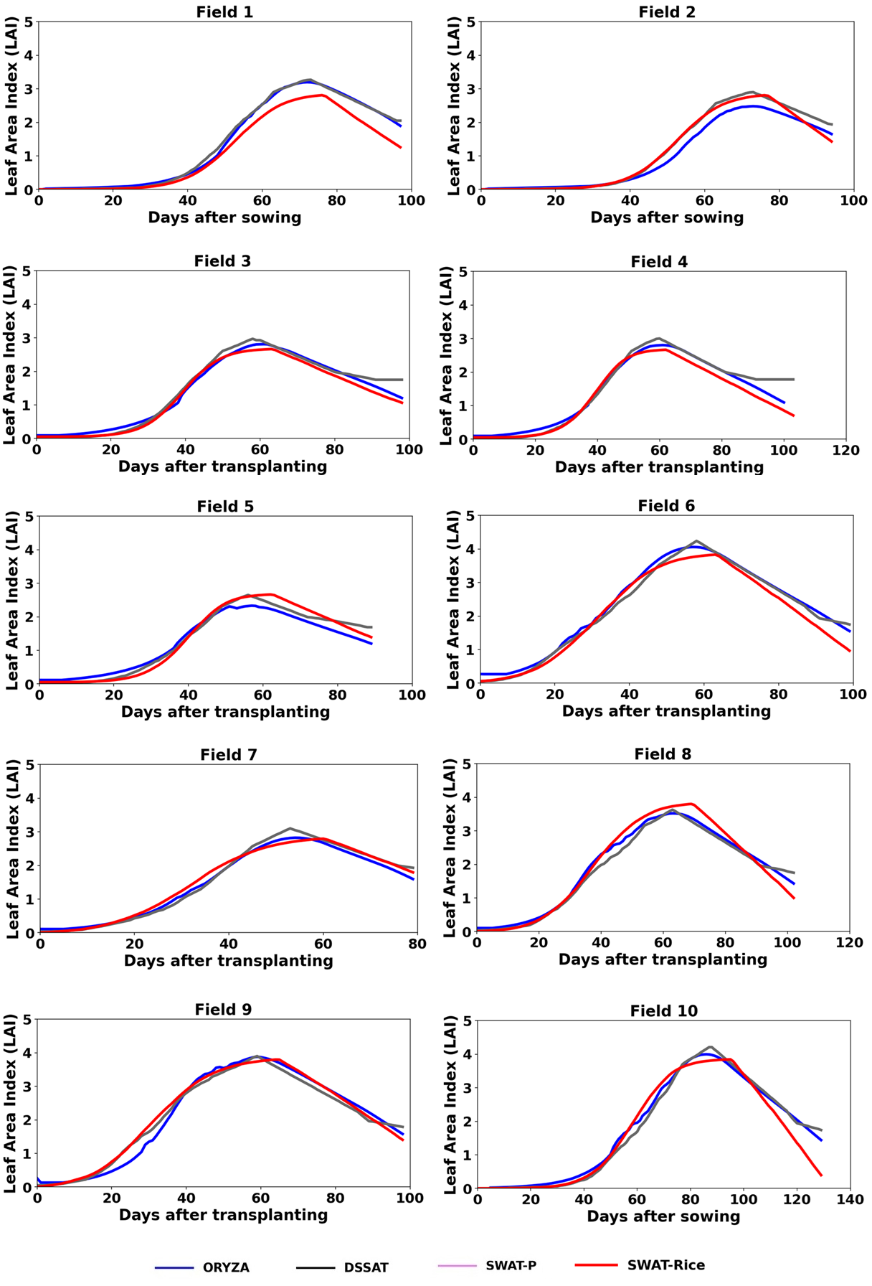
Fig. 13. Simulated leaf area index (LAI) from different models
- Model Applicability and Limitations
The study demonstrates the applicability of SWAT-Rice for field-scale simulation of paddy water balance and ponded-water dynamics under conventional flooded irrigation and varrying groundwater conditions. However, the current evaluation was limited to daily simulations of hydrological processes; performance under alternative irrigation practices, soil textures, sub-daily processes, and water-quality applications needs further evaluation. Sub-daily simulations could better represent intra-day variability in weather, evapotranspiration, and soil-water processes. Although preferential flow through shrinkage cracks has been incorporated, its performance under strongly macropore-dominated flow conditions remains to be evaluated. Similarly, the current crop-growth representation should be further developed to explicitly account for water and nutrient stresses. HYDRUS-1D was used as a numerical process-based reference for water-balance components for which direct observations were unavailable; however, because its parameters were also optimized, it cannot be considered an independent validation dataset. Future field studies incorporating direct measurements of evapotranspiration, percolation, and groundwater dynamics would provide stronger process-level validation. Basin-scale implementation and evaluation are also needed to quantify the effects of paddy-water management on streamflow, groundwater resources, and water use.
- Conclusions
Flooded paddy fields function as dynamic storage–release systems in which interactions among ponded water, soil water, and groundwater influence field- and basin-scale water balance. This study developed SWAT-Rice, a process-based paddy water-balance module for SWAT that integrates established formulations from rice crop models with a new groundwater–soil-water coupling framework. The module incorporates multilayer soil-water routing for puddled and non-puddled conditions and wetting–drying cycles, paddy-specific evapotranspiration, shrinkage-crack-induced preferential flow, and groundwater–soil-water interactions.
SWAT-Rice was evaluated using observed daily ponded-water levels from 10 independent paddy fields representing varying groundwater conditions, crop characteristics, rice establishment methods, and cropping seasons. A controlled inter-model comparison was conducted with ORYZA, DSSAT-CERES Rice, HYDRUS-1D, and SWAT-P using common field and management inputs, while only necessary model-specific parameters were optimized against observed ponded-water levels. HYDRUS-1D was used as a numerical process-based reference for water-balance components for which direct field observations were unavailable. Differences in simulated ponded-water dynamics and water-balance partitioning were associated with differences in underlying process representations.
Major findings and implications from the study include:
- Ponded-water dynamics: SWAT-Rice reproduced observed daily ponded-water levels across the ten fields, with NSE values ranging from 0.46 to 0.74 (mean = 0.57, median = 0.55). Its performance was comparable to the established rice crop models and HYDRUS-1D and substantially better than SWAT-P. HYDRUS-1D showed the highest mean NSE (0.59), followed by SWAT-Rice (0.57), DSSAT-CERES Rice (0.55), and ORYZA (0.53), while HYDRUS-1D also showed the highest median NSE (0.60).
- Major water loss pathways: ET and percolation were the major water-loss components in 7 of the 10 fields evaluated.
- Process representation: The inter-model comparison showed that SWAT-Rice provided improved representation of soil-water routing, percolation, evapotranspiration, and groundwater–soil-water interactions compared with the conventional SWAT-P formulation.
- Groundwater interactions: Explicit simulation of daily groundwater-table dynamics and groundwater–soil-water exchange within SWAT-Rice improved its ability to reproduce soil-water storage and subsurface fluxes under varying groundwater conditions.
- Importance of process-level evaluation: Comparison with HYDRUS-1D demonstrated that satisfactory runoff performance alone may not ensure realistic representation of individual paddy water-balance components, highlighting the need for process-level inter-model evaluation.
The present study demonstrates that integrating paddy-specific hydrological formulations into SWAT can improve the simulation of paddy water balance and groundwater interactions while retaining the spatially distributed structure required for watershed-scale applications. SWAT-Rice provides a process-based framework for evaluating alternative irrigation practices and simulating basin-scale water use and hydrological responses in rice-dominated regions.
CRediT authorship contribution statement
M. Shyma: Conceptualization, Methodology, Software, Validation, Formal analysis, Investigation, Data Curation, Visualization, Writing – Original Draft, Writing – Review & Editing. V. Harithalekshmi: Investigation, Writing – Review & Editing. Kirthiga Murugesan: Conceptualization, Writing – Review & Editing. Balaji Narasimhan: Conceptualization, Methodology, Resources, Writing – Review & Editing, Supervision, Project administration, Funding acquisition.
Appendix A. Supplementary data
The following are the Supplementary data for this article: https://github.com/shymamangalath/SWAT-Rice.git
Software and/or data availability
The new SWAT-Rice model was developed from the original SWAT source code (Rev. 670), which was modified and compiled using Intel Visual Fortran under the Intel® oneAPI Toolkits (2023) environment integrated with Microsoft Visual Studio 2022.
Year first available: 2024.
Developers: M. Shyma, Balaji Narasimhan
Email: nbalaji@civil.iitm.ac.in
License: Indian Institute of Technology, Madras.
Software availability: The SWAT-Rice source code, executables, and example datasets are freely available from the GitHub repository: https://github.com/shymamangalath/SWAT-Rice.git
Data availability: The example datasets required to reproduce the simulations presented in this study are available on GitHub. Detailed instructions for model setup, execution, input preparation, and output processing are provided in the README file included with the repository.
Declaration of competing interest
The authors declare that they have no known competing financial interests or personal relationships that could have appeared to influence the work reported in this paper.
Acknowledgement
We are thankful for the funding and support under the NICRA (National Innovations in Climate Resilient Agriculture) project, facilitated by ICAR (Indian Council of Agricultural Research) under Grant/Award Number 2-11(21)/18-19NICRA.

References
Abbaspour, K.C., Johnson, C.A., van Genuchten, M.Th., 2004. Estimating uncertain flow and transport parameters using a sequential uncertainty fitting procedure. Vadose Zone Journal 3 (4), 1340–1352.
Abeysingha, N.S., Singh, M., Islam, A., Sehgal, V.K., 2016. Climate change impacts on irrigated rice and wheat production in Gomti River basin of India: A case study. SpringerPlus 5, 1250.
Anjali, P., Raval, C.H., Patal, H.K., 2025. Water-saving technologies for rice production system: A review. International Journal of Research in Agronomy 8, 232–236.
Arnold, J.G., Srinivasan, R., Muttiah, R.S., Williams, J.R., 1998. Large-area hydrologic modeling and assessment: Part I. Model development. Journal of the American Water Resources Association 34 (1), 73–89.
Barker, R., Dawe, D., Tuong, T.P., Bhuiyan, S.I., Guerra, L.C., 1999. The outlook for water resources in the year 2020: challenges for research on water management in rice production. In: Assessment and Orientation Towards the 21st Century: Proceedings of the 19th Session of the International Rice Commission, Cairo, Egypt, 7–9 September 1998. Food and Agriculture Organization, Rome, Italy, pp. 96–109.
Bailey, R. T., & Hosseini, P., 2022. Comprehensive simulation of salinity transport in irrigated watersheds using an updated version of SWAT-MODFLOW. Environmental Modelling & Software, 159, 105566.
Belder, P., Bouman, B.A.M., Spiertz, J.H.J., 2007. Exploring options for water savings in lowland rice using a modelling approach. Agricultural Systems 92, 91–114.
Bhattacharyya, T., SarKar, D., Sehgal, J.L., Velayutham, M., Gajbhiye, K.S., Nagar, A.P., NimkhedKar, S.S., 2009. Soil taxonomic database of India and the states (1:250,000 scale). NBSSLUP Publ. 143. NBSS & LUP, Nagpur.
Bouman, B.A.M., Kropff, M.J., Tuong, T.P., Wopereis, M.C.S., Ten Berge, H.F.M., Van Laar, H.H., 2001. ORYZA2000: Modeling lowland rice. IRRI, Los Baños and Wageningen University.
Bouman, B.A.M., Lampayan, R.M., Tuong, T.P., 2007. Water management in irrigated rice: Coping with water scarcity. International Rice Research Institute, Los Baños, Philippines.
Bwire, D., Saito, H., Sidle, R.C., Nishiwaki, J., 2024. Water management and hydrological characteristics of paddy-rice fields under alternate wetting and drying irrigation practice as climate smart practice: A review. Agronomy 14 (7), 1421.
Central Ground Water Board (CGWB), 2023. National Compilation on Dynamic Ground Water Resources of India, 2023. Department of Water Resources, River Development and Ganga Rejuvenation, Ministry of Jal Shakti, Government of India, Faridabad, India.
Choi, S., Jeong, J., Kim, M., 2017. Simulating the effects of agricultural management on water quality dynamics in rice paddies for sustainable rice production—Model development and validation. Water 9, 869.
Dai, J.F., Cui, Y.L., Cai, X.L., Brown, L.C., Shang, Y.H., 2016. Influence of water management on the water cycle in a small watershed irrigation system based on a distributed hydrologic model. Agricultural Water Management 174, 52–60.
Danvi, A., Giertz, S., Zwart, S.J., Diekkrüger, B., 2018. Rice intensification in a changing environment: Impact of water availability in inland valley landscapes in Benin. Water 10 (1), 74.
Dash, S.S., Sahoo, B., Raghuwanshi, N.S., 2020. A novel embedded pothole module for Soil and Water Assessment Tool (SWAT) improving streamflow estimation in paddy-dominated catchments. Journal of Hydrology 588, 125103.
Dash, S.S., Sahoo, B., Raghuwanshi, N.S., 2023. SWAT model calibration approaches in an integrated paddy-dominated catchment-command. Agricultural Water Management 278, 108138.
Debnath, M., Chatterjee, S., Nayak, A., Chakraborty, D., Pathak, H., 2025. Water use in rice crop cultivation in India: a quantitative assessment. Agricultural Research, 1–13.
Devkota, K.P., Hoogenboom, G., Boote, K.J., Lamers, J.P.A., Devkota, M.K., Vlek, P.L.G., 2015. Simulating the impact of water saving irrigation and conservation agriculture practices for rice–wheat systems in the irrigated arid drylands of Central Asia. Agricultural and Forest Meteorology 214–215, 266–280.
Du, B., Arnold, J.G., Saleh, A., Jaynes, D.B., 2005. Development and application of SWAT to landscapes with tiles and potholes. Transactions of the ASAE 48, 1121–1133.
Faridani, F., Seyed, S., Naghedifar, S.M., Karimian, F., Basile, B., Ali, A., Ziaei, A., Farid, A., Fiorentino, M., Madonna, F., Lasaponara, R., 2025. Analytical MSMAR versus numerical HYDRUS-1D: Comparative performance analysis in the estimation of soil water components. J. Irrig. Drain. Eng. 151.
Feddes, R.A., Kowalik, P.J., Zaradny, H., 1978. Simulation of Field Water Use and Crop Yield. Wiley, New York.
Feng, L., Bouman, B.A.M., Tuong, T.P., Cabangon, R.J., Li, Y., Lu, G., Feng, Y., 2007. Exploring options to grow rice using less water in northern China using a modelling approach. I: Field experiments and model evaluation. Agricultural Water Management 88, 1–13.
Garg, K., Das, B.S., Khan, S., Bhadoria, P.B.S., 2009. Measurement and modeling of soil water regime in a lowland paddy field showing preferential transport. Agricultural Water Management 96, 1705–1714.
Gassman, P.W., Jeong, J., Boulange, J., Narasimhan, B., Kato, T., Somura, H., et al., 2022. Simulation of rice paddy systems in SWAT: A review of previous applications and proposed SWAT+ rice paddy module. International Journal of Agricultural and Biological Engineering 15 (1), 1–24.
Government of India, Ministry of Agriculture and Farmers Welfare, Department of Agriculture and Farmers Welfare, 2022. Agricultural Statistics at a Glance 2022. Government of India, New Delhi.
Ground Water Estimation Committee (GEC). 2015. Ground Water Resource Estimation Methodology – 2015. Central Ground Water Board, Government of India.
Gupta, H.V., Sorooshian, S., Yapo, P.O., 1999. Status of automatic calibration for hydrologic models: Comparison with multilevel expert calibration. Journal of Hydrologic Engineering 4 (2), 135–143.
Im, S.J., Park, S.W., Jang, T.I., 2007. Application of SCS curve number method for irrigated paddy field. KSCE Journal of Civil Engineering 11, 51–56.
Jamieson, P.D., Porter, J.R., Wilson, D.R., 1991. A test of the computer simulation model ARCWHEAT1 on wheat crops grown in New Zealand. Field Crops Research 27 (4), 337–350.
Janssen, M., Lennartz, B., 2009. Water losses through paddy bunds: Methods, experimental data, and simulation studies. Journal of Hydrology 369, 142–153.
Jeong, J., Arnold, J., Park, S., Sorando, R., Choi, S.-K., Kim, M.-K., 2025. Enhancement of the SWAT+ model for simulating paddy rice cultivation and irrigation management in agricultural watersheds. Journal of Hydrology 659, 133288.
Jones, J.W., Hoogenboom, G., Porter, C.H., Boote, K.J., Batchelor, W.D., Hunt, L.A., et al., 2003. The DSSAT cropping system model. European Journal of Agronomy 18, 235–265.
Kadiyala, M.D.M., Jones, J.W., Mylavarapu, R.S., Li, Y.C., Reddy, M.D., 2015. Identifying irrigation and nitrogen best management practices for aerobic rice–maize cropping system for semi-arid tropics using CERES-rice and maize models. Agricultural Water Management 149, 23–32.
Kang, M.S., Park, S.W., Lee, J.J., Yoo, K.H., 2006. Applying SWAT for TMDL programs to a small watershed containing rice paddy fields. Agricultural Water Management 79, 72–92.
Kato, T., Somura, H., Kuroda, H., Nakasone, H., 2011. Simulation of nutrients from an agricultural watershed in Japan using the SWAT model. International Agricultural Engineering Journal 20 (3), 40–49.
Kim, Y.-J., Kim, H.-D., Jeon, J.-H., 2014. Characteristics of water budget components in paddy rice field under the Asian monsoon climate: Application of HSPF-paddy model. Water 6 (7), 2041–2055.
Kukal, S.S., Aggarwal, G.C., 2002. Percolation losses of water in relation to puddling intensity and depth in a sandy loam rice field. Agricultural Water Management 57, 49–59.
Lee, S., Park, Y.S., Kim, J., Lim, K.J., 2023. Enhanced hydrological simulations in paddy-dominated watersheds using the hourly SWAT-MODFLOW-PADDY modeling approach. Sustainability 15 (11), 9106.
Li, T., Angeles, O., Marcaida, M., Manalo, E., Manalili, M.P., Radanielson, A., Mohanty, S., 2017. From ORYZA2000 to ORYZA (v3): An improved simulation model for rice in drought and nitrogen-deficient environments. Agricultural and Forest Meteorology 237–238, 246–256.
Li, Y., Simunek, J., Jing, L.F., Zhang, Z.T., Ni, L.X., 2014. Evaluation of water movement and water losses in a direct-seeded-rice field experiment using HYDRUS-1D. Agricultural Water Management 142, 38–46.
Li, Y., Simunek, J., Wang, S., Yuan, J., Zhang, W., 2017. Modeling of soil water regime and water balance in a transplanted rice field experiment with reduced irrigation. Water 9 (4), 248.
Manikandan, S., Pazhanivelan, S., Ragunath, K.P., Radha, M., 2019. Comparison of MODIS and Pocket LAI derived rice leaf area index in Thiruvarur district. Int. J. Chem. Stud. 7 (3), 5141–5144.
Mo’allim, A.A., Kamal, M.R., Muhammed, H.H., Soom, M.A.M., Zawawi, M.A.M., Wayayok, A., Man, H.B.C., 2018. Assessment of nutrient leaching in flooded paddy rice field experiment using HYDRUS-1D. Water 10 (6), 785.
Monteith, J.L., 1965. Evaporation and environment. Symposia of the Society for Experimental Biology 19, 205–234.
Moriasi, D.N., Arnold, J.G., Van Liew, M.W., Bingner, R.L., Harmel, R.D., Veith, T.L., 2007. Model evaluation guidelines for systematic quantification of accuracy in watershed simulations. Transactions of the ASABE 50, 885–900.
Nash, J.E., Sutcliffe, J.V., 1970. River flow forecasting through conceptual model. Part I—A discussion of principles. Journal of Hydrology 10, 282–290.
Neitsch, S.L., Arnold, J.G., Kiniry, J.R., Williams, J.R., 2011. Soil and Water Assessment Tool theoretical documentation. Texas Water Resources Institute, College Station, TX.
Ouyang, W., Wei, P., Gao, X., Srinivasan, R., Yen, H., Xie, X., Liu, L., Liu, H., 2020. Optimization of SWAT-Rice for modeling hydrology and diffuse pollution of large rice paddy fields. Environmental Modelling & Software 130, 104736.
Pathak, H., Timsina, J., Humphreys, E., Godwin, D.C., Singh, B., Shukla, A.K., Singh, U., Matthews, R.B., 2004. Simulation of rice crop performance and water and N dynamics, and methane emissions for rice in northwest India using CERES-Rice model. CSIRO Land and Water Technical Report 23/04. CSIRO Land and Water, Griffith, NSW, Australia, 111 pp.
Prabhakar, M., Gopinath, K.A., Ravi Kumar, N., Thirupathi, M., Sai Sravan, U., Srasvan Kumar, G., Samba Siva, G., Chandana, P., Singh, V.K., 2024. Mapping leaf area index at various rice growth stages in southern India using airborne hyperspectral remote sensing. Remote Sens. 16 (6), 954.
Priestley, C.H.B., Taylor, R.J., 1972. On the assessment of surface heat flux and evaporation using large-scale parameters. Monthly Weather Review 100, 81–92.
Radanielson, A.M., Gaydon, D.S., Li, T., Angeles, O., Roth, C.H., 2018. Modeling salinity effect on rice growth and grain yield with ORYZA v3 and APSIM-Oryza. European Journal of Agronomy 100, 44–55.
Rezaei, R., Tabatabaekoloor, M., Mousavi, S.R., Aghili, N.N., 2012.
Effects of puddling intensity on the in-situ engineering properties of paddy field soil.
American Journal of Agricultural and Biological Engineering 3, 22–26.
Ritchie, J.T., 1972. A model for predicting evaporation from a row crop with incomplete cover. Water Resources Research 8 (5), 1204–1213.
Ritchie, J.T., 1998. Soil water balance and plant water stress. In: Tsuji, G.Y., Hoogenboom, G., Thornton, P.K. (Eds.), Understanding options for agricultural production. Kluwer Academic Publishers, Dordrecht, the Netherlands, pp. 41–54.
Sakaguchi, A., Eguchi, S., Kasuya, M., 2014a. Examination of the water balance of irrigated paddy fields in SWAT 2009 using the curve number procedure and the pothole module. Soil Science and Plant Nutrition 60, 551–564.
Sakaguchi, A., Eguchi, S., Kato, T., Kasuya, M., Ono, K., Miyata, A., Tase, N., 2014b. Development and evaluation of a paddy module for improving hydrological simulation in SWAT. Agricultural Water Management 137, 116–122.
Senthilkumar, M., Arumugam, R., Gnanasundar, D., Thambi, D.S.C., Sampath Kumar, E., 2015. Effects of geological structures on groundwater flow and quality in hardrock regions of northern Tirunelveli district, southern India. J. Earth Syst. Sci. 124, 405–418.
Shekhar, S., Mailapalli, D., Raghuwanshi, N., Das, B., 2019. HYDRUS-1D model for simulating water flow through paddy soils under alternate wetting and drying irrigation practice. Paddy and Water Environment 18, 1–13.
Šimůnek, J., Van Genuchten, M.T., Šejna, M., 2005. The HYDRUS-1D software package… University of California-Riverside.
Skaggs, R.W., Youssef, M.A., Chescheir, G.M., 2012. DRAINMOD: Model use, calibration, and validation. Transactions of the ASABE 55, 1509–1522.
Yadav, S., Li, T., Humphreys, E., Gill, G., Kukal, S., 2011. Evaluation and application of ORYZA2000 for irrigation scheduling of puddled transplanted rice in North West India. Field Crops Research 122, 104–117.
Tabbal, D.F., Bouman, B.A.M., Bhuiyan, S.I., Sibayan, E.B., Sattar, M.A., 2002. On-farm strategies for reducing water input in irrigated rice: Case studies in the Philippines. Agricultural Water Management 56, 93–112.
ten Berge HFM. 1989. Heat and water transfer in bare topsoil and lower atmosphere. Simulation Monographs 33. Wageningen (Netherlands): Pudoc. 200 p.
Tian, F., Miao, Q., Shi, H., Li, R., Dou, X., Duan, J., Liu, J., Feng, W., 2023. Study on water and salt transport under different subsurface pipe arrangement conditions in severe saline–alkali land in Hetao irrigation district with DRAINMOD model. Water 15 (16), 3001.
Tsuchiya, R., Kato, T., Jeong, J., Arnold, J.G., 2018. Development of SWAT-Rice for simulating lowland paddy fields. Sustainability 10, 3246.
Tuong, T.P., Bouman, B.A.M., 2003. Rice production in water-scarce environments. In: Water productivity in agriculture. CABI, Wallingford, pp. 53–67.
Tuong, T.P., Bouman, B.A.M., Mortimer, M., 2005. More rice, less water—Integrated approaches for increasing water productivity in irrigated rice-based systems in Asia. Plant Production Science 8, 231–241.
van Genuchten, M.T., 1980. A closed-form equation for predicting the hydraulic conductivity of unsaturated soils. Soil Science Society of America Journal 44 (5), 892–898.
Van Genuchten, M.Th., Pachepsky, Y., 2011. Hydraulic properties of unsaturated soils. In: Encyclopedia of Agrophysics. Springer.
Wickham, T.H., Singh, V.P., 1978. Water movement through wet soils. In: Soils and rice. IRRI.
Wu, D., Cui, Y., Luo, Y., 2019. Irrigation efficiency and water-saving potential considering reuse of return flow. Agricultural Water Management 221, 519–527.
Xie, X., Cui, Y., 2011. Development and test of SWAT for modeling hydrological processes in irrigation districts with paddy rice. Journal of Hydrology 396 (1–2), 61–71.
Xu, B., Shao, D., Tan, X., Yang, X., Gu, W., Li, H., 2017. Evaluation of soil water percolation under different irrigation practices, antecedent moisture and groundwater depths in paddy fields. Agricultural Water Management 192, 149–158.
Yu, Q., Cui, Y., 2022. Improvement and testing of ORYZA model water balance modules for alternate wetting and drying irrigation. Agricultural Water Management 271, Article C.

