Confusion matrix for SDN paper’s model:

This confusion matrix show the percentage of good predictions in an Internal Classifier that are also good predictions in the next Internal Classifier. The accuracy of the later classifier does not drop, they are better than the previous one with respect to the whole data set. What can be seen here is that some well classified examples from the first classifiers are lost by the later classifiers.

Accuracies for the same simple model with different strategies:
The final model is a 11 blocks deep network with 9 block of type 1 (16 channels, kernel:3*3, conv2d; Relu; conv2d with same parameters; and a Residual shortcut)

1) Model trained as a classic CNN:
81.77

2) Model with IC trained from scratch as in the paper:
[67.02, 77.11 81.47 82.11]

3) Model with IC growing every 25 epochs and training for 100 epochs:
[77.38, 79.31, 79.07, 76.45]

4) Model with IC growing every 25 epochs and freezing at epochs 100, 125, 150 and training up to 175:
[78.04 79.84, 78.11, 77.84]

5) Model with IC growing every 25 epochs, freezing the model before the growth and unfreezing it in the middle before the next growth:
[75.13, 75.7, 73.09, 70.78]
###############################################################################
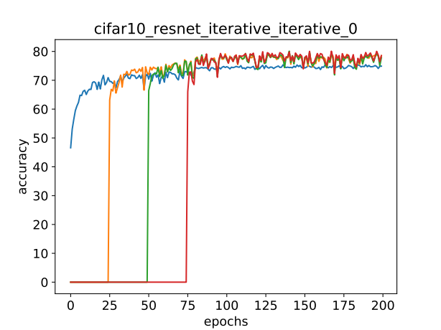
Model grow at [25, 50, 75] trained for 200 epochs 3 milestones: [80, 120, 160] for [0.1, 0.1, 0.1] and base lr 0.01:
test: [76.86, 81.31, 81.34, 81.40]

Model grow at [25, 50, 75] trained for 200 epochs 4 milestones: [75, 120, 160, 180] for [10, 0.1, 0.1, 0.1] and base lr 0.01 → Similar to full IC from scratch when epoch 100 reached
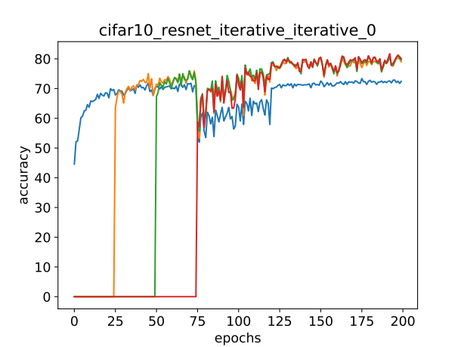
test: [76.18, 81.90, 82.34, 82.60]

Model grow at [25, 50, 75] trained 200 epochs 3 milestones: [120, 160, 180] for [0.1, 0.1, 0.1] and base lr 0.01
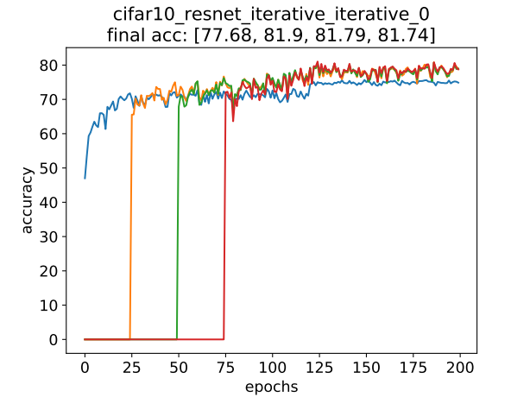

Model grow at [25, 50, 75] trained 200 epochs 3 milestones: [100, 120, 150] for [0.1, 0.1, 0.001] and base lr 0.01
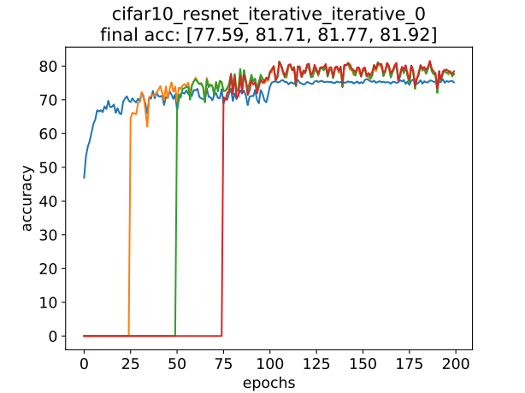

Tests for pruning with differents sparsity and strategy 3:

100: [76.36, 78.90, 77.72, 76.09],
80.0: [75.90, 77.43, 77.61, 75.77],
60.0: [76.13, 76.47, 75.61, 73.84],
50.0: [74.86, 77.45, 76.86, 74.04],
40.0: [70.93, 71.59, 70.14, 67.90],
30.0: [68.93, 68.29, 68.09, 65.20],
20.0: [65.56, 63.96, 64.89, 41.03],
10.0: [53.89, 54.59, 49.36, 21.97],
5.0: [41.46, 34.23, 17.10, 10.00]

