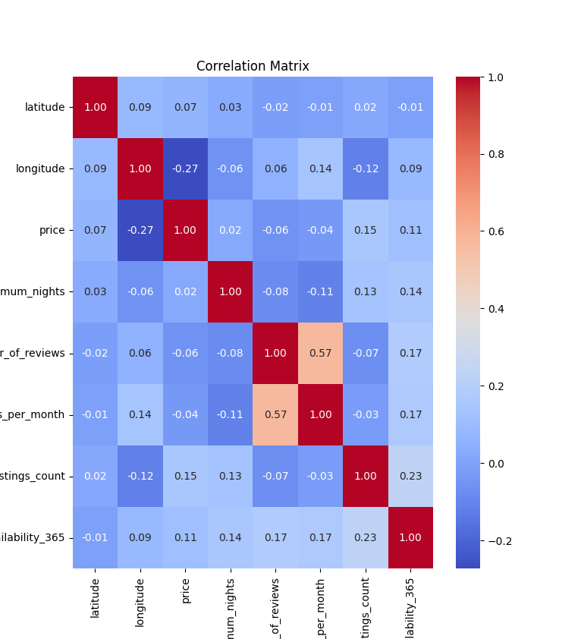
The correlation matrix shows the linear relationship between numerical variables in the dataset.
The values range from -1 to 1:
- 1 means a perfect positive correlation.
- -1 means a perfect negative correlation.
- 0 means almost no linear correlation.
Main observations:
- price has a weak positive correlation with calculated_host_listings_count around 0.15.
- price also has a weak positive correlation with availability_365 around 0.11.
- price has a weak negative correlation with longitude around -0.27.
- number_of_reviews and reviews_per_month have a moderate positive correlation around 0.57.
This means there is no very strong multicollinearity between most variables. Multicollinearity is important because if two predictor variables are highly correlated, the model may have difficulty understanding which variable actually affects the target value.

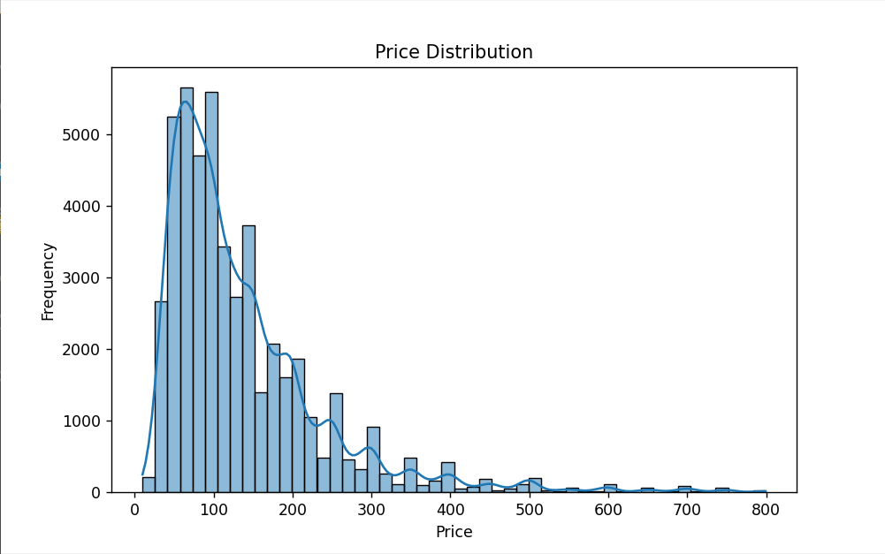
This histogram shows how Airbnb prices are distributed.
Most listings are concentrated in the lower price range, mainly between approximately 50 and 200 dollars. The distribution is right-skewed, which means there are many cheaper listings and fewer expensive listings.
There are also some high-price listings, but they are much less frequent. This shows that the dataset contains outliers and that price is not normally distributed.
This is important because regression models can be affected by extreme values.

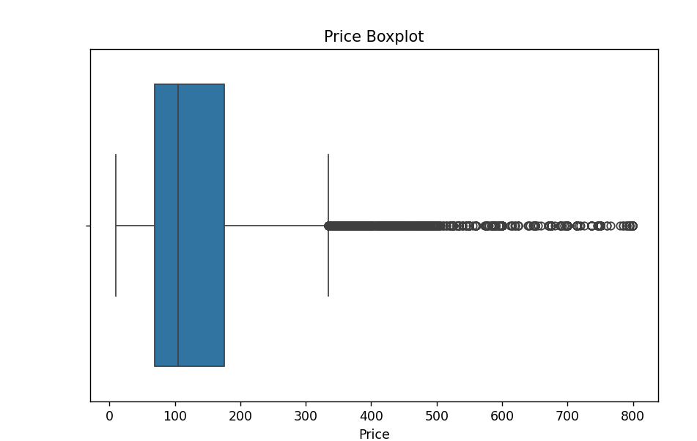
The boxplot also shows the distribution of prices and possible outliers.
Most prices are located inside the box, while many points on the right side represent expensive listings. These points are considered potential outliers.
The median price is around the lower-middle part of the box, which confirms that most listings are relatively affordable compared to the maximum values.
This plot shows that Airbnb prices vary strongly and contain many high-value outliers.

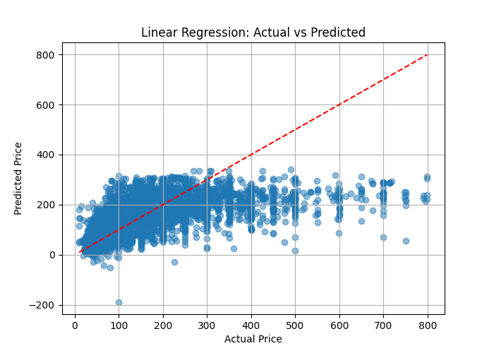
This plot compares actual prices with predicted prices for the Linear Regression model.
The red dashed line represents perfect prediction. If the model predicted prices perfectly, all points would be close to this line.
In this plot, many points are far from the red line, especially for higher actual prices. The model predicts many expensive listings as cheaper than they really are.
This means Linear Regression does not capture the complex relationship between features and price very well. It works as a basic model, but it underestimates expensive listings.

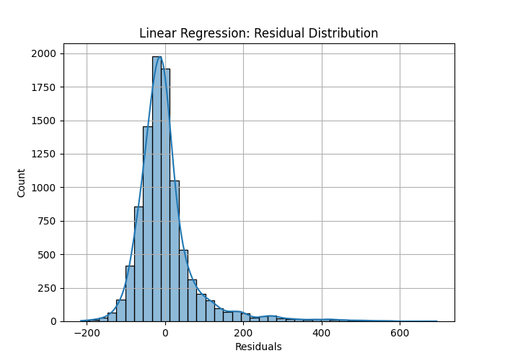
This plot shows the distribution of residuals for Linear Regression.
A residual is the difference between actual and predicted value:
Residual = Actual Price - Predicted Price
Most residuals are close to zero, which means many predictions are not extremely wrong. However, the distribution has a long right tail, meaning the model often underestimates expensive listings.
This confirms that Linear Regression has difficulty predicting high prices.

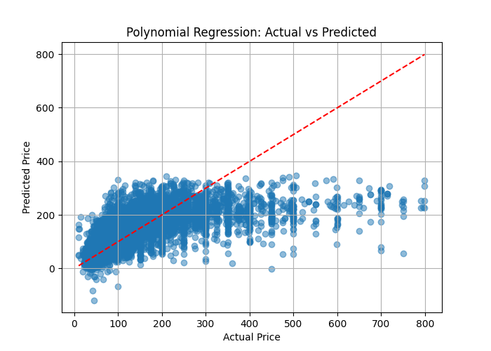
This plot shows actual prices versus predicted prices for Polynomial Regression.
Polynomial Regression performs slightly better than basic Linear Regression because it can capture some nonlinear relationships. However, many points are still far from the red line.
The model still underestimates many expensive listings. Predictions are concentrated mostly below 300, even when actual prices are much higher.
This means Polynomial Regression improves flexibility but still cannot fully model the complexity of Airbnb pricing.
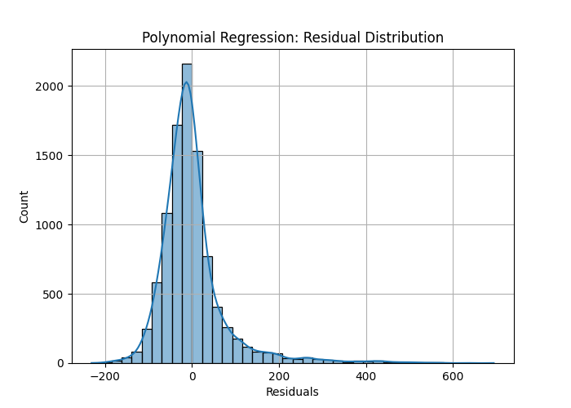
The residual distribution for Polynomial Regression is centered near zero, which is good.
However, the right tail is still visible. This means the model still makes larger errors for some high-price listings.
Compared with Linear Regression, the residual pattern is similar, but Polynomial Regression may slightly reduce some errors because it captures nonlinear patterns.
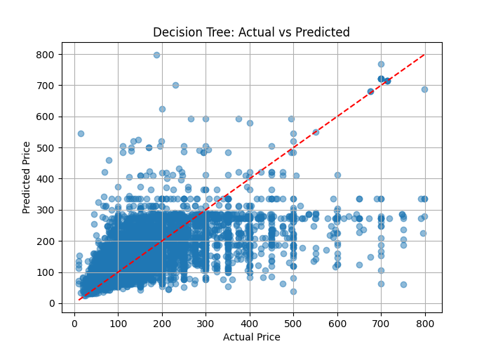
This plot shows the Decision Tree model’s predictions.
Compared with Linear Regression, the Decision Tree can capture more nonlinear patterns. Some predictions are closer to the red line, especially in the lower and middle price ranges.
However, the plot also shows many horizontal clusters. This happens because Decision Trees split data into groups and assign similar predicted values to observations in the same leaf.
The model performs reasonably, but it can still make large errors and may overfit if the tree is too deep.

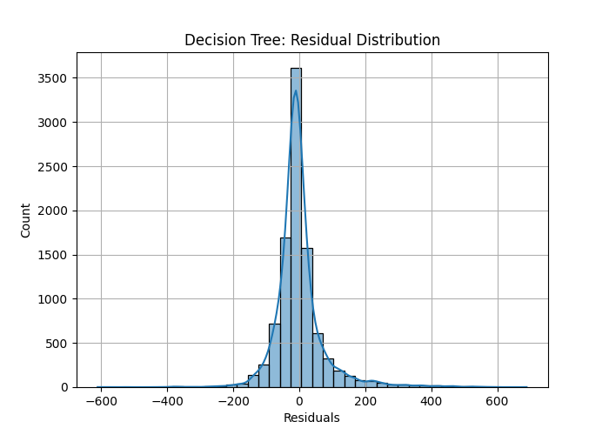
The Decision Tree residual distribution is strongly centered around zero.
This means many predictions are close to the real price. However, there are still long tails on both sides, which means the model sometimes overestimates and sometimes underestimates prices.
The residuals are more concentrated near zero than in Linear Regression, which suggests better performance.

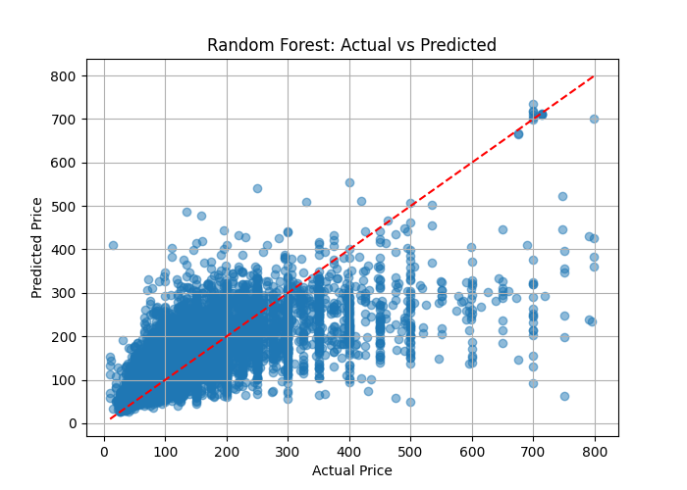
This plot shows the Random Forest model’s predictions.
Random Forest performs better than a single Decision Tree because it combines many trees. This usually gives more stable and accurate predictions.
The points are somewhat closer to the red line compared with Linear Regression and Polynomial Regression. The model captures nonlinear relationships better.
However, the model still underestimates some expensive listings. This happens because high-price listings are less common and harder to predict.

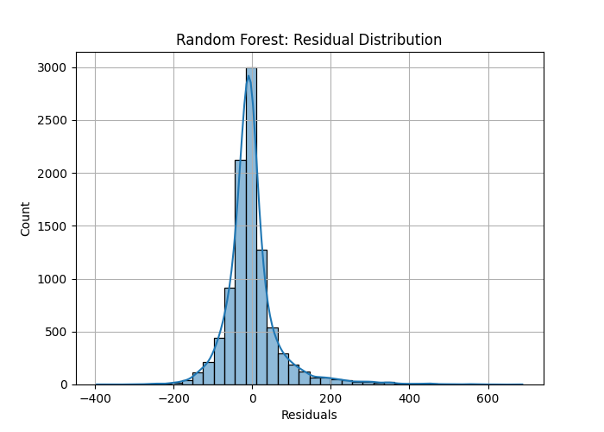
The Random Forest residual distribution is centered close to zero and is relatively narrow.
This means the model makes smaller errors for many listings. Compared with other models, residuals are more concentrated around zero.
This supports the result that Random Forest is the best-performing model in the comparison.

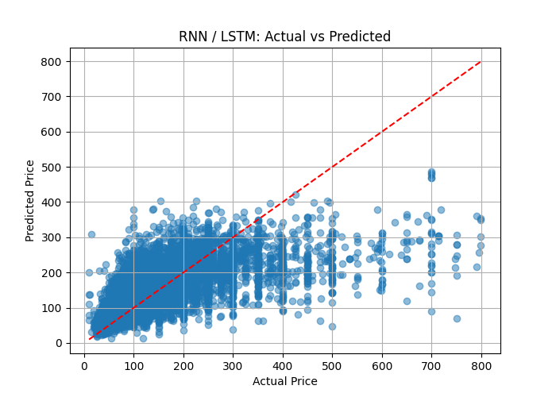
This plot shows the predictions of the RNN/LSTM model.
The model captures some general price patterns, but many predictions are still far from the red line. Similar to other models, it underestimates expensive listings.
RNN/LSTM models are usually designed for sequential data, such as text or time series. This Airbnb dataset is tabular, so RNN/LSTM is not the most suitable model.
Still, the model performs reasonably because it can learn nonlinear relationships.

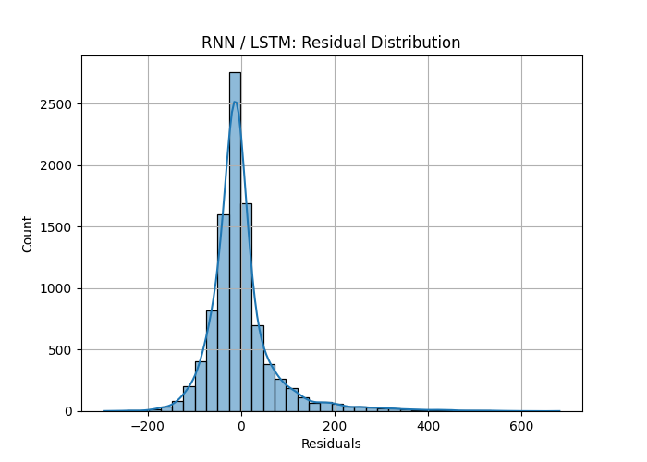
The residuals are centered near zero, which means many predictions are close to the actual values.
However, there is still a long right tail, meaning the model underestimates some expensive listings.
The residual distribution looks relatively good, but RNN/LSTM is harder to interpret and less appropriate for this type of dataset compared with Random Forest.
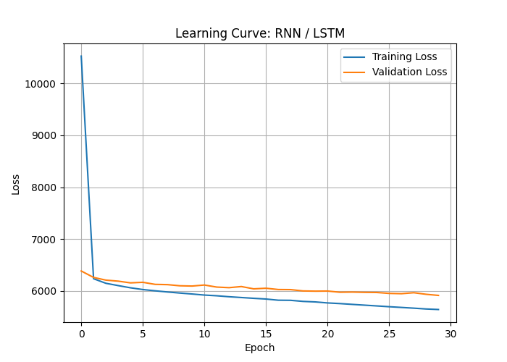
This plot shows the training loss and validation loss over epochs.
The training loss decreases quickly at the beginning, which means the model learns patterns from the data. After several epochs, the loss decreases more slowly.
The validation loss also decreases but remains slightly higher than the training loss. This is normal because validation data is unseen during training.
The gap between training and validation loss is not extremely large, so there is no strong sign of severe overfitting. However, the validation loss becomes almost flat after some epochs, meaning the model stops improving significantly.

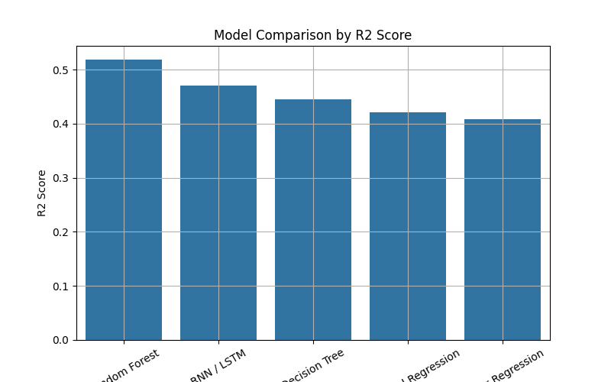
This bar chart compares all models using the R2 score.
R2 score shows how much of the variation in price is explained by the model. Higher R2 means better performance.
According to the chart:
- Random Forest has the best R2 score, around 0.52.
- RNN/LSTM is second, around 0.47.
- Decision Tree is around 0.44.
- Polynomial Regression is around 0.42.
- Linear Regression is around 0.41.
This means Random Forest performed the best overall. It likely performed best because Airbnb prices depend on nonlinear relationships between features such as location, room type, number of reviews, availability, and host activity.

