Exploratory Data Analysis (EDA) Project
Internship Task 3 - Final Report - Data Science Domain (Diamonds Dataset)
Item | Details
Student | Shynav
Program | B.Tech, Artificial Intelligence & Data Science
Task | Exploratory Data Analysis (EDA) Project
Dataset | Diamonds (53,940 records, seaborn built-in)
Tools | Python, Pandas, NumPy, Matplotlib, Seaborn

1. Objective
Analyze a dataset to uncover patterns and trends, using statistical summaries and visualizations, identify correlations and key influencing factors, and present the insights in a structured report.

2. Dataset Overview
The Diamonds dataset contains 53,940 records describing diamonds by price and physical/quality attributes: carat (weight), cut, color and clarity grades, cut proportions (depth, table), and physical dimensions (x, y, z in mm). The dataset has no missing values and no duplicate rows, so this task focuses entirely on exploration rather than cleaning.

3. Statistical Summary
Price ranges from $326 to $18,823 with a mean of about $3,933 and a median well below the mean, which already signals a right-skewed distribution. Carat ranges from 0.2 to 5.01, with most diamonds clustered under 1.5 carats. A small number of rows have a 0 value in a dimension field (x, y, or z), which is physically impossible and was noted but not removed, since it does not affect this exploratory analysis.

4. Univariate Analysis

4.1 Price Distribution
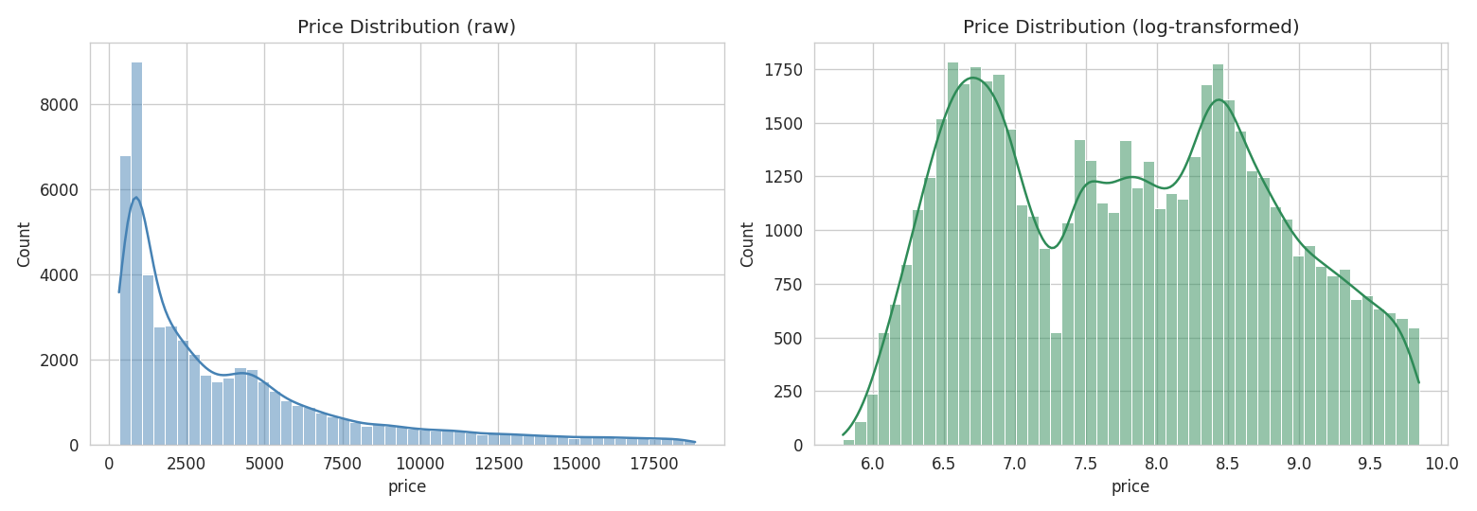
Figure 1: Price distribution, raw (left) and log-transformed (right)
Price is heavily right-skewed: most diamonds are modestly priced, with a long tail of expensive outliers. The log transform makes the distribution far more symmetric, which would be useful for any downstream modeling.

4.2 Carat Distribution
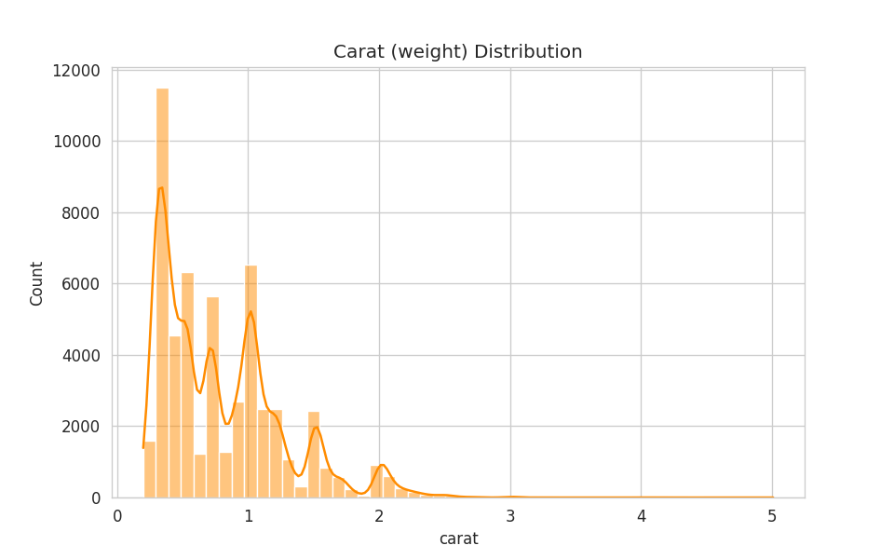
Figure 2: Carat (weight) distribution

4.3 Categorical Feature Counts
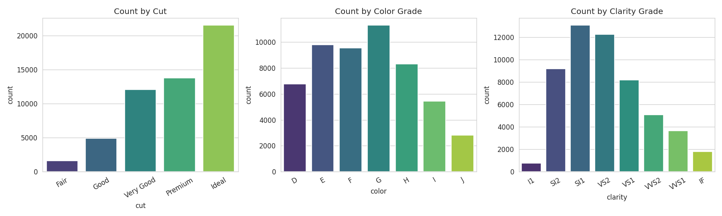
Figure 3: Counts by cut, color, and clarity grade

5. Correlation Analysis
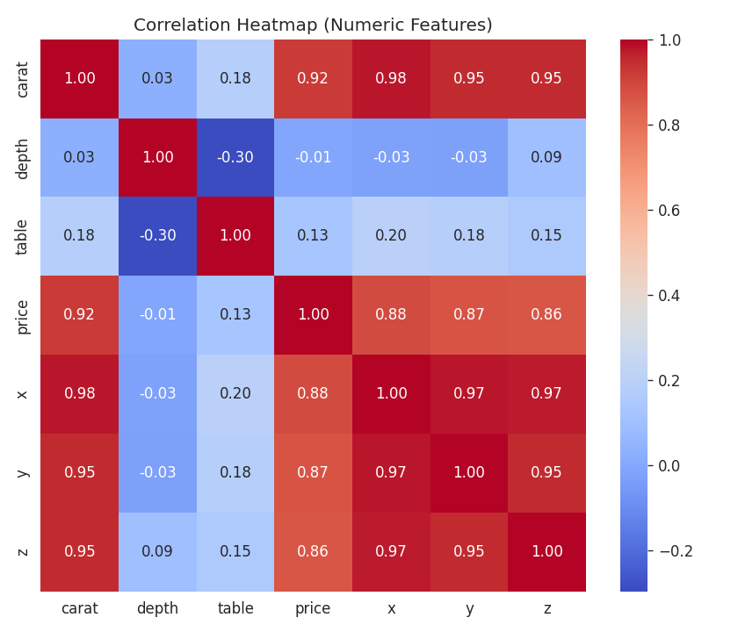
Figure 4: Correlation heatmap of numeric features
Carat has by far the strongest correlation with price (r = 0.92), followed closely by the physical dimensions x, y, z (r = 0.86-0.88) — expected, since size and weight both scale with a diamond's dimensions. Depth and table (cut proportions) show very weak correlation with price on their own (r = -0.01 and 0.13 respectively).

6. Bivariate Analysis - Key Influencing Factors

6.1 Price vs Carat
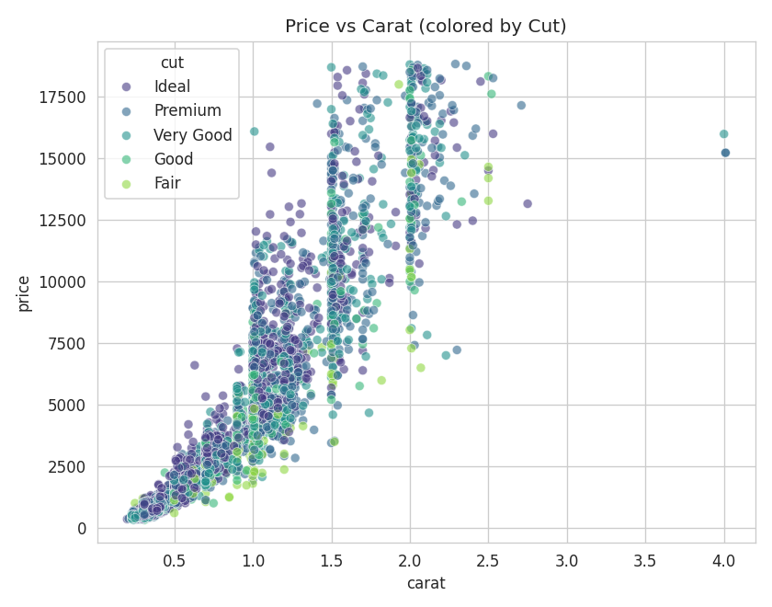
Figure 5: Price vs carat, colored by cut (5,000-point sample)

6.2 Average Price by Quality Grade
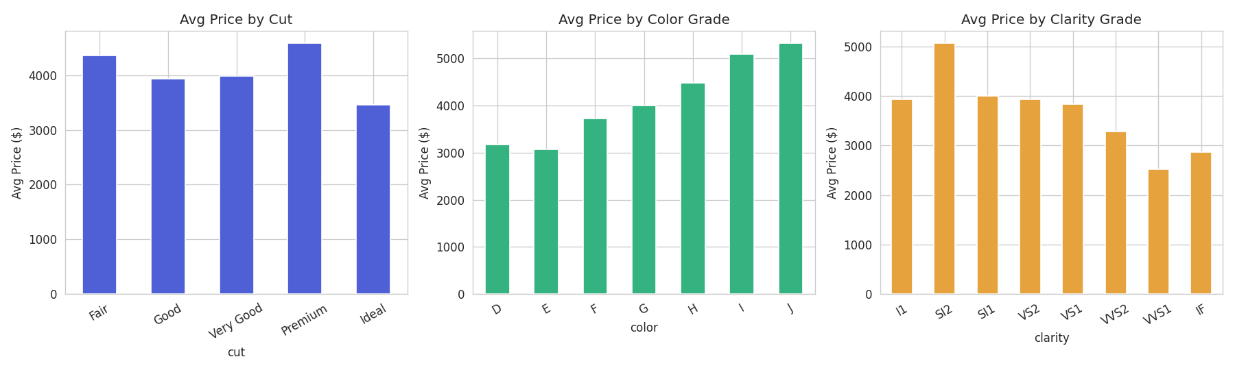
Figure 6: Average price by cut, color, and clarity grade
A surprising pattern: average price does not increase monotonically with better cut grade. Fair-cut diamonds average $4,359, higher than Ideal-cut diamonds at $3,458. This is a confounding-variable effect, not evidence that lower cut quality is worth more.

6.3 Explaining the Confound: Carat by Cut
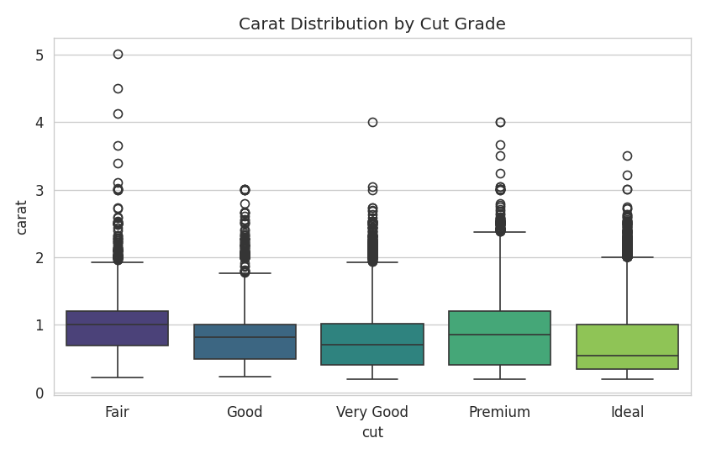
Figure 7: Carat distribution by cut grade
Confirmed: Fair-cut diamonds average 1.05 carats versus 0.70 carats for Ideal-cut diamonds in this dataset. Since carat is the dominant price driver, larger Fair-cut stones outweigh their lower cut quality in the raw price average.

6.4 Price per Carat by Clarity (a fairer comparison)
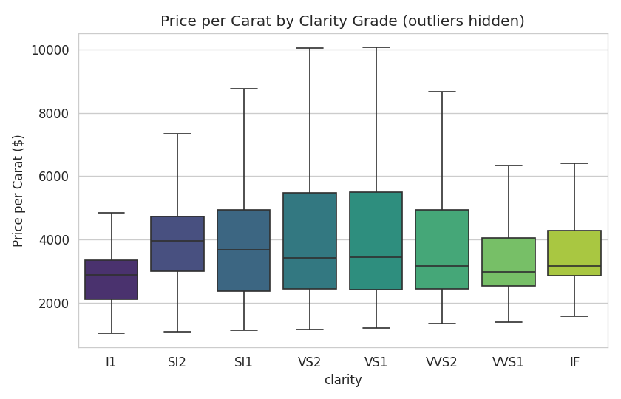
Figure 8: Price per carat by clarity grade (outliers hidden)
Once price is normalized by carat, price per carat does trend upward with better clarity grades - showing clarity's effect on price is real, but was masked by carat differences in the raw comparison above.

7. Combined Dashboard View
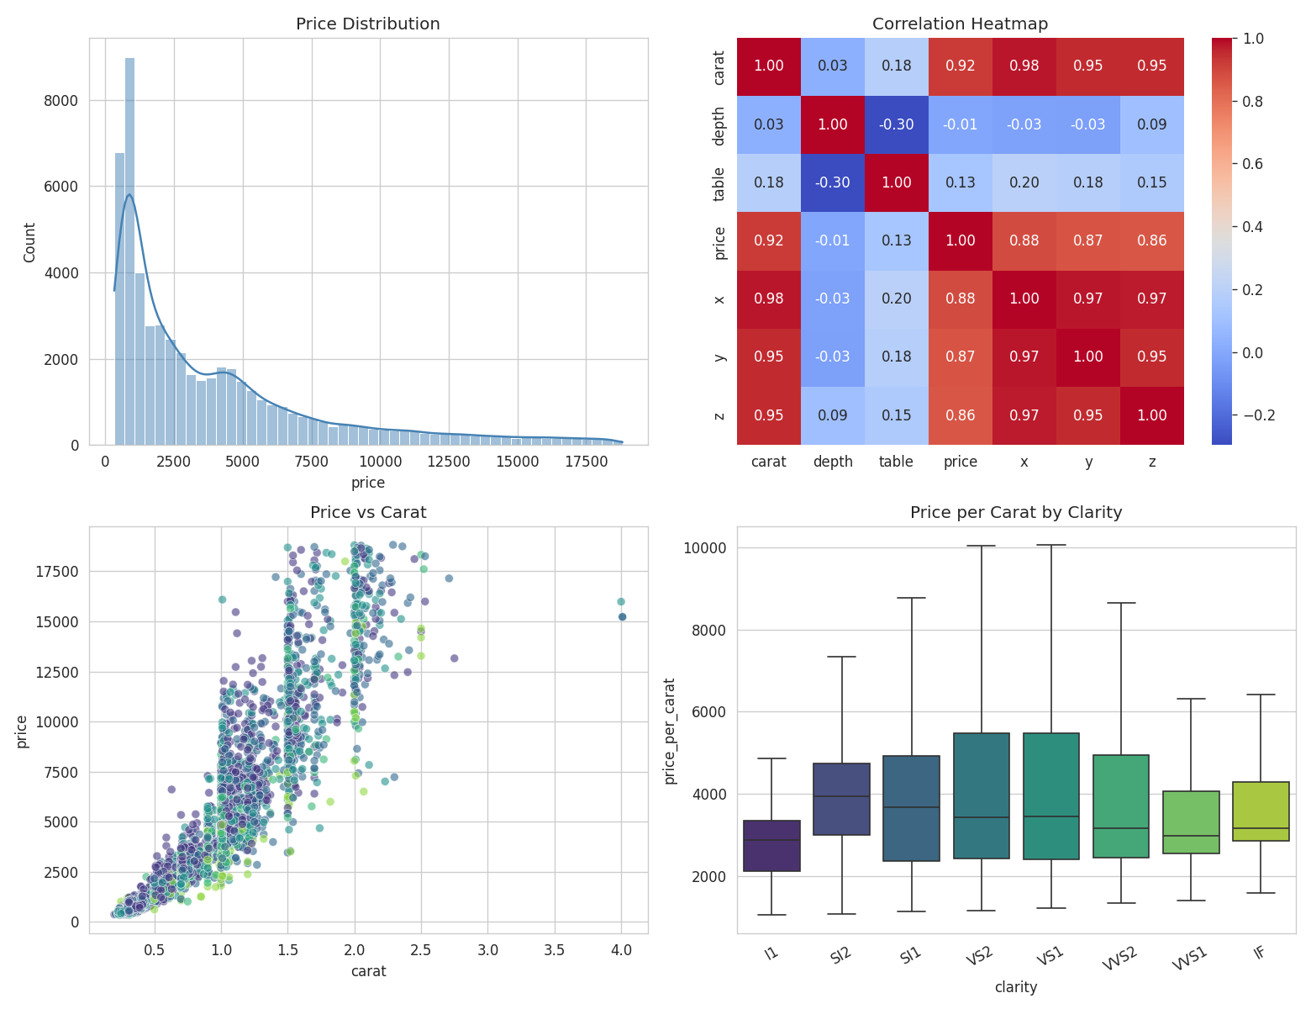
Figure 9: Four-panel summary - price distribution, correlation heatmap, price vs carat, and price per carat by clarity

8. Key Insights
- Carat is the dominant driver of price, correlating at about 0.92 - far stronger than any quality grade on its own.
- Price is right-skewed; a log transform makes the distribution far more symmetric.
- Raw average price by cut is misleading: Fair-cut diamonds can average a higher price than Ideal-cut diamonds purely because they tend to be larger, a confounding variable.
- Clarity's real effect on price only becomes visible once carat is controlled for, using price per carat.
- Physical dimensions (x, y, z) are highly correlated with carat and each other, since they describe the same physical size and carry largely redundant information.

9. Conclusion
This EDA shows that diamond price in this dataset is overwhelmingly explained by size (carat), while quality grades such as cut, color and clarity have smaller effects that are often confounded by size and only become visible once size is controlled for. This is a clear example of why correlation and simple group averages can mislead without checking for confounding variables, which was the core analytical thinking skill this task was meant to build.

10. Deliverables
- EDA_Diamonds_Project.ipynb - executed notebook
- EDA_Diamonds_Report.html - static export of the notebook
- charts/ - all figures used in this report
- Final_Report_EDA.docx - this report

