Predictive Modeling Using Machine Learning
Internship Task 2 - Final Report - Data Science Domain
Item | Details
Student | Shynav
Program | B.Tech, Artificial Intelligence & Data Science
Task | Predictive Modeling Using Machine Learning
Dataset | Breast Cancer Wisconsin (569 samples, 30 features), bundled with scikit-learn
Algorithms | Logistic Regression, Decision Tree, Random Forest
Tools | Python, Pandas, scikit-learn, Matplotlib, Seaborn

1. Objective
Build machine learning models that predict an outcome from data, train and test them for accuracy, and visualize performance using confusion matrices and ROC curves.

2. Problem and Dataset
The task is binary classification: predict whether a breast tumor is malignant or benign from 30 measurements of cell nuclei (radius, texture, perimeter, area, concavity, and so on). The dataset has 569 samples with no missing values. About 63% of samples are benign and 37% malignant, so the split is stratified and recall and F1 are reported alongside accuracy.
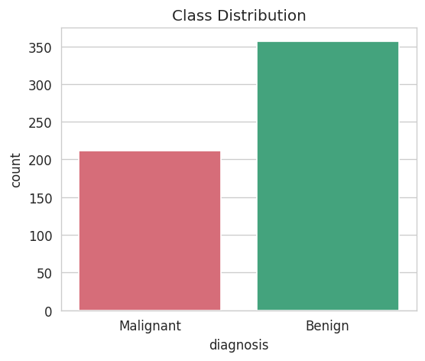
Figure 1: Class distribution

3. Methodology
- Split the data 80/20 into train and test sets (stratified, random_state=42).
- Logistic Regression uses a StandardScaler pipeline; tree-based models do not need scaling.
- Trained Logistic Regression, Decision Tree (max_depth=5) and Random Forest (200 trees).
- Evaluated on the test set using accuracy, precision, recall, F1 and ROC-AUC.
- Checked stability with 5-fold cross-validation.
- Tuned the Random Forest with GridSearchCV.

4. Results

4.1 Test Set Performance
Model | Accuracy | Precision | Recall | F1 | ROC-AUC
Logistic Regression | 0.9825 | 0.9861 | 0.9861 | 0.9861 | 0.9954
Decision Tree | 0.9211 | 0.9565 | 0.9167 | 0.9362 | 0.9163
Random Forest | 0.9561 | 0.9589 | 0.9722 | 0.9655 | 0.9931

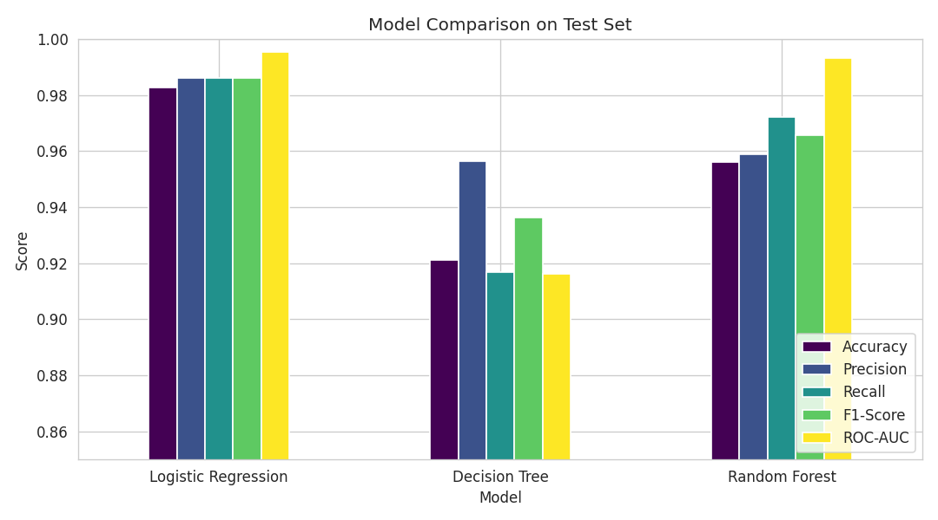
Figure 2: Model comparison on the test set

4.2 Cross-Validation (5-fold accuracy)
Model | Mean Accuracy | Std Dev
Logistic Regression | 0.9807 | 0.0065
Decision Tree | 0.9191 | 0.0180
Random Forest | 0.9578 | 0.0238

4.3 Confusion Matrices
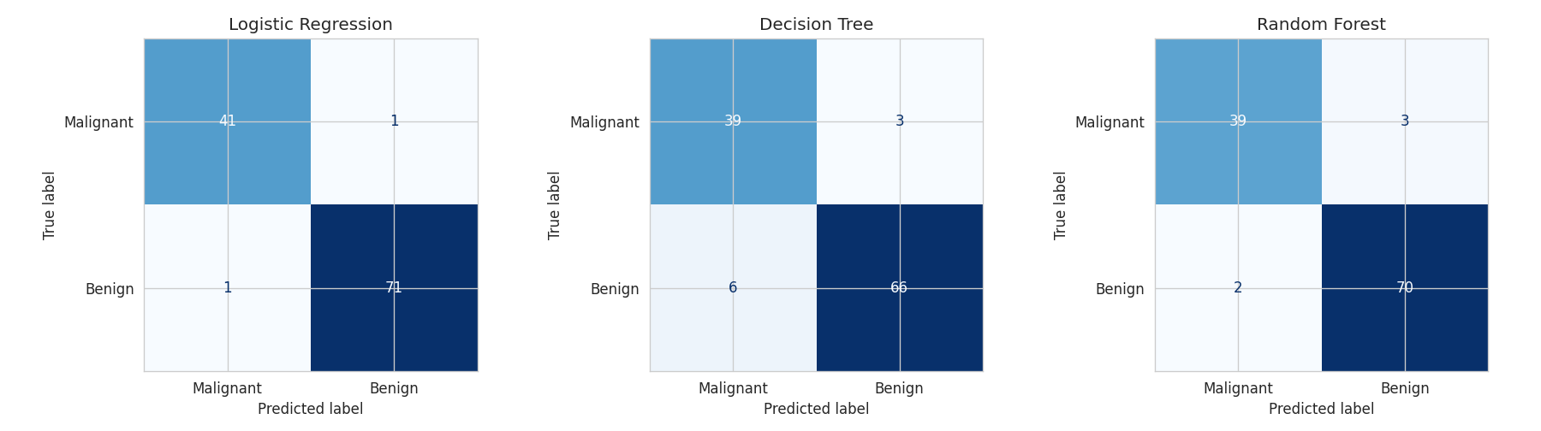
Figure 3: Confusion matrices (test set, 114 samples)
The costliest error in this setting is predicting Benign for a malignant tumor (a false negative), so those cells deserve the most attention when comparing models.

4.4 ROC Curves
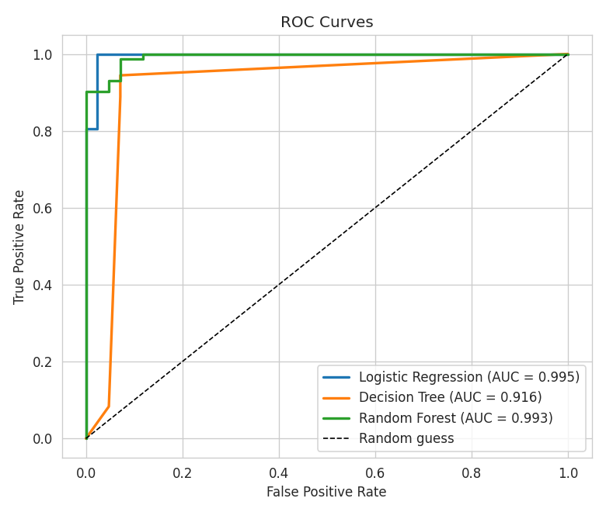
Figure 4: ROC curves for all three models

4.5 Hyperparameter Tuning and Feature Importance
GridSearchCV on the Random Forest selected n_estimators=200, max_depth=None, min_samples_split=2, with a best cross-validated F1 of about 0.968. The Random Forest relies most on worst perimeter, worst radius, worst concave points, worst area and mean concave points.
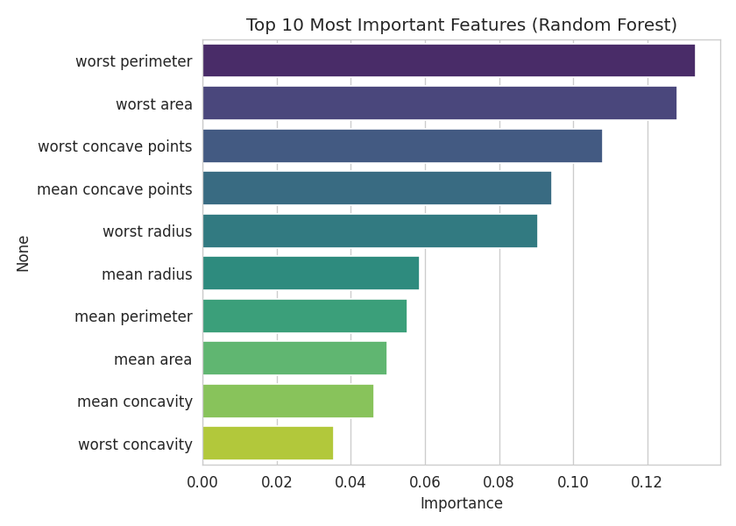
Figure 5: Top 10 features by Random Forest importance

5. Conclusion
- Logistic Regression performed best (98.25% test accuracy, ROC-AUC 0.995), followed by Random Forest (95.6%) and the Decision Tree (92.1%).
- Cross-validation gave the same ranking, so the result is not a lucky split.
- The Random Forest beats the single tree by averaging many trees; the tree is the most interpretable.
- Size and shape measurements of the nuclei drive most predictions.
Limitations: this is a small, clean benchmark dataset with a single test split of 114 samples. Real clinical use would need larger, more varied data, calibration and expert validation.

6. Deliverables
- Predictive_Modeling_ML.ipynb - executed notebook
- Predictive_Modeling_Report.html - static export of the notebook
- model_results.csv - metrics table
- charts/ - all figures used in this report
- Final_Report_Task2.docx - this report

