1
Students Grading Dataset Report
Data Mining COMP 4353 (1)
North American University
By Shynggyssali Mereke & Enes Tor

Dataset Selection
We selected the “Student Performance & Behavior Dataset” dataset for our final project. Our main goal is to apply major data preprocessing steps by implementing what we have learnt throughout the class this semester. The “Student Performance & Behavior Dataset” is a CSV file that has 5000 student records and 23 columns, including academic, demographic and life style related information about those students.

Data Preprocessing Steps
We applied several preprocessing steps before running any data mining model. Those are
Data Cleaning, Data Transformation, Data Reduction, Data Discretization, and Normalization.
Data Cleaning
The very first step of our project was “Data Cleaning”, where we checked the dataset for missing values and found missing data in three columns: Attendance (%), Assignments_Avg and Parent_Education_Level. For Attendance and Assignments_Avg we filled the missing values using the median. For Parent_Education_Level ew filles the missing values using the mode. We also removed irrelevant attributes from the dataset like Student_ID, First_Name, Last_Name and Email since these columns do not help with analysis or prediction.
Data Transformation
The next step was Data Transformation. Since machine learning models work much better with numerical values we converted categorical variables into numerical format. Also an interesting thing we did was using binary encoding for columns with two possible categories like Gender, Extracurricular_Activitied and Internet_Access_at_Home. For example yes/no values were converted into 1 and 0.
Data Reduction
Then, we performed data reduction using attribute subset selection. We removed unnecessary personal identification columns including Student_id, First_Name, Last_Name and Email. This reduced he number of irrelevant features and helped make the dataset easier to analyze. No advanced technique such as PCA was used since the dataset size and structure didn’t really require it.
Data Discretization
The next step of preprocessing was Data Discretization. We applied discretization to the Study_Hours_per_Week column. Study hours were originally continuous numerical values. To simplify this feature we divided the values into three categories - Low, Moderate and High. 0-10 hours = Low, 10-20 hours = Moderate and 20-30h = High.

Normalization
The final preprocessing step was Normalization. We used min-max scaling to scale the numerical features between 0 and 1. This step is very important because different columns have different ranges. For instance total score, attendance percentage, study hours, age and stress level are measured on different scales and without normalization features with larger values could have more influence than features with smaller value.

Histogram Analysis
We also performed histogram analysis to understand the distribution of important numerical variables. Two main columns we analyzed were Total_Score and Study_Hours_per_Week.
Total_Score histogram shows that students’ scores are spread between about 50 and 100 which means there was no strong concentration in only one score range.

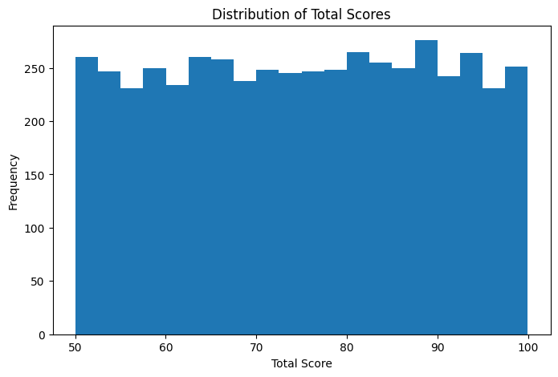
Study_Hours_per_Week histogram shows that study hours are spread between about 5 and 30 hours per week which means students had different study habits and they didn’t all spend the same amount of time studying.
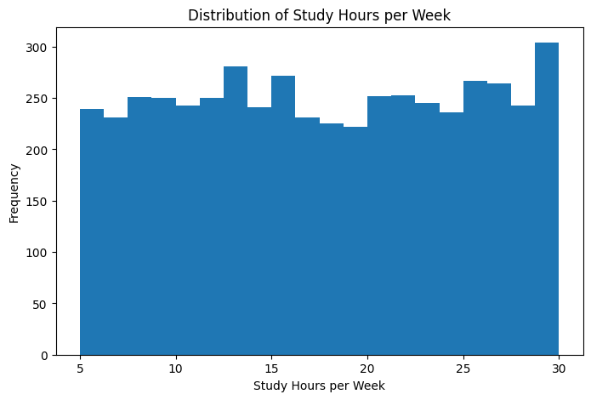

Classification Model: Random Forest Classifier
We used Random Forest Classifier for this project because our target variable Grade is categorical. Since we are predicting grade categories, classification was the correct type of model.

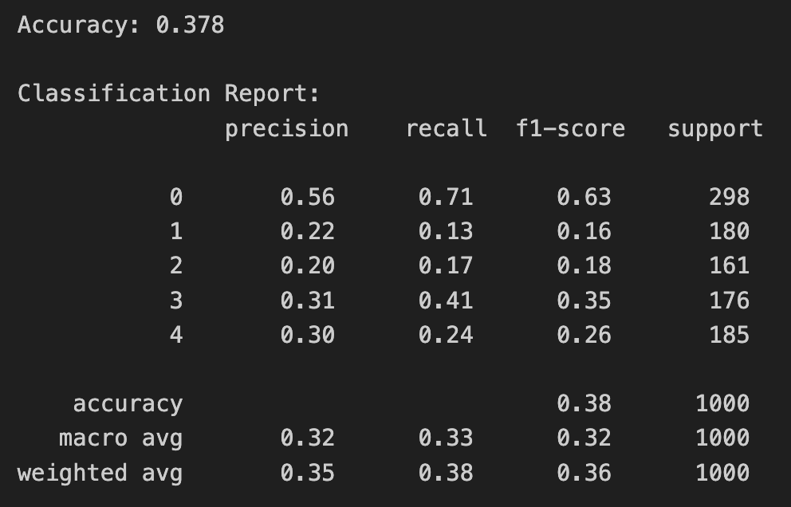

Findings and Insights
From this project we found that preprocessing is necessary before applying machine learning. The original dataset had missing values and inconsistent feature scales which had to be fixes. The missing values were handled using median and mode imputation which allowed us to keep all 5000 rows instead of removing many records. Also removing personal information made the dataset more useful and more appropriate for the analysis. Encoding was important because many columns were categorical. After transformation the dataset became much suitable for math analysis and machine learning models. Discretizing study hours helped simplify the Study_Hours_per_Week column into meaningful groups which made it easier to understand study habits a Low, Moderate or High. The histogram analysis showed that both total scores and study hours were spread across a range of values which means the dataset includes students with different academic performance levels and different study habits. Finally, the model we used – Random Forest Classifier achieved 37.8% accuracy which shows that predicting grades for the available features was challenging.
Final Thoughts
This project helped us apply everything we learned in class, from cleaning and using machine learning models like Random Forest Classifier. We were able to connect the theory to practice and discovered how just a few steps of well-structured preprocessing can reveal deep patterns hidden in the data.
● GitHub Link to Code: https://github.com/shynggyssali/data-mining-project

