

International School

**Capstone Project 1**

CMU-SE 450/CMU-IS 450/CMU-CS450

**Architecture Document**

**Version 1.0**

**Date:** 6 – Mar - 2021

**Consulting System And Training Management Using Chatbot**

**Submitted by**

Nguyen Cong Tuan

Huynh Thanh Rin

Nguyen Ngoc Son

**Approved by**

**Proposal Review Panel Representative:**

Name Signature Date

**Capstone Project 1- Mentor:**

MSC.Huy,Truong Dinh

Name Signature Date

**PROJECT INFORMATION**

|  |  |  |  |
| --- | --- | --- | --- |
| **Project acronym** | CATW | | |
| **Project Title** | Consulting System And Training Management Using Chatbot | | |
| **Start Date** | 06 Mar 2021 | **End Date** | 02 June 2021 |
| **Lead Institution** | International School, Duy Tan University | | |
| **Project Mentor** | MSC.Huy,Truong Dinh | | |
| **Scrum master / Project Leader & contact details** | Son,Nguyen Ngoc  Email: ngocson14270@gmail.com  Tel: 0774551339 | | |
| **Partner Organization** |  | | |
| **Project Web URL** |  | | |
| **Team members** | Name | Email | Tel |
|  | Rin,Thanh Huynh | Huynhthanhrin99@gmail.com | 0919658464 |
|  | Tuan,Nguyen Cong | Shynngu99@gmail.com | 0376394369 |

|  |  |  |  |
| --- | --- | --- | --- |
| **DOCUMENT NAME** | | | |
| **Document Title** | Product Backlog  Document | | |
| **Author(s)** | Team | | |
| **Role** |  | | |
| **Date** | 25 Mar ,2021 | **File name:** | [CATW]Architecturev1.2 |
| **URL** |  | | |
| **Access** |  | | |

REVISION HISTORY

|  |  |  |  |
| --- | --- | --- | --- |
| **Version** | **Date** | **Comments** | **Author** |
| 1.1 | 20 Mar 2021 | Create Architecture for project | C1SE.03 Team |
| 1.2 | 25 Mar 2021 | Update Architecture for project | C1SE.03 Team |

**Table of Contents**

1. **Introduction**
   1. purpose
   2. documents referenced
   3. definitions,acronyms and abbreviations
2. **project statement**
   1. project overview
   2. project goal
3. **achitecture drivers**
   1. system context
   2. quality attributes
4. **contraints**
   1. business contraint
   2. technical contraint
5. **hight- level architecture**
   1. allcation view
   2. component and connection view(C&C)
   3. module view
6. **Introduction**
   1. Purpose

This specification covers the following:

* Brief description of the project, high level requirement, system context for the system.
* Use Case diagram, detail Quality Attribution.
* Architecture presented by the various architecture view types: Component and Connector view (C&C), Module view, Allocation view.

## 1.2 Documents Referenced

|  |  |
| --- | --- |
| **No.** | **References** |
| 1 | CATW_Project Plan_Ver1.1 |
| 2 | CATW_ProductBacklog_Ver1.1 |

**1.3 Definitions, Acronyms and Abbreviations**

|  |  |
| --- | --- |
| **Acronyms** | **References** |
| UI | User Interface |
| QA | Quality Attributes |

1. **Project Statement**

**2.1 Project Overview**

* Project name: Learn English through Film
* Development team:

|  |  |
| --- | --- |
| **Position** | **Full name** |
| Scrum Master | Son,Nguyen Ngoc |
| Team Member | Tuan,Nguyen Cong |
| Team Member | Rin,Thanh Huynh |

**2.2 Project Goals**

The goals of the project are:

* Build the architecture of the project.
* Quality Attributes.

1. **Architecture Driver**

**3.1 System context diagram**

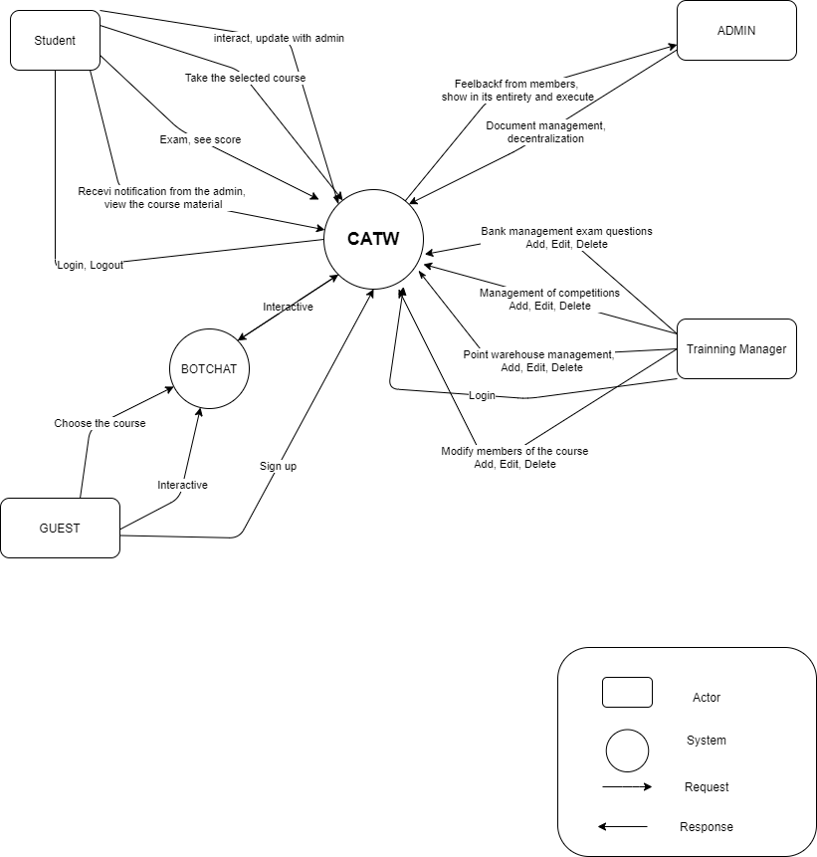

**Figure 1**: System context diagram

**3.2 Quality Attributes**

|  |  |
| --- | --- |
| **Quality Attributes:** Usability | **ID:** QA01 |
| **Stimulus** | Want to feel comfortable and easy to use with the user interface |
| **Source(s) of The Stimulus** | Users |
| **Relevant Environment** | Access website |
| **Architectural Elements** | “**CATW**” website |
| **System Response** | Website provide a User Interface friendly and easy to use. |
| **Response Measure(s)** | Users can use the system easily even the first time and use functions of website with less than 4 clicks. |

|  |  |
| --- | --- |
| **Quality Attributes:** Availability | **ID:** QA02 |
| **Stimulus** | User watch lecture |
| **Source(s) of The Stimulus** | User |
| **Relevant Environment** | Normal operation |
| **Architectural Elements** | “**CATW**” website |
| **System Response** | Video always is available to load. |
| **Response Measure(s)** | 24/7 |

|  |  |
| --- | --- |
| **Quality Attributes:** Availability | **ID:** QA03 |
| **Stimulus** | Login |
| **Source(s) of The Stimulus** | User |
| **Relevant Environment** | Normal operation |
| **Architectural Elements** | “**CATW**” website |
| **System Response** | The information will not unauthorized disclosure for third party |
| **Response Measure(s)** | The password cannot be read from the website |

|  |  |
| --- | --- |
| **Quality Attributes:** Availability | **ID:** QA04 |
| **Stimulus** | Login |
| **Source(s) of The Stimulus** | User |
| **Relevant Environment** | Normal operation |
| **Architectural Elements** | “**CATW**” website |
| **System Response** | The password will be encrypted. |
| **Response Measure(s)** | The password cannot be decrypted. |

# **Contraint**

## 4.1 Business Constraint

* Project will be started in 14/6/2019 and ended in 15/08/2019.
* The team has five people to develop the application. Project will finish in  63 days and cost to develop the entire application is $1174.

## 4.2 Technical Constraint

* Programming Language: C#, HTML5/CSS3, JavaScript/JQuery,
* Web Server: Web server Apache.
* Development tools: Sublime Text, Visual studio.
* Database: Mysql.

1. **Hight- level architecture**
   1. **Allocation View**

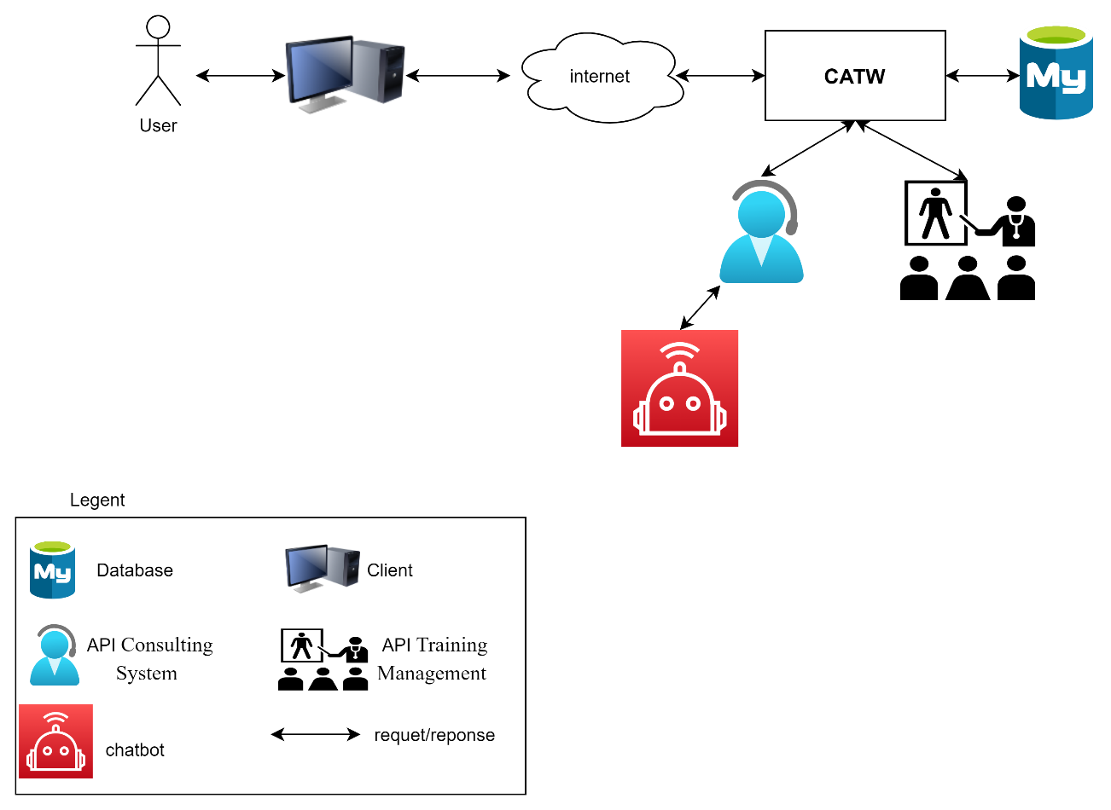

**Figure 2**: Allocation view

* 1. **Component and connection view(C&C)**

We mainly used C&C view to argue and reason about architectural properties, quality attribute requirements, and functional requirements that the system must adhere to.

This view type partitions the system into components that have some runtime presence such as processes, objects, data stores and connectors or that represent pathways of communication such as information flows, and access to shared storage.

The diagram below shows the architecture overview **Consulting System And TrainingManagement Using Chatbot** web application components and other related components. We have representations and behaviors for important components in the following sections.

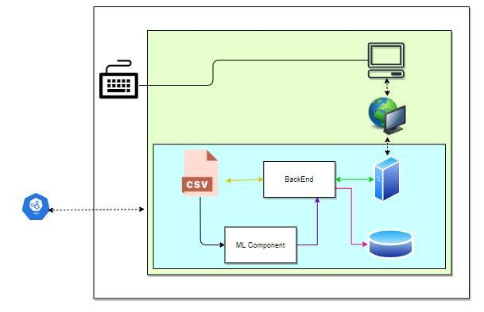

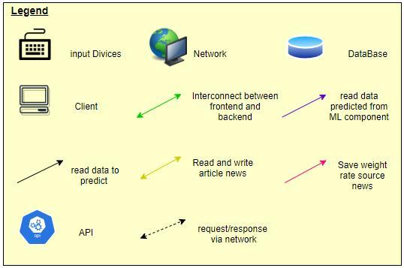

**Figure 2**: C&C view

* 1. **Module View**

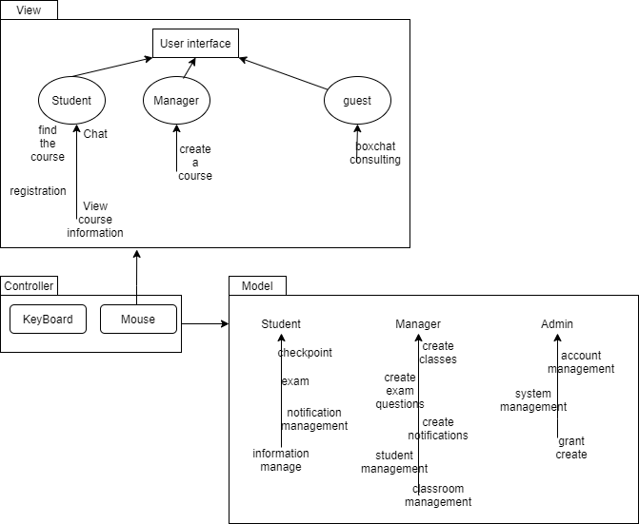

**Figure 3**: Module View