Home Page:

The following picture shows the homepage, which is essentially a log in page. You can click the drop down on the top right and sync all data on your phone with the database so you can log in if you created an account on another device.
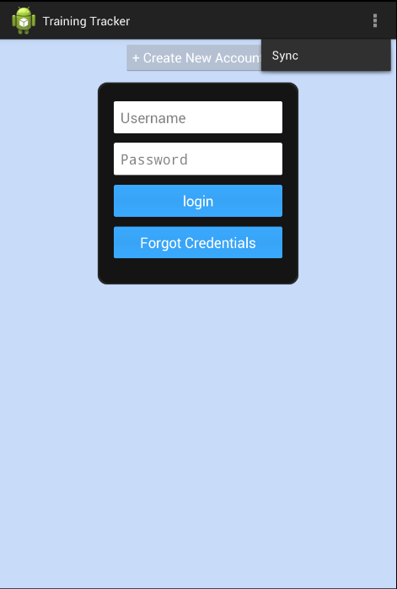

If you do not have an account, you can click the “Create New Account” button which will pop up a dialog show on the next page where you can input all your details, your username and your password.

If you were already logged on your device, you would automatically be logged and asked to confirm the user upon the launch of the app.

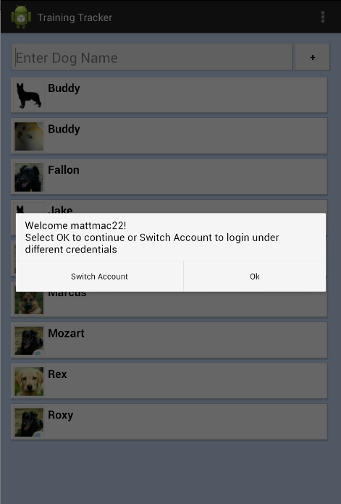

Dog Selection Page:

Once you are logged in and your credentials are confirmed, you will be directed to the dog selection page. On this page, the drop down options on the top right will be ‘Sync’ and ‘Switch accounts’. ‘Sync’ will sync all dog information from the database.

You can search up the name of the dog that you are going to train by typing their name in the search bar, and the page will reorder the dogs on the page so that the top dogs will be the most relevant relative to your query.

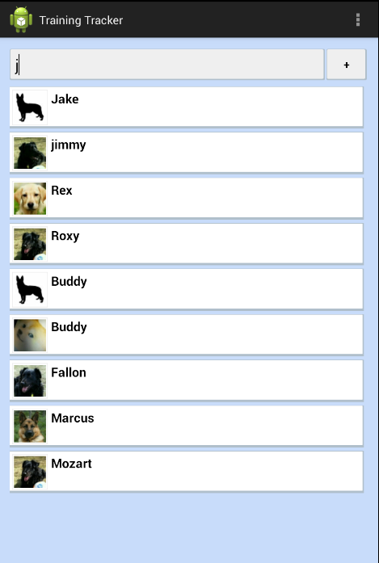

You can add a new dog by clicking the ‘+’ button on the top of the screen right next to the search bar. Doing so will open up the following dialog box where you can create a profile for a new dog.

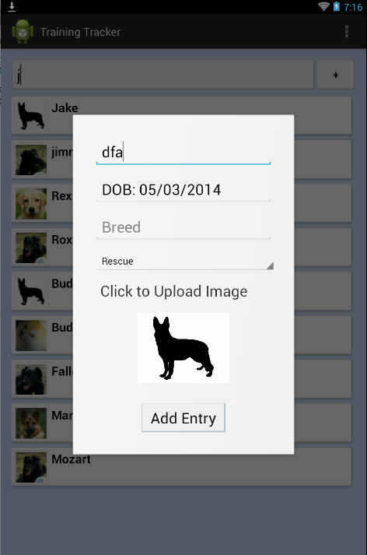

This dialog is customized to make the input of data very fast and easy (as displayed by the pictures on the next page). The first picture shows a very interactive birthday input dialog box, while the second picture displays an autocomplete feature that helps you choose the breed of the dog a little faster.

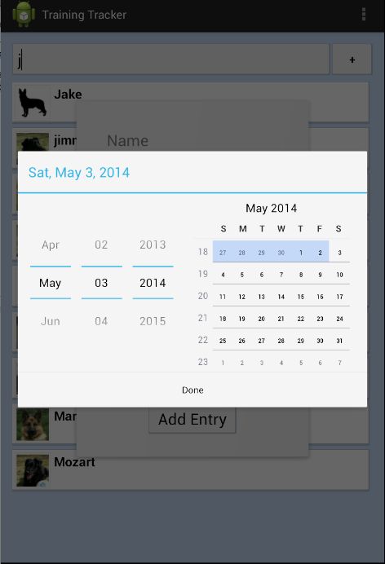

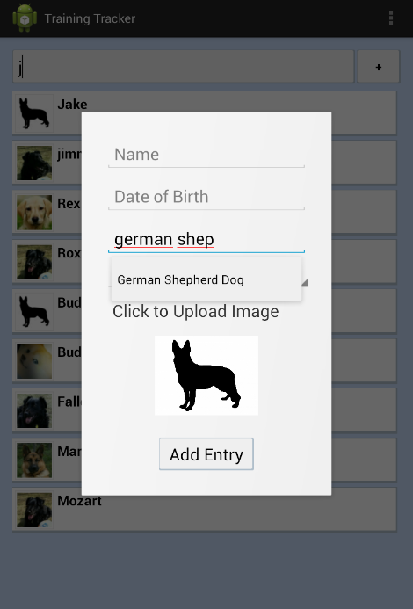
You can either take a picture of the dog on your camera or upload a picture already in your device’s gallery. You will be prompted with the options below when you want to add the picture.

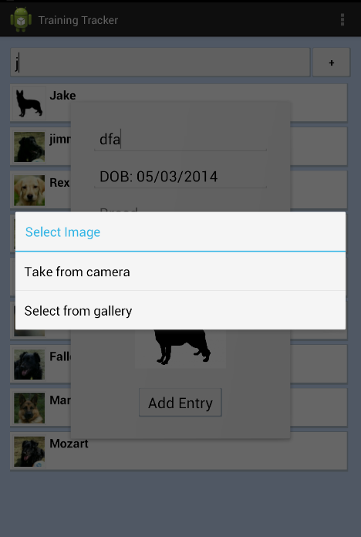

Once you have your dog’s profile set up, you can click on any dog and you will be presented with three options as shown in the next image.

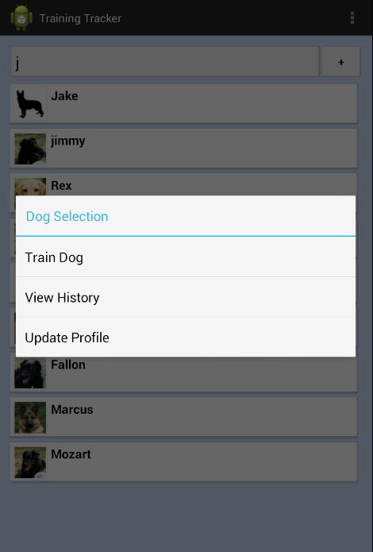

Clicking “Update Profile” will allow you to edit any information you added when creating your dog’s profile when you added the dog.

Clicking “View History” will take you to the following page:

Fdkj

Dog History Page:

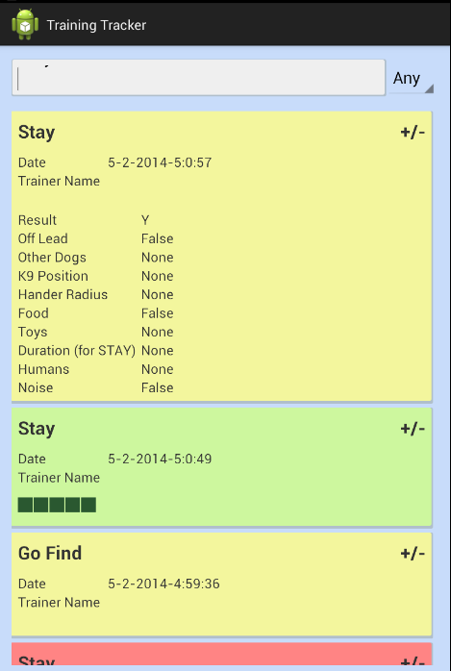

Here you will see all previous training information for this dog (including the exact training session details in a drop down which you can view by clicking “+/-”). All training session information is color-coded. Green represents a success, yellow a planned but unexecuted training session, red a failure and gray an aborted training session.

Plan Training Session Page:

If you had clicked “Train Dog” on the dog selection page for a particular dog, you will be directed to a page where you can select the categories and subcategories of the training session.

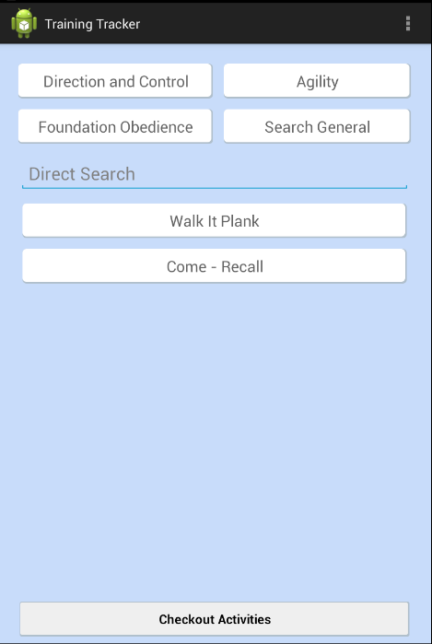

The 4 categories are displayed at buttons on the top of the screen, and clicking any of them will open up a dialog with all the subcategories you can train a dog for.

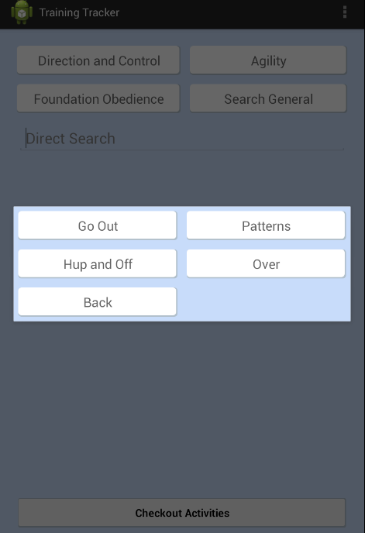

You can also just type the subcategory in the direct search bar.

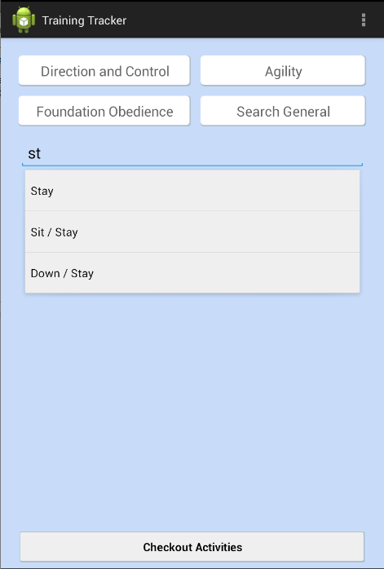

Once you have selected all the skills (subcategories) you want to train your dog for, click the “Checkout Activities” at the bottom of the page to be directed to the page where you can plan out the details of the training session.

Training Session Details:

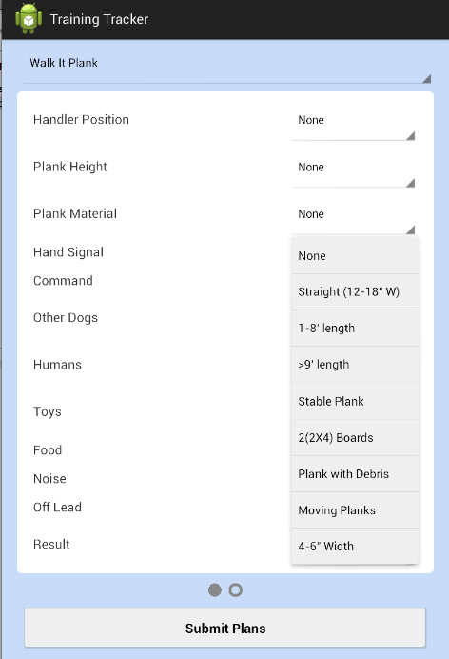

Here you can enter all the information you need for all the training sessions. You can switch between the different training sessions by either swiping your fingers left or right on the screen or by clicking the name of the session you are currently planning for (at the top of the screen – Walk It Plank in the picture above) and select the session.

Once you have planned out all the training sessions, click on Submit Plans.
Training Records:

Once you click “Submit Plans,” you will be directed to the following page.

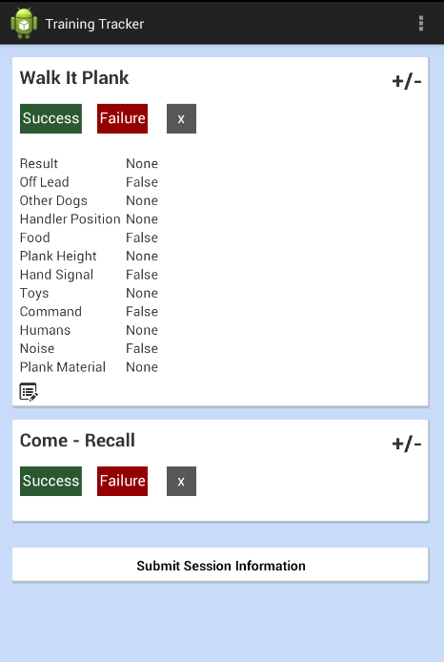

By default, all the sessions will be collapsed and you can press the “+/-“ to expand a particular session and see its details. After the details of the training session in the expanded view, there is a button you can click if you would like to go back and change some details of you training session.

You can click on success or failure for a given session, and the outcome of the trial will be recorded. You can see the outcomes as green (success) or red (failure) boxes both in the collapsed and expanded views. Walk It Plank has 2 success and 1 failure.

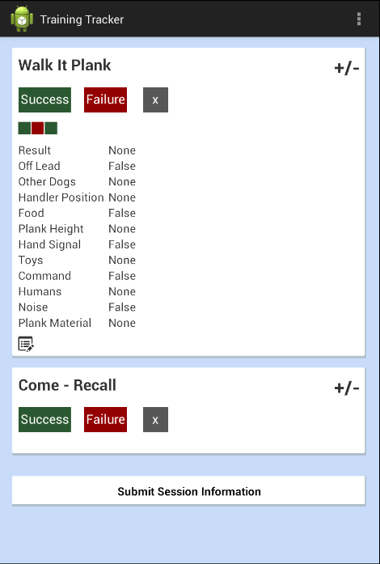

If you recorded the wrong information, you can click on the “X” button next to the “Failure” button to delete your most recent trial. Note that you can only record outcomes for 5 trials for any given training session.

Once you are done recording your data, click on the “Submit Session Information” on the bottom of the page. If you have recorded less than 5 trial data for any of the sessions, the session will be recorded as aborted and you will be notified about it.

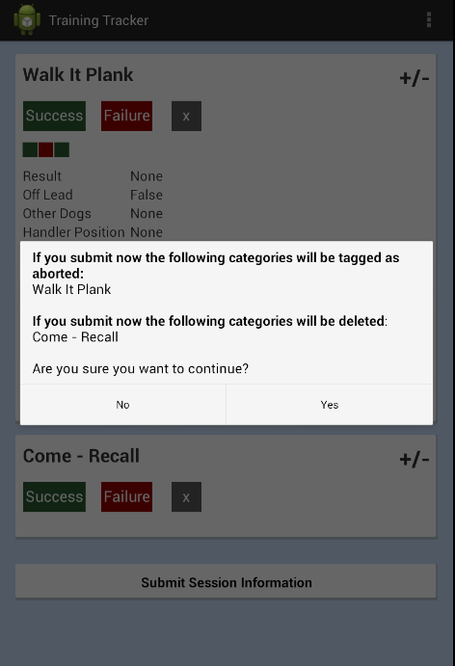

Once you are done, you will automatically be directed to the page where you can enter details for the next training sessions.

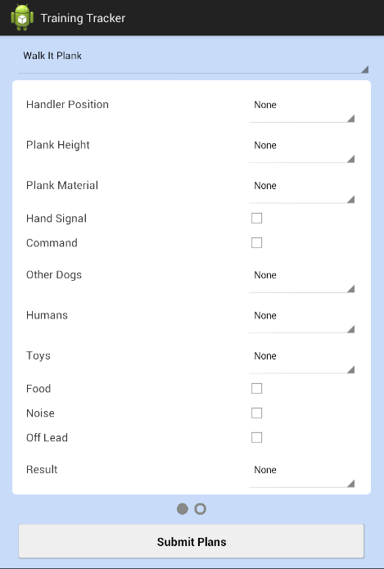

After you have filled out all the information, you will be directed to the page where you can select the next dog that you can train.

