國立中正大學資訊工程學系 軟體工程 期中考試
Software Engineering Midterm Exam (2005/11/16 8:30 AM ~ 10:00 AM)

- Describe at least one software myth in each of the following perspectives and explain in one or two sentences why it is a myth. (9 %)
  - Management Perspective
  - Developer Perspective
  - Customer Perspective

- Compared to the software engineering technologies a decade ago (1995), how is the current state-of-art? Is there any improvement? Explain why do you think there is or isn’t any improvement (give at least five reasons for your answer). (10 %)

- Briefly describe the four phases of Rational Unified Process (RUP). Are all the workflows active in all the four phases? If yes, why do we need to have all active? If no, why not? (10 %)

- Explain how both the waterfall model of the software process and the prototyping model can be iterated using the spiral process model. (10 %)

- Describe five system characteristics that must be assessed during architectural design of a software product. Explain using examples why we cannot achieve all system goals simultaneously. (16 %)

- Explain the difference between broadcast event-driven model and interrupt-driven model. Give an example for each to illustrate your answer. (10 %)

- What are non-functional requirements of a software product? Why are they sometimes more critical than functional requirements? Illustrate your answer with an example. Classify non-functional requirements. (10 %)

- A UML Statechart diagram for a photocopier is shown here. Suppose a user now wants to add the following functionalities to the design, enhance the model to incorporate these additions.
(15 %)
  - Setting print options such as paper size, double-sided printing, paper tray selection, …
  - Automatic continuation of print jobs after problem correction
  - Cancellation of print jobs during printing
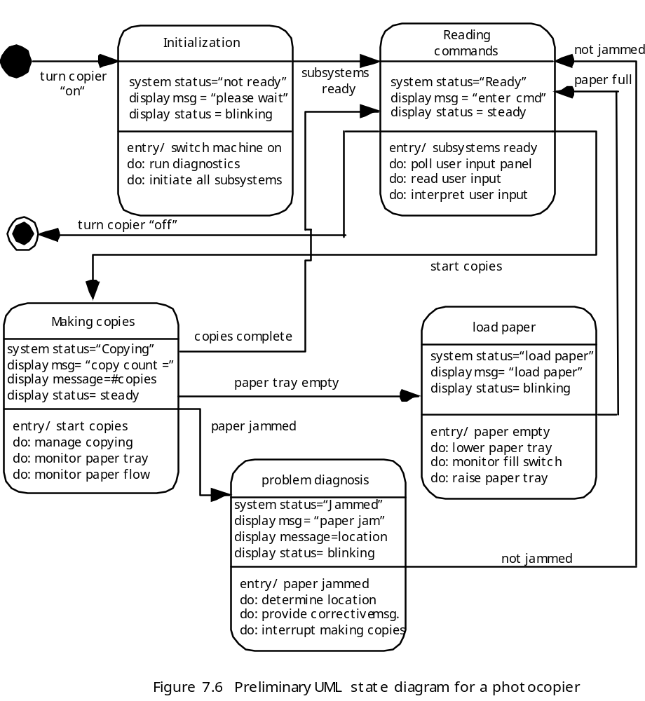

- Model the data processing that might take place in an e-mail system. You should model the mail-sending and mail-receiving processing separately. (10 %)

