Python程序设计基础第二章作业
万伯昀 2023011377
1.题目1
1.1题目
编写函数 is_word_palindrome()，判断某个给定的英文字符串是否为单词回文，非英文单词内容全部忽略，要求英文字符串从文件中读取。
1.2实现思路
回文的标准是反向输一遍一样，以此为要点编函数。
1.3实现代码

def is_word_palindrome(word):
# 移除非字母字符并转换为小写
clean_word = ''.join(filter(str.isalpha, word)).lower()
# 判断是否为回文，也就是倒着读一遍一不一样
return (clean_word == clean_word[::-1])&len(clean_word)!=0

def read_file_and_check_palindrome(file_path):
try:
with open(file_path) as file:
# 读取文件内容
content = file.read()
# 分割单词并检查是否为回文，此处默认用空格分单词，否则也没法分了
words = content.split()
for word in words:
if is_word_palindrome(word):
print(f"'{word}' is a word palindrome.")
else:
print(f"'{word}' is not a word palindrome.")
except FileNotFoundError:
print(f"The file '{file_path}' was not found.")
except Exception as e:
print(f"An error occurred: {e}")

# 测试文件为sample.txt
file_path = 'sample.txt'
read_file_and_check_palindrome(file_path)

1.4本地测试结果
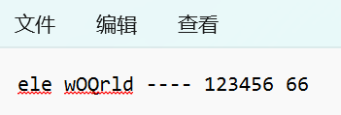
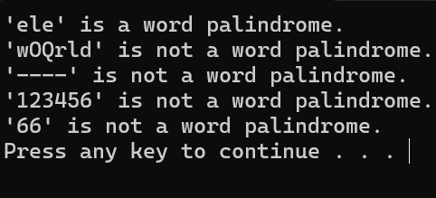
2.题目2
2.1题目
按月输出本年日历，星期日在前。
2.2实现思路
就是输出日历，没啥思路。
2.3代码实现

from datetime import datetime, timedelta

def print_month_calendar(year, month):
"""
Print the calendar for a given year and month.
"""
# 每月第一天
first_day = datetime(year, month, 1)
# 第一天是周几 (0=Monday, 6=Sunday)
first_weekday = first_day.weekday()
# 调整一下，使得周日在前
first_weekday = (first_weekday + 1) % 7

#算出每个月的天数
if month in [4, 6, 9, 11]:
days_in_month = 30
elif month == 2:
if (year % 4 == 0 and year % 100 != 0) or (year % 400 == 0):
days_in_month = 29
else:
days_in_month = 28
else:
days_in_month = 31

# 打印表头
print(f"{'Sun Mon Tue Wed Thu Fri Sat'.center(15)}")
print(f"{'-' * 27}")

# 打空格对齐第一行
print(' ' * (4 * first_weekday),end='')

# 打印每一天
day = 1
for _ in range(days_in_month):
weekday_index = (day + first_weekday - 1) % 7
#这个式子计算几号是星期几
print(f"{day:2d} ", end=' ')
if weekday_index == 6:
#如果是周六就要换行
print()
day += 1

# 一个月的最后一天不是周六也要换行
if (day + first_weekday - 2) % 7 != 6:
print()

# 打印2024年的日历
monlist=[[],[],[],[],[],[],[],[],[],[],[],[]]
for month in range(1, 13):
print(f"\n{2024} {month} Calendar:")
print_month_calendar(2024, month)
2.4测试样例
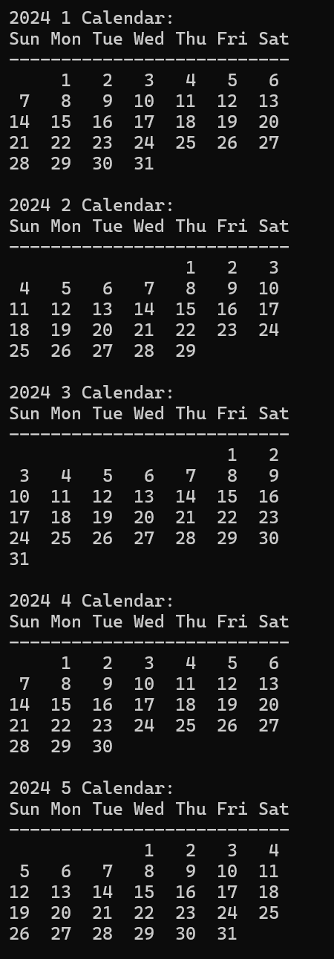
太长了仅截取部分
3.题目3
3.1题目
同上，输出至文件
3.2实现思路
打开一个文件，然后把所有print改成写入文件。
3.3代码实现
from datetime import datetime, timedelta

def print_month_calendar(year, month, file_obj):
"""
Write the calendar for a given year and month to a file object.
"""
# 每月第一天
first_day = datetime(year, month, 1)
# 第一天是周几 (0=Monday, 6=Sunday)
first_weekday = first_day.weekday()
# 调整一下，使得周日在前
first_weekday = (first_weekday + 1) % 7

#算出每个月的天数
if month in [4, 6, 9, 11]:
days_in_month = 30
elif month == 2:
if (year % 4 == 0 and year % 100 != 0) or (year % 400 == 0):
days_in_month = 29
else:
days_in_month = 28
else:
days_in_month = 31

# 打印表头
file_obj.write(f"{'Sun Mon Tue Wed Thu Fri Sat'.center(15)}\n")
file_obj.write(f"{'-' * 28}\n")

# 打空格对齐第一行
file_obj.write(' ' * (4 * first_weekday) )

# 打印每一天
day = 1
for _ in range(days_in_month):
weekday_index = (day + first_weekday - 1) % 7
#这个式子计算几号是星期几
file_obj.write(f"{day:2d} ")
if weekday_index == 6:
#如果是周六就要换行
file_obj.write("\n")
day += 1

# 一个月的最后一天不是周六也要换行
if (day + first_weekday - 2) % 7 != 6:
file_obj.write("\n")

# 打印2024年的日历
with open('2024_calendar.txt', 'w') as calendar_file:
for month in range(1, 13):
calendar_file.write(f"\n{2024} {month} Calendar:\n")
print_month_calendar(2024, month, calendar_file) # Pass the file object as a parameter

3.4测试样例
文件见压缩包
4.题目4
4.1题目
挑战性问题：以四行三列的月份格式打印全年日历，即同时输出第一季度三个月日历后，紧接着输出第二季度三个月日历。
4.2实现思路
把每一行的输出用列表展示，然后每三个月一个zip用来转置输出。
4.3代码实现
from datetime import datetime, timedelta

def print_month_calendar(year, month):
"""
Print the calendar for a given year and month.
"""
# 每月第一天
first_day = datetime(year, month, 1)
# 第一天是周几 (0=Monday, 6=Sunday)
first_weekday = first_day.weekday()
# 调整一下，使得周日在前
first_weekday = (first_weekday + 1) % 7

#算出每个月的天数
if month in [4, 6, 9, 11]:
days_in_month = 30
elif month == 2:
if (year % 4 == 0 and year % 100 != 0) or (year % 400 == 0):
days_in_month = 29
else:
days_in_month = 28
else:
days_in_month = 31

# 打印表头
monlist[month-1].append(f"{'Sun Mon Tue Wed Thu Fri Sat '.center(15)}")
monlist[month-1].append(f"{'-' * 27} ")

# 打空格对齐第一行
monlist[month-1].append(f"{' ' * (4 * first_weekday)}")

# 打印每一天
day = 1
for _ in range(days_in_month):
weekday_index = (day + first_weekday - 1) % 7
#这个式子计算几号是星期几
monlist[month-1][-1]=monlist[month-1][-1]+f"{day:2d} "
if weekday_index == 6:
#如果是周六就要换行
monlist[month-1].append("")
day += 1
monlist[month-1][-1]=monlist[month-1][-1]+" "*((6-weekday_index)*4)
# 一个月的最后一天不是周六也要换行
if (len(monlist[month-1])!=8):
monlist[month-1].append(" "*28)

# 打印2024年的日历
monlist=[[],[],[],[],[],[],[],[],[],[],[],[]]
for month in range(1, 13):
#print(f"\n{2024} {month} Calendar:")
print_month_calendar(2024, month)
#for _ in monlist:
# for j in _:
# print(j)

#用zip来转置一下
list1 = list(zip(monlist[0],monlist[1],monlist[2]))
for _ in list1:
for j in _:
print(j,end=" ")
print()

list2 = list(zip(monlist[3],monlist[4],monlist[5]))
for _ in list2:
for j in _:
print(j,end=" ")
print()

list3 = list(zip(monlist[6],monlist[7],monlist[8]))
for _ in list3:
for j in _:
print(j,end=" ")
print()

list4 = list(zip(monlist[9],monlist[10],monlist[11]))
for _ in list4:
for j in _:
print(j,end=" ")
print()
4.4测试样例
