**COMPUTER NETWORKS LABORATORY-2**

CLIENT-SERVER APPLICATION USING C++

EXP NO.2 NAME: SHYAMALA R.B.

DATE: 10.08.2023 REG NO.: 2021503558

1. Chat Application using TCP

CODE:- Server2.cpp

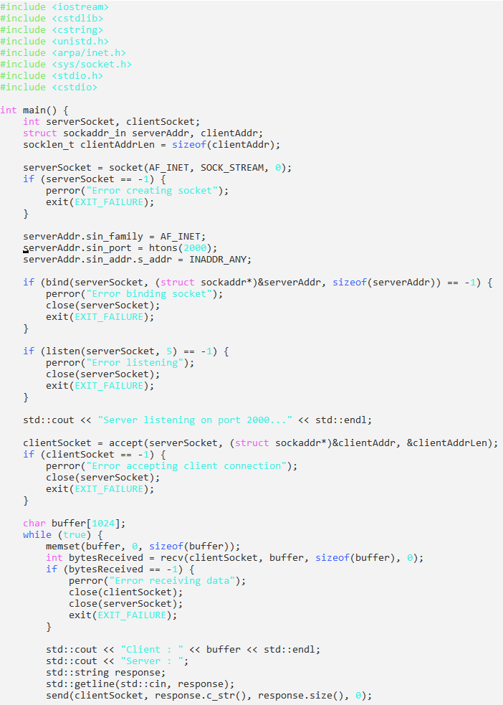

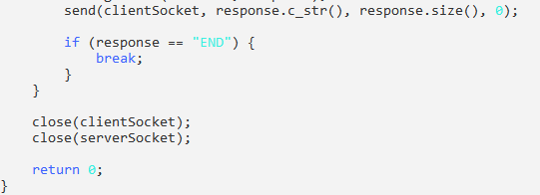

Client2.cpp

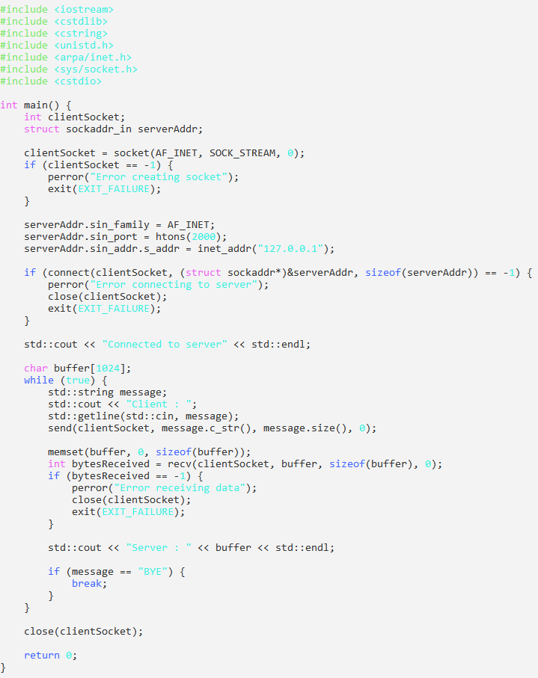

Output:

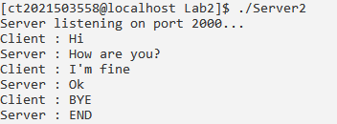

1. Chat Application using UDP

ServerUDP.cpp

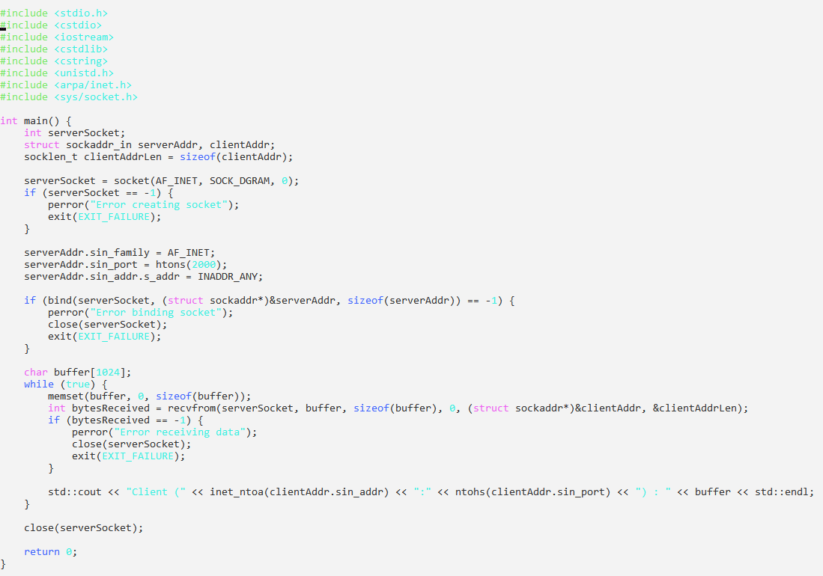

ClientUDP.cpp:

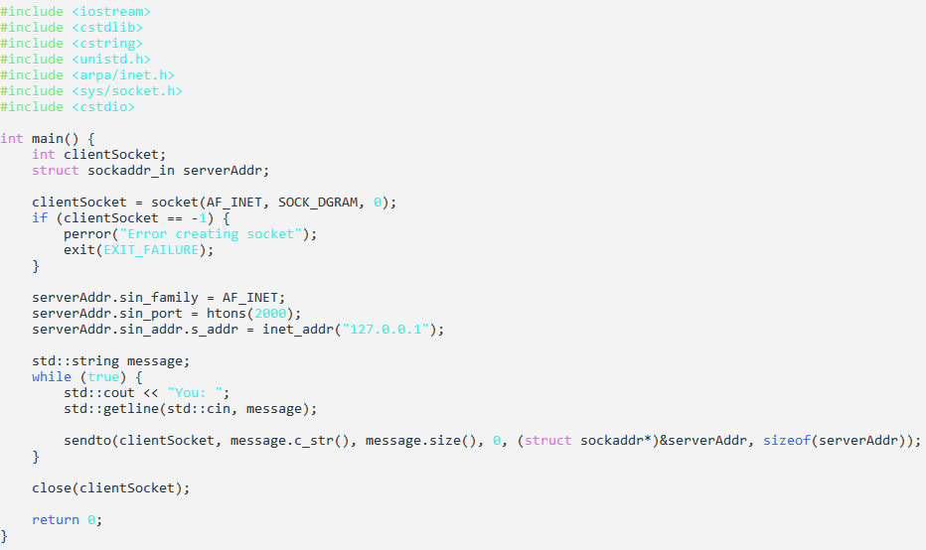

Output:

Server

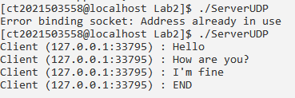

Client

