// Solution1 report

Compilation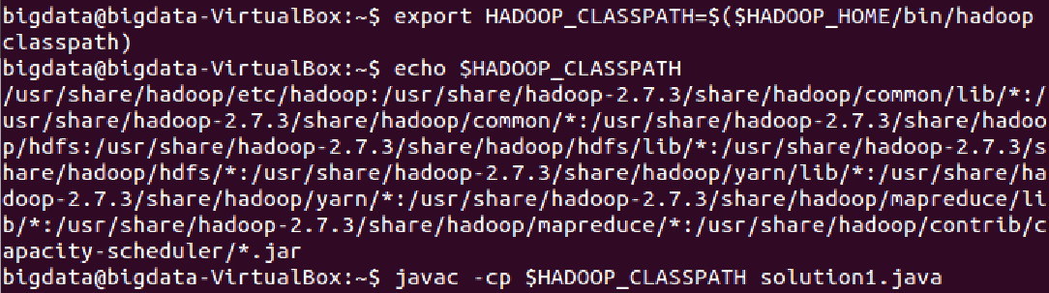

creation of jar file



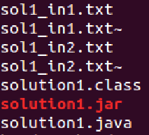

uploading to HDFS two small files for testing

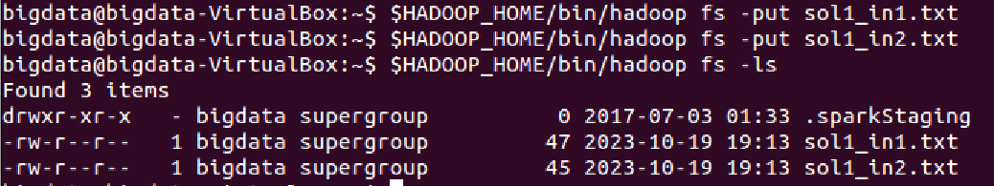

processing of the application

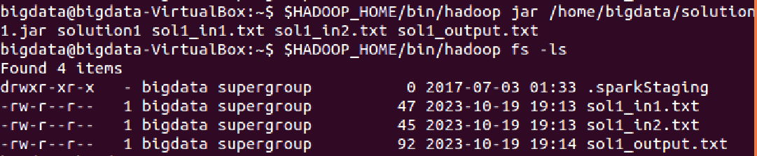

an evidence that two files uploaded into HDFS has been successful merges in one file in HDFS.

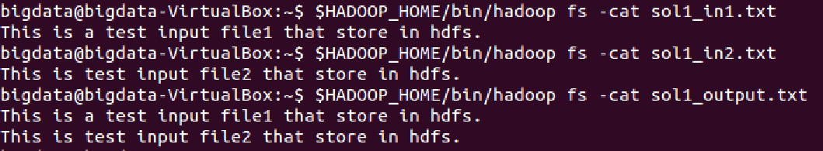

//Solution2 report

Compilation

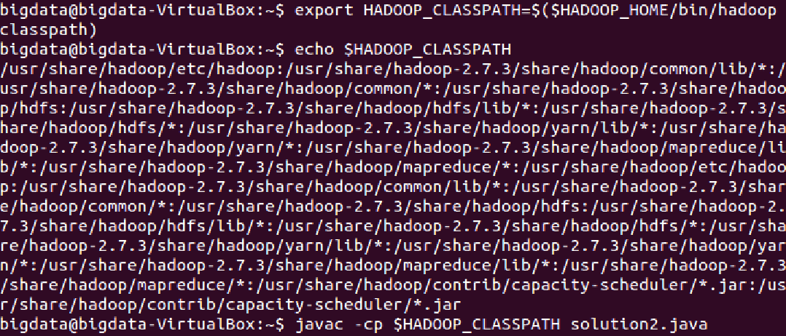

creating jar file

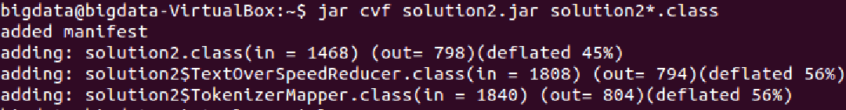

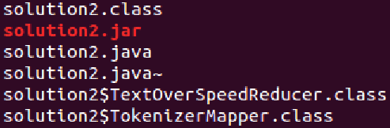

listing of your input file with the speed measurements.

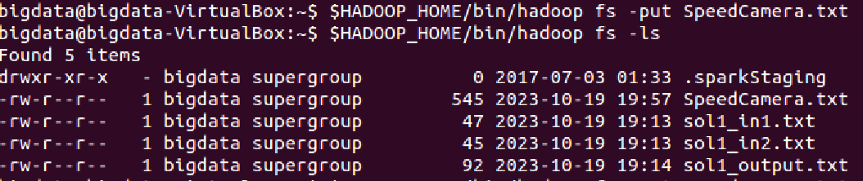

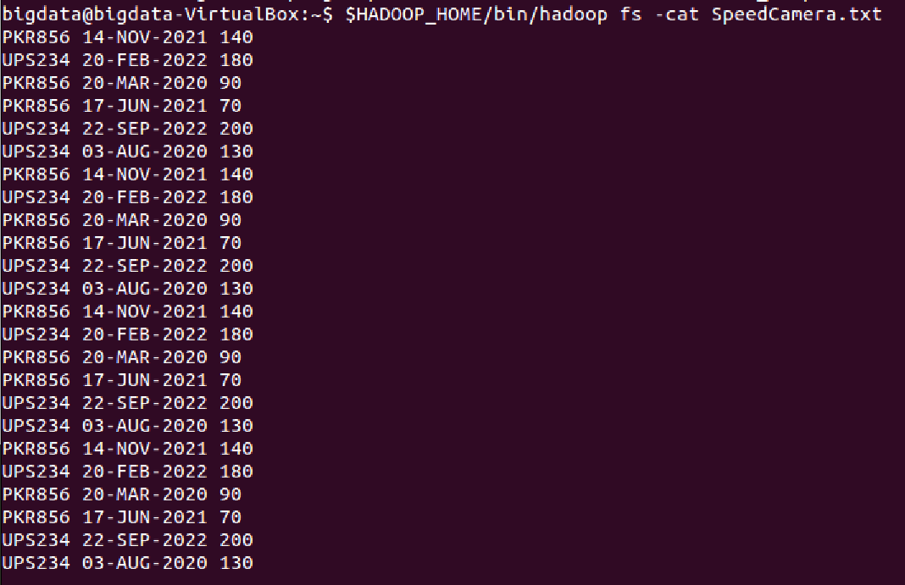

displaying the results of processing solution2.java

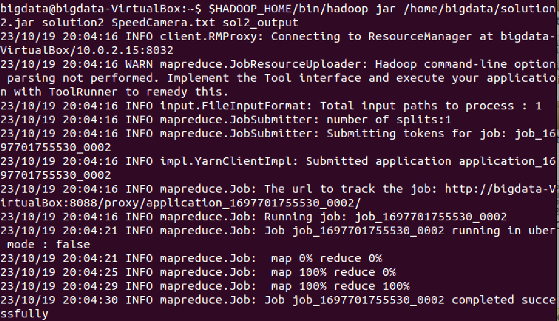



//Solution3 report

Compilation creating jar file

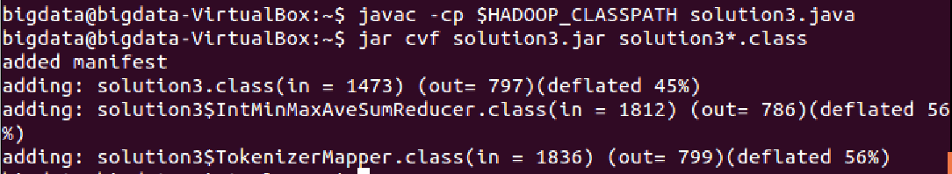

processing, and displaying the results of processing solution3.java

