Task1

(1)

Facts:

1. Total Kilometers
2. Total Trips
3. Total Drivers
4. Total Travels
5. Average Duration
6. Total Fuel Consumption
7. Total Passengers
8. Largest Passengers
9. Average Passengers

Measures:

1. Length
2. the number of trips
3. the number of drivers
4. the number of travels
5. Duration
6. Fuel consumption
7. the number of passengers

Dimension:

1. Time Dimension: year, month, day
2. Bus Dimension: BusID, model, manufacturer
3. Driver Dimension: licence-number, full-name, years-of experience
4. Segment Dimension: end-point-1, endpoint-2,total length
5. Trip Dimension: trip name
6. Depot Dimension: lot-number, street, city
7. Manufacture Dimension: name, city, country

Hierarchies:

1. Time Dimension:Year > month > day
2. Bus Dimension: BusID > model > manufacturer

(2)

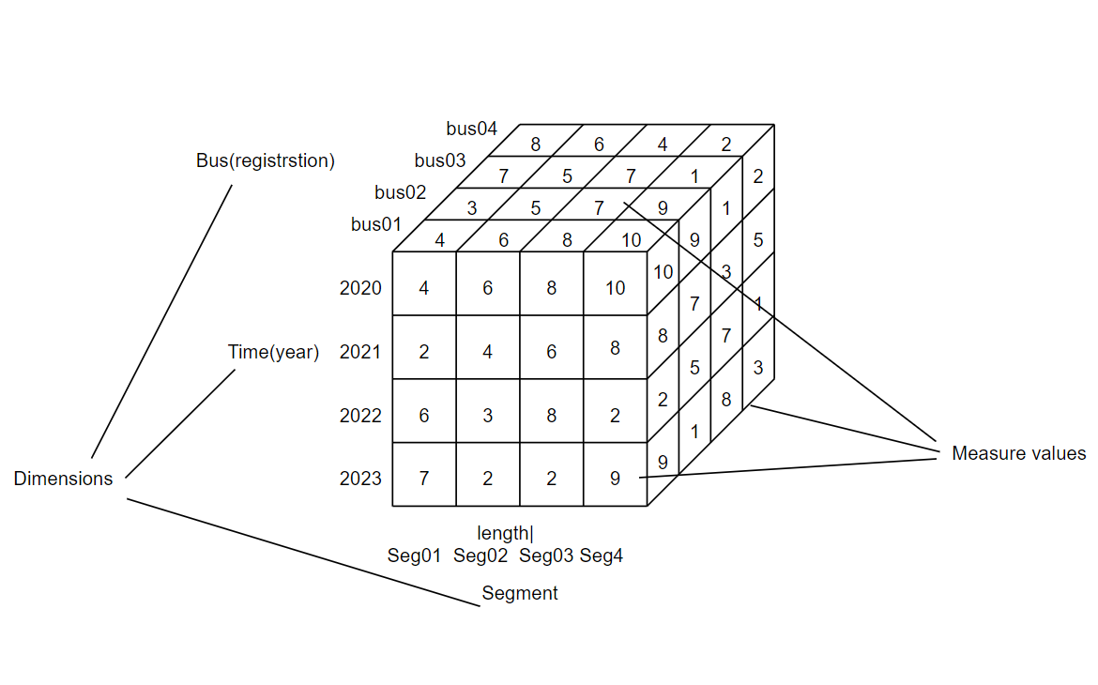

Task2

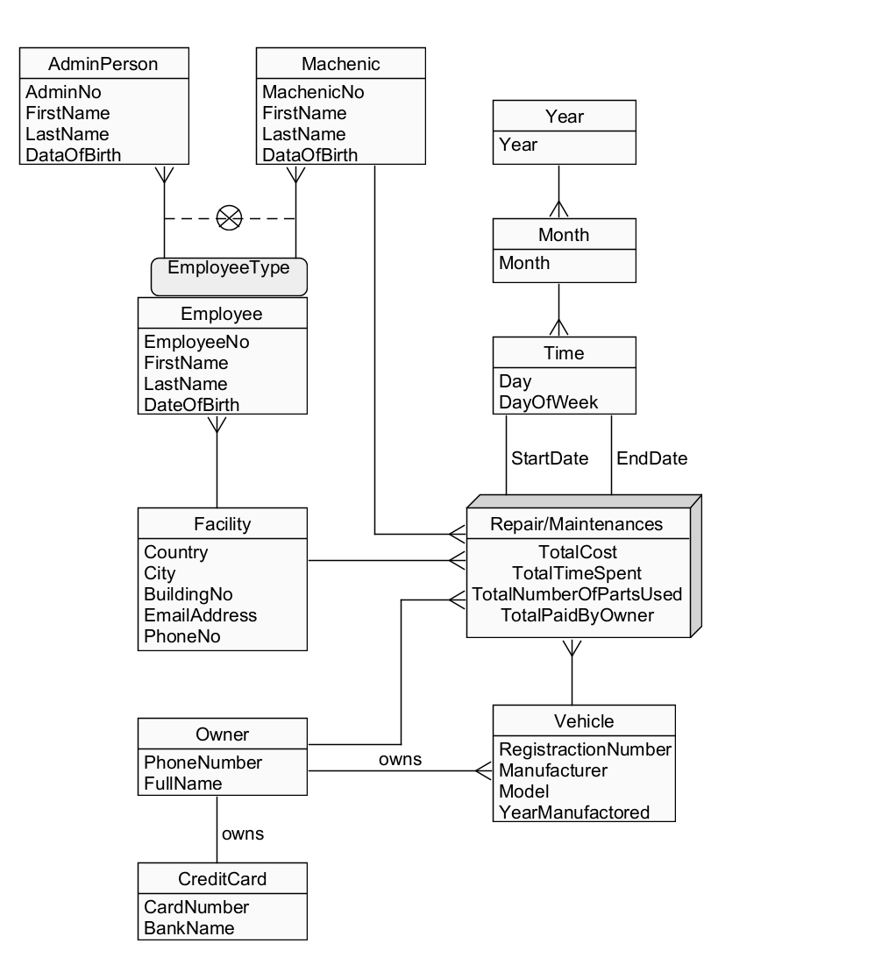

Task3

The output of solution3.hql with no error:

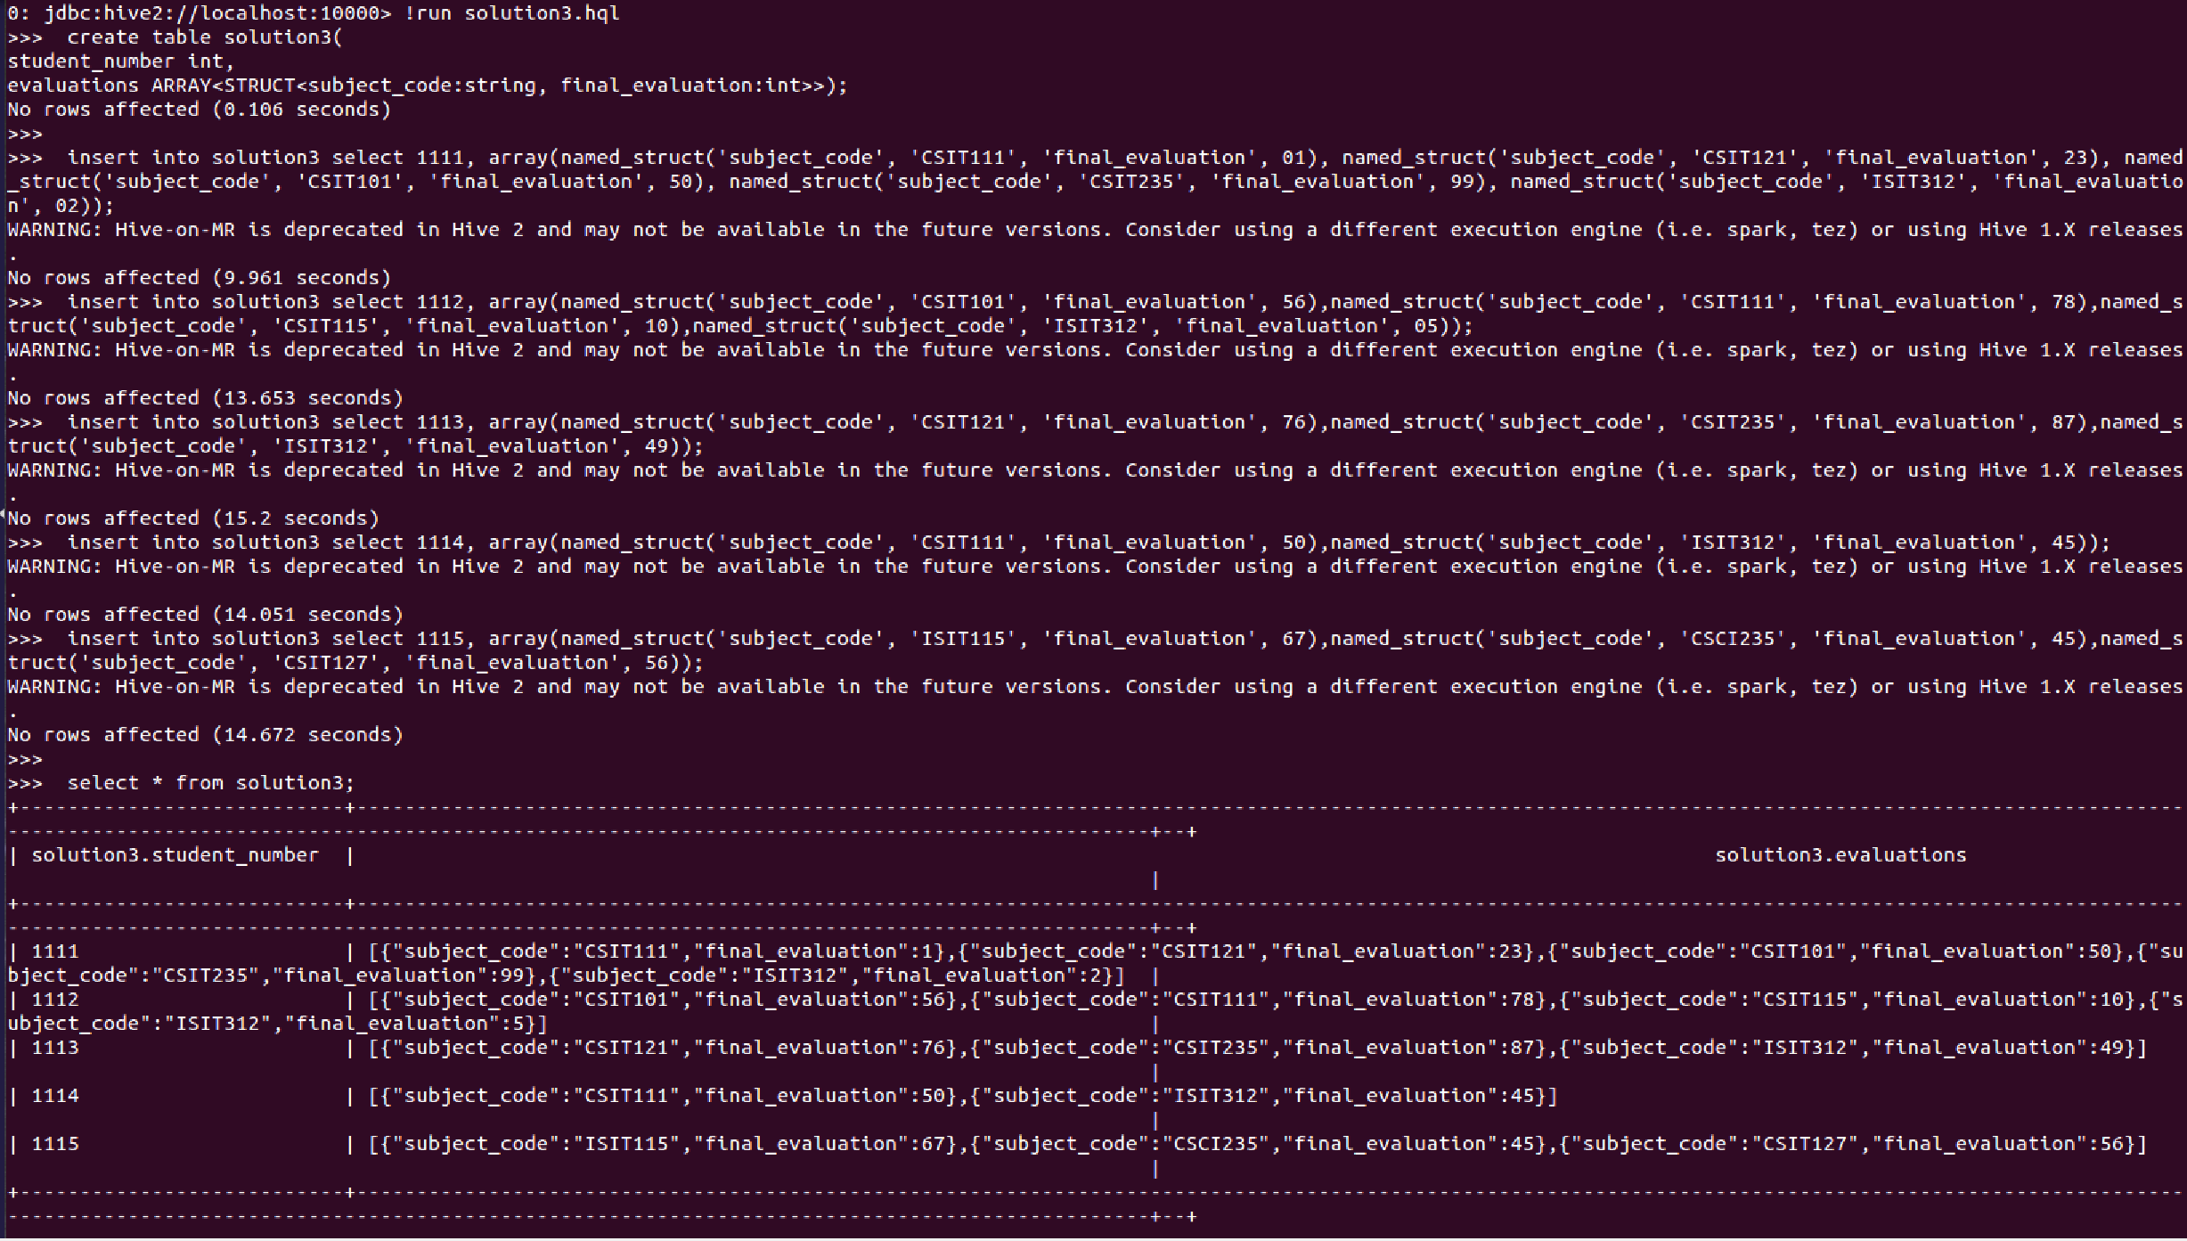

Task4

The output of solution4.hql with no error:

