// ISIT312 Assignment3

// Student Name: Huaiying Shao

// UOW ID: 7910356

Task1

Create HBASE table:

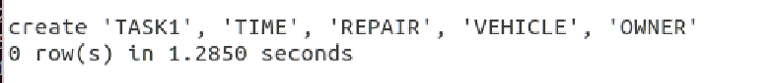

Describe the table schema:

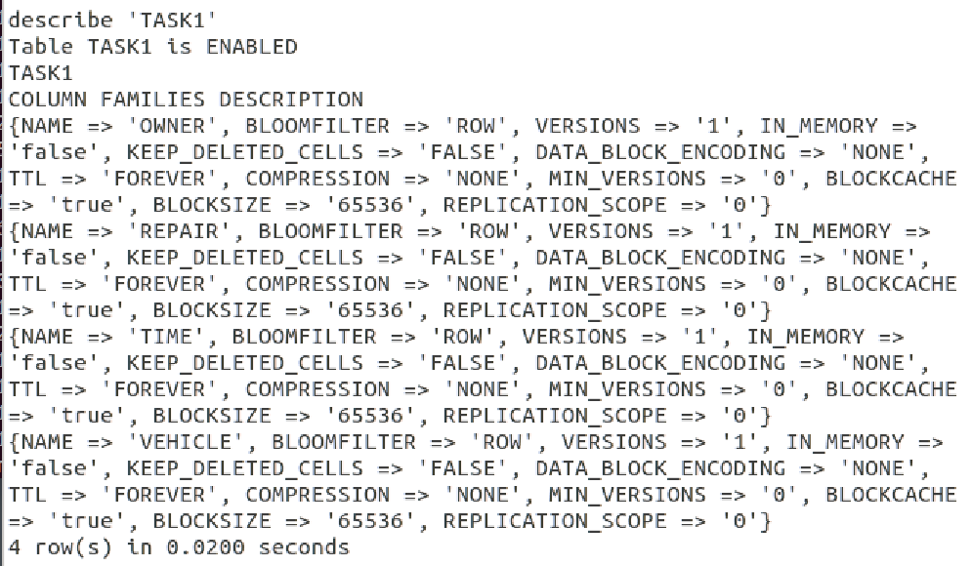

Load sample data into table, put two vehicle into ‘TASK1’:

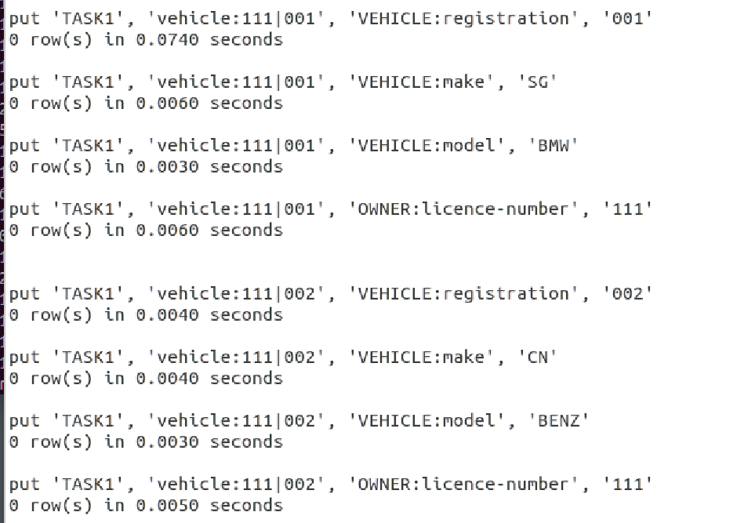

Put one owner into ‘TASK1’, the owner owns two vehicles:

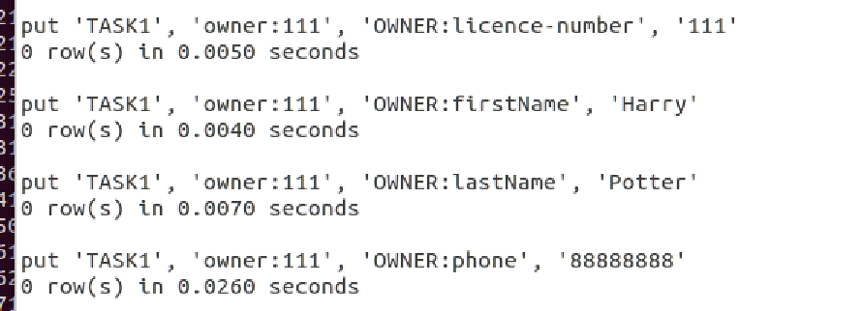

For each vehicle has two repair, insert two repair records for vehicle 001:

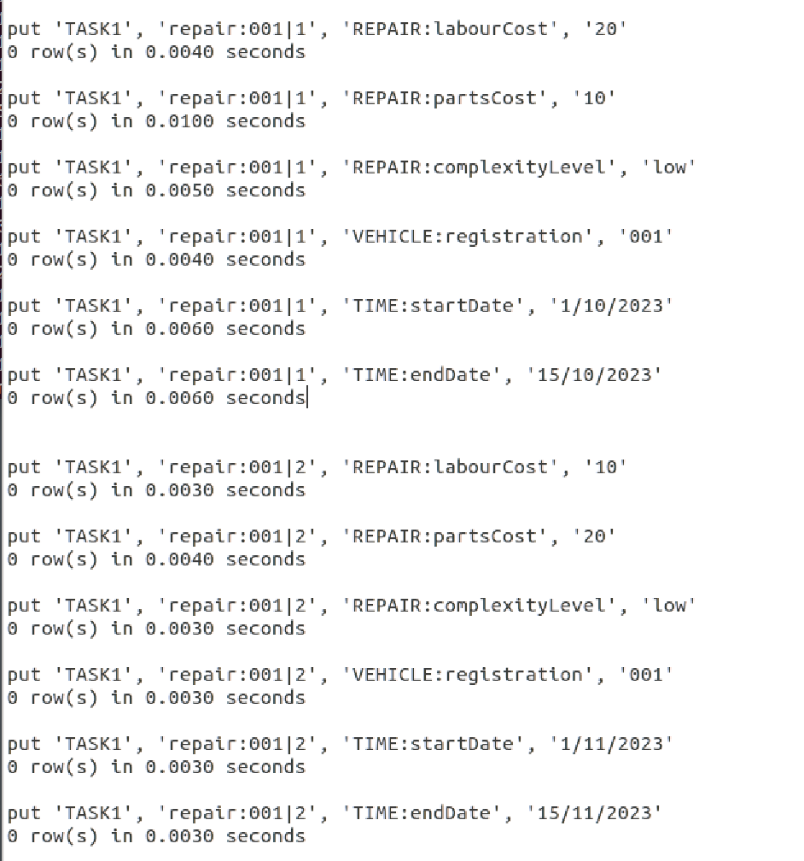

Insert two repair records for vehicle 002:

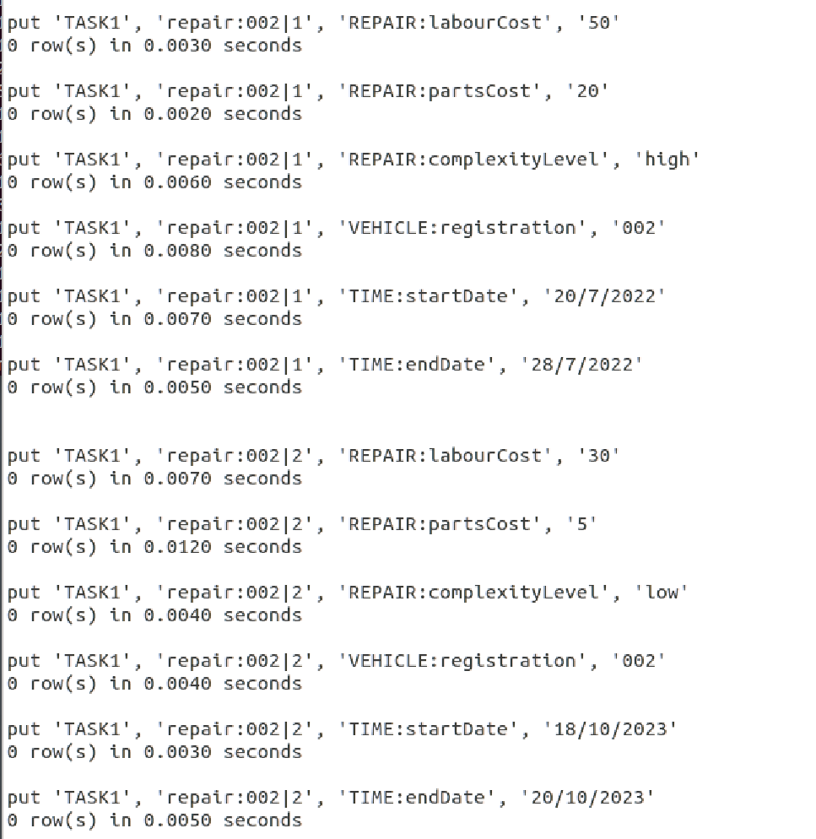

To scan table output:

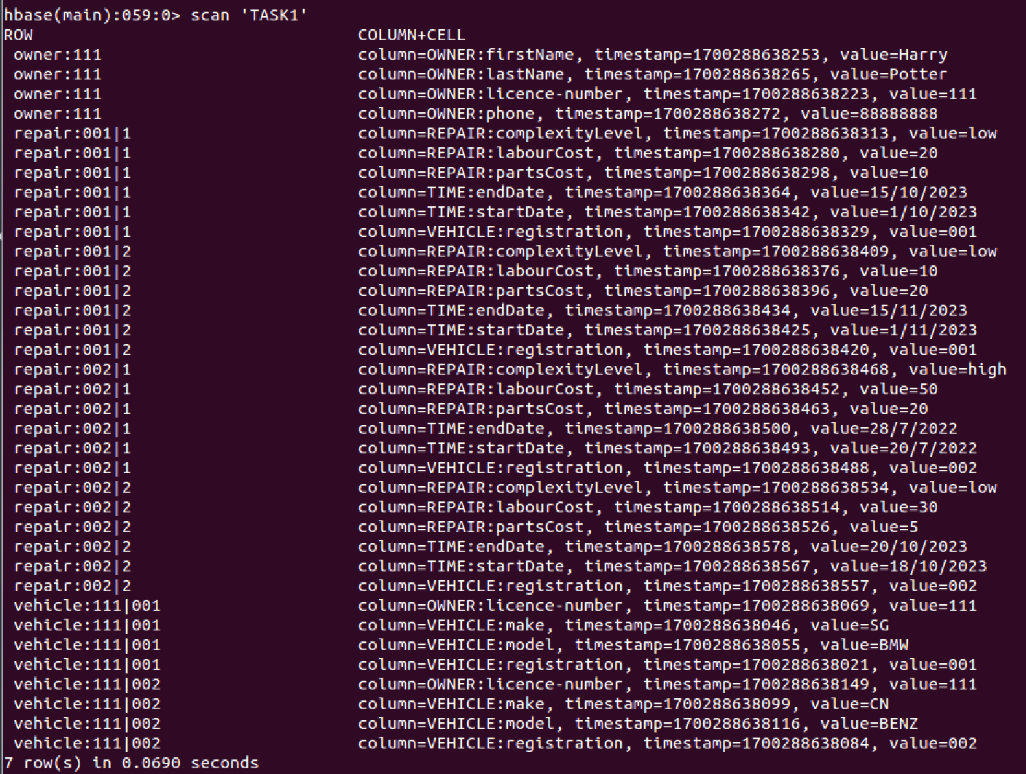

Task2

Processing script ‘task2.hb’ to create table:

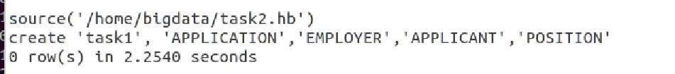

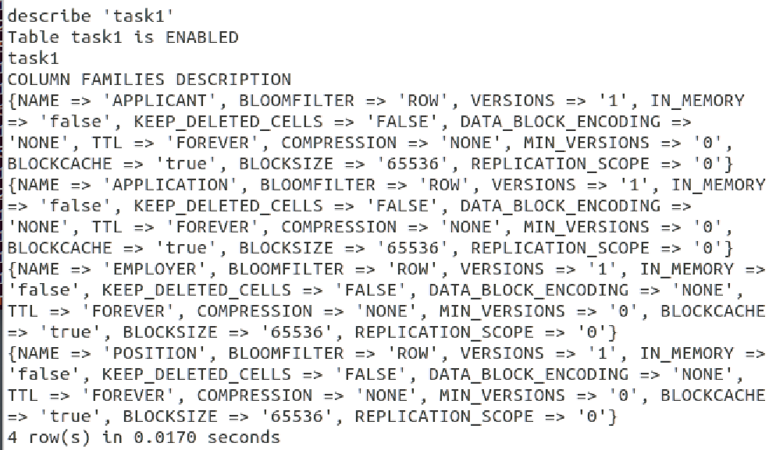

(1)

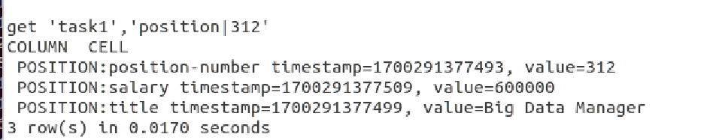

(2)

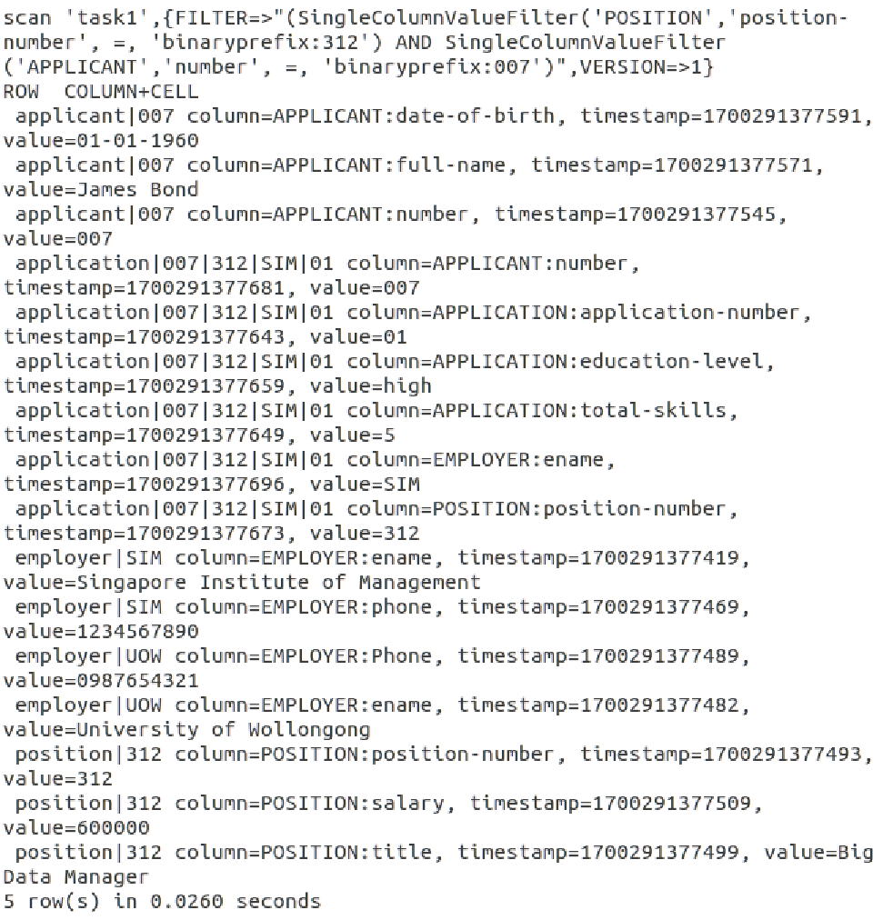

(3)

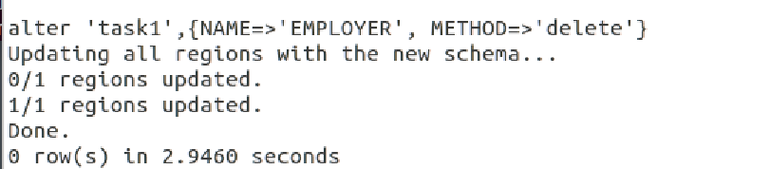

(4)

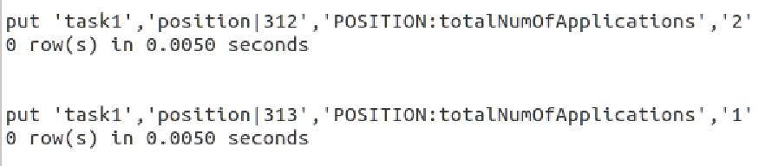

(5)

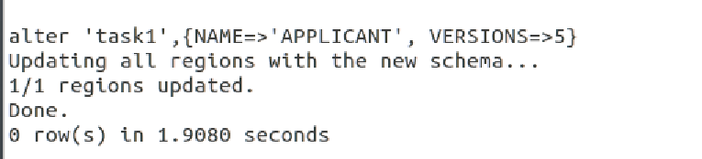

Task3

1. Transfer file into HDFS and create containers:

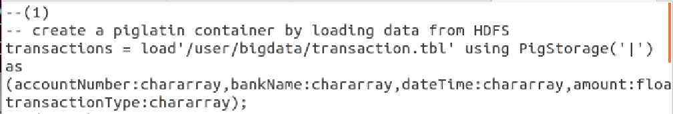

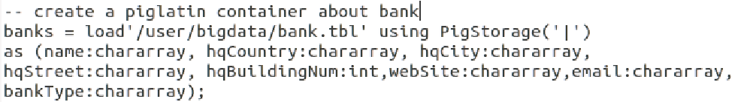

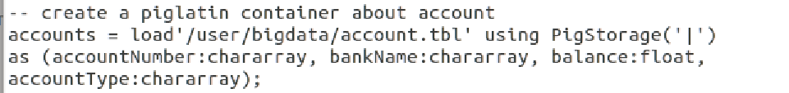

1. Statement & output:

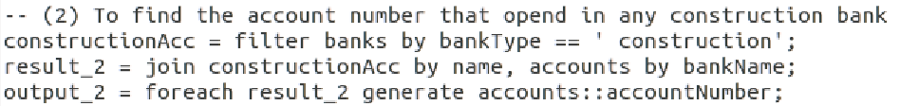

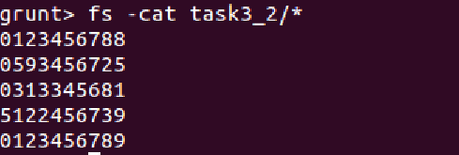

1. Statement & output:

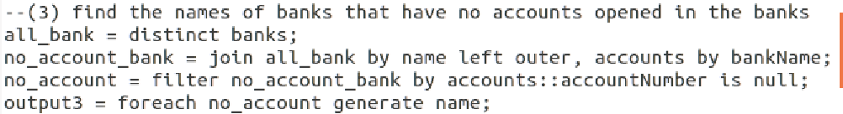

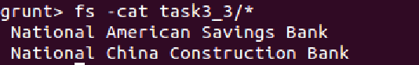

1. Statement & output:

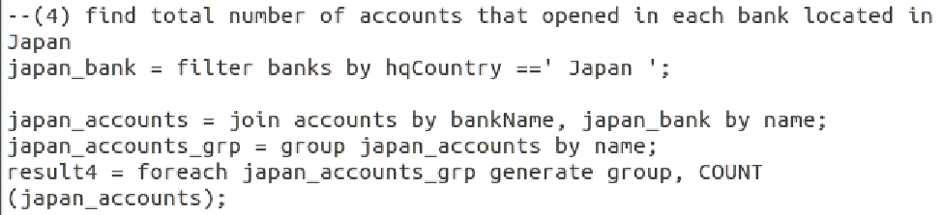

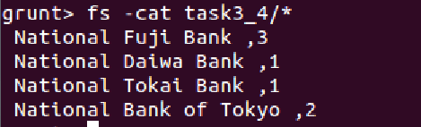

1. Statement & output:

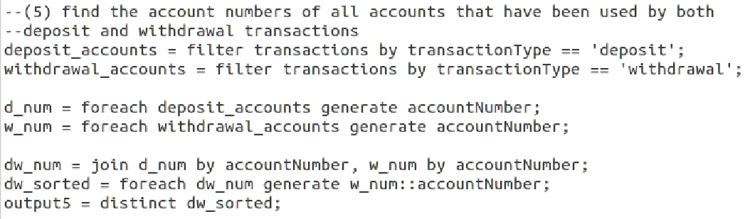

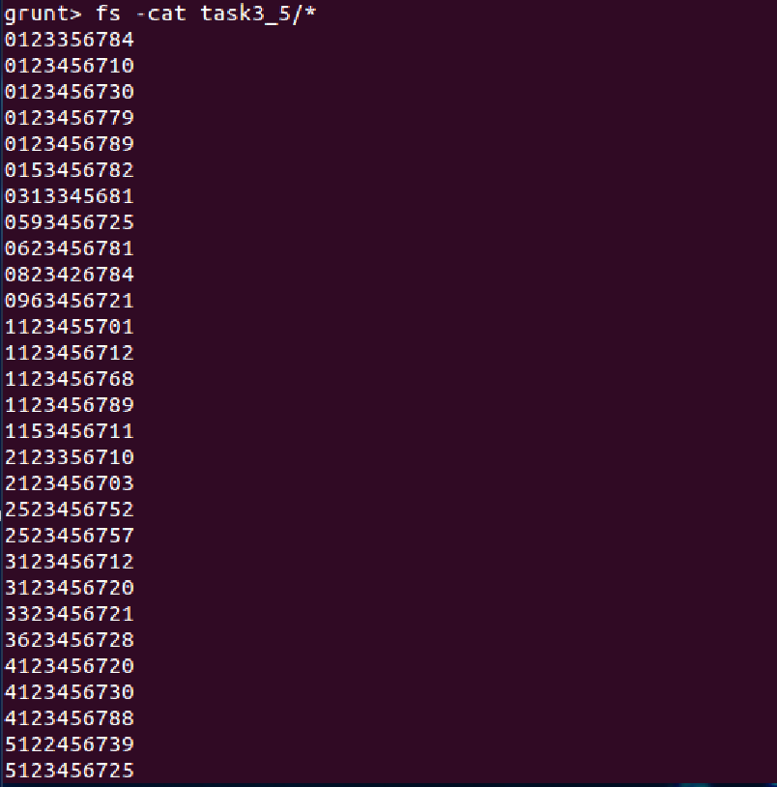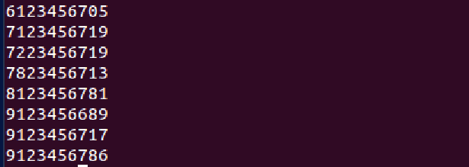

1. Statement & output:

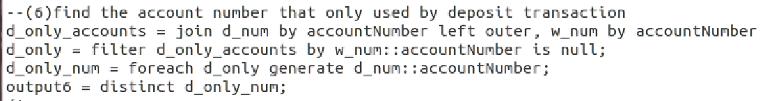

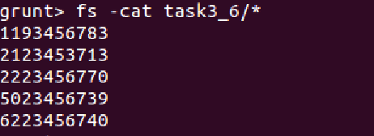

Task4

1. Load file into RDD:

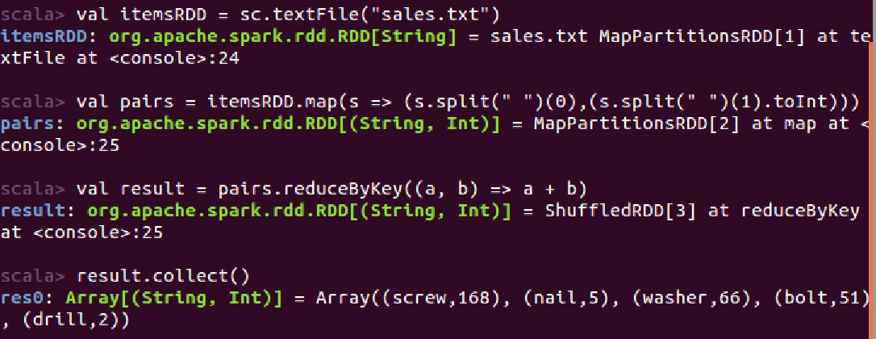

1. Load file into Dataset:

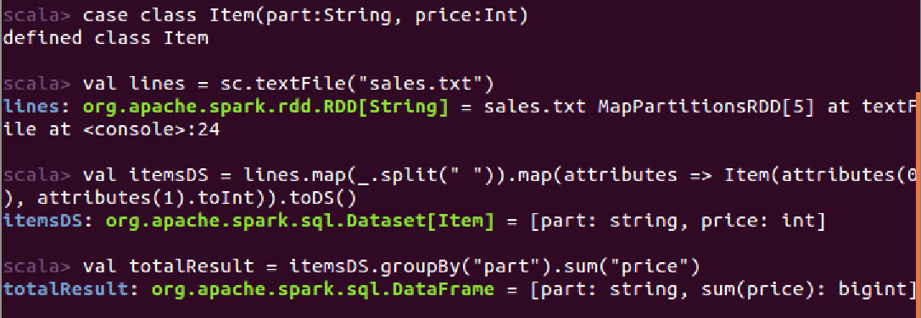

1. Load file into DataFrame:

