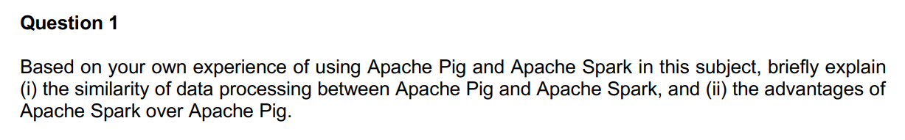
(i) Similarity of data processing between Apache Pig and Apache Spark:
Both Apache Pig and Apache Spark are popular frameworks used for data processing in big data environments. They share some similarities in terms of their approach to data processing:

- Data Flow Language: Apache Pig and Apache Spark both provide a high-level data flow language that allows users to express data transformations and analysis tasks. In Pig, the language is called Pig Latin, while Spark provides APIs in multiple languages like Scala, Java, Python, and R.

- Distributed Processing: Both frameworks are designed for distributed processing, allowing users to scale their computations across a cluster of machines. They handle the complexities of parallelism and fault tolerance, enabling efficient processing of large datasets.

- Data Abstraction: Both Pig and Spark provide abstractions for working with structured and semi-structured data. Pig operates on the concept of DataFlow operators, while Spark introduces the concept of RDDs (Resilient Distributed Datasets) and later evolved into DataFrames and Datasets.

- Support for Various Data Sources: Both frameworks support a wide range of data sources, including Hadoop Distributed File System (HDFS), Apache HBase, Apache Cassandra, and more. They also provide connectors to various data formats such as CSV, JSON, Avro, and Parquet.

(ii) Advantages of Apache Spark over Apache Pig:
While Apache Pig is a powerful data processing tool, Apache Spark offers several advantages over Pig:

- Speed: Apache Spark is known for its in-memory processing capabilities, which can significantly speed up data processing tasks. It keeps the intermediate data in memory, reducing the need for disk I/O and resulting in faster execution times compared to Pig.

- Rich APIs: Spark provides a rich set of APIs in multiple programming languages, allowing developers to write complex data processing logic in a familiar language. It supports APIs for batch processing (RDD), structured processing (DataFrames and Datasets), and streaming processing (Spark Streaming).

- Advanced Analytics: Spark offers a wide range of built-in libraries for advanced analytics and machine learning, such as Spark MLlib and Spark GraphX. These libraries provide efficient implementations of algorithms and tools for data scientists to perform tasks like classification, regression, clustering, and graph processing.

- Integration with Streaming Data: Apache Spark has native support for stream processing through its Spark Streaming module. It allows real-time data ingestion and processing from sources like Apache Kafka, enabling near-real-time analytics and event-driven applications.

- Spark SQL: Spark provides a SQL interface called Spark SQL, which allows users to write SQL queries directly on structured data. This simplifies the data processing workflow for users familiar with SQL and facilitates integration with existing SQL-based systems and tools.

- Ecosystem and Community: Spark has a vibrant and active community with extensive documentation, tutorials, and resources. It has a larger ecosystem of tools and frameworks built around it, making it easier to integrate Spark into existing data processing pipelines and leverage additional functionalities.

Overall, Apache Spark's speed, rich APIs, advanced analytics capabilities, streaming support, SQL interface, and ecosystem make it a compelling choice for data processing in big data environments, providing advantages over Apache Pig in many scenarios.

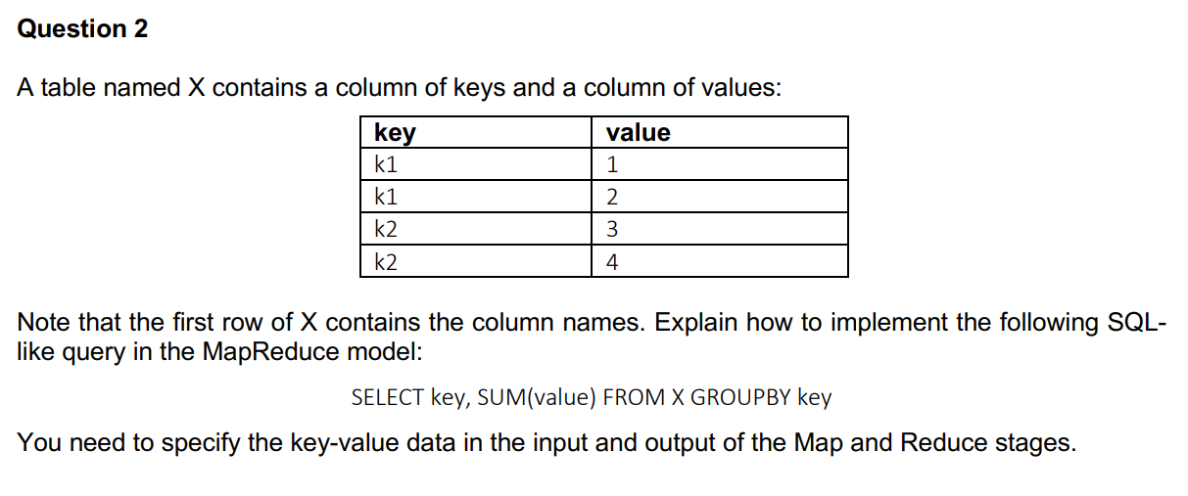
- Map Stage:
Input: The input to the Map stage will be the key-value pairs from the table X. Each key-value pair represents a row in the table.
Map Function: The map function takes each input key-value pair and emits intermediate key-value pairs based on the key. In this case, the map function should emit the key-value pair as (key, value).
Output: The output of the Map stage will be intermediate key-value pairs where the key is the distinct key from the table X, and the value is the corresponding value from the table.

- Shuffle and Sort:
The intermediate key-value pairs outputted by the Map stage will be shuffled and sorted based on the key. This step ensures that all values associated with the same key are grouped together and sent to the same reducer.

- Reduce Stage
Input: The input to the Reduce stage will be the shuffled and sorted intermediate key-value pairs.
Reduce Function: The reduce function takes the input key-value pairs and performs the aggregation operation. In this case, the reduce function should calculate the sum of the values for each key.
Output: The output of the Reduce stage will be the final key-value pairs, where the key is the distinct key from the table X, and the value is the sum of the corresponding values for that key.

The final output of the MapReduce job will be the result of the query "SELECT key, SUM(value) FROM X GROUP BY key," where each key-value pair represents a distinct key from the table X along with the sum of the corresponding values for that key.

Map Stage:
The input to the Map stage will be the data from table X, which consists of key-value pairs.
Each mapper will process a single row of the table at a time.
In the map function, the mapper will extract the key and value from each row.
The mapper will emit a key-value pair where the key is the key column value, and the value is the value column value.

Shuffle and Sort:
The output of the Map stage will be a set of intermediate key-value pairs generated by the mappers.
The MapReduce framework will perform a shuffle and sort step to group together all intermediate key-value pairs with the same key from different mappers.
This step ensures that all values corresponding to a particular key are sent to the same reducer.

Reduce Stage:
Each reducer will receive a key and a list of values associated with that key from the shuffle and sort step.
In the reduce function, the reducer will iterate over the list of values for each key and calculate the sum of the values.
The reducer will emit a key-value pair where the key is the key received from the shuffle and sort step, and the value is the sum of the values.

Final Output:
The output of the Reduce stage will be a set of key-value pairs, where each key represents a distinct key value from the original table X, and the value represents the sum of values associated with that key.
This output can be written to a file or used for further analysis.
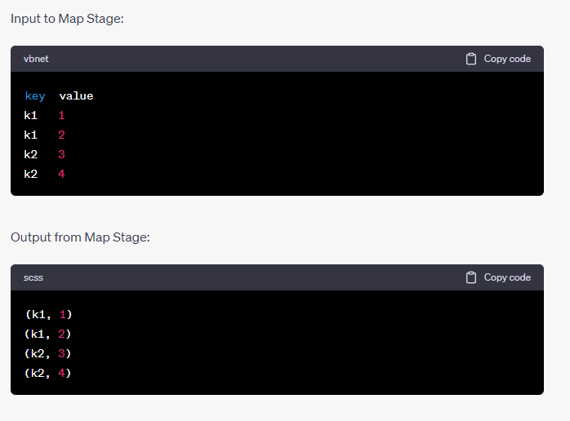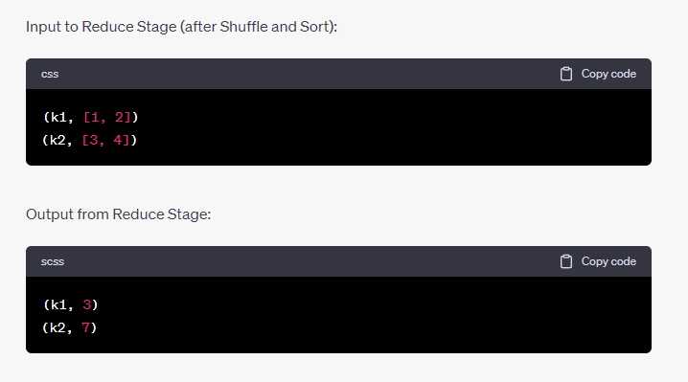

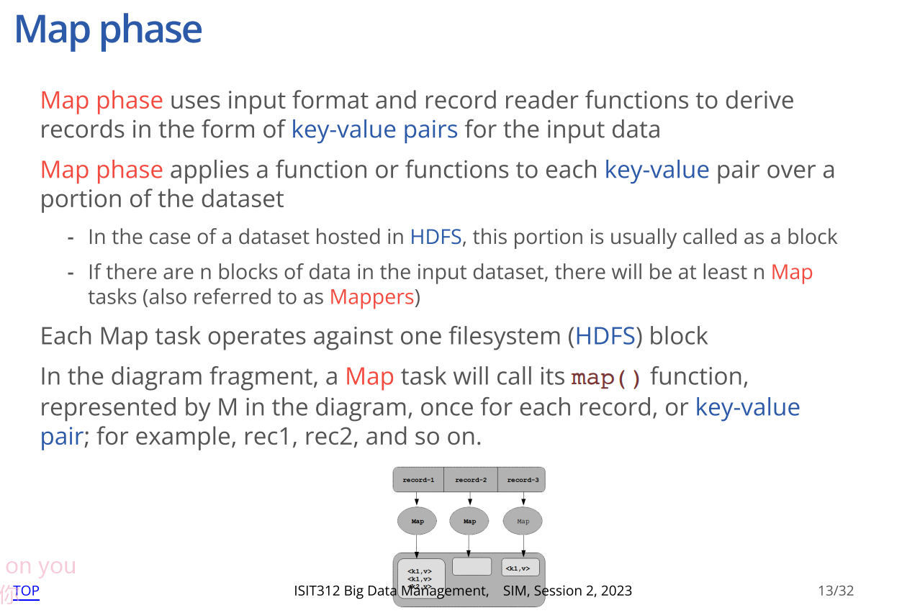
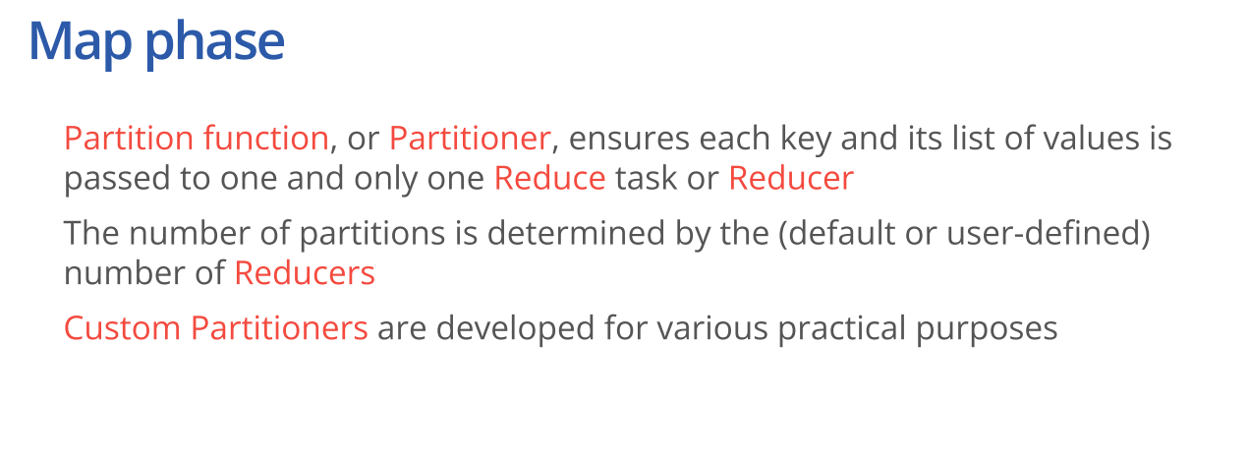
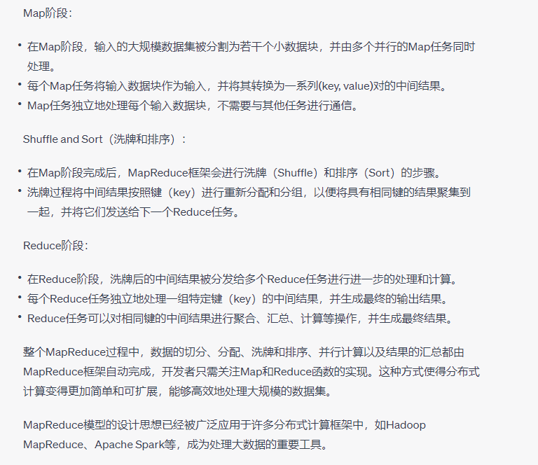

Ppt5
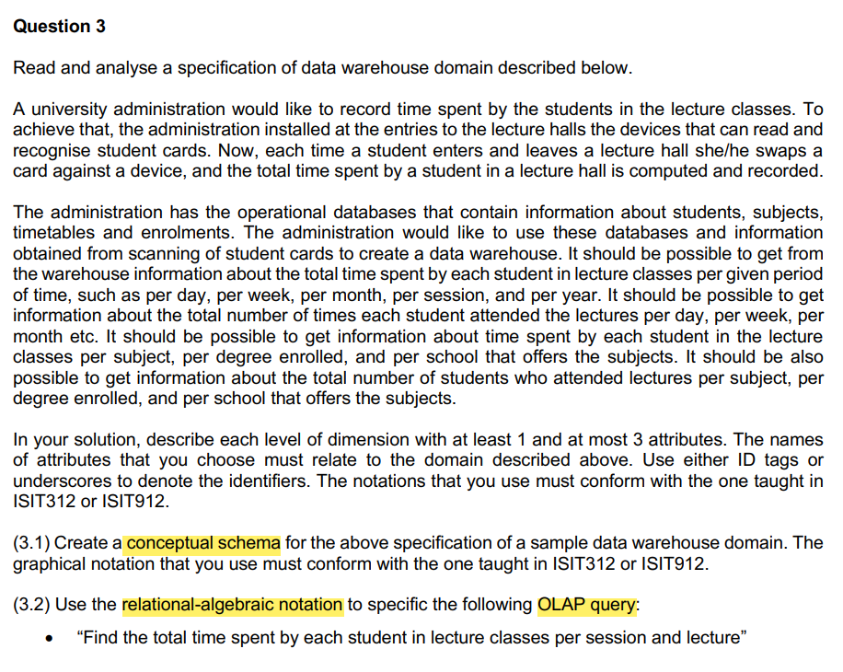

Ppt9

Ppt10
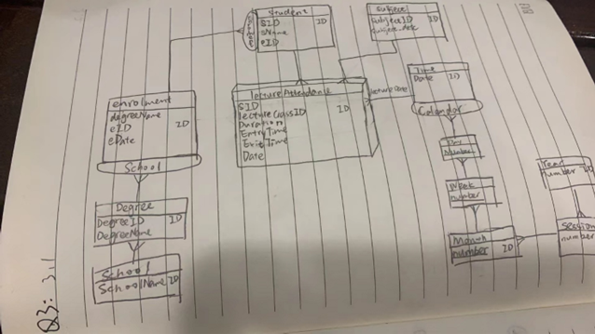

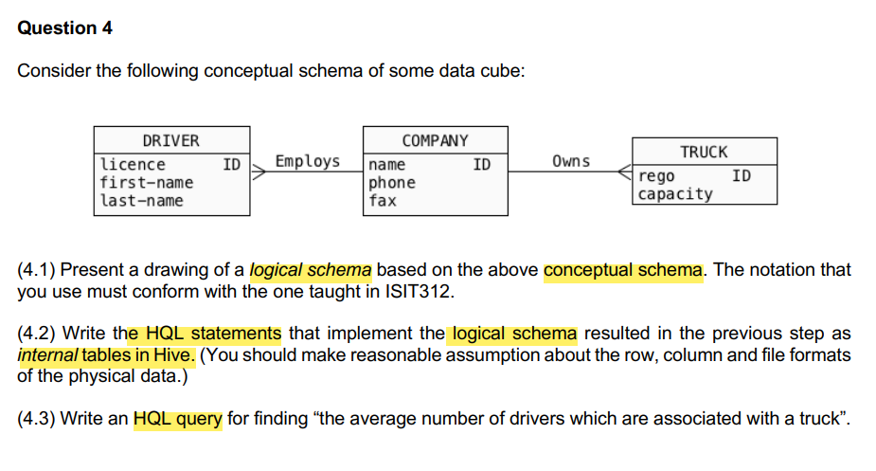
Exet-5
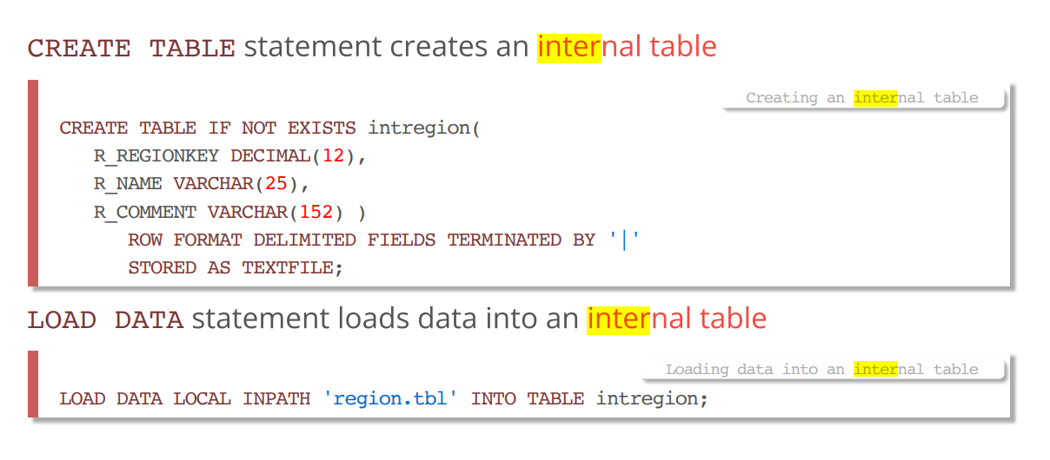
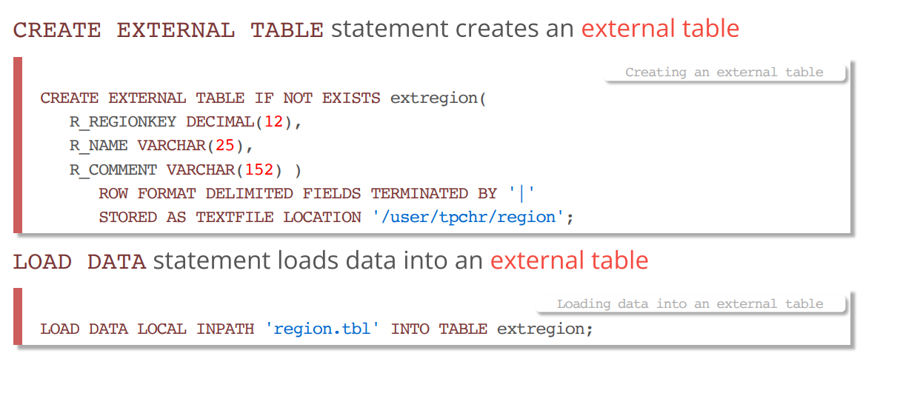
Ppt11{4.1}
Ppt8. 13{4.2}

Ppt12{4.3}

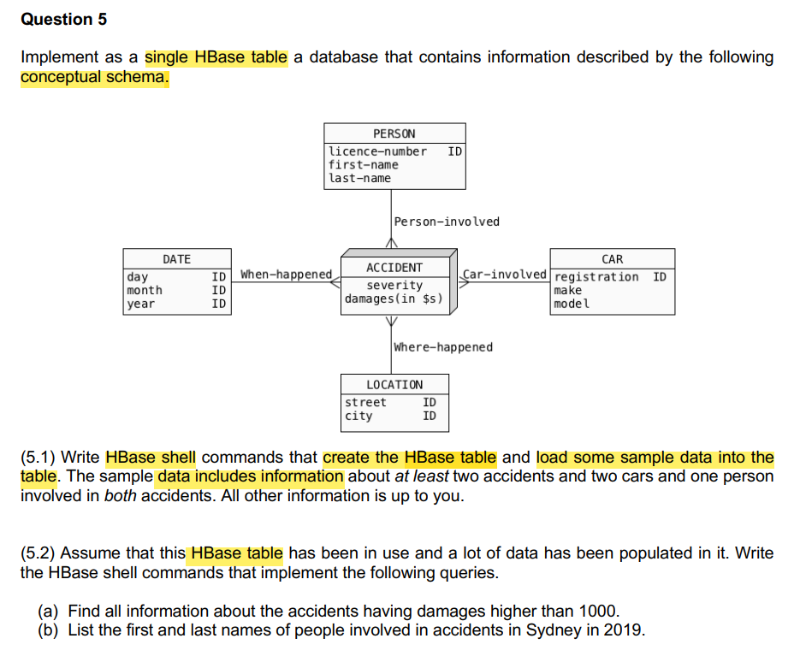
Exercise6 ppt17

# 创建HBase表
create 'car_accidents', 'accident', 'car', 'person'

# 添加样本数据：事故1
put 'car_accidents', 'accident1', 'accident:location', 'New York City'
put 'car_accidents', 'accident1', 'accident:date', '2023-06-07'
put 'car_accidents', 'accident1', 'accident:time', '13:30'
put 'car_accidents', 'car1', 'car:make', 'Honda'
put 'car_accidents', 'car1', 'car:model', 'Accord'
put 'car_accidents', 'car1', 'car:year', '2022'
put 'car_accidents', 'person1', 'person:name', 'John Smith'
put 'car_accidents', 'person1', 'person:age', '35'
put 'car_accidents', 'person1', 'person:license', '123456'
put 'car_accidents', 'person1', 'person:involved_in', 'accident1'

# 添加样本数据：事故2
put 'car_accidents', 'accident2', 'accident:location', 'Los Angeles'
put 'car_accidents', 'accident2', 'accident:date', '2023-06-04'
put 'car_accidents', 'accident2', 'accident:time', '08:45'
put 'car_accidents', 'car2', 'car:make', 'Toyota'
put 'car_accidents', 'car2', 'car:model', 'Corolla'
put 'car_accidents', 'car2', 'car:year', '2020'
put 'car_accidents', 'person1', 'person:name', 'John Smith'
put 'car_accidents', 'person1', 'person:age', '35'
put 'car_accidents', 'person1', 'person:license', '123456'
put 'car_accidents', 'person1', 'person:involved_in', 'accident2'

# 按照accident:damagesqualifier进行范围扫描
scan 'car_accidents', {FILTER => "SingleColumnValueFilter('accident','damages',>, 'binary:1000')"}

# 按照person:involved_in和accident:location qualifier进行筛选
scan 'car_accidents', {FILTER => "QualifierFilter(=,'binary:involved_in') AND ValueFilter(=,'substring:Sydney') AND ValueFilter(=,'substring:2019')"}

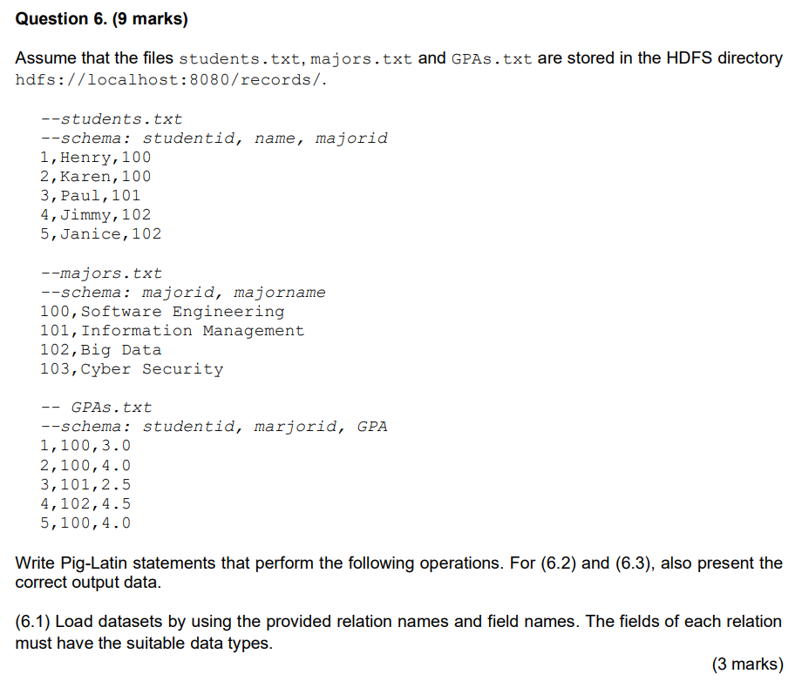
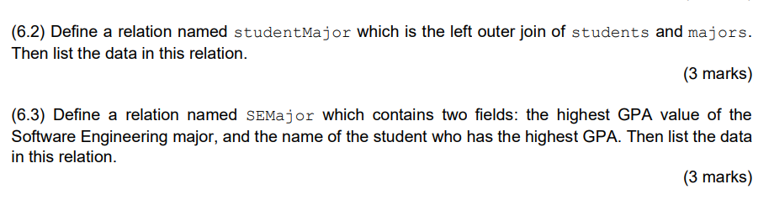

【ppt19】
-- 6.1: Load datasets with appropriate field names and data types
students = LOAD 'hdfs://localhost:8080/records/students.txt' USING PigStorage(',') AS (studentid:int, name:chararray, majorid:int);
majors = LOAD 'hdfs://localhost:8080/records/majors.txt' USING PigStorage(',') AS (majorid:int, majorname:chararray);
gpas = LOAD 'hdfs://localhost:8080/records/GPAs.txt' USING PigStorage(',') AS (studentid:int, majorid:int, GPA:float);

-- 6.2: Define relation studentMajor as the left outer join of students and majors
studentMajor = JOIN students BY majorid LEFT OUTER, majors BY majorid;

-- List data in relation studentMajor
DUMP studentMajor;

-- 6.3: Define relation SEMajor with highest GPA value for Software Engineering major and corresponding student name
SEMajor = FOREACH (GROUP gpas BY majorid) {
ordered = ORDER gpas BY GPA DESC;
top = LIMIT ordered 1;
GENERATE FLATTEN(top.GPA), FLATTEN(top.studentid);
}

-- List data in relation SEMajor
DUMP SEMajor;
~~~~~~~~~~~~~~~~~~~~~~~~~~~~~~~~~~~~~~~~~~~~~~~~~~~~~~~~~~~~
-- Filter students and GPAs for Software Engineering major
se_students = FILTER students BY majorid == 100;
se_gpas = FILTER gpas BY majorid == 100;

-- Join se_students and se_gpas on studentid
se_data = JOIN se_students BY studentid, se_gpas BY studentid;

-- Find the student with the highest GPA
se_max_gpa = FOREACH (GROUP se_data BY se_students::studentid) {
ordered_data = ORDER se_data BY se_gpas::GPA DESC;
top_student = LIMIT ordered_data 1;
GENERATE group AS studentid, FLATTEN(top_student.(se_gpas::GPA, se_students::name)) AS (max_gpa:float, student_name:chararray);
}

-- Define SEMajor relation
SEMajor = FOREACH (GROUP se_max_gpa ALL) {
max_gpa = MAX se_max_gpa.max_gpa;
highest_gpa_student = FILTER se_max_gpa BY max_gpa == se_max_gpa.max_gpa;
GENERATE FLATTEN(highest_gpa_student.(max_gpa, student_name));
}

-- List the data in SEMajor
DUMP SEMajor;

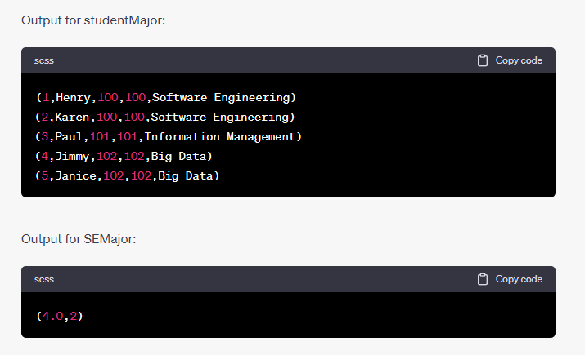
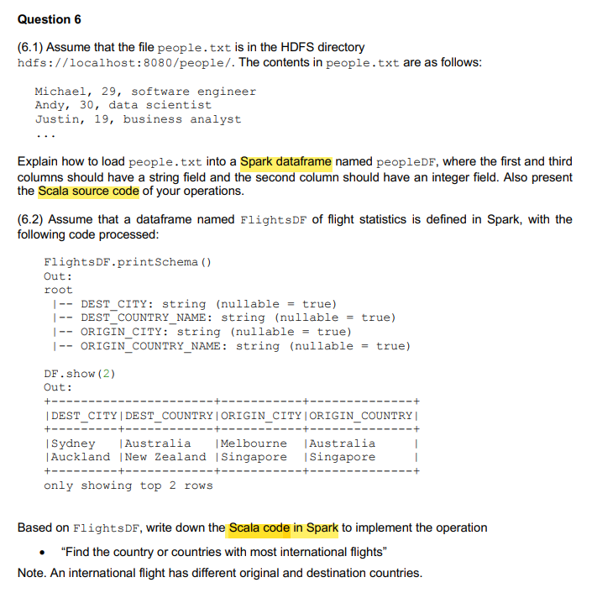

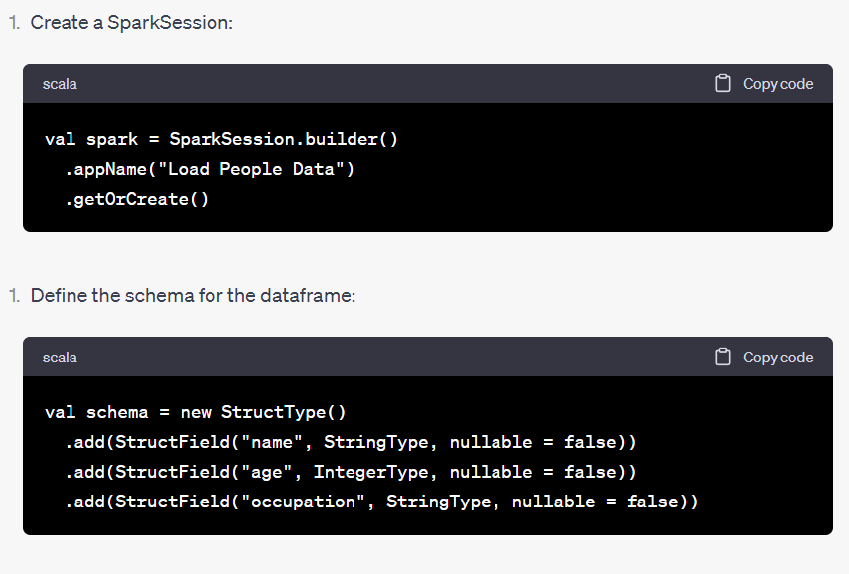
Read the text file and split each line into fields

val lines = spark.read.text("hdfs://localhost:8080/people/people.txt").rdd
val data = lines.map(_.getString(0).split(",")).map(attributes => Row(attributes(0), attributes(1).toInt, attributes(2)))

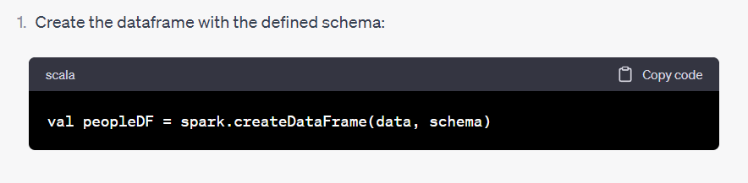

222

import org.apache.spark.sql.functions._

// Group the dataframe by the origin and destination countries
val countryCounts = FlightsDF.groupBy("ORIGIN_COUNTRY_NAME", "DEST_COUNTRY_NAME")
.agg(count("*").alias("flightCount"))

// Filter for international flights where the origin and destination countries are different
val internationalFlights = countryCounts.filter(col("ORIGIN_COUNTRY_NAME") =!= col("DEST_COUNTRY_NAME"))

// Find the country or countries with the most international flights
val maxFlightCount = internationalFlights.agg(max("flightCount")).collect()(0).getLong(0)

// Filter the dataframe to get the country or countries with the most international flights
val countriesWithMaxFlights = internationalFlights.filter(col("flightCount") === maxFlightCount)
.select("ORIGIN_COUNTRY_NAME", "DEST_COUNTRY_NAME")

countriesWithMaxFlights.show()

