ls

./start-hadoop.sh

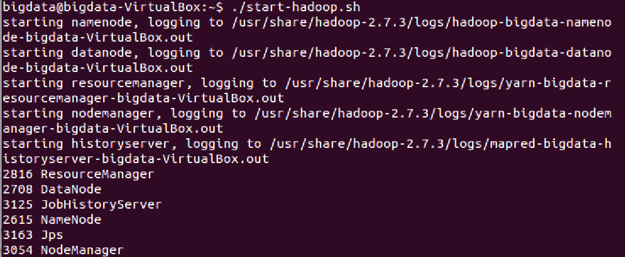

$HADOOP_HOME/bin/hadoop fs -ls

// put a file into the hadoop

cat filename.txt

// compile java

export HADOOP_CLASSPATH=$(HADOOP_HOME_bin/hadoop classpath)

eco $HADOOP_CLASSPATH

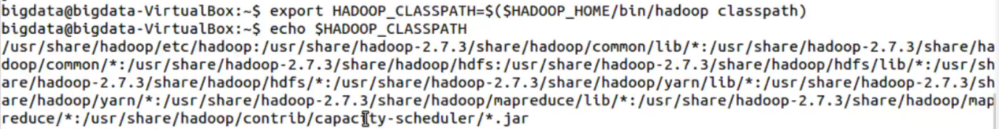

Javac -cp $HADOOP_CLASSPATH filename.java



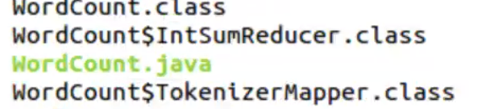

// create jar

jar cvf filename.jar filename*.class(contain all class)

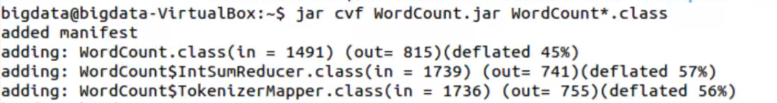

ls

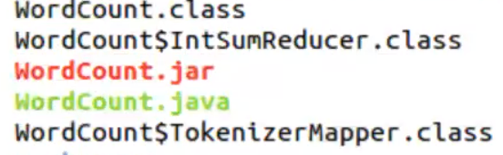

// copy file from local drive into Hadoop

fs -put filename.txt rename.txt

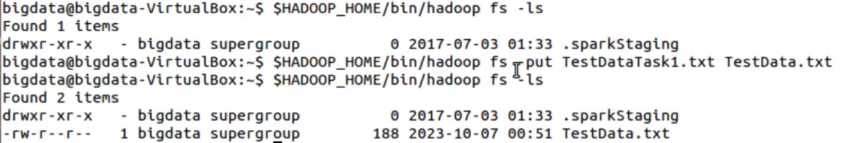

//

// jar filename.jar mainClassOfJava dataInHadoop outputFilename

jar wordCount.jar wordCount task1 taskOutput

