Puck — End-User Guide
Structural-Scarcity Radar + Timing Layer

Puck — End-User Guide
Not financial advice. Puck is research tooling to inform your own judgment. Every name it tracks is cyclical and would fall together in a recession or rate shock. Prices and signals can be wrong or stale. Verify before you act, and consider a fiduciary advisor.
This guide explains every feature, what each number means, and how to use it. Screenshots are auto-generated from the live app by the docs workflow, so they stay current as the app evolves.
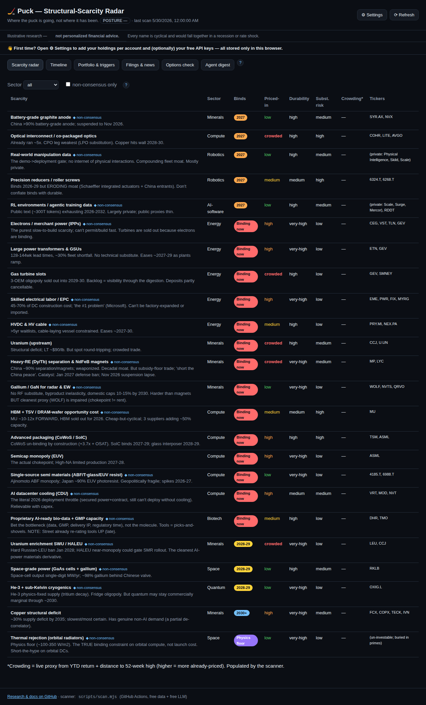
Puck overview

1. What Puck is (the one-paragraph mental model)
Puck has one philosophy: alpha from the scarcity research, timing from the tape. - The alpha is what to own: structural technology scarcities (chokepoints — power, grid, copper, uranium, rare earths, semis, etc.) that bind over 2026–2036, mapped to a real portfolio. - The timing is when to act: a market-regime layer (trend + momentum + volatility + drawdown) that tells you when to deploy/go-all-in vs. when to apply the brakes and raise cash.
A free scanner runs daily on GitHub Actions, pulls free market data, computes everything, and commits it to web/data/signals.json. The dashboard (hosted free on Vercel) just renders that file.
The ? buttons: every section has a circular ? help button that explains it in-app. This guide is the long-form version.

2. Getting started (first 5 minutes)
- Open the dashboard (your Vercel URL). You’ll land on the Scarcity radar.
- A “First time?” banner points you to ⚙ Settings — open it.
- Add your holdings per account (see §9). This is stored only in your browser — never uploaded.
- (Optional) add free API keys (§9.2–9.3) to enable the AI digest and extra data cross-checks.
- Use the tabs across the top to explore. Tap any ? for context.
Nothing you enter in Settings is ever committed to the repo — it lives in your browser’s localStorage.

3. Scarcity radar (the alpha)
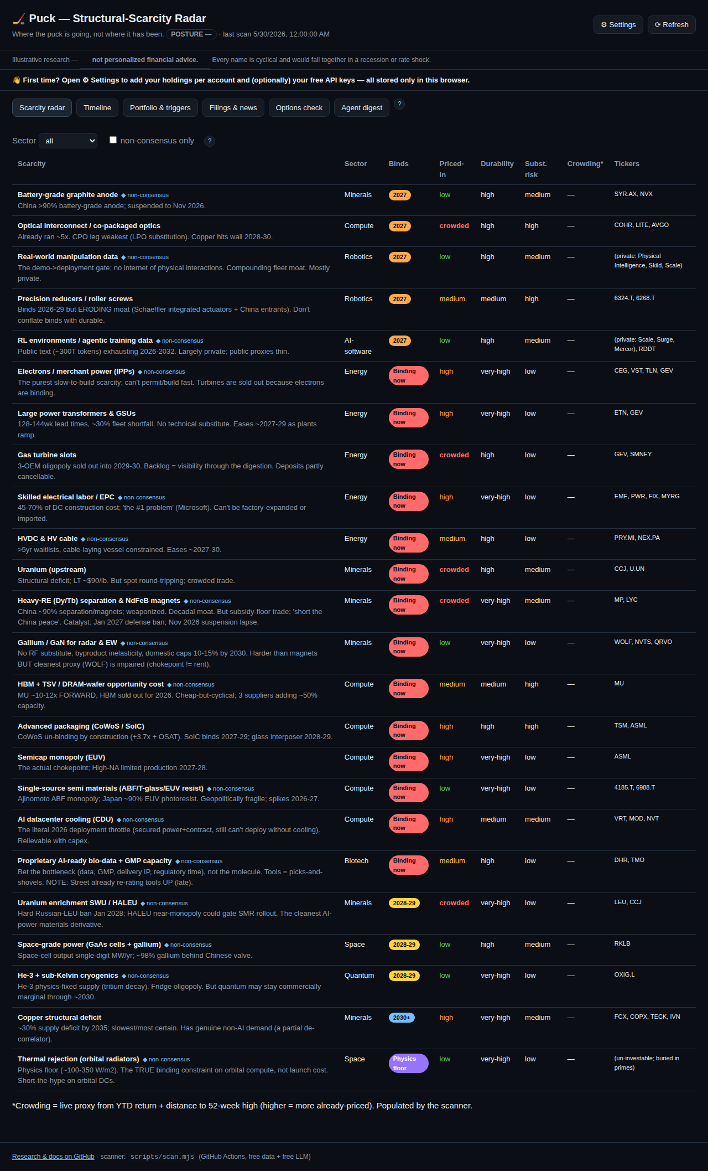
Scarcity radar
Each row is a structural scarcity. How to read the columns:
Column | Meaning | How to use it
Scarcity | The chokepoint + a one-line thesis. ◆ non-consensus = under-appreciated. ▲ drift = its priced-in level has changed since first tracked. | Hunt for non-consensus + low priced-in.
Binds | When it starts biting: now → 2027 → 2028-29 → 2030+ → physics floor. | Earlier = more urgent.
Priced-in | How much the market already reflects it: low → medium → high → crowded. | High/crowded = less edge left; low = more opportunity.
Durability | How long the moat lasts (low → very-high). | Favor very-high.
Subst. risk | Chance a substitute relieves the scarcity. | Lower is better.
Crowding* | A live 0–100 proxy from price action (YTD + distance to 52-week high). | Higher = more already-priced by the market right now.
Tickers | Investable proxies (some scarcities are private/foreign — no clean ticker). | —
Controls: filter by Sector, or tick non-consensus only to see just the under-appreciated theses. The durable edge is low priced-in + high durability + low substitution risk.

4. Timeline
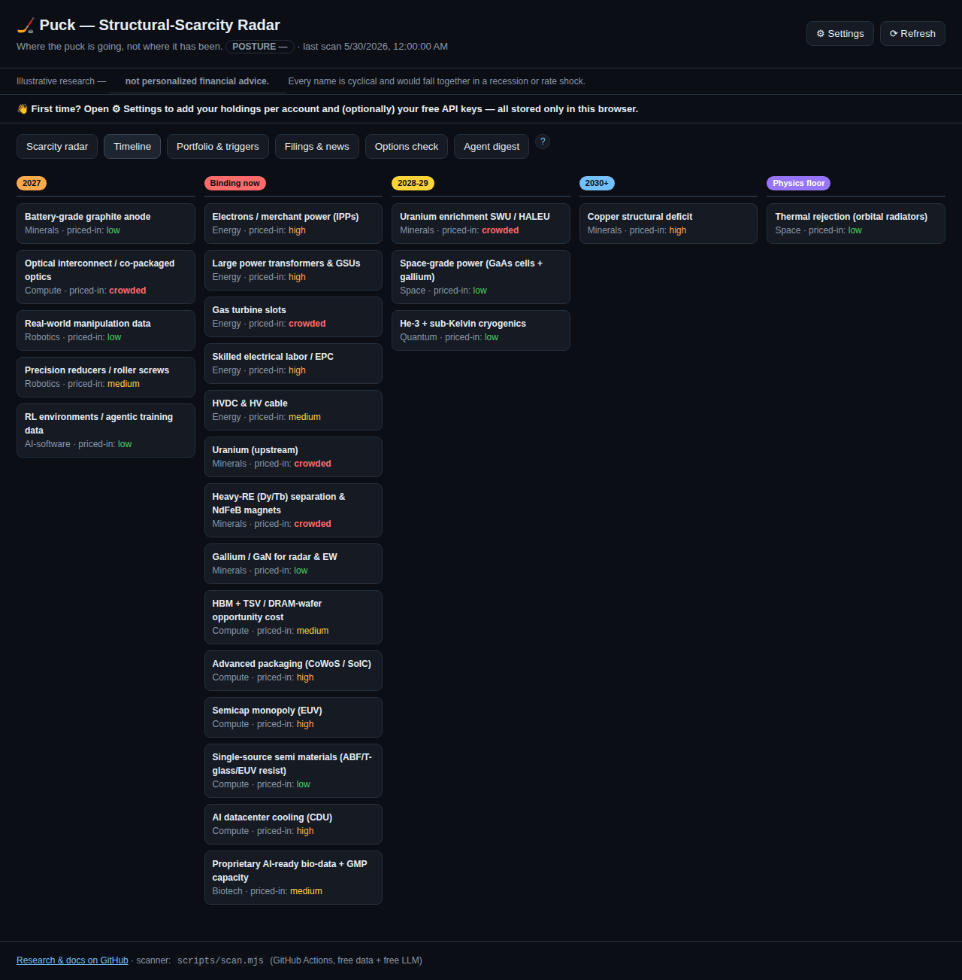
Timeline
The same scarcities, bucketed by when they bind (now → 2027 → 2028-29 → 2030+ → physics floor), each tagged with its priced-in level. Use it to see sequencing — what bites first and what’s a longer-dated, more certain deficit (e.g., copper).

5. Portfolio & triggers
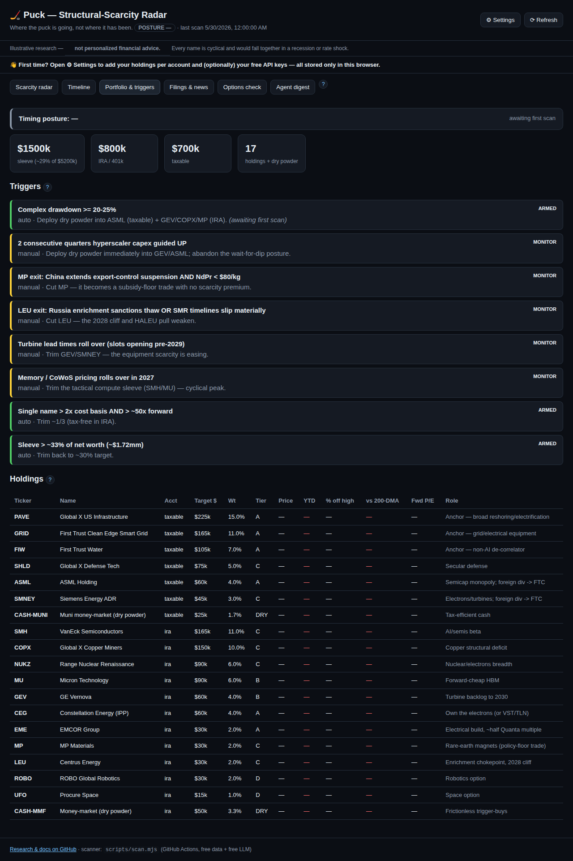
Portfolio and triggers

5.1 Timing posture (the regime)
The colored banner at the top is the timing posture — the heart of “when to act”:
Posture | Meaning | What to do
🟢 risk-on (score ≥70) | Uptrend + positive 12-month momentum, contained volatility | Deploy on schedule / accelerate low-regret anchors
⚪ neutral (45–69) | Mixed | Stick to the DCA calendar; no acceleration
🟠 caution (25–44) | Trend/vol deteriorating | Tap the brakes — slow deploys, build dry powder
🔴 defensive (<25) | Downtrend, drawdown, rising vol | Favor cash; deploy only into the drawdown trigger
It’s a risk dial that paces your DCA, not an all-in/all-out switch. It’s built on independent, replicated research (Faber 200-DMA trend; Moskowitz-Ooi-Pedersen time-series momentum; Moreira-Muir volatility; Hurst-Ooi-Pedersen trend) — not a curve-fit backtest. Full detail: REGIME.md.

5.2 Summary cards
Sleeve size, IRA vs taxable split, holding count, and a data-quality card (✓ OK or ⚠ degraded — see §11).

5.3 Triggers
Rules that tell you to act. Each shows a state — armed (active), monitor (manual watch), or fired (condition met): - Drawdown (auto): complex down ≥20–25% from highs → deploy dry powder. - Trim rule (auto): a name >2× cost basis and >50× forward P/E → trim ⅓ (needs your cost basis from Settings). - Sleeve cap (auto): sleeve value > ~$1.72mm → trim back (needs your holdings from Settings). - Policy triggers (manual): e.g. rare-earth/uranium policy shifts.
When a trigger fires, the scanner opens a GitHub issue (deduped — one open issue at a time). Auto triggers are held on a degraded-data run so bad data can’t fire an action (§11).

5.4 Holdings table
Your target plan: account, target $, weight, tier (deployment pace), live price, YTD, % off high, vs 200-DMA (trend), and Fwd P/E (the “went up a lot ≠ expensive” check; skipped for ETFs). A ⚠ next to a ticker means a data-quality flag (divergent sources, a big jump, or a stale quote — hover to see why).
Tiers: A = 100% now · B = 50% now + months 1–3 · C = 25% now + DCA to month 9 · D = small option sleeve · DRY = cash held for triggers.

5.5 Your holdings (live)
Once you add positions in Settings, this panel shows market value, gain vs cost, % of target, per-account subtotals, and your sleeve value vs the cap — computed from your browser-stored positions × the latest scan prices.

6. Filings & news
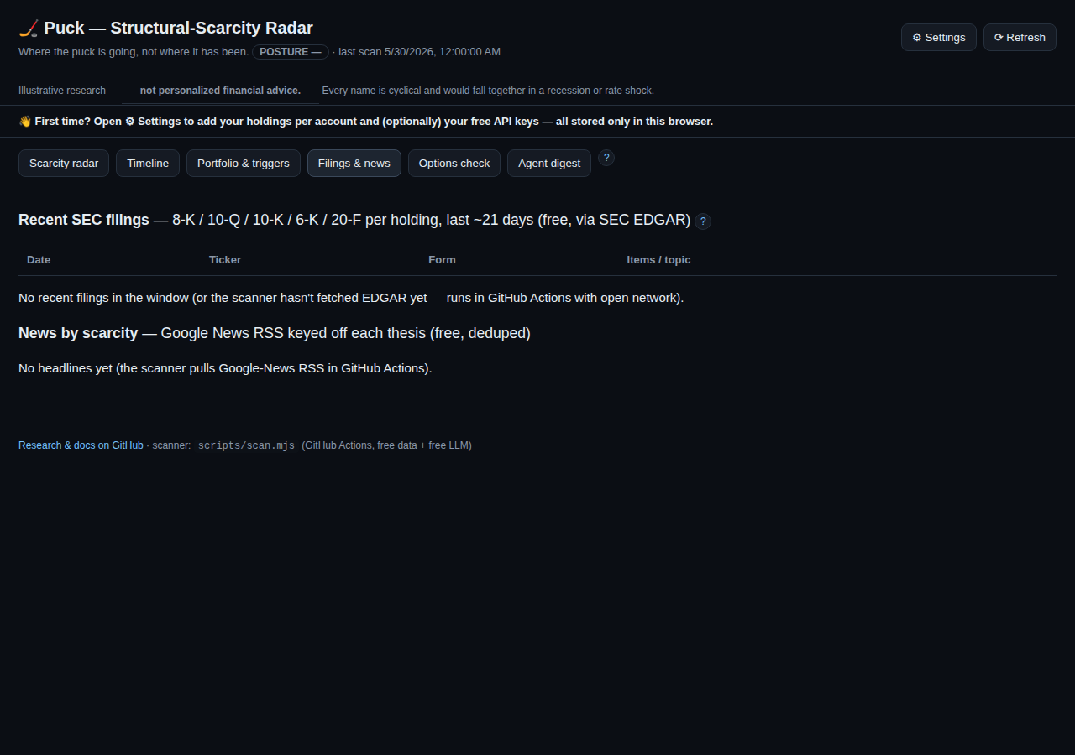
Filings and news
Free, keyless catalysts: - SEC EDGAR filings per holding (8-K/10-Q/10-K/6-K/20-F, last ~21 days). 8-K items are decoded into plain topics (e.g. Results/guidance, Material agreement). A green NEW badge = unseen since the last scan. Click open ↗ to read the filing on SEC.gov. - News by scarcity: Google-News headlines keyed to each scarcity’s thesis terms, deduped, grouped by scarcity. NEW badges mark fresh items.
Both feed the Agent digest. Use this tab to spot catalysts — backlog, capacity, guidance, pricing, policy — that move a thesis.

7. Options check (fair-value before you buy)
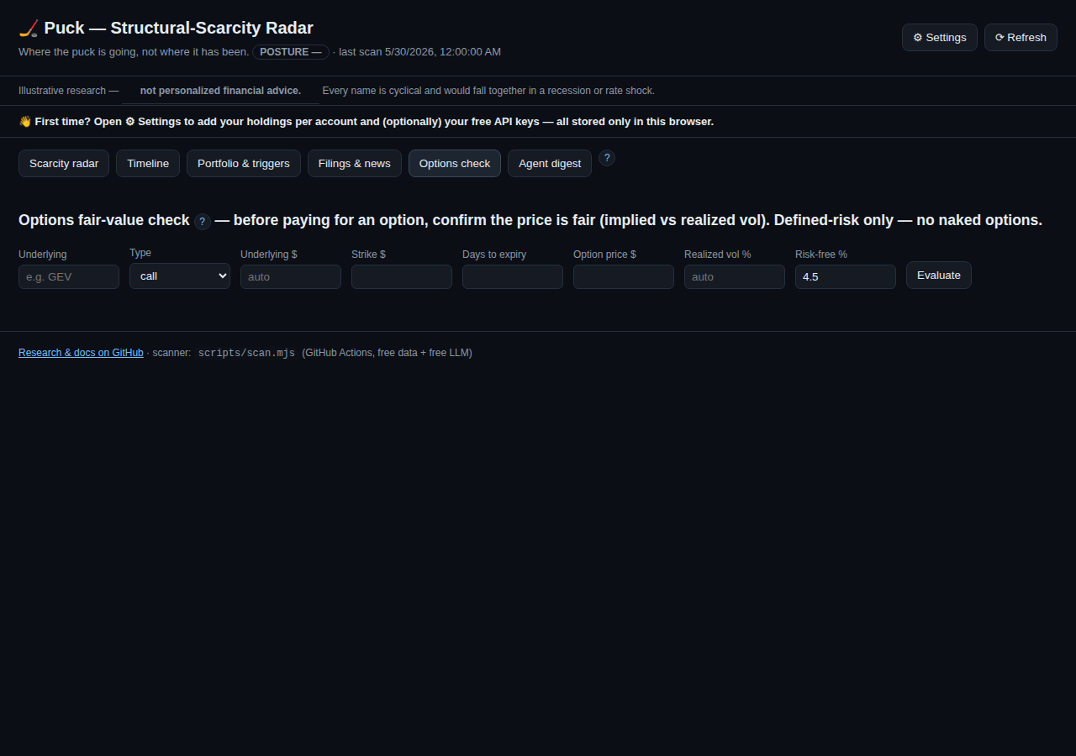
Options check
Before paying for an option, confirm the price is fair. Puck backs out the option’s implied volatility (IV) from its market price (Black-Scholes) and compares it to the underlying’s recent realized volatility (from the scan).
How to use it: 1. Type the underlying ticker — its price and realized vol auto-fill from the latest scan. 2. Choose call/put, enter strike, days to expiry, and the option price (premium). 3. Click Evaluate.
What you get: IV, realized vol, IV ÷ realized, the fair value at realized vol, the edge vs fair, a verdict, and the greeks (delta/vega/theta).
Verdict | Meaning
cheap | IV below realized vol
fair | IV within a normal variance-risk premium (~0.95–1.35× realized)
rich | IV well above realized — you’re paying up for premium
It also suggests a defined-risk structure based on the live posture (defensive → put / put-spread; risk-on → LEAPS call).
Defined-risk only — no naked options (both accounts). Use long calls/puts, debit spreads, collars, covered calls, cash-secured puts. Caveat: realized vol is backward-looking and options carry event/skew premia, so treat this as a sanity check, not a price oracle. Not advice.

8. Agent digest
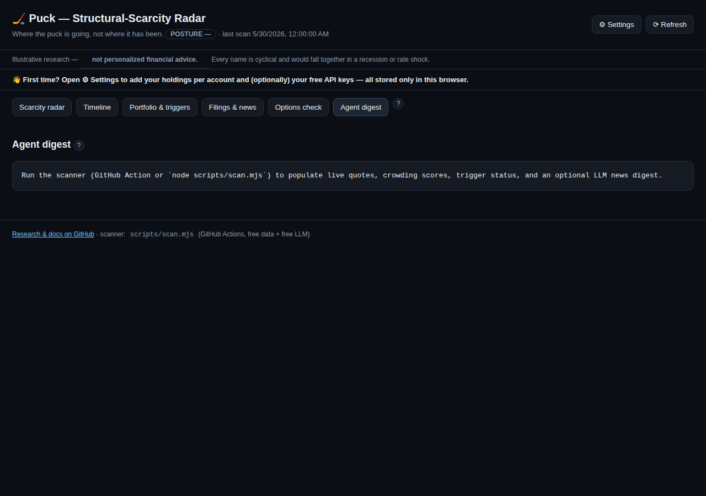
Agent digest
An optional LLM “analyst + red-team” summary of what materially changed (quotes, filings, news, regime) and whether any trigger looks closer. With two free keys it runs cross-model — the analyst on one model, the red-team on another — so it isn’t a model grading itself.
- Automated: set GEMINI_API_KEY (and optionally GROQ_API_KEY) as GitHub repo secrets; the daily scan writes the digest.
- In-browser, on demand: add a Gemini key in Settings and click ✦ Generate digest in browser.

9. ⚙ Settings & onboarding
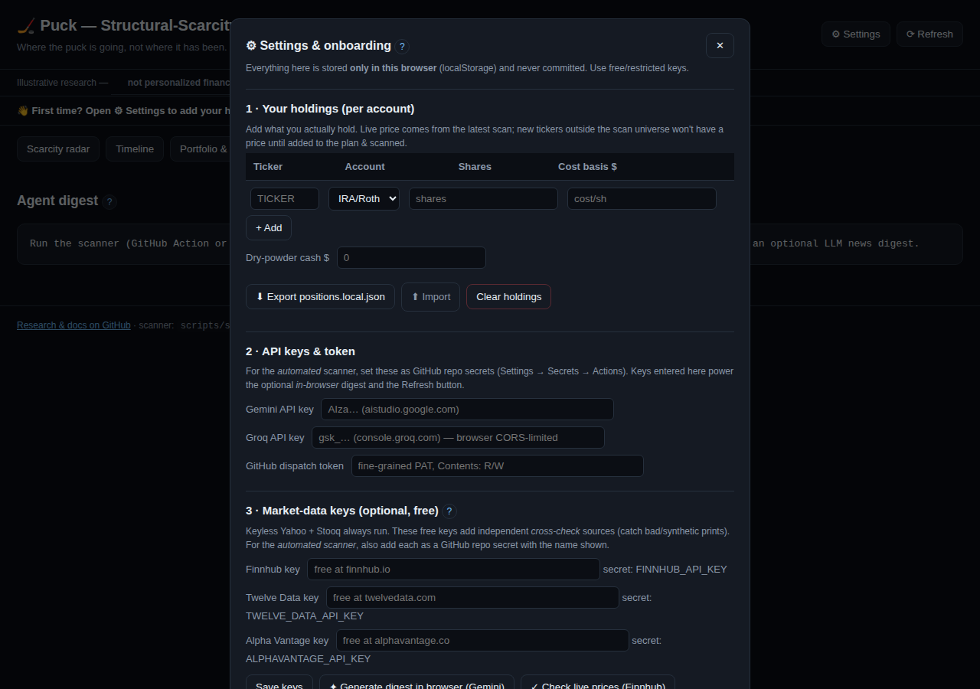
Settings
Everything here is stored only in this browser (localStorage) and never committed.

9.1 Your holdings (per account)
Add each holding: ticker, account (IRA/Roth or Taxable), shares, cost basis, plus your dry-powder cash. Live prices come from the latest scan. - ⬇ Export positions.local.json — download your positions in the exact shape the scanner reads, so the server-side trim rule and sleeve-cap can compute against your real lots. (Drop the file into web/data/ — it’s gitignored, so it’s never committed.) - ⬆ Import — load a positions file back in. - Clear holdings — wipe them from this browser.

9.2 LLM keys (free)
- Gemini (aistudio.google.com) — powers the in-browser digest; CORS-friendly.
- Groq (console.groq.com) — the second model for cross-model red-teaming (used by the scanner).

9.3 Market-data keys (free, optional)
Keyless Yahoo + Stooq always run. These add independent cross-check sources so a bad/synthetic price can’t pass silently: - Finnhub (finnhub.io) — also powers the ✓ Check live prices button (browser-side live vs last scan). - Twelve Data, Alpha Vantage — used by the scanner.
For the automated scanner, also add each as a GitHub repo secret using the exact name shown (e.g. FINNHUB_API_KEY). Keys typed here stay in your browser.

9.4 GitHub dispatch token
A fine-grained PAT (Contents: Read & write) that lets the ⟳ Refresh button trigger a live scan. See §10.

10. ⟳ Refresh (on-demand scan)
The scanner runs automatically on weekdays. To refresh now, click ⟳ Refresh: - The first time, paste your dispatch token (stored only in your browser). - It triggers the GitHub Action; the dashboard auto-polls and live-reloads when fresh data lands (~1–3 min). No manual reload. - No token? Refresh points you to the manual Actions → scan → Run workflow.

11. Data integrity & quality (why you can trust the numbers)
Puck guards against bad/synthetic data: - HTTPS-only sources; plausibility checks (no ≤0 / non-finite prices). - Cross-source corroboration — Yahoo + Stooq (+ any free keys) are compared; a >3% divergence flags the quote (⚠). - Anomaly vs last scan — a >35% jump (likely a bad print / unadjusted split) is flagged. - Freshness — a stale/halted last bar is flagged. - Fail-safe triggers — on a degraded run (too many errors/flags) the auto-triggers are held, so bad data can’t fire an action. The data-quality card on the Portfolio tab shows ✓ OK or ⚠ degraded.
Add free market-data keys (§9.3) for stronger corroboration.

12. Glossary
- Scarcity / chokepoint — an input that’s slow/impossible to expand, so demand outruns supply.
- Priced-in / crowding — how much the market already reflects a thesis (judgment vs. live price proxy).
- Bind window — when a scarcity starts constraining.
- Tier — how fast a holding is deployed (A/B/C/D/DRY).
- 200-DMA — 200-day moving average; price above it = healthier trend (Faber).
- 12-month momentum — trailing one-year return; the time-series-momentum signal (MOP 2012).
- Realized vol — actual recent volatility of the underlying.
- Implied vol (IV) — volatility implied by an option’s price.
- Forward P/E — price ÷ next-year expected earnings.
- Posture / regime — the timing dial (risk-on → defensive).

13. FAQ & troubleshooting
- Prices/options/holdings show “—”. The dashboard needs a completed live scan. Run ⟳ Refresh (or the scan Action), then reload.
- “Stale data” banner. The last scan is >3 days old — trigger a refresh.
- A holding has a ⚠. Sources diverged, a big jump, or a stale quote — hover to see which. Treat the number with caution.
- Digest says “no LLM key set”. Add a Gemini/Groq key (Settings or repo secret).
- Refresh rejected (401/403/404). The dispatch token is missing/insufficient — it needs Contents: Read & write on this repo. It’s auto-cleared so you can re-paste.
- I don’t want my real holdings anywhere shared. They never leave your browser (localStorage), and positions.local.json is gitignored.

This guide is maintained alongside the app. A docs workflow regenerates the screenshots (and the Word version) whenever the UI changes, and a pre-commit hook reminds contributors to update it when web/ changes. See ARCHITECTURE.md §6–§7.

