Puck — End-User Guide
Structural-Scarcity Radar + Timing Layer

Puck — End-User Guide
Not financial advice. Puck is research tooling to inform your own judgment. Every name it tracks is cyclical and would fall together in a recession or rate shock. Prices and signals can be wrong or stale. Verify before you act, and consider a fiduciary advisor.
This guide explains every feature, what each number means, and how to use it. Screenshots are auto-generated from the live app by the docs workflow, so they stay current as the app evolves.
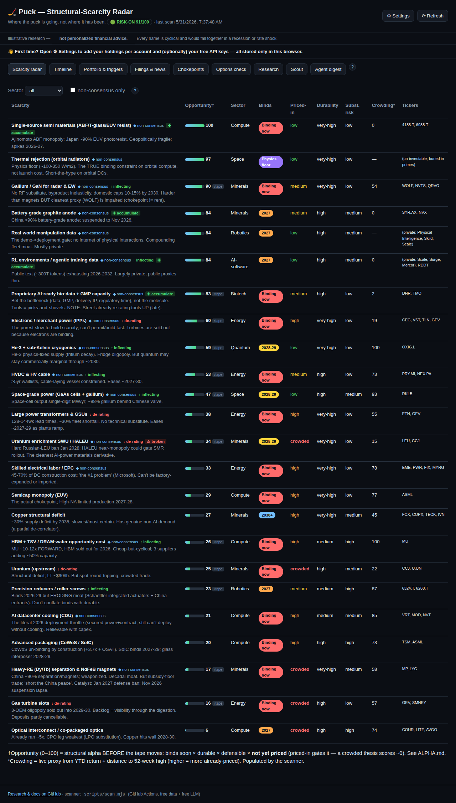
Puck overview

1. What Puck is (the one-paragraph mental model)
Puck has one philosophy: alpha from the scarcity research, timing from the tape. - The alpha is what to own: structural technology scarcities (chokepoints — power, grid, copper, uranium, rare earths, semis, etc.) that bind over 2026–2036, mapped to a real portfolio. - The timing is when to act: a market-regime layer (trend + momentum + volatility + drawdown) that tells you when to deploy/go-all-in vs. when to apply the brakes and raise cash.
A free scanner runs daily on GitHub Actions, pulls free market data, computes everything, and commits it to web/data/signals.json. The dashboard (hosted free on Vercel) just renders that file.
Works on phone and desktop. The layout is responsive — wide tables scroll horizontally and controls stack on a phone, so everything is reachable on iPhone or a large screen.
The ? buttons: every section has a circular ? help button that explains it in-app. This guide is the long-form version.

2. Getting started (first 5 minutes)
- Open the dashboard (your Vercel URL). You’ll land on the Scarcity radar.
- A “First time?” banner points you to ⚙ Settings — open it.
- Add your holdings per account (see §9). This is stored only in your browser — never uploaded.
- (Optional) add free API keys (§9.2–9.3) to enable the AI digest and extra data cross-checks.
- Use the tabs across the top to explore. Tap any ? for context.
Nothing you enter in Settings is ever committed to the repo — it lives in your browser’s localStorage.

3. Scarcity radar (the alpha)
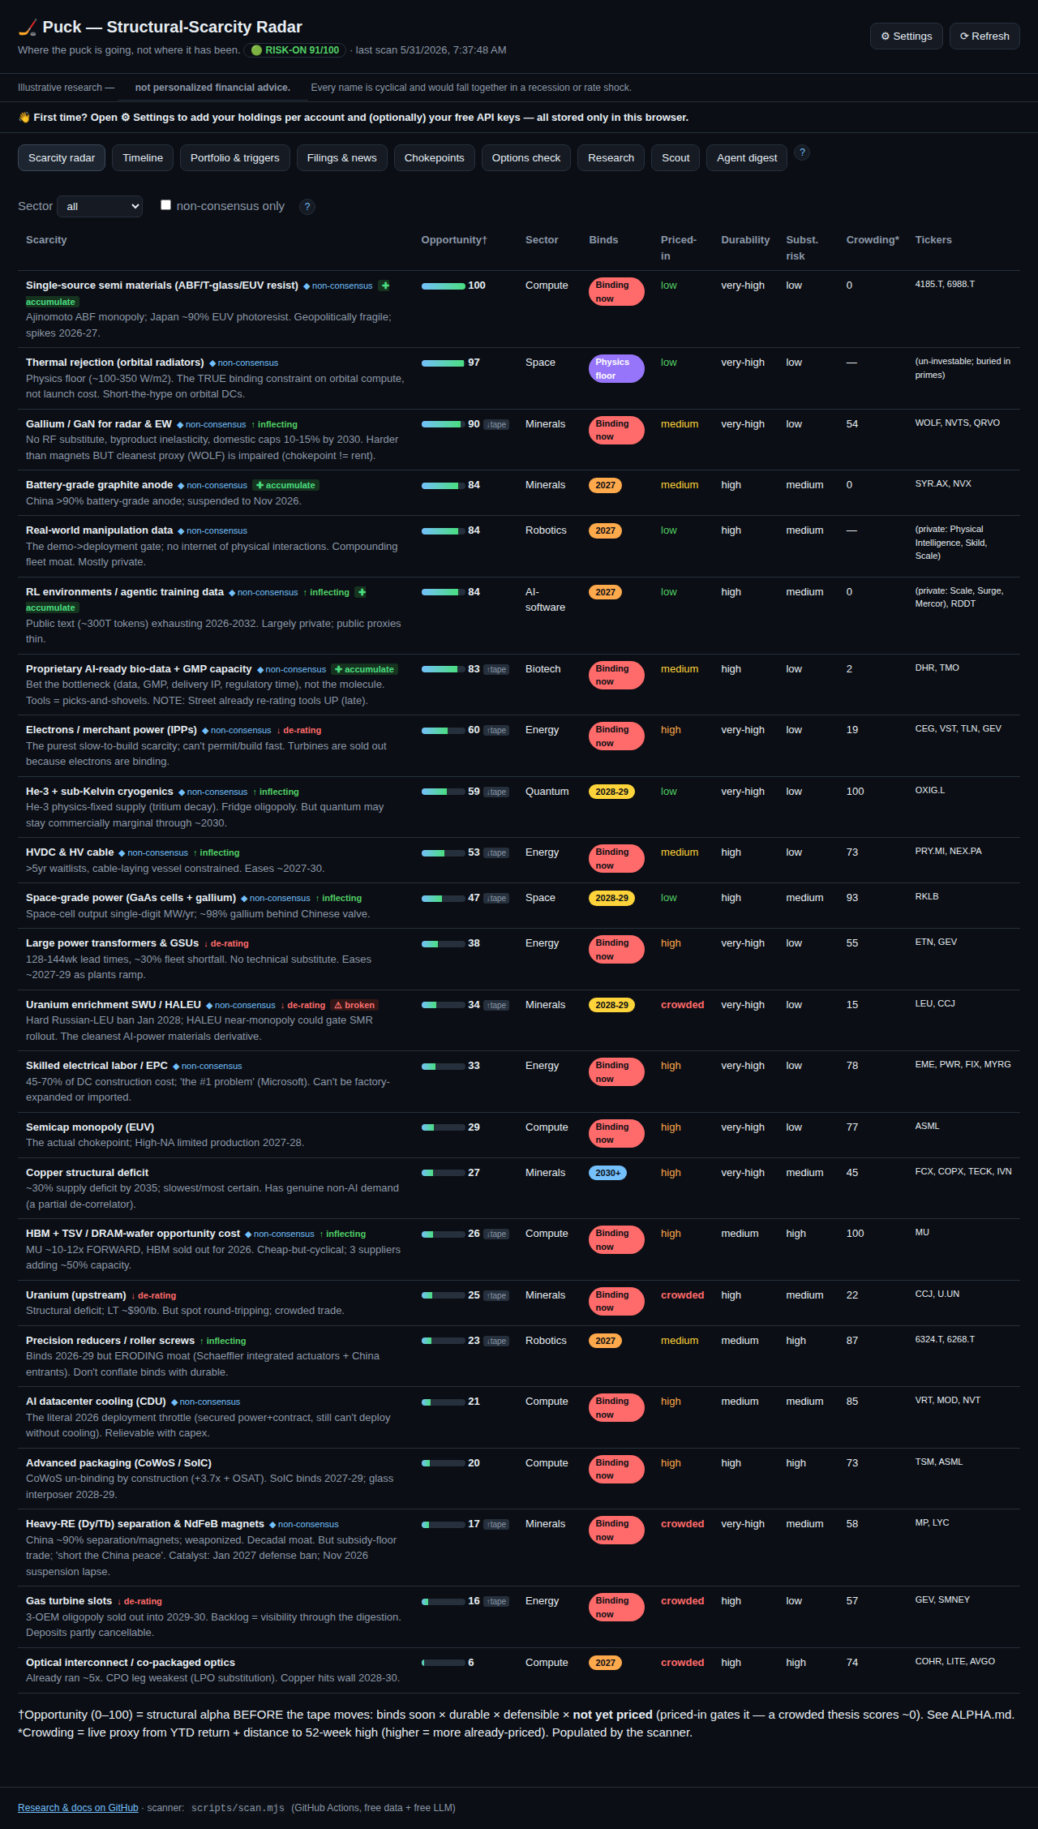
Scarcity radar
Each row is a structural scarcity, ranked by Opportunity Score — where the retail alpha is. How to read the columns:
Column | Meaning | How to use it
Scarcity | The chokepoint + a one-line thesis. ◆ non-consensus = under-appreciated. ▲ drift = its priced-in level has changed since first tracked. | Hunt for non-consensus + low priced-in.
Opportunity† | 0–100 structural-alpha score = binds soon × durable × defensible × not yet priced. Priced-in is a multiplicative gate: a crowded thesis scores ~0 however good the business, because there’s no alpha left in what’s priced. The gate blends the human label (60%) with a live price-derived crowding proxy (40%), so it tracks the tape; a ↑tape / ↓tape chip flags where the market disagrees with the label. Built from the source fields only — no curve-fitting. | Top of the list = the best structural setups. Top scores are graded as relative-outperformance forecasts.
Binds | When it starts biting: now → 2027 → 2028-29 → 2030+ → physics floor. | Earlier = more urgent.
Priced-in | How much the market already reflects it: low → medium → high → crowded. | High/crowded = less edge left; low = more opportunity.
Durability | How long the moat lasts (low → very-high). | Favor very-high.
Subst. risk | Chance a substitute relieves the scarcity. | Lower is better.
Crowding* | A live 0–100 proxy from price action (YTD + distance to 52-week high). | Higher = more already-priced by the market right now.
Tickers | Investable proxies (some scarcities are private/foreign — no clean ticker). | —
Each scarcity may also carry an alpha flag: ↓ de-rating (a crowded thesis losing relative strength vs the AI-capex complex → reduce) or ↑ inflecting (an under-priced thesis gaining → accumulate). This operationalizes the thesis’s core claim and is graded by the Track record over time.
It may also carry a forced-flow flag (ALPHA.md Edge 3 — buying what others are forced to sell): ✚ accumulate = the name is mechanically de-rated (off highs, below trend, falling) while its structural thesis is intact — the footprint of forced/neglect selling. This flag is regime-aware: when the timing dial has the brakes on it shows ⏳ accumulate on trigger — a deploy-when-the- drawdown-trigger-fires priority, not a buy-now call — so selection (what) and timing (when) never contradict. ⚠ broken = de-rated and the thesis is weak → real deterioration, not an opportunity.
Where does the alpha actually come from? See ALPHA.md — the research foundation. In short, a retail investor can only beat the market where a structural constraint stops institutions from doing so: (1) time-horizon arbitrage (you can wait 10 years; a quarterly-judged PM can’t), (2) complexity/inaccessibility (private/foreign/impaired chokepoints with no clean ETF — the chokepoints tab), (3) forced-flow/neglect (buying what others are forced to sell), and (4) behavioral discipline. The Opportunity Score operationalizes #1; the rest are tracked in their own panels. Everything is graded — an ungraded edge is just a story.
Controls: filter by Sector, or tick non-consensus only to see just the under-appreciated theses. The durable edge is low priced-in + high durability + low substitution risk.

4. Timeline
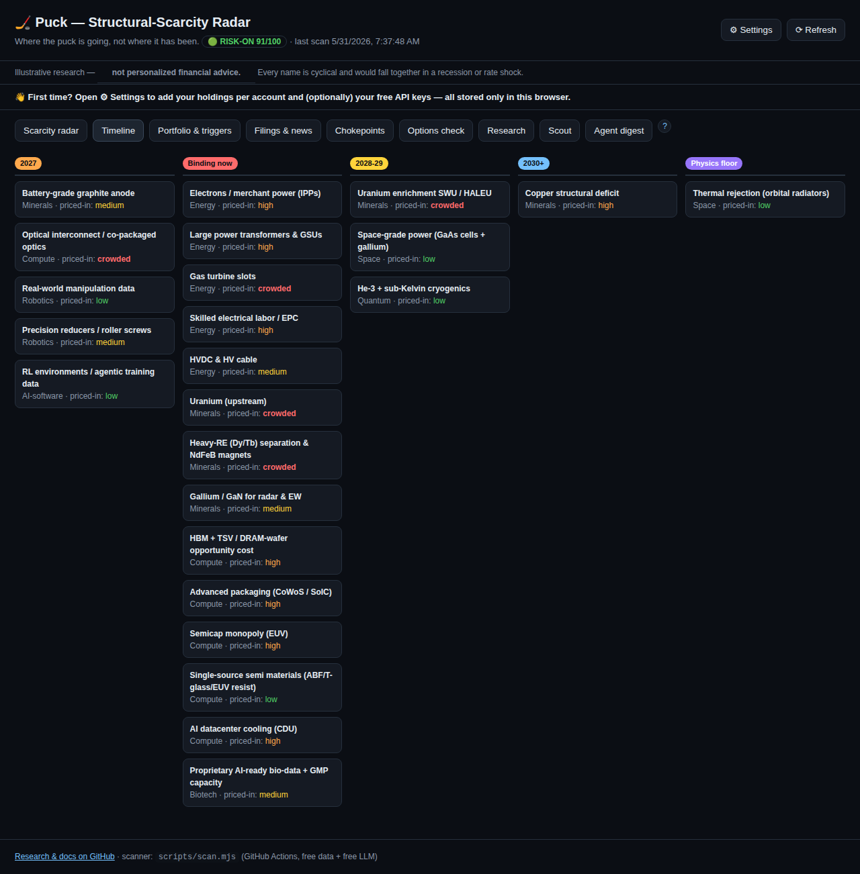
Timeline
The same scarcities, bucketed by when they bind (now → 2027 → 2028-29 → 2030+ → physics floor), each tagged with its priced-in level. Use it to see sequencing — what bites first and what’s a longer-dated, more certain deficit (e.g., copper).

5. Portfolio & triggers
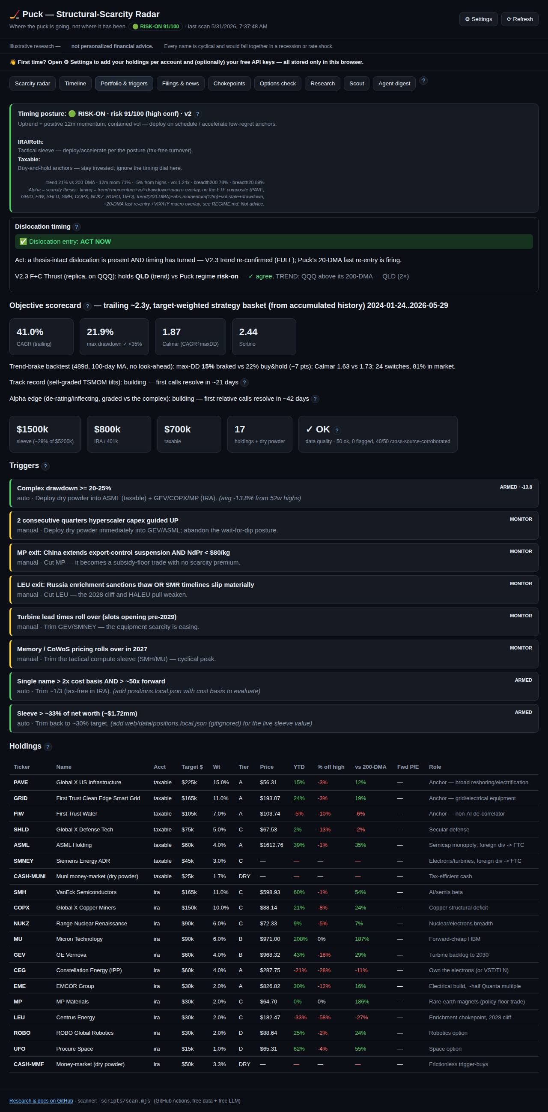
Portfolio and triggers

5.1 Timing posture (the regime)
The colored banner at the top is the timing posture — the heart of “when to act”:
Posture | Meaning | What to do
🟢 risk-on (score ≥70) | Uptrend + positive 12-month momentum, contained volatility | Deploy on schedule / accelerate low-regret anchors
⚪ neutral (45–69) | Mixed | Stick to the DCA calendar; no acceleration
🟠 caution (25–44) | Trend/vol deteriorating | Tap the brakes — slow deploys, build dry powder
🔴 defensive (<25) | Downtrend, drawdown, rising vol | Favor cash; deploy only into the drawdown trigger
It’s a risk dial that paces your DCA, not an all-in/all-out switch. It’s built on independent, replicated research (Faber 200-DMA trend; Moskowitz-Ooi-Pedersen time-series momentum; Moreira-Muir volatility; Hurst-Ooi-Pedersen trend) — not a curve-fit backtest. Full detail: REGIME.md. The posture shows a confidence label (low/medium/high) and warns when the score sits near a band edge — it’s a coarse dial, not a precise number.
v2 refinements: the score is computed on the theme ETFs (a cleaner composite than averaging 19 noisy single names); it’s account-aware — the posture drives your IRA/Roth sleeve (tactical, tax-free turnover) while taxable stays buy-and-hold anchors (shown under the posture); and it carries a per-name TSMOM tilt (which names to lean into vs. trim).
Two overlays (Timing v2): - Macro-stress brake (exit-only). Forces defensive only when two leading risk signals fire together — the VIX term-structure inverts (front VIX ≥ VIX3M) AND high-yield credit widens fast (HYG ~1-month return ≤ −3%). Requiring both makes false alarms rare; being exit-only means it can only de-risk, never add. When it’s on, the posture note shows MACRO-STRESS. - 20-DMA fast re-entry. When ≥60% of holdings reclaim their 20-day average, the posture re-risks one notch — so you don’t stay in cash too long after a V-shaped bottom (the momentum-crash fix). The macro brake always wins over re-entry.

5.1a Dislocation timing + V2.3 cross-check
Just under the posture, the Dislocation timing card answers a single question: when should I take advantage of a dislocation? A dislocation is a name mechanically sold off (off highs, below trend) while its structural thesis is intact (the forced-flow ✚ accumulate flag). The danger is buying one while it’s still falling — a falling knife. So the verdict is:
- ✅ ACT NOW — a thesis-intact dislocation exists and timing has turned: the drawdown trigger fired, the V2.3-style trend re-confirmed (FULL on QQQ), or the 20-DMA fast re-entry is firing.
- ⏳ WAIT — the dislocation is real but timing is still defensive; wait for the turn.
- — none — nothing dislocated into an intact thesis right now.
The V2.3 cross-check is a faithful replica of your F+C Thrust rule, recomputed on QQQ, and shows which instrument it holds (QLD 2× or SGOV) next to Puck’s regime posture — ✓ agree = confirmation, ⚠ diverge = look closer. The exact ladder (first match wins):
- CRASH_OFF (trailing 252-day return < 0 AND 60-day annualized vol > 25%) → SGOV
- else TREND (close > 200-DMA) → QLD
- else THRUST (close > 20-DMA AND the 20-DMA is higher than 10 trading days ago) → QLD
- else → SGOV
…with an exit-only composite-stress overlay: if the ladder picked QLD and VIX/VIX3M ≥ 1.0 for 3 consecutive days and HY-velocity (20-day change in −log(HYG)) sits in the top 5% of its trailing 252-day distribution, it forces SGOV. If any overlay input (^{VIX/}VIX3M/HYG) is missing, the overlay is suppressed (it won’t act on fake data). Puck itself adds no leverage — a 2× QLD sleeve would breach the −35% max-drawdown objective unless gated by a full exit to cash.

5.1b Objective scorecard
The app’s goal is max 10-year return with max drawdown < 35%, and the best Calmar/Sortino. This card measures your strategy basket (target-weighted holdings) over the trailing window: CAGR, max drawdown (turns ⚠ red if it breaches −35%), Calmar (CAGR ÷ maxDD), and Sortino (return ÷ downside risk). It’s a live check on whether the timing/risk layer is actually holding drawdown under the limit while earning a good risk-adjusted return — a backward-looking proxy, not a forecast. A trend-brake backtest line below it shows, on this basket and with no look-ahead, whether a moving-average brake actually cut max-drawdown and improved Calmar vs. buy-and-hold (the dial’s premise, tested).

5.1c Track record (self-grading)
Puck records every dated per-name TSMOM tilt (overweight → expect the stock up over ~21 days; underweight → down) and, when the horizon matures, resolves it against the realized price into a hit-rate. It starts empty and fills in over ~21 days. This is the accountability layer — the system is graded on whether its calls came true, turning opinions into a verifiable, compounding record. A hit-rate persistently below ~50% means the signal isn’t working (which is what you want to know).
A second Alpha edge line grades the harder claim. Each de-rating / inflecting flag becomes a 42-day relative forecast — does the flagged scarcity basket actually under/out-perform the AI-capex complex (the theme ETFs)? That relative move, not raw direction, is the thesis’s real edge, so it is scored separately (de-rating and inflecting buckets). It tells you whether the alpha signal earns its keep.

5.2 Summary cards
Sleeve size, IRA vs taxable split, holding count, and a data-quality card (✓ OK or ⚠ degraded — see §11).

5.3 Triggers
Rules that tell you to act. Each shows a state — armed (active), monitor (manual watch), or fired (condition met). Auto triggers require two consecutive scans to confirm before they fire (the first time a condition is met it shows pending — needs a 2nd confirming scan), so a single bad print or one-day spike can’t fire an action: - Drawdown (auto): complex down ≥20–25% from highs → deploy dry powder. - Trim rule (auto): a name >2× cost basis and >50× forward P/E → trim ⅓ (needs your cost basis from Settings). - Sleeve cap (auto): sleeve value > ~$1.72mm → trim back (needs your holdings from Settings). - Policy triggers (manual): e.g. rare-earth/uranium policy shifts.
When a trigger fires, the scanner opens a GitHub issue (deduped — one open issue at a time). You can also get an email the moment a trigger newly fires (a state change, not every run) — turn it on in Settings → Admin (set the alert email variable) plus the SMTP secrets in SETUP.md §3c. Auto triggers are held on a degraded-data run so bad data can’t fire an action (§11).

5.4 Holdings table
Your target plan: account, target $, weight, tier (deployment pace), live price, YTD, % off high, vs 200-DMA (trend), and Fwd P/E (the “went up a lot ≠ expensive” check; skipped for ETFs). A ⚠ next to a ticker means a data-quality flag (divergent sources, a big jump, or a stale quote — hover to see why).
Tiers: A = 100% now · B = 50% now + months 1–3 · C = 25% now + DCA to month 9 · D = small option sleeve · DRY = cash held for triggers.

5.5 Your holdings (live)
Once you add positions in Settings, this panel shows market value, gain vs cost, % of target, per-account subtotals, and your sleeve value vs the cap — computed from your browser-stored positions × the latest scan prices. The Rebalance column flags any holding whose actual weight has drifted >±25% from its target weight (⚖ trim if overweight, add if underweight). Foreign-currency lots are FX-converted to USD for the sleeve total (a lot with no available FX rate is excluded and noted).

5.6 DCA progress
Once you’ve entered positions, this shows how much of each holding’s target you’ve deployed (shares × cost basis) against the 9-month dollar-cost-averaging calendar — a progress bar + % per holding, and the sleeve total deployed. Use it to stay on the plan and see where dry powder still goes.

5b. Chokepoints (inaccessible / differentiated alpha)
The sharpest thesis idea: the best chokepoints have no clean ETF — they’re private (SpaceX, Physical Intelligence), foreign (ASML, Ajinomoto, Harmonic Drive), or impaired. The app discovers the public proxies exposed to each by searching SEC filings for who mentions the entity (customers/suppliers/ partners). They’re ranked by specificity (a TF-IDF score, 0–1) rather than raw mention count: a diversified megacap that mentions everything once in boilerplate — and shows up across many chokepoints — is a weak proxy, so it’s dimmed and flagged ⚠ generic, while a concentrated pure-play is surfaced first. The app also shows a heat (attention + proxy momentum) and the proxies’ relative strength vs the AI-capex complex. A 🕸 Cross-chokepoint hubs panel maps second-order exposure: public names that appear across multiple bottlenecks (×degree) — a hub (≥3) is a diversified “picks-and-shovels” way to play the whole complex, a degree-1 name is a concentrated pure play. All data-derived (no hand-picked lists); discovered names are research leads, not recommendations.

5.7 Stress test
Applies the thesis’s named shocks to your sleeve and shows the drawdown vs the −35% objective limit: 2027–28 AI-capex digestion, a 2022-style rate shock, a broad recession, and a China rare-earth “peace.” Coarse, documented high-beta shock vectors (not fitted) — a feel for tail risk. Runs entirely in your browser on your stored positions.

5.8 Suggested IRA tilts
The last mile from analysis to allocation: per-name TSMOM tilt × regime → concrete, bounded (±25%) weight deltas. Add overweights only in a risk-on regime; trim underweights in any regime; the taxable sleeve stays buy-and-hold. Graded over time by the Track record. Not advice.

5c. Research (LLM proposals you approve)
The Research tab surfaces the monthly research engine’s proposed reassessments. The engine runs the free LLMs (deep-dive → cross-model red-team → synthesis) over deep evidence — multi-angle news article excerpts + SEC filing passages + the live de-rating / forced-flow / opportunity signals — and proposes updates to each scarcity’s priced-in / bind-window / non-consensus fields only.
Each card shows the before→after change, the LLM’s rationale, its sources, and confidence: - ✓ Accept → open PR opens a GitHub pull request containing just that one change to scarcities.json, which you then merge. Needs a token in Settings → Admin with write access — a classic token with the repo scope, or a fine-grained token with Contents and Pull requests both read/write. (A 404/403 on a public repo means the token can read but not write — usually the classic repo scope wasn’t ticked.) - ✕ Reject dismisses it.
The bot only proposes; you approve, and it can only ever touch those three fields — never the thesis or tickers (the F9 ownership rule, enforced in the browser and the scanner). Not advice.

5d. Scout (finding NEW scarcities)
The Research tab re-scores the known scarcities; the Scout tab hunts for new ones — the alpha-generation frontier. It is deliberately not a trend-finder: by the time something reads as a trend it’s already priced, and ALPHA.md is explicit that there’s no edge in what’s priced. Instead the scout looks for the fingerprint of a binding constraint before anyone names it.
How it works (constraint-shadow): a real shortage shows up first as downstream companies complaining in their SEC filings — “lead times extended”, “unable to secure allocation”, “qualified a second source”. The scout searches that complaint language across all filers, clusters which companies are under broad supply stress (a filer griping under many distinct constraint phrases is a strong lead), and infers the candidate chokepoint from the pattern of who’s complaining — not from a headline. Filers already explained by a known scarcity are dropped (novelty filter); candidates already discussed widely in financial media are down-weighted (the edge is being early, not loud).
The same committee vets it. Each lead is synthesized into a draft scarcity and run through the identical Bull / Bear / Skeptic → CIO + CRO committee that scores the known 24 — so you only ever review adversarially-vetted candidates, never raw noise. The Bear seat (“the specific thing that kills it — supply response, substitution, policy reversal”) does the brutal filtering before anything reaches you.
Each card shows the inferred scarcity, the filer that flagged it + the constraint phrases that fired, the proposed fields, and the committee’s confidence: - ✓ Accept → open PR (add scarcity) opens a pull request that adds the new scarcity to scarcities.json, which you merge. Same token requirement as the Research tab. - ✕ Reject dismisses it.
The scout runs weekly and never edits the watchlist itself — it only proposes; you approve admission (F9). Not advice; every candidate is a lead to investigate, and most should fail the committee.

6. Filings & news
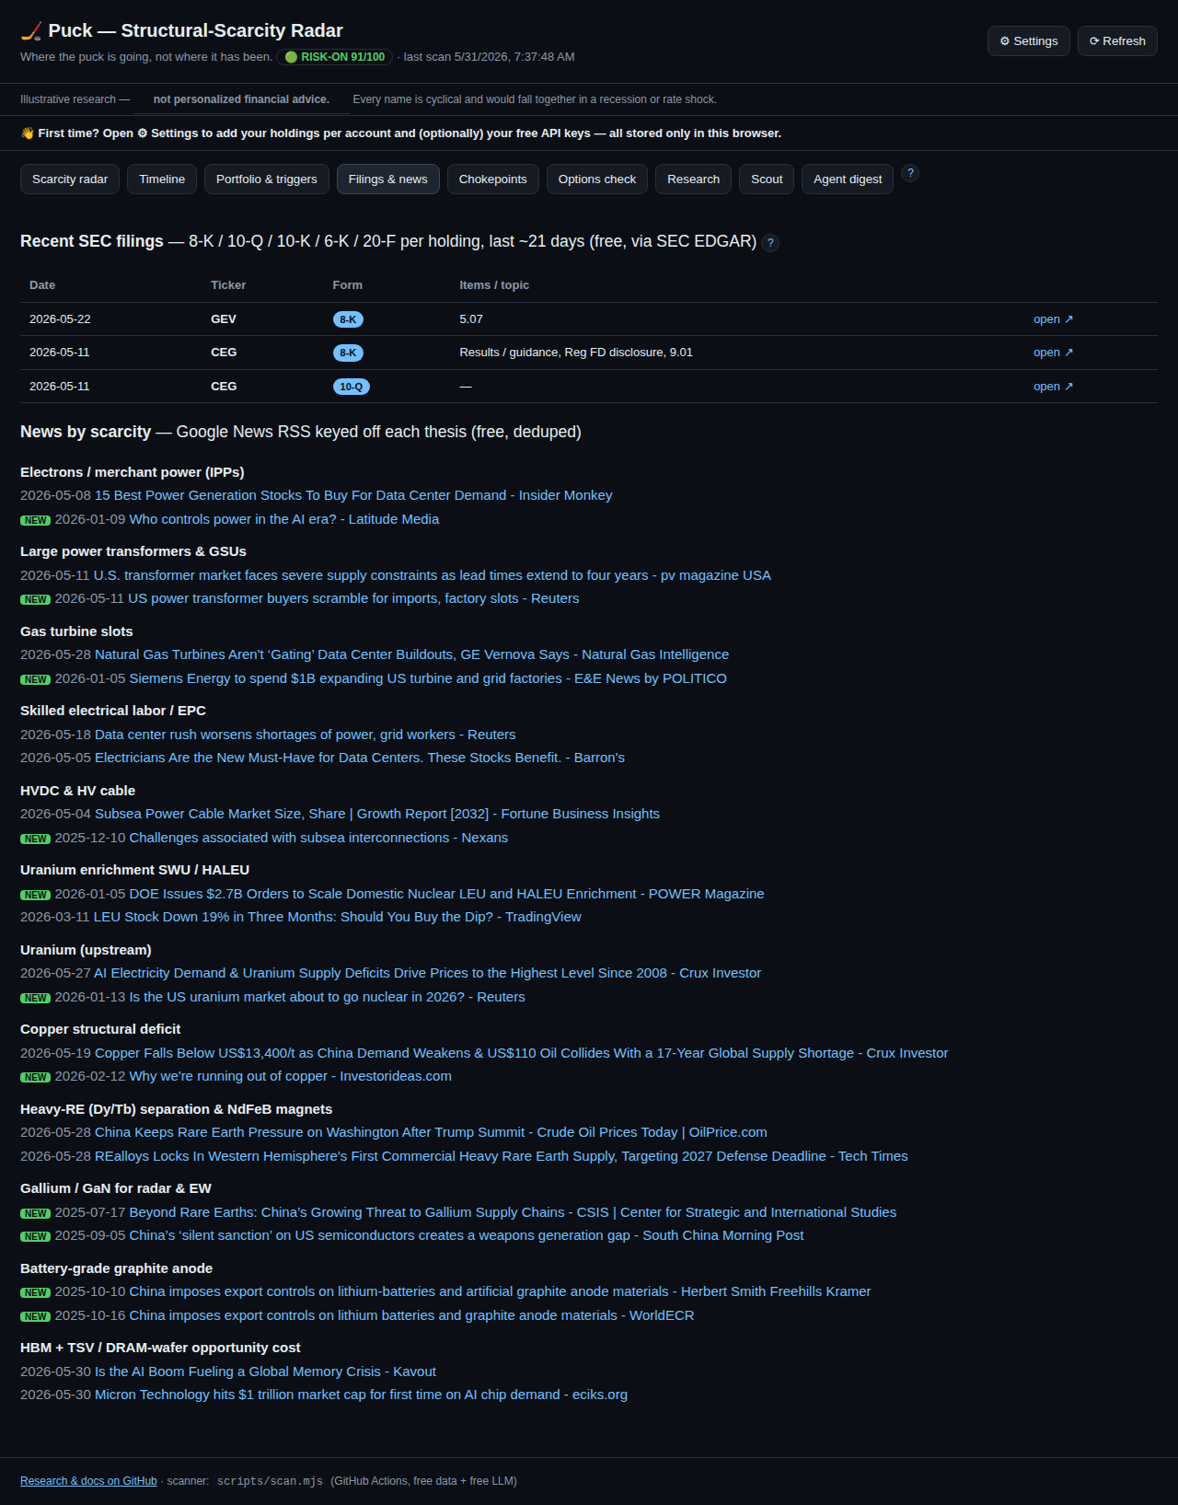
Filings and news
Free, keyless catalysts: - SEC EDGAR filings per holding (8-K/10-Q/10-K/6-K/20-F, last ~21 days). 8-K items are decoded into plain topics (e.g. Results/guidance, Material agreement). A green NEW badge = unseen since the last scan. Click open ↗ to read the filing on SEC.gov. - News by scarcity: Google-News headlines keyed to each scarcity’s thesis terms, deduped, grouped by scarcity. NEW badges mark fresh items.
Both feed the Agent digest. Use this tab to spot catalysts — backlog, capacity, guidance, pricing, policy — that move a thesis.

7. Options check (fair-value before you buy)
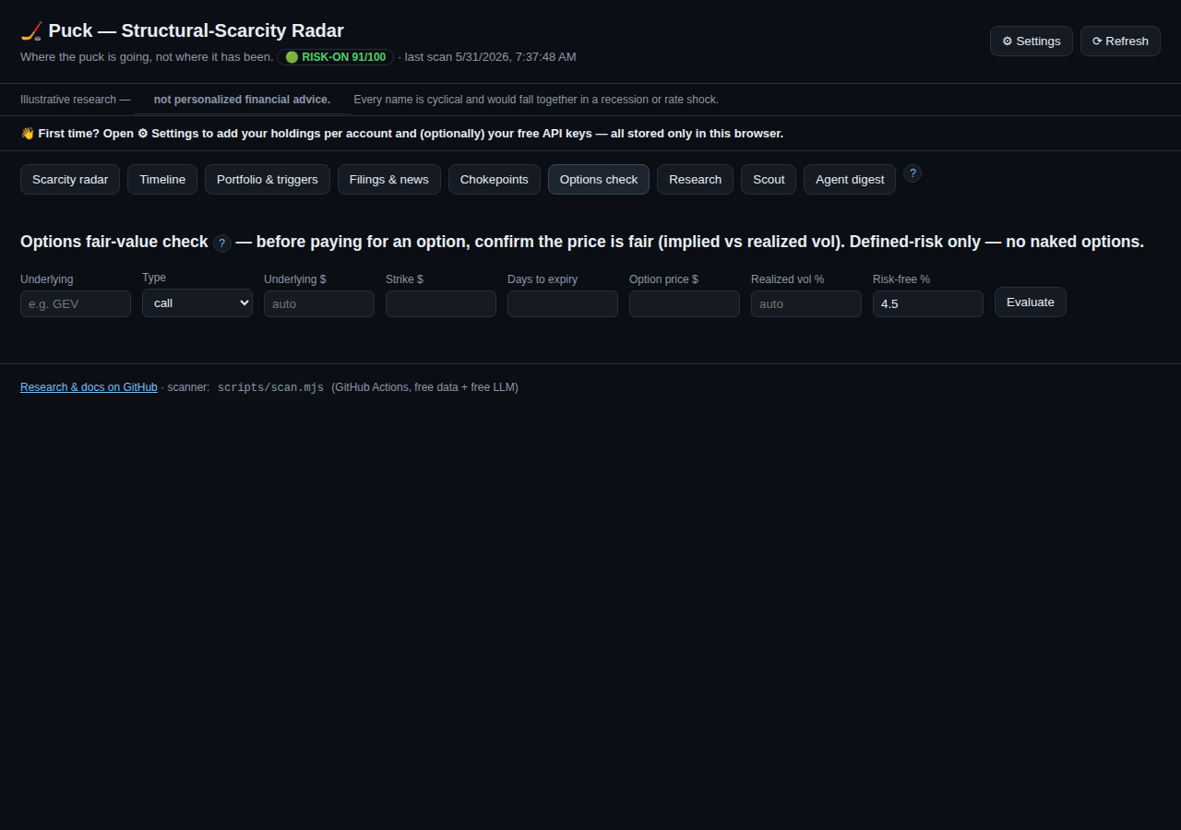
Options check
Before paying for an option, confirm the price is fair. Puck backs out the option’s implied volatility (IV) from its market price (Black-Scholes) and compares it to the underlying’s recent realized volatility (from the scan).
How to use it: 1. Type the underlying ticker — its price and realized vol auto-fill from the latest scan. 2. Choose call/put, enter strike, days to expiry, and the option price (premium). 3. Click Evaluate.
What you get: IV, realized vol, IV ÷ realized, the fair value at realized vol, the edge vs fair, a verdict, and the greeks (delta/vega/theta). When the scan has it, the result also shows the underlying’s market ATM implied vol (from the free Yahoo options chain) next to your option’s IV — a quick check of whether your contract is priced rich/cheap vs the at-the-money market.
Verdict | Meaning
cheap | IV below realized vol
fair | IV within a normal variance-risk premium (~0.95–1.35× realized)
rich | IV well above realized — you’re paying up for premium
It also suggests a defined-risk structure based on the live posture (defensive → put / put-spread; risk-on → LEAPS call).
Defined-risk only — no naked options (both accounts). Use long calls/puts, debit spreads, collars, covered calls, cash-secured puts. Caveat: realized vol is backward-looking and options carry event/skew premia, so treat this as a sanity check, not a price oracle. Not advice.

8. Agent digest
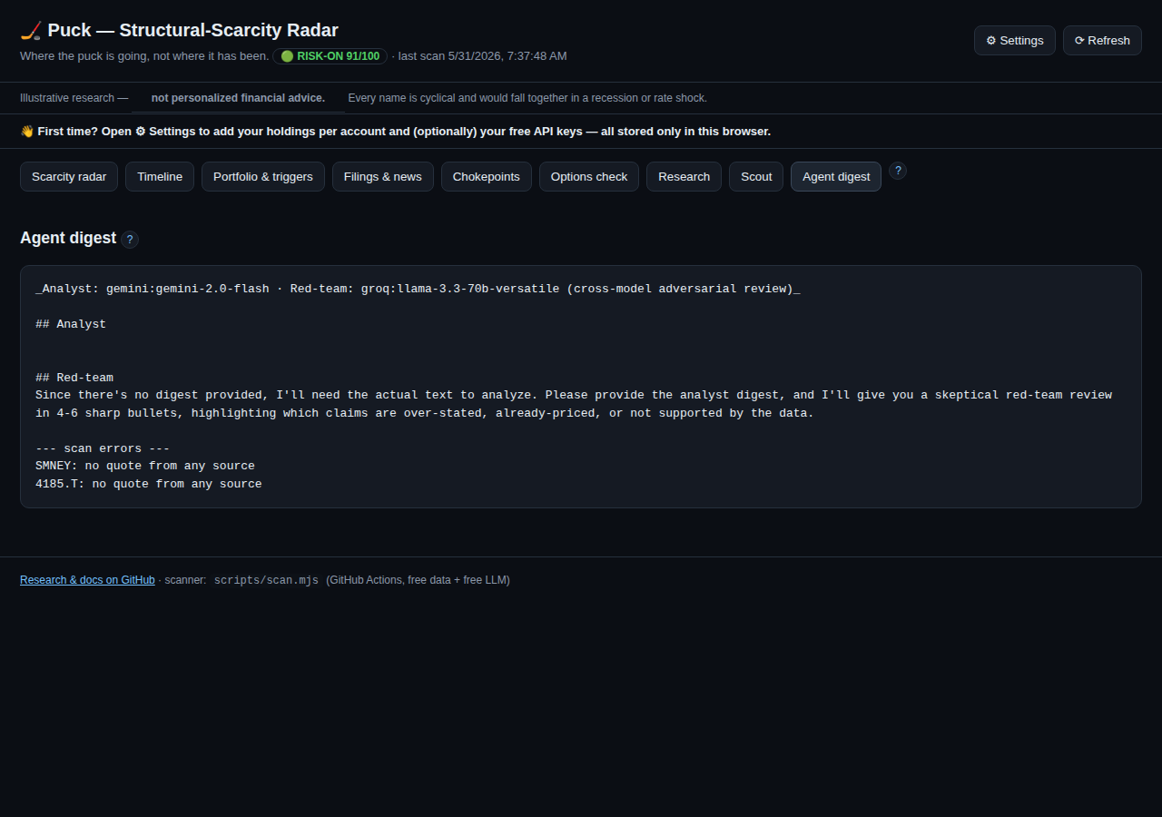
Agent digest
An optional LLM “analyst + red-team” summary of what materially changed (quotes, filings, news, regime) and whether any trigger looks closer. With two free keys it runs cross-model — the analyst on one model, the red-team on another — so it isn’t a model grading itself.
It uses the latest free thinking models by default — Gemini 3.5 Flash and Groq’s gpt-oss-120b — so the analysis actually reasons rather than pattern-matches. Both are overridable via the GEMINI_MODEL / GROQ_MODEL repo variables when newer models ship, so a model retirement needs no code change. If a model is unreachable (retired/blocked/rate-limited) the run now says so loudly in its report instead of silently producing nothing.
- Automated: set GEMINI_API_KEY (and optionally GROQ_API_KEY) as GitHub repo secrets; the daily scan writes the digest.
- In-browser, on demand: add a Gemini key in Settings and click ✦ Generate digest in browser.

9. ⚙ Settings & onboarding
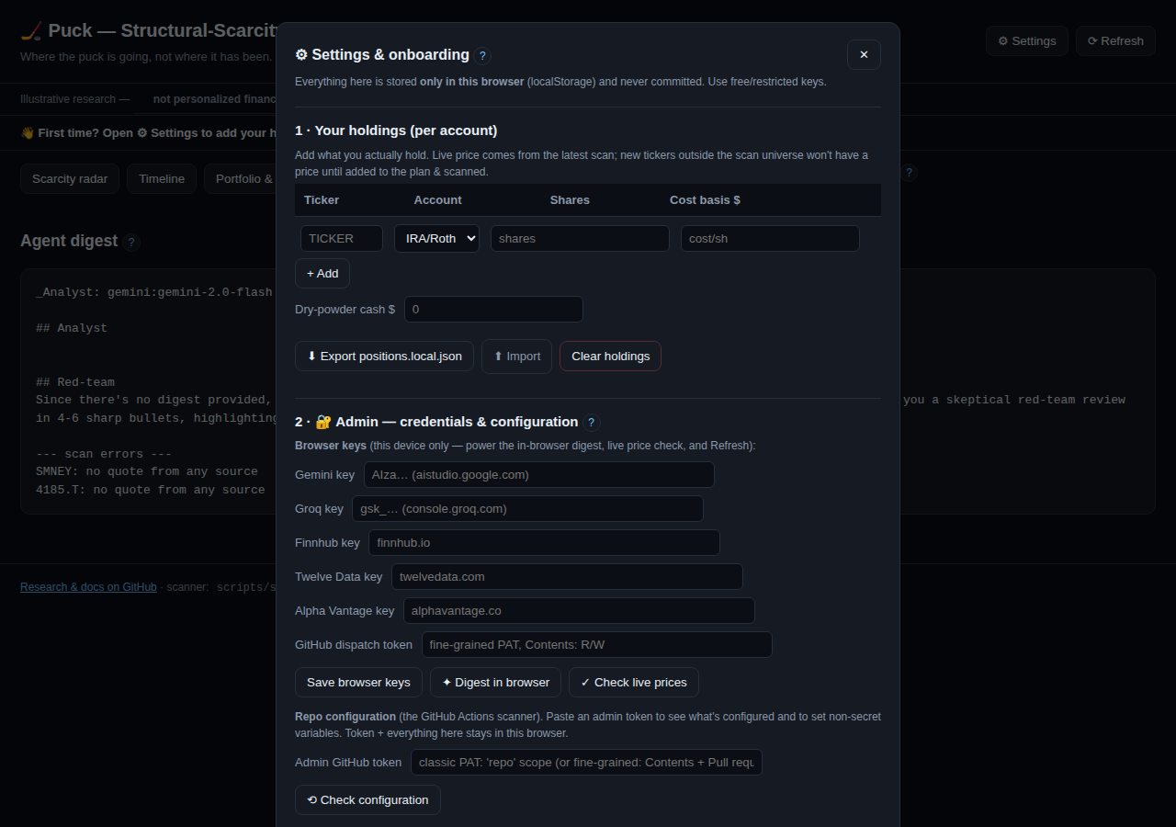
Settings
Everything here is stored only in this browser (localStorage) and never committed.

9.1 Your holdings (per account)
Add each holding: ticker, account (IRA/Roth or Taxable), shares, cost basis, plus your dry-powder cash. Live prices come from the latest scan. - ⬇ Export positions.local.json — download your positions in the exact shape the scanner reads, so the server-side trim rule and sleeve-cap can compute against your real lots. (Drop the file into web/data/ — it’s gitignored, so it’s never committed.) - ⬆ Import — load a positions file back in. - Clear holdings — wipe them from this browser.

9.2 🔐 Admin — credentials & configuration
One place for every credential, in two tiers:
Browser keys (stored only in this browser; power client-side features): - Gemini (aistudio.google.com) — in-browser digest. Groq (console.groq.com) — second red-team model. - Finnhub / Twelve Data / Alpha Vantage — data cross-checks; Finnhub also powers ✓ Check live prices. - GitHub dispatch token (Contents: R/W) — lets ⟳ Refresh trigger a live scan (§10). - Click Save browser keys.
Repo configuration + research review (what the automated scanner uses, and what approves research proposals). Paste an admin GitHub token — a classic token with the repo scope, or a fine-grained token with Contents + Pull requests (read/write, for accepting proposals on the Research tab) plus Secrets: read and Variables: read/write (for the config check). Click ⟲ Check configuration to get a ✅/⬜ status for every secret and variable the scanner can use (LLM keys, data keys, SMTP_USER/SMTP_PASS, ALERT_EMAIL_TO, SEC_USER_AGENT). - Variables (alert email, SEC user-agent) are non-secret — set them right here with Save variables to GitHub. - Secrets (API keys, SMTP password) are write-only in GitHub for security and can’t be set from a static page — the panel shows whether each is configured and links to GitHub’s secrets form to set/rotate them. Email setup details: SETUP.md §3c.
Optional: price-history database (Supabase). The app persists daily price history to a Postgres database so backtests, the objective metrics, and the V2.3 cross-check can use a growing record instead of re-fetching 1–2 years from Yahoo each run. To enable it: 1. Create a free Supabase project; in the SQL Editor, run db/schema.sql (creates the price_history table with row-level security on). 2. In Admin, set SUPABASE_URL (your project URL) and Save variables to GitHub. 3. In GitHub repo Settings → Secrets, add SUPABASE_SERVICE_KEY = your project’s service_role key (it’s a secret, so it can’t be set from this page).
That’s it — the daily scanner starts accumulating history. The service_role key is used only by the scanner (server-side); the dashboard never touches the database, and nothing breaks if you skip this (history persistence is simply disabled). For a one-time deep backfill, run the scan workflow with the --backfill argument (fetches each ticker’s full available history once).
Everything you paste here stays in this browser.

10. ⟳ Refresh (on-demand scan)
The scanner runs automatically on weekdays. To refresh now, click ⟳ Refresh: - The first time, paste your dispatch token (stored only in your browser). - It triggers the GitHub Action; the dashboard auto-polls and live-reloads when fresh data lands (~1–3 min). No manual reload. - No token? Refresh points you to the manual Actions → scan → Run workflow.

11. Data integrity & quality (why you can trust the numbers)
Puck guards against bad/synthetic data: - HTTPS-only sources; plausibility checks (no ≤0 / non-finite prices). - Cross-source corroboration — Yahoo + Stooq (+ any free keys) are compared; a >3% divergence flags the quote (⚠). - Anomaly vs last scan — a >35% jump (likely a bad print / unadjusted split) is flagged. - Freshness — a stale/halted last bar is flagged. - Fail-safe triggers — on a degraded run (too many errors/flags) the auto-triggers are held, so bad data can’t fire an action. The data-quality card on the Portfolio tab shows ✓ OK or ⚠ degraded.
- Cross-source consensus — when sources disagree, the published price is the consensus that excludes the outlier (a lone bad/synthetic print is dropped, not just flagged), and foreign lots are never silently summed as USD.
- XSS-safe — all third-party text (news headlines, filing fields) is HTML-escaped and links are restricted to http(s) before display, so a poisoned feed can’t run code in your browser.
Add free market-data keys (§9.3) for stronger corroboration.

12. Glossary
- Scarcity / chokepoint — an input that’s slow/impossible to expand, so demand outruns supply.
- Priced-in / crowding — how much the market already reflects a thesis (judgment vs. live price proxy).
- Bind window — when a scarcity starts constraining.
- Tier — how fast a holding is deployed (A/B/C/D/DRY).
- 200-DMA — 200-day moving average; price above it = healthier trend (Faber).
- 12-month momentum — trailing one-year return; the time-series-momentum signal (MOP 2012).
- Realized vol — actual recent volatility of the underlying.
- Implied vol (IV) — volatility implied by an option’s price.
- Forward P/E — price ÷ next-year expected earnings.
- Posture / regime — the timing dial (risk-on → defensive).

13. FAQ & troubleshooting
- Prices/options/holdings show “—”. The dashboard needs a completed live scan. Run ⟳ Refresh (or the scan Action), then reload.
- “Stale data” banner. The last scan is >3 days old — trigger a refresh.
- A holding has a ⚠. Sources diverged, a big jump, or a stale quote — hover to see which. Treat the number with caution.
- Digest says “no LLM key set”. Add a Gemini/Groq key (Settings or repo secret).
- Refresh rejected (401/403/404). The dispatch token is missing/insufficient — it needs Contents: Read & write on this repo. It’s auto-cleared so you can re-paste.
- Accept → open PR fails (branch 404/403). The admin token can read but not write. Give it write access: a classic token needs the repo scope ticked, or a fine-grained token needs Contents
  - Pull requests read/write on this repo.
- I don’t want my real holdings anywhere shared. They never leave your browser (localStorage), and positions.local.json is gitignored.

This guide is maintained alongside the app. A docs workflow regenerates the screenshots (and the Word version) whenever the UI changes, and a pre-commit hook reminds contributors to update it when web/ changes. See ARCHITECTURE.md §6–§7.

