start up

config services called first (registered dependencies)(add services to our container(any functionality you want to register)) called by runtime

config method

env check if it host or development based on that we config the pipe line

Http request goes back and fro through the pipeline(add item you want , made up of middleware and mvc is a middleware itself

Other example auth middleware ,Session middleware

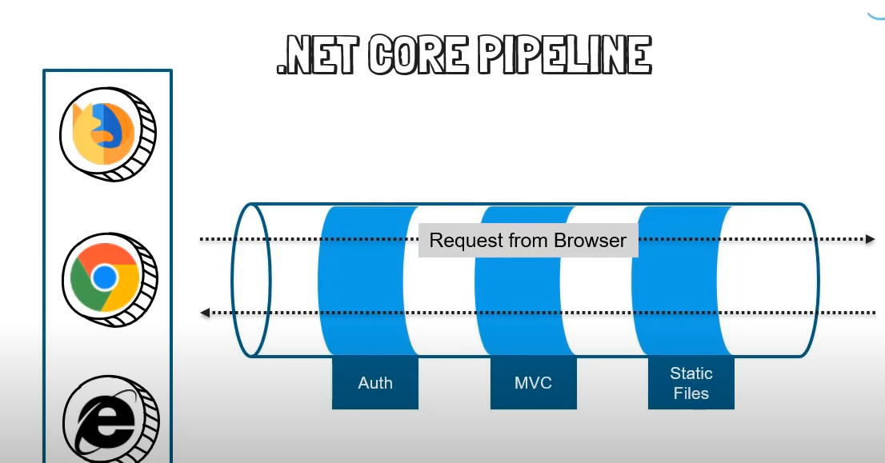

Explained in proj

Possiblle to have all 3

