DOCUMENTATION

- We are making documentation for this Project:-

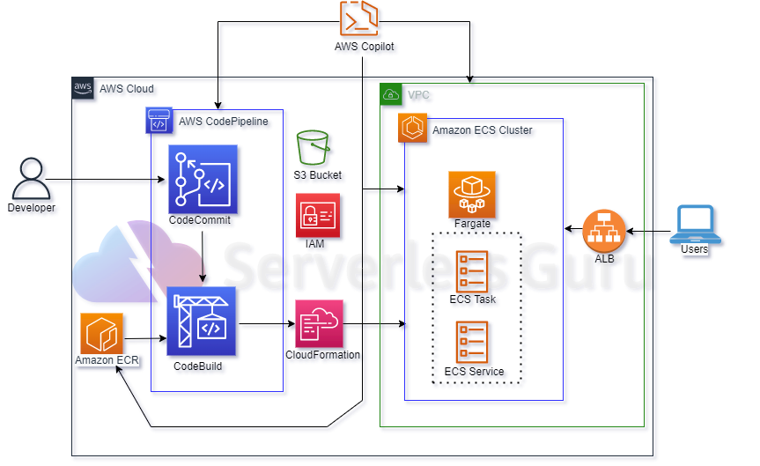


Cloud Infrastructure

- In this documentation we explain how to how to build the infrastructure on AWS with Terraform to implement a CI / CD pipeline for ECS / Fargate.

- Firstly i created a VPC with 2 public subnets in different Availability Zones. The desired tasks are 2 and each task is deployed on each public subnet with Fargate and each task belongs to the same ECS service.

How To create Infra :-

1.


Create subnets and internet gatway resources VPC inside

IAM ROLES & POLICIES
For the CodeBuild is necessary to create a IAM Role&Policy to allow access to ECR to push and pull the Docker images in the ECR repository. Also, is necessary a permission to access a S3 bucket to store the artifacts.
A single Route Table for both Public Subnets
The first Sec-Group is for the ECS Service

2. LoadBalancer :-
Created Application LoadBalancer
Created Target group and Listener inside the LoadBalacer.

3. ECS & ECR :-

Create ECR Repository
Create ECS cluster
CodePipeline, in which Specify Source, Build, Deploy Stages.

4. Pipeline.
CodeCommit Repository

CodeBuild Project

buildspec.yml
This file is very important to create the Docker Image and Pull it to ECR repository
- To update the ECS service is important to specify the containerName and imageUri in a JSON file with the name imagedefinitions.json. This file is an artifact.
- This file must be in the CodeCommit repositor

4. Dockerfile
This Dockerfile create a image with a HTTP Server
This file must be in the CodeCommit repository

3. ECS & ECR :-

Create ECR Repository

Create ECS cluster
CodePipeline, in which Specify Source, Build, Deploy Stages.

