Documentation

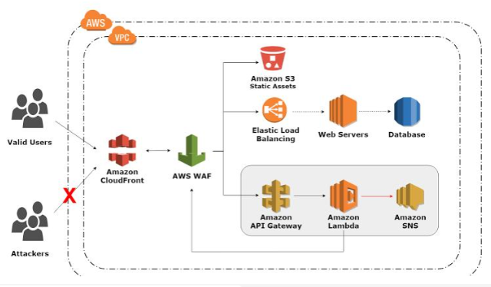

In this project, a web application is deployed on Amazon Web Services cloud platform. Using terraform
In which -
- EC2 instances are auto-scaled with Elastic load balancer ELB to handle web traffic.
- The applciation is running on my domain which is a hosted zone on Route53.
- Networking resources in AWS essential for hosting app on virtual private cloud VPC were created with terraform yaml script and automated with bash scripts.

- Images for books are stored in S3 bucket .
- Code deploy bundle is stored in different S3 bucket.

Terraform

Automating creation of all aws resources
- security groups — web, instance, rds
- internet gateway, VPC, subnets, route table
- rds, instance
- roles, policies
- user data to send to instance

CI/CD
- CircleCI and AWS code-deploy are integrated together in script to test, zip and upload the all web applciation files onto code-deploy S3 bucket.
- While auto-scaling with load balancer, initially code will be deployed on 3 instances.
- Any changes made to master branch will trigger a new build
- refer appspec.yml file in the root of the repository

- Any changes made to master branch will trigger a new build
- refer appspec.yml file in the root of the repository

- refer appspec.yml file in the root of the repository

