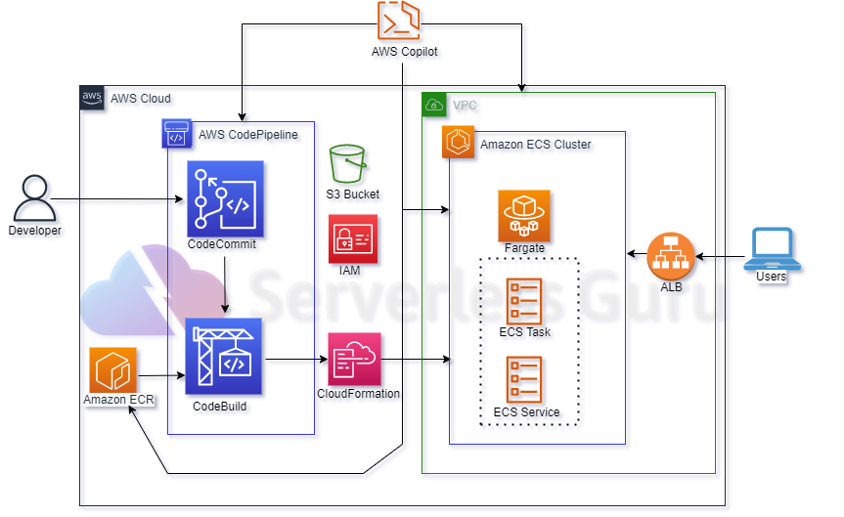

Introduction to Copilot concepts
First, let’s take a quick look at the high-level commands available in CopiCopilot has three main concepts:
- Application – An application is a grouping mechanism for the pieces of your system. Following Conway’s Law you would split up your components into Copilot applications that correspond to the different teams in your organization. For example, if you still have a small organization with a unified development team that works on a bit of everything then you can probably organize things as a single application made up out of one or more services. But if you have multiple teams, each responsible for a single group of components, and very little cross team work, then each team should have their own Copilot application.
- Environment – An environment is one stage of deployment of an application. For example, you might deploy an application to a “QA” environment first so that it can be tested without impacting your customers. Once it has been verified to work as intended, you deploy that version of the application to the “Production” environment so your customers can access it.
- Service – A service is a single long running code process inside a container. An application consists of one or more services. If you are using a monolithic architecture, then it’s likely each application will have just a single service. A more distributed architecture will utilize multiple services for each application. For example, you might have a “website” service with an internet facing load balancer, an internal “API” service that is only accessible via service discovery, and a “background worker” service that works on jobs off a queue. Together these services make up the components of a single application.
.Create a application
Dockerized my application
build and run docker image
.Pushed the Docker image to Amazon ECR.
.Deploy to Amazon ECS Fargate with AWS Copilot
Deploy the application using the following command.
git clone https://github.com/aws-samples/amazon-ecs-cli-sample-app.git demo-app && \
cd demo-app && \
copilot init --app demo \
--name api \
--type 'Load Balanced Web Service' \
--dockerfile './Dockerfile' \
--port 80 \
--deploy

Amazon ECS Cluster Auto Created with Launch Type Fargate

Amazon ECS Cluster Details Which Auto Created
Amazon ECS Cluster Running 1 Service & 1 Task Using AWS Fargate

. Create AWS CodeCommit Repository

.AWS CI/CD Pipeline with AWS Copilot
.IAM ROLE(BUILD PROJECT)
IAM Role Permissions policies by attaching
(AmazonEC2ContainerRegistryFullAccess)
Copilot pipeline using AWS CloudFormation for deployment steps.
After the AWS Copilot CI/CD pipeline is created, As soon as the developer commits and pushes changes to a specific branch it will auto-trigger the relevant deployment pipeline to the auto-deploy container application.

Delete Copilot Application

copilot app delete

