www

Assignment Documentation on AWS
VPC PEERING

AWS VPC Peering

A VPC Peering connection is a networking connection between two VPCs that enable you to route traffic between them using private IPV4 addresses or IPV6 addresses

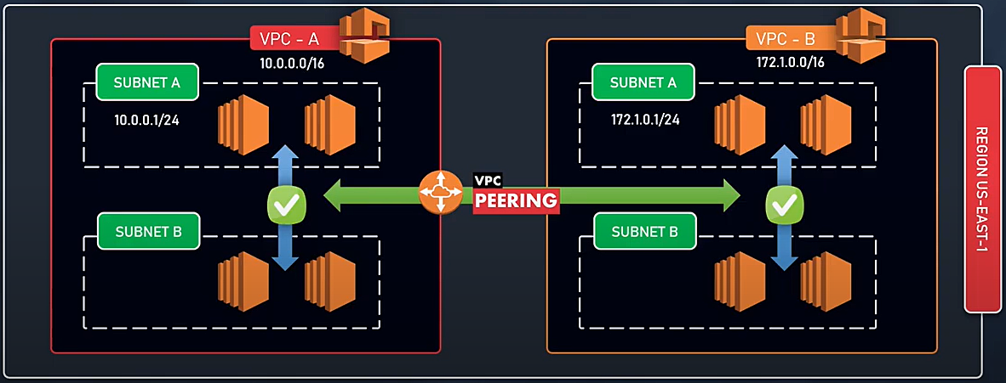

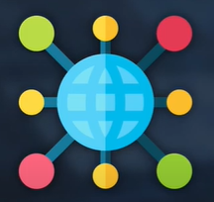

AWS uses the existing infrastructure of a VPC to create a VPC peering connection:
- Sharing data across accounts become easier.
- Sharing data across instance across vpc becomes easier.
- We can establish peering relationship between VPCs across different AWS Regions (also called Inter-Region VPC Peering)
- Can communicate with EC2, RDS, Lambda without needing:
- Gateways
- VPN connections
- Separate network appliances.
- All traffics remains in the Private IP space.

MULTIPLE VPC PEERING CONNECTION

It is a One -To- One relationship between 2VPC.
There is no support for TRANSITIVE relationships or connections.

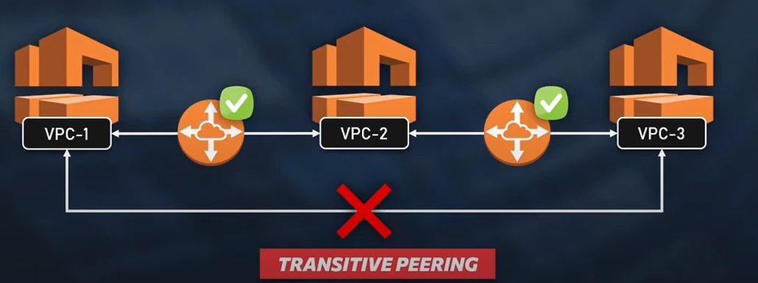

VPC PEERING (Points to Remember)

- You cannot create a VPC peering connection between VPCs that have matching or overlapping IPV4 or IPV6 CIDR blocks.
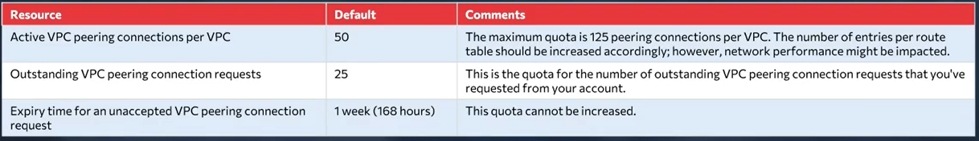
- VPC peering does not support transitive peering relationships.
- You cannot have more than one VPC peering connection between the same two VPCs at the same time.
- Any tags that you create for your VPC peering connection are only applied in the account or region in which you create them.
- You cannot connect to or query the Amazon DNS server in peer VPC.
