############### CLOUDFRONT-WAF ###############

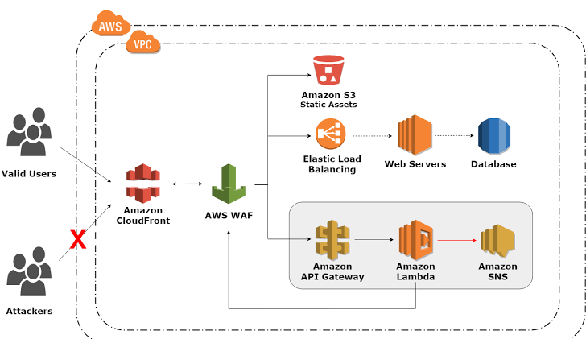

Hear we will be creating a web server that has a CI/CD pipeline implemented on it. we will be attaching a CloudFront on it for low latency. A WAF (Web Application Firewall) to protect against attackers on server. And will be using S3 bucket for static web site hosting. We will be using a Terraform for creating this infra.
Services we will be using.
- VPC that have public subnets attached with internet gateway.
- EC2 instance (Web server) as our server.
- Load Balancer that has target group attached with EC2 instances.
- WAF (Web Application Firewall) that has the rules as per required.
- CloudFront attached with Load Balancer and S3 that will be hosted.
- Codebuild that create artifact that will be stored on S3 for hosting and to be deploy on server
- S3 to store artifact made by CodeBuild and static web hosting.
- CodeDeploy that will ensure that the code will be deploy on right server.
- Codepipeline have build with CodeBuild and deploy on server using CodeDeploy.
- SNS (Simple Notification service) will be using server so that we get alert whenever our server changes its state.
- Policy’s and role’s as per these services required.

Video: - https://drive.google.com/drive/folders/1pxMhDV3pW68GvbI3dmak2yliICKYcARy
Video name: - terraform_assigment.mkv
GitHub Link: - https://github.com/Vikrant1020/ECS_pipeline.git

