VPC PEERING :-

What is VPC peering in AWS?

A VPC peering connection is a networking connection between two VPCs that enables you to route traffic between them using private IPv4 addresses or IPv6 addresses. Instances in either VPC can communicate with each other as if they are within the same network.

The Advantages of VPC Peering
1. Enhanced Security
2. Reduced Network Latency
3. Decreased Costs of Network Expenses

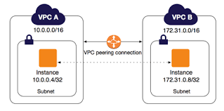

Create a custom VPC
Name your VPC and use the IPV4 CIDR range of your choice, I have used 10.0.0.0/16 for this example and the same procedure with another VPC in different region.

Creating a Subnet in VPC
VPC (Virtual Private Cloud) is your private cloud inside AWS as we mentioned earlier. typically we have to divide our big network into multiple subnets so we can place different resources.
A Subnet allowed to connect to a public network for webserver hosting, A Subnet for a database with no public access and monitored IN/OUT connections (private subnets) etc.
Creating EC2 instances
Under Compute, select EC2 -> Launch instances -> (in the Configure Instance Details form be sure to select the correct VPC under ‘Network’)

Creating Internet Gateway for the Custom VPC created
As we have mentioned earlier, we are going to use the EC2 instance we have created under the custom VPC for hosting an Apache HTTP server.
In order to allow traffic, we must create a Gateway.
For the EC2 under Customer VPC, create an Internet Gateway and make sure to add the following entries in its Route Table
And associate the Custom VPC Public Subnet to it

Create VPC Peering to enable communication
To establish the connection, lets create VPC peering from both VPCs. On the left navigation panel under VPC -> Peering Connections:

VPC (Requester) = DevopsJunction_CustomVPC
VPC (Accepter) = DevopsJunction_DefaultVPC

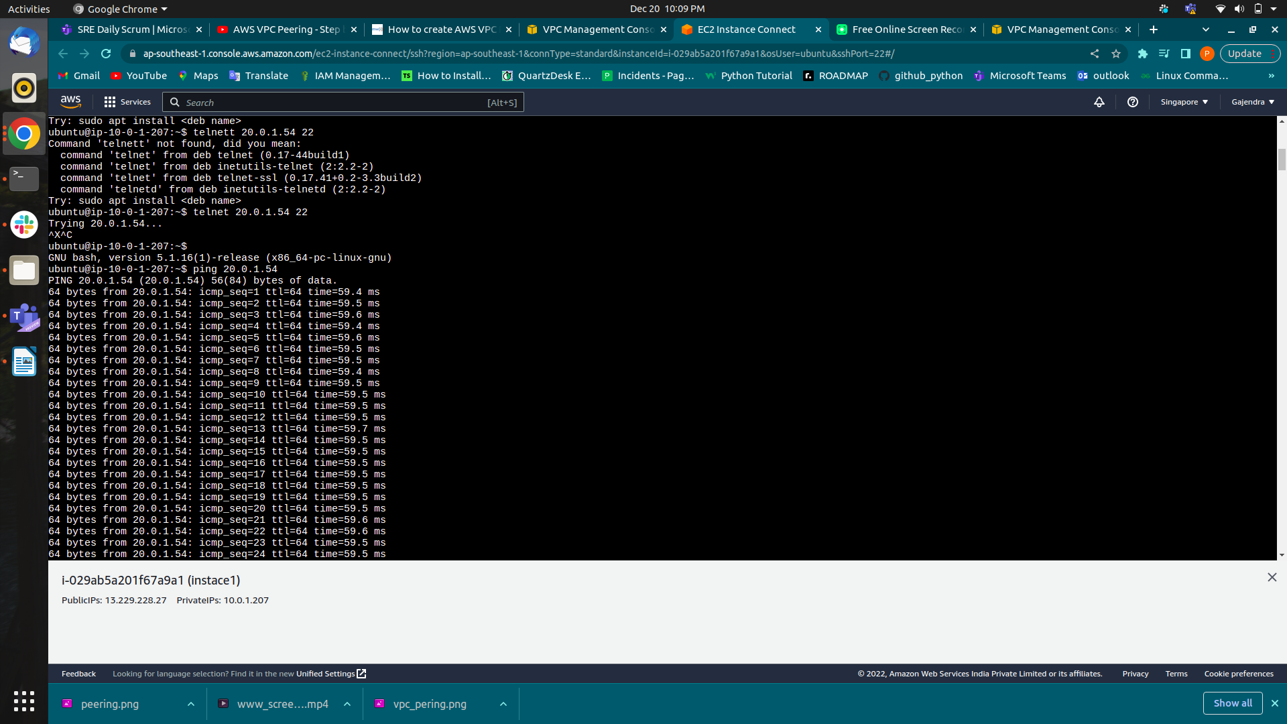
Now try to check the connectivity

NOTE :-

Allowing Traffic in VPC Security Groups.
Edit Security Group of both VPC to allow traffic from each other
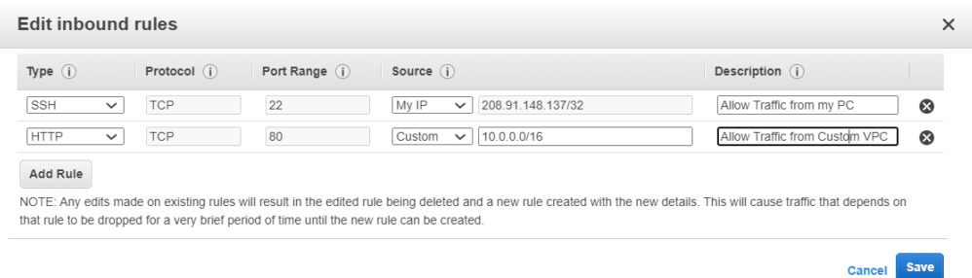
TCP port : The connection-oriented protocol TCP demands handshaking to set up end-to-end communications. Upon establishing the connection, user data is transferred bidirectionally over the connection.

