DOCUMENTATION

- We are making documentation for this Project:-

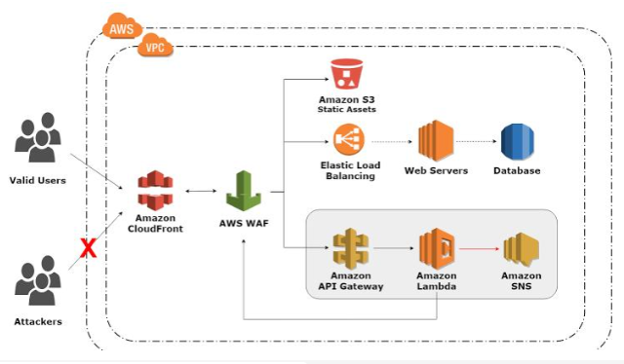


Cloud Infrastructure

- In this documentation we explain how to deploy web application on Amazon Web Service cloud platfrom.
- WE have using CloudFront is a fast content delivery network (CDN) service that securely delivers data with low latency, high transfer speeds, all within a developer-friendly environment., S3 bucket for static website hosted on EC2 instance and they attached to the application loadBalancer. And they all are run by using CI/CD Pipeline.

EXPLANATION OF PROJECT :-
1.
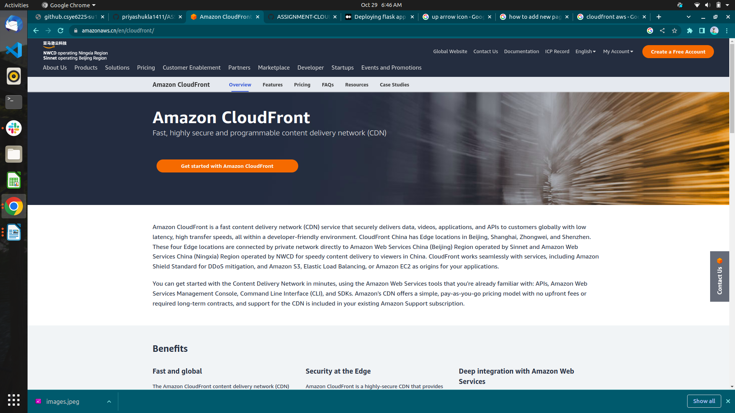

- CloudFront :-

CloudFront basically used Distribute content with low latency and high data transfer rates by serving requests using a network of edge locations around the world. Get started without negotiating contracts and minimum commitment
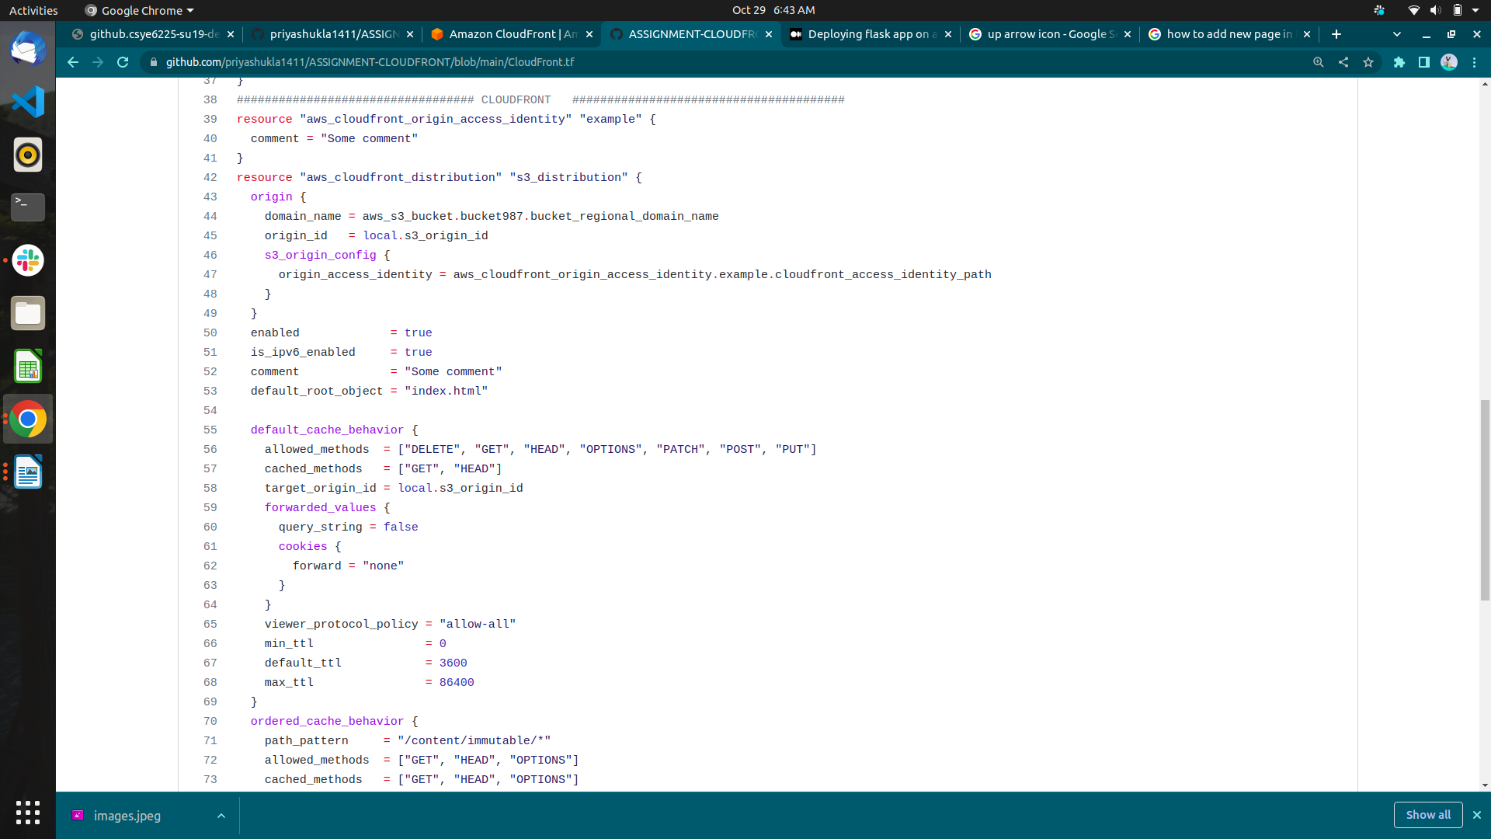
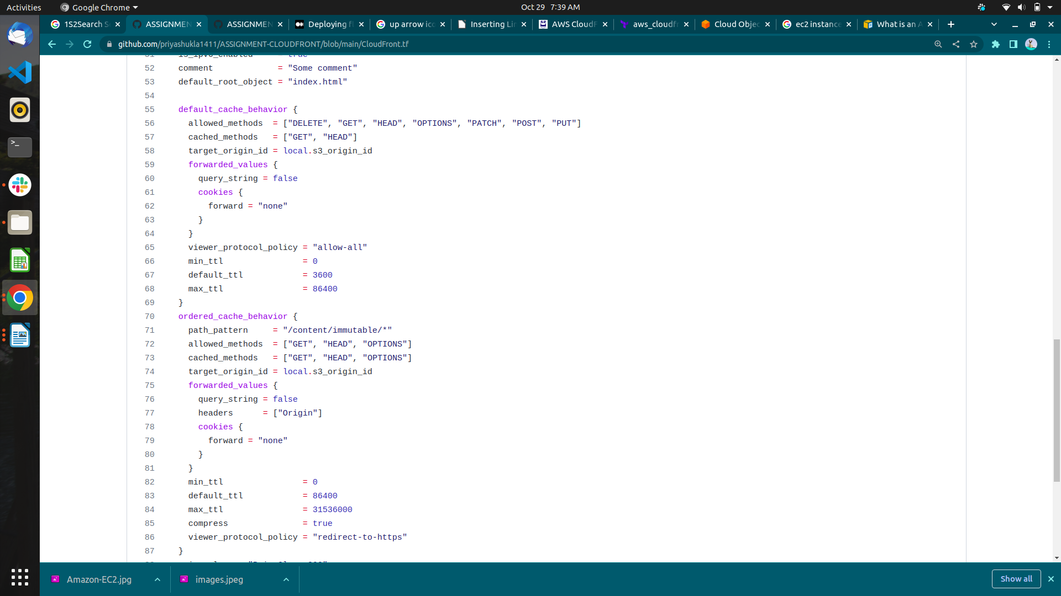
- Default cache behavior :-

- Ordered Cache Behavior
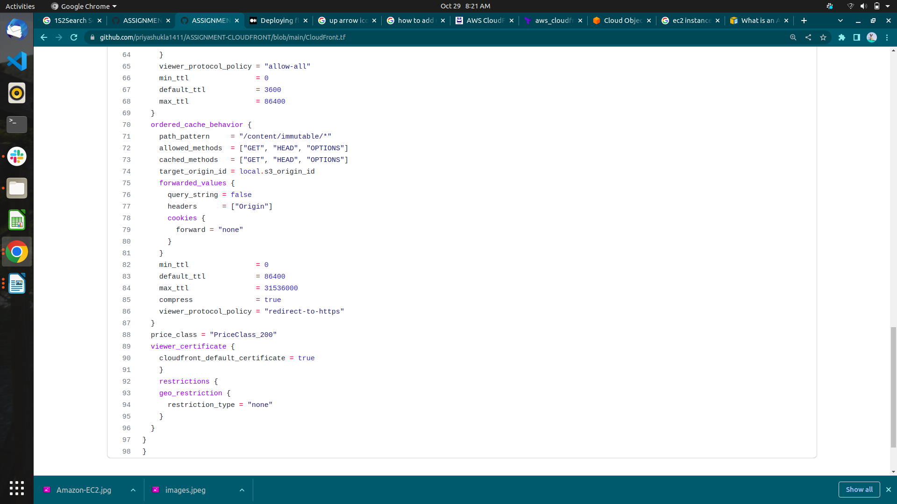

2.


- An Amazon EC2 instance is a virtual server in Amazon's Elastic Compute Cloud (EC2) for running applications on the Amazon Web Services (AWS) infrastructure.

- LoadBalancer :-

- A load balancer serves as the single point of contact for clients. The load balancer distributes incoming application traffic across multiple targets, such as EC2 instances, in multiple Availability Zones. This increases the availability of our application. We add one or more listeners to your load balancer.
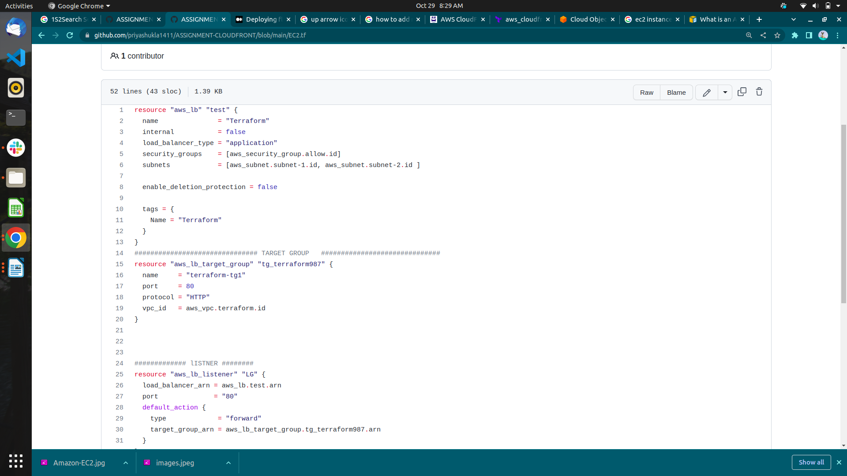

Instance :-

- In this EC2 instance Apache server installed byusing user data.
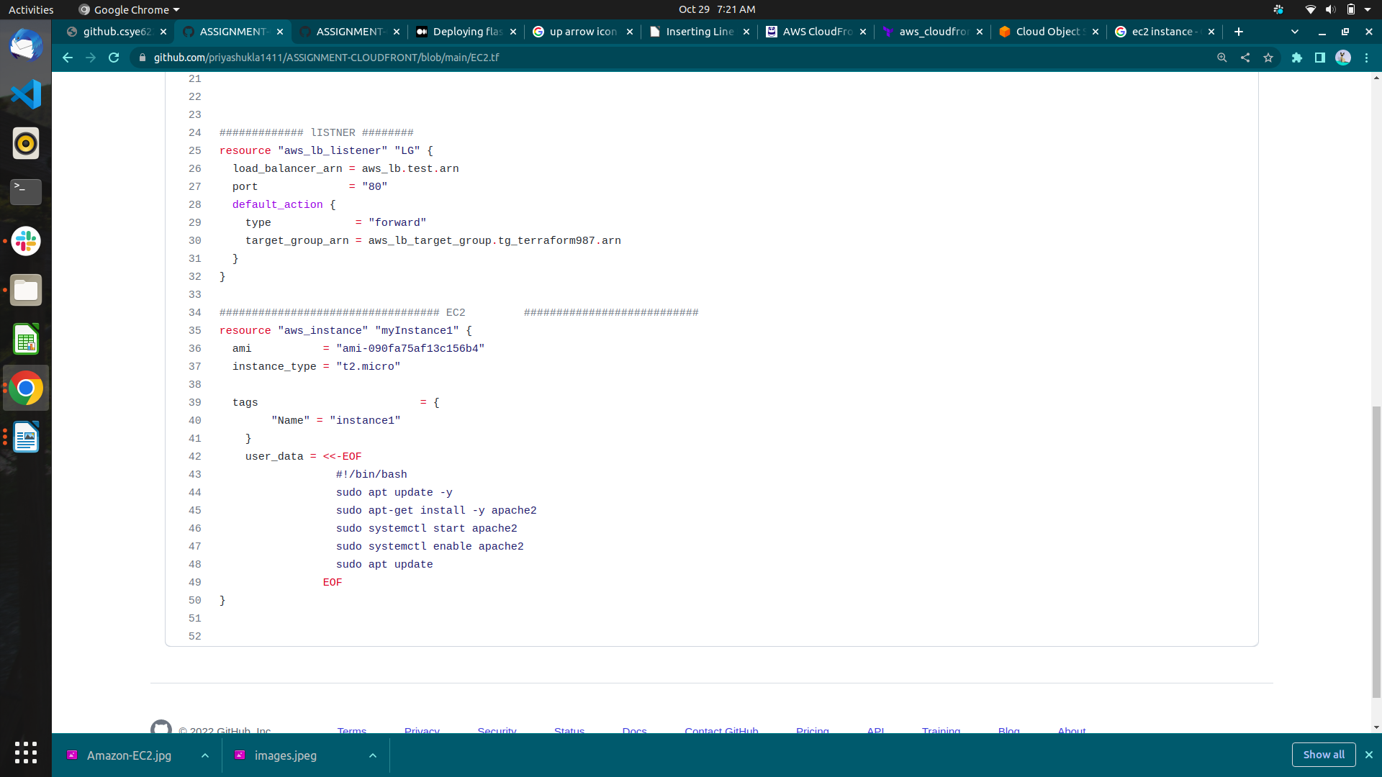
3.
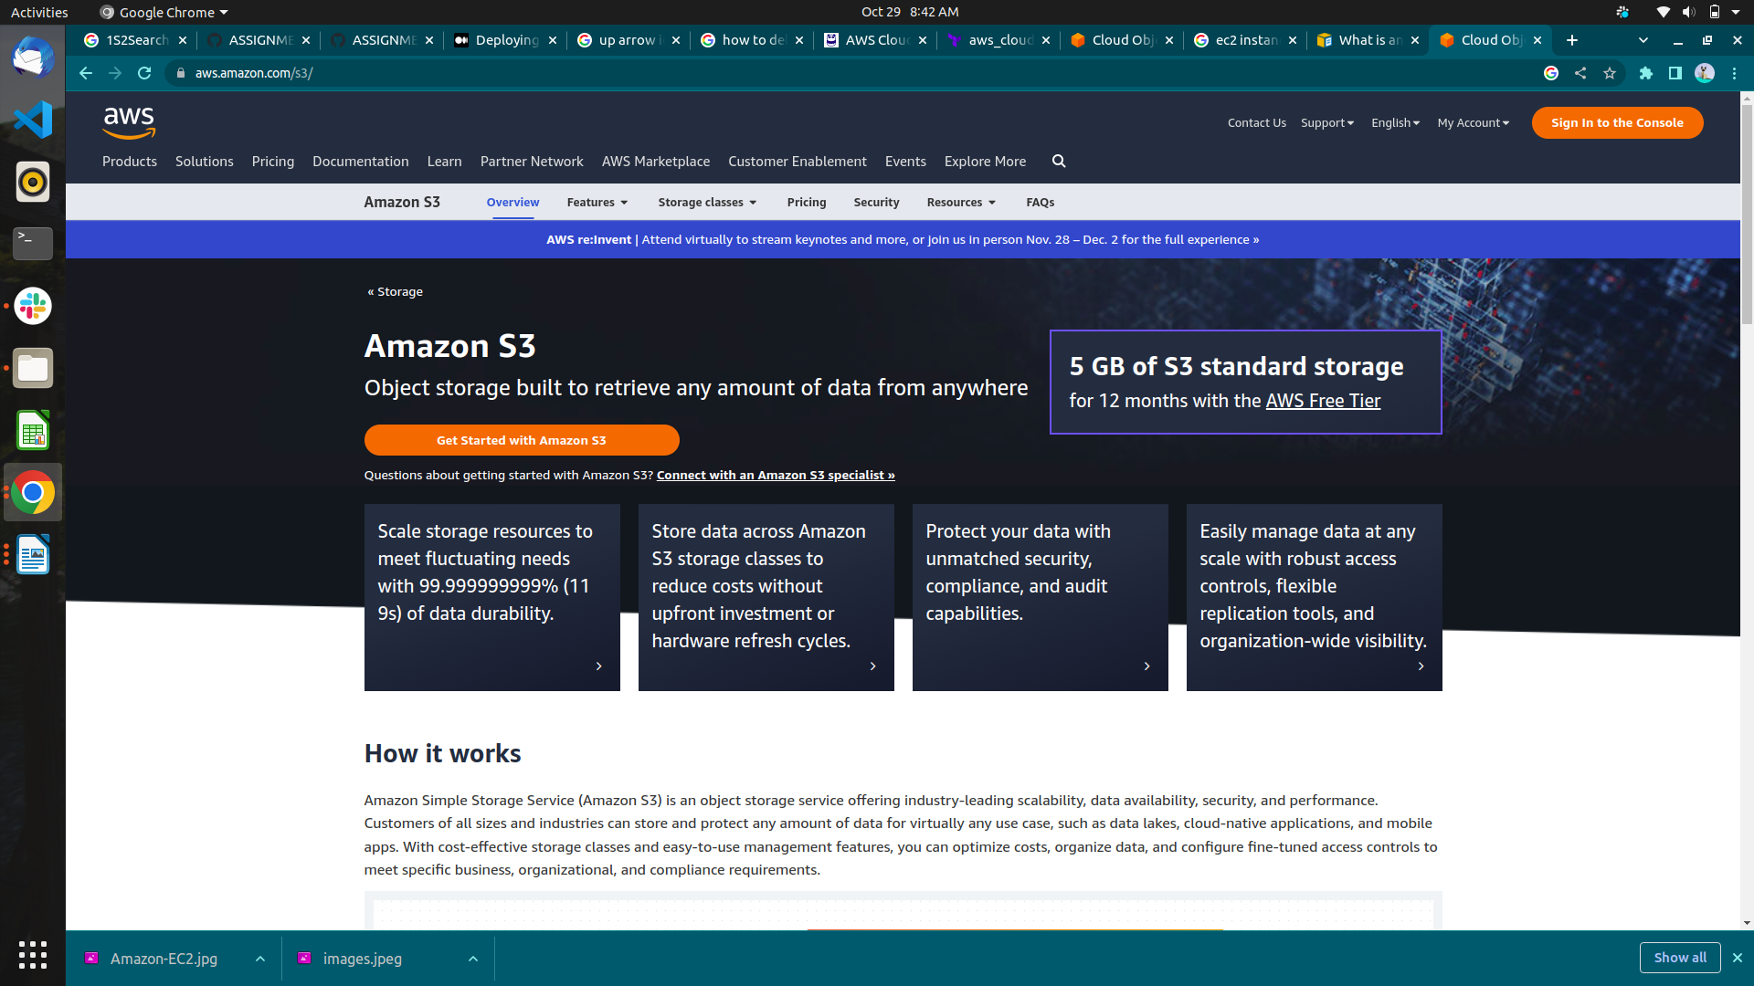

- Amazon S3 is an object storage service that stores data as objects within buckets.
- A bucket is a container for objects. To store your data in Amazon S3, you first create a bucket and specify a bucket name and AWS Region.

S3 Bucket :-
