Database Systems Lab
Project Proposal

1. Objective of the Proposal
The purpose of this proposal is to present the design and development plan for a software system supported by a database. The proposal explains the problem being addressed, the system that will be developed, and the role of the database in the system.
The project focuses on designing a structured database system that will help manage data efficiently for a garments shop. The system will store and organise information about products, customers, sales, suppliers, and inventory. The primary goal is to design and implement a database that ensures proper data management, quick retrieval, and data integrity.

2. Project Team Information
- Student 1 Name: Usman Dawood Afridi
- Student 2 Name: Siaf Akbar
Program & Group: BSSE Group A
Teacher: Ali Hassan
Subject: Database Systems Lab
Project Title:
Akbar Garments Management System

Version Control Section:

1. Version History
The table below tracks all changes made to this document and the project across milestones. New rows will be added as each milestone is completed.

Version | Date | Author(s) | Milestone / Change | Description
1.0 | 2025-04-06 | Usman Dawood Afridi,Siaf Akbar | Milestone 1 — Initial Submission | Database idea proposal
1.1 | 2025-04-24 | Usman Dawood Afridi, Siaf Akbar | Milestone 1 — Version Control Doc Created | Created formal version control document for Milestone 1 submission. Compiled project information, ERD entity list, schema description, and relationships into a structured PDF-ready document. Initial ERD design and relational schema for Akbar Garments Management System. Defined entities: Supplier, Product, Customer, Sales, Sales_Details, Inventory. Documented relationships and primary/foreign keys.
1.2 | 2025-05-13 | Usman Dawood Afridi, Siaf Akbar | Milestone 2 — ERD Design & Normalisation | Normalisation, duplication removal and updating of ERD
1.3 | 2025-05-13 | Usman Dawood Afridi, Siaf Akbar | Milestone 3 — Dataset Pre-processing: | Data synthesis, dataflow, exporting CSV files
1.4 | 2025-05-13 | Usman Dawood Afridi, Siaf Akbar | Milestone 4 — Database Setup (DDL) | Creating the database and all the tables with their required constraints
— | — | — | ----- | -----

Introduction & Background
Garment shops manage a large number of products, suppliers, and daily sales. Many small shops still manage their records manually using notebooks or simple spreadsheets. This method is inefficient and can lead to errors, data loss, and difficulty in tracking inventory.
Akbar Garments is a retail shop that sells winter clothing such as sweaters, jackets, socks, and other related items. Managing product stock, customer purchases, and supplier details manually can become difficult as the business grows. A database-backed management system can help organise this information efficiently and improve the overall operation of the shop.
Problem Statement
Many small garment shops rely on manual record-keeping for tracking products and sales. This creates several problems:
- Product stock is difficult to track accurately.
- Sales records may be lost or incorrectly recorded.
- It is difficult to find information about customers or suppliers.
- Manual calculations can lead to mistakes.
- Generating reports about sales and inventory is time-consuming.
These problems affect shop owners, employees, and customers. Without a proper system, business operations become inefficient. Therefore, a database-based system is required to store and manage data reliably and efficiently.
Proposed Solution

The proposed solution is a Garments Shop Management System supported by a relational database. The system will store all shop-related data such as products, suppliers, customers, inventory, and sales transactions.
The system will allow users to add, update, delete, and view records easily. It will also help track inventory levels and maintain accurate sales records. By using a database system, the shop owner can quickly access information, manage stock effectively, and maintain accurate business records.
Objectives of the System

- Efficient management of product information.
- Maintain accurate inventory records.
- Store and manage customer details.
- Record and track sales transactions.
- Ensure data consistency and integrity.
- Provide fast data retrieval and updates.
Scope of the Project

Included in the Project
- Product management (sweaters, jackets, socks, etc.)
- Customer information management
- Sales transaction management
- Supplier information storage
- Inventory tracking
- Database design and implementation

Excluded from the Project
- Online payment systems
- Mobile application integration
- Advanced analytics and AI-based predictions
Role of Database System
The database system plays a central role in this project. It will store all important information related to the garment shop.

Data Stored
- Product details
- Supplier information
- Customer records
- Sales transactions
- Inventory stock levels

Why a Database is Necessary
A database ensures that all information is stored in a structured and organised way. It prevents data redundancy and allows fast access to data.

Operations
The system will support standard database operations such as:
- Create new records
- Read existing data
- Update records
- Delete records

Data Integrity
Primary keys and foreign keys will be used to maintain relationships between tables and ensure data consistency.

System Features / Functional Requirements
The system will include the following features:
- Product management (add, update, delete products)
- Customer information management
- Supplier information management
- Sales transaction recording
- Inventory management
- Product search functionality
- Stock level tracking
- Sales report generation
- Data update and modification features
Preliminary Data Design
The main entities in the database include:

Product
Attributes:
- Product_ID (Primary Key)
- Name
- Category
- Size
- Color
- Price
- Stock_Quantity
- Supplier_ID (Foreign Key)

Customer
Attributes:
- Customer_ID
- Name
- Phone
- Address

Sales
Attributes:
- Sale_ID
- Date
- Customer_ID
- Total_Amount

Sales_Details
Attributes:
- Sale_Detail_ID
- Sale_ID
- Product_ID
- Quantity
- Price

Supplier
Attributes:
- Supplier_ID
- Name
- Phone
- Address

Inventory
Attributes:
- Inventory_ID
- Product_ID
- Stock_Level
- Last_Updated

Relationships
- One supplier supplies many products.
- One customer can make multiple purchases.
- One sale can contain multiple products.

Existing Systems / Comparative Analysis
Many small shops use manual systems such as notebooks or spreadsheets to manage their records. These systems are simple but have many limitations.
Manual systems are prone to errors, difficult to maintain, and slow when retrieving information. It is also difficult to generate reports or track inventory accurately.
The proposed system improves these limitations by providing a structured database system that allows fast data access, accurate record keeping, and better management of shop operations.

Proposed Technology Stack
Frontend:
HTML, CSS
Backend:
PHP
Database:
MySQL
Tools:
XAMPP, MySQL Workbench, VS Code
Expected Outcomes

After completion of the project, the system will provide an efficient way to manage shop data. The database will organize all information related to products, customers, sales, suppliers, and inventory.
The system will improve accuracy, reduce manual work, and make it easier to track business operations. It will also demonstrate proper database design and implementation as required for the Database Systems Lab project.
Milestone 2 — ERD Design &amp; Normalization

1. Normalization (1NF, 2NF, and 3NF)
Since your schema was designed correctly from the beginning, all tables already satisfy First Normal Form (1NF), Second Normal Form (2NF), and Third Normal Form (3NF). Therefore, no structural changes are required.

1. Product Table
Attributes:
- Product_ID (PK)
- Name
- Category
- Size
- Color
- Price
- Stock_Quantity
- Supplier_ID (FK)

First Normal Form (1NF)
The Product table already satisfies 1NF because each attribute contains a single atomic value. There are no repeating groups, and every product is uniquely identified by Product_ID.

Second Normal Form (2NF)
The Product table is already in 2NF because it uses a single-column primary key (Product_ID). All non-key attributes depend entirely on this key.

Third Normal Form (3NF)
The Product table is already in 3NF because all non-key attributes depend directly on Product_ID. There are no transitive dependencies.

2. Customer Table
Attributes:
- Customer_ID (PK)
- Name
- Phone
- Address

1NF
All fields contain atomic values and each customer is uniquely identified by Customer_ID.

2NF
Since the table has a single primary key, all attributes depend fully on Customer_ID.

3NF
There are no dependencies among non-key attributes. Therefore, the table is in 3NF.

3. Supplier Table
Attributes:
- Supplier_ID (PK)
- Name
- Phone
- Address

1NF
Each field stores a single value, and Supplier_ID uniquely identifies each supplier.

2NF
All attributes depend completely on the single primary key.

3NF
No non-key attribute depends on another non-key attribute.

4. Sales Table
Attributes:
- Sale_ID (PK)
- Date
- Customer_ID (FK)
- Total_Amount

1NF
Each attribute contains atomic values and each sale is uniquely identified by Sale_ID.

2NF
All non-key attributes depend fully on Sale_ID.

3NF
There are no transitive dependencies. Customer_ID is a foreign key and Total_Amount belongs to the sale transaction.

5. Sales_Details Table
Attributes:
- Sale_Detail_ID (PK)
- Sale_ID (FK)
- Product_ID (FK)
- Quantity
- Price

1NF
All attributes contain atomic values.

2NF
Because Sale_Detail_ID is a single-column primary key, all non-key attributes depend entirely on it.

3NF
There are no transitive dependencies. Quantity and Price describe the individual sale item.

6. Inventory Table
Attributes:
- Inventory_ID (PK)
- Product_ID (FK)
- Stock_Level
- Last_Updated

1NF
Each attribute contains only one value.

2NF
All non-key attributes depend fully on Inventory_ID.

3NF
There are no transitive dependencies. All attributes directly describe the inventory record.

Duplicate Removal Analysis:
During duplicate analysis, it was identified that stock information was stored in both the Product and Inventory tables using Stock_Quantity and Stock_Level. Since both attributes represent the same data, Stock_Quantity was removed from the Product table. Stock management is now handled exclusively through the Inventory table, eliminating redundancy and ensuring data consistency.

Updated Product Table (After Duplicate Removal)
The only structural change made to the database was the removal of the redundant Stock_Quantity attribute from the Product table, because stock information is already maintained in the Inventory table through the Stock_Level attribute.

Product Table (Final updated Version)
Attribute | Description
Product_ID (PK) | Unique identifier for each product
Name | Product name (e.g., Sweater, Jacket)
Category | Product category
Size | Product size
Color | Product color
Price | Selling price of the product
Supplier_ID (FK) | References the supplier who provides the product

Removed Attribute
- Stock_Quantity — Removed to eliminate redundancy and avoid inconsistencies.

Updated ERD:
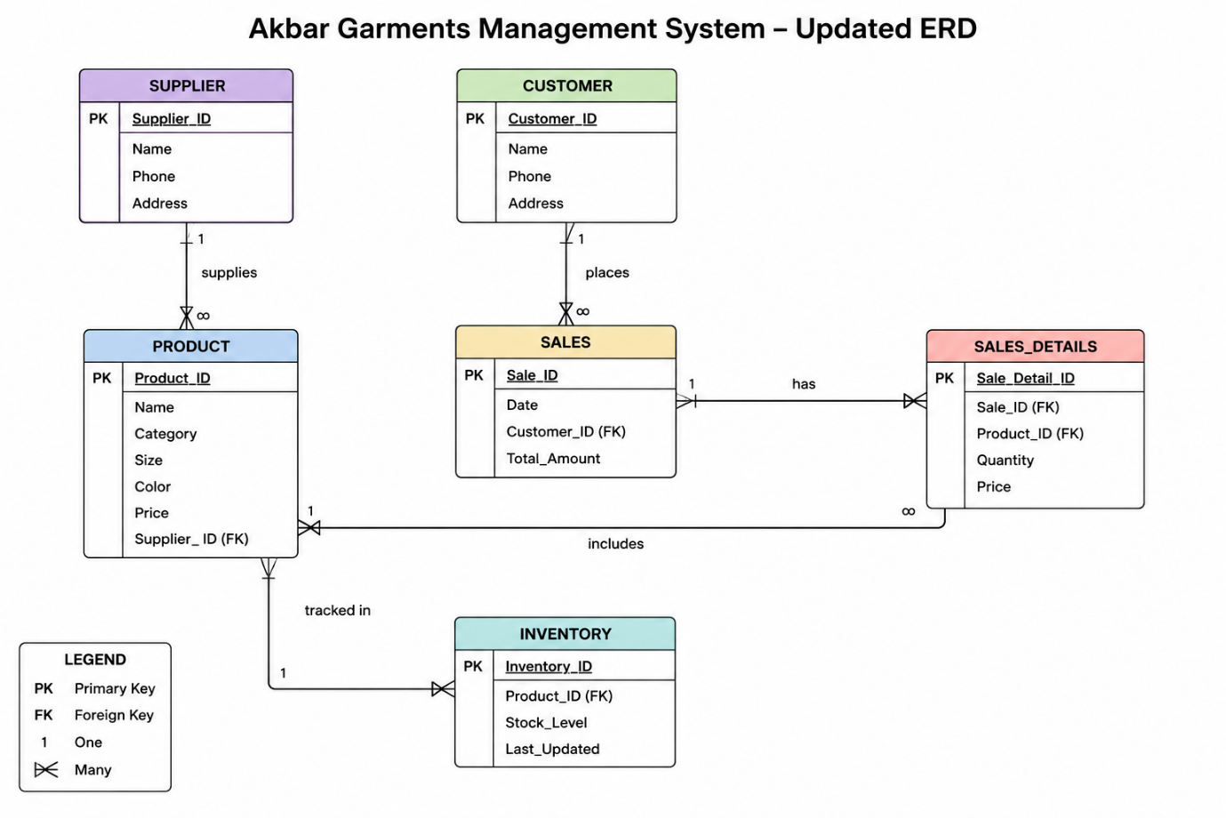

Milestone 3 — Dataset Preprocessing:

Synthetic Data Generation
Since no real-world dataset was available for the Akbar Garments Management System, a complete synthetic dataset was generated using Python and the pandas library. The data was created according to the finalized normalized schema and includes realistic records for suppliers, customers, products, inventory, sales, and sales details. Pakistani-style names, phone numbers, city addresses, garment categories (such as sweaters, jackets, socks, hoodies, and shawls), product prices, stock levels, and transaction dates were generated to simulate actual business operations. A total of six CSV files were produced: Supplier.csv (50 records), Customer.csv (100 records), Product.csv (100 records), Inventory.csv (100 records), Sales.csv (100 records), and Sales_Details.csv (100 records), satisfying the project requirement of at least 50–100 rows per core table.

Data Cleaning and Export
After generation, the dataset was preprocessed to ensure it was clean and ready for import into MySQL. Duplicate records were avoided by generating unique primary keys, all required fields were populated to eliminate null values, and formats were standardized for phone numbers, dates (YYYY-MM-DD), and numeric values. Foreign key relationships were validated to ensure referential integrity across all tables. The final cleaned data was exported as separate CSV files—one for each table—which can be directly loaded into the database during Milestone 5 using LOAD DATA INFILE or INSERT statements.

Dataflow Description
The dataflow of the Akbar Garments Management System begins when shop staff enter master data through the web application developed using HTML, CSS, PHP, and MySQL. Supplier information is entered first and stored in the Supplier table. Products are then added and linked to suppliers through Supplier_ID, while corresponding stock records are created in the Inventory table to track available quantities and update dates. Customer information is recorded in the Customer table whenever a new customer makes a purchase. These tables form the foundation of the system and provide the reference data required for daily business operations.
During a sales transaction, the system first creates a record in the Sales table containing the sale date, customer reference, and total amount. Each product included in the transaction is then stored in the Sales_Details table with its quantity and selling price. The Sales_Details table connects both the Sales and Product tables, allowing the system to identify which products were sold in each transaction. After the sale is completed, the quantity sold is deducted from the Inventory table and the Last_Updated field is refreshed, ensuring that stock levels remain accurate and current.
The stored data is used to generate outputs such as product catalogs, customer purchase histories, sales reports, supplier-product summaries, and low-stock alerts. The complete dataflow ensures that information moves in a structured manner from data entry to transaction processing and finally to reporting. This design maintains data consistency, preserves referential integrity, and supports efficient management of all business activities in the Akbar Garments Management System.
AKBAR GARMENTS MANAGEMENT SYSTEM DATAFLOW
┌──────────────┐
│ Supplier │
│ Supplier_ID │
└──────┬───────┘
│ supplies
▼
┌──────────────┐
│ Product │
│ Product_ID │
│ Supplier_ID │
└──────┬───────┘
│ has stock
▼
┌──────────────┐
│ Inventory │
│ Product_ID │
│ Stock_Level │
└──────────────┘
┌──────────────┐
│ Customer │
│ Customer_ID │
└──────┬───────┘
│ makes
▼
┌──────────────┐
│ Sales │
│ Sale_ID │
│ Customer_ID │
└──────┬───────┘
│ contains
▼
┌──────────────┐
│ Sales_Details│
│ Sale_ID │
│ Product_ID │
│ Quantity │
└──────┬───────┘
│ references
▼
┌──────────────┐
│ Product │
└──────────────┘
Outputs Generated:
• Sales Reports
• Inventory Reports
• Low Stock Alerts
• Customer Purchase History
• Supplier-Product Reports

Milestone 4 — Database Setup (DDL):

Database Implementation
The database for the Akbar Garments Management System was implemented in MySQL based on the finalized ERD and normalized relational schema. The system includes tables for Supplier, Customer, Product, Sales, Sales_Details, and Inventory, with primary keys and foreign keys used to maintain data integrity and relationships between entities.
During normalization and duplicate analysis, the redundant Stock_Quantity attribute was removed from the Product table because stock management is handled through the Inventory table using Stock_Level. Indexes were also created on foreign key columns to improve query performance and data retrieval efficiency.

SQL Database Creation Queries
The following SQL queries were used to create the complete database schema for the Akbar Garments Management System. These queries define all tables, constraints, relationships, and indexes according to the updated ERD and normalized database design.
Queries:
CREATE DATABASE akbar_garments_db;
USE akbar_garments_db;

CREATE TABLE Supplier (
Supplier_ID INT PRIMARY KEY AUTO_INCREMENT,
Name VARCHAR(100) NOT NULL,
Phone VARCHAR(15) NOT NULL UNIQUE,
Address VARCHAR(255) NOT NULL
);

CREATE TABLE Customer (
Customer_ID INT PRIMARY KEY AUTO_INCREMENT,
Name VARCHAR(100) NOT NULL,
Phone VARCHAR(15) NOT NULL UNIQUE,
Address VARCHAR(255) NOT NULL
);

CREATE TABLE Product (
Product_ID INT PRIMARY KEY AUTO_INCREMENT,
Name VARCHAR(100) NOT NULL,
Category VARCHAR(50) NOT NULL,
Size VARCHAR(20) NOT NULL,
Color VARCHAR(50) NOT NULL,
Price DECIMAL(10,2) NOT NULL,
Supplier_ID INT NOT NULL,
FOREIGN KEY (Supplier_ID) REFERENCES Supplier(Supplier_ID)
);

CREATE TABLE Sales (
Sale_ID INT PRIMARY KEY AUTO_INCREMENT,
Date DATE NOT NULL,
Customer_ID INT NOT NULL,
Total_Amount DECIMAL(10,2) NOT NULL,
FOREIGN KEY (Customer_ID) REFERENCES Customer(Customer_ID)
);

CREATE TABLE Sales_Details (
Sale_Detail_ID INT PRIMARY KEY AUTO_INCREMENT,
Sale_ID INT NOT NULL,
Product_ID INT NOT NULL,
Quantity INT NOT NULL,
Price DECIMAL(10,2) NOT NULL,
FOREIGN KEY (Sale_ID) REFERENCES Sales(Sale_ID),
FOREIGN KEY (Product_ID) REFERENCES Product(Product_ID)
);

CREATE TABLE Inventory (
Inventory_ID INT PRIMARY KEY AUTO_INCREMENT,
Product_ID INT NOT NULL,
Stock_Level INT NOT NULL,
Last_Updated DATE NOT NULL,
FOREIGN KEY (Product_ID) REFERENCES Product(Product_ID)
);

CREATE INDEX idx_supplier ON Product(Supplier_ID);
CREATE INDEX idx_customer ON Sales(Customer_ID);
CREATE INDEX idx_sale ON Sales_Details(Sale_ID);
CREATE INDEX idx_product ON Sales_Details(Product_ID);
CREATE INDEX idx_inventory ON Inventory(Product_ID);

~THE END~

