Milestone 1 Submission

Project Information:

Project Title: Akbar Garments Management System
Students:
• Usman Dawood Afridi
• Siaf Akbar
Teacher: Ali Hassan
Subject: Database Systems Lab
Program & Group: BSSE Group A

Entity Relationship Diagram (ERD):

This project includes the following main entities: Supplier, Product, Customer, Sales, Sales_Details, and Inventory. The ERD shows how these entities are related. One supplier can supply many products, one customer can make many purchases, and each sale can contain multiple products through the Sales_Details table.
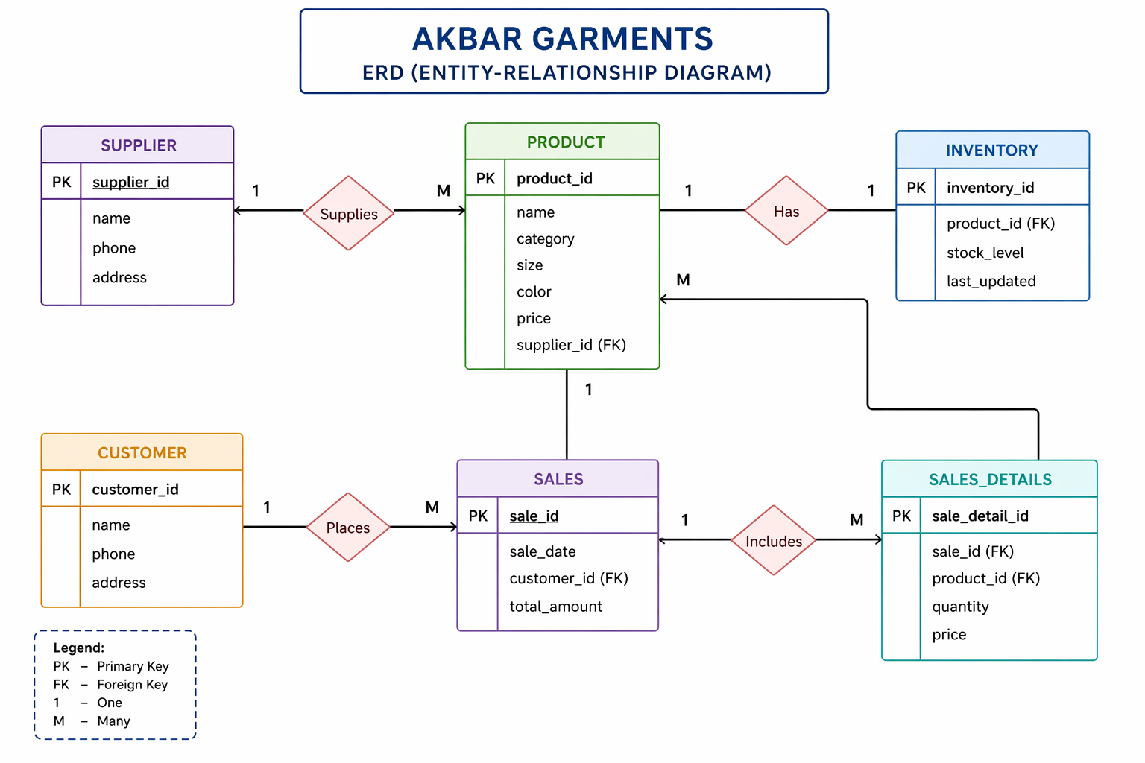

Relational Database Schema Description:

Supplier Table
supplier_id (PK)
name
phone
address

Product Table
product_id (PK)
name
category
size
color
price
supplier_id (FK → Supplier.supplier_id)

Customer Table
customer_id (PK)
name
phone
address

Sales Table
sale_id (PK)
sale_date
customer_id (FK → Customer.customer_id)
total_amount

Sales_Details Table
sale_detail_id (PK)
sale_id (FK → Sales.sale_id)
product_id (FK → Product.product_id)
quantity
price

Inventory Table
inventory_id (PK)
product_id (FK → Product.product_id)
stock_level
last_updated

Relationships:

• One Supplier supplies many Products (1:M).
• One Customer can make many Sales (1:M).
• One Sale can include multiple products through Sales_Details (1:M).
• Each Product has an Inventory record (1:1).

Conclusion:

The proposed database design for Akbar Garments Management System organizes data related to products, customers, suppliers, inventory, and sales. The relational schema ensures proper relationships between entities and maintains data integrity through primary and foreign keys.
_________________________________________________________________________________________________________

