16/09/2022

Contact Manager

Functional scope

Written by Siaka MANSALY

**Summary**

Impact Mapping 1

Front office 2

Back office 2

Tree structure 2

## Impact Mapping

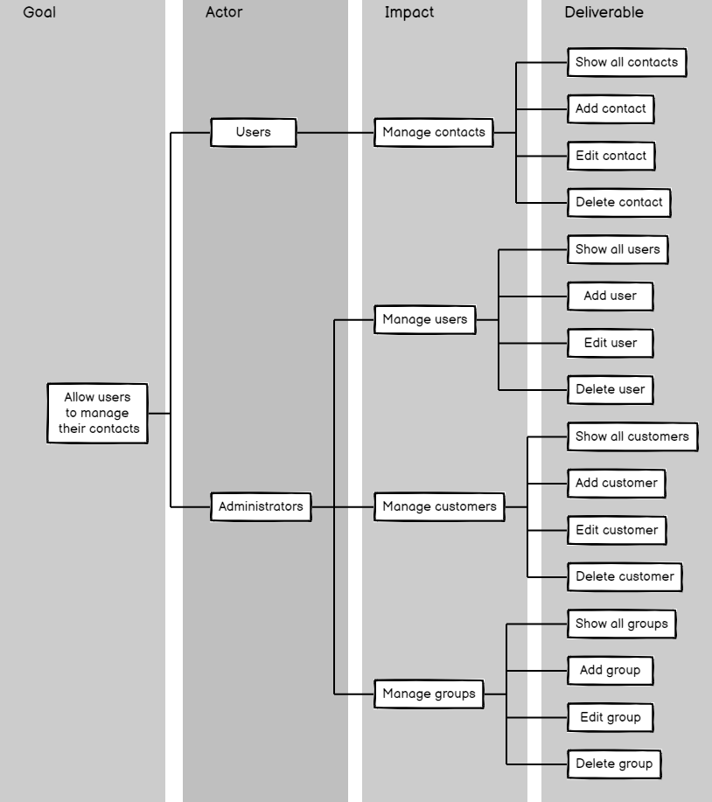

## Front office

|  |  |
| --- | --- |
| Deliverable | Associated constraints |
| Login Form | No particular constraint |

## 

## Back office

|  |  |
| --- | --- |
| Deliverable | Associated constraints |
| Contact management (CRUD) | Users and Administrator |
| Users management (CRUD) | Administrator only |
| Customers management (CRUD) | Administrator only |
| Groups management (CRUD) | Administrator only |
| Show all users | Administrator only |
| Show all customers | Administrator only |
| Show all contacts | Users and Administrator |
| Show all groups | Users and Administrator |

## Tree structure

