U.S. Desk Strategy | September 21, 2021
Market Views | ISSUE #17

September FOMC Preview and Market Implications

GEORGE GONCALVES
Head of U.S. Macro Strategy
Institutional Client Group
T +1-212-405-6687
E

MUFG Securities Americas Inc.
A member of MUFG, a global financial group

We want that Tapering: Its September then, then November, December, What?
Okay… this subtitle will take a little bit of explaining but for those familiar with that catchy tune by Riton & Nightcrawlers feat. Mufasa & Hypeman, you will know what I mean. A modification and an ode to tapering of the intro of that song would go like: You know we finally here, right? Where are we? It's taper time… if we do not get it in September then its either in November or December, what?
This is what tapering has come down to, guessing which month they finally go ahead with the most televised Fed action in history. If the Fed truly wants to separate tapering from tightening they need to just get on with it. However something tells me that given recent price action and uneven data they will still lean on the dovish side, i.e. give us enough guidance without delivering the full taper news.
This meeting is also critical given that we will get the 2024 dots and an update for all the prior years as well, with 2022 being a close call of coming in at 1 hike. The statement will also need a re-writing to suggest that “substantial further progress” has been made on the labor markets (so expect that phrase to drop). It will also be interesting to see how far they can stretch the transitory inflation line.
Bottom-line: Thus far the Fed has been able to avoid a 2013 taper tantrum repeat by stretching out the taper discussion and eventual implemention of their tapering plans. However signs of excess liquidity are everywhere (from the swollen RRP usage to tight spreads and high valuations in risk assets) so the jury is still out for what takes place once tapering is in motion. That however is not the focus of this meeting. The focus at this meeting is the 2024 dots, statement language adjustments (is inflation still transitory and how about the slowing of the economy lately, also transitory), taper and Powell’s Presser (and expect questions on China and the debt ceiling)…
FOMC MARKET SCENARIOS
The last Fed meeting had a slightly hawkish tilt in the statement (characterizing the economy is in a strengthening period) and chair Powell was more upbeat during his press conference too and even downplayed the impact of future CV19 waves on the economy. Yet rates barely moved on the day at the July meeting with 5s30s experiencing a minor flattening twist. At this juncture I feel there is more at risk and depending on what tone is struck, markets may move more, closer to what we saw in June meeting, I lean hawkish.
• | Dovish scenario (15% chance): Fed basically does not make any changes to rates, the 2024 dot has just 1 hike, and no specifics
• | given on taper. In such a scenario vols will come off, belly rates rally and credit spreads and risk assets perform into quarter-end.
• | Neutral scenario (55% chance): After having adjusted RRP rates and setting up the standing repo facility (SRF), the Fed is ready
• | to taper but does not provide the breakdowns or starting date, instead states that before year-end the Fed is preparing to reduce
• | the pace of QE purchases. They do not collectively raise the 2022 dot dampening fears of a faster hiking campaign lies ahead.
• | Hawkish scenario (20% chance): The 2022 submission end up tipping the scales toward 1 median hike projected that year and
• | the 2024 dots have 2 or more hikes built into that terminal rate as well. 5s would come under pressure as the curve flattens.
• | • Uber-hawkish scenario (10%): Take the hawkish scenario and add in the actual launch of the tapering, and starts up in October.

Comparing the actual last three FOMC meeting market moves and average cross-market changes for FOMC events (based on five years of historical data)
 | Bills (bp) |  |  |  | Coupons (bp) |  |  |  | Curves (bp) |  | TIPS (bp) | Vol (bpv) | FX (%) |  | Risk Market
 | 1m | 3m | 6m | 1y | 2yr | 5yr | 10yr | 30yr | 2s10s | 5s30s | 10yr Real | 1y10y vol | Euro | Yen | SPX | IG Spreads
7/28/2021 | (0.3) | 0.1 | 0.1 | 0.1 | (0.2) | 1.2 | (0.8) | (1.3) | (0.7) | (2.6) | (4.7) | (1.3) | 0.2% | 0.1% | 0.0% | (1.1)
6/16/2021 | 1.3 | 1.2 | 0.7 | 1.4 | 4.2 | 11.5 | 8.3 | 2.1 | 4.1 | (9.4) | 15.1 | 0.4 | -1.1% | 0.6% | -0.5% | (1.6)
4/28/2021 | 2.8 | 0.6 | (0.3) | (0.3) | (1.6) | (3.1) | (1.2) | (0.5) | 0.3 | 2.5 | (3.0) | (0.1) | 0.3% | -0.1% | -0.1% | 0.0
Avg Chg day | (2.1) | (1.7) | (1.6) | (0.9) | (1.8) | (2.5) | (2.7) | (2.8) | (0.9) | (0.3) | (1.8) | (0.7) | 0.1% | -0.2% | -0.4% | 0.5
Avg 1-day post | (1.5) | (0.8) | (0.8) | (0.6) | 0.1 | 1.0 | 1.2 | 1.0 | 1.0 | (0.0) | 1.6 | 0.0 | -0.1% | 0.0% | 0.0% | 0.5
Avg 5-day post | (0.7) | (1.1) | (1.4) | (3.6) | (2.9) | (2.4) | (1.8) | (1.6) | 1.1 | 0.8 | (0.6) | 0.6 | -0.2% | -0.1% | -0.6% | 3.7

Source: Bloomberg and MUFG U.S. Macro Strategy

DESK STRATEGY: MARKET VIEWS
©2021 Mitsubishi UFJ Financial Group, Inc. All rights reserved.



FED SEP VIEWS: ALL ABOUT THE DOTS & HOW THEY MARK-TO-MARKET WHAT FEELS LIKE PERSISTENT INFLATION
The Dots: Although there has been much consternation over the Fed’s tapering plans all year long, if one goes back and looks at the largest contributor of rate moves at the recent Fed meetings it was actually the lifting of the ‘23 dots (to suggest 2 hikes) that were updated at the June meeting that led to major rate market moves, especially in the belly. At the September meeting we will get updates for all the future terminal rate (median dots) forecast as well as the introduction of the 2024 rate expectations. I do not think there is major changes done to the 2023 dots so I am focusing on the 2022 and the new 2024 dots. Before I go there, don’t you find it interesting that the long-run dots cloud looks like an upside down arrow, maybe a sign of what is yet to come? I digress.
It’s a close call on the 2022 dots, but as our it would only take 3 FOMC members to raise their dots for the median dot to go to one hike in 2022. Given the clustering of forecasts in 2023, its possible that a similar grouping is formed for 2024 and that would put the 2024 dot closer to 1.125%, suggesting two more hikes then. This would be suggestive of a proper rate hiking campaign of 2 hikes per year for two years running. If the broader FOMC committee wants to deliver a dovish taper I think they would only project 1 hike in 2024 and again no hikes in 2022 just yet as they can always raise the dot estimates next year.
The dots are back in focus: watch the 2022 & 2024 moves Forwards 1M terminal rates and their spread to the dots

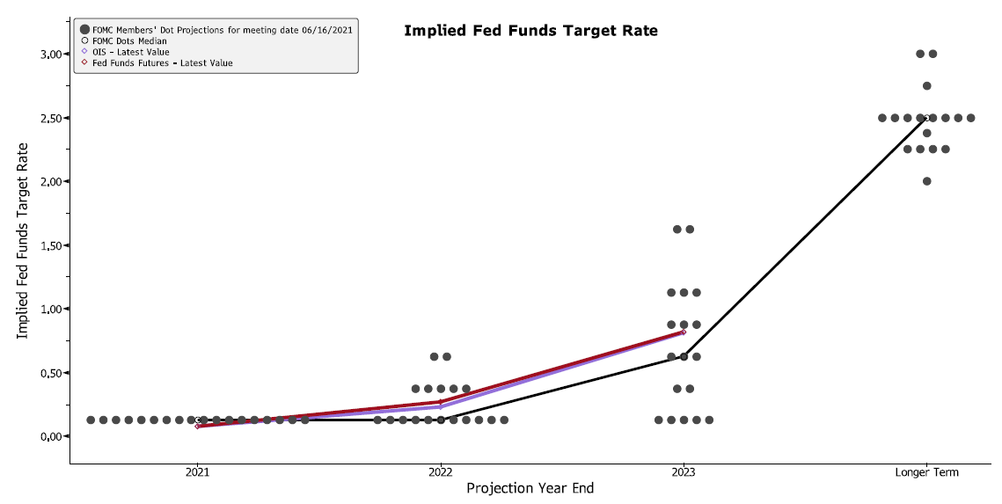

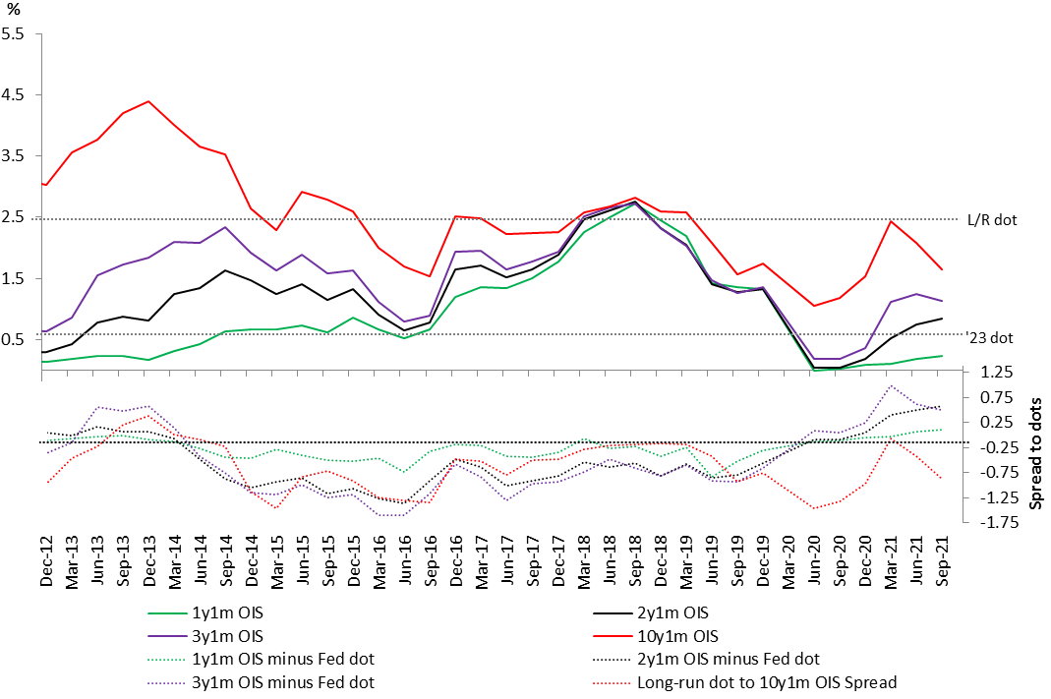

Source: Bloomberg DOTS, MUFG US Macro Strategy Source: Bloomberg, MUFG US Macro Strategy
FED BALANCE-SHEET POLICY OUTLOOK: TAPERING IS IN THE AIR, MAYBE JUST GUIDANCE OR THEY FINALLY DO IT!
Taper time: This will likely go down as the most well televised change in Fed policy in history. So kudos for the Fed in their attempt at making tapering a non-event. That said its always easier to talk about taking action versus delivering on it. I still am of the view that all this marginal excess liquidity has boosted risk assets and we will only know the counterfactual once they get at least half way through the tapering. Also as I have said before, each meeting now is live until we get the taper, so its always possible that the FOMC gives us enough information at the September meeting that it ends up being the tapering announcement. Alternatively, which is my base case, they give guidance but buy optionality to deliver the final plans at either the November (my base case given the OMOs calendar) or December meeting or in their parlance “sometime before year-end” starting in November with $15 bn proportional monthly decline would have them wrap up taper by summer 2022. However if there was a material slowing of the economy or some other exogenous event, I am of the view they could let MBS taper continue (given they own so much of that market) and keep buying USTs at a smaller scale. This 2-stage tapering of pausing/restarting would give them more flexibility.
Fed Ownership of UST vs MBS (% of overall marketplace) Fed Tapering: Start in November, keep flexibility to pause

40.00% | QE1 End | QE3 End | QT
35.00%
30.00%
25.00%
20.00%
15.00%
10.00%
5.00%
0.00%
2009 | 2010 | 2011 | 2012 | 2013 | 2014 | 2015 | 2016 | 2017 | 2018 | 2019 | 2020 | 2021
2009 | Fed MBS Holdings % of Barclays Index |  |  |  |  | Fed UST Holdings % of Marketable Debt Outstanding

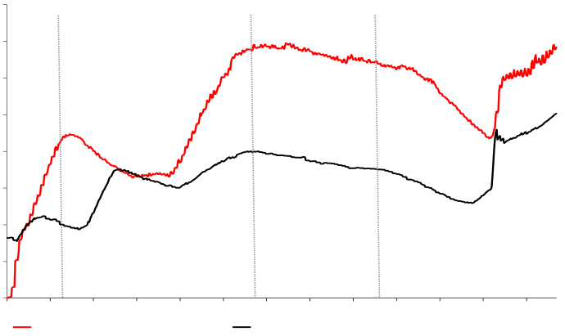
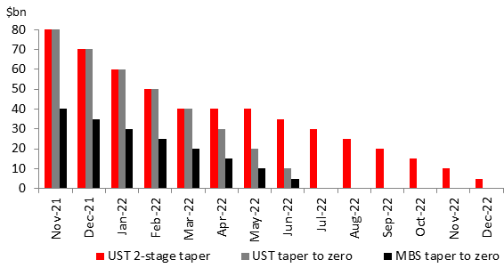

Source: Bloomberg, MUFG US Macro Strategy | Source: Bloomberg, MUFG US Macro Strategy | 2
DESK STRATEGY: MARKET VIEWS | Source: Bloomberg, MUFG US Macro Strategy | 2
©2021 Mitsubishi UFJ Financial Group, Inc. All rights reserved. | Source: Bloomberg, MUFG US Macro Strategy | 2

Notice to Recipients
The information herein provided is for information purposes only, and is not to be used or considered as investment research, a proposal or the solicitation of an offer to sell or to buy or subscribe for securities or other financial instruments. Neither this nor any other communication prepared by MUFG Bank, Ltd. (“MUFG Bank”), MUFG Union Bank, N.A., MUFG Securities Americas Inc., or other MUFG Group Company (collectively, "MUFG") is or should be construed as investment advice, a recommendation or proposal to enter into a particular transaction or pursue a particular strategy, or any statement as to the likelihood that a particular transaction or strategy will be effective in light of your business objectives or operations. Before entering into any particular transaction, you are advised to obtain such independent financial, legal, accounting and other advice as may be appropriate under the circumstances. In any event, any decision to enter into a transaction will be yours alone, not based on information prepared or provided by MUFG. MUFG hereby disclaims any responsibility to you concerning the characterization or identification of terms, conditions, and legal or accounting or other issues or risks that may arise in connection with any particular transaction or business strategy.
Certain information contained in this presentation has been obtained or derived from third party sources and such information is believed to be correct and reliable but has not been independently verified. While MUFG believes that factual statements herein and any assumptions on which information herein are based, are in each case accurate, MUFG makes no representation or warranty regarding such accuracy and shall not be responsible for any inaccuracy in such statements or assumptions. Note that MUFG may have issued, and may in the future issue, other reports that are inconsistent with or that reach conclusions different from the information set forth herein. Such other reports, if any, reflect the different assumptions, views and/or analytical methods of the analysts who prepared them, and MUFG is under no obligation to ensure that such other reports are brought to your attention. Furthermore, the information may not be current due to, among other things, changes in the financial markets or economic environment and MUFG has no obligation to update any such information contained in this presentation. This presentation is not intended to forecast or predict future events. Past performance is not a guarantee or indication of future results. Any prices provided herein (other than those identified as being historical) are indicative only and do not represent firm quotes as to either price or size.
The MUFG logo and name is a service mark of Mitsubishi UFJ Financial Group, Inc., and may be used by it or other Group companies for branding or marketing purposes. Group companies include MUFG Bank, MUFG Americas Capital Leasing & Finance, LLC, Mitsubishi UFJ Trust and Banking Corporation, MUFG Securities Americas Inc., and MUFG Union Bank, N.A. ("MUB”). Corporate or commercial lending or deposit activities are performed by banking affiliates of MUFG, including, in the United States, MUFG Bank and MUB.
This indicative financing proposal is provided for discussion purposes only and does not constitute, nor should it be construed as, a commitment to provide any financing or any assurance that the financing described herein may be available. The terms and conditions of such financing must be fully negotiated and contained in definitive documentation duly authorized, executed and delivered by all parties. In addition, the delivery of a commitment would be subject to, among other things, (i) [MUFG BANK’s][MUB’s] satisfaction with the results of its legal, technical, environmental and business due diligence, (ii) final internal approvals by [MUFG BANK][MUB], (iii) no material adverse change in the financial condition or otherwise of the relevant parties, (iv) no material adverse change or disruption in the relevant financial markets and (v) other customary conditions, including then current market conditions. This indicative financing proposal is confidential and may not be disclosed or released to any other party without the prior written consent of [MUFG BANK][MUB]. MUFG BANK is NOT a member of the FDIC and its deposit products are NOT insured by the FDIC or by any other government agency. MUB is a member of the FDIC and its deposit products are insured up to applicable limits. FLOES™ is a service mark of MUFG Securities Americas Inc.
DESK STRATEGY: MARKET VIEWS  ©2021 Mitsubishi UFJ Financial Group, Inc. All rights reserved. | 3

International Disclaimer
This report has been prepared by a subsidiary of Mitsubishi UFJ Financial Group, Inc. (“MUFG”) which carries on a securities related business.
Legal entities and branches
The securities related businesses within MUFG (together referred to in this presentation as “MUFG Securities”) are: (1) MUFG SECURITIES EMEA PLC (“MUS(EMEA)”) which is authorised in the United Kingdom by the Prudential Regulation Authority (“PRA”) and regulated by the Financial Conduct Authority (“FCA”) and the PRA (FS Registration Number 124512). MUS(EMEA) has a branch office that is registered at Level 3, East Wing, The Gate, Dubai International Financial Centre, PO Box 506894, Dubai, UAE (“Dubai Branch”). The Dubai Branch is authorised to operate in the Dubai International Financial Centre (“DIFC”) as a Non-DIFC Entity (Commercial License Number CL1656) and is regulated by the Dubai Financial Services Authority (Reference Number F002623); (2) MUFG SECURITIES AMERICAS INC. (“MUSA”) which is registered in the United States with the Securities and Exchange Commission (“SEC”) and regulated by the Financial Industry Regulatory Authority (“FINRA”) (SEC# 8-43026; CRD# 19685); (3) MUFG SECURITIES (CANADA), LTD. (“MUS(CAN)”) which is registered in Canada with the Ontario Securities Commission (“OSC”) and regulated by the Investment Industry Regulatory Organization of Canada (“IIROC”) and registered in the United States with the SEC, regulated by FINRA (SEC# 8-69693; CRD# 281904); (4) MUFG SECURITIES ASIA LIMITED (“MUS(ASIA)”) which is incorporated in Hong Kong, licensed under the Hong Kong Securities and Futures Ordinance and regulated by the Hong Kong Securities and Futures Commission (Central Entity Number AAA889). MUS(ASIA) has an office in Australia, MUFG SECURITIES ASIA LIMITED ARBN No. 169 329 453, which is registered at Suite 16 & 52, Level 36 Gateway, One Macquarie Place, Sydney, Australia. In respect of the financial services provided to wholesale clients in Australia, MUS(ASIA), MUS(EMEA), MUSA and MUFG SECURITIES ASIA (SINGAPORE) LIMITED (“MUS(SPR)”) are each exempt from the requirement to hold an Australian financial services licence under the Corporations Act 2001 (“Corporations Act”) under the Australian Securities and Investments Commission (“ASIC”) Class Order Exemption CO 03/1099, CO 03/1103, CO 03/1100 and CO 03/1102, respectively. Each of MUS(ASIA), MUS(EMEA), MUSA and MUS(SPR) are regulated under the laws of Hong Kong, the United Kingdom, the United States and Singapore respectively, which differ from Australian laws; and (5) MUS(SPR) which is licensed as an approved merchant bank by the Monetary Authority of Singapore.
General disclosures
This presentation is for information purposes only and should not be construed as investment research or a solicitation of any offer to buy or sell any security, commodity, futures contract or related derivative (hereafter “instrument”) or to participate in any trading strategy. This presentation does not constitute a personal recommendation and does not take into account the individual financial circumstances, needs or objectives of the recipients. Recipients should therefore seek their own financial, legal, tax or other advice before deciding to invest in any of the instruments mentioned in this presentation.
Certain information contained in this presentation has been obtained or derived from third party sources and such information is believed to be correct and reliable but has not been independently verified. MUFG Securities does not make any guarantee, representation, warranty or undertaking, express or implied, as to the fairness, accuracy, reliability, completeness, adequacy or appropriateness of any information or comments contained in this presentation. Furthermore the information may not be current due to, among other things, changes in the financial markets or economic environment. MUFG Securities has no obligation to update any such information contained in this presentation.
This presentation is not intended to forecast or predict future events. Past performance is not a guarantee or indication of future results. Any prices provided herein (other than those identified as being historical) are indicative only and do not represent firm quotes as to either price or size.
This presentation is proprietary to MUFG Securities and may not be quoted, circulated or otherwise referred to without our prior written consent. Notwithstanding this, MUFG Securities shall not be liable in any manner whatsoever for any consequences or loss (including but not limited to any direct, indirect or consequential loss, loss of profits and damages) arising from any reliance on or usage of this presentation and accepts no legal responsibility to any investor who directly or indirectly receives this material.
Country and region specific disclosures
This presentation is not directed to, or intended for distribution to or use by, any person or entity who is a citizen or resident of or is located in any locality, state, country or other jurisdiction where such distribution, publication, availability or use would be contrary to any law, regulation or rule.
In this regard, please note the following in relation to the jurisdictions in which MUFG Securities has a local presence:
United Kingdom / European Economic Area (EEA): This presentation is intended for distribution to a “professional client” or “eligible counterparty” as those terms are defined in the rules of the FCA and PRA. In other EEA countries, this presentation is intended only for persons regarded as professional investors (or equivalent) in their home jurisdiction. This presentation has been prepared in accordance with MUS(EMEA)’s organisational and administrative arrangements for managing conflicts of interest. Such arrangements include policies which set out guidelines relating to the production of research including (but not limited to) restrictions on access to information, personal dealing and inducements.
DESK STRATEGY: MARKET VIEWS  ©2021 Mitsubishi UFJ Financial Group, Inc. All rights reserved. | 4

United States of America: This presentation, when distributed by MUSA, is intended for Institutional Investors (“Institutional Accounts” as defined by FINRA Rule 4512(c)). When distributed by a non-US affiliate of MUSA, this presentation is intended for distribution solely to “major U.S.
institutional investors” or “U.S. institutional investors” pursuant to Rule 15a-6 under the U.S. Securities Exchange Act of 1934, as amended.
Securities referenced in this presentation may have been underwritten by MUSA and/or its affiliates. Nothing in this presentation should be considered an offer or solicitation of an offer to buy or sell securities or any other financial product or a commitment of any kind with respect to any transaction.
IRS Circular 230 Disclosure: MUFG Securities does not provide tax advice. Accordingly, any discussion of U.S. tax matters included herein (including any attachments) is not intended or written to be used, and cannot be used, in connection with the promotion, marketing or recommendation by anyone not affiliated with MUSA of any of the matters addressed herein or for the purpose of avoiding U.S. tax-related penalties.
Hong Kong: This presentation is only intended for distribution to a “professional investor” as that term is defined in the Securities and Futures Ordinance and should not be passed onto any other person.
Singapore: This presentation is only intended for distribution to an "institutional investor", "accredited investor" or "expert investor" as those terms are defined under regulation 2 of the Financial Advisers Regulation. It is solely for the use of such investors and shall not be distributed, forwarded, passed on or disseminated to any other person. Investors should note that, as a result of exemptions that apply when this presentation is distributed to "accredited investors" and "expert investors", MUS(SPR) is exempt from complying with certain requirements under the Financial Advisers Act, including section 25 of the Financial Advisers Act (which requires a financial adviser to disclose all material information on certain investment products), section 27 (which requires a financial adviser to have a reasonable basis for making recommendations on investments) and section 36 (which requires a financial adviser to disclose any interests that it holds in securities that it recommends).
Japan: This Note, when distributed by MUFG Securities affiliates located outside of Japan, is intended for distribution in accordance with Article 58-2 of the Financial Instruments Exchange Act 1948 (“FIEA”) i) to a “Financial Instruments Business Operator” engaged in “Securities-Related Business” as defined in the FIEA or ii) to the government, the Bank of Japan, a qualified financial institution defined in Article 209 of the Cabinet Office Ordinance Concerning Financial Instruments Business, Etc., or an Investment Manager. When distributed by Mitsubishi UFJ Morgan Stanley Securities Co., Ltd., this Note is intended for distribution to a “Professional Investor (tokutei-toushika)” as defined in the FIEA.
United Arab Emirates: This presentation is only intended for distribution to a “Professional Client” or “Market Counterparty” as those terms are defined under the rules of the Dubai Financial Services Authority and only a person meeting the criteria for these terms should act upon this presentation.
Australia: This presentation is only intended for distribution to persons in Australia who are sophisticated or professional investors for the purposes of section 708 of the Corporations Act of Australia (“Corporations Act”), and are wholesale clients for the purposes of section 761G of the Corporations Act. This Note is not intended to be distributed or passed on, directly or indirectly, to any other class of persons in Australia.
Other jurisdictions: MUFG Securities also relies on local registrations or regulatory exemptions in order to undertake certain securities business in other countries. In Thailand, MUS(EMEA) has a derivatives dealer registration with the Securities and Exchange Commission, Thailand. In Canada, MUS(EMEA) and MUSA each operate under an international dealer exemption registered with the securities regulators. MUS(EMEA) operates under the exemption in Alberta, Quebec, Ontario, British Columbia and Manitoba. MUSA operates under the exemption in all Canadian Provinces and Territories.
DESK STRATEGY: MARKET VIEWS  ©2021 Mitsubishi UFJ Financial Group, Inc. All rights reserved. | 5

Macro & FICC Research | Published: 2021�09�23 07�29
Nordic Alert | 
Fed signals tapering decision in November – Norges Bank expected to hike rates today
Global key stories
Yesterday’s FOMC meeting was slightly more hawkish than generally expected with the Fed now signalling a tapering decision at its 2�3 November meeting. Fed “dots” became more hawkish with half of the committee now seeing a first rate hike already next year and the median forecast suggesting that rates will move backto the pre-pandemic levels of 1.75�2.00% by end�2024 (read more in our Fed review ). The implied probability for a 25bps rate hike by end�2022 priced by fed funds futures jumped from 75% to 95%, thedollar gained slightly, and the 10y Treasury yield returned to pre-FOMC levels after an initial spike higher.Interestingly, while the yield curve flattened, the market pricing for short rates for the coming 3�5 years didnot increase, meaning that the OIS market is pricing a faster pace of hikes in the beginning but no more hikes than before over a longer term. We have been arguing in SEB FI & FX Strategy that long term rate hikeexpectations (terminal rate) are likely to rise meaningfully only when the growth anxiety fades and themarket sentiment turns better. With weaker macro data and China risk as headwinds, we think this will take some time and continue to target the 10y Treasury yield at 1.50% at the end of this year. US stock marketsadvanced around 1% after four days of declines in major indices, and the US index futures are pointingcautiously higher. Most Asian markets are edging higher this morning, aided by the PBoC’s liquidity injection and hopes that a disorderly collapse of Evergrande Group can be avoided. The company said that it hasresolved a domestic bond coupon payment due today and the imminent focus is now on a USD 83.5 millioncoupon on a dollar bond also due today. According to media reports, Chinese authorities are preparing for a restructuring where the state may take over Evergrande and divide the company into three parts and mergethem with state-owned companies. According to Bloomberg, Evergrande Group has USD 669 million ofinterest due in dollar bonds through the end of this year and USD 7.4bn in maturing dollar bonds in 2022. Today’s macro focus will be on PMI data for September and BOE’s rate decision.
BOE moving towards the exit. The MPC is split but the balance is shifting towards a start of a normalization
process. BOE’s new Chief Economist Pill is known to be critical on a too extensive QE policy and GovernorBailey has said that economic conditions to warrant a rate hike ware met already in August, despite a unanimous vote to keep rates unchanged. We believe that the MPC will decide to end asset purchases andpave the way for a small rate hike in 2022. We expect a moderation of further sterling appreciation, aimingEUR/GBP at 0.84 and 0.81 in end�2021 and 2022, respectively.
PMI-day. In the euro area, composite PMI took a small step lower in August as services joined the slight
decline in manufacturing but levels are still strong though for most components. For manufacturing, the major
four euro area economies’ production is still below, or close to pre-pandemic levels. For services, the outlook
is mixed. The summer has been a clear improvement compared to last year, but things are still not back tonormal and the Delta wave remains a headwind. In the US, sentiment indicators signal that US manufacturing has lost some momentum recently but remain in clear expansionary territory with strong demand butcontinued supply disturbances. Price indexes have remained elevated. Services PMI declined already in Julyand is more at risk from the spread of the Delta variant. However, retail sales data for August suggestconsumers remain resilient. PMI services prices peaked in May but have remained high.
Nordic key stories
Norges Bank: Rate hike and slightly higher rate path. Norges Bank is widely expected to hike the policy
rate today by 25bps to 0.25% and strong economic developments suggest that also the rate path will be
revised somewhat higher. However, while lower unemployment and rising capacity constraints are expectedto push wages higher, the latest increase in electricity prices is a downside risk to domestic demand and could potentially become a factor that can affect the interest rate trajectory during next year. We think the

positive factors dominate for now and stick to our forecast of a policy rate at 1.25% in end�2022 and 1.50%
in end�2023. After the market pricing turned more hawkish in recent weeks, we think the short end of the
NOK curve looks attractive to receive at these levels. Deteriorating risk appetite have stolen the limelight
from Norges Bank and pushed EUR/NOK clearly higher in recent days. Read more in .
Risk/reward favours an upside in EUR/NOK. Fully priced hike in the rates market and expectations on a
more hawkish rate path provides little room for a hawkish surprise and much more for a dovish one. NorgesBank weekly flows show that foreigners have added plenty of NOK the past four weeks making positioning a bit more sensitive for an adverse move, i.e. higher EUR/NOK. Long-term drift is higher in EUR/NOK. Octoberseasonality for EUR/NOK points also higher as the currency pair has risen in October for five straight years.
Today's key events
Chart package for the most important events this week
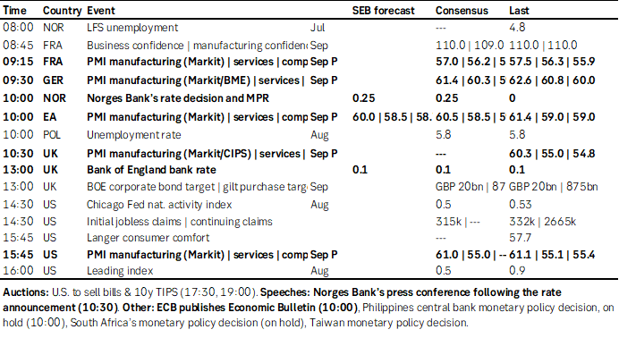
Market data
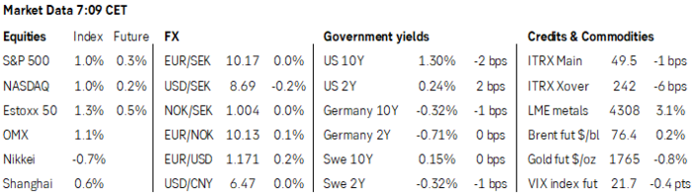
Jussi Hiljanen
jussi.hiljanen@seb.fi
�46850623167

