Parliament Browser: Handbook

WiSe 2022/2023 Abschluss Projekt by Siamak & Trey

Content

* Requirements
* Instructions
* Bugs

Requirements

In order to use this program, you must have Java version 1.8 installed on a compatible device with ability to input numbers and letters. An internet connection and access to the Goethe University Text Technology Lab Database is necessary. This can be via a VPN provided by the University or using campus Wi-Fi.

Minimum **Specifications: 512MB RAM**

Recommended: IntelliJ, AnyConnect

Important Notice

In some instances, you will be required to change some settings in IntelliJ to start the program. It is recommended to increase the maximum Heap-Memory size to at least 4GB for an optimal experience. Low Heap-Memory size can lead to slower processing of plenary protocols.

Expected Memory and CPU usage at 4GB:

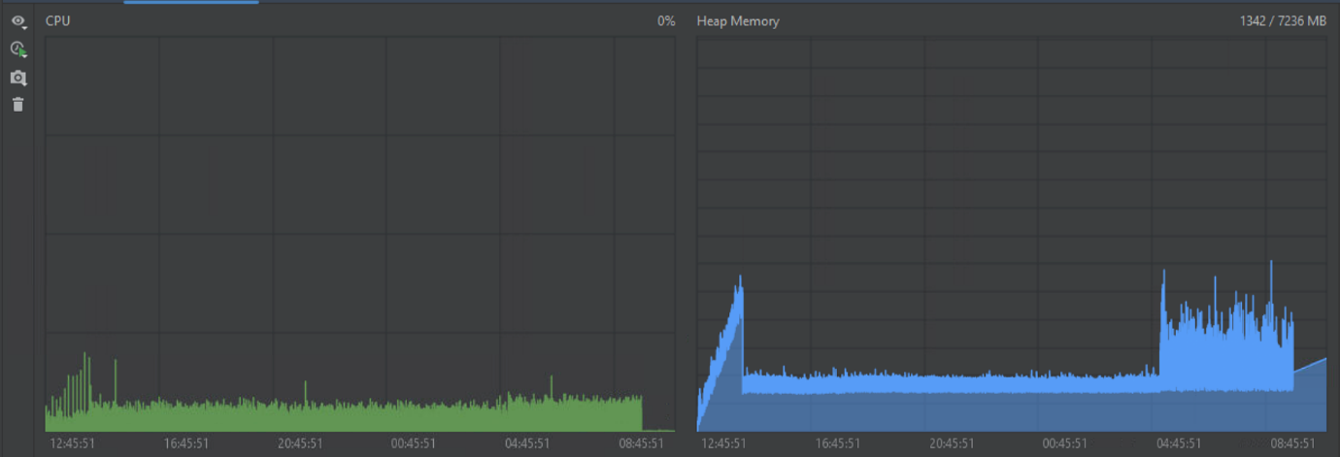

If further assistance is needed, please feel free to contact us at [s5487971@stud.uni-frankfurt.de](mailto:s5487971@stud.uni-frankfurt.de).

Instructions

To start the whole program you will need to run the backend part first.

Backend

1. Start the Program by calling the MainClass-Method or it through e.g., IntelliJ’s run feature.
2. After running the MainClass method you will prompted with the following options. You can select a option by typing the corresponding number into the console.

(1) : API (Without XML-Analysis; Very Quick !)

This starts the API for the Frontend.

(2) : Download & Parse all XMLs (Takes Too Much Time !)

The program will check if XMLs Files are provided in the XML folder. If this is not the case, it will automatically download all protocols from the 19. Wahlperiode and 20. Wahlperiode form <https://www.bundestag.de/services/opendata> and will parse these XML files, process them and upload the extracted information to the provided database. It will also download and upload Images of speakers and members of the Bundestag from <https://bilddatenbank.bundestag.de/>

After the Process you will be welcomed to the main menu:

(1) : MongoDB

Gives you the ability to perform operations on database by providing certain information. You can update existing information in the database.

(2) : NLP

Will run NLP on all Speeches and Comments in the database and will save/upload the results to the same database. A prompt will let you know if this operation was used previously, or NLP Data is already processed and available in the database.

(3) : Quit

Exit the application.

(4) : Create MongoDB-Doc

Gives you the option to add new collections by following the instructions in application.

(5) : Read MongoDB-Doc

Read a Collection/File in MongoDB database by following the instruction in application.

E.g. You can choose between, by choosing an object you can see its data.

(1) : AgendaItems

(2) : Comments

(3) : Fractions

(4) : Parties

(5) : Protocols

(6) : Speakers

(7) : Speeches

Expected output 🡺Fraction: BÜNDNIS 90/DIE GRÜNEN; Members: [[ Helge Limburg, Maria Mein-Schneink…]]….

(3) : Quit

Exit the application.

Frontend

1. After starting the API, you can open your browser of choice and type in <http://localhost:4567>

You will see following the following window:

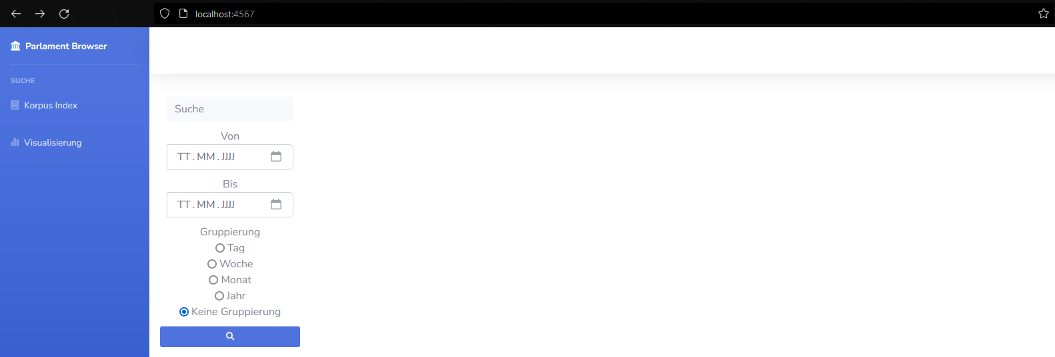

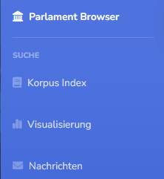

The **Parliament Browser** Icon and Text are like a Home Button.

**Korpus Index**: This will open the Korpus Index where you can manually search for Protocols.

**Visalisierung**: You can visualize Data.

**Nachrichten**: Send messages to other users.

**Korpus Index:**

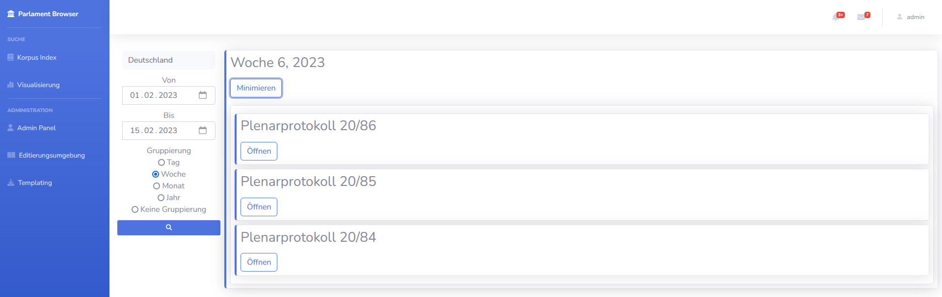

**Suche**: You can search for certain terms in protocols.

**Von**: Starting range for search. (You can also use the calendar widget to input date)

**Bis**: End range for search. (You can also use the calendar widget to input date)

**Gruppierung**: Grouping of protocols.

After filling out the required information you can press on .

***Important Notice***: The search for these Protocols can take a few seconds that is why it is recommended to keep the search radius smaller. E.g., in the picture above, you can see we searched for all Plenary protocols from 01.02.2023 to 15.02.2023 grouped by Weeks.

Here you can expand each object to reveal more information.

Ein Bild, das Text enthält.

You can see that in this Protocol the additional agenda items had these speakers with name, picture, their ID, their party, party ID, fraction and fraction ID.

Press on the **name** E.g., “Andreas Jung” to go to the “Volltext-darstellung” where you can see his speech and more information.

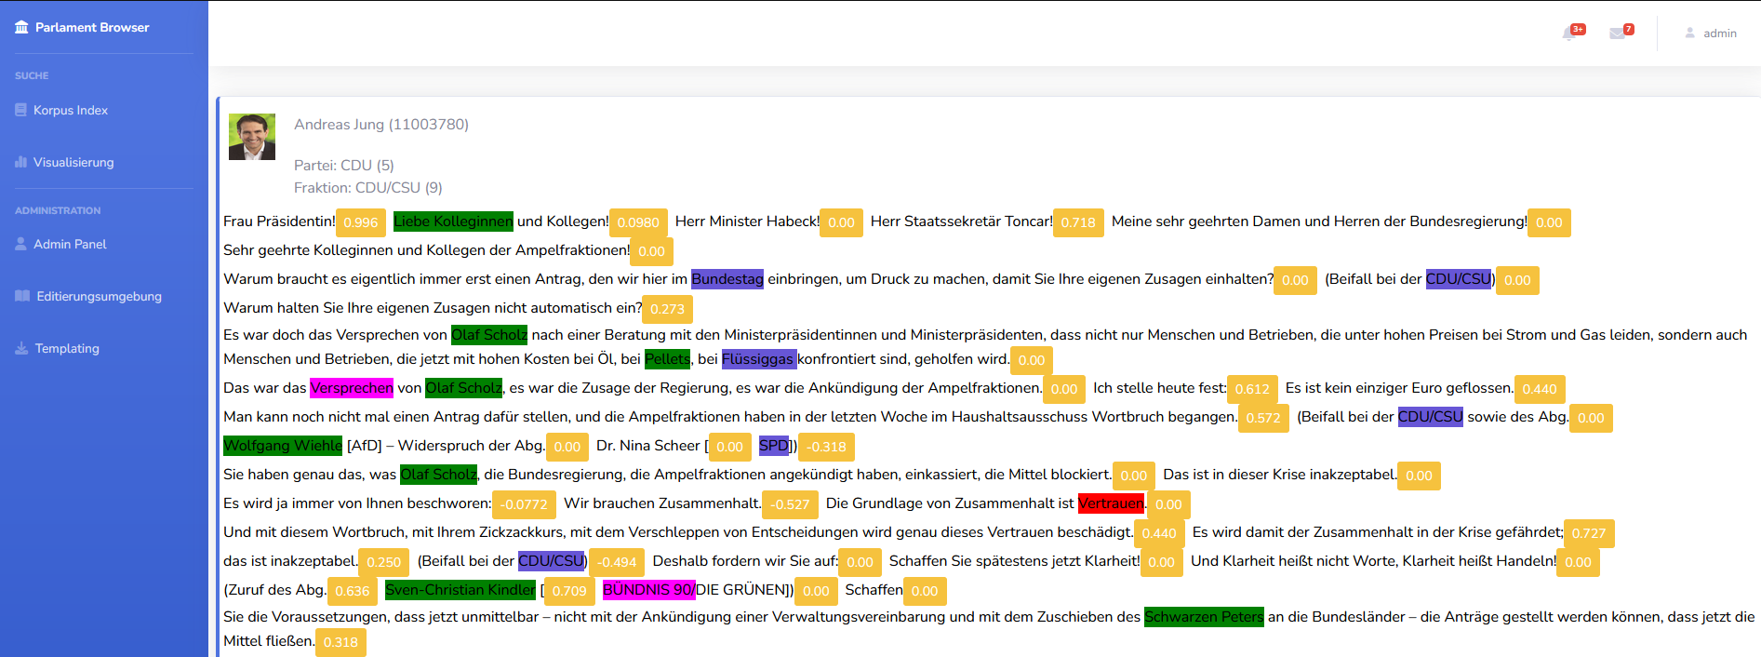

There you can see the sentiment of that sentence.

**Example:**



**Visalisierung**:

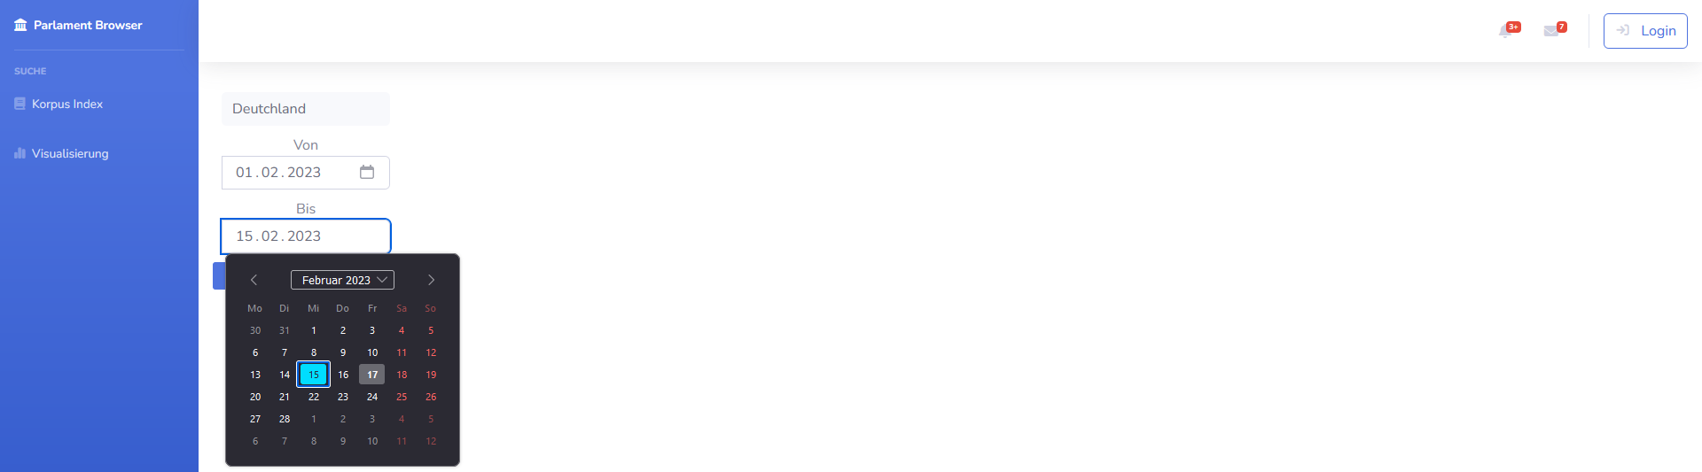

You will start with a blank window.

**Suche**: You can search for certain terms in protocols.

**Von**: Starting range for search. (You can also use the calendar widget to input date)

**Bis**: End range for search. (You can also use the calendar widget to input date)

After filling out the required information you can press on .

***Important Notice***: The visualization of these protocols can take a few moments, that is why it is recommended to keep the search radius as small as possible. E.g., in the picture above, you can see we want to visualize all Plenary protocols from 01.02.2023 to 15.02.2023.

Visualization of protocols:

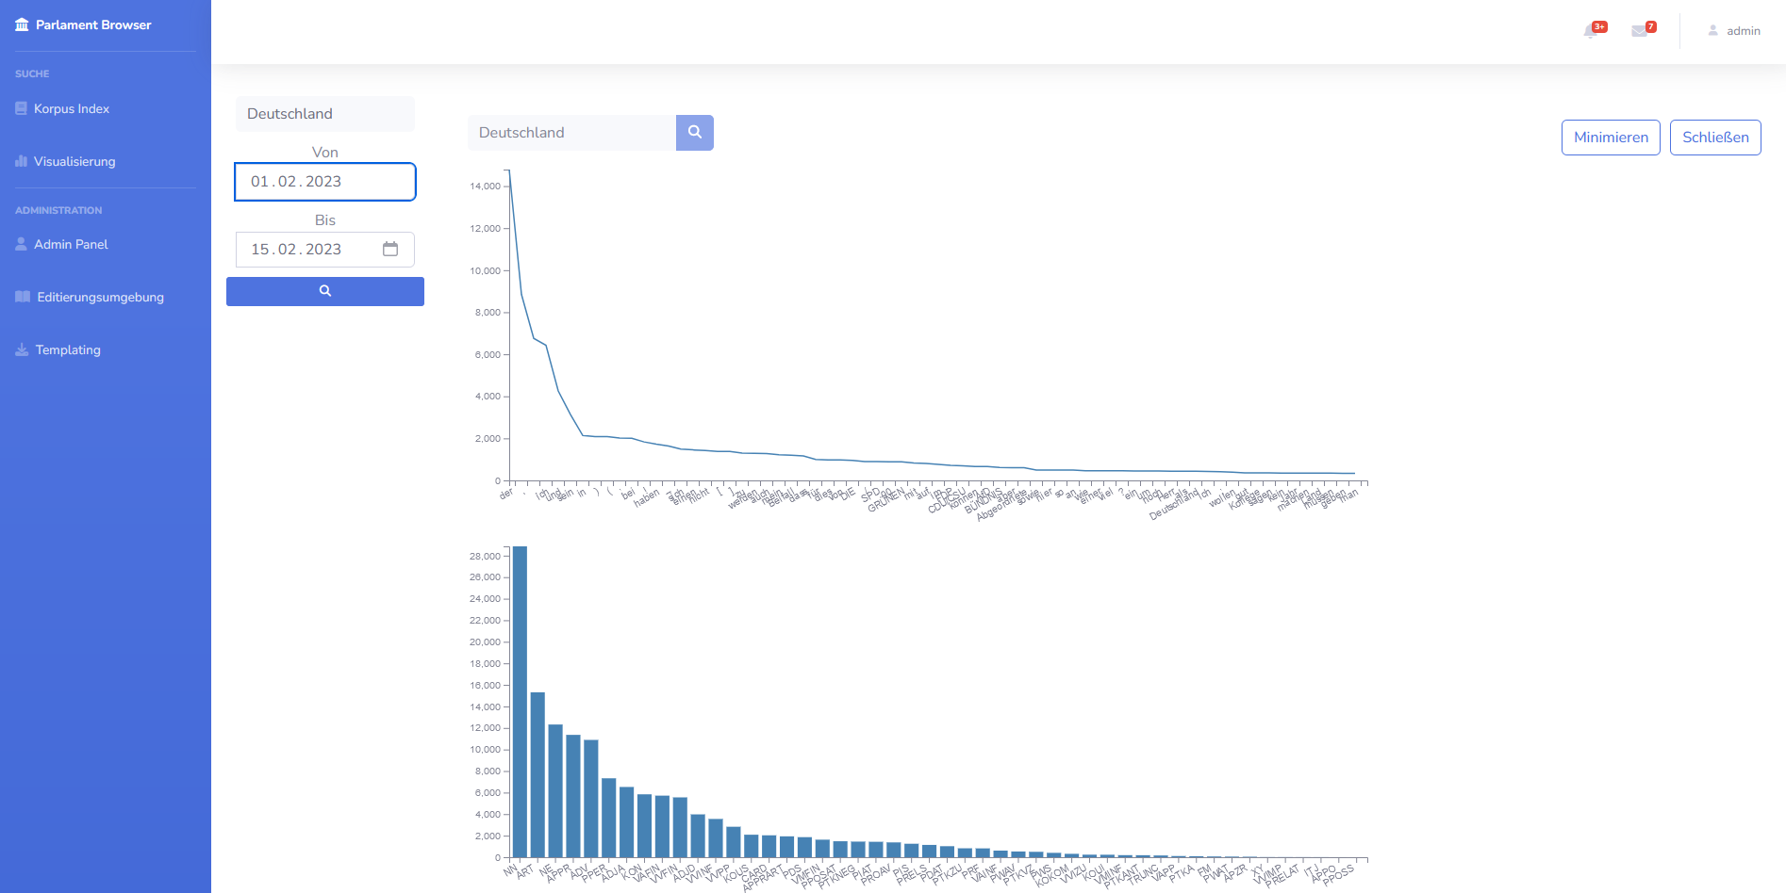

You can press on “Minimieren” to minimize the charts so in case you have multiple request and “Schließen” closes that particular chart window.

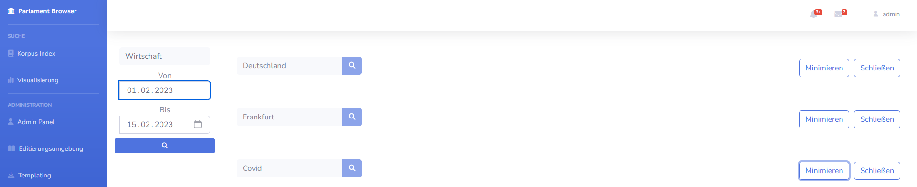

On some charts, you can hover over them to reveal more information!

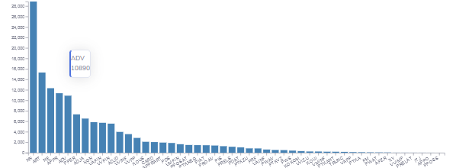

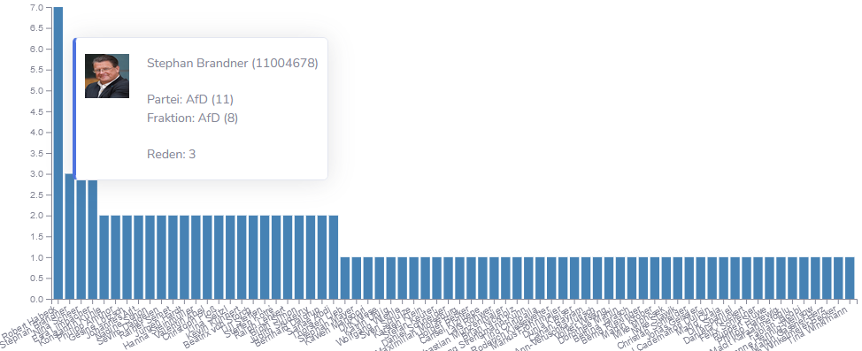

**Login**

By pressing the login button in the upper right corner of the page. You can log in with username: admin password: admin for more features like user management, latex templates or databases editing.

username: Admin
password: Admin

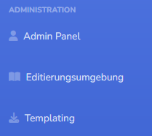

**Admin Panel**: manage users.

**Editierungsumgebung**: manage protocols and members of Bundestag and edit PDF/Latex templates.

**User bearbeiten:**

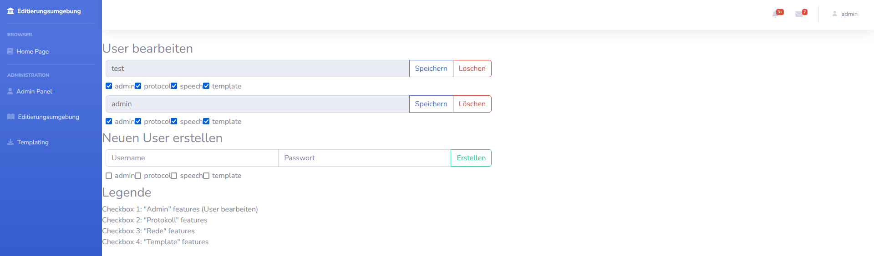

Here you can manage the users of the website while being logged in as a admin. You can edit, add or delete users and manage permissions. Change permissions by ticking the boxes and saving. Delete a user by pressing “Löschen”. Add new user bei adding Username and Password and given him permissions.

Checkbox 1: "Admin" features (edit users)

Checkbox 2: "Protokoll" features, edit protocols.

Checkbox 3: "Rede" features, edit speech.

Checkbox 4: "Template" features

**Editierungsumgebung**:

Ein Bild, das Text enthält.

Here you can either manage “Plenarprotokoll” and “Abgeordnete” or export “Templates” by pressing on the corresponding blue buttons.

This is the window for adding new protocols. Just fill in the required information and press save!

Ein Bild, das Text enthält.

This is the Latex Template window where you can typ in latex code to generate a PDF file.

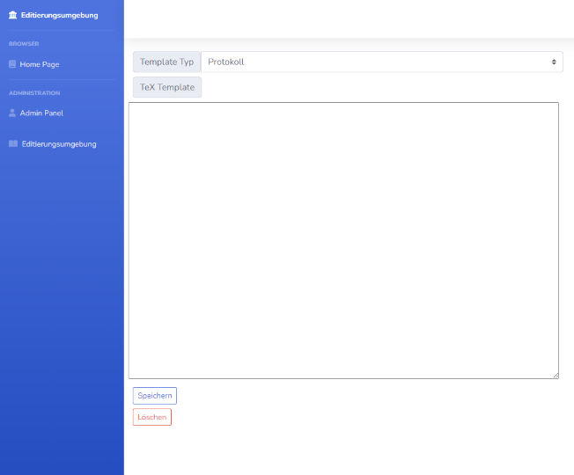Ein Bild, das Text enthält.

**Chat Function:**

Just type in the receiver and the message and the user, if available or “online” will receive the message!

Ein Bild, das Text, Screenshot, computer, Computer enthält.

Bugs

* If an instance of MainClass was running and was not terminated correctly, the main menu might not work correctly. Fix this by closing the corresponding PORT or restarting your computer (closes Port).
* Normally wrong input should be caught but, in some instances, this does not work correctly so please pay attention to the option in the terminal and try to be accurate with input.