Waterfall Methodology
Local Community Skill Exchange and Help Board
Group F | Syed Abdullah Maaz | Fahad Ahmed

This diagram shows the Waterfall Model for our community platform where neighbors post help requests and offers, match by location and skill, and rate each other. Each phase is completed before moving to the next.

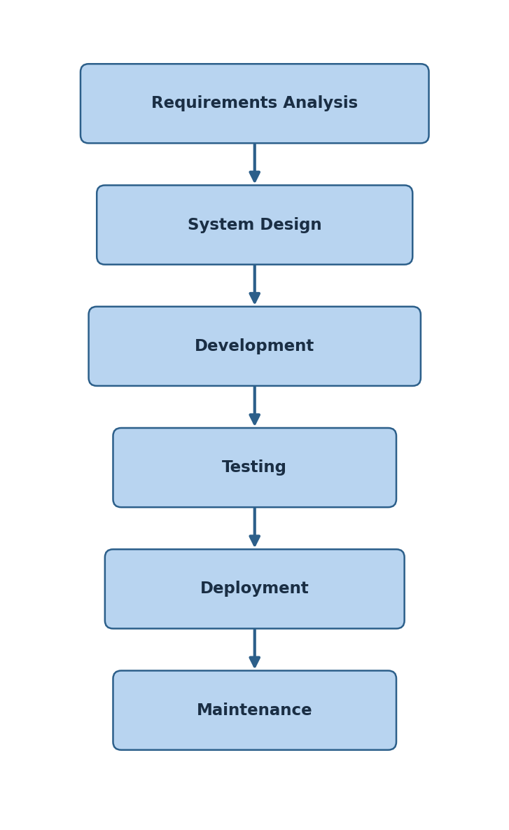

Project Phases
Phase | Timeline | Duration | Description | Notes
Requirements Analysis | Week 1–2 | 2 weeks | Define what the platform needs: user registration, help posts, nearby search, chat, and ratings. | Focus on core features first — registration, listings, and messaging.
System Design | Week 3–4 | 2 weeks | Plan the architecture using Django, PostgreSQL, GeoDjango, and Django Channels. | Create database schema, API design, and UI wireframes.
Development | Week 5–9 | 5 weeks | Build the prototype: backend APIs, frontend UI, real-time chat, and user profiles. | Backend first, then connect the frontend.
Testing | Week 10–11 | 2 weeks | Test all features using pytest-django. Fix bugs and check usability. | Test registration, search, chat, and rating workflows.
Deployment | Week 12 | 1 week | Deploy the working prototype to a server. Set up database, Redis, and email. | Run final checks before going live.
Maintenance | Week 13+ | Ongoing | Fix bugs, update content, and manage the moderation panel. | Monitor performance and respond to user feedback.

