Assessment 2 — Project Documentation
Local Community Skill Exchange and Help Board
Group F | Syed Abdullah Maaz | Fahad Ahmed

This document combines the agile project plan and requirements specification for a community platform where neighbors post help requests and offers, match by location, chat in real time, and rate each other. The project runs in 2 sprints of 2 weeks each.

Agile Project Plan

Agile Sprint Diagram
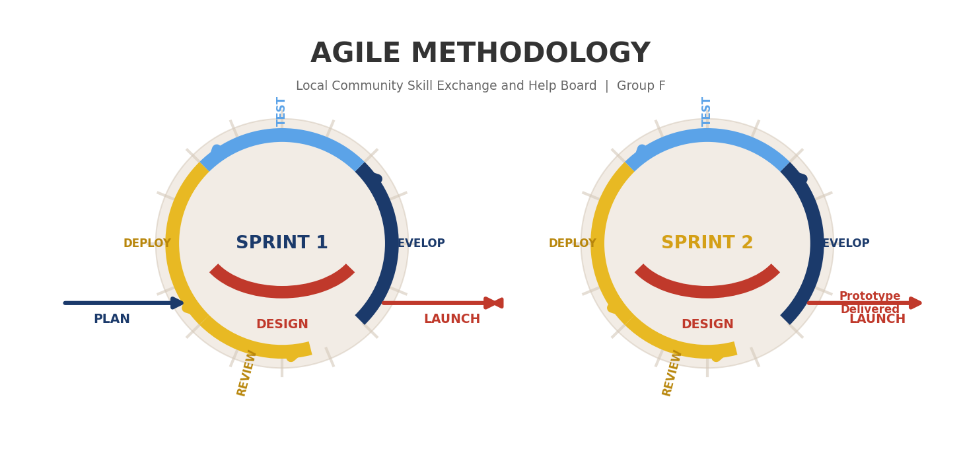

Sprint Summary
Sprint | Duration | Objective | Outcome
Sprint 1 | Week 1–2 | User accounts, profiles, listings, admin | Register, profile, post/browse listings; 12 unit tests
Sprint 2 | Week 3–4 | Search, chat, ratings, safety, deployment | Full prototype with chat, ratings, moderation; 18 integration tests

Sprint 1 Backlog
Task | Requirements | Implementation
Django + PostgreSQL setup | NFR-07, NFR-11 | backend/config/, docker-compose.yml
Registration & email verification | FR-01, FR-02 | backend/accounts/
Login, logout, password reset | FR-03, FR-04 | backend/accounts/
User profiles | FR-05 | backend/profiles/
Roles and permissions | FR-06 | backend/accounts/permissions.py
Listings and categories | FR-07 – FR-10 | backend/listings/
Input validation & listing detail | FR-23, FR-24 | backend/listings/, */forms.py
Admin moderation panel | FR-11 | backend/moderation/
Docker env configuration | NFR-17 | docker-compose.yml, .env.example
Unit tests | NFR-12 | backend/tests/ (12 tests)

Sprint 2 Backlog
Task | Requirements | Implementation
Nearby, keyword search, dashboard | FR-12, FR-25, FR-27 | backend/listings/filters.py
Match, chat, in-app notifications | FR-14 – FR-16, FR-26 | backend/chat/, notifications/
Ratings and reviews | FR-17, FR-18 | backend/reviews/
Report, block, moderator workflow | FR-19, FR-20, FR-28 | backend/moderation/
Rate limiting & logging | NFR-18, EXT-01, EXT-05 | settings.py, throttling.py
Health check, backup, deploy | EXT-02 – EXT-04, NFR-16 | docs/DEPLOYMENT.md, scripts/
Integration tests & deploy | NFR-12 – NFR-14 | backend/tests/, docs/DEPLOYMENT.md

Functional Requirements
Each functional requirement describes what the system must do. The Sprint column indicates when the requirement is implemented; Implementation Location shows the planned module path under backend/.

ID | Requirement | Description | Sprint | Implementation Location
FR-01 | User registration | New residents create accounts with email and password. | Sprint 1 | accounts/views.py, accounts/models.py
FR-02 | Email verification | Verification link sent; unverified users cannot post or chat. | Sprint 1 | accounts/views.py, notifications/email.py
FR-03 | Login and logout | Secure session-based authentication for members. | Sprint 1 | accounts/views.py, accounts/urls.py
FR-04 | Password reset | Time-limited reset link via email. | Sprint 1 | accounts/views.py, templates/emails/
FR-05 | User profile | Skills, bio, suburb/postcode, optional photo. | Sprint 1 | profiles/models.py, profiles/views.py
FR-06 | Role-based access | Member, Moderator, and Admin roles with permissions. | Sprint 1 | accounts/permissions.py, accounts/models.py
FR-07 | Create help listing | Post 'I need help' or 'I can help' with details. | Sprint 1 | listings/models.py, listings/views.py
FR-08 | Browse listings | Public feed of active help listings. | Sprint 1 | listings/views.py, templates/listings/
FR-09 | Listing categories | Predefined categories for discovery. | Sprint 1 | listings/models.py (Category)
FR-10 | Edit and close listing | Owners edit or mark listings complete. | Sprint 1 | listings/views.py
FR-11 | Admin moderation panel | Admins manage users, posts, and reports. | Sprint 1 | moderation/admin.py, listings/admin.py
FR-12 | Nearby search | Filter listings by suburb, postcode, or radius. | Sprint 2 | listings/filters.py, listings/services/location.py
FR-13 | Skill-based matching | Filter by skill keywords and category. | Sprint 2 | listings/filters.py
FR-14 | Express interest / match | Open a private chat thread between users. | Sprint 2 | listings/views.py, chat/models.py
FR-15 | Real-time chat | Live messaging via Django Channels + Redis. | Sprint 2 | chat/consumers.py, config/asgi.py
FR-16 | Chat history | Persisted message history per conversation. | Sprint 2 | chat/models.py, chat/views.py
FR-17 | Star ratings | 1–5 star rating with optional review text. | Sprint 2 | reviews/models.py, reviews/views.py
FR-18 | Display aggregate rating | Average rating shown on user profiles. | Sprint 2 | profiles/views.py, reviews/models.py
FR-19 | Report user or listing | Reports queued for moderator review. | Sprint 2 | moderation/models.py, moderation/views.py
FR-20 | Block user | Block prevents messages and hides listings. | Sprint 2 | moderation/models.py, chat/services.py
FR-21 | Match notifications | Email alerts for interest and new messages. | Sprint 2 | notifications/tasks.py, notifications/email.py
FR-22 | Responsive web UI | Core flows work on desktop and mobile. | Sprint 1–2 | templates/base.html, static/css/
FR-23 | Input validation | Field-level errors for invalid or edge-case input. | Sprint 1 | */forms.py, */serializers.py
FR-24 | Listing detail view | Full listing page with author and actions. | Sprint 1 | listings/views.py, templates/listings/detail.html
FR-25 | Keyword search | Search listings by title/description text. | Sprint 2 | listings/filters.py, templates/listings/search.html
FR-26 | In-app notifications | Unread alerts for matches, messages, ratings. | Sprint 2 | notifications/models.py, templates/notifications/
FR-27 | Personal dashboard | Member view of listings, matches, chats. | Sprint 2 | accounts/views.py, templates/accounts/dashboard.html
FR-28 | Moderator report workflow | Review, resolve, or dismiss user reports. | Sprint 2 | moderation/views.py, moderation/models.py

Non-Functional Requirements
Non-functional requirements define quality attributes: security, performance, usability, testability, and deployability.

ID | Requirement | Description | Sprint | Implementation Location
NFR-01 | Security — authentication | Hashed passwords; protected routes require auth. | Sprint 1 | config/settings.py, accounts/authentication.py
NFR-02 | Security — CSRF and XSS | CSRF tokens and template auto-escaping. | Sprint 1 | Django middleware, DRF settings
NFR-03 | Security — authorisation | Object-level permissions by role. | Sprint 1 | accounts/permissions.py, */permissions.py
NFR-04 | Data privacy | Suburb/postcode only; no exact addresses stored. | Sprint 1 | profiles/models.py, profiles/forms.py
NFR-05 | Performance — page response | Listing pages load within 3 seconds. | Sprint 2 | DB indexes, pagination, query optimisation
NFR-06 | Performance — real-time chat | Messages delivered within 2 seconds. | Sprint 2 | chat/consumers.py, Redis CHANNEL_LAYERS
NFR-07 | Reliability — data persistence | PostgreSQL with transactional integrity. | Sprint 1 | config/settings.py, migrations
NFR-08 | Scalability | Stateless REST + ASGI for horizontal scaling. | Sprint 2 | config/asgi.py, docs/DEPLOYMENT.md
NFR-09 | Usability | Core journeys ≤ 5 clicks with clear errors. | Sprint 1–2 | Templates, Sprint review UX checks
NFR-10 | Accessibility | WCAG 2.1 Level A basics (semantic HTML, contrast). | Sprint 2 | templates/base.html, docs/ACCESSIBILITY.md
NFR-11 | Maintainability | Modular Django apps per domain. | Sprint 1 | backend/ app structure, docs/ARCHITECTURE.md
NFR-12 | Testability | ≥ 30 automated tests (pytest-django). | Sprint 1–2 | tests/, conftest.py, pytest.ini
NFR-13 | Observability | Structured logging for errors and moderation. | Sprint 2 | config/settings.py (LOGGING)
NFR-14 | Deployability | Docker Compose + env-based staging deploy. | Sprint 2 | docker-compose.yml, docs/DEPLOYMENT.md
NFR-15 | Email deliverability | Configurable SMTP / console backend. | Sprint 1–2 | config/settings.py, notifications/email.py
NFR-16 | Reliability — availability | ≥ 99% uptime; friendly error pages. | Sprint 2 | templates/500.html, health-check endpoint
NFR-17 | Portability | Runs in Docker/staging via env vars only. | Sprint 1–2 | docker-compose.yml, .env.example, settings.py
NFR-18 | Security — rate limiting | Throttle login, report, and chat endpoints. | Sprint 2 | config/settings.py, accounts/throttling.py

Extended Requirements
Extended requirements (GeeksforGeeks) support monitoring, reliability, and future expansion beyond core features: logging, monitoring, analytics, backup, and rate limiting.

ID | Requirement | Description | Sprint | Implementation Location
EXT-01 | Logging | Record errors and key events for audit/debug. | Sprint 2 | config/settings.py (LOGGING), views/consumers
EXT-02 | Monitoring and alerting | Health-check endpoint; deployment monitoring notes. | Sprint 2 | config/views.py, docs/DEPLOYMENT.md
EXT-03 | Usage analytics | Admin summary of registrations, listings, matches. | Sprint 2 | analytics/models.py, analytics/views.py
EXT-04 | Backup and disaster recovery | DB backup script and restore documentation. | Sprint 2 | scripts/backup_db.sh, docs/DEPLOYMENT.md
EXT-05 | Rate limiting (API) | Request quotas on public/authenticated APIs. | Sprint 2 | DRF throttle classes in settings.py

Requirements Traceability
Sprint | Functional | Non-Functional | Extended
Sprint 1 | FR-01 – FR-11, FR-22 (base), FR-23 – FR-24 | NFR-01 – NFR-04, NFR-07, NFR-11, NFR-12 (12 tests), NFR-15, NFR-17 | —
Sprint 2 | FR-12 – FR-28, FR-22 (complete) | NFR-05 – NFR-06, NFR-08 – NFR-18 | EXT-01 – EXT-05

Acceptance: prototype complete when users can register with validated input, post/browse/detail listings, keyword and nearby search, chat in real time, receive in-app notifications, leave ratings, and admins/moderators resolve reports — with ≥ 30 passing automated tests and documented backup/health-check procedures.

